Dr Jon Turvey

Pass mrcpsych

paper a textbook

Table of Contents

1. Behavioural Science and Sociocultural Psychiatry 34

1.1 Basic Psychology 34

1.1.1 Learning theory and clinical applications 34

1.1.2 Visual and auditory perception 39

1.1.3 Information processing and attention 44

Information processing and attention 44

Models of attention: 45

Measuring attention: 45

Illusions 46

Hallucinations 46

Attention in Schizophrenia 47

Attention in other disorders 48

1.1.4 Memory 50

Memory: Influences Upon and Optimal Conditions for Encoding, Storage and Retrieval 50

Encoding: 50

Storage: 50

Retrieval: 50

Primary Working Memory Storage Capacity and the Principle of Chunking 51

Working memory: 51

Principle Of chunking: 51

Semantic Episodic and Skills Memories and other Aspects of Long-Term/Secondary Memory 52

Semantic memory: 52

Episodic memory: 52

Flashbulb memory: 52

Procedural memory: 52

Long-term or secondary memory: 53

Sensory memory: 53

Distortion, Schema, Inference, and Elaboration in Relation to Memory 53

Distortion: 53

Schemas: 54

Inference: 54

Elaboration: 54

Schema: 54

The Process of Forgetting 54

Memory Failure: 55

Emotional Factors and Retrieval 56

In Short-Term Memory: 56

Long-Term Memory: 56

Emotional factors affecting the process of forgetting: 56

Retrieval factors affecting the process of forgetting: 56

The Relevance of this to Memory Disorders and their Assessment 57

Amnesia: 57

Memory assessment: 58

1.1.5 Thought 60

Thought 60

The Possible Relationship with Language 60

Concepts, Prototypes and Cores: Deductive and Inductive Reasoning 61

Problem-Solving Strategies, Algorithms and Heuristics 62

1.1.6 Personality 64

Personality: Derivation of Nomothetic and Idiographic Theories 64

Nomothetic theory: 64

Idiographic theory: 64

Trait and Type Approaches and Elementary Personal Construct Theory 65

Principles Underlying Psychoanalytic, Social Learning, Cognitive Neuroscience and Humanistic Approaches 66

Psychoanalytical defence mechanisms and development: 67

Construction and Use of Inventories, Rating Scales, Grids and Q-Sort 69

1.1.7 Motivation and Maslow 73

Motivation: Needs and Drives 73

Drive reduction theory: 73

Arousal theory: 74

Extrinsic Theories (Based on Primary and Secondary Drive Reduction) and Homeostasis 74

Extrinsic motivation: 74

Hypothalamic Systems and Satiety 75

Intrinsic Theories, Curiosity, and Optimum Levels of Arousal 75

Intrinsic motivation: 75

Limitations of Approach and Attempts to Integrate 75

Cognitive Consistency and the Need for Achievement (nAch) 76

Maslow’s Hierarchy of Needs 76

1.1.8 Emotion 79

Emotions and Components of Emotional Responses 79

Types of emotions: 79

Components 79

Subjective experience: 79

Physiological response: 79

Behavioural or expressive response: 79

Critical Appraisal of James-Lang and Cannon-Bard Theories 79

Cognitive Appraisal: Differentiation and Status of Primary Emotions 80

Differentiation and Status of Primary Emotions 80

Emotions and Performance 80

Yerkes-Dodson law: 81

1.1.9 Stress 84

Stress: Physiological and Psychological Aspects 84

Situational Factors: Life Events, Daily Hassles/Uplifts, Conflict, and Trauma 84

Vulnerability and Invulnerability 84

Type A Behavior Theory 84

Coping Mechanisms 85

Locus of Control, Learned Helplessness, and Learned Resourcefulness 85

Resilience 86

1.1.10 States and levels of awareness 87

Levels of Consciousness and Evidence or Unconscious Processing 87

Arousal, Attention, and Alertness 87

Sleep Structure and Dreaming 87

Parasomnias 87

Biorhythms and Effects of Sleep Deprivation 88

Hypnosis and Suggestibility 88

Meditation and Trances 89

1.2 Social Psychology 91

1.2.1 Attitudes 91

Attitudes: Components and Measurement 91

Thurstone scales: 92

Likert scales: 93

Osgood semantic differential scales: 93

Attitude Change and Persuasive Communication 94

Cognitive Consistency and Dissonance 94

How do Attitudes Influence Behaviour? 95

1.2.2 Self-psychology 97

Self-Psychology: 97

Self-concept: 97

Self-esteem: 97

Self-image: 97

Self-Recognition and Personal Identity 97

1.2.3 Interpersonal issues and social behaviour 99

Interpersonal Issues: Person Perception, Affiliation and Friendship 99

Types of interpersonal conflicts: 99

Potential resolution methods: 99

Attribution Theory, ‘Naive Psychology’ and the Fundamental Attribution Error 100

Dispositional (internal) attribution: 100

Situational (external) attribution: 100

‘Naive psychology’: 100

Fundamental attribution error: 101

Social Behaviour in Social Interactions 101

What is an example of social behaviour? 102

‘Theory of Mind’ as it Might Apply to Pervasive Developmental and Personality Disorders 102

Autism: 103

Schizophrenia: 104

Depression and anxiety: 104

Elemental Linguistics as Applied to Interpersonal Communication 104

1.2.4 Leadership and social behaviour 107

Leadership, Social Influence, Power, and Obedience 107

Leadership: 107

Social influence: 107

Power: 107

Obedience: 107

Types of Social Power 107

Influence Operating in Small and Large Groups or Crowds 108

Conformity: 108

Polarization: 109

Groupthink: 109

Risky-shift phenomenon: 110

Deindividuation: 111

Communicative Control in Relationships 111

1.2.5 Intergroup behaviour 113

Intergroup Behaviour: Prejudice, Stereotypes and Intergroup Hostility 113

Prejudice: 113

Stereotypes: 113

Intergroup hostility: 113

Social identity and group membership: 113

Group Membership: 114

1.2.6 Aggression 115

Defining Aggression 115

Explanation According to Social Learning Theory & Operant Conditioning 115

‘Bobo doll’ experiment: 115

Ethnology 116

Frustration Theories 116

Milgram’s experiment: 118

Stanford prison experiment: 118

Physiological Arousal Concepts 119

The Influence of Television and other Media 119

Family and Social Backgrounds of Aggressive Individuals 120

Personality Disorders and Aggression 121

Culture and Aggression 122

War and peace: 122

1.2.7 Altruism 128

Defining Altruism 128

Psychological approaches to altruism: 128

Cost-arousal model: 129

Evolution, game theory and neuroscience: 129

Social Exchange Theory 130

Helping Relationships 131

Interpersonal Cooperation 131

1.3 Social Science & Socio-cultural Psychiatry 133

1.3.1 Social terms and sick roles 133

Descriptive Terms: Social Class, Socio-Economic Status and their Relevance to Psychiatric Disorder and Health Care Delivery 133

The Social Role of Doctors 134

The Sick Role 134

The Illness Behaviour 135

1.3.2 Family life 136

Family Life in Relation to Major Mental Illness 136

1.3.3 Social factors and life events 138

Social Factors and Specific Mental Health Issues 138

Depression, schizophrenia and addictions: 138

Social Determinants of Mental Illness 139

Life Course: 139

Parents, families and households: 139

Community: 139

Country-level factors: 140

1.3.4 The sociology of residential institutions 142

The Sociology of Residential Institutions 142

Major Residential Institutions in Sociology 142

Family: 142

Religion: 142

Politics: 143

Economy: 143

Education: 143

Purpose of Sociological Institutions 143

Socialisation: 143

Personal development: 143

Reproduction: 144

Purpose-driven: 144

Maintaining public order: 144

1.3.5 Criminology and penology 146

Criminology and Penology 146

Retribution: 146

Deterrence: 146

Incapacitation: 146

Rehabilitation: 147

Restoration: 147

1.3.6 Stigma and prejudice 148

Stigma 148

Social stigma: 148

Self-stigma: 148

Institutional stigma: 148

Prejudice 148

1.3.7 Ethnic minorities, acculturation and mental health 150

Ethnic Minorities, Acculturation and Mental Health 150

1.3.8 Ethic and philosophy in psychiatry 152

Ethics in Psychiatry 152

Ethical principles and laws: 152

Philosophy in Psychiatry 153

2 Human Development 155

2.1 Human Development 155

2.1.1 Basic frameworks for conceptualising development 155

Basic Frameworks for Conceptualising Development: Nature & Nurture, Stage Theories and Maturational Tasks 155

Nature and nurture: 155

Stage theories: 156

Definition of maturity and maturational tasks: 156

Examination of Gene-Environment Interactions with Specific Reference to Intelligence 157

Relative Influence of Early Versus Later Adversities 158

The Relevance of Developmental Framework for Understanding the Impact of Specific Adversities such as Trauma 159

Historical Models and Theories: Freud and General Psychoanalytic; Social-Learning and Piaget 159

2.1.2 Methodology for studying development 161

Methodology for Studying Development: Cross-Sectional, Cohort and Individual Studies 161

Cross-sectional studies: 161

Cohort studies: 162

Individual studies: 163

Identification and Evaluation of Influences 164

2.1.3 Attachment theory 166

Bowlby Attachment Theory and its Relevance to Emotional Development, Affect Regulation and Human Relationships in Childhood and Adulthood 166

Emotional development: 166

Affect regulation: 167

Human relationships in childhood and adulthood: 168

Mary Ainsworth’s Attachment Theory and the Strange Situation Experiment 169

Conditions for secure attachment: 171

Types and clinical relevance of insecure and disorganised attachment: 171

Early Separation and its Consequences 172

Consequences of Failure to Develop Selective Attachments 173

Brief Consideration of Attachment, Maternal ‘Bonding’ and Parental Sensitivity 174

2.1.4 Family relationships 176

Aspects of Family Relationships and Parenting Practices 176

Parenting styles: 176

The influence of parental attitudes compared with parenting practices 177

Systemic Theory Including Supportive Systems in Development 178

Aspects of Distorted Family Function 179

Discord: 180

Overprotection: 180

Rejection: 180

Enmeshment: 180

The Impact of Bereavement, Parental Divorce and Intra-Familial Abuse on Subsequent Development and Mental Health of the Child 180

The Relevance of Different Family Structures Including Cultural Influences on Family and the Stages of Family 181

Group development: 182

2.1.5 Temperament 185

Individual Temperamental Differences and their Impact on Parent-Child Relationships 185

Origins, Typologies and Stability of Temperament and the Evolution of Character and Personality 185

Childhood Vulnerability and Resilience with Respect to Mental Health 186

2.1.6 Cognitive development and Piaget 188

Cognitive Development with Critical Reference to Key Models 188

Bio-psychosocial model: 188

Piaget’s model: 189

The Impact of Attributions and Beliefs, and Cultural, Genetic and Other Influences 190

The Relevance of Pre-Operational and Formal Operational Thought to Communication with Children and Adults 191

2.1.7 Language development 193

Basic Outline of Language Development in Childhood with Special Reference to Environmental Influences and Communicative Competence 193

Environmental influences: 194

Language developmental delays: 195

Communicative competence: 196

2.1.8 Development of social competence and relationships 198

Development of Social Competence and Relationships with Peers 198

Acceptance: 198

Group formation: 199

Cooperation: 199

Friendships: 200

Isolation: 200

Rejection: 201

Components of Popularity 202

2.1.9 Moral development and Kohlberg 204

Moral Development with Critical Reference to Kohlberg’s Stage Theory 204

Pre-conventional level: 205

Conventional level: 206

Post-conventional level: 206

Relationship to the Development of Social Perspective Taking 207

2.1.10 Emotional literacy and regulation 209

Development of Emotional Literacy and Regulation in Childhood and Adolescence 209

Possible aetiological and maintenance mechanisms of emotional literacy and regulation: 209

Development of Fears in Childhood and Adolescence with Reference to Age 211

Possible aetiological and maintenance mechanisms: 212

2.1.11 Sexual development 216

Sexual identity: 216

Sexual preferences: 217

Gender dysphoria: 217

Psychosexual development: 219

2.1.12 Adolescence 221

Adolescence as a Development Phase with Special Reference to Pubertal Changes 221

‘Taskmastery’: 221

Conflict with parents and authority: 222

Affective stability and ‘turmoil’: 223

Normal and Abnormal Adolescent Development 223

2.1.13 Adaptations in adult life 226

Adaptations in Adult Life 226

Pairing: 226

Parenting: 227

Illness: 228

Bereavement and loss: 229

2.1.14 Pregnancy and childbirth 231

Pregnancy and Childbirth and the Stresses both Physiological and Psychological 231

Physiological: 232

Psychological: 232

2.1.15 Personal identity 234

The Development of Personal (Ego-) Identity in Adolescence and Adult life 234

Work, Ethnic, Gender and Other Identities 234

Mid-life ‘crises’ 235

2.1.16 Normal ageing 237

Normal Ageing and its Impact on Physical, Social, Cognitive and Emotional Aspects of Individual Functioning 237

Social Changes Accompanying Old Age 238

Importance of loss: 239

Personality changes with ageing: 240

Social and Economic Factors in Old Age 240

2.1.17 Genetic influences 244

Genetic Influences on Development Including Gene-Environment Interactions 244

2.1.18 Neuroimaging and its role in understanding development 246

Neuroimaging and its Role in Understanding Development 246

Up-to-date findings in this field: 247

3 Neuroscience 249

3.1 Basic Techniques in Neuroscience 249

3.1.1 Recording from the brain 249

Single Unit Recordings 249

EEG – normal findings 249

Evoked response techniques: 250

Applications to the investigation of cerebral pathology, seizure disorders, psychiatric disorders and effects of drugs on the EEG: 252

Sleep and EEG: 254

Microdialysis: 254

3.1.2 Neuroimaging 257

Neuroimaging and its Role in Understanding Brain Function 257

Computer Tomography: 257

Magnetic Resonance Imaging: 258

Diffusion Tensor Imaging: 262

Single Photon Emission Computed Tomography: 263

Positron Emission Tomography: 263

Magnetic Resonance Spectroscopy: 265

3.1.3 Perturbing brain function 266

Perturbing brain function 266

Lesion studies: 266

Electrical stimulation: 266

Transcranial Magnetic Stimulation: 267

Optogenetics: 267

Transcranial Direct-Current Stimulation: 267

Deep brain stimulation: 268

Vagus nerve stimulation: 268

3.1.4 Animal models of psychiatric disease 271

Animal models of psychiatric disease 271

Animal models of schizophrenia: 271

Animal models of depression: 271

Animal models of bipolar disorder: 272

3.1.5 Computational modelling and data-analytics 274

Computational Modelling and Data-Analytic Descriptions 274

3.2 Cells 275

3.2.1 Cell types 275

The Types of Cells Found Within the Nervous System and their Anatomical and Functional Localization in Layers in Different Parts of the Cortex 275

Neurons 276

Glial cells 276

Astrocytes: 277

Oligodendrocytes: 277

Microglial: 278

Ependymal cells: 279

Scwann cells: 280

Satellite cells: 281

Cerebral Cortex Cells 282

Pyramidal cells: 283

Fusiform cells: 283

Stellate cells: 284

Horizontal cells: 284

Cerebral Cortex Layers 284

Molecular layer (plexiform): 284

External granular layer: 284

External pyramidal layer: 285

Internal granular layer: 285

Internal pyramidal layer: 285

Multiform layer: 285

3.2.2 Fundamentals of neurons and receptors 286

Fundamental Concepts in the Physiology of Neurons, Synapses and Receptors 286

Parts of the neuron: 286

An Understanding of Resting Potential, Action Potential, Ion Fluxes and Channels 287

Resting potential: 287

Action potential: 288

Ion fluxes: 288

Ion channels: 288

An Understanding of G-protein Coupled Receptors, Allosteric Modulation of Receptors, Synaptic Plasticity and Pruning etc. 289

G-protein coupled receptors: 289

Allosteric modulation: 289

Plasticity and pruning: 289

3.2.3 Modelling neurons and circuits 291

Modelling Single Neurons and their Combination in Circuits 291

Computational neuroscience: 291

3.3 Neurotransmitters and Receptors 293

3.3.1 Neurotransmitter and synaptic physiology 293

Transmitter Synthesis, Storage, Release and Uptake 293

Synthesis: 293

Storage and release: 293

Uptake: 294

Ion Channels and Calcium Flux in Relation to Synaptic Physiology 294

Ion channels: 294

Calcium flux: 295

3.3.2 Receptor structure and function 296

Knowledge of Receptor Structure and Function in Relation to the Neurotransmitters 296

Acetylcholine receptors: 297

Dopamine receptors: 297

GABA receptors: 298

Glutamate receptors: 298

Noradrenaline receptors: 298

Serotonin receptors: 299

Excitatory amino acids: 300

Pre-synaptic and post-synaptic receptors: 300

3.3.3 Principle second messenger systems 302

Knowledge of the Principle Second Messenger Systems Related to Neurotransmitters 302

Neurotransmitters Related to Basic Neuronal Homeostasis and Plasticity 303

Neuronal homeostasis: 303

Plasticity: 303

3.3.4 Basic pharmacology of neurotransmitters 305

Basic Pharmacology of Neurotransmitters 305

Noradrenaline: 305

Serotonin: 305

Dopamine: 306

Acetylcholine: 307

GABA receptors: 307

Excitatory amino acids 308

3.3.5 Neuropeptides 310

Knowledge of Neuropeptides 310

Corticotrophin-releasing hormone: 311

Cholecystokinin: 312

Ghrelin: 312

Leptin: 312

Glucagon-like peptide-1: 312

Enkephalins and Endorphins: 312

The endocannabinoid system: 313

Orexins: 313

Substance P: 313

3.3.6 Genetic association studies 315

Links Between Neurotransmitter Systems and Findings from Genetic Association Studies in Psychiatry 315

3.3.7 Recreational drugs 317

Effects of Common Recreational Drugs on Neurotransmission and the Link to Mental Health Symptoms 317

Opioids: 317

Cocaine: 317

Cannabis: 318

3.4 Neuroanatomy 320

3.4.1 General anatomy of the brain 320

General Anatomy of the Brain 320

Forebrain: 320

Midbrain: 320

Hindbrain: 320

Brainstem: 321

Functions of the Lobes and Some of the Major Gyri Including the Prefrontal Cortex 321

Cerebral cortex: 321

Gyrus and sulcus: 322

Cerebellum: 322

Frontal lobe: 323

Prefrontal cortex: 323

Parietal lobe: 324

Temporal lobe: 324

Occipital lobe: 325

Cingulate gyrus: 325

Limbic system: 326

Amygdala: 326

Hippocampus: 327

Thalamus and hypothalamus: 327

Hemisphere Lesions 328

Working Knowledge of Cranial Nerve and Spinal Cord Structure 328

Cranial nerves: 328

Spinal cord: 329

3.4.2 Basal ganglia 331

The Anatomy and Function of the Basal Ganglia 331

Caudate: 332

Putamen: 332

Globus pallidus: 333

Ventral pallidum: 334

Substantia nigra: 334

Subthalamic nucleus: 335

3.4.3 Temporal lobe, hippocampus, amygdala and epilepsy 337

The Internal Anatomy and Function of the Temporal Lobes, Hippocampal Formation and Amygdala, Neurogenesis and its Possible Role in Mental Health 337

Temporal lobes: 337

Hippocampal formation: 338

Amygdala: 339

Neurogenesis: 340

Temporal Lobe Epilepsy 340

3.4.4 Frontal lobes and cingulate gyrus 344

The Internal Anatomy and Function of the Frontal Lobes and Cingulate Gyrus 344

Frontal lobes: 344

Frontal lobe injury: 344

Cingulate Gyrus: 345

3.4.5 Major white matter pathways 347

The Major White Matter Pathways Relevant to Integrated Behaviour 347

Corpus callosum: 347

Fornix: 347

Papez’s circuit: 347

Other pathways relevant to integrated behaviour: 348

3.4.6 Major neurochemical pathways 350

The Anatomical Course of Major Neurochemical Pathways 350

Nigrostriatal dopamine pathway: 351

Mesolimbic dopamine pathway: 351

Mesocortical dopamine pathway: 352

Tuburoinfundibular dopamine pathway: 352

Ascending noradrenergic pathway from the locus coeruleus: 353

Basal forebrain cholinergic pathway: 353

Brain stem cholinergic pathway: 353

Corticofugal glutamate system: 354

Serotonin pathway: 354

3.5 Neural Circuits 357

3.5.1 Appetite, hunger and thirst 357

The Neural Circuits Involved in Appetite, Hunger and Thirst, Including Disturbance in Eating Disorders, Mood Disorders and Medication Side Effects 357

Appetite, hunger and thirst: 357

Eating disorders: 357

Mood disorders: 358

Medication side-effects: 359

3.5.2 Sleep 360

The Neural Circuits Involved in Sleep, Arousal, Effects of Sleep Deprivation, Primary Sleep Disorders, and the Role of Sleep in Other Psychiatric Disorders 360

Sleep: 360

Arousal: 360

Effects of sleep deprivation: 361

Primary sleep disorders: 362

Role of sleep in other psychiatric disorders: 362

3.5.3 Sex 364

The Neural Circuits Involved in Sex, Including Effects of Hormonal Treatments, Gender Identity, Disturbances Related to Psychiatric Disorders, and Psychotropic-Induced Disturbances 364

Sex: 364

Effects of hormonal treatments: 364

Gender identity: 365

Disturbances related to psychiatric disorders: 365

Psychotropic-induced disturbances: 366

3.5.4 Aggression 368

The Neural Circuits in Aggression and How These Can be Disturbed n Psychiatric Disorders 368

3.5.5 Pain 369

The Neural Circuits Involved in Pain and Chronic Pain 369

Pain: 369

Chronic pain: 369

3.5.6 Motor control 371

Motor Control Including the Neurobiology of Extra-Pyramidal Side-Effects 371

3.5.7 Learning 372

Learning Including Computational Models Both in Normal Learning and in Pathology (Associative Learning by Hebbian Adaptation, Unsupervised vs. Supervised, Reinforcement) 372

Computational models: 372

Associative learning by Hebbian adaptation: 373

Unsupervised and supervised learning: 373

Reinforcement learning: 374

3.5.8 Habit formation 376

Habit Formation Including the Neurobiology of Obsessions and Compulsions 376

Neurobiology of obsessions and compulsions: 376

3.5.9 Motivation, reward and pleasure 378

Motivation, Reward and Pleasure, Including the Relevance to Mood Disorders, Psychosis and Emotional Instability 378

Motivation, reward and pleasure in mood disorders: 378

Motivation, reward and pleasure in psychosis: 379

Motivation, reward and pleasure in emotional instability: 379

3.5.10 Emotion 381

Emotion and its Regulation Including Relevance to Mood Disorders, Psychosis and Emotional Instability 381

Emotion in mood disorders: 381

Emotion in psychosis: 382

Emotion in emotional instability: 382

3.5.11 Perception 384

Perception 384

3.5.12 Attention 385

Attention and Impairment in Attention Deficit Hyperactivity Disorder 385

Impairment in Attention Deficit Hyperactivity Disorder: 385

3.5.13 Memory 387

Memory Including in Dementia and Post-Traumatic Stress Disorder 387

Dementia: 387

Post-Traumatic Stress Disorder: 388

3.5.14 Executive function 389

Executive Function, Hypofrontality and Impulsivity 389

Executive function: 389

Hypofrontality: 389

Impulsivity: 390

3.5.15 Empathy and theory of mind 392

Empathy and Theory of Mind Including in Autism and Dissocial Behaviour 392

Empathy: 392

Theory of mind: 392

Autism Spectrum Disorder: 392

Dissocial behaviour: 393

3.5.16 Default mode and salience networks 395

Default Mode 395

Salience Networks 395

3.6 Modulators (Hormone, Inflammatory Responses) 397

3.6.1 The neuroendocrine system 397

The Neuroendocrine System 397

Pituitary Gland 397

Hypothalamic Regulation of the Pituitary Secretions 397

Anterior pituitary release: 397

Feedback control: 398

The Function of the Posterior Pituitary Gland 398

3.6.2 Stress response 399

Stress: Physiological and Psychological aspects 399

Stress Response Effect of Glucocorticoids 400

Acute Stress Reaction 401

3.6.3 Hormonal and neuroendocrine changes in psychiatric disorders 403

Hormonal Changes in Psychiatric Disorders 403

Mood disorders related to the menstrual cycle and pregnancy: 403

Thyroid hormone disorders and their psychiatric features: 404

Adrenal gland insufficiency and psychiatric disorders: 405

Suprachiasmatic nucleus and the pineal gland: 405

Gonadal hormone dysgenesis and psychiatric disorders: 406

Growth hormone disorder and psychiatric features: 406

Anatomy of the Neuroendocrine System 406

The Hypothalamus: 406

The Pituitary gland: 406

Neuroendocrine Changes in Psychiatric Disorders 407

Psychiatric features of diabetes mellitus: 407

3.6.4 Inflammation and immune responses in psychiatric disorders 409

An Understanding of the Effects of Inflammation and the Immune Response on Neural Function 409

Onset and Maintenance of Psychiatric Illness with Regards to Inflammation and Immune Response 409

3.7 Genetics 411

3.7.1 Basic concepts of genetics 411

Cell Division 411

Types of Cell division: 411

Gene 411

Transcription and Translation 412

Human Genome 412

Gene mutations: 413

Patterns of Inheritance 413

Family, Twin and Adoption Studies 415

Family studies: 415

Twin studies: 416

Adoption studies: 416

Direct Gene Analysis 416

Gene Tracking Analysis 417

What is a Genetic Marker? 417

What is Linkage Studies? 417

What is a LOD Score? 417

Genome-Wide Association Studies 417

Genetic Variants 418

Genetic Influences on Development Including Gene-Environment Interactions 418

3.7.2 Genetic abnormalities and clinical practice 419

Types of Genetic Abnormalities 419

Single-gene disorder and mitochondrial mutations: 419

Conditions associated with chromosome abnormalities: 420

Principal Inherited Conditions 422

Parental Identification 423

Genetic Counselling 423

Organization of Clinical Genetic Services – DNA Banks 423

3.7.3 Methods to identify genetic disorders 425

Methods to Identify Genetic Disorders 425

Brief Explanations of Methodologies for Identifying Genes 426

Computational tools: 427

Techniques in Molecular Genetics 428

Restriction enzymes: 428

Blotting methods: 429

Restriction Fragment Length Polymorphism (RFLP): 429

Genetic recombination: 430

3.7.4 Heterogeneity and phenotypes 431

Molecular and Genetic Heterogeneity 431

Phenotypes and Genotypes 431

3.7.5 Epigenetics 433

Epigenetics 433

DNA methylation: 433

Histone modification: 434

Causes of Epigenetics: 434

Effect of Epigenetics: 435

How Drugs, Psychotherapy, and Good/Adverse Experiences can Modify Epigenetics 436

3.7.6 Gene modification 438

Genetic Modification 438

Zinc Finger Nuclease: 439

Transcription Activator-Like Effector Nucleases: 439

CRISPR 440

CRISPR-associated (Cas) genes: 440

3.8 Neurodevelopment and Neuroplasticity 442

3.8.1 Development and localisation of cerebral functions 442

The Development and Localization of Cerebral Functions throughout the Life Span from the Foetal Stages Onwards 442

Localisation of function: 443

3.8.2 Neurodevelopmental models of psychiatric disorders 444

Neurodevelopmental Models of Psychiatric Disorders 444

Depression: 444

Schizophrenia: 445

Autism Spectrum Disorder: 446

Narcolepsy: 447

Other neurodevelopmental models: 448

3.8.3 Neurobiology of attachment 450

Neurobiology of Attachment 450

Infant and Mother attachment: 450

Maternal attachment to the Infant: 451

Olfactory Learning: 451

Development of an adult-adult pair attachment: 451

3.8.4 Neuroplasticity 452

Neuroplasticity 452

Neurobiological Effects of Stress 452

Neurobiological Effects of Learning and Psychological Therapies 453

3.8.5 Intelligence and learning disability 455

Intelligence 455

IQ and intelligent testing: 455

Triarchial theory of intelligence: 456

Intelligence changing with age: 456

Learning Disability 457

Severities of learning disability: 457

3.8.6 Effects of brain injury 459

Effects of Injury at Different Ages on the Brain 459

Effects of Brain Injury on the Anatomy 459

Effects of Brain Injury on the Mental Function 460

3.9 Integrated Neurobiology 462

3.9.1 Autism 462

Autism 462

Aetiology of autism: 462

Genetics: 463

Weak central coherence model: 463

Integrated neurobiology approach: 463

Challenges for the future: 464

3.9.2 ADHD 466

Attention Deficit Hyperactivity Disorder 466

Genetics: 466

Signs and symptoms: 466

Anatomical brain changes in ADHD: 467

3.9.3 Drug addiction 470

Drug Use, Addiction, Tolerance, Withdrawal, and Relapse 470

Dependence and addiction: 470

Tolerance: 470

Withdrawal: 471

Relapse: 471

The Role of Dopamine in Addiction 471

Learning Mechanisms Underlying Addiction 472

3.9.4 Anxiety disorders 473

Anxiety Disorders 473

Generalized Anxiety Disorders 474

Symptoms: 475

Genetics and Neurobiology: 475

Management: 476

Phobias 476

Social phobia: 476

Specific phobia: 476

Panic Disorder 477

Adjustment Disorder 477

3.9.5 Post-traumatic stress disorder 479

Post-Traumatic Stress Disorder 479

Symptoms: 479

Neurobiology of PTSD 480

DSM vs ICD 481

3.9.6 Obsessive-Compulsive disorder and related conditions 484

Obsessive-Compulsive Disorder 484

Diagnosis: 484

Aetiology: 485

Phenomenology: 485

Management: 485

Neurobiology of OCD 486

Brain imaging: 487

3.9.7 Major depressive disorders 488

Major Depressive Disorders 488

DSM vs ICD 488

White Matter Hyperintensities 489

Pathophysiology of Depression 490

Monoamine hypothesis: 490

Dysregulation of the hippocampus and the hypothalamic-pituitary-adrenal axis: 490

Neurotransmitters in MDD recovery: 491

3.9.8 Bipolar affective disorder 493

Bipolar Affective Disorder 493

Symptoms: 493

DSM vs ICD 493

Neurobiology of BPAD 494

Hypothalamic-pituitary axis dysfunction: 495

3.9.9 Schizophrenia and psychosis 496

Schizophrenia 496

First-rank symptoms: 496

DSM vs ICD: 497

Gross changes: 498

Histological changes: 498

Dopamine dysfunction: 498

Psychosis 500

3.9.10 Neurocognitive deficits in psychotic disorders 502

Neurocognitive Deficits in Psychotic Disorders 502

3.9.11 Self-harm and suicidality 504

Self-Harm and Suicidality 504

Behavioural signs: 505

Psychological signs: 505

Suicidality: 505

3.9.12 Medically unexplained symptoms 507

Medically Unexplained Symptoms 507

3.9.13 Delirium 510

Delirium 510

Symptoms: 511

Types of Delirium: 512

3.10 Neurodegeneration 513

3.10.1 Neuropathology of neurodegeneration and surrounding controversies 513

Neuropathology of Neurodegeneration 513

Controversies in the Pathophysiology of Neurodegeneration 514

3.10.2 Alzheimer’s disease 517

The Neuropathology of Alzheimer’s disease 517

Diagnosing criteria: 519

Symptoms: 520

Management: 520

3.10.3 Vascular dementia 522

The Neuropathology of Vascular Dementia 522

Notable types of vascular dementia: 523

Symptoms: 523

Risk factors: 523

Diagnosis: 524

3.10.4 Frontotemporal dementia and Pick’s disease 525

The Neuropathology Frontotemporal Dementia 525

The Neuropathology of Pick’s Disease 525

Symptoms: 527

Cause: 527

3.10.5 Lewy body diseases including Parkinson’s disease 529

Lewy Body Diseases Including Parkinson’s Disease 529

Symptoms: 530

3.10.6 Prion diseases 532

Prion Diseases 532

Sporadic CJD vs variant CJD: 534

Symptoms: 535

3.10.7 HIV 537

Neuropsychiatric Manifestation of Human Immunodeficiency Virus (HIV) 537

Central nervous system entry: 537

Symptoms: 538

Assessment and investigation: 538

Treatment: 538

4 Clinical Psychopharmacology 540

4.1 General Psychopharmacology 540

4.1.1 History and evolution of psychotropic compounds 540

Outline Knowledge of the History and Evolution of Psychotropic Compounds 540

4.1.2 Classification 542

Classification of Major Classes and Intra-Class Groups 542

Major classes: 542

Intra-Class groups: 543

4.1.3 The placebo effect 548

The Placebo Effect 548

Factors affecting the placebo effect: 549

The History of the Placebo Effect 549

4.1.4 Compliance and adherence 552

Compliance and Adherence – Relevance and Methods of Maximisation 552

Compliance: 552

Adherence: 552

Relevance and methods of maximisation: 553

4.1.5 Assessment methods, monitoring, efficacy, and tolerability 554

Assessment Methods and Monitoring 554

Efficacy 554

Tolerability 555

4.1.6 Basic principles of drug development 556

Basic Principles of Drug Development and Evaluation 556

Phase I: 557

Phase II: 557

Phase III: 557

The RCT in Psychiatry 558

Randomisation: 558

Endpoints (primary/secondary): 559

Superiority and non-inferiority: 559

Accounting for missing data: 559

4.1.7 Drug regulation 560

Drug Regulation 560

The purposes and processes of licensing: 560

‘Approved’ versus ‘off-label’: 561

Branded versus generic drugs: 562

4.1.8 Principles of rational prescribing 564

Principles of Rational Prescribing – the ‘Risk/Benefit’ Appraisal 564

General Medical Council advice: 564

4.2 Pharmacokinetics 566

4.2.1 General principles of pharmacokinetics 566

General Principles of Pharmacokinetics 566

Absorption: 566

Distribution: 567

Metabolism: 568

Elimination: 569

4.2.2 Kinetic changes in health and disease 571

Effect of Mode of Administration on Kinetics 571

Protein Binding – Consequences in Health and Disease 572

Clinical Pharmacokinetics 573

Half-life (t½): 573

Tmax/Cmax: 573

Volume of distribution (Vd): 574

Area Under the Curve (AUC): 574

Relevance to prescribing: 575

Principle of Kinetic Modelling – Linear Versus Zero-Order Kinetics: 576

Practical implications: 576

CYP450 system – Major Isoforms; Substrates, Inducers and Inhibitors 577

4.2.3 Kinetic changes in health and disease 580

Kinetic changes in Health (e.g. pregnancy) and Disease and Across the Life Span 580

Pregnancy: 580

Disease: 580

4.2.4 Psychotropics 582

Psychotropics and Relation to Psychopharmacology 582

Lipophilicity vs hydrophilicity: 582

The blood-brain barrier – structure and function especially in relation to psychopharmacology: 583

4.2.4 Principles of pharmacogenomics and pharmacogenetics 585

Principles of Pharmacogenomics and Pharmacogenetics 585

Pharmacogenomics vs pharmacogenetics: 585

Principles of pharmacogenomics: 585

4.2.5 Principles of therapeutic drug monitoring 587

Principles of Therapeutic Drug Monitoring 587

Limitations with Psychotropics 587

Clozapine: 588

4.3 Pharmacodynamics 590

4.3.1 Drug receptor and binding mechanisms 590

Main Receptor Subtypes in Relation to Psychotropic Drug Actions 590

Outline Knowledge of Receptor Structure/Function – ‘Superfamilies’: 591

Metabotropic – with emphasis on G protein-coupled receptors: 592

Ionotropic receptors: 593

Receptor Binding Mechanisms – Concept of Affinity and Basic Assessment Methods 594

Receptor Binding Profiles of Commonly Utilised Agents 595

Major Pharmacological Actions at Receptor Sites 595

Concept of intrinsic activity: 596

Agonism: 596

Antagonism: 596

Partial agonism: 596

Inverse agonism: 597

Intracellular Effects of Receptor Activation Signalling Cascades/Second Messengers/Gene Networks 597

4.3.2 Mechanisms of action of major psychotropic/psychoactive drug classes 600

Putative Mechanisms of Action of Major Psychotropic/Psychoactive Classes (‘Target’ Actions) at Molecular and Systems Levels 600

Antipsychotics: 600

Antidepressants: 600

Mood stabilisers: 601

Sedative hypnotics: 602

Cognitive enhancers: 603

Opioids: 603

Psychostimulants: 604

Cannabinoids: 604

Hallucinogenics: 605

Novel (new) psychoactive substances: 605

4.3.3 Major pharmacological theories 607

Major Aetiological Theories Underpinned by Pharmacological Mechanisms 607

Dopamine hypothesis: 608

Biogenic amine hypothesis: 608

Cholinergic hypothesis (cognition): 608

Cholinergic-adrenergic hypothesis (mood): 608

Glutamatergic hypothesis: 609

Amyloid cascade hypothesis: 609

4.3.4 Adverse actions of major psychotropic/psychoactive drug classes 611

‘Non-Target’ (Off-Target/Adverse) Actions of Major Psychotropic/Psychoactive Classes and their Management 611

General Pharmacology 611

Specific Pharmacology 612

Extrapyramidal symptomatology: 612

Neuromalignant syndrome: 613

Serotonin syndrome: 614

Idiosyncratic – Toxic/Allergic Reactions 614

Blood dyscrasias: 614

Hepatotoxicity/allergic hepatitis: 614

Skin reactions – including outline knowledge of Stevens-Johnson syndrome/toxic epidermal necrolysis myocarditis/cardiomyopathy: 615

4.3.5 Teratogenicity and developmental abnormalities in pregnancy 617

Teratogenicity and Developmental Abnormalities Associated with Psychotropic Drug use in Pregnancy 617

4.3.6 Non-psychotropic medications 619

Teratogenicity and Developmental Abnormalities Associated with Psychotropic Drug use in Pregnancy 619

4.3.7 Neurochemical changes association with ECT 621

Putative Neurochemical Changes Associated with ECT 621

4.4 Therapeutics 623

4.4.1 Treatment goals and prescribing 623

Establishing Goals of Treatment 623

Rational Prescribing 623

In the context of specific psychiatric diagnoses (disorders and severities of disorder): 624

In the context of phases of illness (acute/subacute/maintenance): 625

In the context of physical health status/co-prescribed medications: 626

In the context of age: 626

Tailored Prescribing and the Individual Risk-Benefit Appraisal 627

4.4.2 Doses ranges and treatment resistance 629

Knowledge of Dose Ranges, Minimum Effective Doses, and Time Scales for Evaluating Efficacy 629

Strategies for Managing Non-/Poor-Response 629

‘Treatment resistance’ (schizophrenia/major depression): 630

Systematic strategies for managing ‘treatment resistance’: 631

Recommendations for Switching within Major Classes and across Compounds 632

Antidepressant switching: 632

Antipsychotic switching: 634

4.4.3 Monitoring 637

Monitoring 637

Efficacy: 637

Tolerability: 637

Knowledge of Commonly Utilised Standardised Schedules 637

4.4.4 Dependency and withdrawal 639

Dependency and Withdrawal – including Management 639

With substances of abuse: 639

With prescribed psychotropics: 641

4.4.5 Prescribing in special circumstances 642

Prescribing in Special Circumstances 642

Children and adolescents: 642

The elderly: 643

Eating disorders: 643

Physical co-morbidities: hepatic failure/renal failure/cardiovascular disease: 644

Pregnancy: 645

4.4.6 Controlled substances 647

Controlled Substances 647

Drugs used in the Management of Addictions 647

Putative Modes of Action and Safety/Tolerability Issues 648

4.4.7 Psychiatric emergencies 650

The Pharmacological Management of Psychiatric Emergencies 650

The Pharmacological Management of Emergency Psychiatric Side Effects 650

Neuroleptic Malignant Syndrome: 650

Serotonin syndrome: 651

Acute akathisia: 651

4.4.8 Adverse event reporting 652

Adverse Event Reporting 652

4.4.9 Advice on driving 655

Advice on Driving and Other Complex Behaviours 655

Psychosis: 655

Electroconvulsive therapy: 655

4.4.10 Drug-drug interactions 657

Drug-Drug Interactions 657

Pharmacokinetically mediated: 657

Pharmacodynamically mediated: 658

4.4.11 Major (non-psychotropic) drugs associated with adverse actions on mental state 659

Major (Non-Psychotropic) Drugs Associated with Adverse Actions on Mental State 659

5 Classification and Assessment in Psychiatry 661

5.1 Classification Systems 661

5.1.1 ICD and DSM 661

Working Knowledge of ICD and DSM Classification and Diagnostic Systems 661

Main differences between ICD-10 and ICD-11: 661

Main differences between ICD-11 and DSM-5: 662

Main Subgroups of Psychiatric Disorder in Both ICD and DSM: 663

Medical disorders and biological markers: 663

Zone of rarity: 663

Uncertain threshold of diagnosis: 663

Reliability: 664

Main Differences between ICD and DSM 664

5.1.2 ICD and DSM psychiatric disorders 667

Schizophrenia 667

Post-schizophrenic depression: 668

Depressive Disorders 669

Atypical depression specifier: 669

Seasonal depression: 669

Post-partum depression: 670

Bipolar Disorder 670

Rapid cycling: 671

Acute Stress Reaction 671

Post-Traumatic Stress Disorder 672

Alcohol Dependence 672

Notable alcohol-related conditions: 672

Delirium 673

Cannabis 674

Acute cannabis effect: 674

Personality Disorders 675

Neurodevelopmental Disorders 676

5.1.3 WHO classification of impairments, disabilities, and handicaps 680

WHO Classification of Impairments, Disabilities, and Handicaps 680

Impairment: 680

Disability: 681

Handicap: 681

5.1.4 A working knowledge of “statementing” for special needs education 682

A Working Knowledge of “Statementing” for Special Needs Education 682

5.2 Assessment of Psychiatric Disorders 684

5.2.1 History taking and examination of the mental state 684

History Taking and Examination of the Mental State 684

Psychiatric History 684

Questioning Techniques 685

Useful Acronyms 685

SADAFACES – Low mood: 685

FIDGET – High mood: 686

SADPERSONS – Suicidality: 686

Mental State Examination 686

Appearance: 686

Behaviour: 686

Speech: 687

Mood: 687

Perception: 687

Thought form: 687

Thought content: 687

Cognition: 687

Insight: 687

5.2.2 Descriptive psychopathology 689

Descriptive Psychopathology 689

Disorders of Self 689

Disorders of Emotion 689

Disorders of Speech 690

Disorders of Thought 690

Disorders of Perception 691

Pseudohallucinations versus hallucinations: 695

Movement Disorders 695

Disorders of Cognition 698

Uncommon Psychiatric Syndromes 698

5.2.3 Dynamic psychopathology 701

Dynamic Psychopathology 701

5.2.4 Assessment of physical factors 704

Assessment of Physical Factors including Investigations 704

Depression 704

Thyroid investigations: 705

Anxiety 706

Physical symptoms: 706

Investigations: 706

Psychosis 706

Differential diagnoses: 707

Other factors: 707

Dementia 708

Anorexia Nervosa 710

1st investigations: 711

Investigations to consider: 712

Electrocardiography 712

5.2.5 Imaging of the nervous system 714

Imaging of the Nervous System 714

Structural Imaging 714

Computed Tomography (CT): 714

Functional Imaging 715

Magnetic Resonance Imaging (MRI): 715

Emission Tomography (PET and SPECT): 715

Magnetic Resonance Spectroscopy (MRS): 716

Diffusion Tensor Imaging (DTI): 717

5.2.6 Working knowledge of medicine 719

Working Knowledge of Medicine Including Physical Examination, Diagnosis, Investigation and Treatment of Common Conditions 719

Physical examination and diagnosis: 719

General examination: 719

Cardiovascular: 719

Neurological: 720

Abdominal: 721

Investigations 721

ECG and psychiatry medications: 722

5.2.7 Rating scales in psychiatry 724

Rating Scales in Psychiatry 724

Alcohol Dependence 725

Bipolar 725

Dementia 725

Depression and Anxiety 726

Global Function 727

Medication 727

Obsessive Compulsive Disorder 727

Schizophrenia 727

5.2.8 Risk assessment 729

Understanding the Principles of Risk Assessment 729

Factors to Consider 729

History: 729

Environment: 730

Working Knowledge of at Least One Recognised Risk Assessment  Tool Used to Assess Risk 730

# Behavioural Science and Sociocultural Psychiatry

## 1.1 Basic Psychology

### 1.1.1 Learning theory and clinical applications

**Learning Theory: Classical, Operant, Observational and Cognitive Models**

Learning theory refers to a variety of proposals put forward to explain behavioural changes that are a product of practice. The varieties of learning displayed by mammalian species include classical, operant, observational and cognitive models. The process of learning is described as the acquisition of new knowledge, behaviours, attitudes or ideas. It can happy via unconscious and conscious pathways.

**Classical conditioning:**

Classical conditioning is an unconscious process of learning and is also the most straightforward. An automatic conditioned response is paired with a stimulus. Classical conditioning was proposed by Ivan Petrovich Pavlov (1849-1936) and involves a neutral stimulus, such as a bell, that is accompanied by an effective stimulus such as being fed (Akpan, 2020). A response, such as salivation, is eventually evoked by the neutral stimulus and is then said to be conditioned.

Classical conditioning has numerous clinical applications. Ex-drug users, for example, frequently have cravings when they are in a drug-related environment or around persons who they associate with previous highs. It is frequently advised to avoid situations that may rekindle their desire to use drugs. It has also been demonstrated that classical conditioning can have an effect on the human immune system. When a specific taste is associated with a medicine that promotes an immune response, the taste itself can occasionally elicit the immunological response at a later time. Classical conditioning can also be used in overcoming phobias.

**Operant conditioning:**

On the other hand, operant conditioning which is attributed to B.F Skinner involves achieving behaviour change through punishment and rewards. In this context, the subject is conditioned to repeat rewarded behaviours while avoiding the punished behaviours. Thus, in operant conditioning, the stimuli can be aversive (negative) or appetitive (positive). Moreover, it is possible that the stimuli in question may cause the subject to offer a similar response to stimuli that share some characteristics with the original stimulus (generalization). The responses achieved can be classed as positive or negative reinforcement. Positive reinforcement refers to the introduction of stimuli to increase the possibility of the subject repeating the behaviour while negative reinforcement refers to the removal of the stimulus to encourage the desired behaviour.

The two videos below from Khan Academy perfectly cover the exam syllabus: generalization, discrimination, extinction, spontaneous recovery, stimulus, unconditioned response, and classical conditioning.

**Observational learning:**

Albert Bandura explained in his 1977 book ‘Social Learning Theory’ that “most human behaviour is learned observationally through modelling: from observing others one forms an idea of how new behaviours are performed, and on later occasions, this coded information serves as a guide for action.” A component of social learning theory is observational learning which suggests that observation and modelling play a key role in how and thus why people learn. Learning is more than the result of direct experience, but can occur simply by observing other people’s behaviour. Observational learning does not happy passively.

The **optimal conditions** for observational learning are:

* Attention
* Retention
* Reproduction
* Motivation

Philosophers such as Tolman argued that learning is not passive but rather the active acquisition of new information (Blanton). He also came up with the term latent learning in reference to the notion that learned behaviour is not immediately observable at the time of learning, but is more distinct with time (Johnson and Crowe). Kohler also believed in insight learning, a reference to the idea that a subject could suddenly acquire the skill and knowledge necessary to overcome a problem without trial and error or practice (Windholz and Lamal). In addition, observational learning refers to learning by watching rather than by doing and has its origin in social learning theory-which proposes that learning is through observing and modelling people in our immediate environment.

**Cognitive learning:**

Cognitive learning theory is another theory from Albert Bandura and follows the idea that social structure affects our health status. In order to develop ‘health’ it is necessary to alter the social systems which the person lives within. Changing the behaviours alone is not enough. The theory suggests that behaviour is affected by internal cognitive factors as well as external stimuli.

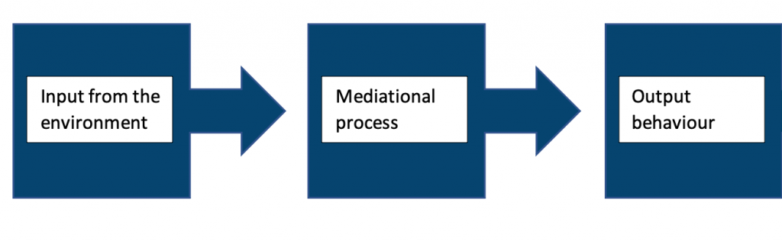

**The Concepts of Extinction and Reinforcement**

On the other hand, extinction occurs when the positive reinforcement is removed thus the desired behaviour is not strengthened (van Haaren, 2020).  Furthermore, the schedule of reinforcement can be achieved in either an intermittent or continuous way and consists of two types according to the interval or time of response and according to the ratio or amount of response (Ziv, 2017).

**Learning Processes and Aetiological Formulation of Clinical Problems, Including the Concepts of Generalisation, Secondary Reinforcement, Incubation and Stimulus Preparedness**

There are several learning processes and concepts that can be relevant in the aetiological formulation of clinical problems, including:

|  |  |
| --- | --- |
| **Learning Processes:** | **Summary:** |
| **Generalization** | This refers to the tendency of a learned response or behaviour to be elicited by stimuli that are similar to, but not identical to, the original stimulus. For example, if a person learns to fear a specific type of spider, they may also experience fear when confronted with other types of spiders or with insects that resemble spiders. |
| **Secondary reinforcement** | This refers to the reinforcing effects of stimuli that are associated with primary reinforcing stimuli, such as food or water. For example, if a person learns to associate a particular sound with receiving a reward, the sound itself may become reinforcing, even in the absence of the reward. |
| **Incubation** | This refers to the idea that learning or problem-solving can occur unconsciously, over time, as a result of repeated exposure to a problem or stimulus. |
| **Stimulus preparedness** | This refers to the idea that certain stimuli or learning situations are more easily learned or acquired by an organism due to evolutionary or genetic factors. For example, humans are thought to have a higher degree of stimulus preparedness for learning about social and personal relationships than they do for learning about physical processes or abstract concepts. |

These concepts can be relevant in the aetiological formulation of clinical problems because they can help to explain how and why certain behaviours or responses develop, and how they might be maintained or modified (Brush, 2014) (McConnel, 1990).

**Escape and Avoidance Conditioning**

Escape and avoidance conditioning are two types of learning that involve an organism’s response to a stimulus that is unpleasant or aversive. In escape conditioning, an organism learns to perform a particular behaviour or response in order to escape or remove itself from the unpleasant stimulus. In avoidance conditioning, an organism learns to perform a particular behaviour or response in order to avoid or prevent the occurrence of an unpleasant stimulus.

Both escape and avoidance conditioning involve negative reinforcement, which is the strengthening of a behaviour or response by the removal or avoidance of an unpleasant stimulus. For example, if a dog is placed in a crate and is given a treat every time it barks, it will likely learn to bark more frequently in order to receive more treats. In this case, the dog is performing the behaviour (barking) in order to escape the unpleasant stimulus (being placed in the crate).

Escape and avoidance conditioning can be useful in certain situations, but they can also be problematic if an organism becomes overly reliant on them or if the behaviours or responses used to escape or avoid the unpleasant stimulus are inappropriate or harmful.

**Clinical Applications in Behavioural Treatments**

|  |  |
| --- | --- |
| **Term:** | **Summary:** |
| **Cueing** | Cueing refers to the use of external stimuli or prompts to help a learner retrieve or recall information from their memory. Cues can be verbal, visual, or auditory, and they can be used to help learners remember specific facts or concepts, or to trigger the use of a particular strategy or skill. |
| **Flooding** | A technique that involves directly exposing the individual, for an extended time, to anxiety-producing stimuli that are considered to be of maximum intensity. The aim is to eventually desensitize the subject. |
| **Prompting** | Physical or verbal guidance evokes the desired behaviour which is then reinforced. |
| **Shaping** | Teaching new complex behaviours through reinforced natural actions that closely resemble the desired behaviour. |
| **Habituation** | A type of learning occurs when an organism becomes less responsive to a stimulus over time as a result of repeated exposure to the stimulus. |
| **Reciprocal habituation** | Reciprocal habituation is a specific type of habituation in which an organism’s initial response to a stimulus is typically strong, but as the stimulus is presented repeatedly, the organism’s response to the stimulus decreases. |
| **Non-reciprocal habituation** | In contrast, non-reciprocal habituation refers to situations in which an organism’s response to a stimulus does not change over time, even with repeated exposure to the stimulus. |
| **Chaining** | Teaching complex behaviour by breaking it down into simple components. |
| **Implosion** | A therapeutic technique in which clients imagine and relive aversive scenes associated with their anxiety with the help of a therapist. |

**The Impact of Various Reinforcement Schedules**

In psychology and behaviourism, reinforcement is the use of rewards or other incentives to increase the likelihood that a particular behaviour or response will occur again in the future. There are several different reinforcement schedules that can be used to provide reinforcement, and each one can have a different impact on the frequency and consistency of a particular behaviour.

One common reinforcement schedule is continuous reinforcement, in which a behaviour is reinforced every time it occurs. This schedule is often used when trying to establish a new behaviour or when working with very young children or animals. Continuous reinforcement can be effective in creating a strong, consistent response to a particular stimulus, but it can also be time-consuming and may not be sustainable in the long term.

Another reinforcement schedule is partial reinforcement, in which a behaviour is reinforced only some of the time. This schedule can be further divided into several subtypes, including fixed ratio, variable ratio, fixed interval, and variable interval. Each of these subtypes involves reinforcing a behaviour based on specific criteria or schedule, such as reinforcing a behaviour after it has occurred a certain number of times (fixed ratio) or reinforcing a behaviour at randomly spaced intervals (variable interval). Partial reinforcement schedules can be more sustainable than continuous reinforcement, but they may also be less effective at establishing strong, consistent responses to stimuli.

|  |  |  |
| --- | --- | --- |
| **Subtype of Partial Reinforcement:** | **Summary:** | **Example:** |
| **Fixed ratio** | A reinforcement schedule in which a behaviour is reinforced after it has occurred a specific number of times. | A manufacturer of car parts rewards an assembly line worker with a bonus every time they produce 10 finished parts. |
| **Variable ratio** | A reinforcement schedule in which a behaviour is reinforced after it has occurred an unpredictable number of times. | A casino rewards slot machine players with a payout after an unpredictable number of spins. |
| **Fixed interval** | A reinforcement schedule in which a behaviour is reinforced for the first time after a specific amount of time has elapsed. | A teacher rewards a student with a sticker every Friday for turning in their homework on time all week. |
| **Variable interval** | A reinforcement schedule in which a behaviour is reinforced for the first time after an unpredictable amount of time has elapsed. | A company rewards its employees with a surprise gift every few weeks as a way to boost morale. |

**The Psychology of Punishment**

In psychology, punishment is the use of negative consequences or aversive stimuli to decrease the likelihood that a particular behaviour or response will occur again in the future. Punishment is often contrasted with reinforcement, which is the use of positive consequences or rewards to increase the likelihood of a particular behaviour or response.

Punishment is only effective if it is administered immediately and in adequate volume to mitigate the occurrence of undesired behaviour. Punishment is more effective when its implementation is agreed upon by the recipient, or makes sense to them, and is combined with the differential reinforcement of the desired behaviour (Kestner, 2018). However, punishment may result in an array of undesirable results that include behavioural rigidity, negative modelling, inappropriate avoidance of other stimuli occurring simultaneously, and aggression towards the situation.

**References:**

(1) Akpan, B., 2020. Classical and Operant Conditioning—Ivan Pavlov; Burrhus Skinner. In Science Education in Theory and Practice (pp. 71-84). Springer, Cham.

(2) Blackman, D., 2017. Operant conditioning: an experimental analysis of behaviour. Routledge.

(3) Blanton, B.B., 1998. The application of the cognitive learning theory to instructional design. International Journal of Instructional Media, 25(2), p.171.

(4) Brush, F.R. ed., 2014. Aversive conditioning and learning. Academic Press.

(5) Cain, C.K., 2019. Avoidance problems reconsidered. Current Opinion in Behavioral Sciences, 26, pp.9-17.

(6) Johnson, A. and Crowe, D.A., 2009. Revisiting Tolman, his theories and cognitive maps. Cogn Crit, 1, pp.43-72.

(7) Kestner, K.M., Diaz‐Salvat, C.C., St. Peter, C.C. and Peterson, S.M., 2018. Assessing the repeatability of resurgence in humans: Implications for the use of within‐subject designs. Journal of the Experimental Analysis of Behavior, 110(3), pp.545-552.

(8) McConnell, J.V., 1990. Negative reinforcement and positive punishment. Teaching of Psychology, 17(4), pp.247-249.

(9) van Haaren, F., 2020. Extinction revisited: Implications for application. Behavior Analysis: Research and Practice, 20(1), p.36.

(10) Wegener, G., 2020. Conditioning.

(11) Windholz, G. and Lamal, P.A., 1985. Kohler’s insight revisited. Teaching of Psychology, 12(3), pp.165-167.

(12) Ziv, G., 2017. The effects of using aversive training methods in dogs—A review. Journal of veterinary behavior, 19, pp.50-60.

(13) Rehman, I., Mahabadi, N. and Rehman, C.I. (2019). Classical Conditioning. [online] Nih.gov. Available at: https://www.ncbi.nlm.nih.gov/books/NBK470326/.

(14) An Approach to Children’s Smoking Behaviors Using Social Cognitive Learning Theory. (2010). Asian Pacific Journal of Cancer Prevention, [online] 11(4), pp.1143–1149. Available at: http://journal.waocp.org/article_25340.html.

(15) Classical conditioning: Extinction, spontaneous recovery, generalization, discrimination. [online] Available at: https://www.youtube.com/watch?v=qaOC_3KA3P8&t=1s [Accessed 17 Dec. 2022].

(16) Classical conditioning: Neutral, conditioned, and unconditioned stimuli and responses | Khan Academy. [online] Available at: https://www.youtube.com/watch?v=-6KzZKuQ1lk&t=13s [Accessed 17 Dec. 2022].

### Visual and auditory perception

**Basic Principles of Visual and Auditory Perception**

**Gestalt (visual) perception:**

Perceptual organization is defined as the ability to cognitively organise sensory data. Gestalt psychologists pointed out that this sort of organization is crucial for the functioning of visual and auditory perception. Very importantly, the perceptual organisation is orderly and not random, as also indicated by the word ‘Gestalt’, which means ‘organised structure’ in German. Gestalt psychologists supported that perceptual organization consists of procedures of grouping and segregation (Pratt & Koffka, 1936). Among the factors that govern figure-ground separation, they identified size, contrast, symmetry etc. That is, even if humans experience a complex world, where different entities have different characteristics, (ex. colour, textures, constancy, contours), our perception system is made in a way that perceives objects in a structured way.

Gestalt psychology has made big contributions to understanding visual perception. It has been crucial to distinguish between sensation and perception. Both ‘top-down’ and ‘bottom-up’ processing is likely to occur in perception. Illusions are erroneous concepts, and there is still a lot of conjecture as to how best to ‘explain’ or understand why they occur.

Visual perception is the ability to perceive the surrounding world using light in the visible spectrum reflected by objects in the environment through photopic vision (daytime vision), colour vision, scotopic vision (night vision), and mesopic vision (twilight vision). This is distinct from visual acuity, which refers to how well a person can see (for example, “20/20 vision”).  Even if a person has 20/20 vision, they can have issues with visual perceptual processing.

**Figure-ground differentiation:** is a perceptual grouping that is required for visual object recognition. Identifying a figure from the backdrop is a term used in Gestalt psychology. For example, the “figure” is black lettering on printed paper, and the “background” is a white sheet.

**Visual object constancy:** is the capacity to recognise an object by its image despite variation in the image when the object is seen from multiple angles.

**Visual pathway:**

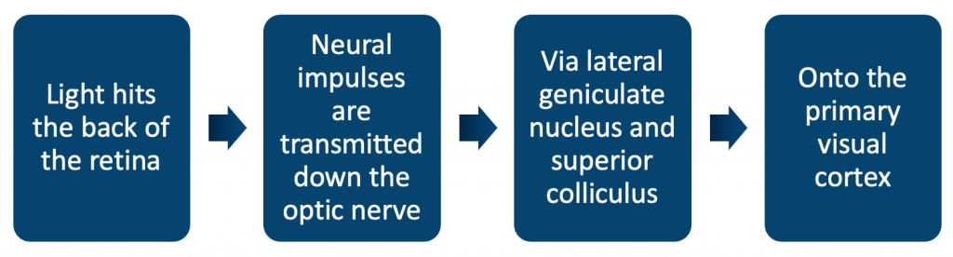

**Auditory perception:**

Auditory perceptual organisation is more complex than visual perceptual organisation. For instance, if two items are in the same line of sight for the observer, one will obscure the other for the viewer, thus facilitating the viewing of one object and its properties but obscuring the vision of the other. In this case, the observer can at least observe one item and notice its properties correctly. In addition, when there are two events occurring at the same time, they often mingle together and reach the listener’s ear as one sound wave. In this case, it is difficult for the listener to differentiate one sound from the other. Therefore, the segregation and localisation of sounds is a more complex process than the grouping and segmentation of events in a visual scene. Even if the listener manages to distinguish the sounds, categorising a sound event is more difficult than categorizing a visual event. This is because sounds are hardly ever distinguishable by the existence of discrete features, but by their multiple auditory dimensions (Holt and Lotto, 2006).

**Auditory pathway:**

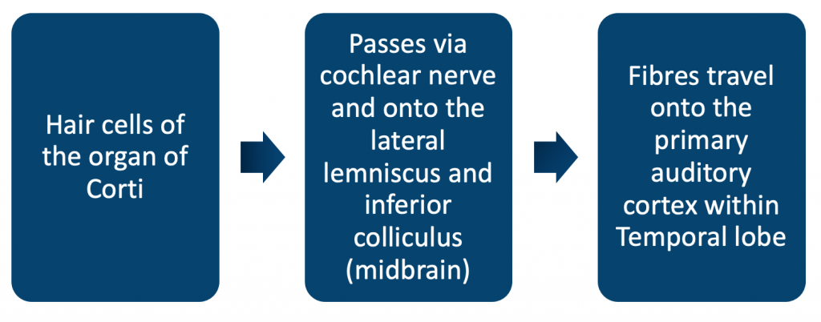

**Set and other aspects of perceptual organisation:**

You could believe that what you see is what you get when it comes to our impressions of the world around us. However, research reveals that your own past experiences, expectations, motivations, beliefs, emotions, and even culture all have a strong influence (and bias) on how you perceive the world (Biggs, 2015). A perceptual set is basically a tendency to view things only in a certain way.

A perceptual set is an excellent example of top-down processing. Perceptions in top-down processing begin with the most general and progress toward the more detailed. Expectations and prior information have a strong influence on such impressions. When we expect something to appear in a certain way, we are more likely to see it in that manner.

|  |  |
| --- | --- |
| **Example of Forces of Influence:** | **Summary:** |
| **Motivation can influence perceptual sets and how we understand our surroundings** | We may be motivated to regard members of the opposite side as too aggressive, weak, or inept if we are supporting our preferred sports team. In one classic experiment, subjects were denied meals for several hours. Those who had gone without eating were considerably more likely to identify ambiguous images as food-related objects when they were presented with them later.  They were more driven to see the visuals in a specific way because they were hungry (Sanford 1936). |
| **Expectations have a crucial influence as well** | If we expect others to behave in specific ways in certain situations, our perceptions of these people and their jobs will be influenced. One of the most well-known tests on the effect of expectation on perceptual sets involved presenting subjects with a series of numbers or letters.  The subjects were next presented with an ambiguous visual that might be read as either the number 13 or the letter B. Those who looked at the numbers were more likely to see it as a 13, but those who looked at the letters were more likely to see it as the letter B (Bruner 1955). |
| **Culture also shapes our perceptions of people, objects, and circumstances** | Surprisingly, researchers discovered that people from various cultures perceive perspective and depth cues differently (de Bruine, 2015). |
| **Emotions can have a significant impact on how we view our surroundings** | When we are furious, we are more prone to detect antagonism in others. One investigation found that when subjects became accustomed to associating a nonsense syllable with minor electrical shocks, they experienced physiological responses to the syllable even when it was provided subliminally (Murre, 2015). |
| **Attitudes can also have a powerful influence on perception** | Gordon Allport demonstrated that prejudice could have an influence on how quickly people categorize people of various races (Barlow, 2013). |

**Visual and Auditory Development in Children**

In the 1960s experiments were carried out on monocularly-deprived kittens which demonstrated that for the optic cells to develop fully and allow full binocular vision, then both eyes need to be receiving input during early life. This suggested a critical period in early life for visual development. The visual system retains a degree of plasticity, which becomes ‘hardwired’ as we become adults. The first 5 years of life are the most critical. The critical period appears to be complete by the ages of 7-9 years old.

Research has shown that hearing is essential for the development of speech. Alongside the visual critical period is a critical period that exists for vocal learning.

Visual and auditory impairment in children does not significantly affect IQ, but creates unique challenges nonetheless.

**Perception as an Active Process**

According to Piaget (1953) visual perception is very limited at birth and therefore the development of perceptual capabilities is a result of an intensive and gradual process of learning in the first months after birth. Hebb (2012) described the different stages of perceptual development starting from the dominance of colour, to gradually ending at the recognition of an object as a whole through the employment of attention to the distinct parts of an item. Moreover, Piaget’s constructionist theory supported that perception has to develop in a structured way so that the human brain can understand the surrounding reality. Therefore, he saw perception as an active process, humans’ sensory system and brain are actively engaging in visual stimuli and are gradually becoming more competent at recognising and classifying an object and its properties.

**The Development of Visual Perception as an Illustration of Environmental Interaction**

When we enter a visual environment, we get an impression of its objects, and we take context-specific actions. The question at this point is how visual perceptions evolve over time. Research has frequently searched for answers by examining the perceptual system of infants. Are infants born with a sufficiently organised visual system, which is able to group shapes, colours and textures into coherent shapes, or does it undergo a period of gradual development and maturation, where experience helps them notice and analyse visual information, in order to make context-appropriate interpretations? (Gibson. 1979)

Another theory of visual perceptual development supports that the infant’s ability to cognitively distinguish different categories of stimuli is associated with the requirements of their environment. In line with this, one key observation showed that infants 9-12 months of age were more able to differentiate and maintain in their memory visual stimuli that they encountered more often, compared to stimuli they viewed less frequently. (Scott, et al, 2007).

During this first year of life, the visual system, and the brain undergo dramatic development. More importantly, there is a reciprocal interaction between these physical changes and the environment. Through this interaction, humans gradually form perceptual representations of their surrounding visual world. Therefore, experience plays a key role in the maturation of the visual perceptual system.

**References:**

(1) Dehaene, S., Changeux, J.-P., Naccache, L., Sackur, J., & Sergent, C. (2006). Conscious, preconscious, and subliminal processing: A testable taxonomy. Trends in Cognitive Sciences, 10, 204–211.

(2) Desimone, R., & Duncan, J. (1995). Neural mechanisms of selective visual attention. Annual Review of Neuroscience, 18, 193–197

(3) Dewi Rees W (1971): The hallucinations of widowhood. Br Med J 4: 37–41.

(4) Galaverna, F. S., Morra, C. A., & Bueno, A. M. (2012). Attention in patients with chronic schizophrenia: Deficit in inhibitory control and positive symptoms. The European Journal of Psychiatry, 26(3), 185–195.

(5) Gibson, J.J. (1979). The ecological approach to visual perception. New York ; Hove, England: Psychology Press.

(6) Gregory, R. L. (2009). Seeing Through Illusions. Oxford: Oxford University Press.

(7) Hebb, D.O. (2012). The organization of behavior : a neuropsychological theory. New York: Routledge, Taylor & Francis Group.

(8) Helmholtz (1867). Handbuch der physiologischen Optik. Leopold Voss: Leipzig.

(9) Holt, L.L. and Lotto, A.J. (2006). Cue weighting in auditory categorization: Implications for first and second language acquisition. The Journal of the Acoustical Society of America, 119(5), pp.3059–3071. doi:10.1121/1.2188377.

(10) Johns, L.C., Nazroo, J.Y., Bebbington, P. and Kuipers, E. (2002). Occurrence of hallucinatory experiences in a community sample and ethnic variations. British Journal of Psychiatry, 180(2), pp.174–178. doi:10.1192/bjp.180.2.174.

(11) Kimchi, R., Yeshurun, Y., & Cohen Savransky, A. (2007). Automatic, stimulus-driven attentional capture by objecthood. Psychonomic Bulletin and Review, 14(1), 166–172.

(12) Kouider, S., de Gardelle, V., & Dupoux, E. (2007). Partial awareness and the illusion of phenomenal consciousness. Behavioral and Brain Science., 30, 510–511.

(13) Lowe, D.G. (1987). Three-dimensional object recognition from single two-dimensional images. Artificial Intelligence, 31(3), pp.355–395. doi:10.1016/0004-3702(87)90070-1.

(14) Piaget, J. (1953). The origins of intelligence in the child. London: Routledge and Kegan Paul.

(15) Pratt, C.C. and Koffka, K. (1936). Principles of Gestalt Psychology. The American Journal of Psychology, 48(3), p.527. doi:10.2307/1415906.

(16) Scott, L.S., Pascalis, O., & Nelson, C.A. (2007). A domain-general theory of the development of perceptual discrimination. Current Directions in Psychological Science, 16, 197-201.

(17) Sperling, G. (1960). The information available in brief visual presentations. Psychological Monographs, 74(498).

(18) Winokur, G., Scharfetter, C. and Angst, J. (1985). The diagnostic value in assessing mood congruence in delusions and hallucinations and their relationship to the affective state. European Archives of Psychiatry and Neurological Sciences, 234(5), pp.299–302. doi:10.1007/bf00381040.

(19) Lawson, R. (1999). Achieving visual object constancy across plane rotation and depth rotation. Acta Psychologica, 102(2-3), pp.221–245. doi:10.1016/s0001-6918(98)00052-3.

(20) Biggs A, Adamo S, Dowd E, Mitroff S. Examing perceptual and conceptual set biases in multiple-target visual search. Attention, Perception, & Psychophysics. 2015;77(3):844-855. doi:10.3758/s13414-014-0822-0

(21) Sanford R. The effects of abstinence from food upon imaginal processes: A preliminary experiment. J Psychol. 1936;2(1):129-136. doi:10.1080/00223980.1936.9917447

(22) Bruner J, Minturn A. Perceptual identification and perceptual organization. J Gen Psychol. 1955;53(1):21-28. doi:10.1080/00221309.1955.9710133

(23) de Bruïne G, Vredeveldt A, van Koppen PJ. Cross-cultural differences in object recognition: Comparing asylum seekers from Sub-Saharan Africa and a matched Western European control group. Appl Cogn Psychol. 2018:32(4):463-473. doi:10.1002/acp.3419

(24) Murre JM, Dros J. Replication and Analysis of Ebbinghaus’ Forgetting Curve. PLoS One. 2015;10(7):e0120644. Published 2015 Jul 6. doi:10.1371/journal.pone.0120644

(25) Barlow FK, Hornsey MJ, Thai M, Sengupta NK, Sibley CG. The wallpaper effect: the contract hypothesis fails for minority group members who live in areas with a high proportion of majority group members. PLoS One. 2013;8(12):e82228. doi:10.1371/journal.pone.0082228

### Information processing and attention

# **Information processing and attention**

Research has debated whether perceptual organisation relies on attention. It is certain, that in goal-oriented situations, humans deploy attention to gather the information that will help them achieve a goal. (Desimone and Duncan, 1995). If we know, for instance, where is the place of our target/goal, we can deliberately direct our attention to this place. However, is attention automatically deployed every time perceptual processing is activated?

Kimchi et al (2007) conducted a study on whether perceptual organisation takes place without attention. The findings of the studies demonstrated that certain aspects of perceptual organisation such as figure-ground differentiation can occur without attention, while others rely on attentional processing. These findings contradict the traditional theories, which support that attention is not an essential element of perceptual organisation, as the latter can function attentively.

## **Models of attention:**

|  |  |
| --- | --- |
| ***Model:*** | ***Summary:*** |
| **‘Cocktail party problem’** | Colin Cherry in 1953 identified that people have the ability to focus on one conversation at a party despite other stimuli, such as background noises or other conversations happening simultaneously. |
| **Broadbent’s filter model** | This model explained the above phenomenon and suggested information is stored in short-term memory prior to going through a filter. The filter then selects the relevant stimuli to focus on. |
| **MacKay’s experiment on filter theory** | Mackay suggested that information which is not attended or focused on is still perceived, even if it can not be recalled. |

**Attentional bias:**is being able to attend to an important stimulus despite trying to attend to another.

## **Measuring attention:**

Attention and information processing occur in the parietal and frontal lobes. The ‘detection threshold’ considers the limit at which people will detect information in their environment. Various techniques and tests can be employed to measure attention:

|  |  |
| --- | --- |
| **Test:** | ***Summary:*** |
| **Visual probe technique** | Assesses selective attention. Used to determine whether an individual is more of less prone to being influenced by certain surrounding stimuli. Commonly used in neuropsychological assessments to determine the present and severity of anxiety type. |
| **Continuous performance test (Conners CPT 3)** | Used to help diagnose ADHD. Assesses whether attentional deficits are impulsive or inattentive. |
| **Spatial attention tasks** | Spatial attention is the process of attending to visual stimuli over a specific area, that is directing attention to a location in space. Spatial attention tasks can be used to determine any issues with initiating, stopping, shifting or switching attention. |

# **Illusions**

Dehaene et al. (2006) supported that cognitive illusion is a reflection of the observer’s over-confidence that they see everything in a scene, while they are only able to see specific objects. In other words, they are so confident in their ability to obtain information from their environment, that they believe that the speculations they make reflect what it truly exists in a visual scene. The classical Sperling paradigm (Sperling 1960) shows that the participants were inclined to report that they see a whole array of letters, although one of the items was not a letter, but a catch symbol that looked like a letter (Kouider et al., 2007). These results prove that the observer can only capture limited information in the visual environment. Yet, observers are often ignorant of this limitation and tend to rely on predictions and generalities.

However, we should not view illusions as falsities of our perceptual system. Instead, Gregory (2009) argued that human perception is by nature made to function in a way that amplifies sensory/visual stimuli to understand the environment more efficiently and act accordingly. Therefore, he did not see illusions as failures of our perception or dysfunctions of our apparatus, but instead he viewed them as expressions of the power of human perception.

# **Hallucinations**

Our brain combines ‘bottom-up’ information gathered by our sensory system with ‘top-down’ information/predictions drawn from what we already know. ‘Top-down’ cognitive processing is often deployed by the human brain in order to interpret new information and infer what it is sensing (Helmholtz HV, 1867).

Hallucinations are often affected by one’s emotional state. For instance, in cases of people experiencing depression, hallucinations are often expressed with themes of illness and guilt. The relation between hallucinations and one’s affective state is also evidenced by experiments around mood manipulation. (Winokur et al, 1985). According to Dewi Rees’ study (1971), hallucinations often occur during periods of grief. According to Johns LC (2002) people who experience hallucinations of their loved ones do not undergo any impairment in their cognitive functioning. Thus, hallucinations may be nonclinical and should not be confused with other psychotic disorders.

There are a vast number of cognitive theories in the literature covering hallucinations, including self-monitoring and source-monitoring defects. Along with the opposing theories, this field of psychiatry and neurology continues to be investigated. Functional imaging shows the involvement of associative sensory areas.

Visual hallucinations are more likely to be associated and typical or organic pathology.

Auditory hallucinations have associations with volume changes within the superior and medial temporal gyri.

# **Attention in Schizophrenia**

Attention is a key mechanism of our perceptual system, which enables us to gather and process information precisely and rapidly. Very importantly, attention interacts with other parts of our cognitive system, such as senses, memory, language etc. Galaverna et al (2012) assessed the role of attention in schizophrenia by firstly analysing its different components. Patients diagnosed with chronic schizophrenia were assessed with the Scale for the Assessment of Positive and Negative Symptoms against a healthy control group. The results showed that schizophrenic patients obtained lower scores in all areas of attention in comparison with the control group. Among the areas that were considered most impaired were inhibitory control and sustained attention.

People who suffer from schizophrenia process facial expressions differently from people without schizophrenia. Studies of attention suggest that schizophrenics have a reduced ability to shift away from irrelevant stimuli. Thought to be an involuntary process of remaining fixated on something which is irrelevant, such as the forehead, which will not provide the full understanding of what the person they are interacting with is expressing.

Delusions are thought to occur because they make inferences with irrelevant information and unrelated events. When combined with an abnormal style of reasoing then delusions can result.

Hallucinations could occur because of a heightened awareness of unstructured and ambiguous sensory input. When combined with an intrusion of irrelevant material from the patient’s long-term memory then hallucinations can result.

Reduced capacity to shift attention away from uncomfortable intrusions would gradually lead to an accumulation of rage and annoyance, which could lead to aggressiveness. Because of the type of delusion or hallucination they are experiencing, the person with schizophrenia may simply consider aggression as necessary for self-preservation or defence.

According to others, the central cognitive function provides feedback on our intentions and plans. This feedback process is thought to be disturbed in schizophrenia. If internally produced goals and plans enter the conscious without an appropriate feedback system, they may be attributed to coming from outside rather than from inside. Passivity phenomena are actions and intents that are perceived to originate externally (Frith, 1995).

# **Attention in other disorders**

**ADHD:**Using CPT (continuous performance test), attentional deficits and different types of error occur more frequently in ADHD than in controls (Epstein et al, 2003).

**Depression:**Often poor memory is a symptom mentioned by patients suffering from depression. This is likely caused by impaired attention, which is a biological symptom of reduced concentration.

**Anxiety:**In anxiety disorders, there is often heightened attention. Physical anxiety may show reduced impulsivity and greater response inhibition.

**References:**

(1) Dehaene, S., Changeux, J.-P., Naccache, L., Sackur, J., & Sergent, C. (2006). Conscious, preconscious, and subliminal processing: A testable taxonomy. Trends in Cognitive Sciences, 10, 204–211.

(2) Desimone, R., & Duncan, J. (1995). Neural mechanisms of selective visual attention. Annual Review of Neuroscience, 18, 193–197

(3) Dewi Rees W (1971): The hallucinations of widowhood. Br Med J 4: 37–41.

(4) F. S., Morra, C. A., & Bueno, A. M. (2012). Attention in patients with chronic schizophrenia: Deficit in inhibitory control and positive symptoms. The European Journal of Psychiatry, 26(3), 185–195.

(6) Gregory, R. L. (2009). Seeing Through Illusions. Oxford: Oxford University Press.

(7) Helmholtz (1867). Handbuch der physiologischen Optik. Leopold Voss: Leipzig.

(8) Johns, L.C., Nazroo, J.Y., Bebbington, P. and Kuipers, E. (2002). Occurrence of hallucinatory experiences in a community sample and ethnic variations. British Journal of Psychiatry, 180(2), pp.174–178. doi:10.1192/bjp.180.2.174.

(9) Kimchi, R., Yeshurun, Y., & Cohen Savransky, A. (2007). Automatic, stimulus-driven attentional capture by objecthood. Psychonomic Bulletin and Review, 14(1), 166–172.

(10) Kouider, S., de Gardelle, V., & Dupoux, E. (2007). Partial awareness and the illusion of phenomenal consciousness. Behavioral and Brain Science., 30, 510–511.

(11) Sperling, G. (1960). The information available in brief visual presentations. Psychological Monographs, 74(498).

(12) Winokur, G., Scharfetter, C. and Angst, J. (1985). The diagnostic value in assessing mood congruence in delusions and hallucinations and their relationship to the affective state. European Archives of Psychiatry and Neurological Sciences, 234(5), pp.299–302. doi:10.1007/bf00381040.

(13) Epstein, J. (2003). Relations Between Continuous Performance Test Performance Measures and ADHD Behaviors. Journal of Abnormal Child Psychology, 31(5), pp.543–554.

### 1.1.4 Memory

## **Memory: Influences Upon and Optimal Conditions for Encoding, Storage and Retrieval**

Memory is defined as the experience, awareness, and recall of sensations, ideas, and events (Klein, 2015).

Memories are processed via ***encoding***, ***storage*** and ***retrieval***.

## **Encoding**:

Encoding is the transfer of sound or imager (sensory input) into a form that allows memory registration. The process of learning new information is referred to as "encoding,”. There a numerous aids to assist in encoding memories more easily, such as: mnemonics, primacy-recency effects, and chunking. That is the means by which data is acquired, processed, modified, and finally stored. The following four approaches are commonly used to encode information:

 (1) **"Visual encoding"**, which refers to how something appears

 (2) **"Acoustic encoding"**, which refers to how something sounds;

 (3) **"Semantic encoding"**, which refers to what something means

 (4) **"Tactile encoding”** refers to how something feels.

Even though information can usually get into the memory system through one of these manners, the way it is stored might be different from how it was encoded in the first place (McLeod, 2007).

## **Storage**:

The word "storage" is used to describe "how", "where", "how much", and "for how long" encoded data is kept in the memory system. The **modal model of memory** (storage) focuses on the fact that there are two types of memory (Tonegawa et al., 2015):

* **Long-term memory (LTM)**
  + LTM capacity is unlimited from minutes to a lifetime.
* **Short-term memory (STM)**
  + STM capacity has been shown to be **7 +/- 2 in digit span experiments**.

The encoded information is first stored in the "short-term memory", and if needed, it is then stored in the "long-term memory".

## **Retrieval**:

 Retrieval is the procedure that enables someone to access the information that has been 'saved'. The information that is stored in STM and LTM is recalled in distinct ways due to their differences (Tonegawa et al., 2015).

LTM is retrieved by making connections, while STM is retrieved in the order in which information was stored like when you remember where you parked your car by going back to the shopping mall entrance.

LTM memory can be retrieved in two different forms: voluntary (automatic recall) and involuntary (active process).

## **Primary Working Memory Storage Capacity and the Principle of Chunking**

## **Working memory**:

Working memory refers to the ability of the brain to keep information in mind for brief periods, such as when we are making a decision or solving a problem.

Short-term memory understanding was further improved by Baddeley and Hitch (1974). This later became known as Baddeley's multi-storehouse model, as summarized with subcomponents of working memory:

|  |  |
| --- | --- |
| ***A subcomponent of working memory:*** | ***Summary:*** |
| **Central Executive** | Responsible for higher cognitive processes - planning and problem-solving. |
| **Phonological loop** | Attempts to explain acoustic coding that happens in STM. |
| **Visuospatial sketchpad** | Uses visual and spatial information to represent the size, shape and colour of an image. |
| **Episodic buffer** | Acts as a backup store, communicating with the working memory and LTM. |

Working memory can be tested using the digit span test. Specifically, damage to the left hemisphere and dorsolateral prefrontal cortex will cause deficits in working memory.

**Primary working memory capacity:** In terms of working memory, primary memory is frequently regarded as a type of limited-capacity storage capable of holding between 3 and 5 items at any given time (Shipstead et al., 2014).

## **Principle Of chunking**:

Each piece of information should be provided in manageable chunks (Sargent et al., 2010). The term "chunking" refers to the process of grouping smaller information units into bigger ones. By combining each data point into a broader whole, it is possible to remember more information. This technique improves memory performance. It allows a person to convey information in a manner that is simple to comprehend and recall for your audience. The idea behind chunking is that our working memory is easily overrun by too much information.

According to research, given an assortment of irrelevant facts to remember, there is a crucial difference in performance at approximately seven items. People can process up to seven pieces of information with ease, but any more than that is tough. Chunking can be a useful memory enhancement technique. By introducing chunking tactics into your daily study routine, you may discover that you are able to retain more information(Fonollosa et al., 2015).

***Example***: Phone numbers are one the most common examples of chunking. For instance, the sequence 4-7-1-1-3-2-4 would be chunked as 471-1324.

## **Semantic Episodic and Skills Memories and other Aspects of Long-Term/Secondary Memory**

Secondary memory is also referred to as long-term memory. This is a memory you will keep for the rest of your life. These can contain information that is processed, stored, forgotten for a time, and then retrieved.

## **Semantic memory**:

Semantic memory centres on factual and theoretical knowledge of the world and its verbal manifestation(Yee et al., 2014). Therefore, it facilitates language-based interaction. This involves both conceptual and verbal knowledge.

***Example***: When you eat an apple, you realize that it is a fruit and, based on what you know, you can explain its importance.

## **Episodic memory**:

Episodic memory is centred on the experiences that a person has had during the many stages of his life, and it is primarily responsible for recalling life events(Sugar and Moser, 2019). These are the recollections that have been stored away within the limbic system.

This will depend on a person's memory from their own point of view, but it won't take into account numbers and facts that are obvious.

***Example***: The good time you had at your friend's wedding with your crew.

## **Flashbulb memory**:

Flashbulb memories are precise recollections of how people first learned about a significant event.

***Example:*** What were you doing when you first learned about the 9/11 twin towers tragedy?

They are more likely to be episodic (of occurrences) than semantic (of facts) recollections. All flashbulb memories have one thing in common: a high level of emotional arousal at the time the experience was committed to memory.

## **Procedural memory**:

Procedural memory is referred to as skill memory. Skill memory focuses mostly on how to perform a complicated task.

***Example***: Driving a car or a scooter necessitates the execution of a number of sequential tasks.

## **Long-term or secondary memory**:

There are a number of theories that study long-term memory; however, most are based on the storage of information in three different forms: sensory memory, primary memory, and secondary memory. The **multi-store model** by Atkinson and Shiffrin describes sensory memory, STM and LTM as permanent structural components and explained how information moved between storage systems.

Primary and secondary memories are those that allow us to retain information over longer periods of time(Hartshorne et al., 2019).

Another theory was that LTM is either **declarative** or **non-declarative**:

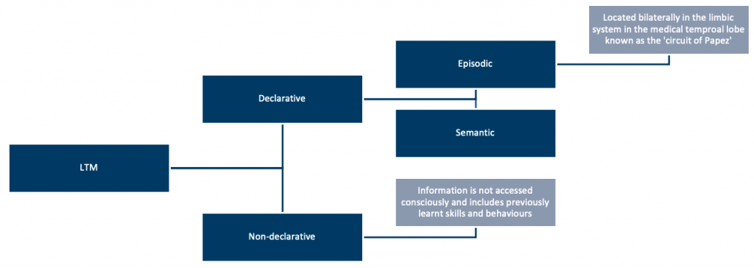

## **Sensory memory**:

Sensory memory is the ability to store information in the immediate environment without being consciously aware of it.

|  |  |
| --- | --- |
| **Sensory memory type:** | ***Summary:*** |
| **Echoic memory** | Via auditory stimuli |
| **Haptic memory** | Via touch stimuli |
| **Iconic memory** | Via sight stimuli |

## **Distortion, Schema, Inference, and Elaboration in Relation** to Memory

## **Distortion**:

Memory distortions occur when the brain develops fabricated memories. These erroneous memories are subsequently stored in the brain without their validity being evaluated(Schacter et al., 2011).

***Example***: Occasionally, we may believe that we had a conversation that we never had. Or our memory of a certain day and conversation may differ from that of another individual. When we have memory distortions, we perceive similar circumstances.

## **Schemas**:

The memory of every individual has a collection of schemas. A memory schema is a compilation of past experiences(Ghosh and Gilboa, 2014). Memory is used to recall and activate these events and associations in order to shape judgments and thinking.

***Example***: The memory of rapid eye movement during sleep.

## **Inference**:

Inference can be viewed as a logical process in which preexisting memories are recovered and merged to answer a fresh query(Joshi et al., 2020). Inferences are missing parts of information that a person fills in based on their existing knowledge, theories, or beliefs.

***Example***: For instance, if a person enters a room and notices that the digital clocks are flashing, they can "infer" that there was a recent power outage.

## **Elaboration**:

Elaboration is a cognitive learning approach that incorporates any improvement of information that explains or defines the relationship between the material to be learned and information related(Bartsch et al., 2018).

***Example***: A learner's previous experience and knowledge or consecutively delivered information.

## **Schema**:

A "schema" is a concept or image of something that happened in the past. Information that is primary or fundamental is referred to as elaboration. Inference - conclusions are drawn from the information. Distortion - the result of poor representation of facts determines how we think, feel and work.

## **The Process of Forgetting**

The inability to access or recall previously taught information is known as forgetting.

The Ebbinghaus curve or the ‘forgetting curve’ postulates that memory retention decreases over time. This curve depicts how information decays over time when no effort is made to keep it. A related notion is memory strength, which relates to the longevity of memory traces in the brain. The longer a person can recall anything, the stronger his or her memory. An Ebbinhaus curve claims that individuals halve their memory of freshly gained knowledge in a couple of days or weeks unless they intentionally examine the subject:

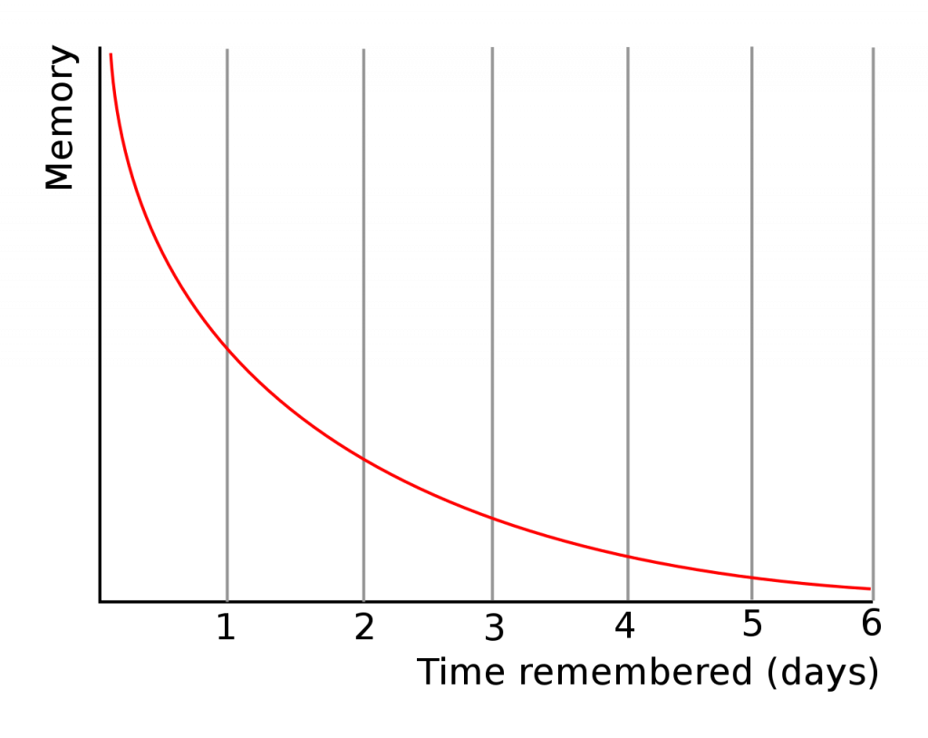

## **Memory Failure**:

|  |  |
| --- | --- |
| ***Reason for memory failure:*** | ***Summary:*** |
| **Transience** | Memory's decreased accessibility with time. |
| **Absent-mindedness** | Gaps in concentration and forgetfulness. To some extent, memory is generated, however there is a problem in accessing memory (for example, remembering you left £20 in your pocket but only after it was sent to the dry cleaners). |
| **Blocking** | The temporary inaccessibility of stored data, as in tip-of-the-tongue syndrome. |
| **Suggestion** | The assimilation of incorrect information into memory as a result of leading inquiries, dishonesty, and other factors. |
| **Bias** | Bias refers to retrospective distortions caused by present knowledge and assumptions. |
| **Persistence** | Unfavourable memories that people can't get rid of, such as the unrelenting, intrusive memories of post-traumatic stress disorder. |
| **Misattribution** | The mistaken attribution of memories or the belief that you have seen or heard something you actually have not. Examples include Deja Vu and cryptomnesia. |

## **Emotional Factors and Retrieval**

## **In Short-Term Memory**:

**Decay:** This takes place when information is not "rehearsed," which means that it is not given any thought. It is believed that the physical trace of such memories fades over time.

**Displacement:** When previously stored memories are replaced by more recent ones, a phenomenon known as displacement takes place. Despite the fact that everyone is aware of the immense potential of memory, particularly long-term memory, research conducted by Norman has demonstrated that by using the serial probe approach, numbers can take the place of ones that have been previously memorized (Davis and Zhong, 2017).

**Interference:** If a person has been trying to memorize similar content, including words that sound very similar to one another, it can be difficult for them to retain the information they have learned.

There are two types of interference: proactive and retroactive. Proactive interference occurs when one's older memories prevent one from forming new memories (Frise, 2018). Retroactive interference occurs when one's more recent memories become corrupted by more recent information.

## **Long-Term Memory**:

Long-term is meant to have an infinite amount of capacity and duration. However, information can still be forgotten due to deterioration such as temporary forgetting and interference from other memories.

## **Emotional factors affecting the process of forgetting**:

**These include:**

* stress
* anxiety
* Feelings of aggression
* Depression

These factors impede attention and prevent the creation of new memories and the recall of existing ones (Roozendaal, 2002).

## **Retrieval factors affecting the process of forgetting**:

**These include:**

* Positive mood
* Knowledge
* Belief
* Personal experience

## **The Relevance of this to Memory Disorders and their Assessment**

Memory disorders occur when a person has trouble forming and retaining new memories. They can be caused by brain damage, diabetes, other health problems, or psychological disorders(Gold et al., 2019).

Basically, memory disorders are divided into three main groups - amnesia, confabulation, and dementia (Hsieh et al., 2019).

* **Amnesia** is the loss of memory or the inability to form new memories.
* **Confabulation**, or false memories, occurs when someone makes up a story about an event that actually has not happened.
* **Dementia** refers to a decline in mental functioning that results in loss of abilities such as language skills, judgment, emotions and memory.

Memory problems may also be caused by medical conditions, substance abuse, or neurological condition. When a memory impairment has no known origin or is caused by a medical disease, normal brain function will not be present, and the individual's memories will not be able to be recorded as they should be(Islam et al., 2020).

## **Amnesia:**

Amnesia is associated with damage to the following: medial temporal lobe, hippocampus, and midline diencephalon.

|  |  |
| --- | --- |
| ***Type of amnesia:*** | ***Summary:*** |
| **Anterograde amnesia** | Anterograde amnesia is the inability to form new memories (the inability to transfer new information from the short-term to the long-term store).  Although the specific mechanism is unknown, it is considered to be caused primarily by hippocampal injury. |
| **Retrograde amnesia** | The term "retrograde amnesia" refers to the loss of memory for knowledge obtained prior to the commencement of the amnesia. An exam is a traumatic insult e.g. a head injury. Episodic memory is more vulnerable than semantic memory. |
| **Transient global amnesia** | Transient global amnesia is a condition characterised by transient memory loss.  It typically affects people over the age of 50 and resolves on its own within 24 hours.  There is no definite aetiology, but it has been proposed that it is a variant of a migraine, a type of epilepsy, and a TIA presentation (transient ischemic attack). |
| **Semantic amnesia** | Semantic amnesia impairs semantic memory and manifests mostly as difficulties with language usage and acquisition. |
| **Psychogenic amnesia** | Psychogenic amnesia (also known as dissociative amnesia) is a memory condition characterised by rapid retrograde episodic memory loss that can last from hours to years. Fugue experiences are a prevalent feature of global psychogenic amnesia, which is defined by a rapid loss of autobiographical memories for the entirety of a person's past. Situation-specific amnesia (also known as lacunar amnesia) is a memory gap for a traumatic occurrence that can occur in a variety of settings, such as post-traumatic stress disorder (PTSD) or being the victim of an offence. |
| **Source amnesia** | The inability to remember where, when, or how previously learned information was gained, despite retaining factual knowledge, is referred to as source amnesia. |

## **Memory assessment:**

There are many tests that assess different aspects of memory. The most common and widely used tests to assess a person's ability to remember information from long-term memory are:

|  |  |
| --- | --- |
| ***Test:*** | ***Summary:*** |
| **California Verbal Learning Test** | Assesses episodic verbal learning and memory and is sensitive to a variety of clinical disorders.  The test attempts to link memory deficits with poor performance on certain tasks. It measures encoding, recall and recognition in a single-item presentation mode (auditory-verbal). |
| **Rey Auditory Verbal Learning Test** | There are five presentations of a 15-word list (list A), each followed by an effort at recall.  This is followed by a second 15-word interference list (list B). There is additional testing for delayed recall and recognition.  The ability to measure the pace of learning, rather than recall a single stimulus or set stimuli, is a significant characteristic of the AVLT. |

Other tests to examine different aspects of memory include:

* **Encoding performance test (EFT)**
* **"Delayed word recall test" (DWRT)**
* **WAIS-III and WMS-III.**
* **Verbal fluency test**

**References**:

(1) Bartsch, L. M., Singmann, H., Oberauer, K. J. M. & Cognition 2018. The Effects of Refreshing and Elaboration on Working Memory Performance, and Their Contributions to Long-term Memory Formation. 46, 796-808.

(2) Davis, R. L. & Zhong, Y. J. N. 2017. The Biology of Forgetting—a Perspective. 95, 490-503.

(3) Fonollosa, J., Neftci, E. & Rabinovich, M. J. P. C. B. 2015. Learning of Chunking Sequences in Cognition and Behavior. 11, E1004592.

(4) Frise, M. 2018. Forgetting. New Directions in the Philosophy of Memory. Routledge.

(5) Ghosh, V. E. & Gilboa, a. J. N. 2014. What is a Memory Schema? A Historical Perspective on Current Neuroscience Literature. 53, 104-114.

(6) Gold, J. M., Barch, D. M., Feuerstahler, L. M., Carter, C. S., Macdonald Iii, a. W., Ragland, J. D., Silverstein, S. M., Strauss, M. E. & Luck, S. J. J. S. B. 2019. Working Memory Impairment Across Psychotic Disorders. 45, 804-812.

(7) Hartshorne, J. K., Makovski, T. J. M. & Cognition 2019. The Effect of Working Memory Maintenance on Long-term Memory. 47, 749-763.

(8) Hsieh, S.-w., Chen, C.-h., Huang, P., Li, C.-h., Yang, S.-t. & Yang, Y.-h. J. N. 2019. The Long-term Risk of Dementia After Transient Global Amnesia: a Population-based Cohort Study in Taiwan. 53, 201-208.

(9) Islam, M. A., Jia, S. & Bruce, N. D. J. A. P. A. 2020. How Much Position Information Do Convolutional Neural Networks Encode?

(10) Joshi, V., Le Gallo, M., Haefeli, S., Boybat, I., Nandakumar, S. R., Piveteau, C., Dazzi, M., Rajendran, B., Sebastian, a. & Eleftheriou, E. J. N. C. 2020. Accurate Deep Neural Network Inference Using Computational Phase-change Memory. 11, 1-13.

(11) Klein, S. B. J. W. I. R. C. S. 2015. What Memory is? 6, 1-38.

(12) Mcleod, S. A. J. R. 2007. Stages of Memory-encoding Storage and Retrieval. 21, 2015.

(13) Roozendaal, B. J. N. O. L. & Memory 2002. Stress and Memory: Opposing Effects of Glucocorticoids on Memory Consolidation and Memory Retrieval. 78, 578-595.

(14) Sargent, J., Dopkins, S., Philbeck, J., Chichka, D. J. J. O. E. P. L., Memory, & Cognition 2010. Chunking in Spatial Memory. 36, 576.

(15) Schacter, D. L., Guerin, S. A. & Jacques, P. L. S. J. T. I. C. S. 2011. Memory Distortion: an Adaptive Perspective. 15, 467-474.

(16) Shipstead, Z., Lindsey, D. R., Marshall, R. L., Engle, R. W. J. J. O. M. & Language 2014. The Mechanisms of Working Memory Capacity: Primary Memory, Secondary Memory, and Attention Control. 72, 116-141.

(17) Sugar, J. & Moser, M. B. J. H. 2019. Episodic Memory: Neuronal Codes for What, Where, and When. 29, 1190-1205.

(18) Tonegawa, S., Pignatelli, M., Roy, D. S. & Ryan, T. J. J. C. O. I. N. 2015. Memory Engram Storage and Retrieval. 35, 101-109.

(19) Yee, E., Chrysikou, E. G. & Thompson-schill, S. L. 2014. Semantic Memory.

### 1.1.5 Thought

## **Thought**

Thoughts are often divided into two categories:

1. **Propositional thought** – which deals with facts and ideas
2. **Imaginal thought** – which is related to visual imagery

Neurons associated with thought are located in the cortex, but how they are organised to produce thought is unknown. A hierarchical model suggests that specialised neurons function for the production of thought, but this is very circumstantial still today.

**Thought disorder** is mostly assessed by understanding the use of language by the patient. A number of examples include: not following grammatical rules, incomprehensible speech, or the use of idiosyncratic words.

## **The Possible Relationship with Language**

Whether language forms our thoughts and actions, or whether our thoughts and beliefs shape our language, has been a topic long investigated by researchers and psychologists (Boroditsky, 2001). When one expresses a thought in a language, do they begin with a completely shaped idea and then “translate” it into a sequence of words? Or is it the other way around, where the thought is not entirely formed until the sequence of words is assembled? If we consider the former view, a thought could be formed without the presence of language. In the latter view, however, every thought is totally dependent upon, and is not dissimilar from, language (Fedorenko and Varley, 2016).

Some philosophers like Humboldt support the concept of language being wired with thought. He quotes: “…the idea is born, becomes an object and returns, perceived anew as such, into the subjective mind. For this, language is inevitable,”. This implies that without language we would not have the ability to think or even have the capability to express ourselves at all (Zinken, 2008).

As a counter-argument, there are people with global aphasia, who have been able to provide evidence of fantastic addition and subtraction capabilities, solve logic problems, love music, think about the other person’s thoughts, and have strived successfully in life. These individuals have almost no capacity to comprehend or produce language.

Findings from neuroimaging studies demonstrate that when healthy adults understand a sentence, they then can strongly engage the Broca’s area. However, this was not possible when they were given the task to perform other nonlinguistic tasks like arithmetic, listening to music or even storing information in working memory. Many aspects of thought engage distinct brain regions and do not depend on the language (Fedorenko, Behr, and Kanwisher, 2011).

Thus, to conclude, there are many aspects of thought that are found to engage distinct brain regions from, and thus, do not depend on, language (Fedorenko and Varley, 2016).

## **Concepts, Prototypes and Cores: Deductive and Inductive Reasoning**

**Concepts** are mental categories that group together objects, activities, relations, abstraction, or qualities that have common properties. This helps to reduce complexity. Psychological experiments with concepts have revealed that our cognitive schema is more in line with the use of ‘fuzzy concepts’ than ‘well-defined concepts’.

‘**Fuzzy concepts’:** share some resemblance, but have no core properties. The members vary in how similar they are to the concept.

**‘Well-defined concepts’:** will have fewer properties and are easier to learn and use.

Normally, reasoning processes can be divided into two types: inductive/forward and deductive/backwards (Fischer, 1998). In the former inductive reasoning process, a person initially observes numerous individual facts and then proceeds to form a conclusion about an idea or principle grounded on those facts. There still exists a likelihood that a conclusion could be wrong, even though the idea or principle supporting that conclusion is true. This is due to the fact that conclusions cannot be generalized, which they are, by the learner, who does not observe all related examples (Johnson-Laird, 1994).

In contrast, a deductive reasoning process involves a person establishing one or more sets of models. This they do whilst solving a given problem, purely based on general knowledge and solid formed principles. Following this, a person draws a conclusion or proposes a solution based on the mental model or set of models.

Inductive and deductive reasoning processes have diverse features and can be deployed in various ways while solving complex problems (Scavarda, 2006). However, it is vital to check the soundness of the conclusions or solutions before authenticating a mental model. This is done by probing for counterexamples. In a case where counterexamples are not considered, the solutions can be taken as valid and the conclusions can be believed as true (Shin, 2019).

We are susceptible to a variety of logical fallacies involving the use of inductive reasoning, such as confirmation bias, conjunctions fallacies like the ‘Monty Hall problem,’ and our inclination to both over-estimate and under-estimate the frequency of uncommon events.

A clinical trial involved carrying out neuroimaging to test the neurophysiological predictions made by these two models of reasoning. Ten normal volunteers performed deductive and inductive reasoning tasks. There was also a recording of their regional cerebral blood flow pattern using PET imaging. The volunteers were provided sentences to process. The deduction condition resulted in activation of the left inferior frontal gyrus (Brodmann areas 45, 47). The induction condition resulted in the activation of a large area including the left medial frontal gyrus, the left cingulate gyrus, and the left superior frontal gyrus (Brodmann areas 8, 9, 24, 32) (Goel, 1997).

## **Problem-Solving Strategies, Algorithms and Heuristics**

According to the problem-solving literature, problems are categorized based on clarity (well-defined vs. ill-defined) or on the underlying cognitive processes (analytical, memory retrieval, and insight) (Sprugnoli, et al., 2017). Problem-solving strategies are actions people take deliberately to accomplish anticipated objectives (Liao and Jiao, 2022). The foremost step in problem-solving includes defining the problem, followed by creating a representation in the working memory. When a problem is identified, it is vital to clarify exactly what it is and establish the cause prior to seeking a solution. This solution-seeking process should comprise of contributions from those directly involved in the problematic situation. This aids individuals by bringing forward their viewpoint, appreciating why any modification in practice is essential and what changes to expect as a result of the steps taken. Some approaches to identifying and analyzing problems in practice include the Five Whys analysis, fishbone diagram, problem tree analysis, and Seven-S Model (Hewitt-Taylor, 2012).

Psychologists use an algorithm in circumstances when accuracy is crucial or when each decision needs to follow the same process (Bobadilla-Suarez and Love, 2018). An algorithm is a set of step-by-step procedures that delivers an accurate answer to a particular problem. On the other hand, if time is of the essence, an algorithm is likely not the best choice for psychologists. They then make use of Heuristics to solve problems. It is this when the problem-solver notices an event in the environment. Heuristics are generally used in the everyday state of affairs, like figuring out the best route to get from point A to point B.

Knowing which approach to use for problem-solving is important, however, one needs to make choices based on their requirements for timeliness as well as accuracy.

**References**:

(1) Bobadilla-Suarez, S., Love, B. C. (2018). ‘Fast or frugal, but not both: decision heuristics under time pressure’, Journal of Experimental Psychology: Learning, Memory, and Cognition, 44(1), pp. 24-33.

(2) Boroditsky, L. (2001) ‘Does language shape thought? Mandarin and English speakers’ conceptions of time’, Cognitive Psychology, 43(1), pp. 1-22.

(3) Fedorenko, E. and Varley, R. (2016) ‘Language and thought are not the same thing: evidence from neuroimaging and neurological patients’, Annals of the New York Academy of Sciences, 1369(1), pp. 132-153.

(4) Fedorenko, E., Behr, M. K., and Kanwisher, N (2011) ‘Functional specificity for high-level linguistic processing in the human brain’, Proceedings of the National Academy of Sciences, 108(39), pp. 16428-16433.

(5) Fischer, R (1998) ‘Public relations problem solving: heuristics and expertise’, Journal of Public Relations Research, 10(2), pp. 137–153.

(6) Goel, V., Gold, B., Kapur, S., Houle, S. (1997) ‘The seats of reason? An imaging study of deductive and inductive reasoning’, NeuroReport, 24;8(5), pp. 1305-1310.

(7) Hewitt-Taylor, J. (2012). ‘Identifying, analysing and solving problems in practice’, Nursing Standard (through 2013), 26(40), pp. 35-41.

(8) Johnson-Laird, P. N. (1994) ‘Mental models and probabilistic thinking’, Cognition, 50(1-3), pp. 189–209.

(9) Liao, M. and Jiao, H. (2022) ‘Modelling multiple problem-solving strategies and strategy shift in cognitive diagnosis for growth’, British Journal of Mathematical and Statistical Psychology, 10.

(10) Luo J., Li W., Qiu J., Wei D., Liu Y., Zhang Q. (2013), ‘Neural basis of scientific innovation induced by heuristic prototype’, PLoS ONE 8.

(11) Scavarda, A. J., Bouzdine‐Chameeva, T., Goldstein, S. M., Hays, J. M., Hill, A. V. (2006) ‘A methodology for constructing collective causal maps’, Decision Sciences, 37(2), pp. 263–283.

(12) Shin, H. S. (2019) ‘Reasoning processes in clinical reasoning: from the perspective of cognitive psychology’, Korean Journal of Medical Education, 31(4), pp. 299-308.

(13) Sprugnoli, G., Rossi S., Emmendorfer A., Rossi A., Liew S.-L., Tatti E., et al. (2017) ‘Neural correlates of Eureka moment’, Intelligence, 62, pp. 99–118.

(14) Zinken, J. (2008) ‘The metaphor of ‘linguistic relativity’, History & Philosophy of Psychology, 10(2), pp. 1–10.

### 1.1.6 Personality

## **Personality: Derivation of Nomothetic and Idiographic Theories**

‘Personality refers to the enduring characteristics and behaviour that comprise a person’s unique adjustment to life, including major traits, interests, drives, values, self-concept, abilities, and emotional patterns.’ (Anaya and Pérez-Edgar, 2019).

Multiple theories elucidate the structure and development of personality in diverse ways. All these theories come to an agreement that personality helps determine behaviour.

Psychologists generally follow either the Nomothetic approach or the Idiographic approach.

## **Nomothetic theory:**

The nomothetic theory looks for generalizations across groups of people. Traits and dimensions that are universal to all of us. The term “nomothetic” arises from the Greek word “nomos”, meaning law, and the root “thetes”, which means to establish or to place. So, the nomothetic approach can be thought of as the approach that looks for general laws. Psychologists who follow a nomothetic approach tend to emphasize the similarities between people, as opposed to the differences. Moreover, to make deductions and predictions about general human behaviour psychologists more often rely on scientific methods, experiments, statistical analyses, the use of group averages and other quantifiable data (Kleinberg, et al., 2018). This approach has been very successful in uncovering general laws of human behaviour. However, it focuses on generalities without consideration of individual differences. Moreover, it relies on experiments, which do not work in all circumstances.

## **Idiographic theory:**

The idiographic theory, on the contrary, focuses on individual differences, qualitative data, and individual experiences. The term “idiographic” originates from the Greek word “idios” meaning “private”. There have been several different approaches that lie under the category of idiographic psychology (Beck and Jackson, 2020). These include phenomenology, hermeneutics, and case study methods. All these approaches share the common goal of understanding behaviour from the perspective of the individual, even though each of them has a different focus. An advantage of this approach is that it allows for a more in-depth understanding of behaviour, as well as being able to study rare events. However, it is costly and also makes it hard to generalize the findings of research to the population as a whole.

The main proponents of the idiographic theory were Gordon Allport, Carl Rogers, George Kelly, and Abraham Maslow. They stated that personalities can be changeable, with no fixed traits defining the individual.

## **Trait and Type Approaches and Elementary Personal Construct Theory**

Personality theories that describe individual variations in behaviour have developed in clinical, psychometric and experimental traditions for many years (Ferguson, 2013). They generally explore the differences in individual behaviours in what appear to be similar situations.

Hans Eysenck’s Trait theory is based on the social cognitive perspective. It was developed from the experimental tradition to individual differences and which are seen as rigid ways in which people can differ from each other (Kassin, 2003). The objective of trait theory is to search for commonplace dimensions from a wide variety of people, which would then aid theorists to foresee the behaviour of an individual in certain circumstances (Fleeson and Jayawickreme, 2015). This theory asserts that personality is fixed and genetically derived. Following this, Eysenck and Rachman added that personality is not about absolute categories (e.g. introvert) but of dimensions (‘more/less strongly introverted). The Eysenck’s Personality Inventory is used to produce scores through experimental methods. This inventory produces psychometric inventories to measure traits.

Eysenck identified three dimensions when classifying personality. This theory is commonly referred to as the ‘Gigantic Three’. Each dimension is seen to have a biological basis.

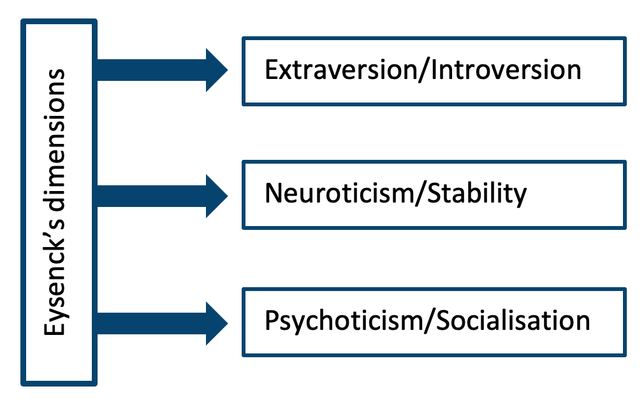

A strength of trait theory is how finely its methods suit its aims. Plotting an individual with the help of a score makes it possible to classify how people may act in particular situations.

Trait theory has been around for more than a century. It has its disadvantage like traits are determined subjectively by the creator of the list, rather than the individual. There is still no agreement about which or the number of traits most suitably describe personality. It has received much critique, unlike the Personal construct theory (Butt, 2012).

George Kelly’s ‘Personal construct theory’ emphasizes that personality not being fixed. He adds that a modification in personality is conceivable though not easily attained. Personal construct theory is a form of phenomenology which looks at how individuals appear dissimilar to each other (Butt, 2012). George Kelly emphasized individual differences and regarded personality as an individual experience (Stevens, 2007). Based on the phenomenological perspective, which emphasizes how things (particularly other people) appear dissimilar to each individual, personal construct theory helps to understand how a person uses their subjective experiences to form a set of personal constructs which then aid them to give the logic of the world and to take into consideration the difference of each individuals personality (Butt 2012).

One of the weaknesses of the personal construct theory is how Kelly was unable to explore where constructs arise from and how different individuals form different systems of construction.

## **Principles Underlying Psychoanalytic, Social Learning, Cognitive Neuroscience and Humanistic Approaches**

According to Sigmund Freud, psychoanalysis is defined as

1. a theory of mind or personality,
2. a means of investigating the unconscious processes,
3. and a method of treatment.

At present, it is most appropriate to categorize psychoanalytic perspectives on personality prototypically and not through any set of defining features. Psychoanalytic approaches take as obvious the importance of unconscious cognitive, affective, and motivational processes; conflicting mental processes; compromises among competing psychological tendencies that can be negotiated on the unconscious level; defence and self-deception; the impact of the past, directly or in interaction with genetic predispositions, on current functioning; the enduring impacts of interpersonal patterns established in childhood; and the effect of sexual, aggressive, attachment-related, self-esteem, and other wishes and fears on thought, feeling, and behaviour, whether or not the person is aware of it (Westen, Gabbard, and Ortigo, 2008).

The Social learning theory focuses on the significance of observation and modelling. Some of the processes that establish outcomes of observed behaviour include attention, retention, motor reproduction, and motivation (Whitney, 2015).

The cognitive neuroscience of long-term memory is embedded with the hypothesis that a certain task measures a single cognitive process. Each cognitive process is mediated by a single brain area. However, these assumptions are crude and hamper the understanding of the true mechanisms of memory (Scott, 2012).

The humanistic approach in psychology developed in the 1960s and 70s brought in a new perspective. The focus was that the study of psychology should focus not only on the purely mechanistic aspects of cognition but purely on the effect of the environment on behaviour. It was proposed instead that the emphasis of psychological study should be on the particulars of human experience. The humanistic approach focuses on the personal worth of the human, the centrality of human values, and the creative, active nature of individuals. The approach is optimistic and has its focuses on the noble human ability to beat hardship, agony and despair (Joseph, 2012).

Whether human behaviour comes from heredity factors (nature) or is a product of the environment (nurture) is a question psychologists are confronted with today. Heredity and the environment do not act independently and both nature and nurture are essential for almost all behaviour (Davids and Baker, 2007). Therefore, instead of defending extreme nativist or environmentalist views, most investigations are now directed towards the ways in which nature and nurture interact. The Interactionist approach is the view that both nature and nurture work together to determine human behaviour.

## **Psychoanalytical defence mechanisms and development:**

|  |  |
| --- | --- |
| **Philosopher/Psychologist** | **Concept** |
| **Sigmund Freud** | Three-part structure: id, ego and superego. Described development of personality through different psychosexual developmental stages (**the oral, the anal, the phallic, the latent, and the genital**). He also introduced the concept of ‘defence’, which his daughter Anna Freud defined with the first nine defence mechanisms that are employed by the ego to protect itself from anxiety or danger. |
| **Carl Jung** | Described the **collective unconscious**as having a biological base and reflective of themes and ideas that are universal. Jung spoke about a collective unconscious containing archetypes: anima, animus and shadow. Anima is usually related to the emotional, empathetic, and sensitive aspects, while Animus is related to the active, intellectual, exploring side of the personality. |
| **Erik Erikson** | Developed psychosocial development into 8 development stages. |

***Freud’s psychosexual developmental stages:***

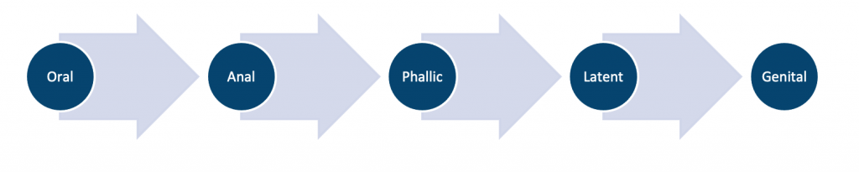

**Erikson’s psychosocial development stages:**

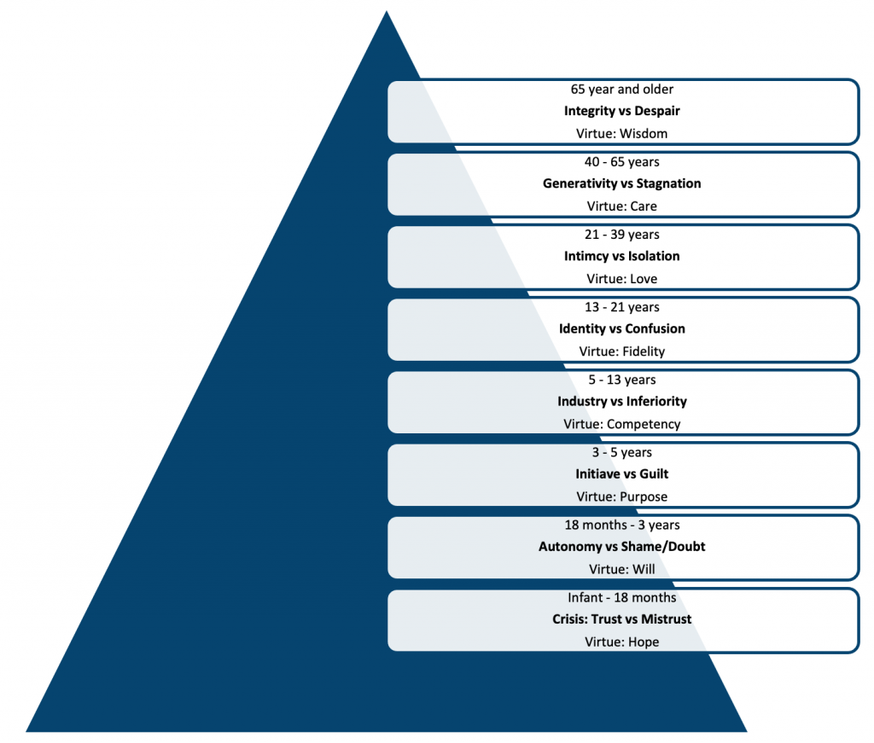

## **Construction and Use of Inventories, Rating Scales, Grids and Q-Sort**

To study human behaviour, surveys are perhaps the most used methodological tool among academic researchers. Self-administered survey questionnaires (and guided interviews) are now used widely to bring forth behaviours, attributes, beliefs, and attitudes among populations. Researchers, however, must be aware of the research objectives when constructing items consisting of a summated rating scale (Shane, 2005).

|  |  |
| --- | --- |
| ***Personality test:*** | ***Summary:*** |
| **Minnesota Multiphasic Personality Inventory (MMPI)** | Personality inventories are completed by the patient/individual rather than the physician.MMPI is the most common. |
| **Myers-Briggs Type Indicator (MBTI)** | A psychometric tool that assesses psychological preferences in terms of how an individual perceives their environment/the world and consequently makes decisions. Developed following Carl Jung’s work. |
| **Thematic Apperception Test (TAT)** | A projective test where patients are presented with pictures and asked to create a story. Alongside this, they are questioned about their thoughts and feelings. The concept is that unconscious themes will emerge, which are then interpreted and explored further. |
| **Sentence Completion Test** | A projective test that involves an open-ended form. The individual is presented with the first part of an uncompleted sentence and asked to complete it in their own words. |
| **Cattell’s 16 PFQ** | A multiple-choice personality questionnaire that uses factor analysis and correlation coefficients. It measures the 16 primary traits and the ‘Big Five’ secondary traits. |
| **Eysenck Personality Inventory** | The Eysenck Personality Inventory (EPI) measures two pervasive, independent dimensions of personality, Extraversion-Introversion and Neuroticism-Stability, which account for most of the variance in the personality domain. |
| **Draw a Man test** | Involves completing three separate drawings; one of a man, one of a woman and a drawing of themselves. Following this, they are requested to draw a whole person without any further instructions. This measures: personality, intelligence, sensory defects, developmental progress and visual-motor coordination. |
| **International Personality Disorder Examination (IPDE)** | A consistent approach for investigating personality disorders in DSM-5 and ICD-10. Two parts: a self-administered screening questionnaire and a semi-structured interview. |

**Q-sort techniques** assess personality pathology, mental, and interpersonal issues. They are also utilized in quantifying the psychotherapeutic process. Q-sort methods aid in studying research questions that are clinically relevant, however, they are extremely hard to grasp. They are also used for “dismantling studies” (Löffler-Stastka, 2011).

**References**:

(1) Anaya, B., and Pérez-Edgar, K. (2019) ‘Personality development in the context of individual traits and parenting dynamics’, New Ideas in Psychology, 53, pp. 37-46.

(2) Beck, E. D., and Jackson, J. J. (2020) ‘Consistency and change in idiographic personality: A longitudinal ESM network study’, Journal of Personality and Social Psychology, 118(5), pp. 1080-1100.

(3) Butt, T. (2012). ‘Individual differences’. In Langdridge, D. Taylor, S. and Mahendran, K. (Eds.), Critical Readings in Social Psychology (2nd ed., pp45–64). Milton Keynes: The Open University.

(4) Davids, K., and Baker, J. (2007) ‘Genes, environment and sport performance: why the nature-nurture dualism is no longer relevant.’ Sports Medicine, 37(11), pp. 961-980.

(5) Ilan, J., and Walter, D. (2017)‘Biological theories of crime versus psychological theories of crime — Comparison and evaluation of their contributions to our understanding of crime and/or criminal justice. 10.13140/RG.2.2.14740.14726.

(6) Kassin, S. M. (2003) Psychology. USA: Prentice-Hall, Inc.

(7) Kleinberg, J., Lakkaraju, H., Leskovec, J., Ludwig, J., Mullainathan, S. (2018) ‘HUMAN DECISIONS AND MACHINE PREDICTIONS’, The Quarterly Journal of Economics, 133(1), pp. 237-293.

(8) Ferguson, E. (2013) ‘Personality is of central concern to understand health: towards a theoretical model for health psychology.’ Health Psychology Review, 7, S32 – S70.

(9) Fleeson, W., and Jayawickreme, E. (2015) ‘Whole Trait Theory’, Journal of Research in Personality, 1;56, pp. 82-92.

(10) Freud, S. (1987) ‘The origin and development of psychoanalysis. By Sigmund Freud, 1910.’ American Journal of Psychology, 100(3-4), pp. 472-488.

(11) Joseph, S. (2012) ‘How Humanistic Is Positive Psychology? Lessons in Positive Psychology From Carl Rogers’ Person-Centered Approach-It’s the Social Environment That Must Change.’ Frontiers in Psychology, 12.

(12) Löffler-Stastka, H. (2011) ‘Use of Q-sort assessment methods for diagnostic purposes and in treatment evaluation?. Z Psychosom Med Psychother, 57(4), pp. 319-324.

(13) Scott, S (2012) ‘The cognitive neuroscience of memory Introduction’. Cognitive neuroscience. 3, pp. 139-141.

(14) Shane, D. (2005). ‘Construction, Implementation, and Analysis of Summated Rating Attitude Scales’, American Journal of Pharmaceutical Education, 69.

(15) Stevens, R. (2002) ‘Person Psychology: Psychoanalytic and Humanistic Perspectives’inMiell, D, Phoenix, A. and Thomas, K. (Eds.), Mapping Psychology – Book 2, Chapter 9, Milton Keynes: The Open University.

(16) Westen, D., Gabbard, G. O., and Ortigo, K. M. (2008). Psychoanalytic approaches to personality. In O. P. John, R. W. Robins, & L. A. Pervin (Eds.), Handbook of personality: Theory and research (pp. 61–113). The Guilford Press.

(17) Whitney, D. (2015) ‘Theories of Crime and Criminal Behavior and Their Implications for Security. Security Supervision and Management: Theory and Practice of Asset Protection’: Fourth Edition. 37-49. 10.1016/B978-0-12-800113-4.00003-1.

### 1.1.7 Motivation and Maslow

## **Motivation: Needs and Drives**

Motivation is considered one of the most important competencies by which human behaviour is determined. It is however dependent on intrinsic drives and needs which can be physical or objective. The examples of water and food represent physical needs while self-esteem represents examples of psychological or subjective needs (Navy, 2020). They influence how a person behaves and are hence considered motivational to behaviour. Noteworthy is that the needs are ranked in a hierarchy as explained by Abraham Maslow who categorized needs into basic and secondary or the higher order ones leading to self-actualization (Navy, 2020). Nevertheless, for the need to trigger action, there are internal drives that are considered intrinsic forces by which humans are enticed to pursue a need (Navy, 2020). A drive can be illustrated through the state of mind whereupon registering hunger, one is motivated to take the action of cooking or buying food to satisfy the need of hunger.

## **Drive reduction theory:**

Drive-reduction theory holds that the basic reason for all human behaviour is to diminish ‘drives.’ A ‘drive’ is a state of arousal or pain caused by physiological or biological requirements such as hunger, thirst, or the desire for warmth.

**Primary drives** provide the reinforcement required for basic survival. The hypothalamuscontrols the homeostatic systems. Effectors result in change and sensors detect this change.

Hunger is a primary drive:

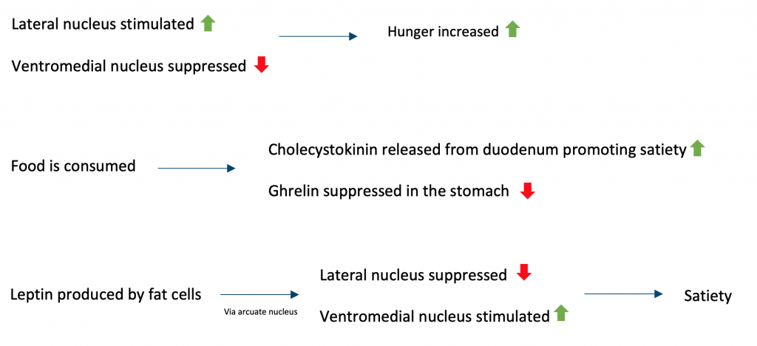

**Secondary drives** support primary drives. A clear difference from the primary drives is that they are not essential to survival. Social behaviours are associated with the nano peptide hormones vasopressin and oxytocin.

## **Arousal theory:**

According to the arousal theory of motivation, individuals are driven to engage in activities or situations that maintain or raise their degree of arousal. Increased activity in the dopaminergic mesolimbic system is associated with increased arousal.

Yerkes and Dodson proposed the hypothesis in 1908, after discovering an inverted-U relationship between task difficulty and performance:

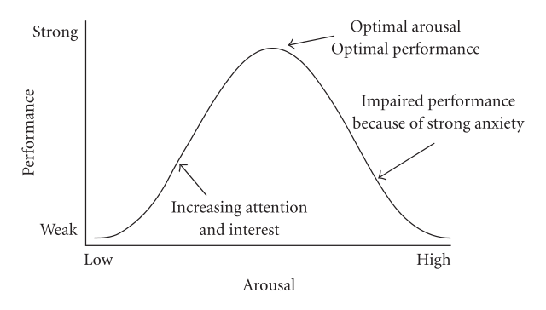

## **Extrinsic Theories (Based on Primary and Secondary Drive Reduction) and Homeostasis**

According to extrinsic theories, as represented by the drive reduction theory, human behaviours are motivated by homeostasis. It is the desire to achieve a state of physical and mental equilibrium under the core premise that motivation is triggered by biological needs (Legault, 2020). Competition for trophies and completing work for monetary rewards are examples of extrinsic rewards which explain human behaviour. The need-based theory illustrated by Abraham Maslow equally supports the notion of homeostatic forces triggering observable behaviour by human agents (Legault, 2020). From cognitive theories, inconsistencies and contradictions in cognitions by a person such as represented by beliefs and attitudes are equal factors that create a disequilibrium hence triggering behaviour as one pursues the state of mental and physical equilibrium. Therefore, based on primary and secondary drive reduction, extrinsic theories play a crucial role in explaining the motivation for human behaviour and actions.

## **Extrinsic motivation:**

* Behaviours are driven by external benefits is the main hypothesis of extrinsic theories.
* According to operant conditioning, behaviours are reinforced if they result in an external reward or the avoidance of punishment.
* The incentive theory of motivation proposes people are motivated by a desire for rewards and reinforcement while avoiding activities that may result in punishment. Working for a wage is an example.

## **Hypothalamic Systems and Satiety**

The sensation of fullness and satisfaction in a person’s mind comes from what is regarded as stimulation. The hypothalamus in the human brain is considered to be the coordination centre of human actions (Talakoub, et al., 2017). It has the primary responsibility of causing one to realize what is regarded as homeostasis or the stable state. Located in the hypothalamus is the satiety centre which is responsible for registering the feeling of satisfaction. It stimulates the production of hormones by which body processes are triggered for the realization of a state of bodily balance and the feeling of satisfaction (Talakoub, et al., 2017). For example, through pituitary hormones, the body temperature and heart rate are regulated. Therefore, the hypothalamic system plays an important role via the satiety centre to stimulate and produce the feeling and sensation of satisfaction. It is therefore credited for influencing human behaviour and actions.

## **Intrinsic Theories, Curiosity, and Optimum Levels of Arousal**

When considering intrinsic motivation, curiosity or inquisitiveness, and eagerness to learn what does not have a direct concern to a person feature dominantly. Curiosity is hence featured as a strong intrinsic motivation by which spontaneous exploration and active learning are inspired (Gopalan, et al., 2017). Through intrinsic theories, autonomy, purpose, and mastery are featured by which human behaviour can be explained. Based on the needs and drives, intrinsic motivation to pursue healthy biological necessities such as food and sex are explained. In past studies, curiosity plays a critical role in explaining the recorded levels of arousal (Gopalan, et al., 2017). With higher levels of curiosity, heightened levels of satisfaction are realised through the exploratory behaviours that result. Therefore, from the intrinsic theories of human behaviour, human behaviour which is not triggered by the realisation of external rewards and pressures is explained. Curiosity is featured dominantly in the explainer as it also influences the levels of arousal recorded by a person.

## **Intrinsic motivation:**

* Intrinsic theories suggest motivation may be innate, as opposed to acquired.
* Curiosity is related to our innate practice of seeking out new experiences and discovering new information. This contributes to our development and understanding.

## **Limitations of Approach and Attempts to Integrate**

As a complex phenomenon, motivation attracts both intrinsic and extrinsic explanations. It is particularly complicated when considering integration as a phenomenon of mental processes. Integration regards positive psychological development leading to maturity in habits and behaviour (Shaver, Hazan & Bradshaw, 2021). Often, the discourse focuses on how a person overcomes and outlives past behaviours and positively embraces new ones. When considering the motivations that influence behavioural integration both extrinsic and intrinsic factors are featured (Shaver, Hazan & Bradshaw, 2021). They also inform the challenges and limitations that are encountered in the processes. It however becomes challenging to determine the outcome of attempts to integrate due to the lack of what is regarded as zero point or the reference position (Shaver, Hazan & Bradshaw, 2021). The success or failure of attempts to integrate hence takes a high regard for subjectivity.

## **Cognitive Consistency and the Need for Achievement (nAch)**

The need for achievement is defined as a person’s desire to make significant accomplishments such as taking control and mastering skills. Illustrations of activities that people do to realise the desire are to pursue intense and often prolonged routines of activities (Hilkenmeier, 2018). An internal drive or motivation is considered to be a determining force for the need for achievement. However in other instances, external forces such as the social expectation for one to win causes a person to realise a higher need for achievement. For a pleasant psychological state to be realised, congruency between the need for achievement and cognitive consistency is required (Hilkenmeier, 2018). By definition, cognitive consistency regards the concept that one’s preferences in thoughts, attitudes, opinions, and beliefs are congruent or well-aligned without contradiction. With the inconsistency of incongruence, an unpleasant psychological state and tension ensue.

McClelland who proposed the ‘need for achievement’ theory suggested behaviour could be drawn down to three social objectives:

* **Need for achievement (nAch):** mastery and control of skills in comparison to peers. The satisfaction gained through achievement and competition.
* **Need for affiliation (nAf):** maintaining effective relationships with people. Aim for a sense of belonging.
* **Need for power (nP):** exerting an impact on others via leadership roles and personal status.

## **Maslow’s Hierarchy of Needs**

The Maslow hierarchy of needs is a psychological framework for understanding human needs and how they rate in preference which was advanced by the American psychologist Abraham Maslow. Human innate curiosity and desires were also incorporated into the Maslow Hierarchy of Needs framework to advance the discourse of how human behaviours and actions are occasioned (Fallatah & Syed, 2018). The thoughts of the psychologist noted how physiological needs as represented by food and clothing, safety, love and belonging, esteem, and self-actualisation play unique roles in informing actions and behaviours by people. A hierarchical order was advanced where Maslow notes that the physiological needs rank basic at the bottom of the needs whereas self-actualisation comes at the top of the pyramid (Fallatah & Syed, 2018). The implication is that before pursuing self-actualisation, a person would be more concerned with the bottom or basic needs as represented by food.

Maslow’s hierarchy of needs states the following five needs are to be obtained in hierarchical order:

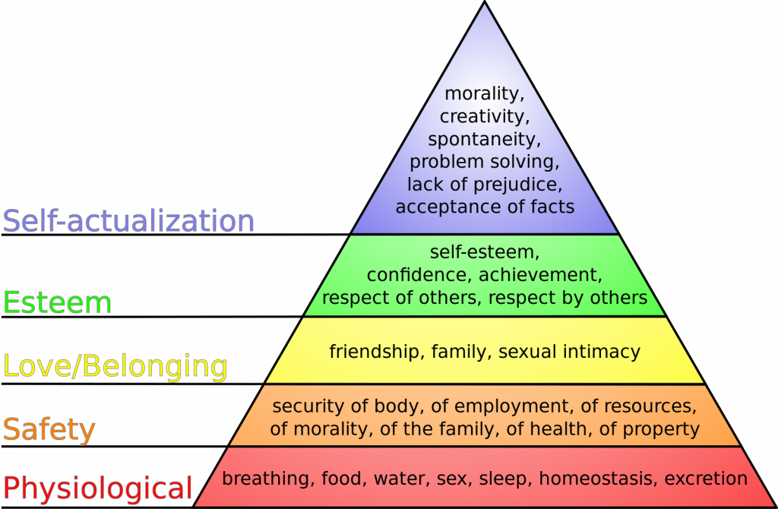

**References**:

(1) Fallatah, R. H. M., & Syed, J. (2018). A critical review of Maslow’s hierarchy of needs. Employee Motivation in Saudi Arabia, 19-59.

(2) Gopalan, V., Bakar, J. A. A., Zulkifli, A. N., Alwi, A., & Mat, R. C. (2017, October). A review of the motivation theories in learning. In AIP Conference Proceedings (Vol. 1891, No. 1, p. 020043). AIP Publishing LLC.

(3) Hilkenmeier, F. (2018). The impact of motive disposition on group performance. Cogent Psychology, 5(1), 1507123.

(4) Legault, L. (2020). Intrinsic and extrinsic motivation. Encyclopedia of personality and individual differences, 2416-2419.

(5) Navy, S. L. (2020). Theory of human motivation—Abraham Maslow. In Science Education in Theory and Practice (pp. 17-28). Springer, Cham.

(6) Shaver, P. R., Hazan, C., & Bradshaw, D. (2021). The integration of three behavioral systems. Attachment Theory and Research: A Reader, 74.

(7) Talakoub, O., Paiva, R. R., Milosevic, M., Hoexter, M. Q., Franco, R., Alho, E., … & Hamani, C. (2017). Lateral hypothalamic activity indicates hunger and satiety states in humans. Annals of clinical and translational neurology, 4(12), 897-901.

### 1.1.8 Emotion

## **Emotions and Components of Emotional Responses**

The particular reactions of people to events or circumstances or their cognitive feelings are known as emotions. The situation that evokes the emotion determines the type of emotion the person will feel (Shariff and Tracy, 2011). For example, when someone hears good news, they are happy. When someone is in danger, they become afraid.

### **Types of emotions**:

There are numerous theories regarding the wide range of emotions that people can feel (Utz, Schultz and Glocka, 2013). According to various psychological studies and theories, there are six universal emotions which are the following:

1. Joy
2. Sorrow
3. Despair
4. Loathing
5. Frustration, and
6. Surprise

### **Components**

Arousing from an emotional experience are feelings. This falls into the same category as hunger or pain because the experiencer is aware of it. Emotion creates a feeling that can be influenced by memories, beliefs, and other things (Carpenter and Trull, 2012). It has been divided into three components:

### **Subjective experience:**

It includes the six different types of universal emotions a person experiences.

### **Physiological response:**

When a person is touched by emotion, his body reacts to it. For example, if a person feels anxiety, his heart palpation may increase. This is a kind of physiological response to an emotion.

### **Behavioural or expressive response**:

The ability to interpret exact emotions either by body language or facial expressions is the behavioural response.

## **Critical Appraisal of James-Lang and Cannon-Bard Theories**

James Lange’s theory and Cannon’s theory are the two main theories that attempt to explain how our emotional and physiological responses are triggered in response to environmental stimuli. Bard’s year 1927 brought the conception of the Cannon-Bard theory, which stood in stark contrast to the James-Lange theory (Cannon, 1927a). The James-Lange theory was originally formulated in the second half of the 19th century (Cannon, 1927b). In James Lange’s theory, emotions come after physical reactions (Crapanzano, 1984), but in Cannon-Bard’s theory, both emotional and physical reactions begin at the same time (Dror, 2013). James Lange’s theory can be compared to the Cannon-Bard theory, which states that emotions come after physical reactions. This is the main difference between the two explanatory models (Dror, 2013).

## **Cognitive Appraisal: Differentiation and Status of Primary Emotions**

An emotional situation is assessed cognitively when a person considers how the event will affect them, interprets the various elements of the event and determines their response (Smith and Ellsworth, 1985); all of this assessment is done through cognitive assessment. It is done in two steps:

* Primary appraisal
* Secondary appraisal

 It usually occurs in three situations which would have when there is neither physical stimulation nor clear cues as to how the situation should be interpreted, cognitive evaluations usually take place (Tomaka et al., 1997).

### **Differentiation and Status of Primary Emotions**

Primary emotions can be differentiated by a cognitive appraisal, like shame, guilt, embarrassment, etc. (Scherer, 2005). In particular, these cognitive evaluations happen when a person blames himself or herself for what they did. Attribution is when someone tries to explain why they did something or why someone else did something. When people attribute internal blame to their own actions, they hold themselves responsible for their actions (Folkman et al., 1986). When a person attributes an external cause to their own behaviour, they are blaming an external source (i.e., another person, luck, situational influences). Internal self-attributions are the root cause of all self-conscious feelings (Folkman et al., 1986).

## **Emotions and Performance**

There is a strong correlation between the study of emotions in organizations and especially the relationship between emotions and job performance (Crawley, 2004). People’s emotional temperament has a direct impact on how well they perform in their professional and personal lives. More specifically, task performance evaluations can be enhanced by positive feelings such as performance rewards, backup support, and positive attitudes and evaluations from superiors, but task evaluations themselves cannot be enhanced (Meneghel, Salanova and Martínez, 2014). According to supervisors, the quality of work performed can be negatively affected by emotions such as anger and humiliation, as well as devious or biased behavior.

Positive affect was linked to more organizational citizenship behavior and helpful but unrelated work behaviors, like volunteering more hours or helping a coworker. Being in a bad mood can cause a drop in performance at work (Meneghel, Salanova and Martínez, 2014b). Negative affect is linked to more withdrawn behavior and less productive actions at work, like theft, abuse, sabotage, and not showing up for work. Rispens and Demerouti (2016) found that negative emotions are linked to more accidents at work.

### **Yerkes-Dodson law:**

The Yerkes–Dodson law is an empirical relationship between pressure and performance, originally developed by psychologists Robert M. Yerkes and John Dillingham Dodson in 1908.

The law dictates that performance increases with physiological or mental arousal, but only up to a point.

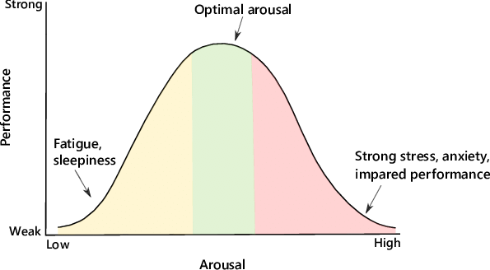

**References:**

(1) Cannon, W.B. (1927) “The James-Lange Theory of Emotions: A Critical Examination and an Alternative Theory,” The American Journal of Psychology, 39(1/4), p. 106. Available at: https://doi.org/10.2307/1415404.

(2) Carpenter, R.W. and Trull, T.J. (2012) “Components of Emotion Dysregulation in Borderline Personality Disorder: A Review,” Current Psychiatry Reports, 15(1). Available at: https://doi.org/10.1007/s11920-012-0335-2.

(3) Crapanzano, V. (1984) “Life-Histories: Lives: An Anthropological Approach to Biography . L. L. Langness, Gelya Frank. ; Life Histories and Psychobiography: Explorations in Theory and Method . William McKinley Runyan. ; Carmen: The Autobiography of a Spanish Woman . Hans C. Buechler, Judith-Maria Buechler. ; Son of Tecun Uman: A Maya Indian Tells His Life Story . James D. Sexton. ; Nisa: The Life and Words of a !Kung Woman . Marjorie Shostak.,” American Anthropologist, 86(4), pp. 953–960. Available at: https://doi.org/10.1525/aa.1984.86.4.02a00080.

(4) Crawley, E.M. (2004) “Emotion and performance,” Punishment &Amp; Society, 6(4), pp. 411–427. Available at: https://doi.org/10.1177/1462474504046121.

(5) Dror, O.E. (2013) “The Cannon–Bard Thalamic Theory of Emotions: A Brief Genealogy and Reappraisal,” Emotion Review, 6(1), pp. 13–20. Available at: https://doi.org/10.1177/1754073913494898.

(6) Folkman, S. et al. (1986) “Dynamics of a stressful encounter: Cognitive appraisal, coping, and encounter outcomes.,” Journal of Personality and Social Psychology, 50(5), pp. 992–1003. Available at: https://doi.org/10.1037/0022-3514.50.5.992.

(7) Meneghel, I., Salanova, M. and Martínez, I.M. (2014) “Feeling Good Makes Us Stronger: How Team Resilience Mediates the Effect of Positive Emotions on Team Performance,” Journal of Happiness Studies, 17(1), pp. 239–255. Available at: https://doi.org/10.1007/s10902-014-9592-6.

(8) Rispens, S. and Demerouti, E. (2016) “Conflict at Work, Negative Emotions, and Performance: A Diary Study,” Negotiation and Conflict Management Research, 9(2), pp. 103–119. Available at: https://doi.org/10.1111/ncmr.12069.

(9) Scherer, K.R. (2005) “What are emotions? And how can they be measured?,” Social Science Information, 44(4), pp. 695–729. Available at: https://doi.org/10.1177/0539018405058216.

(10) Shariff, A.F. and Tracy, J.L. (2011) “What Are Emotion Expressions For?,” Current Directions in Psychological Science, 20(6), pp. 395–399. Available at: https://doi.org/10.1177/0963721411424739.

(11) Smith, C.A. and Ellsworth, P.C. (1985) “Patterns of cognitive appraisal in emotion.,” Journal of Personality and Social Psychology, 48(4), pp. 813–838. Available at: https://doi.org/10.1037/0022-3514.48.4.813.

(12) Tomaka, J. et al. (1997) “Cognitive and physiological antecedents of threat and challenge appraisal.,” Journal of Personality and Social Psychology, 73(1), pp. 63–72. Available at: https://doi.org/10.1037/0022-3514.73.1.63.

(13) Utz, S., Schultz, F. and Glocka, S. (2013) “Crisis communication online: How medium, crisis type and emotions affected public reactions in the Fukushima Daiichi nuclear disaster,” Public Relations Review, 39(1), pp. 40–46. Available at: https://doi.org/10.1016/j.pubrev.2012.09.010.

(14) Saeed, A., Trajanovski, S., Van Keulen, M. and Van Erp, J. (2017). Deep Physiological Arousal Detection in a Driving Simulator Using Wearable Sensors. 2017 IEEE International Conference on Data Mining Workshops (ICDMW). doi:10.1109/icdmw.2017.69.

### 1.1.9 Stress

## **Stress: Physiological and Psychological Aspects**

Stress is a reaction to stimuli the brain or body interprets as a challenge or obstacle. It comes in different forms, including physiological and psychological stress. The former case involves external and external conditions that challenge normal cell or organism functioning. Physiological stress is the effect of the failure of the human body to respond effectively to physical stimuli (Kagias, Nehammer & Pocock 2012). For example, when people are exposed to cold, they become stressed since such environments interfere with their body functionality. Psychological stress occurs when a person perceives that particular demands and needs exceed their adaptive abilities. It affects the emotional and physical well-being of the sufferer depending on the cause and the person.

## **Situational Factors: Life Events, Daily Hassles/Uplifts, Conflict, and Trauma**

Life events like having sick relatives or financial problems can lead to stress. Such situations make a person feel that they cannot solve their current issue or may stop looking for solutions; consequently, they feel stressed. Daily hassles like having a demanding job could lead to stress. This is true when jobs have challenging tasks that exceed workers’ abilities. Even though demanding work may motivate workers to realize their full potential, it leads to stress when it becomes difficult to cope. Conflicts like unhealthy relationships result in stress since they create toxic environments people cannot adjust to. Traumatic events such as physical assault result in stress and evoke psychological and physical responses that lead to anxiety, sadness, and agitation.

## **Vulnerability and Invulnerability**

Vulnerability means a patient is susceptible to a negative outcome, such as harm. In other words, they are not protected against factors or dangers that could result in adverse health consequences. Satici (2016) explains that vulnerability is natural for people, meaning that each individual has a specific fragility level that makes them susceptible to stress. Patients may have a cognitive bias or certain beliefs that exposes them to psychological issues. Vulnerability shapes maladaptive reactions to situations that make patients more susceptible to psychological disorders. Hill, Duggan and Lapsley (2011) say that invulnerability is the sense of protection against harm. In this case, psychiatry patients do not feel personal stress could adversely affect them. Invulnerability is instrumental in helping patients protect themselves or cope with stressors and, hence, avoid psychological issues.

## **Type A Behavior Theory**

Type A behaviour theory explains how people react to stressors. It holds that people with Type A personalities strive to work against time and are highly competitive (Mcleod 2017). In essence, they are punctual, ambitious, and organized. Individuals with Type A personalities are self-critical and focus on goals without paying attention to the efforts needed to accomplish those goals. According to Mcleod (2017), people with Type A personalities are susceptible to stress or experience higher stress levels. This is due to their impatience since they need to be fast in their tasks. Individuals with Type A personalities are also highly competitive and will criticize themselves if they fail to win, resulting in stress (Mcleod 2017). They are easily angered and may see the worst in people.

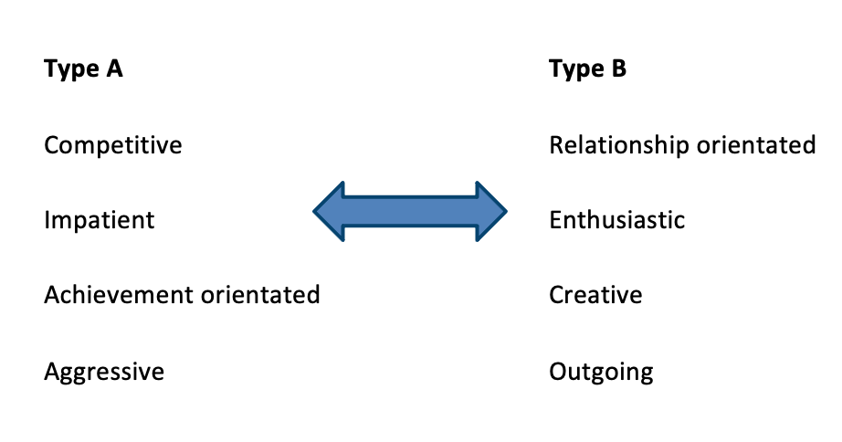

## **Coping Mechanisms**

Coping mechanisms refer to strategies people use to adjust to stressful and traumatic events. They help people adapt to changes and maintain physical and psychological well-being (Algorani & Gupta, 2021). Life events, whether positive or negative, can result in stress. Positive occasions may include getting married, buying a house, or having a baby, whereas adverse occurrences may consist of getting a divorce, the death of a loved one, or hospitalization. Both cases create environments that require significant adjustments in life. People need coping mechanisms to adjust effectively and avoid consequent psychological and physical effects. Coping styles may be problems, emotion, or meaning-focused. Problem-focused means that a person strives to address the issue leading to stress. The emotion-focused mechanism aims to suppress stress-related emotions (Algorani & Gupta 2021). People using the meaning-focused style try to understand the meaning of a problem to deal with it appropriately.

## **Locus of Control, Learned Helplessness, and Learned Resourcefulness**

Locus of control is the degree to which a person feels they have control over their behaviour. It influences how people respond to life events and how well they are motivated to take action. A person can have an internal or external locus of control. In the former case, people believe that they control their behaviour and manage how they behave. For example, a person may claim that they excelled in their examinations since they studied hard. People with an external locus of control view their actions as a result of influence from external forces. Learned helplessness is a state of mind in which a person believes they cannot change certain situations. Consequently, they begin to act helpless, compelling them to ignore opportunities for change or relief. Learned resourcefulness refers to the skills or behaviours that help a person cope with stressful events.

## **Resilience**

Resilience refers to the mental, emotional, and behavioural capacity to deal with challenging life events. When people face difficult situations, they may develop abilities to cope with similar experiences in the future. The primary factor contributing to resilience is how people view and engage with the world. Another factor is the availability of resources, including help from people (American Psychological Association, 2012). The last factor is specific coping strategies, in which people have skills like high self-esteem to deal with challenging life experiences.

**References:**

(1) Kagias, K., Nehammer, C. & Pocock, R 2012, ‘Neuronal Responses to Physiological Stress’, Frontiers in Genetics, 3. doi:10.3389/fgene.2012.00222.

(2) Satici, S.A 2016, ‘Psychological Vulnerability, Resilience, And Subjective Well-Being: The Mediating Role of Hope’, Personality and Individual Differences, vol.102, pp.68–73. doi:10.1016/j.paid.2016.06.057.

(3) Hill, P.L., Duggan, P.M. & Lapsley, D.K 2011, ‘Subjective Invulnerability, Risk Behavior, and Adjustment in Early Adolescence’, The Journal of Early Adolescence, vol.32, no.4, pp.489–501. doi:10.1177/0272431611400304.

(4) Mcleod, S 2017. Type A and Type B Personality Theory. [online] Simply Psychology. Available at: https://www.simplypsychology.org/personality-a.html.

(5) Algorani, E.B. & Gupta, V 2021, Coping Mechanisms. [online] PubMed. Available at: https://www.ncbi.nlm.nih.gov/books/NBK559031/.

(6) American Psychological Association 2012, Building Your Resilience. American Psychological Association. [online] Available at: https://www.apa.org/topics/resilience.

### 1.1.10 States and levels of awareness

## **Levels of Consciousness and Evidence or Unconscious Processing**

Personality and behaviour stem from conflicting psychological forces with three levels of consciousness; the preconscious, conscious, and unconscious. The preconscious contains information, including memories, thoughts, and feelings, that can be transferred to the conscious mind (Cherry, 2020). They are ideas that people can access but do not actively think about them. The consciousness consists of information people know at any moment (Cherry, 2020). In other words, it refers to thoughts and feelings a person is experiencing currently, including their awareness of the environment. The unconscious is part of the mind that contains reserved information. It consists of unpleasant contents, that are repressed to prevent them from causing harm (Cherry, 2020). For example, childhood trauma is held in the unconscious mind to avoid causing effects like anxiety.

## **Arousal, Attention, and Alertness**

Arousal is being psychologically alert, which can be from an emotional, mental, or physical perspective. Each person has an arousal level that best works for them. Therefore, when people become overly aroused, they seek or rather engage in activities that calm them down (Cherry, 2019). The reverse is true since individuals with low arousal levels seek stimulating activities to regain energy. Attention is the ability to process information in an environment and respond appropriately to stimuli (McCallum, 2019). Attention is about focusing on a particular object or subject and ignoring any other competing stimuli to make sense of the world. On the other hand, alertness is being aware and ready to respond to surrounding environments.

## **Sleep Structure and Dreaming**

Sleep is a significant part of daily routine that exists in two forms: rapid eye movement (REM) and non-rapid eye movement (non-REM). REM sleep is characterized by decreased brain activities and rapid eye movements (Colten & Altevogt, 2015). Although the eyes move around rapidly, they do not send signals to the brain. Dreaming occurs during the REM sleep phase, and slowed muscle activities prevent people from acting out their dreams (Colten & Altevogt, 2015). Non-REM sleep happens in three phases: In the first stage, the eyes are closed, but an individual can easily wake up (Colten & Altevogt, 2015). The second phase includes light sleep, heart rate, and slow brain activity. The last stage is the deep sleep stage, where it is difficult to arouse an individual; if they wake, they might appear disoriented.

## **Parasomnias**

Parasomnias are unusual behaviours or experiences that happen when a person sleeps or after waking up. The sufferer may appear awake, but they are asleep, and their physical events do not wake them. The unusual behaviours are grouped depending on the sleep phase, Non-REM, and REM (Pacheco, 2020). In the former case, an individual experiences events like sleep terrors where they wake up terrified. They also have confusional arousals, meaning they appear awake but are confused about time and space. Non-REM Parasomnias include sleepwalking and sleep-related eating disorders (Pacheco, 2020). Parasomnias during REM sleep include night disorders, bedwetting, sexsomnia, exploding head syndrome, and recurrent isolated sleep disorders.

## **Biorhythms and Effects of Sleep Deprivation**

Biorhythms, also known as circadian rhythms are the natural, internal processes that regulate the sleep-wake cycle and other behavioural and physiological processes in living organisms. These rhythms are driven by an internal “biological clock” that is influenced by various cues, such as light exposure and physical activity, and are present in most living organisms, including humans (Suni, 2020).

Circadian rhythms are critical for maintaining optimal health and well-being, as they help regulate various physiological processes, including hormone production, metabolism, and immune function. When our circadian rhythms are disrupted, such as by sleep deprivation or shift work, it can lead to a range of negative effects on our health and well-being.

Sleep deprivation is a common cause of disrupted circadian rhythms, as it interferes with the normal sleep-wake cycle and can cause a range of problems, including fatigue, decreased alertness and productivity, impaired cognitive performance, mood swings, and increased risk of accidents. Chronic sleep deprivation has also been linked to a range of health problems, including a weakened immune system, reduced ability to fight off infections, and an increased risk of developing chronic diseases such as diabetes and heart disease.

Circadian rhythms play a critical role in regulating various physiological processes and maintaining good health. Disruptions to these rhythms, such as sleep deprivation, can have negative effects on our health and well-being and should be avoided whenever possible. It is important to prioritize getting adequate, consistent sleep in order to support healthy circadian rhythms and maintain optimal health and well-being

## **Hypnosis and Suggestibility**

Hypnosis refers to being alert and aware of the surroundings, allowing for improved concentration on a subject or stimuli. On the other hand, suggestibility is accepting suggestions from another person and acting according to those suggestions. Watts (n.d.) explains that suggestibility is not a product of hypnosis. The author argues that hypnosis merely influences suggestibility, meaning that being alert does not necessarily determine whether individual acts according to suggestions. Some people are confrontational and question every aspect of life (Watts, n.d.). As such, they do not react promptly to suggestions. Other people and non-suggestible do not respond to suggestions other than acknowledging the statements they hear.

## **Meditation and Trances**

Mediation is a way of thinking where a person concentrates on objects or stimuli until they are absorbed into the object. The resulting impact is an intensive reflection of the higher self. As a person meditates, they become relaxed, free of worries, and may exhibit positive emotions such as happiness (Rahman, 2022). Trace is a state of mind in which a person is not fully alert. It differs from sleep in that the person focuses on a particular object. People in trance mode cannot hear, see, or respond to what is happening in their surroundings (Rahman, 2022). However, they can move their body parts, including their eyes and hands.

**References:**

(1) Cherry, K 2019. The Arousal Theory and Our Individual Behaviors. [online] Verywell Mind. Available at: https://www.verywellmind.com/the-arousal-theory-of-motivation-2795380.

(2) Cherry, K 2020. The Structure and Levels of the Mind According to Freud. [online] Verywell Mind. Available at: https://www.verywellmind.com/the-conscious-and-unconscious-mind-2795946#:~:text=Conscious%2C%20Preconscious%2C%20and%20Unconscious. [Accessed 11 Dec. 2022].

(3) Colten, H.R. & Altevogt, B.M 2015. Sleep Physiology. [online] Nih.gov. Available at: https://www.ncbi.nlm.nih.gov/books/NBK19956/.

(4) McCallum -Garrido, G 2020. Locus of Control | Simply Psychology. [online] www.simplypsychology.org. Available at: https://www.simplypsychology.org/locus-of-control.html.

(5) McCallum, W.C 2019. Attention. Encyclopædia Britannica. [online] Available at: https://www.britannica.com/science/attention.

(6) Pacheco, D 2020. Parasomnias – Types, Symptoms, & Causes. [online] Sleep Foundation. Available at: https://www.sleepfoundation.org/parasomnias.

(7) Rahman, S 2022. Meditation vs Trance. [online] buddingbuddhist.com. Available at: https://buddingbuddhist.com/meditation-vs-trance/ [Accessed 12 Dec. 2022].

(8) Suni, E 2020. What is Circadian Rhythm? [online] Sleep Foundation. Available at: https://www.sleepfoundation.org/circadian-rhythm.

(9) Watts, T. n.d. Suggestibility and Hypnosis. [online] Selfhypnosis.com. Available at: https://www.selfhypnosis.com/suggestibility/.

## 1.2 Social Psychology

### 1.2.1 Attitudes

## **Attitudes: Components and Measurement**

The attitude of a person is their feeling and/or thoughts, beliefs and behaviour predispositions towards people, groups, ideas, or objects. Attitudes tend to have a direction (positive or negative) as well as an intensity. The reason attitudes are important in psychiatry is how they can influence the behaviour of the individual and consequently how they act or behave in a certain situation.

The tripartite model of attitudes notes three components:

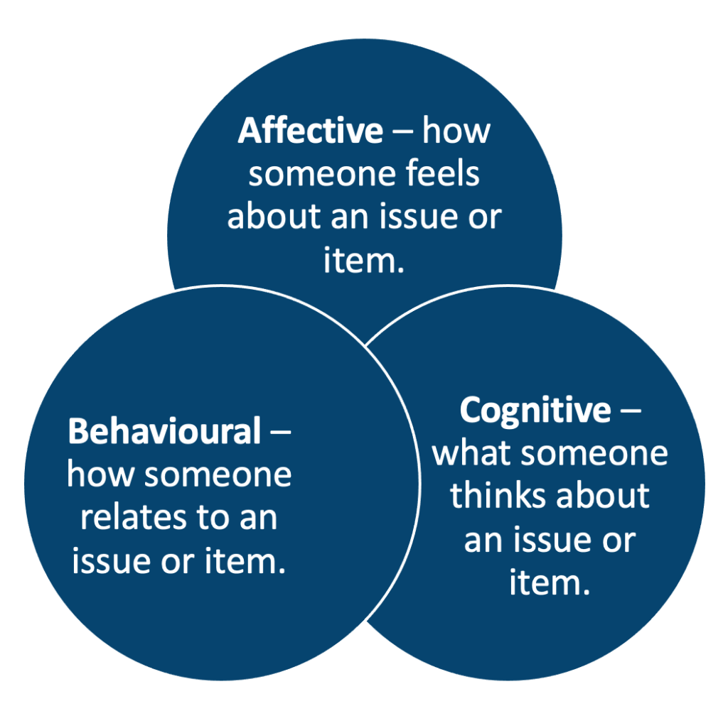

Stronger-held attitudes are more accessible (recalled more easily) as opposed to weaker attitudes. This means that a stronger attitude is more likely to be activated in the presence of associated stimuli, thus having an influence on thought and behaviour.

Various scholars have developed ways of measuring attitudes by proposing different scales:

|  |  |  |  |
| --- | --- | --- | --- |
| **Measurement** | ***Summar***y | ***Pro’s*** | ***Con’s*** |
| **Thurstone scale** | Series of agree/disagree items assessing varying strengths of that attitude. | Quantitative measures; can access all aspects of an attitude; anonymous responses are possible. | Responses influenced by social desirability; challenges to create/test these scales; a poor measure of implicit attitudes. |
| **Likert scale** | Measure attitude on numerical scales. | As above | As above |
| **Osgood semantic differential scale** | Rate attitudes/topics on a series of bipolar adjectives. | As above | As above |
| **Projective** | Open interpretation of an ambiguous stimulus. | Less vulnerable to social desirability. | The answer may be unrelated to attitudes of interest. Interpretation is more subjective. |
| **Computerised** | Speed of reaction/accuracy used to assess the strength of an attitude. | Quantitative measure. | Poor set shifting and slow reaction times may result in accurate results. |

## **Thurstone scales**:

A **Thurstone scale**, one of the measures of attitude, uses “agree or disagree” statements to measure the level of attitude towards a given statement (Richardson, 1960). The Thurstone scale is usually complex and time-consuming, so researchers and scientists prefer other scales to measure attitude (Richardson, 1960). The Thurstone scale is essentially categorized into three; the method of appearing intervals, the method of successive intervals, and the method of paired comparison. The method of equal-appearing intervals involves choosing items equally spaced.

***Figure 1. An example of a Thurstone scale***

## **Likert scales**:

The **Likert scale** is widely used. The principle was developed in 1932 when individuals were asked to respond to questions regarding their attitudes (Joshi et al., 2015). Unlike the Thurstone scale, which has fixed answers, the Likert scale asks the degree to which an individual agrees to these questions. The variety of agreements includes; strongly agree, agree, do not know, disagree, and strongly disagree. Providing these options gives an individual the freedom to express their attitudes in a broad manner. Thus, the Likert scale gives the researcher a wider variety of knowing how a respondent thinks and attitudes towards a given topic.

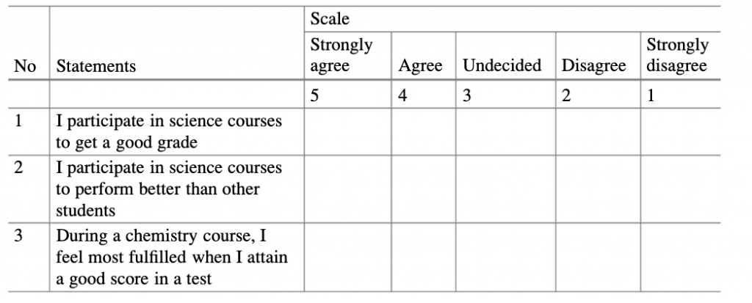***Figure 2. An example of a Likert scale***

## **Osgood semantic differential scales**:

The Osgood semantic differential scale uses two bipolar adjectives to find an appropriate position for the respondent (Heise, 1969). For example, an adjective like warm or cold might be used to describe a feeling, and the respondent is made to select this to measure attitude. Where there is an adjective, the respondent is made to place a mark near the desirable adjective, thus giving the researcher a hint of the respondent’s attitude. These objectives can be assigned a range of one to seven, depending on the closeness with the desired adjective.

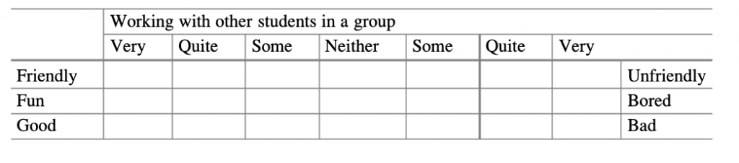***Figure 3. An example of a Likert scale***

## **Attitude Change and Persuasive Communication**

Persuasive communication is an important element when it comes to convincing an individual to act in the desired manner. Strong persuasive arguments always lead to a positive association and direct an attitude toward the desired direction of the message (Guyer et al., 2019). For example, suppose an individual had a negative attitude towards a statement or an opinion, depending on the persuasive nature of the researcher. In that case, an attitude can be got through positively speaking about the same statement or opinion. Persuasive communication is therefore categorized into weak and strong arguments, where an individual is likely to follow a given lead according to how the information will be portrayed.

In broader examples, speeches, posters, advertisements, and presentations are written with a strong persuasion to change the audience’s attitudes. The strength of an argument would make an audience desire to listen more and change an attitude toward a given subject (Guyer et al., 2019). In a political context, politicians usually use persuasive tones to make the crowd like them, and they would usually speak what the crowd would like to hear so that they can be loved. Siero & Doosje (1993) proposed a model to elaborate on the social judgment theory using various forms of attitude change. The experiment found that the message that produced the desired outcome, with the greatest persuasion, led to the greatest attitude change compared to messages with little persuasion.

The persuasiveness of a message is dependent on three things:

* **Message** – argument and/or emotional appeal.
* **Source** – credibility, trustworthiness, attractiveness and similarity to the receiver.
* **Recipient** – relevance, motivation and cognitive capacity to process the message.

**Elaboration likelihood model:**demonstrates that the more motivated a person is to process a message, then the more likely they are to focus on the arguments presented. Instead of being swayed by superficial cues such as the number and repetition of arguments (Payne, 2008).

## **Cognitive Consistency and Dissonance**

Cognitive consistency describes how we carry out a given behaviour and value similarly. Cognitive consistency describes preference and congruence to belief, values, and behaviour so that any change would lead to a distorted normal outcome or expectation. These beliefs and attitudes cannot contradict for whatever reason (‌Gawronski & Brannon, 2019). Consistency will always be a priority when an individual likes something at a given time because they believe they are right in their judgment. Any incongruency or inconsistency usually leads to tension and a detrimental psychological state, so the individual must seek change in behaviour and attitude to find congruency and reduce tension. Cognitive in this state means thoughts and beliefs held by an individual, and any interference with this may lead to serious psychological consequences.

On the other hand, cognitive dissonance is when an individual holds two contradicting beliefs, values, and attitudes. Cognitive dissonance is when beliefs are incongruent, leading to mental discomfort (‌Gawronski & Brannon, 2019). Most individuals like being consistent with their beliefs, and any disturbance or turbulence within their minds is enough to cause provocation. According to the American Psychological Association, cognitive dissonance results in an unpleasant psychological state, and individuals in this state would strive to ensure they resume their previous consistency.

## **How do Attitudes Influence Behaviour?**

Attitude and behaviour are related because one is a manifestation of the other. Focusing on a specific attitude or belief makes a person act that way. For example, if a person is focused on religious doctrines and believes this is the only way to be morally upright, their behaviour tends to follow them (Ajzen et al., 2018). Thus, actions are more consistent with behaviour because an individual expresses what they experience from the inside. Attitude ensures that a person exhibits cognitive consistency and avoids instances of mental breakdown due to guilt and peer pressure.

There are a number of different models and theories for how attitude influences behaviour:

|  |  |
| --- | --- |
| **Influence:** | **Description:** |
| **Intention-behaviour gap** | Attitudes influence an individual’s intention to participate in behaviour, which consequently influences the likelihood the behaviour will occur. But intention does not always translate to actual behaviour. |
| **Health belief model** | Behaviour reflects a weighing-up of a person’s cognitions (health beliefs) about a particular illness and preventative behaviour. An individual understanding of risk tends to be overly optimistic. |
| **Protection motivation theory** | A discrepancy between behavioural intention, which is influenced by attitudes and actual behaviour. |
| **Theory of planned behaviour** | A person’s behavioural intention is dependent on attitudes, subjective norms and the perceived control someone has over their own behaviour. |

**References:**

(1) Ajzen, I., Fishbein, M., Lohmann, S., & Albarracín, D. (2018). The influence of attitudes on behavior. The handbook of attitudes, 197-255.

(2) Conner M, Sparks P (2005). Theory of planned behaviour and health behaviour. In Predicting Health Behaviour. Open University Press.

‌(3) Gawronski, B., & Brannon, S. M. (2019). What is cognitive consistency, and why does it matter?

(4) Guyer, J. J., Briñol, P., Petty, R. E., & Horcajo, J. (2019). Nonverbal behavior of persuasive sources: A multiple process analysis. Journal of Nonverbal Behavior, 43(2), 203-231.

(5) Heise, D. R. (1969). Some methodological issues in semantic differential research. Psychological Bulletin, 72(6), 406.

(6) Joshi, A., Kale, S., Chandel, S., & Pal, D. K. (2015). Likert scale: Explored and explained. British journal of applied science & technology, 7(4), 396.

(7) Payne, C.R. (2008). The elaboration likelihood model of persuasion: Implications for trial advocacy. International Journal of Speech Language and the Law, 14(2). doi:10.1558/ijsll.2007.14.2.309.

(8) Richardson, C. E. (1960). Thurstone scale for measuring attitudes of college students toward physical fitness and exercise. Research Quarterly. American Association for Health, Physical Education and Recreation, 31(4), 638–643.

(9) Siero, F. W., & Doosje, B. J. (1993). Attitude change following persuasive communication: Integrating Social Judgment Theory and the Elaboration Likelihood Model. European Journal of Social Psychology, 23(5), 541–554. https://doi.org/10.1002/ejsp.2420230510

### 1.2.2 Self-psychology

## **Self-Psychology:**

## **Self-concept:**

Self-concept is how an individual sees themselves in a given state. Self-concept includes an individual’s ability and beliefs, which are true to their capacity. Self-concept depends on many factors, including age, sexual orientation, religion, and beliefs (Kravets & Korobkinaa, 2022). Self-concept is also comprised of self-esteem and self-image, meaning they dictate a person’s worth in a given situation.

## **Self-esteem:**

Self-esteem is the dictation of how a person feels about themselves; usually, the value and worth a person hold to themselves. Self-esteem can be high or low, depending on the level of energy they are viewed. High self-esteem involves a willingness to learn new things, developing coping mechanisms under pressure, emotional stability, and happiness to share ideas and experiences. Low self-esteem is a negative, draining energy that makes people think they are awful.

## **Self-image:**

Self-image is how an individual sees their physical and mental state. Depending on their experiences, an individual’s self-image builds over time (Kravets & Korobkinaa, 2022). Positive self-image includes the feeling of confidence, positive comparison, and positive feedback from other peers. Early childhood experiences and life events contribute to a person’s self-image; therefore, a person is likely to become what they have made to believe over time.

## **Self-Recognition and Personal Identity**

**Self-recognition** is the ability to notice oneself separate from others. Self refers to various elements, including physical, emotional, and psychological traits (Kilroy, 2021). Physical recognition is the possession of the material embodiment of a person so that a person can be aware of how they are. Self-recognition occurs in stages, with face recognition occurring from 18-24 months (Kilroy, 2021). Thus, attributes of self can be either physical or psychological depending on how a person first views themselves. The ability to self-recognize depends on each person and is an attribute different according to personality and environment subjected to growth (Kilroy, 2021). Thus, self-recognition builds confidence as a person grows, which is essential in establishing positive self-esteem.

**Personal** **identity** is about how an individual views themselves as different from others around them. The major distinguishing factors include hobbies, interests, education, and personality traits. Personal traits are also attributed to a person’s growth because as they grow, their interests develop, and they identify themselves as unique or with specific characteristics in terms of choices and preferences. Psychologists such as John Locke describes personal identity as a psychological continuity in which, at every stage, a person realizes who they are and what they would like to associate with. Therefore, personal identity also ensures that a person becomes more confident in themselves as they realize that they are unique compared to others.

**References**:

(1) Kilroy, E. (2021). Self-Recognition. In: Volkmar, F.R. (eds) Encyclopedia of Autism Spectrum Disorders. Springer, Cham.

(2) Kravets, M., & Korobkina, T. (2022). History of the “self-concept” development. Collection of scientific papers «SCIENTIA,» (November 11, 2022; Vilnius, Lithuania), 183-185.

### 1.2.3 Interpersonal issues and social behaviour

## **Interpersonal Issues: Person Perception, Affiliation and Friendship**

## **Types of interpersonal conflicts:**

Interpersonal conflict is any type of conflict that involves two or more people. Workplace conflicts arise whenever two or more people express different points of view. This can happen between co-workers, managers or clients and customers. To understand interpersonal conflicts and how best to approach a resolution, it’s important to consider every type. Here are the four types of interpersonal conflicts:

**(1) Pseudo-conflicts**: arise when two parties want different things and can’t come to an agreement. If two team leaders are working on a project but one wants everyone to take notes on a computer and the other wants everyone to use pen and paper, this would be a pseudo-conflict. Their desire to approach a project in two different ways and failing to see eye-to-eye is the reason for the conflict.

**(2) Policy-related interpersonal conflict:** When conflict relates to a decision or situation that involves both parties, it can be a policy-related interpersonal conflict. For example, if a leader assigns a work project to a team, the members of the team may disagree on the best way to complete it. When policy-related interpersonal conflicts arise in the workplace, it’s best to resolve them through compromise.

**(3) Value-related interpersonal conflicts:** Sometimes conflicts occur between two people when they have different underlying value systems. This kind of conflict can be hard to identify when it first occurs because the people who are in the conflict often think the other party is being stubborn or disagreeable, wherein they just have different underlying values. One colleague may put such a high value on their time outside of the office that they refuse to check e-mails or be reachable during non-office hours.

**(4) Ego-related interpersonal conflicts**: In ego conflicts, losing the argument has the potential to damage a person’s pride. Sometimes ego conflicts arise when many small conflicts are unresolved. One example of ego-related interpersonal conflict results is if one co-worker is already sensitive about a manager favouring another employee. If the manager then asks both parties for their opinion, the co-worker who is already sensitive about the manager favouring the other employee might say or represent his or her bigger feelings about the manager’s favouring. This would escalate the conflict further than the situation might warrant.

## **Potential resolution methods**:

**Withdrawal:** Withdrawal avoids conflict, and this method may be helpful for intense conflicts or minor disagreements that may not warrant thorough discussions. For example, it may not be productive to argue with a co-worker about whether hot or iced coffee is better.

**Accommodation:** Accommodation is a conflict resolution method in which you consider the other person’s needs over your own. For example, you may enact accommodation in a conflict over an office re-design by letting a colleague make the colour scheme decisions.

**Competition:**Those who choose the competition resolution to strive to convince others to see why their perspective is best. For example, during a road construction project, you may argue for more safety measures and provide safety data to support your claim.

**Compromise:** When you choose a compromise, both parties work to find a solution that satisfies everyone. For example, during the office re-design, your colleague may choose the colour scheme while you choose the new furniture.

**Collaboration:** Though collaboration often takes more time and effort than other resolution methods, it may provide more long-term benefits. When your team has the time, choosing collaboration can help build relationships and communication skills.

## **Attribution Theory, ‘Naive Psychology’ and the Fundamental Attribution Error**

Attribution theory formally described by Fiske and Taylor in 1991 is: “Attribution theory deals with how the social perceiver uses the information to arrive at causal explanations for events.  It examines what information is gathered and how it is combined to form a causal judgment”.

## **Dispositional (internal) attribution**:

Dispositional attribution is where an individual’s actions are explained by their personality, beliefs, or opinions. In other words, something that is inherently characteristic of that person. For instance, Johnny may always insist on putting his socks on before his pants because it brings him good luck.

## **Situational (external) attribution**:

Situational attribution is where an individual’s actions are explained by their environment, people, or perhaps their circumstances. In other words, their actions are driven by external factors from them as a person. For instance, Jill loses her temper with one of the staff at the shop. However, she had just been fired which resulted in an emotional reaction.

## **‘Naive psychology’:**

In social psychology, **naive psychology** (realism) is the human tendency to believe that we see the world around us objectively and that people who disagree with us must be uninformed, irrational, or biased.

Naive psychology provides a theoretical basis for several cognitive biases, which are systematic errors when it comes to thinking and making decisions. These include the:

* **False consensus effect** – the tendency to see one’s own behavioural choices and judgements as common and appropriate to present circumstances while viewing alternative responses as uncommon.
* **Actor-observer bias** – a tendency to attribute one’s own actions to external causes while attributing other people’s behaviours to internal causes.
* **Bias blind spot** – the tendency of recognizing the impact of biases on the judgment of others, while failing to see the impact of biases on one’s own judgment.
* **Fundamental attribution error**

The term was coined by social psychologist Lee Ross in the 1990s. It is related to the philosophical concept of naive realism, which is the concept that our senses allow us to perceive objects directly, without any intervening processes. Against this concept, it was argued in the mid-20th century that perception is inherently subjective.

## **Fundamental attribution error:**

The fundamental attribution error refers to an individual’s tendency to attribute another’s actions to their character or personality while attributing their behaviour to external situational factors outside of their control. Overestimating elements of a person’s personality while at the same time, underestimating situational factors has been a pervasive problem in Western culture when trying to explain the cause of an event or behaviour. The fundamental attribution error often distorts an observer’s judgment of an individual.

## **Social Behaviour in Social Interactions**

Social interactions are defined as the acts, actions, or practices of two or more people that are mutually oriented towards each other’s selves, that is, any behaviour that attempts to influence or take into account each other’s subjective experiences or intentions.

All behaviour that influences or is influenced by other members of the same species is considered social behaviour.

Individual interactions are characterized by social behaviour. These can be aggressive, cooperative, altruistic, or parental. Individuals form social relationships when they interact repeatedly with strangers, relatives, members of the same or opposite sex, and members of the same or different generations. Sets of consistent social relationships generate social systems or social organizations that can be variations on monogamous or polygamous themes of sexual relations.

## **What is an example of social behaviour?**

The tendency for humans to look to others for clues on how to act in a situation. For example, people tend to follow each other to find an exit in a fire even if they have knowledge of the layout of the building themselves

Interpersonal conflict refers to any type of conflict involving two or more people. It’s different from an intrapersonal conflict, which refers to an internal conflict with yourself.

Mild or severe, interpersonal conflict is a natural outcome of human interaction. People have very different personalities, values, expectations, and attitudes toward problem-solving. When you work or interact with someone who doesn’t share your opinions or goals, conflict can result.

## **‘Theory of Mind’ as it Might Apply to Pervasive Developmental and Personality Disorders**

The ability to attribute mental states to ourselves and others is known as the ‘Theory of Mind’. In other terms ‘Theory of Mind’ refers to the ability to understand that other people have their own thoughts, feelings, beliefs, and perspectives that are distinct from our own. It is a crucial aspect of social cognition and is thought to develop in humans around the age of 4 years old. It is one of the essential elements of social interaction. ‘Theory of mind’ is a complex aspect of social cognition that is preserved in dreaming despite notable degradation of reasoning about the physical.

Numerous empirical investigations show that this capacity emerges in toddlers as young as 15 months old and declines with age. This skill has been demonstrated in apes as well. Some people with autism, Asperger’s syndrome, schizophrenia, depression, or social anxiety disorder have a problem with the ‘theory of mind’ and do badly on associated tasks.

In individuals with pervasive developmental disorders, such as autism spectrum disorder (ASD), the ‘Theory of mind’ can be impaired, leading to difficulties in social interactions and communication. People with autism may have difficulty understanding the mental states of others and predicting their behaviour, which can impact their ability to engage in social relationships.

Personality disorders, such as borderline personality disorder (BPD), can also be associated with impairments in the ‘Theory of mind’. People with BPD may have difficulty understanding the perspectives and emotions of others and may struggle to regulate their own emotions in response to social cues. This can lead to difficulties in interpersonal relationships and impulsive or erratic behaviour.

It is important to note that the relationship between ‘Theory of mind’ and developmental and personality disorders is complex and multifaceted and that these disorders are typically characterized by a range of symptoms and behaviours beyond impairments in ‘Theory of mind’. Further research is needed to fully understand the role of ‘Theory of Mind’ in these disorders and to develop effective interventions to support individuals affected by them.

Having a ‘Theory of Mind’ is crucial because it allows you to predict and understand the behaviour of others. Throughout infancy and childhood, children develop the skills they’ll need to develop their own theory of mind. A false-belief task, intended to examine a child’s knowledge that other people can have views about the world that contradict reality, is the conventional test for ‘Theory of Mind’.

The ‘theory of mind’ was derived from the **Sally-Anne test**, which was carried out by Simon Baron-Cohen. The study comprised many groups of youngsters, including those who were autistic. The researchers performed the following:

Sally leaves the room after placing a marble in a basket. During her absence, Anne removes the stone from the basket and places it in a box. When Sally returns to the room, the kid is asked, ‘Where will Sally look for her marble?’ The majority of autistic children pointed to or named the box, but the majority of non-autistic children identified the basket. The researchers came to the conclusion that the autistic youngsters who chose the box were unable to communicate.

## **Autism:**

Although research shows that humans have the ability to understand the ‘theory of mind’, some are more capable than others. Children with autism, a spectrum disorder characterised by difficulties with social skills, repetitive activities, and nonverbal communication (Hodges, 2020), have a deficit in ‘theory of mind’ abilities.

In an original study done by Simon Baron-Cohen, 80% of people with autism failed a false belief task (1985). While further research backs up this assertion, it also shows that children with autism can pass false belief tasks when expressly instructed to do so, in contrast to five-year-old children who can do so naturally.

The distinction is that persons with autism cannot demonstrate spontaneous false belief attribution outside of the lab context (Senju, 2012). On the neurological side, children and adults with autism have reduced activation in brain regions related to the ‘theory of mind’, such as the medial prefrontal cortex and temporoparietal junction (Castelli et al., 2002).

## **Schizophrenia:**

Patients suffering from schizophrenia, a mental condition marked by a lack of contact with reality, also struggle with the ‘theory of mind’. A meta-analysis published in 2007 found that patients with schizophrenia had a consistent deficiency in the ‘theory of mind’, as indicated by their consistently low performance on false belief tasks (Sprong et al., 2007).

Furthermore, schizophrenics, like people with autism and Asperger’s, have lower recruitment of the mPFC during false belief tasks (Dodell-Feder, 2014).

## **Depression and anxiety:**

Patients suffering from depression also struggle with the ‘theory of mind’ and have impairments in integrating contextual information about other people, as well as deficiencies in ‘theory of mind’ (Wolkenstein et al., 2011).

According to a 2008 study, both non-psychotic and psychotic depressed people performed significantly worse on tests involving the ‘theory of mind’ social-perceptual and social-cognitive components (Wang et al., 2008).

Similarly, patients with social anxiety disorder, which is characterized by interpersonal dysfunction, are much less accurate than control groups at reading mental states (Washburn et al., 2016).

## **Elemental Linguistics as Applied to Interpersonal Communication**

The interpersonal communication model has six major elements: a sender, a receiver, a medium, encoding and decoding, and feedback. Information flows between sender and receiver. This flow represents both the core problem and the core opportunity.

The importance of interpersonal communication:

* Improved Relationships with Family
* Improved Relationships with Friends and Lovers
* Improved Relationships with Colleagues
* Improved Physical and Emotional Health

**References:**

(1) Baron-Cohen, S., Leslie, A. M., & Frith, U. (1985). Doesthe autistic child have a “theory of mind[”](https://pages.uoregon.edu/eherman/teaching/texts/Baron-Cohen%20Leslie%20Frith%20Does%20the%20Autistic%20Child%20Have%20a%20Theory%20of%20Mind.pdf). Cognition, 21(1), 37-46.

(2) Berry, Z. and Frederickson, J. (2015). Explanations and implications of the fundamental attribution error: a review and proposal. Journal of Integrated Social Sciences www.JISS.org, [online] 5(1), pp.44–57. Available at: https://jiss.org/documents/volume_5/issue_1/JISS%202015%205(1)%2044-57%20FAE.pdf.

(3) Castelli, F., Frith, C., Happé, F., & Frith, U. (2002). Autism, Asperger syndrome and brain mechanisms for the attribution of mental states to animated shapes. Brain, 125(8), 1839-1849.

(4) Dawkins, R. (2010). Robert Seyfarth: Theory of Mind. YouTube. Available at: https://www.youtube.com/watch?v=XDtjLSa50uk.

(5) Dodell-Feder, D., Tully, L. M., Lincoln, S. H., & Hooker, C. I. (2014). The neural basis of theory of mind and its relationship to social functioning and social anhedonia in individuals with schizophrenia. NeuroImage: Clinical, 4, 154-163.

(6) Hodges, H., Fealko, C. and Soares, N. (2020). Autism spectrum disorder: definition, epidemiology, causes, and clinical evaluation. Translational Pediatrics, [online] 9(Suppl 1), pp.S55–S65. doi:10.21037/tp.2019.09.09.

(7) Marks, G. and Miller, N. (1987). Ten years of research on the false-consensus effect: An empirical and theoretical review. Psychological Bulletin, 102(1), pp.72–90. doi:10.1037/0033-2909.102.1.72.

(8) Pronin, E., Lin, D.Y. and Ross, L. (2002). The Bias Blind Spot: Perceptions of Bias in Self Versus Others. Personality and Social Psychology Bulletin, 28(3), pp.369–381. doi:10.1177/0146167202286008.

(9) Senju, A. (2012). Spontaneous theory of mind and its absence in autism spectrum disorders. The Neuroscientist, 18(2), 108-113.

(10) Sprong, M., Schothorst, P., Vos, E., Hox, J., & Van Engeland, H. (2007). Theory of mind in schizophrenia: meta-analysis. The British Journal of Psychiatry, 191(1), 5-13.

(11) Wang, Y. G., Wang, Y. Q., Chen, S. L., Zhu, C. Y., & Wang, K. (2008). Theory of mind disability in major depression with or without psychotic symptoms: a componential view. Psychiatry research, 161(2), 153-161.

(12) Washburn, D., Wilson, G., Roes, M., Rnic, K., & Harkness, K. L. (2016). Theory of mind in social anxiety disorder, depression, and comorbid conditions. Journal of anxiety disorders, 37, 71-77.

(13) Wolkenstein, L., Schönenberg, M., Schirm, E. and Hautzinger, M. (2011). I can see what you feel, but I can’t deal with it: Impaired theory of mind in depression. Journal of Affective Disorders, 132(1-2), pp.104–111. doi:10.1016/j.jad.2011.02.010.

(14) www.simplypsychology.org. (n.d.). Theory of Mind | Simply Psychology. [online] Available at: https://www.simplypsychology.org/theory-of-mind.html#problem.

### 1.2.4 Leadership and social behaviour

# **Leadership, Social Influence, Power, and Obedience**

## **Leadership:**

The ability to guide, motivate and inspire others to achieve a common goal or vision (Daft, 2014).

* Involves setting direction, making decisions, and providing support and resources to help others achieve success.
* Good leaders are able to create a sense of purpose and direction as well as communicate their vision and expectations effectively.
* Leadership can be exercised in various settings, including businesses, non-profit organizations, and political contexts.

## **Social influence:**

The process by which an individual’s thoughts, feelings, or behaviour are affected by the presence or actions of others (Rashotte, 2007).

* Can be positive or negative, and can be exerted through direct or indirect means.
* Examples include conformity, persuasion, and peer pressure.

## **Power:**

The ability to influence the actions, decisions, and outcomes of others (Kotter, 2010).

* Can be exercised in various ways, including through the use of authority, coercion, or manipulation.
* Can be derived from various sources, including personal characteristics, social status, or access to resources.

## **Obedience:**

The willingness to comply with the requests or orders of an authority figure (Hibou, 2011).

* Can be motivated by a desire to avoid punishment or to gain rewards, or by a belief in the authority of the figure.
* Can be influenced by social norms, cultural values, and personal relationships.

# **Types of Social Power**

|  |  |
| --- | --- |
| **Type of power:** | **Summary:** |
| **Legitimate power:** | Derived from a position of leadership or formal authority, such as a parent, teacher, or manager(Fiske and Berdahl, 2007). |
| **Coercive power:** | Derived from the use of force or threats, such as physical intimidation or punishment. |
| **Reward power:** | Derived from the ability to offer incentives or rewards, such as praise, recognition, or material benefits. |
| **Expert power:** | Derived from specialized knowledge or skills, such as technical expertise or professional credentials. |
| **Reference power:** | Derived from the ability to influence others through the use of social proof or the endorsement of others, such as celebrities or influencers. |

# **Influence Operating in Small and Large Groups or Crowds**

The influence of individuals within groups or crowds can vary depending on the size and type of group. In general, the influence of individuals can be affected by factors such as group dynamics, leadership, social norms, and the presence of a common goal.

Small groups, such as a close-knit team or a family, tend to have a more intimate and personal dynamic. In these groups, individuals may be more likely to have a strong influence on one another, as they have established relationships and a shared history. In small groups, individuals can also be more easily held accountable for their actions and decisions, which can lead to a greater sense of responsibility and a higher degree of influence.

In large groups or crowds, the influence of individual actors can be greatly diminished. In these contexts, individuals may feel anonymous and less accountable for their actions and may be more likely to conform to the actions of the larger group. This can lead to the phenomenon of “herding behaviour,” where individuals act in a similar manner to those around them, even if their own opinions or beliefs differ.

The size and type of group can also influence the level of influence that leaders or charismatic individuals may have. In small groups, leaders may have a strong influence on group decisions and behaviour, while in large groups, they may have to work harder to maintain their influence and control over the group. In crowds, the presence of a charismatic leader or powerful figure can often lead to increased influence and compliance, but the influence of such individuals may also be more temporary or situational.

## **Conformity:**

Conformity is a tendency to align one’s behaviour with the expectations or norms of a group.

## **Polarization:**

Polarization: the tendency for groups to become more extreme in their views or attitudes over time.

## **Groupthink:**

Groupthink: the tendency for group members to prioritize agreement and harmony over critical thinking or dissent (Janis, 2008).

Groupthink refers to the phenomenon where individuals in a group, driven by a desire for unanimity and conformity, make irrational or suboptimal decisions. Groupthink can lead to poor problem-solving and decision-making, as well as a lack of creativity and innovation.

There are a number of factors that can increase or decrease the risk of groupthink:

|  |  |
| --- | --- |
| **Factor increasing groupthink:** | **Description:** |
| **Group cohesiveness** | A high degree of group cohesiveness, or the feeling of close relationships and loyalty among group members, can increase the risk of groupthink, as individuals may be more likely to conform to the opinions of others to maintain group harmony. |
| **Insulated decision-making** | When a group is isolated from outside information or dissenting opinions, the risk of groupthink can increase, as individuals may not be exposed to alternative viewpoints or new ideas. |
| **Direct pressure to conform** | When a group leader or other influential member exerts direct pressure on group members to conform to a particular viewpoint, the risk of groupthink can increase. |
| **Unquestioning acceptance of group norms** | When group members blindly accept group norms and values without questioning them, the risk of groupthink can increase, as individuals may be less likely to critically evaluate group decisions. |

|  |  |
| --- | --- |
| **Factor decreasing groupthink:** | **Description:** |
| **Diversity of opinions** | Encouraging diversity of opinions and perspectives within a group can decrease the risk of groupthink, as individuals are exposed to a range of ideas and can engage in constructive debate. |
| **Open and critical discussion** | Encouraging open and critical discussion within a group can decrease the risk of groupthink, as individuals are encouraged to express their opinions and ideas and to challenge the views of others. |
| **Independent evaluation** | Encouraging group members to independently evaluate and make decisions can decrease the risk of groupthink, as individuals are less likely to rely on the opinions of others and more likely to think for themselves. |
| **Consideration of outside information** | Encouraging the consideration of outside information and expert opinions can decrease the risk of groupthink, as individuals are exposed to a wider range of viewpoints and can make more informed decisions. |

## **Risky-shift phenomenon:**

The risky-shift phenomenon is a social psychological phenomenon that refers to the tendency of groups to make decisions that are riskier than the decisions that individual members of the group would make on their own. This phenomenon occurs because, in a group setting, individuals are more likely to adopt a more extreme position than they would individually, and the influence of more extreme members of the group can shift the overall risk level of the group.

The risky-shift phenomenon is often observed in group decision-making contexts, such as political debates, business meetings, or jury deliberation. It can occur when group members conform to the opinions of others, engage in social comparison, or become more confident in their opinions as a result of group discussion.

The phenomenon is thought to be due to a number of factors, including social influence, group polarization, and the “diffusion of responsibility” effect, where individuals feel less personally responsible for the consequences of a decision when they are part of a group.

It’s important to be aware of the potential for the risky-shift phenomenon in group decision-making contexts, as it can lead to decisions that are riskier than what individual members would have preferred. Strategies for mitigating the effects of the risky-shift phenomenon include encouraging diversity of opinions, promoting open and critical discussion, and providing group members with information about the risks and benefits of different options.

## **Deindividuation:**

Deindividuation: the tendency for individuals to lose their sense of personal responsibility and behave in ways that are atypical for them when part of a large, anonymous crowd.

# **Communicative Control in Relationships**

Communicative control is the ability to influence or regulate the communication of others in a relationship (Eğeci and Gençöz, 2006). It can take many forms, such as through the use of nonverbal cues, verbal statements, or the manipulation of information.

In healthy relationships, communicative control is often used to facilitate mutual understanding, resolve conflicts, and maintain balance and equality in the relationship. However, in unhealthy or abusive relationships, communicative control can be used as a tool to manipulate, dominate, or control the other person.

**Examples of communicative control in relationships include:**

* Interrupting or talking over the other person to dominate the conversation
* Using non-verbal cues, such as eye-rolling or dismissive body language, to convey disapproval or disinterest
* Withholding information or lying to manipulate the other person’s beliefs or actions
* Using criticism, guilt, or shame to manipulate the other person’s behaviour.

**References:**

(1) Daft, R.L. and Lane, P.L. (2015). Leadership. Stamford Cengage Learning.

(2) Eğeci, İ.S. and Gençöz, T. (2006). Factors Associated with Relationship Satisfaction: Importance of Communication Skills. Contemporary Family Therapy, 28(3), pp.383–391. doi:10.1007/s10591-006-9010-2.

(3) Hibou, B. 2011. The force of obedience, Polity.

(4) Janis, I. L. (2007). Groupthink. In R. P. Vecchio, R. P. Vecchio (Eds.) , Leadership: Understanding the dynamics of power and influence in organizations (2nd ed.) (pp. 157-169). Notre Dame, IN US: University of Notre Dame Press.

(5) Kotter, J. P. 2010. Power and influence, Simon and Schuster.

(6) Rashotte, L. (2007). Social Influence. The Blackwell Encyclopedia of Sociology. [online] doi:10.1002/9781405165518.wbeoss154.

### 1.2.5 Intergroup behaviour

# **Intergroup Behaviour: Prejudice, Stereotypes and Intergroup Hostility**

Intergroup behaviour refers to the ways in which people in different social groups interact and relate to each other. It can be influenced by a variety of factors, including prejudice, stereotypes, and intergroup hostility.

## **Prejudice:**

Prejudice refers to negative attitudes or beliefs about members of a particular group, often based on stereotypes or misinformation (Fiske, 1998). Prejudice can lead to discrimination or the unequal treatment of individuals based on their group membership.

## **Stereotypes:**

Stereotypes are oversimplified and often inaccurate beliefs about the characteristics or behaviours of people in a particular group (Bordalo et al., 2016).

* They can be based on a variety of factors, such as race, ethnicity, gender, sexual orientation, or religion.
* Stereotypes can lead to prejudice and discrimination by providing a basis for negative attitudes and behaviours toward members of the stereotyped group.

## **Intergroup hostility:**

Intergroup hostility is the negative feelings or behaviours towards members of another group (Schaafsma and Williams, 2012).

* It can take many forms, such as aggression, hostility, or discrimination.
* It can be fueled by prejudice, stereotypes, and a desire to dominate or exclude the other group.

## **Social identity and group membership**:

Social identity is part of an individual’s identity that is derived from their membership in a particular social group or category (Jenkins, 2014). Social identity is an important concept in social psychology, as it helps to explain how people perceive and relate to themselves and others.

* It is often influenced by factors such as race, ethnicity, gender, sexual orientation, religion, nationality, or age.
* It is often shaped by a variety of factors, including personal experiences, social norms, and cultural values.

## **Group Membership**:

Group membership refers to an individual’s membership in a particular social group or category (Charness et al., 2007). It provides a sense of belonging, support, and identity, but it can also lead to intergroup conflicts and prejudices.

Group membership can also have a significant impact on an individual’s social identity (Sutter, 2009). When an individual identifies with a particular social group or category, they may adopt the values, beliefs, and behaviours associated with that group.

* Group membership can be voluntary or involuntary, depending on the nature of the group and the individual’s relationship with it
* It can be multifaceted, with an individual belonging to multiple groups based on different characteristics.
* Group membership can be based on a variety of characteristics, such as race, ethnicity, religion, nationality, gender, sexual orientation, age, ability, or occupation
* It can also influence an individual’s access to resources, opportunities, and privileges
* Group membership can be a source of pride and self-esteem, but can also lead to pressure to conform to group norms and expectations.

An individual’s group membership may influence how they are perceived and treated by others, as well as their access to resources, opportunities, and privileges.

**References:**

(1) Bordalo, P., Coffman, K., Gennaioli, N. & Shleifer, A. J. T. Q. J. O. E. 2016. Stereotypes. 131**,** 1753-1794.

(2) Charness, G., RigottiI, L. & Rustichini, A. J. A. E. R. 2007. Individual behaviour and group membership. 97**,** 1340-1352.

(3) Fiske, S. T. 1998. Stereotyping, prejudice, and discrimination.

(4) Jenkins, R. 2014. Social identity, Routledge.

(5) Schaafsma, J. & Williams, K. D. J. J. O. E. S. P. 2012. Exclusion, intergroup hostility, and religious fundamentalism. 48**,** 829-837.

(6) Sutter, M. J. A. E. R. 2009. Individual behaviour and group membership: Comment. 99**,** 2247-57.

### 1.2.6 Aggression

## **Defining Aggression**

Despite limited variances, a commonly accepted definition of **aggression** is “any behaviour enacted with the intention to harm another person, who is motivated to avoid that harm” (Warburton & Anderson, 2015). As this definition centres around the intent, it allows the term to incorporate all nuances of aggression.

* **Reactive aggression:**associated with the frustration-aggression theory. If someone feels threatened this results in anger and will drive them to react to and harm the source of that threat.
  + Reactive aggressive behaviour is impulsive with little to no consideration of the consequences.
* **Proactive (instrumental) aggression**: stems from the social learning model of aggression. Suggesting that aggression is an acquired behaviour. Aggressive acts are reinforced by rewards over time.
  + Proactive aggressive behaviour is premeditated with instrumental and reward-focused goals.

## **Explanation According to Social Learning Theory & Operant Conditioning**

Social learning theory points to direct experience and observational learning as being solely responsible for the development of aggressive behaviours (Bandura, 2001). As we create expectations based on our experiences and mimic behaviour which has a rewarding outcome, individuals who witness violence and then see the perpetrators rewarded are more likely to re-enact these behaviours themselves (Orue, et al., 2011). As per the operant conditioning model, the opposite is also true in that visible opposition to aggressive behaviours by family, peers and bystanders can decrease the likelihood of perpetration (Orphinas, et al., 1999). Operant conditioning with positive reinforcement can lead to increased behaviours, in this case, aggression.

For example, if a child is given a treat when they have been aggressive they will associate that behaving in this manner is acceptable due to a positive association.

According to the social learning theory, people learn primarily through observation, imitation, and modelling.

Children demonstrated imitative behaviour when they observed aggressive behaviour being rewarded.

## **‘Bobo doll’ experiment:**

The Bobo Doll Experiment is a classic study in social psychology that was conducted by psychologist Albert Bandura in the 1960s. The experiment aimed to examine the effects of observation and modelling on aggressive behaviour in children.

In the experiment, children were randomly assigned to one of three groups. In the first group, children observed an adult model act aggressively towards a Bobo Doll, an inflatable toy that would bounce back up when punched or hit. In the second group, children observed a non-aggressive adult model playing with toys. In the third group, children had no exposure to any adult model.

After observing the adult models, the children were then placed in a room with the Bobo Doll and other toys and were observed for their behaviour. The results showed that the children who observed the aggressive adult model were more likely to display aggressive behaviour towards the Bobo Doll compared to children in the other two groups.

The Bobo Doll Experiment provided evidence for the theory of social learning, which suggests that individuals can learn new behaviours by observing others. The experiment also showed that aggressive behaviour can be learned through observation and modelling and that the presence of a model who behaves aggressively can lead to an increase in aggressive behaviour in children.

The Bobo Doll Experiment has had a significant impact on the field of social psychology and has been widely cited in studies on aggression and social learning. It has also been used to inform theories of media violence and its effects on children.

## **Ethnology**

There is no single cause or predictor for the manifestation of aggression, however, there are several personal, situational, environmental and biological factors which can result in an individual having a greater predisposition to aggressive behaviour including genetics (de Brouwer, et al., 2018), mental health (Wagels, et al., 2022), substance abuse (Laitano, et al., 2022) and acute hormone fluctuations (Denson, et al., 2018) among others. The General Aggression Model (Anderson & Bushman, 2002) (Allen, et al., 2018) is an all-inclusive framework for comprehending aggression. It looks at how social, cognitive, psychological, developmental, and biological factors influence aggression.

## **Frustration Theories**

Frustration theories are a set of psychological theories that attempt to explain the causes and effects of frustration. Frustration is a common psychological experience that occurs when an individual’s goals or desires are blocked or thwarted.

There are several prominent frustration theories, including:

|  |  |
| --- | --- |
| ***Theory***: | **Description:** |
| **Frustration-aggression hypothesis** | Frustration can result in aggression when the source of that frustration cannot be challenged, the aggression is displaced onto an innocent target. The frustration-aggression hypothesis, initially penned in the late 1930s (Dollard, et al., 1939), defines frustration as “an unexpected blockage of an anticipated goal attainment” and theorises that each frustration or provocation endured leads to subsequent aggression unless the individual anticipates such behaviour bringing about a negative consequence or punishment. |
| ***Cue-arousal theory*** | The likelihood of aggression being expressed is increased if there are cues for aggression in place. |
| ***Relative deprivation theory*** | A feeling of social economic or political injustice can result in aggressive behaviour. |
| ***Excitation transfer theory*** | If two events occur in quick succession, arousal from the first event may be misattributed to the following event. Transfer of aggression. |
| **Drive theory** | According to this theory, frustration arises when an individual’s drive or motivation to achieve a goal is blocked. The drive theory suggests that frustration occurs when the organism’s needs and wants are not satisfied and that this unfulfilled drive leads to increased tension and frustration. |
| **Equity theory** | This theory suggests that frustration arises when an individual perceives that they are not being treated fairly in comparison to others. This can occur when an individual feels that they are putting in more effort than they are receiving in return, or when they believe that they are receiving less reward than they deserve. |
| **Learned helplessness theory** | According to this theory, frustration can lead to feelings of hopelessness and helplessness, which can result in passive behaviour. This occurs when an individual perceives that they have no control over the events or outcomes in their life, leading to a sense of powerlessness and frustration. |
| **Attribution theory** | This theory suggests that frustration can arise when individuals attribute their failure to internal, stable, and global causes, such as lack of ability, rather than to external, temporary, and specific causes, such as lack of effort. This attribution can lead to decreased motivation and increased frustration. |

Frustration can have a range of effects on individuals, including decreased motivation, increased aggression, and decreased well-being. Understanding frustration theories can help individuals to better understand the causes and effects of frustration and to develop strategies for coping with frustration in a healthy and effective way.

## **Milgram’s experiment:**

The Milgram experiments were a series of psychological studies conducted by Stanley Milgram in the 1960s to investigate obedience to authority. The experiments were designed to examine the extent to which people would obey an authority figure who instructed them to perform actions that were harmful to others.

In the experiments, participants were asked to administer electric shocks to a learner (who was actually a confederate of the experimenter) each time the learner made a mistake on a memory task. The shocks started out mild and increased in intensity with each mistake. The participants were told that the shocks were real, and the learner’s responses indicated that the shocks were becoming increasingly painful.

The results of the Milgram experiments showed that a high percentage of participants (65-85%) obeyed the authority figure and continued to administer the shocks, even when the learner was screaming in pain. The results were seen as evidence of the power of obedience to authority, and the studies have been widely cited in discussions of obedience, conformity, and the potential for ordinary people to commit acts of evil (Blass, et al., 1999).

The Milgram experiments have been both praised and criticized for their methodology and ethics. While they provide valuable insights into the power of obedience to authority, some argue that the studies were unethical because they exposed participants to psychological stress and trauma.

Despite the ethical concerns, the Milgram experiments remain an important part of the psychological literature and continue to be studied and discussed in contemporary discussions of obedience and the psychology of power.

## **Stanford prison experiment:**

The Stanford Prison Experiment was a psychological study conducted by psychologist Philip Zimbardo in 1971 to examine the effects of perceived power and institutional roles on human behaviour. The study was designed to simulate a prison environment, with college students randomly assigned to play the role of either prisoner or guard. In brief, Zimbardo and his colleagues (1973) wanted to know if the cruelty observed among guards in American jails was due to the guards’ sadistic personalities (i.e., dispositional) or had more to do with the prison environment (i.e., situational).

The results of the study were striking and revealed that the participants quickly took on their assigned roles, with the guards becoming increasingly abusive and the prisoners becoming passive and submissive. The situation escalated quickly, leading to serious abuse and mistreatment of the prisoners by the guards.

The study was intended to last two weeks but was terminated after only six days due to the extreme and unethical behaviour of the participants. The results of the study showed that people can become deeply influenced by the social roles they are assigned and can quickly adopt the attitudes and behaviours associated with those roles.

The Stanford Prison Experiment has had a significant impact on the field of social psychology and has been widely cited in discussions of the power of situational influences on behaviour. The study also raises important ethical questions about the responsibility of researchers and the treatment of human subjects in psychological studies. Despite its ethical controversies, the Stanford Prison Experiment remains an important and influential study in the field of psychology.

The experiment highlighted how people effortlessly adhere to the social roles they are expected to perform, especially when the positions are as highly stereotyped as those of prison guards. Because the guards were given authority, they began to act in ways they would not normally act in their everyday life.

## **Physiological Arousal** **Concepts**

In the context of aggression, depictions in media and real-world experiences can have significant physiological effects such as increased heart rate and blood pressure. This increased state of arousal can have a negative impact on cognitive functions; reducing their ability to regulate aggressive behaviours, and subsequently increasing the probability of the individual becoming overtly aggressive (Tyson, 1998).

Strong evidence suggests that aggression or violence is more likely to occur during hot weather (Anderson, 1989).

Overcrowding in both animal models and human studies have resulted in increased aggression (Calhoun, 1962). Higher population densities lead to higher levels of violence.

Men in general show more aggressive behaviours than women, especially for physical violence. Women respond with higher levels of guilt and anxiety following aggressive acts.

## **The Influence of Television and other Media**

The impact of exposure to violence and aggression in the media has been well investigated, demonstrating a moderate correlation with aggressive tendencies (Bushman & Huesmann, 2006) alongside impaired development within the prefrontal cortex (Hummer, 2015). Regarding violent video games specifically, there are indications that exposure can cause desensitization to real-life violence (Carnagey, et al., 2007), but whether this results in increased aggressive behaviour remains a highly contentious topic. There’s strong evidence to support concerns in younger children (Coker, et al., 2015), and since imitation is most common in younger children (Bussey & Perry, 1976) and aggressive behaviours are typically imitated when rewarded  (Bandura, 1997) this makes sense in the context of video games and recent correlations between anger and approach motivation (Veenstra, et al., 2018). The impact on adolescents and adults, however, is controversial, with studies both supporting and rejecting the hypothesis (Przybylski & Weinstein, 2019) (Ferguson, et al., 2015) (Lam, et al., 2013). Considering the scale and development of individual factors as we mature, this is entirely plausible.

A 2003 longitudinal follow-up study showed childhood exposure to media violence predicted early adult aggressive behaviour (Huesmann et al, 2003).

In summary, children who consume violent media and more prone to exhibiting violent behaviour and demonstrate a higher acceptance of aggressiveness. Also children exposed to either violent or non-violent video games, when subsequently exposed to violent media show increased aggressive behaviour (Huesmann & Laramie, 2006).

## **Family and Social Backgrounds of Aggressive Individuals**

An individual’s upbringing and home life can have a significant impact on aggressive tendencies, with positive relationships, normative family constructs, and parental opposition to fighting having a positive impact in reducing aggressive behaviours – with the latter being the most crucial (Orphinas, et al., 1999).

Although we have discussed these factors in isolation, there is no factor which is singularly accountable for the development of aggressive tendencies. There is however evidence to support the compounding of multiple risk factors; exposure to family conflict alongside exposure to violence in the media has been found to correlate with increased aggressive behaviours (Fikkers, et al., 2013), with similar impacts found within peer groups – depending on whether they approve or respond with criticism (Bullo & Schulz, 2022).

Parental factors associated with the development of aggression:

* Inconsistent disciplinary procedures
* Paternal absence
* Lack of supervision
* Harsh punishment
* Family history of antisocial behaviour

There is a strong association between lower socio-economic status and conduct problems. Observational behavioural learning in children in the context of violence is more likely to be observed in neighbourhoods of lower socio-economic status.

Traits associated with higher levels of aggressive behaviour:

* Trait anger
* Type A personality
* Narcissism
* Impulsivity

## **Personality Disorders and Aggression**

Personality disorders are mental health conditions characterized by patterns of thoughts, behaviours, and emotions that are rigid, and inflexible, and interfere with an individual’s ability to function in daily life. There is evidence to suggest that some personality disorders can be associated with an increased risk of aggression.

For example, individuals with antisocial personality disorder (also known as sociopathy or psychopathy) have a higher risk of engaging in violent and aggressive behaviour. These individuals often lack empathy, have difficulty following social norms and rules, and are prone to impulsive and criminal behaviour.

Borderline personality disorder (BPD) is another personality disorder that has been linked to increased aggression. People with BPD often experience intense and unstable emotions, as well as feelings of abandonment and fear of abandonment. This can lead to impulsive and erratic behaviour, including physical aggression.

It is important to note that not all individuals with personality disorders engage in aggressive behaviour and that there are many factors that can contribute to the development of aggression, including biological, environmental, and psychological factors.

Moreover, it is also important to understand that personality disorders are treatable and that with the help of mental health professionals, individuals with personality disorders can learn to manage their symptoms and improve their overall functioning. This may include psychotherapy, medication, and other forms of treatment, as well as support from friends, family, and the community.

|  |  |
| --- | --- |
| **Personality disorder:** | **Aggressive traits described:** |
| **Paranoid personality disorder** | High levels of rumination, a low threshold for provocation, and a heightened danger perception are connected with paranoid personality disorder and violence. |
| **Dissocial personality disorder** | There are two distinct developmental trajectories for this disorder and it is most strongly associated with violent crime. |
| **Narcissistic personality disorder** | They are sensitive to criticism and consequently can react with rage. Their lack of empathy in relationships can result in aggressive behaviours. |
| **Psychopathic traits** | Linked to violent behaviours. These people will demonstrate a lack of remorse, empathy, callousness and impulsivity following these aggressive acts. |

## **Culture and Aggression**

Culture can have a significant impact on aggression and the expression of aggressive behaviour. Cultural norms, values, and beliefs can shape an individual’s beliefs about what is acceptable behaviour and influence the way they respond to situations that may trigger aggression. For example, some cultures may have a history of resolving conflicts through aggressive means, such as physical violence. In these cultures, aggression may be seen as a legitimate means of resolving disputes, and individuals may feel more inclined to act aggressively in response to perceived threats. On the other hand, some cultures may place a higher value on peaceful conflict resolution and may discourage the use of aggression as a means of resolving disputes. In these cultures, individuals may be more likely to use alternative methods of conflict resolution, such as negotiation and compromise.

Culture can also shape the way that aggressive behaviour is perceived and responded to by others. In some cultures, aggression may be seen as a sign of strength, while in others it may be viewed as a weakness. This can influence the way that others react to an aggressive individual and may affect the likelihood of the aggressive behaviour escalating. Additionally, cultural factors such as exposure to media and exposure to violent experiences can also impact the expression of aggression. For example, exposure to violent media has been linked to increased aggression in some studies, while exposure to violence in real life has been linked to increased aggression in others.

Overall, culture plays a complex and multi-faceted role in shaping aggressive behaviour, and it is important to understand the cultural context in which aggressive behaviour occurs in order to effectively address and prevent it.

## **War and peace:**

Research as late as 1997 suggests that during wartime societies will legitimise violence and consequently rates of violence and homicide increase once wars have occurred (Ember, 1997). War can result in increases in depression, post-traumatic stress disorder as well as substance misuse problems.

Aggression in society can be influenced by the presence of war or peace. During times of war, aggression levels can be heightened due to the increased sense of threat, competition for resources, and exposure to violence. This can lead to increased aggression at both the individual and collective levels.

In times of war, individuals may feel a greater need to defend themselves, their families, and their communities, which can lead to increased levels of aggressive behaviour. At the same time, the use of violence as a means of resolving conflict may be normalized, making it more likely that individuals will act aggressively in response to perceived threats.

In peacetime, on the other hand, levels of aggression can be lower due to a reduced sense of threat and increased stability. In peaceful societies, individuals may feel less need to act aggressively and may be more likely to use alternative means of resolving conflicts, such as negotiation and compromise.

However, it is important to note that peace does not necessarily guarantee an absence of aggression. There can still be instances of violence and aggression within peaceful societies, as well as individual differences in the expression of aggressive behaviour.

Additionally, the transition from war to peace can be a challenging period, as individuals and societies must adjust to a new reality and learn to manage their aggression in non-violent ways. During this period, it may be necessary to provide support and resources to help individuals and communities transition to a peaceful state.

**References**:

(1) Allen, J. J., Anderson, C. A. & Bushman, B. J., 2018. The general aggression model. Current Opinion in Psychology, Volume 19, pp. 75-80.

(2) Anderson, C. A. & Bushman, B. J., 2002. Human aggression. Annual Review of Psychology, Volume 53, pp. 27-51.

(3) Anderson, C.A. (1989). Temperature and aggression: Ubiquitous effects of heat on occurrence of human violence. Psychological Bulletin, 106(1), pp.74–96. doi:10.1037/0033-2909.106.1.74.

‌(4) Andreoni, J. & Miller, J., 1993. Rational cooperation in the finitely repeated prisoner’s dilemma: experimental evidence. The Economic Journal, Volume 103, pp. 570-585.

(5) Bandura, A., 1997. Self-efficacy: The essence of control. New York: Freeman.

(6) Bandura, A., 2001. Social cognitive theory: An agentic perspective. Annual Review of Psychology, Volume 52, pp. 1-26.

(7) Blass, T. (1999). The Milgram Paradigm After 35 Years: Some Things We Now Know About Obedience to Authority1. Journal of Applied Social Psychology, 29(5), pp.955–978. doi:10.1111/j.1559-1816.1999.tb00134.x.

(8) Bullo, A. & Schulz, P. J., 2022. Do peer and parental norms influence media content-induced cyber aggression?. Computers in Human Behavior, Volume 129, pp. 107-136.

(9) Burke, R. J. & Weir, T., 1978. Benefits to adolescents of information helping relationships with their parents and peers. Psychological Reports, 42(3), pp. 1175-1184.

(10) Bushman, B. J. & Huesmann, L. R., 2006. Short-term and long-term effects of violent media on aggression in children and adults. Archives of Pediatric & Adolescent Medicine, 160(4), pp. 348-352.

(11) Bussey, K. & Perry, D. G., 1976. Sharing reinforcement contingencies with a model: A social-learning analysis of similarity effects in imitation research. Journal of Personality and Social Psychology, 34(6), pp. 1168-1176.

(12) Calhoun J, 1962. Population density and social pathology. Scientific American. **206** (3): 139–148. PMID 13875732.

(13) Carnagey, N. L., Anderson, C. A. & Bushman, B. J., 2007. The effect of video game violence on physiological desensitization to real-life violence. Journal of Experimental Social Psychology, 43(3), pp. 489-496.

(14) Coker, T. R. et al., 2015. Media Violence Exposure and Physical Aggression in Fifth-Grade Children. Academic Pediatrics, 15(1), pp. 82-88.

(15) Cropanzano, R. & Mitchell, M. S., 2005. Social exchange theory: an interdisciplinary review. Journal of Management, 31(6), pp. 874-900.

(16) de Brouwer, A. P. et al., 2018. Variants in PUS7 Cause Intellectual Disability with Speech Delay, Microcephaly, Short Stature, and Aggressive Behaviour. The American Journal of Human Genetics, Volume 103, pp. 1045-1052.

(17) Denson, T. F., O’Dean, S. M., Blake, K. R. & Beames, J. R., 2018. Aggression in Women: Behaviour, Brain and Hormones. Frontiers in Behavioural Neuroscience, Volume 12, p. 81.

(18) Dollard, J. et al., 1939. Frustration and aggression. New Haven, C.T.: Yale University Press.

(19) Fehr, E. & Fischbacher, U., 2003. The nature of human altruism. Nature, Volume 425, pp. 785-791.

(20) Ember, M. (1997). Empowering Ethnography and Archaeology Studies. Anthropology News, 38(7), pp.30–30. doi:10.1111/an.1997.38.7.30.2.

(21) Ferguson, C. J. et al., 2015. Digital poison? Three studies examining the influence of violent video games on youth. Computers in Human Behaviour, Volume 50, pp. 399-410.Fikkers, K. M. et al., 2013. Double dose: high family conflict enhances the effect of media violence exposure on adolescents’ aggression. Societies, Volume 3, pp. 280-292.

(22) Huesmann, L.R., Moise-Titus, J., Podolski, C.-L. and Eron, L.D. (2003). Longitudinal relations between children’s exposure to TV violence and their aggressive and violent behavior in young adulthood: 1977-1992. Developmental Psychology, [online] 39(2), pp.201–221. doi:10.1037/0012-1649.39.2.201.

(23) Huesmann, L.R. and Taylor, L.D. (2006). THE ROLE OF MEDIA VIOLENCE IN VIOLENT BEHAVIOR. Annual Review of Public Health, [online] 27(1), pp.393–415. doi:10.1146/annurev.publhealth.26.021304.144640.

(24) Hummer, T., 2015. Media violence effects on brain development: what neuroimaging has revealed and what lies ahead. American Behavioural Scientist, 59(14), pp. 1790-1806.

(25) Jerabeck, J. M. & Ferguson, C. J., 2013. The influence of solitary and cooperative violent video game play on aggressive and prosocial behavior. Computers in Human Behavior, 29(6), pp. 2573-2578.

(26) Johnson, M. J., Kim, K. H., Colarelli, S. M. & Boyajian, M., 2021. Coachability and the development of the coachability scale. Journal of Management, Volume 40, pp. 585-610.

(27) Kerr, B., Godfrey-Smith, P. & Feldman, M. W., 2004. What is altriusm?. Trends in Ecology and Evolution, 19(3), pp. 135-140.

(28) Kollock, P., 1998. Social dilemmas: the anatomy of cooperation. Annual Review of Sociology, Volume 24, pp. 183-214.

(29) Laitano, H. V. et al., 2022. Anger and substance abuse: a systematic review and meta-analysis. Braz J Psychiatry, 44(1), pp. 103-110.

(30) Lam, L. T., Cheng, Z. & Liu, X., 2013. Violent online games exposure and cyberbullying/victimization among adolescents. Cyberpsychology, Behavior, and Social Networking, 16(3), pp. 159-165.

(31) Macy, M. W. & Skvoretz, J., 1998. The evolution of trust and cooperation between strangers: A computational model. American Sociological Review, 63(5), pp. 638-660.

(32) Orphinas, P., Murray, N. & Kelder, S., 1999. Parental influences on students’ aggressive behaviors and weapons carrying. Health Education & Behavior, 26(6), pp. 774-787.

(33) Orue, I. et al., 2011. Monkey see, monkey do, monkey hurt: Longitudinal effects of exposure to violence on children’s aggressive behaviour. Social Psychology and Personality Science, 2(4), pp. 432-437.

(34) Ostrom, E., 2000. Collective action and the evolution of social norms. Journal of Economic Perspectives, Volume 14, pp. 137-158.

(35) Paraskevaidis, P. & Andriotis, K., 2017. Altruism in tourism: Social Exchange Theory vs Altruistic Surplus Phenomenon in host volunteering. Annals of Tourism Research, Volume 62, pp. 26-37.

(36) Przybylski, A. K. & Weinstein, N., 2019. Violent video game engagement is not associated with adolescents’ aggressive behaviour: evidence from a registered report. Royal Society Open Science, 6(171474).

(37) Reynolds, W. J. & Scott, B., 2002. Empathy: a crucial component of the helping relationship. Journal of Psychiatric and Mental Health Nursing, 6(5), pp. 363-370.

(38) Salem, A. A. et al., 2022. Altruistic behaviors and cooperation among gifted adolescents. Frontiers in Psychology, Volume 13.

(39) Simpson, B. & Willer, R., 2015. Beyond altruism: sociological foundations of cooperation and prosocial behavior. Annual Review of Sociology, Volume 41, pp. 43-63.

(40) Tyson, P. A., 1998. Physiological arousal, reactive aggression, and the induction of an incompatible relaxation response. Aggression and Violent Behavior, 3(2), pp. 143-158.

(41) Veenstra, L., Bushman, B. J. & Koole, S. L., 2018. The facts on the furious: a brief review of the psychology of trait anger. Current Opinion in Psychology, Volume 19, pp. 98-103.

(42) Wagels, L., Habel, U., Raine, A. & Clemens, B., 2022. Neuroimaging, hormonal and genetic biomarkers for pathological aggression — success or failure?. Current Opinion in Behavioural Sciences, Volume 43, pp. 101-110.

(43) Warburton, W. A. & Anderson, C. A., 2015. Social Psychology of Aggression. [Online] Available at: http://www.craiganderson.org/wp-content/uploads/caa/abstracts/2015-2019/15WA.pdf. [Accessed 15 December 2022].

### 1.2.7 Altruism

## **Defining Altruism**

The definition of altruism is “behaviour that benefits others at a personal cost to the behaving individual” (Kerr, et al., 2004), which “provides an understanding of social solidarity in modern societies” (Paraskevaidis & Andriotis, 2017) is generally accepted, however, there is marginal variance within the biological literature depending on how the cost and benefit of the behaviour within the scenario are assessed. Aristotle and the ancient Greeks recognised acts of helping others as desirable behaviour. Kant articulated that altruism can constitute a part of a universal moral law. Modern examples of this type of behaviour can be found in charity work, volunteering, and blood donation, among others.

In comparison to true altruism, reciprocal altruism exists in a “tit-for-tat” framework (where one individual benefits one day – and another the next) and is particularly prudent in small and stable dyads where repeated interactions are likely (Andreoni & Miller, 1993). This type of altruism is also commonplace where an individual can expect to exert personal cost today but receive reciprocal economic or reputational benefits in the future (Fehr & Fischbacher, 2003).

Exocentric altruists act truly in another person’s interest, as opposed to endocentric altruists who act primarily to satisfy their own internal drives.

Émile Durkheim wrote about altruistic suicides occurring when the ‘needs of society transcend those of the individual’.

## **Psychological approaches to altruism**:

There are several psychological approaches to understanding altruism, including evolutionary psychology, social psychology, and developmental psychology.

Evolutionary psychology suggests that altruism evolved as a way to increase inclusive fitness or the number of copies of one’s genes that are passed on to future generations. This theory suggests that altruistic behaviour towards close relatives can increase their survival, and therefore the survival of genes that are shared between them.

Social psychology focuses on the social factors that influence altruistic behaviour, such as social norms and the perception of others. Social psychologists have shown that people are more likely to engage in altruistic behaviour when they believe that their actions will be perceived positively by others, and when they believe that their actions will be aligned with social norms.

Developmental psychology studies how altruistic behaviour develops over the lifespan. Research has shown that altruistic behaviour emerges in early childhood and that it is influenced by factors such as socialization, moral development, and personality. For example, children who are taught to think about others and value empathy are more likely to engage in altruistic behaviour.

Overall, psychological approaches to altruism provide a rich and diverse understanding of this complex phenomenon. By examining the interplay between individual differences, social factors, and developmental processes, psychologists are able to provide a nuanced and nuanced understanding of the motivations and mechanisms underlying altruistic behaviour.

## Cost-arousal model**:**

The cost-arousal model is a psychological theory that attempts to explain why individuals engage in altruistic behaviour. According to this model, altruistic behaviour is motivated by a cost-benefit analysis in which individuals weigh the costs of helping others against the benefits of feeling good about their actions.

According to the cost-arousal model, when people encounter someone in need, they experience arousal of negative emotions, such as sympathy or empathy. This arousal signals the need to engage in a cost-benefit analysis, in which they weigh the costs and benefits of helping the individual in need. If the benefits of helping are perceived to be greater than the costs, the individual is more likely to engage in altruistic behaviour.

The cost-arousal model also suggests that the degree of arousal experienced by an individual will influence their decision to help. For example, if an individual is highly aroused by the suffering of another person, they may be more likely to help, even if the costs are high. On the other hand, if an individual is less aroused, they may be less likely to help, even if the costs are low.

Overall, the cost-arousal model provides a useful framework for understanding why individuals engage in altruistic behaviour. By considering both the emotional response to need and the cost-benefit analysis, this model provides a more nuanced understanding of the complex motivations underlying altruistic behaviour.

## **Evolution, game theory and neuroscience:**

Altruism is a complex phenomenon that has been studied from a variety of perspectives, including evolution, game theory, and neuroscience.

From an evolutionary perspective, altruism can be seen as a way for individuals to increase their inclusive fitness or the number of copies of their genes that are passed on to future generations. For example, altruistic behaviour towards close relatives, such as caring for siblings, can help increase the survival of these relatives, and therefore the survival of genes that are shared between them.

Game theory provides a mathematical framework for understanding how altruistic behaviour can emerge in a population. For example, in the prisoner’s dilemma game, two individuals are faced with a choice of whether to cooperate or defect. If both individuals cooperate, they both receive a positive outcome. However, if one individual defects and the other cooperates, the defector receives a higher reward and the cooperator receives a lower reward. This game illustrates how altruistic behaviour can be rational and self-interested, as cooperating can lead to a better outcome for both individuals.

Neuroscience has also provided insights into the mechanisms underlying altruistic behaviour. For example, imaging studies have shown that altruistic behaviour is associated with increased activity in brain regions involved in empathy and social cognition, such as the anterior cingulate cortex and the inferior parietal cortex. Additionally, research has shown that the hormone oxytocin, which is involved in social bonding, can increase altruistic behaviour in humans. Neuroscience has suggested that altruists may be more sensitive to distress. Other studies have drawn similarities between the reward pathways for material gratification and altruistic gratification.

## **Social Exchange Theory**

Social Exchange Theory is a sociological theory that explains social behaviour in terms of the exchange of rewards and costs between individuals. According to this theory, individuals engage in social interactions with the expectation of receiving rewards and avoiding costs. The rewards and costs associated with a particular behaviour will influence whether the behaviour is repeated or not in the future. Social exchange theory argues that individuals make decisions about their behaviour based on their calculations of the rewards and costs associated with different actions. For example, if an individual perceives that the rewards of helping a friend are greater than the costs, they are more likely to engage in the behaviour. On the other hand, if the costs are perceived to be greater than the rewards, the individual is less likely to engage in the behaviour. Social exchange theory provides a framework for understanding how individuals make decisions about their behaviour in social situations and how they evaluate the outcomes of these decisions.

Social exchange theory can also be viewed as a conceptual paradigm for understanding social and organisational behaviour, bridging the disciplines of anthropology, psychology, and sociology (Cropanzano & Mitchell, 2005). An example of reciprocal rather than true altruism, social exchange represents a culmination of interaction-generated obligations. These obligations take place alongside the generation of a relationship which over time and through reciprocation, develops to become extremely loyal and trusting.

Social exchange theory considers that people make decisions by consciously or unconsciously weighing the costs/benefits of relationships, with the rationale or goal of maximising their return.

## **Helping Relationships**

Helping relationships can be an example of either true or reciprocal altruism, as they can be established within a familial (parents, siblings), personal (friends, charity work) or professional (nurses, psychiatrists) context. These relationships can improve life satisfaction alongside mental and physical wellbeing for the individual in receipt of help, in addition to reducing perceived levels of stress (Burke & Weir, 1978). For these benefits to be realised, empathy and an “ability to communicate an understanding of a client’s world” is crucial (Reynolds & Scott, 2002).

## **Interpersonal Cooperation**

Interpersonal interaction and cooperation are fundamental facets of altruism, as one or more individuals must come together to waive reward or benefit, to achieve a common goal (Johnson, et al., 2021). Particularly within newly established groups, inner conflict is experienced at an individual level; is the risk worth it for short-term individual gain, or should they instead hold on for longer-term group benefits which may outweigh the former (Salem, et al., 2022). This phenomenon is typically researched using a combination of Cooperation Theory and Game Theory; in dyads, this includes social dilemmas such as ‘Prisoner’s Dilemma’, ‘Assurance’ and ‘Chicken’, with larger groups using the ‘Public Goods Dilemma’ or ‘Commons Dilemma’ (Kollock, 1998). Interestingly, in one-off scenarios with strangers (where there is no evidence of past behaviour or promise of future interactions), players typically demonstrate mutual non-cooperation (Macy & Skvoretz, 1998). However, in scenarios where a social exchange is permitted, individuals start off favouring group goals, with this tailing off as the game intensifies – to save themselves from being exploited by those with selfish motivations (Ostrom, 2000). As it is impossible to run these experiments with a single player, there is no way to rule out whether the primary cause for initial cooperation is due to altruistic motivations or social norms and mechanisms (Simpson & Willer, 2015).

**References**:

(1) Andreoni, J. & Miller, J., 1993. Rational cooperation in the finitely repeated prisoner’s dilemma: experimental evidence. The Economic Journal, Volume 103, pp. 570-585.

(2) Burke, R. J. & Weir, T., 1978. Benefits to adolescents of information helping relationships with their parents and peers. Psychological Reports, 42(3), pp. 1175-1184.

(3) Cropanzano, R. & Mitchell, M. S., 2005. Social exchange theory: an interdisciplinary review. Journal of Management, 31(6), pp. 874-900.

(4) Fehr, E. & Fischbacher, U., 2003. The nature of human altruism. Nature, Volume 425, pp. 785-791.

(5) Jerabeck, J. M. & Ferguson, C. J., 2013. The influence of solitary and cooperative violent video game play on aggressive and prosocial behavior. Computers in Human Behavior, 29(6), pp. 2573-2578.

(6) Johnson, M. J., Kim, K. H., Colarelli, S. M. & Boyajian, M., 2021. Coachability and the development of the coachability scale. Journal of Management, Volume 40, pp. 585-610.

(7) Kerr, B., Godfrey-Smith, P. & Feldman, M. W., 2004. What is altriusm?. Trends in Ecology and Evolution, 19(3), pp. 135-140.

(8) Kollock, P., 1998. Social dilemmas: the anatomy of cooperation. Annual Review of Sociology, Volume 24, pp. 183-214.

(9) Macy, M. W. & Skvoretz, J., 1998. The evolution of trust and cooperation between strangers: A computational model. American Sociological Review, 63(5), pp. 638-660.

(10) Ostrom, E., 2000. Collective action and the evolution of social norms. Journal of Economic Perspectives, Volume 14, pp. 137-158.

(11) Paraskevaidis, P. & Andriotis, K., 2017. Altruism in tourism: Social Exchange Theory vs Altruistic Surplus Phenomenon in host volunteering. Annals of Tourism Research, Volume 62, pp. 26-37.

(12) Reynolds, W. J. & Scott, B., 2002. Empathy: a crucial component of the helping relationship. Journal of Psychiatric and Mental Health Nursing, 6(5), pp. 363-370.

(13) Salem, A. A. et al., 2022. Altruistic behaviors and cooperation among gifted adolescents. Frontiers in Psychology, Volume 13.

(14) Simpson, B. & Willer, R., 2015. Beyond altruism: sociological foundations of cooperation and prosocial behavior. Annual Review of Sociology, Volume 41, pp. 43-63.

## 1.3 Social Science & Socio-cultural Psychiatry

### 1.3.1 Social terms and sick roles

# **Descriptive Terms: Social Class, Socio-Economic Status and their Relevance to Psychiatric Disorder and Health Care Delivery**

The general public and sociologists perceive that the term **social class** represents socioeconomic status or the financial category. However, the formal definition of social class refers to characteristics associated with a certain economic status that is less likely to change or are more difficult to change (Baumeister & Bushman, 2020). On the other hand, Chiu and Hong (2013) explained that social class can be defined as the cultural and social aspects of life, which may include character, knowledge, behaviour, and lifestyles of people in a family and a society. Moreover, social classes are often described as “lower class”, “upper class”, “working class”, or “high class” as these all classes have different socioeconomic implications for how they lead their lives.

**Socioeconomic status (SES)**is also known as a socioeconomic class which represents the integration of various life factors such as occupation, education, wealth, health, and income of a person which determine a person’s status in relation to other people in a society. The term SES was proposed by the German sociologist named Max Weber (1864-1920), believing that social stratification results from the sum of economic classes, a social status reflected by a person’s level of prestige in relation to others, and group power or authoritative power. Weber further defined SES as the level of a person’s ability to get what they want to be characterized by financial stability for buying power (Jones, 2013).

Parker (2013) described that social class and SES are deeply rooted in mental health and psychiatry because these complex definitions of economic power take into account social status in certain professions considered noble, such as doctors, teachers, healthcare professionals, and psychiatrists. It also takes into account the lack of honour and even shame associated with SES that may be associated with different aspects of life such as education, work, social life, or service. This is why these aspects of life greatly impact the mental health of a person. The same goes for the stigma often associated with lower SES which may shape the mental health of the people living in lower SES. Psychiatrists often create SES models that use methods to measure and classify factors that impact mental health and these were used to identify characteristics associated with low, medium or high SES for each individual  (Baumeister & Bushman, 2020). It is important for psychiatrists and mental health professionals to assess the SES of their clients because its existence reflects the unequal access to rights, resources and power in society, represented by the social stratification which may trigger different psychiatric issues. Moreover, SES has a great influence on a person’s access to education, quality of life, and nutritional habits that may affect socially known individuals (Chiu & Hong, 2013). Similarly, it is also important for psychiatrists to examine to what extent these people can offer favourable economic and employment opportunities, political commitment, power, health, and longevity within a certain SES (Jones, 2013).

# **The Social Role of Doctors**

The social role of doctors is exhibited by the effectiveness of doctor-patient interactions that have been inextricably linked to the social burden of illnesses. According to Chiu and Hong (2013), the social role of doctors can be divided into two types of interactions between doctors and patients which are patient-centred and doctor-patient-centred. Doctor-Patient-centered is the physician-directed approach in which interaction by doctors is viewed as the primary interaction because they are providers of care while patients are passive recipients, and doctors make decisions regarding illnesses and communicate in an authoritative way directly with patients. In a doctor-centred role, the format of social interaction is characterized by closed questions and prompts and more information is provided than shared.

However, recent researchers have moved towards the patient-centred social role of doctors because doctor-patient consultation is based on direct and logical communication between the doctor and patient. The doctor’s social role is evident in patient-centred care as he explores patients’ experiences and concerns through listening, reflecting, and leading questions. This is to encourage patients to participate in self-care and obtain their treatment plan so that they can also participate and play their role in their treatment and battling illnesses (Jones, 2013).

# **The Sick Role**

On the other hand, Parsons (1951) introduced the sick role of the patient which is described as the rights and duties of the patient. Rights of the patients include freedom from normal duties such as work, household chores or caring duties, as well as being free from illness. The duties of the patient include an obligation to participate and seek medical attention and treatment. These rights and duties are seen as transitory and universal and work together for the benefit of patients and the interests of society as a whole (Parker, 2013).

The sick role has been the subject of much criticism and debate over the years. Some have argued that the concept is too narrow and does not take into account the complex social, psychological, and economic factors that influence how individuals experience illness. Others have argued that the concept reinforces stereotypes and reinforces the idea that those who are ill are not fully functional members of society.

Despite these criticisms, the sick role remains an important concept in the sociological understanding of health and illness. It highlights the social norms and expectations that shape the experiences of individuals who are ill and provides a framework for understanding the ways in which society responds to illness and health.

# **The Illness Behaviour**

The illness behaviour of the patients is evident by acute or short-term illnesses such as the flu or food poisoning, where they don’t work well. However, illness behaviour is very limited when it applies to chronic or long-term health conditions. This is because it makes assumptions about illness and recovery that don’t necessarily apply to chronic illness and that illnesses always lead to recovery. It also ignores the fact that relief from normal duties is not always necessary for all illnesses (Jones, 2013). Chiu and Hong (2013) argued that the concept of illness behaviour does not satisfactorily explain how patients with chronic diseases can cope with their social lives and their illnesses. Furthermore, illness behaviour also makes assumptions about the doctor-patient relationship reflecting that all patients are naturally unique and doctors should always be active for medical assistance and always helpful.

Illness behaviour refers to the ways in which individuals perceive, respond to, and cope with symptoms of illness. It encompasses the beliefs, attitudes, and actions that individuals exhibit in relation to their health.

Individuals with a high level of illness behaviour are more likely to seek medical help, follow doctor’s orders, and comply with treatment regimens. On the other hand, individuals with low levels of illness behaviour may ignore symptoms, avoid seeking medical care, and be less likely to comply with treatment recommendations.

Illness behaviour can be influenced by various factors, including personality, culture, and previous experiences with illness. For example, individuals who are more anxious or who have a history of negative experiences with the healthcare system may be more likely to avoid seeking medical help.

**References:**

(1) Baumeister, R. F., & Bushman, B. J. (2020). Social psychology and human nature. Cengage Learning.

(2) Chiu, C. Y., & Hong, Y. Y. (2013). Social psychology of culture. Psychology Press.

(3) Jones, M. (2013). Social psychiatry: A study of therapeutic communities. Routledge.

(4) Parker, I., 2013. The Crisis in Modern Social Psychology (Psychology Revivals): and how to end it. Routledge.

### 1.3.2 Family life

# **Family Life in Relation to Major Mental Illness**

Treatment of individuals with mental health illnesses or disorders may be effective and successful when stable and supportive relationships, communication, and emotional support from the family members are involved. Although financial support can also often have a positive effect on people with mental health problems. But some people with major mental health illnesses may need intense family support, while others may need little help for treatment or some may need only daily companionship to recover from their mental health disorders  (Baumeister & Bushman, 2020).

A study conducted by Alegría et al. (2018) showed that negative family relationships can lead to stress which may affect mental health and even lead to different physical and psychological symptoms. Moreover, Adler, Glymour, and Fielding (2016) claimed that unsupportive families can harm the mental health of individuals or make a mental illness worse. Most mental health patients rely on support comes from family members and if a family member refuses to support the recovery process can be negatively affected.

Psychiatric patients tend to exacerbate when there is a strong emotional expression in their surroundings. The impact of family members’ words, behaviour, and attitudes is high because they feel that they are emotionally connected to them (Brown & Harris, 2012). For instance, a substance abuse patient can relapse to substance abuse when he/she feels a lack of support, emotional detachment, and stigma from the family members, which may trigger a cycle of relapse and recovery. The only way out of this maelstrom for the whole family is joint therapy to prevent flare-ups and relapses (Amaresha & Venkatasubramanian, 2012). In this way, everyone together restores and improves each other’s health with less stress and relapses. Families learn to accept that family members are sick and need help to recover. Czyz, Liu, and King (2012) highlighted that educating family members about mental illness is a way of expressing emotions that can be less meaningful. Besides this, knowing the anomalies will help them understand and recognize certain behaviours. Families will become more aware of the needs and requirements of the disease while family conflicts are significantly reduced and relationships between loved ones are improved.

**References:**

(1) Adler, N. E., Glymour, M. M., & Fielding, J. (2016). Addressing social determinants of health and health inequalities. Jama, 316(16), 1641-1642.

(2) Alegría, M., NeMoyer, A., Falgàs Bagué, I., Wang, Y., & Alvarez, K. (2018). Social determinants of mental health: where we are and where we need to go. Current psychiatry reports, 20(11), 1-13.

(3) Amaresha, A. C., & Venkatasubramanian, G. (2012). Expressed emotion in schizophrenia: an overview. Indian journal of psychological medicine, 34(1), 12-20.

(4) Baumeister, R. F., & Bushman, B. J. (2020). Social psychology and human nature. Cengage Learning.

(5) Brown, G. W., & Harris, T. (2012). Social origins of depression: A study of psychiatric disorder in women. Routledge.

(6) Czyz, E. K., Liu, Z., & King, C. A. (2012). Social connectedness and one-year trajectories among suicidal adolescents following psychiatric hospitalization. Journal of Clinical Child & Adolescent Psychology, 41(2), 214-226.

### 1.3.3 Social factors and life events

# **Social Factors and Specific Mental Health Issues**

Mental health issues can be treated by designing comprehensive strategies that address these social determinants at the population level can improve the mental health of the population and reduce inequality. Because these strategies are more focused on improving mental health conditions by considering the social factors influenced by the conditions in which people are born, grow up, nurture,  work, married, and lead a life  (Baumeister & Bushman, 2020). According to Parker (2013), the systemic disparities in mental health based on gender, age, race, income, education, or geographic area of residence are both unfair and unjust due to which systemic inequalities between social groups are raised. Weick (2015) claimed that systemic inequalities are perceived to be avoidable are unjust which can be reduced by addressing social factors or social determinants.

Adler, Glymour, and Fielding (2016) identified that major health illnesses such as depression and anxiety are distributed along a gradation of socioeconomic status and the poor and disadvantaged people suffer most and disproportionately from major mental health disorders. A systematic review conducted by Compton and Shim (2015) related to the epidemiological literature investigated the prevalence of mental disorders and poverty in low- and middle-income regions. It was found that more than 70% of the studies reported that there is a positive relationship between measures of poverty and major mental illnesses. However, the strength of the relationship is influenced by the type of poverty measures used. Silva, Loureiro and Cardoso (2016) also confirmed that the link between low income and mental illnesses is rooted in each other and people living in lower SES and poor economic situations are more likely to develop major mental health disorders.

## **Depression, schizophrenia and addictions**:

|  |  |
| --- | --- |
| **Mental illness:** | **Social factors:** |
| **Depression** | Social factors that can contribute to the development of depression include stress, low socio-economic status, lack of social support, and traumatic life events such as the loss of a loved one, physical or sexual abuse, or bullying. Studies have also shown that people who are exposed to high levels of chronic stress, such as those living in poverty or working in high-stress jobs, are more vulnerable to depression. |
| **Schizophrenia** | Social factors that can increase the risk of developing schizophrenia include poverty, homelessness, and exposure to urban living environments. Other risk factors include growing up in a high-stress family environment, experiencing abuse or neglect, and social isolation. People who experience these risk factors are more likely to develop the condition, although the exact cause of schizophrenia remains unknown. |
| **Addictions** | Social factors that can contribute to the development of addiction include peer pressure, availability of drugs, early exposure to drugs, and stressful life events such as trauma, abuse, or neglect. Additionally, people who are exposed to poverty, homelessness, or other forms of social marginalization may be more vulnerable to addiction as they may use drugs or alcohol to cope with stress and emotional pain. |

# **Social Determinants of Mental Illness**

A multi-layered framework was presented by Chiu and Hong (2013) to understand the social determinants of mental illnesses. This framework was applied to design strategies, policies, and interventions to prevent and reduce major mental disorders and promote mental health and well-being. The key areas of this framework are listed below which are important for two reasons. First, is that they influence the risk of psychiatric illness and second, they enable interventions to reduce the risk.

## **Life Course:**

The social influences throughout all stages of life including prenatal, perinatal, infancy, adolescence, working and family years, and old age are represented by life path. There is a greater need to take action and measures to address health inequality at different stages of life. This is because, Silva, Loureiro and Cardoso (2016) highlighted that the symptoms of physical and major mental health illnesses are developed later in life, but are triggered by the experiences and events of the initial stages of life. Similarly, Compton and Shim (2015) suggested that stress and childhood trauma that occurs during the sensitive developmental period of early childhood affects the biological stress control system, immune system, and neural mechanisms in the brain that control psychological health. The effects of life-course stressors on these systems can be reduced by social support, responsiveness, love, and stable relationships with others.

## **Parents, families and households:**

The social influences of parental behaviours and attitudes and the associated conditions such as income, parental employment, access to resources, water, food/nutrition, sanitation, housing, the status of employment and unemployment physical and mental health of parents maternal greatly impact the mental health of the families and individuals (Adler, Glymour, & Fielding, 2016).

## **Community:**

The social factors related to the local community include social trust, safety, rate of violence/crime, community participation, built environment, and characteristics of the natural and local relationships (Baumeister & Bushman, 2020). Similarly, Weick (2015) claimed that community services are imperative to maintain the mental health of a community because early childhood facilities, education services and schools, youth services, clean water and sanitation, healthcare facilities, and social services should be addressed by the community service providers to ensure mental health. Community services provide a platform for developing and improving norms, social practices, and values while promoting community empowerment and participation. These types of social factors are driven by community-based efforts to improve key social determinants of mental health by integrating communities so that violence and discrimination can be prevented and access to economic resources could be improved  (Silva, Loureiro & Cardoso, 2016). Compton and Shim (2015) argued that many low- and middle-income countries lack the financial and human resources to design strategies and interventions for mental health care.

## **Country-level factors:**

Social factors that impact mental health at the country level include poverty, inequality, governance, discrimination, armed conflicts, human rights, and national policies. Moreover, Chiu and Hong (2013) highlighted that access to education, employment, health, housing and healthcare services are imperative to be ensured at the country level for appropriate social protection of mental health. Countries with low levels of political freedom unstable political environments and underdeveloped service and monitoring systems lead to vulnerability for the population, which negatively affects mental health. Primary healthcare at the country level plays an important role in addressing mental health needs and promoting mental health. It is the first point of contact between citizens and health services in most countries of the world (Alegría et al., 2018). This allows for early recognition of mental disorders and prevents them from happening again in the future as well as promoting more professional services through the direct provision and referral of mental health (Parker, 2013). However, there are large differences between countries in the provision of primary health care because, in some countries, country-level primary healthcare is the main source of health care for the poor, disadvantaged people, and mental health patients  (Silva, Loureiro & Cardoso, 2016).

**References:**

(1) Adler, N. E., Glymour, M. M., & Fielding, J. (2016). Addressing social determinants of health and health inequalities. Jama, 316(16), 1641-1642.

(2) Alegría, M., NeMoyer, A., Falgàs Bagué, I., Wang, Y., & Alvarez, K. (2018). Social determinants of mental health: where we are and where we need to go. Current psychiatry reports, 20(11), 1-13.

(3) Baumeister, R. F., & Bushman, B. J. (2020). Social psychology and human nature. Cengage Learning.

(4) Chiu, C. Y., & Hong, Y. Y. (2013). Social psychology of culture. Psychology Press.

(5) Compton, M. T., & Shim, R. S. (2015). The social determinants of mental health. Focus, 13(4), 419-425.

(6) Parker, I., 2013. The Crisis in Modern Social Psychology (Psychology Revivals): and how to end it. Routledge.

(7) Silva, M., Loureiro, A., & Cardoso, G. (2016). Social determinants of mental health: a review of the evidence. The European Journal of Psychiatry, 30(4), 259-292. Weick, K. E. (2015). The social psychology of organizing. M@ n@ gement, 18(2), 189

(8) Weick, K. E. (2015). The social psychology of organizing. M@ n@ gement, 18(2), 189.

### 1.3.4 The sociology of residential institutions

# **The Sociology of Residential Institutions**

In sociology, the term “residential institution” is used to refer to social customs, patterns, rules, organizational systems, and rituals (Goldman et al., 2020). Therefore, Chow and Priebe (2013) proposed a comprehensive definition of a residential institution as a place where people live and receive institutional care while studying or working. Unity and cohesion among people is the need of society, which is maintained by the residential institutions. These institutions help identify the social needs of society whereas the decline of these institutions could lead to unrest and inequalities among the people.

Residential institutions have played an important role in the social well-being of American and British societies. Weick (2015) described that the development of residential institutions has shaped the residents and organized residents according to their occupational and economic constraints so that they can be successful. These institutions are appealing to residents and the general public because they provide housing and assistance to the poor, the disabled, the mentally ill, displaced women, and criminals. The social importance of residential institutions is evident in the social well-being of the individuals or groups of people who live together with a common goal which is usually related to their society  (Silva, Loureiro & Cardoso, 2016). On the other hand, Goldman et al. (2020) explained that there are various social bargaining tools that are designed to meet the social needs within the premise of residential institutions such as health care, education, government, economy, religion, and family. According to Chow and Priebe (2013), sociology views residential institutions as social institutions that are known to better serve human needs that exist in an informal or formal social order or organization that reflects human psychology, culture, customs, character, etc.

# **Major Residential Institutions in Sociology**

Some of the major residential institutions that interact and make up a society include the following:

## **Family:**

The family represents the most primary social institution as it creates or shapes people or family members to become adults and make their own families in the future. Families represent well-organized relationships among family members that promote a reliable way to meet basic social needs (Chiu & Hong, 2013).

## **Religion:**

Religious residential institutions represent a place where a set of spiritual beliefs are promoted about authoritative forces that exist in the universe and rituals to express these beliefs are characterized by religion. This allows a person to face social or socioeconomic crises with strength as people follow different religious beliefs with established patterns of behaviour to deal with the situations (Baumeister & Bushman, 2020).

## **Politics:**

The regulatory function of government as a political institution is to manage and maintain law and order in order to ensure social stability. The aim of political institutions is the development of society for the correct and effective project implementation for the decentralization of management  (Goldman et al., 2020).

## **Economy:**

Economic residential institutions provide and maintain the material existence of society by meeting basic human needs such as food, clothing, shelter, etc. Such institutions may include agriculture, credit, markets, banks, etc. (Silva, Loureiro & Cardoso, 2016). However, Parker (2013) explained that economic residential institutions are linked with the things like property, political stability, government, and competitive open markets.

## **Education:**

An educational residential institution is a place where the process of enabling oneself takes place and where the students and teachers socialize informally or formally. These institutions develop knowledge and skills and prepare students for real-world practices to help them broaden their horizons and make them more open to new ideas and ideas  (Goldman et al., 2020).

# **Purpose of Sociological Institutions**

The primary functions of residential institutions include:

## **Socialisation**:

Learning through socialising is a lifelong process that begins at birth and continues until death. People tend to learn by communicating and meeting with people in residential institutions. Socializing at residential institutions is aimed at learning the norms of social life so that people can develop their way of thinking (Silva, Loureiro & Cardoso, 2016). According to Landgarten (2013), a family teaches basic values, morals and norms, while residential institutions teach and introduce life lessons learned through experiences and observations.

## **Personal development:**

Personality development is the result of residential institutions because these institutions are the backbone of society as they shape the individual’s feelings, habits, thoughts, and attitudes as part of their personality, which are later developed in the responsible members of society.

## **Reproduction:**

The institution of a family reproduces other human beings to make them significant members of social life such as human goods, traditions, services, etc. Similarly, an economic institution reflects the reproduction process as it distributes and produces materials, goods, products, and services. While political institutions replicate the reproduction process by reinforcing power and status and academic institution reproduces the lifestyles of different people (Goldman et al., 2020).

## **Purpose-driven:**

The residential institutions are created to meet specific needs or goals and they are focused on constant social needs and individualistic goals of the people. The purpose of an educational institute is to provide quality education, while governmental institutions are purposed for protecting people. Similarly, the purpose of healthcare institutions is to provide sanitation, and healthcare services, and the purpose of a defence institute is to prevent disputes or conflicts from outside (Landgarten, 2013).

## **Maintaining public order:**

Societies tend to maintain and follow law and order through cooperation and connection with other institutions. When institutions are collaborated and come together to take charge and control the law and order in society, law and order can be effectively maintained reflecting social harmony and social stability  (Goldman et al., 2020).

**References:**

(1) Baumeister, R. F., & Bushman, B. J. (2020). Social psychology and human nature. Cengage Learning.

(2) Chow, W. S., & Priebe, S. (2013). Understanding psychiatric institutionalization: a conceptual review. BMC psychiatry, 13(1), 1-14.

(3) Goldman, P. S., van Ijzendoorn, M. H., Sonuga-Barke, E. J., Bakermans-Kranenburg, M. J., Bradford, B., Christopoulos, A., … & Zeanah, C. H. (2020). The implications of COVID-19 for the care of children living in residential institutions. The Lancet Child & Adolescent Health, 4(6), e12.

(4) Landgarten, H. B. (2013). Family art psychotherapy: A clinical guide and casebook. Routledge.

(5) Parker, I., 2013. The Crisis in Modern Social Psychology (Psychology Revivals): and how to end it. Routledge.

(6) Silva, M., Loureiro, A., & Cardoso, G. (2016). Social determinants of mental health: a review of the evidence. The European Journal of Psychiatry, 30(4), 259-292.

(7) Weick, K. E. (2015). The social psychology of organizing. Management, 18(2), 189.

### 1.3.5 Criminology and penology

# **Criminology and Penology**

Criminology can be defined as an interdisciplinary field, which is dedicated to the scientific study of crime, law, and regulations. On the other hand, penology refers to the scientific and logical study of the consequences, impacts, and methods of punishing criminals (Pangod, 2018). According to Garfinkel (2017), criminology and penology represent the social sciences and socio-cultural psychiatry sections. This is because the relationship between crime and mental illness is well known but they are complex and often misunderstood. There are disproportionate rates of mental illness and mental vulnerability among criminals residing in imprisonment. Therefore, psychiatrists should have a good understanding of the basics of criminology and penology as psychiatrists can have a crucial role in the further development of the criminal and justice system (González et al., 2017).

The five main principles of criminology and penology include retribution, deterrence, incapacitation, rehabilitation, and restoration.

## **Retribution:**

It reflects the punishment according to an acceptable moral response to a crime. This concept has existed since ancient times and today the level of government varies according to the seriousness of the crime committed. This principle is often criticized because jurisdictions often adhere to predetermined tax rates. This often results in critical situations being overlooked which can lead to unfair decisions, such as paying unemployment fines (Pangod, 2018).

## **Deterrence:**

Deterrence is often the opposite of punishment, which is defined by punishment as a threat designed to deter individuals from committing any crime in the near or far future. It is often argued that deterrence cannot serve its ultimate purpose because offenders often do not think about future punishments before committing crimes, so deterrence is useless (Garfinkel, 2017).

## **Incapacitation:**

Incapacitation is also intended to prevent offenders from committing crimes in the future just like deterrence, but it differs from deterrence as it is usually done by physical methods. For example, physical confinement does not allow one to commit crimes under constant surveillance. Another example is the cutting off of a thief’s hand which not only incapacitates the thief but also prevents others from doing the same (Parker, 2013).

## **Rehabilitation:**

It is aimed to bring people back to useful lives under the assumption that people don’t commit crimes very often. It is designed to prevent the usual crime and repetition of crime by the offenders (Garfinkel, 2017).

## **Restoration:**

The final goal of criminology and penology is to gain restorative justice. The goal of restoration is to bring criminals to justice for their crimes, while criminals have to compensate for damages caused by apologies, refunds or other actions (González et al., 2017).

**References:**

(1) Garfinkel, P. (2017). Reinventing punishment: A comparative history of criminology and penology in the nineteenth and twentieth centuries.

(2) González-Sala, F., Osca-Lluch, J., Tortosa Gil, F., & Peñaranda Ortega, M. (2017). Characterization of Legal Psychology through psychology journals included in Criminology & Penology and Law categories of Web of Science.

(3) Pangod, P. P. (2018). Criminology and Penology.

(4)Parker, I., 2013. The Crisis in Modern Social Psychology (Psychology Revivals): and how to end it. Routledge.

### 1.3.6 Stigma and prejudice

# **Stigma**

Stigma refers to a negative attitude or belief that is held by an individual or group towards individuals who have a particular characteristic, such as a mental illness. Stigma can be expressed through actions, such as discrimination or exclusion, or through attitudes and beliefs, such as stereotypes or misunderstandings. The impact of stigma on individuals with mental illness can be profound, leading to reduced access to care, discrimination, and increased feelings of shame and hopelessness.

Stigma often comes from misunderstanding, fear, or misrepresentation which may lead to mental illnesses. A literature review by Masuda et al. (2012) found that stigma, discrimination, and prejudice is the most crucial social concern because even the general public accepts or practice discrimination. This triggers the need for the treatment and care of physical and mental health disorders. A study by Parker, (2012) identified several types of stigma which are described below:

## **Social stigma:**

This includes discriminatory behaviour or negative attitudes of other people towards mental illness.

## **Self-stigma:**

It refers to the negative behaviour of mental health patients regarding their physical or mental health conditions (Weick, 2015).

## **Institutional stigma:**

It is more systemic and involves private and government regulations and policies that limit opportunities for people with mental illness either intentionally or unintentionally. This can be evident in the lack of a financial budget for mental health prevention and treatment strategies or a lack of mental health services compared to other types of care (Marsella & White, 2012).

# **Prejudice**

Prejudice refers to an attitude or belief that is formed without adequate information or knowledge about a particular group of people. In the context of mental illness, prejudice refers to negative attitudes and beliefs that are held towards individuals with mental health conditions. Prejudice can be expressed through actions, such as discriminatory behaviour, or through attitudes and beliefs, such as stereotypes or misconceptions. Like stigma, prejudice can have a negative impact on individuals with mental illness and can contribute to a lack of understanding and support.

Stigma and prejudice directly affect the patients with mental illnesses along with their families and loved ones who help them. This is why Masuda et al. (2012) further explained that prejudice can be a major barrier for mental health patients and families to seek or access mental health services being members of a diversified culture. This is because seeking psychiatric help for mental illnesses may conflict with their cultural, ethnic or family values which may be important for emotional containment and avoiding embarrassment.

Stereotypes and prejudices perceive that people with mental illnesses are dangerous, incompetent and guilty of erratic and unpredictable behaviour. Moreover, as a result of discrimination, employers cannot hire them, the landlord cannot rent, and the healthcare system cannot provide high-quality standards of care (Schwab, 2013). Stigma and discrimination can exacerbate symptoms and limit access to care. A systematic review by Weick (2015) found that stigmatization can negatively impact recovery among mental health patients. This is because discrimination and prejudice trigger a loss of hope, low self-esteem, greater psychiatric symptoms, problematic social relationships, lack of willingness to continue treatment, and increased difficulty in working.

**References:**

(1) Marsella, A. J., & White, G. (2012). Cultural conceptions of mental health and therapy (Vol. 4). Springer Science & Business Media.

(2) Masuda, A., Hill, M. L., Morgan, J., & Cohen, L. L. (2012). A psychological flexibility-based intervention for modulating the impact of stigma and prejudice: A descriptive review of empirical evidence.

(3) Parker, R. (2012). Stigma, prejudice and discrimination in global public health. Cadernos de Saúde Pública, 28(1), 164-169.

(4) Schwab, J. (2013). Sociocultural roots of mental illness: An epidemiologic survey. Springer Science & Business Media.

(5) Weick, K. E. (2015). The social psychology of organizing. Management, 18(2), 189

### 1.3.7 Ethnic minorities, acculturation and mental health

# **Ethnic Minorities, Acculturation and Mental Health**

Ethnic minorities and acculturation can have a significant impact on mental health. Acculturation refers to the process of adapting to a new culture as a result of migration or exposure to different cultures. The experience of acculturation can vary depending on factors such as an individual’s personal characteristics, cultural background, and the dominant culture they are exposed to.

Studies have shown that acculturation can have both positive and negative impacts on mental health. On the one hand, acculturation can provide individuals with exposure to new opportunities and experiences, leading to increased feelings of personal growth and well-being. On the other hand, acculturation can also lead to cultural stress and identity confusion, which can contribute to mental health problems, such as depression, anxiety, and substance abuse.

For ethnic minorities, acculturation can be particularly challenging, as they may experience discrimination and prejudice, which can compound the stress and mental health challenges associated with acculturation. Additionally, ethnic minorities may also face barriers to accessing mental health services, such as language barriers, lack of culturally-sensitive care, and stigma related to mental illness.

It’s important to recognize the unique challenges faced by ethnic minorities in the context of acculturation and mental health. This includes providing culturally-sensitive mental health services, reducing barriers to care, and promoting policies that support the mental health and well-being of ethnic minorities. By addressing these challenges, we can improve the mental health outcomes for ethnic minorities and reduce the overall impact of mental illness in society.

Multicultural societies are particularly challenging for mental health services as different groups have different prevalence rates, disease patterns and perceptions of what is the appropriate approach to care and how it is delivered. The discrimination, stigma, and prejudice associated with mental illness should be regarded as a serious problem, especially in the acculturation process and diversified cultural, ethnic, or racial communities (Schwab, 2013). Ethnic minorities should try to tailor a service to meet all of these needs can be daunting as there may be changes in clinical practice, service delivery and the way services are ordered due to which minority communities face complex challenges related to acculturation. Therefore, corrective strategies are required for the support of non-governmental agencies, social services and other health sectors (Marsella & White, 2012).

**References:**

(1) Marsella, A. J., & White, G. (2012). Cultural conceptions of mental health and therapy (Vol. 4). Springer Science & Business Media.

(2) Schwab, J. (2013). Sociocultural roots of mental illness: An epidemiologic survey. Springer Science & Business Media.

### 1.3.8 Ethic and philosophy in psychiatry

# **Ethics in Psychiatry**

Ethical practice in psychiatry is influenced by the concept of bioethical philosophy for good ethical skills and growing evidence. There are several ethical concepts within psychiatry which include respect, fidelity, non-maleficence, confidentiality, and justice and equality (Schwab, 2013). These ethical principles are needed to be maintained by psychiatrists and clinicians to avoid ethical conflicts with mental health patients and families.

Ethics in psychiatry involves the application of ethical principles and values to the practice of psychiatry, including the delivery of mental health care, the use of psychiatric treatments, and the conduct of research in the field of psychiatry. The goal of ethics in psychiatry is to promote respect for the dignity and autonomy of individuals, to ensure that treatments are safe and effective, and to prevent harm.

Some of the key ethical issues in psychiatry include informed consent, confidentiality, involuntary treatment, use of restraints, use of electroconvulsive therapy, and the use of psychotropic medications. For example, informed consent involves ensuring that individuals are fully informed about the risks and benefits of treatment and are able to make informed decisions about their care. Confidentiality involves protecting the privacy and confidentiality of individuals’ mental health information.

## **Ethical principles and laws:**

Ethics in medicine is based on several key principles that guide the practice of medicine and ensure that patients are treated with dignity and respect. Some of the most commonly recognized ethical principles in medicine include:

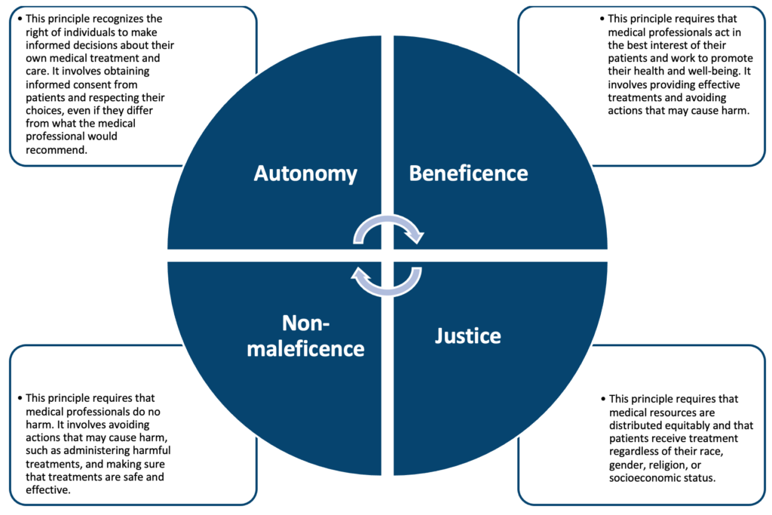

International laws around ethics in medicine and science include the Nuremberg Code, which was developed after World War II to establish ethical guidelines for medical research, and the Declaration of Helsinki, which is a set of ethical guidelines for medical research involving human subjects. These laws and guidelines help to ensure that medical research is conducted in an ethical manner, with the goal of promoting the well-being of individuals and society.

The World Medical Association has developed the International Code of Medical Ethics, which provides guidance for medical professionals on ethical issues in the practice of medicine. This code outlines the ethical principles that medical professionals should follow, including respect for patient autonomy, confidentiality, and informed consent, and it provides guidance on how to address ethical dilemmas that may arise in the course of medical practice.

# **Philosophy in Psychiatry**

Philosophy has a long-standing relationship with psychiatry and has had a significant impact on the development of the field. Philosophy provides a framework for exploring fundamental questions about the nature of the mental illness, the goals of treatment, and the ethical implications of psychiatric practices.

One of the key areas where philosophy has influenced psychiatry is in the understanding of the nature of the mental illness. Philosophers have explored questions such as whether mental illness is a biological or psychological phenomenon, whether mental disorders are real illnesses, and whether they are best understood as diseases or as social constructions.

Philosophy has also played an important role in shaping the goals and objectives of psychiatric treatment. For example, some philosophers have emphasized the importance of preserving the autonomy and dignity of individuals, while others have emphasized the goal of relieving suffering and restoring function.

In addition to these fundamental questions, philosophy has also had a significant impact on the ethics of psychiatric practices. For example, philosophers have explored questions related to the use of involuntary treatment, the use of restraints, the use of psychotropic medications, and the role of the psychiatrist in society.

The integration of philosophy and psychiatry continues to be an important area of research and study. By exploring the philosophical foundations of psychiatry, we can gain a deeper understanding of the nature of mental illness and the goals and principles that guide psychiatric practice. This can help us to develop better treatments and to promote the well-being of individuals affected by mental illness.

**References:**

(1) Schwab, J. (2013). Sociocultural roots of mental illness: An epidemiologic survey. Springer Science & Business Media.

# 2 Human Development

## 2.1 Human Development

### 2.1.1 Basic frameworks for conceptualising development

## Basic Frameworks for Conceptualising Development: Nature & Nurture, Stage Theories and Maturational Tasks

There are several basic frameworks for conceptualizing human development, including:

1. **The biopsychosocial model:** views development as the interplay between biological, psychological, and social factors.
2. **The stage theory of development:**proposes that individuals pass through a series of predetermined stages in a specific order, such as Piaget’s theory of cognitive development or Erik Erikson’s theory of psychosocial development.
3. **The systems theory of development:** views development as the result of interactions between different systems, such as the family, school, and community.
4. **The ecological systems theory:** proposes that development is influenced by different levels of the environment, including the microsystem, mesosystem, exosystem, and macrosystem.
5. **The socio-cultural perspective:** emphasizes the role of culture and social context in shaping human development.
6. **The human development perspective:** focuses on the lifelong process of growth, change, and adaptation across multiple domains of human functioning.

## **Nature and nurture:**

Nature refers to the genetic and biological factors that influence development, such as chromosomes, hormones, and brain structure. These factors are inherited from our parents and determine our physical characteristics, as well as our predisposition to certain behaviours and abilities.

Nurture, on the other hand, refers to the environmental factors that influence development, such as family, culture, and society. These factors shape how we think, feel, and behave, and can either support or hinder our development.

The nature vs. nurture debate has been ongoing for decades, with some arguing that development is primarily determined by genetics, while others argue that the environment is more important. However, most researchers today recognize that development is the result of an interaction between nature and nurture.

Both nature and nurture play a role in human development, influencing physical, cognitive, social, and emotional development. Thus, it’s important to consider both genetic and environmental factors when studying human development.

## **Stage theories:**

Stage theories in human development propose that individuals pass through a series of predetermined stages in a specific order, each characterized by a unique set of physical, cognitive, social, and emotional milestones. Some examples of stage theories in human development include:

1. **Piaget’s theory of cognitive development** proposes that children pass through four stages of cognitive development (sensorimotor, preoperational, concrete operational, and formal operational) as they construct an understanding of the world around them.
2. **Erik Erikson’s theory of psychosocial development** proposes that individuals pass through eight stages of development (trust vs. mistrust, autonomy vs. shame and doubt, initiative vs. guilt, industry vs. inferiority, identity vs. role confusion, intimacy vs. isolation, generativity vs. stagnation, integrity vs. despair) as they navigate the challenges and opportunities of each stage.
3. **Bronfenbrenner’s Ecological Systems theory** proposes that development is influenced by different levels of the environment, including the microsystem, mesosystem, exosystem, and macrosystem.
4. **Freud’s psychoanalytic theory of personality development** proposes that individuals pass through five stages of psychosexual development (oral, anal, phallic, latent, and genital) as they negotiate the different desires and anxieties of each stage.
5. **Lawrence Kohlberg’s theory of moral development** proposes that individuals pass through three levels of moral reasoning (pre-conventional, conventional, and post-conventional) as they develop a sense of right and wrong.

It’s important to note that, while stage theories can provide a useful framework for understanding development, they should not be seen as rigid or deterministic. Development is a complex and dynamic process, and individuals may not pass through the stages in the exact order or at the same pace as others.

## **Definition of maturity and maturational tasks:**

Maturity refers to the achievement of a level of physical, cognitive, social, and emotional development that is considered to be typical or normative for one’s age and culture. It is often associated with the ability to function independently and take responsibility for one’s own well-being (Stearns, 2020).

Maturational tasks are the key developmental challenges and milestones that individuals are expected to achieve at different stages of life. These tasks are thought to be universal across cultures and are often linked to specific age ranges (Havinghurst, 1972).

Examples of maturational tasks in human development include:

1. **Infancy and childhood:** Learning to trust and form attachments to caregivers, developing basic motor and cognitive skills, and learning to communicate and express emotions.
2. **Adolescence:**Developing a sense of identity and self-worth, forming intimate relationships, and achieving independence from parents.
3. **Early adulthood:** Establishing a career, forming a stable relationship and starting a family, achieving financial independence.
4. Middle adulthood: Navigating the challenges of parenting, maintaining relationships, and dealing with the physical and emotional changes of ageing.
5. **Late adulthood:**Coming to terms with one’s own mortality, passing on knowledge and values to future generations, and achieving a sense of wisdom and contentment.

It’s important to note that not everyone will achieve all the maturational tasks in the same way and at the same time, as development is a personal and unique experience. Additionally, some of the tasks might not be relevant for certain cultures or societies (Arnett, 2004).

## Examination of Gene-Environment Interactions with Specific Reference to Intelligence

The study of gene-environment interactions with regard to intelligence is a complex and multidisciplinary field. Intelligence is a trait that is influenced by both genetic and environmental factors, and the specific ways in which these factors interact is not yet fully understood. Studies have shown that genetic factors account for around 50-80% of the variation in intelligence, with the remaining 20-50% being influenced by environmental factors. The specific genes and environmental factors that influence intelligence are not well understood, but research suggests that they likely interact in complex and dynamic ways. Some studies have found that certain genetic variations may be more or less sensitive to certain environmental factors, leading to different outcomes in terms of intelligence. Additionally, there may be gene-environment interactions that are specific to certain populations or subgroups. Understanding these interactions is important for better understanding the nature and development of intelligence, as well as for identifying potential targets for interventions to improve cognitive functioning.

One way that researchers study gene-environment interactions is by looking at twin studies. Identical twins have the same genetic makeup but may have different experiences and environments. By comparing the intelligence of identical twins who were raised together to those who were raised apart, researchers can get a sense of the relative contributions of genetics and environment to intelligence.

Another way to study gene-environment interactions is to look at adopted children, who have different genetic backgrounds than their adoptive parents but share a common environment. Studies have found that adopted children tend to resemble their biological parents more in terms of intelligence than their adoptive parents, suggesting that genetics plays a stronger role in intelligence than the shared environment.

Additionally, studies have found that certain environmental factors, such as poverty, malnutrition, and poor access to education can have a negative impact on cognitive development, particularly in early childhood. However, these environmental factors likely interact with genetic factors to influence cognitive outcomes, and more research is needed to fully understand these interactions.

Overall, it’s important to note that intelligence is a complex trait that is influenced by both genetic and environmental factors, and the specific ways in which these factors interact are not yet fully understood. However, research in this field can provide important insights into the nature of intelligence and the potential for interventions to improve cognitive functioning (Turkheimer, 2003).

## Relative Influence of Early Versus Later Adversities

The relative influence of early versus later adversities in human development is an area of ongoing research, with evidence suggesting that both early and later adversities can have a significant impact on development.

Early adversities, such as abuse, neglect, or poverty during childhood, have been linked to a range of negative outcomes, including poor physical health, cognitive delays, and behavioural problems. These adversities can disrupt normal development, particularly during critical periods in early childhood when the brain is rapidly developing.

Later adversities, such as trauma, loss, or chronic stress during adolescence or adulthood, can also have a significant impact on development. These adversities can lead to negative outcomes such as anxiety, depression, and post-traumatic stress disorder. Additionally, later adversities can also exacerbate the negative effects of early adversities, leading to more severe outcomes.

It is important to note that some individuals may be more resilient to adversities than others, and that protective factors such as supportive relationships, good coping skills, and access to resources can mitigate the negative effects of adversities. Furthermore, research suggests that the timing and duration of adversity, as well as the presence of protective factors, may moderate the effects of adversity on development.

Overall, both early and later adversities can have a significant impact on human development, and it is important to take into account the timing and duration of adversities, as well as the presence of protective factors when considering the effects of adversities on development.

## The Relevance of Developmental Framework for Understanding the Impact of Specific Adversities such as Trauma

A developmental framework is an important tool for understanding the impact of specific adversities such as trauma on human development. Developmental frameworks provide a way to understand how different experiences and environments shape an individual’s development across the lifespan.

Trauma is a specific adversity that can have a significant impact on human development, and a developmental framework allows researchers and practitioners to understand how the timing and severity of trauma may influence the long-term effects on an individual.

For example, early childhood trauma can have a profound impact on normal development, particularly in areas such as attachment, emotional regulation, and cognitive development. Trauma experienced during adolescence can also be disruptive, as it may lead to difficulties with identity formation and difficulties in forming healthy relationships. Trauma experienced in adulthood may lead to difficulties coping with stress and difficulty forming trusting relationships.

Additionally, a developmental framework can help researchers and practitioners understand how the presence of protective factors, such as the quality of parent-child relationships, can mitigate the negative effects of trauma.

In conclusion, understanding the impact of specific adversities such as trauma on human development through a developmental framework is essential for developing effective interventions and support for individuals who have experienced trauma. It helps practitioners and researchers to understand how different experiences and environments shape an individual’s development across the lifespan and how to mitigate and prevent negative effects (Perry, 2019).

## Historical Models and Theories: Freud and General Psychoanalytic; Social-Learning and Piaget

There have been several historical models and theories of human development, including the psychoanalytic perspective developed by Sigmund Freud, the social-learning perspective, and the cognitive-developmental perspective developed by Jean Piaget.

The psychoanalytic perspective, developed by Sigmund Freud, emphasizes the role of unconscious processes and early childhood experiences in shaping personality and behaviour. According to this perspective, early experiences shape the development of the psyche, including the id (the unconscious, primitive drives), the ego (the conscious, rational self), and the superego (the moral self). This theory suggests that early childhood experiences, especially those related to relationships with parents, play a critical role in shaping the development of the psyche and personality.

The social-learning perspective, emphasizes the role of the environment and learning in shaping behaviour. According to this perspective, individuals learn through observation and modelling of others’ behaviour and through reinforcement and punishment. This theory suggests that individuals acquire knowledge, skills, values, and attitudes through their interactions with others and that these interactions shape their behaviour and development.

The cognitive-developmental perspective, developed by Jean Piaget, emphasizes the role of cognitive processes and the gradual development of understanding and thought. According to this perspective, individuals go through a series of stages in cognitive development, including sensorimotor, preoperational, concrete operational, and formal operational stages. Each stage is characterized by a different level of understanding and thought, and individuals progress through these stages in a predictable sequence.

Overall, these historical models and theories provide different perspectives on the nature of human development, and they continue to influence current research and practice in the field (Kagan, 2017).

**References:**

(1) Arnett, J. J. (2004). Emerging adulthood: The winding road from the late teens through the twenties. New York: Oxford University Press.

(2) Havighurst, R. J. (1972). Developmental tasks and education. New York: Longman.

(3) Kagan, J. (2017). The Nature of the Child. New York: Basic Books

(4) Perry, B.D. (2019). The Neurosequential Model of Therapeutics: A Developmental Framework for Trauma-Informed Care. Journal of Child Neurology, 34(1), 1-14.

(5) Stearns, S. C., & Rodrigues, A. M. (2020). On the use of “life history theory” in evolutionary psychology. Evolution and Human Behavior, 41(6), 474–485.

(6) Turkheimer, E., Haley, A., Waldron, M., D’Onofrio, B., & Gottesman, I. (2003). Socioeconomic status modifies heritability of IQ in young children. Psychological Science, 14(6), 623-628.

### 2.1.2 Methodology for studying development

## **Methodology for Studying Development: Cross-Sectional, Cohort and Individual Studies**

There are several different methodologies that researchers use to study development, including:

|  |  |
| --- | --- |
| **Methodology:** | **Summary:** |
| **Longitudinal studies** | These studies follow individuals over time, often from childhood through adulthood, to observe how development unfolds. This allows researchers to track changes in behaviour, cognition, and other characteristics over time. |
| **Cross-sectional studies** | These studies compare individuals of different ages or developmental stages at a single point in time. This allows researchers to compare and contrast different groups of people at different developmental stages. |
| **Experimental studies** | These studies compare individuals of different ages or developmental stages at a single point in time. This allows researchers to compare and contrast different groups of people at different developmental stages. |
| **Naturalistic observation** | This method involves observing individuals in their natural environment without the manipulation of variables. This allows researchers to study behaviour, cognition, and other characteristics in the context of real-life situations. |
| **Surveys and self-report measures** | This method relies on individuals to provide information about their own behaviour, cognition, and other characteristics. Surveys and self-report measures can provide useful information about development but, it may be affected by the subjectivity of the individuals. |

Each of these methodologies has its own strengths and limitations, and researchers often use multiple methodologies in a single study to gain a more comprehensive understanding of development.

## Cross-sectional studies:

Cross-sectional studies are a type of observational research design that involve collecting data from a group of individuals at a single point in time. These studies are often used in human development studies to examine differences in a particular characteristic (e.g. cognitive ability, behaviour, physical health) across different age groups. They can provide valuable information about the typical course of development for a particular trait, but they do not allow for the examination of change over time. Therefore, cross-sectional studies are typically used in conjunction with other research designs, such as longitudinal studies, to gain a more complete understanding of human development (Belsky, 2009).

Cross-sectional studies can be useful for identifying patterns and trends in development, such as differences in cognitive abilities or behaviour across different age groups. For example, a cross-sectional study might be used to compare the reading abilities of children at different stages of development, such as 5-year-olds, 8-year-olds, and 11-year-olds. By comparing these groups at the same time, the study can identify any differences in reading abilities across different ages, and this can provide insight into the typical course of reading development.

Additionally, cross-sectional studies can be used to examine the relationship between different variables, such as the relationship between age and memory performance. This can be done by comparing the memory performance of individuals at different ages within the same study.

Cross-sectional studies can also be used to examine the relationship between different variables, such as the relationship between age and memory performance. This can be done by comparing the memory performance of individuals at different ages within the same study. This can provide insight into the factors that influence memory performance and how they change over time.

However, cross-sectional studies also have some limitations. One of the main limitations is that they do not allow for the examination of change over time. Since data is only collected at a single point in time, it is not possible to determine whether the differences observed between groups are due to changes that have occurred over time or due to other factors such as genetics or environment. Therefore, cross-sectional studies are typically used in conjunction with other research designs, such as longitudinal studies, to gain a more complete understanding of human development.

## Cohort studies:

Cohort studies are a type of observational research design that involves following a group of individuals (the “cohort”) over a period of time. These studies are often used in human development studies to examine changes in a particular characteristic (e.g. cognitive ability, behaviour, physical health) across the lifespan (Schaie, 2005).

One of the main advantages of cohort studies is that they allow for the examination of change over time, which is a critical aspect of understanding human development. For example, a cohort study might be used to follow a group of individuals from birth to adulthood in order to examine changes in cognitive abilities, such as memory and problem-solving, across the lifespan. By following the same individuals over time, researchers can see how these abilities change as the individual ages and gain insight into the typical course of cognitive development.

Cohort studies can also be used to examine the relationship between different variables, such as the relationship between socioeconomic status and cognitive development. This can be done by following a group of individuals with different socioeconomic backgrounds over time and comparing their cognitive development.

Additionally, cohort studies are also useful for identifying risk factors for certain health conditions or diseases and for monitoring the impact of interventions over time.

However, cohort studies also have some limitations. One of the main limitations is that they can be time-consuming and expensive to conduct, as they require following the same individuals over a period of several years. Another limitation is that there is a risk of losing participants over time, which can affect the representativeness of the sample and the generalizability of the results.

## Individual studies:

Individual studies are a type of research design that focuses on the examination of a single individual or a small number of individuals. These studies are often used in human development studies to gain a detailed understanding of the characteristics and experiences of a particular individual or group of individuals. Individual studies can take various forms, such as case studies, which involve the in-depth examination of a single individual, or multiple case studies, where a small number of individuals are examined. They can also include interviews, observations, and psychological testing (Yarrow, 1977).

One of the main advantages of individual studies is that they allow for a detailed examination of the unique characteristics and experiences of a particular individual or group of individuals. This can provide valuable information about the factors that influence development, such as the impact of specific life events or the role of family dynamics.

Individual studies can also be used to examine the experiences of individuals who are rare or understudied, such as individuals with rare genetic disorders or those who have experienced unique life events.

Additionally, individual studies can be used to generate hypotheses for further research and can be a valuable complement to other research designs such as cross-sectional and cohort studies.

However, individual studies also have some limitations. One of the main limitations is that the findings may not be generalizable to the larger population, as they are based on a small number of individuals. Another limitation is that the results may be influenced by researcher bias, as the researcher may have a preconceived idea of what to expect from the study.

## **Identification and Evaluation of Influences**

Identifying and evaluating influences in human development is a key aspect of understanding how individuals change and grow over time. There are a variety of different factors that can influence human development, including both biological and environmental factors.

Biological factors that can influence human development include genetics, hormones, and brain development. For example, genetics can play a role in the development of certain cognitive abilities and mental health conditions, while hormones can influence the development of physical characteristics and behaviours.

Environmental factors that can influence human development include the family environment, the social environment, and the cultural context. For example, the family environment can play a role in the development of social and emotional skills, while the social environment can influence the development of cognitive abilities and behaviours. Cultural context can also play a role in shaping development, by influencing values, beliefs, and customs.

To evaluate the influences on human development, researchers use different research designs, such as cross-sectional, longitudinal and individual studies. They use statistical methods to analyze the data and look for patterns and trends to identify the significant factors that influence development.

Additionally, researchers can use experimental and quasi-experimental designs to investigate the causal relationship between different factors and human development. For example, researchers might use a randomized controlled trial to evaluate the effects of a particular intervention on cognitive development.

It’s important to note that human development is a complex process that is influenced by multiple factors, and that these factors interact with each other in different ways. Therefore, to gain a comprehensive understanding of human development, it is important to consider multiple perspectives and use multiple research methods (Shanahan, 2018).

**References:**

(1) Belsky, J., & Pluess, M. (2009). Beyond diathesis stress: Differential susceptibility to environmental influences. Psychological Bulletin, 135(6), 885–908.

(2) Schaie, K. W. (2005). Developmental influences on adult intelligence. The Handbook of Intelligence, 1, 517–536.

(3) Shanahan, M. J., & Tamis-LeMonda, C. S. (2018). Child development in cultural context. In Handbook of Child Psychology and Developmental Science (pp. 1–35). New York: Wiley.

(4) Yarrow, L. J., & Scott, J. P. (1977). The psychological assessment of the individual. Annual Review of Psychology, 28(1), 551–572.

### 2.1.3 Attachment theory

## **Bowlby Attachment Theory and its Relevance to Emotional Development, Affect Regulation and Human Relationships in Childhood and**Adulthood

Attachment theory is a psychological theory of human development that was first proposed by John Bowlby in the 1950s. The theory describes how infants form emotional and physical bonds with their caregivers, and how these bonds influence the child’s development throughout their life (Bowlby, 1969).

According to Bowlby’s theory, infants are born with an innate drive to form attachments with others, and they use their caregivers as a “secure base” from which to explore the world. Bowlby argued that the quality of the attachment relationship between the infant and the caregiver has a significant impact on the child’s development. He proposed that children who form secure attachments with their caregivers are more likely to develop into well-adjusted individuals, while children who form insecure attachments may have difficulty forming healthy relationships and may be at risk for emotional and behavioural problems.

Bowlby’s theory also describes how children learn to use their attachment figures as a “mental representation” or “internal working model” of relationships. This model is used as a guide for how the child perceives and expects to be treated by others. Bowlby’s theory suggests that this internal working model is shaped by the experiences of the child in the early years and has a profound impact on the child’s social and emotional development throughout life.

Bowlby’s theory has been widely studied and supported by research. Studies have found that children who form secure attachments with their caregivers tend to have better outcomes in terms of their emotional and behavioural development. Researchers have also found that the quality of attachment can be measured and that interventions can be developed to help parents and caregivers create a more secure attachment with their children (Ainsworth, 1978).

## Emotional development:

John Bowlby’s attachment theory is highly relevant to emotional development as it emphasizes the importance of early relationships in shaping the child’s emotional experiences and behaviours. According to the theory, the quality of the attachment relationship between the child and the primary caregiver plays a crucial role in the child’s emotional development.

Bowlby proposed that infants have an innate drive to form attachments with others and that the attachment relationship serves as a foundation for the child’s emotional well-being. A secure attachment relationship with a caregiver provides the child with a sense of safety and security, which in turn allows the child to explore and learn about the world with confidence. On the other hand, an insecure attachment relationship can lead to feelings of anxiety and insecurity, which can interfere with the child’s emotional development.

Bowlby’s theory also suggests that the internal working model of relationships, which is formed in the early years, has a profound impact on the child’s emotional development throughout life. Children with a secure attachment history tend to have a more positive internal working model, which is characterized by trust and security in relationships. They are more likely to form healthy relationships, have better emotional regulation, and be less prone to anxiety and depression. On the other hand, children with an insecure attachment history tend to have a more negative internal working model, characterized by mistrust and insecurity in relationships. They are more likely to have difficulties in forming healthy relationships and may be at risk for emotional and behavioural problems.

Attachment theory has been supported by research in various fields, including developmental psychology, neuroscience, and psychiatry. Studies have found that the quality of the attachment relationship is related to the child’s emotional development and that interventions can be developed to help parents and caregivers create a more secure attachment with their children, which in turn can promote the child’s emotional well-being (Cassidy, 2008).

## Affect regulation:

Bowlby’s attachment theory is also highly relevant to affect regulation, which refers to the process by which individuals manage their emotional states. According to the theory, the attachment relationship plays a crucial role in the development of affect regulation.

Bowlby proposed that the attachment figure serves as a “secure base” from which the child can explore the world and regulate their emotions. A secure attachment relationship provides the child with a sense of safety and security, which allows the child to regulate their emotions more effectively. For example, a child with a secure attachment to their caregiver may be better able to calm down after becoming upset or may be less likely to experience intense or prolonged emotional reactions.

On the other hand, an insecure attachment relationship can interfere with the child’s ability to regulate their emotions. Children with insecure attachments may have difficulty managing their emotions and may be more prone to emotional outbursts or withdrawal. They may also have difficulty with self-soothing and might rely on external sources such as drugs or alcohol to regulate their emotions.

Research has supported the link between attachment and affect regulation. Studies have found that children with a secure attachment history tend to have better emotional regulation, while children with an insecure attachment history tend to have more difficulty with affect regulation. Additionally, interventions that aim to promote secure attachment, such as parent-child interaction therapy, have been shown to improve affect regulation in children.

In summary, Bowlby’s attachment theory emphasizes the importance of early relationships in shaping the child’s emotional experiences and behaviours, and it highlights the role of attachment in the development of affect regulation (Fonagy, 1997).

## **Human relationships in childhood and**adulthood:

Human relationships play a critical role in both childhood and adulthood. During childhood, relationships with parents, family members, and peers provide the foundation for social and emotional development. These early relationships shape an individual’s understanding of themselves, others and the world around them, and they also set the stage for future relationships.

In childhood, parent-child relationships are particularly important for the development of a secure attachment. Secure attachment is characterized by a sense of safety and trust in the relationship, and it is associated with better emotional regulation and social skills. Children with a secure attachment to their parents are more likely to have positive self-esteem, be less prone to anxiety and depression, and have better relationships with their peers.

Peer relationships also play a key role in childhood development. Children learn important social skills such as cooperation, communication, and empathy through interactions with their peers. They also learn how to navigate social hierarchies and develop a sense of belonging and self-worth.

In adulthood, relationships continue to play a critical role in shaping individuals’ emotional well-being and overall quality of life. Adult relationships include romantic partnerships, friendships, and professional relationships. These relationships provide support, companionship, and a sense of belonging. They also provide opportunities for personal growth and self-discovery.

Research has found that individuals with strong, supportive relationships in adulthood are more likely to have better physical and mental health, and a higher overall quality of life. On the other hand, individuals with poor quality or lacking relationships are more likely to experience emotional and physical health problems.

Overall, relationships are a fundamental aspect of human development, and they play a critical role in shaping both childhood and adulthood experiences.

## Mary Ainsworth’s Attachment Theory and the Strange Situation Experiment

Mary Ainsworth’s attachment theory is a psychological theory of human development that builds on the work of John Bowlby. Ainsworth’s theory focuses on the nature of the attachment relationship between infants and their primary caregivers, and how this relationship influences the child’s development.

Ainsworth proposed that the attachment relationship is characterized by four distinct patterns: secure attachment, avoidant attachment, ambivalent attachment and disorganized attachment:

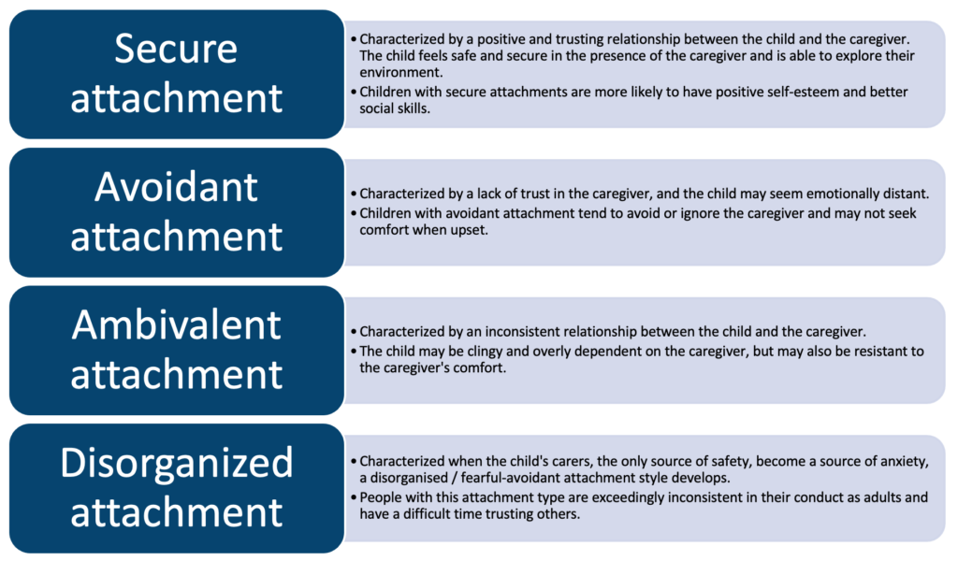

Ainsworth’s theory also includes the “Strange Situation” procedure, which is a laboratory-based assessment that is used to measure the quality of the attachment relationship. The procedure involves placing the child in a series of separation and reunion episodes with the caregiver and observing the child’s response to separation and reunion. The child’s behaviour during these episodes, such as their level of distress upon separation, the way they greet the caregiver upon reunion, and their level of comfort and exploration while the caregiver is present, is used to infer the quality of the attachment relationship.

The “Strange Situation” procedure, developed by Mary Ainsworth, is a laboratory-based assessment that is used to measure the quality of the attachment relationship between an infant and their primary caregiver. The procedure involves the following eight steps:

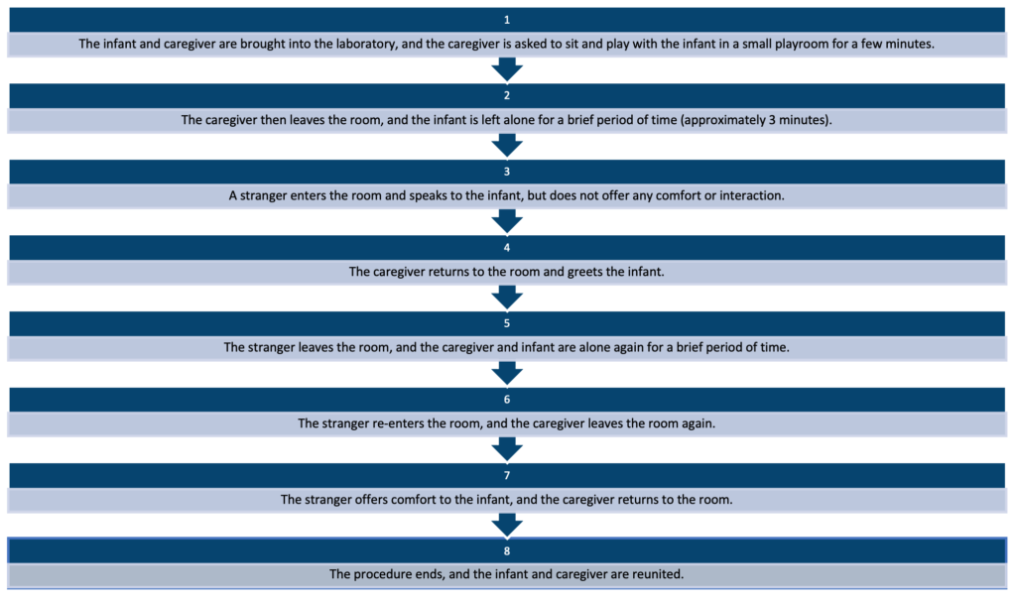

The infant’s behaviour during these episodes, such as their level of distress upon separation, the way they greet the caregiver upon reunion, and their level of comfort and exploration while the caregiver is present, is used to infer the quality of the attachment relationship. It is important to note that the Strange Situation is a standardized procedure and the length of time for each step may vary depending on the study and the child’s behaviour. Also, the procedure is typically only done once with each child and caregiver, and the results are used to classify the child’s attachment style into one of the three categories described by Ainsworth: secure, avoidant, ambivalent or disorganized.

It’s also worth mentioning that the strange situation procedure is widely used to assess attachment in young infants and has been found to be a valid measure of attachment, however, it may not be suitable for assessing attachment in older children or adults, as attachment styles and behaviours can change over time.

Additionally, it’s important to keep in mind that the Strange Situation is only one measure of attachment and it may not capture the complexity of the attachment relationship. Therefore, it’s important to consider other measures, such as observation of parent-child interactions in naturalistic settings, parent-report measures and interview of the child when assessing attachment.

Ainsworth’s theory has been widely studied and supported by research. Studies have found that the quality of the attachment relationship is related to the child’s emotional and social development and that interventions can be developed to help parents and caregivers create a more secure attachment with their children, which in turn can promote the child’s well-being.

Ainsworth’s attachment theory has also been expanded upon by other researchers, such as Mary Main, who developed the concept of “dismissing-avoidant” and “preoccupied-resistant” attachment styles in addition to Ainsworth’s original three styles (Main, 1990).

Overall, Ainsworth’s attachment theory has been a significant contribution to the field of developmental psychology, and it has provided an important framework for understanding the role of early relationships in shaping a child’s social and emotional development (Ainsworth, 1978).

## **Conditions for secure attachment**:

According to attachment theory, a secure attachment is characterized by a positive and trusting relationship between the child and the caregiver. In order for a child to develop a secure attachment, certain conditions need to be met:

1. **Sensitivity:** The caregiver needs to be sensitive to the child’s needs and respond appropriately to their signals. This includes responding quickly to the child’s cries and providing comfort when the child is upset.
2. **Consistency:** The caregiver needs to provide consistent and reliable care for the child. This includes being available to the child when they need comfort and providing a sense of security and predictability.
3. **Emotional availability:** The caregiver needs to be emotionally available to the child, meaning they are able to understand and respond to the child’s emotional needs. They are able to empathize with the child and provide emotional support when needed.
4. **Positive interactions:**The caregiver needs to provide positive interactions with the child, such as play, affection, and verbal communication. This helps the child to feel valued and loved.
5. **Supportive environment:** The child needs to be in a supportive environment that promotes their well-being and development. This includes having access to appropriate nutrition, health care, and educational opportunities.

It’s important to note that these conditions aren’t mutually exclusive and the attachment relationship is dynamic and constantly changing, so the conditions

## **Types and clinical relevance of insecure and disorganised attachment**:

In attachment theory, insecure attachment is characterized by a negative or inconsistent relationship between the child and the caregiver. There are several types of insecure attachment, including:

1. **Avoidant attachment:** characterized by a lack of trust in the caregiver, and the child may seem emotionally distant. Children with avoidant attachment tend to avoid or ignore the caregiver and may not seek comfort when upset.
2. **Ambivalent/Resistant attachment:**characterized by an inconsistent relationship between the child and the caregiver. The child may be clingy and overly dependent on the caregiver, but may also be resistant to the caregiver’s comfort.
3. **Disorganized/disoriented attachment:** characterized by a lack of a coherent strategy for coping with separation and reunion with the caregiver. Children with a disorganized attachment may display contradictory behaviours, such as approaching and avoiding the caregiver at the same time, or showing signs of confusion or fear when the caregiver returns.

Insecure and disorganized attachment styles have been linked to a range of emotional and behavioural problems in children and adults. Children with insecure attachments tend to have difficulty regulating their emotions and may be more prone to emotional outbursts or withdrawal. They may also have difficulty with self-soothing and might rely on external sources such as drugs or alcohol to regulate their emotions.

Adults with insecure or disorganized attachment styles may have difficulty forming and maintaining healthy relationships, they may also experience difficulties with emotional regulation and may be at risk for mental health problems such as anxiety, depression and post-traumatic stress disorder (Ainsworth, 1978).

In terms of clinical relevance, identifying insecure and disorganized attachment styles can help professionals such as therapists, social workers, and paediatricians to develop appropriate interventions for children and families. These interventions may include parent-child interaction therapy, which aims to improve the quality of the attachment relationship, and therapy for the child to help with emotional regulation and social skills.

## Early Separation and its Consequences

Early separation, such as when a child is separated from their primary caregiver, can have a significant impact on the child’s development and well-being. Research has shown that early separation can lead to a variety of negative consequences, including:

1. **Attachment disruptions:**Early separation can disrupt the attachment relationship between the child and their primary caregiver, leading to difficulties in forming secure attachments with others in the future.
2. **Emotional and behavioural problems:**Children who experience early separation may have difficulty regulating their emotions and may be more prone to emotional outbursts or withdrawal. They may also have difficulty with self-soothing and might rely on external sources such as drugs or alcohol to regulate their emotions.
3. **Developmental delays:** Early separation can lead to developmental delays in areas such as language, cognitive, and social development.
4. **Increased risk for mental health problems:** Children who experience early separation may be at an increased risk for mental health problems such as anxiety, depression, and post-traumatic stress disorder.
5. **Negative impact on the caregiver:** Early separation can also have a negative impact on the caregiver, particularly if the caregiver is not able to provide consistent and reliable care for the child in the future.

It’s important to keep in mind that each child’s experience with early separation is unique, and the severity and duration of the separation will also play a role in the outcome. Also, early separation can be a result of different situations such as adoption, foster care, institutional care, or parental incarceration. The child’s age, temperament, and pre-existing emotional and developmental conditions may also affect how they cope with separation. Additionally, the quality of care and support that the child receives following the separation can also play a role in mitigating the negative consequences.

It is also important to note that interventions such as providing a stable and nurturing environment, therapeutic support, and maintaining contact with the primary caregiver (if possible) can help to mitigate the negative effects of early separation.

In summary, early separation can have a significant impact on a child’s emotional, behavioural, and developmental well-being, and it is important to provide support and interventions to mitigate these negative consequences (Bowlby, 1988) (Lieberman, 2005).

## Consequences of **F**ailure to Develop Selective Attachments

Failure to develop selective attachments, or the ability to form healthy, secure attachments with specific individuals, can have a number of negative consequences. These consequences can include:

1. **Emotional difficulties:** Children who have difficulty forming selective attachments may have trouble regulating their emotions and may be more prone to emotional outbursts or withdrawal. They may also have difficulty with self-soothing and may rely on external sources such as drugs or alcohol to regulate their emotions.
2. **Social difficulties:** Children who have difficulty forming selective attachments may have difficulty forming and maintaining healthy relationships with others. They may also have difficulty understanding and navigating social cues and may struggle with social interactions.
3. **Developmental delays:** Failure to develop selective attachments can lead to developmental delays in areas such as language, cognitive, and social development.
4. **Increased risk for mental health problems:** Children who have difficulty forming selective attachments may be at an increased risk for mental health problems such as anxiety, depression, and post-traumatic stress disorder.
5. **Difficulty adapting to new environments:** Children who have difficulty forming selective attachments may struggle to adapt to new environments, such as starting school or moving to a new home.

It’s important to note that selective attachment can be influenced by a variety of factors, such as the child’s temperament, family dynamics, and exposure to adverse experiences. Therefore, early identification and interventions can help to mitigate the negative consequences of failure to develop selective attachments (Lieberman, 2005).

## Brief Consideration of Attachment, Maternal ‘Bonding’ and Parental Sensitivity

Attachment, maternal bonding, and parental sensitivity are all related concepts in the field of child development and parenting.

Attachment refers to the emotional bond that forms between a child and their primary caregiver. This bond is thought to be important for the child’s emotional and social development, as well as their overall well-being.

Maternal bonding refers to the emotional connection that develops between a mother and her child, particularly during the early weeks and months after birth. This bonding process is thought to be crucial for the development of a secure attachment between the mother and child.

Parental sensitivity refers to the ability of a parent or caregiver to understand and respond appropriately to the child’s signals and needs. Parents who are sensitive to their child’s needs are more likely to provide the child with the consistent and responsive care that is needed for a secure attachment to form.

Research has found that the quality of the attachment relationship, maternal bonding and parental sensitivity are all related to the child’s emotional and social development. Parents who are able to form a secure attachment, bond well with their child, and are sensitive to their child’s needs are more likely to raise children who are emotionally and socially well-adjusted. Conversely, problems in any of these areas can contribute to difficulties in the child’s development.

In summary, attachment, maternal bonding and parental sensitivity are all important concepts in the field of child development and parenting, and they are closely related to the child’s emotional and social development (Felders, 2010).

**References:**

(1) Ainsworth, M. D. S., Blehar, M. C., Waters, E., & Wall, S. (1978). Patterns of attachment: A psychological study of the strange situation. Hillsdale, NJ: Erlbaum.

(2) Bowlby, J. (1969). Attachment and loss: Vol. 1. Attachment. London: Hogarth Press.

(3) Bowlby, J. (1988). A Secure Base: Parent-Child Attachment and Healthy Human Development. London: Routledge.

(4) Cassidy, J., & Shaver, P. R. (2008). Handbook of Attachment: Theory, Research, and Clinical Applications. New York: Guilford Press.

(5) Felders, P., van den Berg, G. P., & Bakermans-Kranenburg, M. J. (2010). The role of parental sensitivity in the development of attachment. Attachment & Human Development, 12(4), 359–371.

(6) Fonagy, P., & Target, M. (1997). Attachment and Reflective Function: Their Role in Self-Organization. Development and Psychopathology, 9(4), 679–700.

(7) Lieberman, A. F., Van Horn, P., & Ippen, C. G. (2005). The effects of early separation on child and adolescent development. Journal of Infant, Child, and Adolescent Psychotherapy, 4(1), 5–25.

(8) Main, M., & Solomon, J. (1990). Procedures for identifying infants as disorganized/disoriented during the Ainsworth Strange Situation. In M. T. Greenberg,

### 2.1.4 Family relationships

## Aspects of Family Relationships and Parenting Practices

There are many aspects of family relationships and parenting practices that can affect a child’s development and well-being. Some of these include:

* **Communication:** The quality and frequency of communication within a family can greatly impact the way children feel about themselves and their relationships with others.
* Conflict resolution: Families that are able to effectively manage and resolve conflicts are more likely to have children who can do the same in their own relationships.
* Discipline: The way parents discipline their children can have a significant impact on their behaviour and long-term development.
* Parental warmth: The emotional closeness and support provided by parents can help children feel secure and valued, and can also foster self-esteem and emotional well-being.
* **Positive role models:**Children who have positive role models in their parents or other family members are more likely to develop healthy relationships and make positive life choices.
* **Attachment:** The emotional bond between the parents and the child, this secure bond is the foundation of trust and emotional security in children
* **Cultural values:** Family cultural values can have a big impact on parenting practices and child development, it’s important for parents to understand and respect their cultural background and transmit those values to their children.

All of these factors can work together to create a positive and supportive family environment that helps children thrive.

## Parenting styles:

The four parenting styles that are commonly used in psychology are authoritative parenting, authoritarian parenting, permissive parenting, and neglectful parenting. They are based on the 1960s research of developmental psychologist Diana Baumrind at the University of California, Berkeley. In the 1980s, Maccoby and Martin also contributed by refining the model. According to Baumrind’s theory, there is a close relationship between the type of parenting style and the behaviour of children. Different parenting styles can influence child development and outcomes (Masud, 2014).

In the United States, roughly 46% of parents employ an authoritative parenting style, 26% employ an authoritarian parenting style, 18% employ a permissive parenting style, and 10% employ a neglectful parenting style 3.

European parents are about 2% more likely to have an authoritative style, and for Asian parents, they are 2% more likely to have an authoritarian style, the distribution is relatively stable.

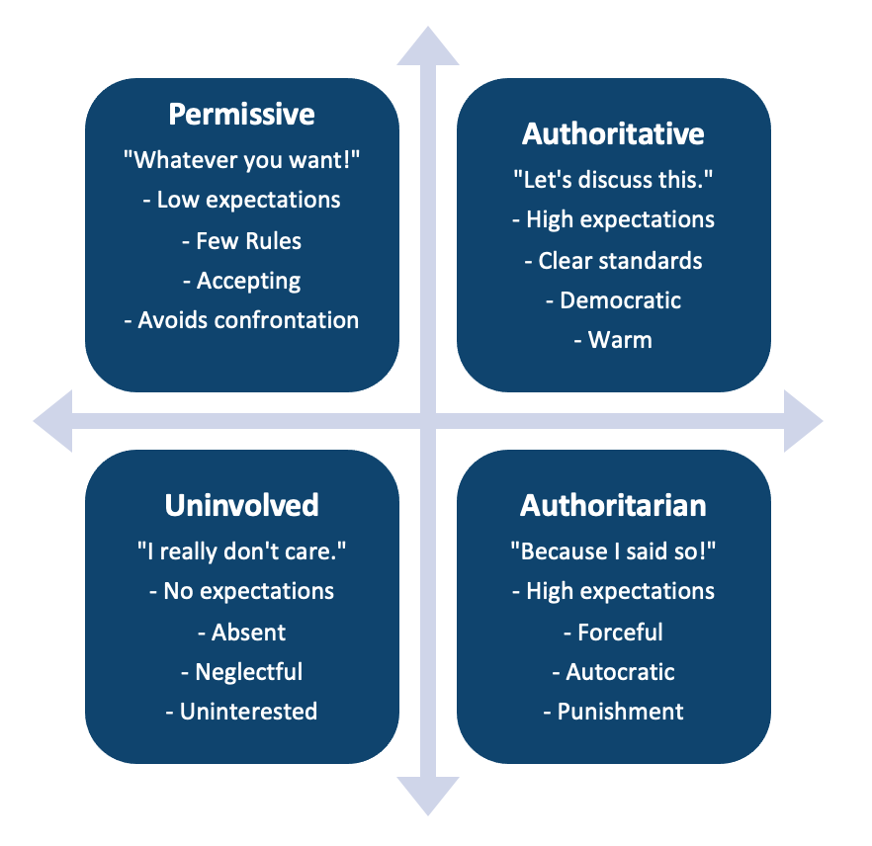

## The influence of parental attitudes compared with parenting practices

Parental attitudes and parenting practices both play important roles in shaping a child’s development and well-being.

Parental attitudes refer to the beliefs and values that parents hold about child-rearing, such as their beliefs about discipline, the role of parents in children’s lives, and their expectations for their children’s behaviour. These attitudes can shape the way parents interact with their children and can influence the type of parenting practices they use. For example, parents who hold permissive attitudes may be more likely to use indulgent or lenient parenting practices, while parents who hold authoritarian attitudes may be more likely to use strict or demanding parenting practices.

Parenting practices, on the other hand, refer to the specific actions and behaviours that parents engage in with their children, such as how they communicate with their children, how they discipline them, and how they spend time with them. These practices can have a direct impact on children’s development, as they can shape children’s behaviour and emotional well-being.

While parental attitudes can influence parenting practices, it’s also possible for parenting practices to change parental attitudes over time. For example, a parent who initially holds an authoritarian attitude may become more permissive after experimenting with different parenting techniques and seeing positive results.

In summary, parental attitudes and parenting practices are both important factors in shaping a child’s development and well-being, but they are distinct and can both influence and be influenced by each other (Breiner, 2016)

## Systemic Theory Including Supportive Systems in Development

Systemic theory refers to a perspective that views individuals, families, and communities as interconnected systems that are constantly interacting and influencing one another. This theory suggests that in order to understand and support development, it is important to consider the multiple systems that are at play, including the individual, family, community, and larger cultural and societal systems.

One key aspect of the systemic theory is the idea of supportive systems. A supportive system refers to any system that provides resources, support, and guidance to help individuals and families achieve their goals and overcome challenges. Examples of supportive systems include:

* Family support: This refers to the emotional, practical, and financial support provided by family members to one another.
* Community support: This refers to the resources and services available in the community that can support individuals and families, such as social services, healthcare, and educational programs.
* Cultural support: This refers to the values, beliefs, and traditions of a cultural group that can provide a sense of identity, belonging, and guidance for individuals.
* Societal support: This refers to the laws, policies, and programs put in place by society that can help ensure that individuals and families have access to basic needs and opportunities.

In addition to supportive systems, the systemic theory also emphasizes the importance of considering the interactions and relationships between systems. For example, a child’s development may be influenced by the interactions between their family, their community, and the larger cultural and societal systems they are part of. This perspective can help identify points of intervention where a change in one system can improve the functioning of other systems.

Overall, systemic theory suggests that in order to support development, it is important to consider the multiple systems that are at play and to create support systems that can help individuals and families achieve their goals and overcome challenges (Bronfenbrenner, 1979) (Anderson, 2002).

## Aspects of Distorted Family Function

There are several aspects of distorted family function that can negatively impact the well-being of family members and the functioning of the family as a whole. Some examples include:

* **Lack of clear boundaries:** Families that lack clear boundaries between family members may experience difficulties with communication and decision-making, and may have difficulty establishing healthy relationships with others.
* **Poor communication:**Families that have poor communication patterns may struggle to understand one another and may be more likely to experience conflicts and misunderstandings.
* **High levels of conflict:** Families that experience high levels of conflict may struggle to resolve problems and may be more likely to experience problems with emotional regulation and physical health.
* **Lack of cohesion:**Families that lack cohesion may have difficulty working together and may struggle to support one another through difficult times.
* **Rigidity:** Families that are rigid in their roles and expectations may struggle to adapt to change and may be more likely to experience conflicts and difficulties.
* **Dependence:**Families that are dependent on one another may struggle to develop healthy autonomy and may be more likely to experience problems with emotional regulation and physical health.
* **Enmeshment:** Families that are enmeshed may struggle to develop healthy boundaries and may be more likely to experience difficulties with communication and decision-making.
* **Triangulation:** Families that triangulate may struggle to communicate effectively and may be more likely to experience conflicts and misunderstandings.

These are just some examples of how distorted family function can negatively impact the well-being of family members and the functioning of the family as a whole, but it is important to note that every family is unique and that what might be a distorted function in one family, might be a healthy function in another.

Discord, overprotection, rejection, and enmeshment are all aspects of distorted family function that can have negative impacts on the well-being of family members and the functioning of the family as a whole. All of these aspects of distorted family function can have negative impacts on the well-being of family members and the functioning of the family as a whole. They can make it difficult for family members to communicate effectively, resolve conflicts, and establish healthy relationships with one another. It is important for families to work on addressing these issues and creating a more healthy and supportive family environment.

## Discord:

Discord refers to a lack of harmony or agreement within a family. It can manifest in various forms such as verbal or physical abuse, constant arguing, and a lack of cooperation. When there is discord in a family, it can create a negative and stressful environment that can lead to emotional and psychological problems for all members.

## Overprotection:

Overprotection is when parents or caregivers protect their children too much, not allowing them to experience independence or face challenges on their own. This can lead to children not developing self-reliance and the ability to cope with difficult situations. Overprotection can also create a lack of trust between parent and child, and may lead to children feeling inadequate or not capable of dealing with life on their own.

## Rejection:

Rejection is when a family member, usually a parent, emotionally or physically distances themselves from their child. This can have severe consequences on the child’s emotional, social, and psychological development. Children who experience rejection from a parent may feel a sense of abandonment, have a low self-esteem, and may struggle with trust issues in their future relationships.

## Enmeshment:

Enmeshment is when family members are overly involved in each other’s lives and boundaries are not clearly defined. This can lead to a lack of privacy and autonomy, and can make it difficult for family members to develop their own identities. Enmeshed families may also have difficulty resolving conflicts and may struggle to establish healthy relationships with others.

## The Impact of Bereavement, Parental Divorce and Intra-Familial Abuse on Subsequent Development and Mental Health of the Child

The impact of bereavement, parental divorce, and intra-familial abuse on the subsequent development and mental health of a child can be significant and long-lasting.

Bereavement, or the loss of a parent or caregiver, can have a significant impact on a child’s emotional and psychological well-being. Children may experience feelings of grief, abandonment, and loss, as well as changes in their academic and social performance. They may also struggle with trust issues, anxiety, and depression, and may have difficulty forming new attachments.

Parental divorce can also have a major impact on children’s development and mental health. Children may experience feelings of loss, insecurity, and uncertainty about their future, as well as changes in living arrangements and family dynamics. They may struggle with adjusting to new living situations and may have difficulty maintaining relationships with both parents. Children of divorce may also experience decreased academic performance and increased behavioural problems.

Intra-familial abuse, including physical, emotional, and sexual abuse, can have severe and long-lasting effects on a child’s mental health and development. Children who experience abuse may have difficulty trusting others may suffer from anxiety and depression and may have difficulties with attachment and relationships. They may also struggle with academic and social performance. Abused children may also develop behavioural problems, and emotional regulation difficulties, and can have a hard time forming healthy relationships in the future.

It is important for professionals and caregivers to recognize the potential negative impacts of these experiences and provide appropriate support and interventions to help children cope and heal. This can include therapy, counselling, and support groups, as well as creating a safe and stable home environment. It is also important to provide education and resources to parents and caregivers to help them support their children during these difficult times.

## The Relevance of Different Family Structures Including Cultural Influences on Family and the Stages of Family

Nuclear families, which consist of a mother, father, and children, have been the traditional family structure in Western societies. However, other family structures, such as extended families, where multiple generations live together, or single-parent families, where one parent raises children alone, have become increasingly common. Each of these different family structures can have a unique impact on individuals and society.

Cultural influences can also play a significant role in shaping family dynamics and values. For example, some cultures may place a greater emphasis on marriage and traditional gender roles, while others may prioritize the needs and autonomy of individual family members. The concept of the “nuclear family” being the norm has been challenged in recent decades by increased acceptance of diverse family structures. The rise of non-traditional families such as same-sex parents and blended families has further expanded the diversity of family structures.

There are many different types of family structures, each with its own unique characteristics and dynamics. Some common types of family structures include:

1. **Nuclear family:** A family unit consisting of a mother, father, and children. This is considered the traditional family structure in Western societies.
2. **Extended family:** A family unit that includes multiple generations living together, such as grandparents, parents, and children. This type of family structure is common in many cultures around the world.
3. **Single-parent family:** A family unit where one parent raises children alone. This can occur due to death, divorce, or never-married parents.
4. **Blended family:** A family unit where two people with children from previous relationships come together to form a new family.
5. **Same-sex parent family:** A family unit where children are raised by two people of the same sex.
6. **Grandparent-led family:**A family unit where grandparents have taken over the role of primary caretaker for their grandchildren.
7. **Foster family:** A family unit where children are temporarily placed with a family that is not their biological family.
8. **Adoptive family:**A family unit where a child is legally adopted and becomes a permanent member of the family.
9. **Kinship care family: A** family unit where a child is placed with a relative, such as an aunt or grandparent, rather than a non-relative foster family

These are just a few examples of the many different types of family structures that exist. Family structures can vary widely based on cultural, economic, and social factors, and can change over time as individuals and families experience different life events.

Overall, family structures and the cultural influences on them can have a significant impact on individuals and society. Understanding these dynamics can help individuals, families, and professionals better support and serve diverse families.

## Group development:

Tuckman’s stages of group development, also known as Tuckman’s stages of group dynamics, are a model that describes the five stages that a group goes through as it develops. These stages are:

|  |  |
| --- | --- |
| **Tuckman’s stages of group development:** | **Summary:** |
| **1) Forming** | During this stage, the group is brought together and begins to establish its purpose and goals. Members are polite and cautious with one another and may be hesitant to express their true feelings or ideas. |
| **2) Storming** | As the group begins to work together, conflicts may arise as members struggle to establish roles and relationships. This stage can be challenging, but it is necessary for the group to work through these issues in order to move forward. |
| **3) Norming** | As the group continues to work together, members begin to develop a sense of cohesion and establish a set of norms and expectations for how the group will function. |
| **4) Performing** | The group is now able to work together effectively and efficiently. Members have a clear understanding of their roles and responsibilities and are able to accomplish the group’s goals. |
| **5) Adjourning** | This stage marks the end of the group’s work together. Members may experience feelings of sadness or loss as they say goodbye to one another, but they have accomplished their goals and the group has been successful. It’s important to note that Tuckman later added a fifth stage called “Adjourning” or “mourning” which emphasizes that, at the end of the group process, members may experience feelings of sadness or loss as they say goodbye to one another. This model is widely used in fields such as psychology, business, and education to understand group dynamics and help groups work together more effectively. |

It’s important to note that Tuckman later added a fifth stage called “Adjourning” or “mourning” which emphasizes that, at the end of the group process, members may experience feelings of sadness or loss as they say goodbye to one another. This model is widely used in fields such as psychology, business, and education to understand group dynamics and help groups work together more effectively (Tuckman, 1965).

Families go through different stages throughout their lifecycles. These stages were first proposed by Tuckman, and are forming, storming, norming, performing and adjourning. Each stage has its own challenges and dynamics that families need to navigate through. For example, during the “storming” stage, family members may experience conflict as they work to establish roles and boundaries within the family. The “performing” stage is when the family is running smoothly and everyone is comfortable with their role within the family.

**References:**

(1) Breiner, H., Ford, M. and Gadsden, V.L. (2016). Parenting Knowledge, Attitudes, and Practices. [online] Nih.gov. Available at: https://www.ncbi.nlm.nih.gov/books/NBK402020/.

(2) Masud, H., Thurasamy, R. and Ahmad, M.S. (2014). Parenting styles and academic achievement of young adolescents: A systematic literature review. Quality & Quantity, 49(6), pp.2411–2433. doi:10.1007/s11135-014-0120-x.

(3) Tuckman, B. W. (1965). Developmental sequence in small groups. Psychological Bulletin, 63(6), 384-399.

### 2.1.5 Temperament

## Individual Temperamental Differences and their Impact on Parent-Child Relationships

Individual temperamental differences can have a significant impact on parent-child relationships. Temperament refers to a person’s innate characteristics and tendencies, such as activity level, mood, and reactivity to stimuli.

For example, a child with a high activity level and a short attention span may require a different parenting approach than a child with a more laid-back temperament. A parent with a more easygoing temperament may have an easier time adjusting to a child with a high energy level, while a parent with a more high-strung temperament may find it more challenging. Similarly, a child with a more sensitive temperament may be more easily upset or affected by their environment, while a child with a more resilient temperament may be less affected. A parent who is more sensitive to the child’s needs may be better suited to raising a sensitive child than a parent who is less attuned to the child’s emotions.

Additionally, a child with a high emotional reactivity may have a harder time regulating their emotions, while a child with a lower emotional reactivity may be more able to remain calm in stressful situations. These differences in temperament can lead to difficulties in parenting if parents do not understand the child’s needs, for example, parents with high emotional reactivity may have a hard time managing the child’s emotions.

Parents with different temperaments may respond differently to their child’s behaviour. For instance, a parent with a more easygoing temperament may be more likely to overlook or forgive a child’s misbehaviour, while a parent with a more strict temperament may be more likely to discipline the child. It’s important to note that these are just examples and that each child and parent is unique and may have different temperaments and personalities. Understanding and being aware of ones own and the child’s temperament can help in developing parenting strategies that work best for the specific relationship.

In summary, individual temperamental differences can have a big impact on parent-child relationships. Parents who understand their child’s temperament and adapt their parenting style accordingly can help foster positive and healthy relationships (Overbeek, 2007).

## Origins, Typologies and Stability of Temperament and the Evolution of Character and Personality

The origins of temperament can be traced back to early theories in psychology and psychiatry, such as the concept of the “four humors” in ancient Greek medicine. These early theories proposed that an individual’s temperament was determined by the balance of four bodily fluids: blood, phlegm, yellow bile, and black bile. In more recent times, temperament has been studied extensively in the field of developmental psychology, with many different typologies proposed. One of the most widely accepted typologies is that of Thomas and Chess, who identified three broad temperament categories: easy, difficult, and slow-to-warm-up.

Easy children are generally regular in their habits, adaptable, and approach new situations with enthusiasm. Difficult children are highly active and intense, have irregular habits, and tend to be irritable and negative. Slow-to-warm-up children are less active and more reserved and take longer to adjust to new situations.

Research has suggested that temperament is relatively stable over time, with individual differences in temperament remaining relatively consistent from infancy through adulthood. However, it’s important to note that, while temperament provides a foundation for personality development, it does not determine it. Character and personality are shaped by a complex interplay of genetics, environment, and life experiences.

Some theories propose that character and personality are the product of an evolutionary process, shaped by natural selection to adapt to different environments and social contexts. For example, people with certain temperaments may have been more likely to survive and reproduce in certain environments, leading to the development of certain personality traits.

Overall, temperament and personality are complex and multi-faceted concepts that are influenced by a variety of factors. While temperament provides a foundation for personality development, it does not determine it, and character and personality continue to evolve throughout an individual’s lifetime (Thomas, 1977).

## Childhood Vulnerability and Resilience with Respect to Mental Health

Childhood vulnerability and resilience are important factors that can impact mental health outcomes. Vulnerability refers to a child’s susceptibility to negative life events and experiences, such as abuse, neglect, or poverty, which can increase the risk of developing mental health problems. Resilience, on the other hand, refers to a child’s ability to cope with and recover from adverse experiences.

Children who are considered vulnerable may have a number of risk factors, such as a history of abuse, neglect, or poverty, which can increase their susceptibility to mental health problems. They may also have a genetic predisposition to certain mental health conditions, or a lack of protective factors, such as a supportive family or positive social connections. On the other hand, children who are considered resilient may have a number of protective factors that can help them cope with and recover from adverse experiences. These can include a strong sense of self-worth and self-esteem, positive relationships with family and friends, and effective coping skills.

Research has shown that a combination of vulnerability and resilience factors can affect mental health outcomes for children. For example, a child who has experienced abuse but also has a supportive family and positive social connections may be more likely to recover from the experience than a child who has experienced the same abuse but has no protective factors.

It’s important to note that, while some children may be more vulnerable to mental health problems, resilience can be developed and strengthened through various interventions such as family and individual therapy, educational support and a safe and stable environment.

Overall, childhood vulnerability and resilience are important factors that can affect mental health outcomes for children. Understanding the interplay between these factors can help in developing effective interventions to support the mental health of vulnerable children and promote resilience (Valle, 2005).

**References:**

(1) Overbeek, G., Stattin, H., Vermulst, A., Ha, T. and Engels, R.C.M.E. (2007). Parent-child relationships, partner relationships, and emotional adjustment: A birth-to-maturity prospective study. Developmental Psychology, [online] 43(2), pp.429–437. doi:10.1037/0012-1649.43.2.429.

(2) Thomas, A., Chess, S., & Birch, H. G. (1977). Temperament and development. New York: Brunner/Mazel.

‌(3) Valle, L. A., Holden, G. W., & Wolf, D. (2005). Resilience in children exposed to family violence. Journal of Interpersonal Violence, 20(2), 195-209.

### 2.1.6 Cognitive development and Piaget

## Cognitive Development with Critical Reference to Key Models

Cognitive development refers to the process by which individuals develop the ability to think, reason, and understand the world around them. There are several key models that have been proposed to understand cognitive development, including the bio-psychosocial model and Piaget’s model.

## Bio-psychosocial model:

The bio-psychosocial model of cognitive development emphasizes the interplay of biological, psychological, and social factors in shaping cognitive development. This model suggests that the development of cognitive abilities is influenced by a complex interplay of genetic and environmental factors, including biology, culture, and experience. It also emphasizes that cognitive development is dynamic and non-linear, and the different stages of cognitive development are not fixed but may change based on the individual’s experiences and environment. One of the key references for the bio-psychosocial model is the article “A Bio-Psycho-Social Model of Health and Disease” by George Engel, published in the Journal of the American Medical Association in 1977 (Engel, 1977).

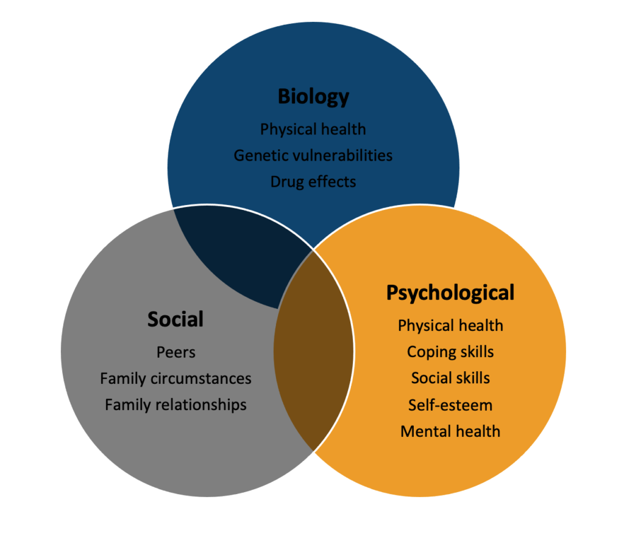

## Piaget’s model:

Piaget’s model of cognitive development is one of the most influential and widely studied models in the field of developmental psychology. According to Piaget, children actively construct their understanding of the world through their experiences and interactions, and their cognitive abilities evolve through a series of distinct stages. These stages are the sensorimotor stage (birth to 2 years), preoperational stage (2-7 years), concrete operational stage (7-11 years) and formal operational stage (11 years and above)

In the sensorimotor stage, infants and young children learn about the world through their senses and movements. They learn about objects and their properties through exploration and manipulation. The pre-operational stage is marked by the increased use of symbols, such as words and pictures, to represent objects and ideas. However, children at this stage lack the ability to think logically and systematically about objects and relationships.

The concrete operational stage is characterized by a greater ability to think logically and systematically, but it is still limited to concrete objects and situations. Children at this stage can perform mental operations such as classifying, ordering and seriation. The final stage, the formal operational stage, is marked by the ability to think abstractly, reason logically, and consider hypothetical scenarios (Piaget, 1929).

Piaget’s model has been widely studied and has had a significant impact on the field of developmental psychology. However, it’s important to note that Piaget’s model has also been criticized for its lack of emphasis on the role of culture, language and social context in cognitive development, and for not taking into account individual differences in cognitive development.

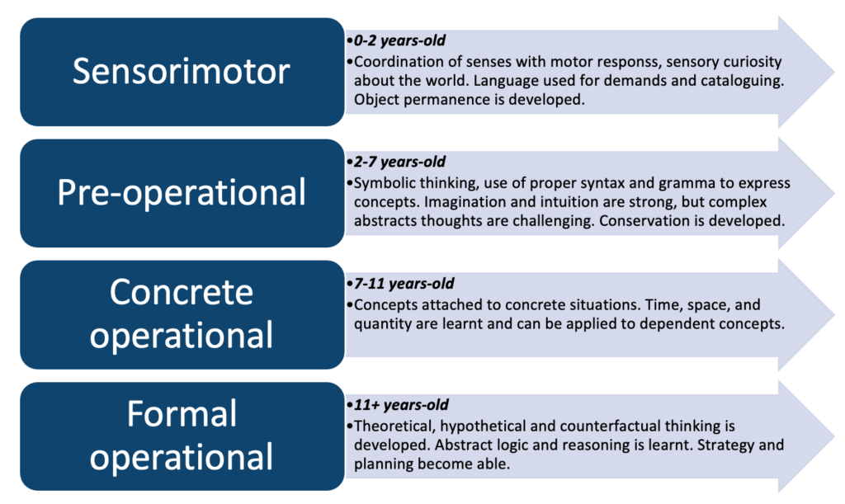

Both models, the bio-psychosocial model and Piaget’s model, provide important perspectives on cognitive development and can be used in combination to understand the complex processes that shape cognitive development.

## The Impact of Attributions and Beliefs, and Cultural, Genetic and Other Influences

Attributions and beliefs can have a significant impact on cognitive development. Attributions refer to the explanations we give for the causes of events and behaviours, and can include internal (e.g., ability) or external (e.g., luck) factors. Beliefs, on the other hand, are the convictions and assumptions that individuals hold about themselves and the world around them (Dweck, 1995).

Research has shown that attributions and beliefs can affect cognitive development in several ways. For example, children who make internal attributions for their successes (e.g., “I did well because I am smart”) tend to have higher self-esteem and are more motivated to learn than children who make external attributions (e.g., “I did well because the test was easy”). Similarly, children who hold a growth mindset – the belief that abilities can be developed through effort and learning – tend to have better academic outcomes than children who hold a fixed mindset – the belief that abilities are fixed and cannot be changed.

Cultural, genetic, and other factors can also influence cognitive development. Culture can shape cognitive development by providing children with different beliefs, values, and expectations, as well as different opportunities and resources for learning. For example, some cultures may place a greater emphasis on individual achievement, while others may place a greater emphasis on group harmony. Genetics can also play a role in cognitive development by influencing the development of the brain and the expression of certain genes. For example, research has found that genetic factors can influence intelligence, memory, and other cognitive abilities. Other factors, such as nutrition, health, and the environment, can also influence cognitive development. For example, children who grow up in poverty may have less access to nutritious food and educational resources, which can negatively impact cognitive development.

Overall, attributions, beliefs, and cultural, genetic, and other factors can all have a significant impact on cognitive development. Understanding the interplay between these factors can help in developing effective interventions to support cognitive development and promote positive outcomes (Nisbett, 2003).

## The Relevance of Pre-Operational and Formal Operational Thought to Communication with Children and Adults

Pre-operational and formal operational thought are two stages of cognitive development proposed by Jean Piaget. Pre-operational thought occurs during the preoperational stage (ages 2-7) and is characterized by the use of symbols, such as words and pictures, to represent objects and ideas, but children at this stage lack the ability to think logically and systematically about objects and relationships. Formal operational thought occurs during the formal operational stage (11 years and above) and is marked by the ability to think abstractly, reason logically, and consider hypothetical scenarios.

The relevance of pre-operational and formal operational thought to communicate with children and adults is that these stages of cognitive development determine the level of abstraction, reasoning, and logical thinking that children and adults are capable of. Therefore, the way we communicate with them should be adjusted accordingly. For example, when communicating with children who are in the preoperational stage, it’s important to use concrete and simple language, and to provide visual aids, such as pictures and diagrams, to help them understand abstract concepts. It’s also important to be aware that children at this stage have difficulty with mental operations such as classifying, ordering and seriation (Flavell, 2000).

When communicating with children who are in the formal operational stage, it’s important to use abstract and complex language and to provide logical reasoning and hypothetical scenarios to help them understand complex concepts. They also have a better understanding of cause-and-effect relationships and can think about multiple solutions to a problem (Piaget, 1929).

In terms of communication with adults, those who are in the formal operational stage are able to understand and communicate abstract and complex ideas and are able to think critically and logically, so communication can be more sophisticated and nuanced.

It is important to note that cognitive development is not a fixed process and there is a wide range of variability among individuals. Therefore, when communicating with children or adults, it’s important to take into account their individual cognitive development level, as well as their cultural, social, and emotional context to ensure effective communication.

**References:**

(1) Dweck, C. S., Chiu, C., & Hong, Y. (1995). Implicit theories and their role in judgments and reactions: A world from two perspectives. Psychological Inquiry, 6(4), 267-285.

(2) Engel, G. L. (1977). The need for a new medical model: A challenge for biomedicine. Science, 196(4286), 129-136.

(3) Flavell, J.H. and Markman, E.M. (2000) Cognitive Development: An Information Processing Approach. San Diego: Harcourt Brace Jovanovich College Publishers.

(4) Nisbett, R. E., & Masuda, T. (2003). Culture and point of view. Proceedings of the National Academy of Sciences, 100(19), 11163-11170.

(5) Piaget, J. (1929). The Child’s Conception of the World. London: Routledge.

### 2.1.7 Language development

## Basic Outline of Language Development in Childhood with Special Reference to Environmental Influences and Communicative Competence

Language development in childhood is a complex process that involves the acquisition of both the ability to understand language (receptive language) and the ability to use language to communicate (expressive language). The development of language begins in infancy and continues throughout childhood, with significant milestones occurring at different ages (Piaget, 1954).

During the first year of life, infants begin to develop prelinguistic skills, such as cooing and babbling, which are precursors to the development of speech. By 12 months, most infants have developed the ability to understand and use a few words, such as “mama” and “dada.”

Between the ages of 1 and 2, children begin to develop a larger vocabulary and improve their ability to understand and use language. They also begin to develop the ability to use language in meaningful ways, such as by making requests or asking questions.

Between the ages of 2 and 3, children’s vocabulary and language skills continue to expand, and they begin to develop more complex grammatical structures, such as combining words to form simple sentences. They also begin to develop the ability to engage in conversations and to use language for different purposes, such as making requests or asking questions.

Between the ages of 3 and 6, children continue to develop their language skills and begin to understand and use more complex grammatical structures. They also begin to develop more sophisticated communicative competence, such as the ability to understand and use figurative language and to convey their thoughts and feelings more effectively.

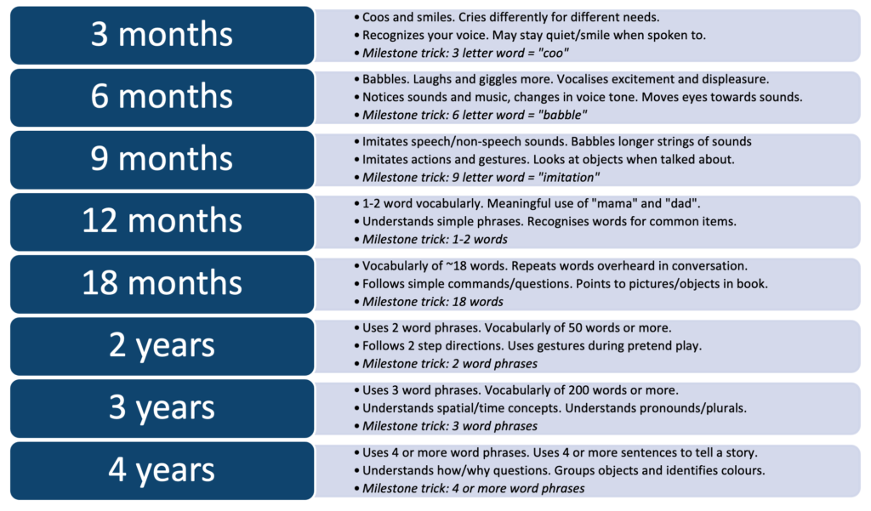

## **Environmental influences:**

Language development in children is a complex process that is heavily influenced by the environment in which they are raised. A child’s exposure to language, the social context in which they are exposed to it, and their home language all play a critical role in shaping their language development.

One of the most important factors that affect a child’s language development is the quantity and quality of language exposure they receive. Children who are exposed to more language and a wider variety of words are more likely to develop stronger language skills. This can be achieved through reading to children, engaging in conversation, and encouraging children to express themselves verbally. Children who are exposed to less language or who are not provided with opportunities to learn a language may experience delays in their language development.

Another important factor that affects a child’s language development is the social context in which they are exposed to language. Children who are exposed to more complex and varied forms of language, such as that used in literature or in academic settings, will typically develop stronger language skills than children who are only exposed to simpler forms of language.

A child’s home language can also affect the development of a new language. Children who are bilingual or multilingual will have an easier time learning a new language if they have a strong foundation in their first language.

However, when a child’s environment is not supportive of their language development, it can lead to pathological conditions. For example, if a child is not exposed to enough language, or is exposed to language in a negative or unsupportive environment, it can lead to delays in language development or difficulty in acquiring language. Additionally, if a child is exposed to a language that is not their home language in a negative or unsupportive environment, it can lead to difficulty acquiring that language. Additionally, hearing loss and neurological, or cognitive disorders can also affect language development in children.

In cases of language delays, it is essential to identify the underlying cause, which could be environmental or pathological, and provide appropriate interventions. This may include speech therapy, language therapy, or other forms of support to help the child develop their language skills.

Overall, the environment in which a child is raised plays a critical role in shaping their language development, and pathological conditions can arise when the environment is not supportive of language development. It is essential to be aware of the environmental and pathological factors that can affect language development in children and to provide appropriate interventions to support language development (Charman, 2002).

## **Language developmental delays:**

Language developmental delays in children refer to a delay in the acquisition and use of language skills that are typically seen in children of the same age. These delays can manifest in various ways, such as difficulty with understanding or using words, difficulty with grammar and sentence structure, or difficulty with social interactions that involve language.

There are several possible causes of language developmental delays in children. One of the most common causes is a lack of exposure to language, which can occur if a child is not provided with opportunities to hear and learn a language, such as if they are not read to or spoken to regularly. Additionally, a child’s hearing or vision loss can also lead to language delays.

Another possible cause of language developmental delays is a neurological disorder, such as autism spectrum disorder, which can affect a child’s ability to process and understand language. Cognitive disorders, such as intellectual disability, can also impact language development. Furthermore, some children may have a genetic predisposition for language delays. Certain genetic conditions, such as Down Syndrome, are associated with language delays.

Autism Spectrum Disorder (ASD) is a neurodevelopmental disorder that affects an individual’s ability to communicate and interact with others. Language development is one of the areas that are most commonly impacted in individuals with ASD. There are several ways in which ASD can affect language development. One of the most common ways is through delays in the onset of spoken language. Many individuals with ASD do not begin to speak until later than typically developing children and may have difficulty acquiring the vocabulary and grammar necessary for effective communication. Additionally, some individuals with ASD may not develop functional speech at all and instead rely on alternative forms of communication such as sign language or an assistive technology (Baron-Cohen, 1992).

Another way in which ASD can affect language development is through difficulty with pragmatic language. Pragmatic language refers to the use of language in social contexts, such as understanding and using nonverbal cues, maintaining a conversation, and understanding sarcasm or idiomatic expressions. Individuals with ASD often have difficulty with these skills, which can make it hard for them to understand the intentions and perspectives of others and to participate in social interactions. Additionally, individuals with ASD can have difficulty with prosody, which refers to the intonation and rhythm of speech. They may have monotonous or robotic-like speech, which can make it difficult for others to understand them.

There are several theories as to why individuals with ASD experience these difficulties with language development. One theory is that individuals with ASD have difficulty with processing and integrating information from multiple sources, such as visual, auditory, and proprioceptive, which affects the ability to understand and use language. Another theory suggests that individuals with ASD have an atypical neural organization that affects their ability to process language. Additionally, some researchers believe that individuals with ASD have a specific deficit in the neural mechanisms that are responsible for social cognition, which affects their ability to understand and use language in social contexts (Tager-Flusberg, 2001).

## **Communicative competence:**

Communicative competence, which is the ability to use language effectively and appropriately in different contexts and situations, also plays an important role in language development. This includes not only the mastery of grammar and vocabulary, but also the ability to use language for different purposes, understand and follow social rules, and interpret and respond to nonverbal cues.

Language development in childhood is a complex process that involves the acquisition of both receptive and expressive language skills, with significant milestones occurring at different ages. Environmental influences, such as the quality and quantity of language exposure, play a crucial role in this process, and children who are exposed to rich and varied language experiences tend to develop stronger language skills than those who are not (Goldin-Meadow, 2002).

Research has also shown that the home language environment plays a crucial role in language development. Children who are exposed to more than one language from an early age have been found to have a cognitive advantage and may have better metalinguistic awareness, which is the ability to reflect on and analyze language (Bialystok, 2001).

Additionally, the quality of parenting, including the responsiveness and sensitivity of the parents, has been shown to be an important factor in language development. Parents who respond to their child’s verbal and nonverbal communication, provide opportunities for their child to engage in conversation and provide appropriate feedback, tend to have children with stronger language skills.

Overall, language development in childhood is a dynamic and ongoing process that is shaped by a combination of genetic and environmental factors. A child’s exposure to rich and varied language experiences, responsive and sensitive parenting, and communicative competence are crucial in promoting strong language development.

**References:**

(1) Baron-Cohen, S., Allen, J., & Gillberg, C. (1992). Can autism be detected at 18 months? The needle, the haystack, and the CHAT. British Journal of Psychiatry, 161(1), 839-843.

(2) Bialystok, E. (2001). Bilingualism in Development: Language, Literacy, and Cognition. Cambridge University Press.

(3) Charman, T., & Baird, G. (2002). Joint attention and the early development of social communication. International Journal of Language & Communication Disorders, 37(S1), 31-46.

(4) Goldin-Meadow, S., & Levine, C. S. (2002). The role of parenting in children’s language development. Child Development, 73(5), 1861-1873.

(5) Piaget, J. (1954). The Construction of Reality in the Child. New York: Basic Books

(6) Tager-Flusberg, H. (2001). The neural basis of language development in autism. In J. A. Burack, T. Charman, N. Yirmiya, & P. R. Zelazo (Eds.), The Development of Autism: Perspectives from Theory and Research (pp. 103-127). Mahwah, NJ: Erlbaum.

### 2.1.8 Development of social competence and relationships

## Development of Social Competence and Relationships with Peers

Social competence refers to the ability to effectively navigate and interact within social situations. It is an important aspect of child development and is closely related to the development of relationships with peers. Social competence can be developed through various experiences, such as playing with other children, participating in group activities, and receiving positive feedback from others. Parents and caregivers can also play a role in promoting social competence by providing opportunities for social interactions and teaching social skills. As children grow, they will develop more complex relationships with their peers and learn to navigate different social dynamics. The development of social competence and relationships with peers is a continuous process that evolves as children grow and gain new experiences (Payton, 2000).

A child’s social competence can be divided into three main components: social behaviour, social knowledge, and social cognition. Social behaviour refers to the child’s actual social interactions and behaviour, such as cooperation and sharing with others. Social knowledge refers to the child’s understanding of social rules, such as taking turns and following rules. Social cognition refers to the child’s ability to understand and navigate social situations, such as understanding others’ perspectives and emotions. These components are related to one another and they are important for children’s overall social competence (Vaughn et al, 2009).

## Acceptance:

Acceptance is an important aspect of social competence and the development of relationships with peers. Acceptance refers to the degree to which a person is welcomed and included within a social group. Children who are accepted by their peers have a higher sense of belonging and self-worth, which can lead to better mental and emotional well-being.

The development of acceptance within a child can be nurtured by promoting positive social interactions, encouraging cooperation, and fostering an environment of empathy and understanding. Parents and caregivers can help children develop acceptance by teaching them social skills, such as how to communicate effectively, share, and take turns. Additionally, providing opportunities for children to participate in group activities, such as sports teams or clubs, can help them develop acceptance by learning to work with and appreciate others who may be different from themselves.

Acceptance also plays a key role in the development of relationships with peers. Children who are accepted by their peers are more likely to form positive and lasting relationships with them. Acceptance is also closely related to the concept of inclusivity, which is the practice of making sure that all people are included, respected, and valued regardless of their differences.

The development of acceptance is a critical aspect of social competence and the development of relationships with peers. Parents and caregivers can play an important role in nurturing acceptance in children by providing opportunities for social interactions, teaching social skills and fostering an inclusive environment.

## Group formation:

Group formation refers to the process by which individuals come together to form a social group. It is an important aspect of social competence and the development of relationships with peers, as it allows children to interact and collaborate with others.

Children typically form groups with those who are similar to them in some way, such as age, interests, or personality. As children grow and develop, their group formation can change as they encounter new people and experiences. For example, a child may start out playing with a small group of friends in their neighbourhood, but as they enter school, they may start to form new groups based on their classroom or extracurricular activities.

The process of group formation can also be influenced by a child’s level of social competence. Children who are more socially competent are better able to navigate and interact in social situations, which can make it easier for them to form groups. On the other hand, children who struggle with social competence may have difficulty forming groups and may feel excluded.

Parents and caregivers can play an important role in promoting group formation by providing opportunities for social interactions, such as playdates or group activities. They can also help children develop social skills, such as communication and cooperation, which can make it easier for them to form groups. Additionally, they can also foster an inclusive and respectful environment, where children can feel comfortable approaching and interacting with others, regardless of their differences.

Group formation is an important aspect of social competence and the development of relationships with peers. It allows children to interact and collaborate with others and can be influenced by a child’s level of social competence, opportunities for social interactions, and fostering an inclusive environment.

## Cooperation:

Cooperation refers to the ability to work together with others to achieve a common goal. It is an important aspect of social competence and the development of relationships with peers, as it allows children to collaborate and accomplish tasks together.

Cooperation is a complex skill that develops over time. Young children may have difficulty understanding the perspectives of others and may struggle with sharing and taking turns. As children grow and develop, they learn to take others’ needs and feelings into account, and they become better able to work together. Children who are more cooperative tend to have better relationships with their peers.

Cooperation can be fostered by providing children with opportunities to interact and work together with others, such as participating in group activities or playing games that require teamwork. Parents and caregivers can also teach children social skills, such as communication, empathy, and problem-solving, which are essential for cooperation. Additionally, praising and rewarding children for cooperative behavior can help to reinforce and encourage it.

## Friendships:

Friendship refers to a close relationship between two or more individuals who share a mutual connection and understanding. It is an important aspect of social competence and the development of relationships with peers. Friendships provide children with a sense of belonging, support, and companionship, which are essential for their social and emotional well-being.

The development of friendships begins in early childhood and evolves over time. Young children tend to form friendships based on proximity and shared activities, such as playing together in the same class or neighbourhood. As children grow and develop, their friendships become more complex and are based on shared interests and values. Children’s social skills, such as communication, empathy, and cooperation, also play a role in the development of friendships.

Friendships can be fostered by providing children with opportunities to interact with others, such as participating in group activities or playdates. Parents and caregivers can also teach children social skills, such as communication, which can help them form and maintain friendships. Additionally, fostering an inclusive and respectful environment can help children to form friendships with a diverse group of peers.

However, friendships can also be challenged by factors such as bullying, exclusion, or the introduction of new peers. Children may struggle to form or maintain friendships, which can negatively impact their social and emotional well-being. Parents and caregivers can help children navigate these challenges by teaching them coping strategies and providing support.

## Isolation:

Isolation refers to the state of being alone or cut off from others. It can occur when a child lacks social connections and interactions with their peers. Isolation can have a negative impact on a child’s social competence and the development of relationships with peers, as it can lead to feelings of loneliness, depression and low self-esteem.

Isolation can occur for a variety of reasons. Children who have difficulty with social skills, such as communication or cooperation, may struggle to form friendships and may be more likely to experience isolation. Children who have experienced bullying, exclusion or other negative social interactions may also be at risk of isolation. Additionally, children who have limited opportunities for social interactions, such as those who live in rural areas or have limited access to extracurricular activities, may also be at a higher risk of isolation. Parents and caregivers can help children who are at risk of isolation by providing opportunities for social interactions, such as playdates or group activities. They can also teach children social skills, such as communication and cooperation, which can help them form and maintain friendships. Additionally, fostering an inclusive and respectful environment can help children to form friendships with a diverse group of peers. It is also important to note that some children may naturally be more introverted, and less inclined to socialize, this does not necessarily mean that they are isolated, and the approach should be adapted accordingly.

Isolation is a state of being alone or cut off from others and can have a negative impact on a child’s social competence and the development of relationships with peers. It can occur for a variety of reasons and parents and caregivers can play an important role in preventing it by providing opportunities for social interactions, teaching social skills, fostering an inclusive environment and providing support to navigate challenges.

Captive isolation is a severe form of isolation and can be particularly challenging for adults as it involves a loss of freedom and control over one’s life. Being cut off from social interactions and relationships can lead to feelings of loneliness, depression, and anxiety, which can negatively impact an adult’s mental and emotional well-being. These feelings can also make it more difficult for an adult to navigate social situations and form new relationships when they are released from captivity. This extreme type of isolation can also lead to a loss of social skills and the ability to effectively communicate and interact with others. Adults who are isolated for extended periods may find it difficult to pick up on social cues, understand other people’s perspectives, or hold a conversation. This can make it more challenging for them to form and maintain relationships once they are released.

## Rejection:

Rejection refers to the act of being excluded or not accepted by others. It can have a significant impact on social competence and the development of relationships with peers. Rejection can lead to feelings of low self-esteem, self-doubt, and loneliness, which can negatively impact an individual’s mental and emotional well-being. These feelings can also make it more difficult for an individual to navigate social situations and form new relationships.

Children and adults who experience rejection may develop a fear of rejection, which can lead to social anxiety and avoidance of social situations. They may become more withdrawn, less likely to initiate social interactions, and may find it harder to form and maintain relationships. Rejection can also affect an individual’s self-perception, leading them to develop negative self-talk and negative perceptions of themselves. They may feel like they are not good enough, and this can limit their interactions with others and further perpetuate their isolation. Additionally, rejection can also affect an individual’s social skills, for example, people who are rejected may struggle to read social cues, understand others’ perspectives and communicate effectively.

Parents, caregivers and society can play a role in helping individuals cope with rejection by teaching coping strategies and providing emotional support. They can also teach children and adults how to communicate effectively, empathize with others and how to form and maintain relationships. Additionally, fostering an inclusive and respectful environment can help individuals to form connections and relationships with a diverse group of peers, which can help to buffer the negative effects of rejection.

## Components of Popularity

Popularity refers to the degree to which an individual is well-liked, respected, and accepted by others within a social group. It is a complex construct that can be influenced by a variety of factors. The following are some of the components of popularity:

|  |  |
| --- | --- |
| **Component:** | **Brief description:** |
| **Social skills** | Individuals who are skilled at communication, cooperation, and problem-solving tend to be more popular with their peers. |
| **Physical appearance** | Individuals who are considered attractive or physically appealing may be more popular with their peers. |
| **Confidence and self-esteem** | Individuals who have high self-esteem and confidence tend to be more popular with their peers as they tend to be more outgoing, assertive, and less likely to be affected by rejection. |
| **Sense of humour** | Individuals who have a good sense of humour tend to be more popular with their peers as they tend to be more entertaining and fun to be around. |
| **Intelligence** | Individuals who are considered intelligent tend to be more popular with their peers as they tend to be more respected and admired. |
| **Social status** | Individuals who come from high-status families or who have high-status positions within a group may be more popular with their peers. |
| **Personality** | Individuals who are considered friendly, kind, and empathetic tend to be more popular with their peers. |

It’s worth noting that popularity is dynamic and subject to change, it can be influenced by many different factors and can also change over time. Additionally, popularity can also have negative effects such as bullying, exclusion, and social pressure.

**References:**

(1) Payton, J.W., Wardlaw, D.M., Graczyk, P.A., Bloodworth, M.R., Tompsett, C.J. and Weissberg, R.P. (2000). Social and Emotional Learning: A Framework for Promoting Mental Health and Reducing Risk Behavior in Children and Youth. Journal of School Health, 70(5), pp.179–185. doi:10.1111/j.1746-1561.2000.tb06468.x.

(2) Vaughn, B.E., Shin, N., Kim, M., Coppola, G., Krzysik, L., Santos, A.J., Peceguina, I., Daniel, J.R., Veríssimo, M., DeVries, A., Elphick, E., Ballentina, X., Bost, K.K., Newell, W.Y., Miller, E.B., Blake Snider, J. and Korth, B. (2009). Hierarchical Models of Social Competence in Preschool Children: A Multisite, Multinational Study. Child Development, 80(6), pp.1775–1796. doi:10.1111/j.1467-8624.2009.01367.x.

### 2.1.9 Moral development and Kohlberg

## Moral Development with Critical Reference to Kohlberg’s Stage Theory

Lawrence Kohlberg’s stage theory of moral development is one of the most widely studied and discussed theories in the field of moral psychology. The theory proposes that individuals progress through a series of six stages in order to develop a more sophisticated understanding of moral reasoning. These stages are grouped into three levels: pre-conventional, conventional, and post-conventional (Kohlberg, 1984).

|  |  |
| --- | --- |
| **Level**: | **Summary:** |
| **Pre-conventional level** | The first level, pre-conventional reasoning, is focused on avoiding punishment and seeking rewards. At the first stage of this level, the individual is motivated by fear of punishment and seeks to avoid it at all costs. The second stage is characterized by the desire for rewards and the desire to please authority figures. |
| **Conventional level** | The second level, conventional reasoning, is focused on conforming to societal norms and expectations. At the third stage, the individual seeks to be a good boy or girl and to be seen as a responsible member of society. The fourth stage is characterized by the desire to be a good person and to be seen as a responsible member of society. |
| **Post-conventional level** | The third level, post-conventional reasoning, is focused on the recognition of universal moral principles and the ability to make reasoned judgments about the greater good. In the fifth stage, the individual recognizes that certain actions are inherently right or wrong, regardless of their consequences. The sixth stage is characterized by the recognition of universal moral principles, such as justice and human rights, and the ability to make reasoned judgments about the greater good. |

Kohlberg’s theory has been widely studied and discussed and has been influential in the field of moral psychology. However, it has also been criticized for its lack of cultural and gender-specific considerations. Some researchers argue that the theory is overly cognitive and individualistic and does not take into account the social and cultural context in which moral reasoning takes place. Others have argued that the theory is biased towards the perspective of Western, middle-class, and male individuals. Despite these criticisms, Kohlberg’s theory of moral development remains a widely studied and influential theory in the field of moral psychology (Haidt, 2001) (Turiel, 2002).

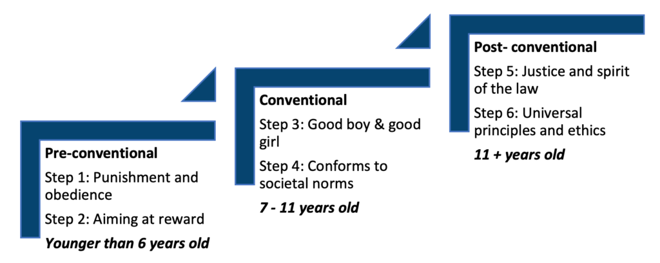

## **Pre-conventional level**:

Pre-conventional reasoning refers to the earliest level of moral development where individuals are focused on avoiding punishment and seeking rewards. This level is characterized by a focus on personal gain and self-preservation, rather than an understanding of societal norms or moral principles.

The **first stage of pre-conventional reasoning** is known as the punishment and obedience orientation. At this stage, individuals are motivated by fear of punishment and seek to avoid it at all costs. They view rules and authority as absolute and unchangeable and see obedience as the only way to avoid punishment. This stage is often observed in very young children, who have not yet developed the ability to understand the consequences of their actions or the perspective of others.

The **second stage of pre-conventional reasoning** is known as the instrumental relativist orientation. At this stage, individuals understand that rules can be negotiated and that rewards can be obtained for following them. They are motivated by self-interest and the desire to please authority figures and see rules as a means to an end. This stage is often observed in older children, who have begun to understand the concept of cause and effect and the idea that they can influence the outcome of events through their actions.

It is important to note that pre-conventional reasoning is not necessarily an indication of immaturity or lack of moral development. It is a natural and necessary stage in the development of moral reasoning, and individuals may continue to use pre-conventional reasoning even as they move on to more advanced stages. Additionally, pre-conventional reasoning is not exclusively the domain of children, adults may also be found at these stages, especially in certain situations.

Pre-conventional reasoning is the first step in the moral development process and is fundamental for the development of more advanced stages of moral reasoning.

## **Conventional** level:

Conventional reasoning refers to the middle level of moral development where individuals are focused on conforming to societal norms and expectations. This level is characterized by a focus on the expectations of the social group and the desire to be seen as a responsible member of society.

The **third stage of conventional reasoning** is known as the “good boy-good girl” orientation. At this stage, individuals seek to be seen as good boys or good girls and to be viewed positively by others. They understand that rules and laws have a social purpose and that obedience is expected of them. They base their moral judgments on what is expected of them by their parents, teachers, and other authority figures. This stage is often observed in children and adolescents, who are developing their sense of self and their place in the world.

The **fourth stage of conventional reasoning** is known as the “law and order” orientation. At this stage, individuals understand that rules and laws are necessary for the functioning of society and that obedience is important for the well-being of the group as a whole. They base their moral judgments on the idea that laws and rules should be obeyed for the greater good, and they view those who break the law as deviant or immoral. This stage is often observed in adolescents and adults, who have a more mature understanding of the consequences of their actions and the needs of the group.

Conventional reasoning is an important stage in the moral development process as it allows individuals to understand the social and societal norms that govern their behaviour. However, it is important to note that it does not consider the moral principles that underlie these norms. People may continue to use conventional reasoning even as they move on to more advanced stages.

## **Post-conventional level**:

Post-conventional reasoning refers to the highest level of moral development where individuals are focused on recognizing universal moral principles and the ability to make reasoned judgments about the greater good. This level is characterized by a focus on individual rights, justice, and the recognition of the inherent value of human life.

The **fifth stage of post-conventional reasoning** is known as the “social contract” orientation. At this stage, individuals recognize that certain actions are inherently right or wrong, regardless of their consequences. They understand that laws and rules are created by society and can be changed if they do not align with moral principles. They base their moral judgments on the idea of mutual social contracts and agreements that aim to protect the rights of all individuals. This stage is often observed in individuals who have developed a sense of personal autonomy and a strong sense of social responsibility.

The **sixth stage of post-conventional reasoning** is known as the “universal ethical principle” orientation. At this stage, individuals recognize universal moral principles such as justice, equality, and human rights. They base their moral judgments on these principles and are able to make reasoned judgments about the greater good. They are able to transcend the laws and rules of society and make judgments based on a sense of global community and the inherent value of human life. This stage is often observed in individuals who have developed a high level of moral maturity and have a deep understanding of the interconnectedness of all people.

Post-conventional reasoning is the highest level of moral development, and it allows individuals to understand the moral principles that underlie the laws and rules of society. It is important to note that not everyone reaches this level and people may continue to use conventional and pre-conventional reasoning in certain situations.

## Relationship to the Development of Social Perspective Taking

The development of social perspective-taking, or the ability to understand and take into account the perspectives of others, is closely related to the stages of moral development proposed by Lawrence Kohlberg.

Pre-conventional reasoning, as discussed earlier, is characterized by a focus on personal gain and self-preservation, rather than an understanding of societal norms or moral principles. At the first stage of pre-conventional reasoning, individuals are motivated by fear of punishment and seek to avoid it at all costs, they have not yet developed the ability to understand the perspectives of others.

In contrast, conventional reasoning is characterized by a focus on the expectations of the social group and the desire to be seen as a responsible member of society. At the third stage of conventional reasoning, individuals seek to be seen as a good boy or good girl and to be viewed positively by others. They understand that rules and laws have a social purpose and that obedience is expected of them, and begin to consider the perspective of the authority figures in their lives.

Finally, post-conventional reasoning is characterized by a focus on recognizing universal moral principles and the ability to make reasoned judgments about the greater good. At the fifth stage of post-conventional reasoning, individuals recognize that certain actions are inherently right or wrong, regardless of their consequences. They understand that laws and rules are created by society and can be changed if they do not align with moral principles, and begin to consider the perspectives of others as they make moral judgments.

In summary, as individuals progress through the stages of moral development proposed by Kohlberg, they also develop a more sophisticated understanding of the perspectives of others. This is reflected in their moral reasoning, which becomes increasingly focused on the needs and rights of others, rather than just their own self-interest.

**References:**

(1) Haidt, J. (2001). The emotional dog and its rational tail: A social intuitionist approach to moral judgment. Psychological Review, 108(4), 814–834.

(2) Kohlberg, L. (1984). The psychology of moral development: The nature and validity of moral stages. San Francisco: Harper & Row. –

(3) Turiel, E. (2002). The culture of morality: Social development, context, and conflict. Cambridge University Press.

### 2.1.10 Emotional literacy and regulation

## **Development of Emotional Literacy and Regulation in Childhood and Adolescence**

Emotional literacy and emotional regulation are crucial skills that are developed during childhood and adolescence. Emotion literacy refers to the ability to understand and label emotions, while emotional regulation refers to the ability to manage and express emotions in appropriate ways. These skills are essential for the overall well-being and functioning of an individual (Denham, 1998).

The development of emotional literacy and emotional regulation is a complex process that is influenced by both nature and nurture. Biology and genetics play a role in the development of emotional regulation by shaping the individual’s emotional reactivity, the threshold for emotional arousal, and emotional regulation strategies (Kagan, 1998). However, environmental factors and experiences also shape the development of emotional literacy. For example, parents and caregivers who provide children with a safe and nurturing environment and model appropriate emotional expression can support the development of emotion literacy (Denham, 1998). Furthermore, experiences of emotional trauma, neglect, or abuse can negatively impact the development of emotional literacy and emotional regulation (Perry, 1995).

In light of this, parents, caregivers, and teachers can support the development of emotional literacy and emotional regulation in children by providing them with a safe and nurturing environment, modelling appropriate emotional expression, and teaching them how to identify and manage their emotions (Denham, 1998). Additionally, children can benefit from learning and practising techniques such as mindfulness and cognitive-behavioural therapy to improve their emotional regulation (Kuppens, 2008).

In conclusion, Emotion literacy and emotional regulation are important skills that develop during childhood and adolescence. They are influenced by a combination of nature and nurture and can be supported by providing children with a safe and nurturing environment, modelling appropriate emotional expression, and teaching children how to identify and manage their emotions.

## **Possible aetiological and maintenance mechanisms** of emotional literacy and regulation:

Aetiological mechanisms refer to the causes or factors that contribute to the development of a particular condition or disorder. In the case of emotional literacy and emotional regulation, aetiological mechanisms include both biological and environmental factors.

Biological factors that may contribute to the development of emotional literacy and emotional regulation include genetics, brain development, and neurochemistry. For example, genetic variations in certain genes have been associated with differences in emotional reactivity and regulation (Hariri, 2006). Additionally, research has shown that certain regions of the brain, such as the amygdala and prefrontal cortex, are involved in emotional processing and regulation (Davidson, 2004). Furthermore, imbalances in neurochemicals such as serotonin and dopamine have been linked to difficulties in emotion regulation (Coccaro, 2006).

Environmental factors that may contribute to the development of emotional literacy and emotional regulation include early childhood experiences, parenting style, and culture. For example, children who have experienced emotional trauma, neglect, or abuse may have difficulty developing emotional literacy and emotional regulation (Perry, 1995). Additionally, a lack of appropriate emotional support and guidance from parents and caregivers can also negatively impact the development of these skills (Denham, 1998). Furthermore, cultural values and norms can influence the way emotions are expressed and regulated (Kitayama, 2006).

Maintenance mechanisms refer to the factors that contribute to the persistence of a condition or disorder. In the case of emotional literacy and emotional regulation, maintenance mechanisms include both individual and environmental factors.

Individual factors that may maintain difficulties in emotional literacy and emotional regulation include cognitive and behavioural patterns, personality, and temperament. For example, individuals who have difficulty identifying and labelling emotions may have a hard time regulating them as well. Additionally, people with certain personality traits, such as neuroticism, may be more prone to experience difficulties in emotion regulation (Gross, 2002). Furthermore, temperament can also play a role in the maintenance of difficulties in emotion regulation, as some individuals may be more reactive or sensitive to emotional stimuli (Rothbart, 1981).

Environmental factors that may maintain difficulties in emotional literacy and emotional regulation include stress, lack of social support, and exposure to negative life events. For example, exposure to chronic stress can make it more difficult for an individual to regulate their emotions (McEwen, 2007). Additionally, a lack of social support can contribute to difficulties in emotion regulation, as the presence of others can provide a buffer against stress and negative emotions (Uchino, 2004). Furthermore, exposure to negative life events can also contribute to difficulties in emotion regulation, as they can trigger intense and overwhelming emotions (Nolen-Hoeksema, 2000).

The aetiology of difficulties in emotional literacy and emotional regulation involves a complex interplay between biological and environmental factors, while maintenance mechanisms can be driven by individual and environmental factors.

## **Development of Fears in Childhood and Adolescence with Reference to Age**

The development of fears in childhood and adolescence is a complex process that is influenced by a combination of biological, cognitive, and environmental factors. Fears are normal and adaptive responses to potential threats, but excessive or irrational fears, known as phobias, can interfere with daily functioning.

During the first year of life, infants are primarily focused on developing a sense of trust and safety with their primary caregivers. At this stage, infants may show fear responses to unfamiliar or sudden stimuli, such as loud noises or strange faces, but they do not yet have the cognitive ability to understand the concept of danger.

In early childhood (around 2-6 years old), children begin to develop a sense of object permanence, which means they understand that objects and people still exist even when they cannot see them. This cognitive development allows children to begin to understand the concept of danger and to develop specific fears, such as fear of animals or fear of the dark. Children at this stage may also develop fears as a result of direct experiences, such as being bitten by a dog or getting lost.

During middle childhood (around 7-12 years old), children continue to develop cognitively and emotionally. They begin to understand the concept of probability and recognize that some events are more likely to happen than others. This understanding allows them to begin to differentiate between realistic and unrealistic fears. Children at this stage may also develop social fears, such as fear of rejection or embarrassment. They are also more likely to be influenced by the fears and concerns of their peers and parents.

In adolescence (around 13-18 years old), individuals continue to develop cognitively and emotionally, and their fears may change as a result. Adolescents begin to understand the concept of abstract reasoning, which allows them to consider the potential consequences of their actions and to think about future events. This cognitive development can lead to the development of fears related to personal safety, such as fear of crime, and fears related to personal identities, such as fear of failure. Additionally, adolescents may be more likely to develop phobias, as they have a greater ability to understand the concept of danger and to imagine potential threats.

In conclusion, the development of fears in childhood and adolescence is a complex process that is influenced by a combination of biological, cognitive, and environmental factors. Fears are normal and adaptive responses to potential threats, but excessive or irrational fears, known as phobias, can interfere with daily functioning. The fears and phobias that people develop change as they age, with infants primarily showing fear responses to sudden stimuli, children between 2-6 years old developing specific fears, middle childhood children developing social fears, and adolescents developing fears related to personal safety and identity.

## **Possible aetiological and maintenance mechanisms:**

Aetiological mechanisms refer to the causes or factors that contribute to the development of a particular condition or disorder. In the case of fears in childhood and adolescence, aetiological mechanisms include both biological and environmental factors.

Biological factors that may contribute to the development of fears include genetics, brain development, and neurochemistry. For example, genetic variations in certain genes have been associated with differences in fear reactivity and regulation (Hariri, 2006). Additionally, research has shown that certain regions of the brain, such as the amygdala, are involved in the processing of fear and threat-related stimuli (LeDoux, 1996). Furthermore, imbalances in neurochemicals such as cortisol and adrenaline have been linked to excessive fear and anxiety (Rosen, 1998)

Environmental factors that may contribute to the development of fears include early childhood experiences, parental modelling, and cultural influences. For example, children who have experienced traumatic events or have been exposed to fearful situations may develop excessive fears (Muris, 2001). Additionally, parental modelling of fearful behaviour or verbalization of fears can contribute to the development of fears in children (Muris, 2001). Furthermore, cultural influences may also play a role in shaping the types of fears that individuals develop, as cultural norms and values can influence the perception of threats and what is considered to be dangerous (Kitayama, 2006).

Maintenance mechanisms refer to the factors that contribute to the persistence of a condition or disorder. In the case of fears in childhood and adolescence, maintenance mechanisms include both individual and environmental factors.

Individual factors that may maintain fears include cognitive and behavioural patterns, personality, and temperament. For example, individuals who have a tendency to focus on negative thoughts and experiences may be more likely to maintain their fears (Beck, 1976). Additionally, personality traits such as neuroticism or introversion may also be associated with an increased risk of maintaining fears (Eysenck, 1967). Furthermore, temperament can also play a role in the maintenance of fears, as some individuals may be more reactive or sensitive to fearful stimuli (Rothbart, 1981).

Environmental factors that may maintain fears include ongoing exposure to fearful stimuli, lack of social support, and exposure to negative life events. For example, ongoing exposure to traumatic or stressful events can make it more difficult for an individual to overcome their fears (McEwen, 2007). Additionally, a lack of social support can contribute to the maintenance of fears, as the presence of others can provide a buffer against stress and negative emotions (Uchino, 2004). Furthermore, exposure to negative life events can also contribute to the maintenance of fears, as they can trigger intense and overwhelming emotions (Nolen-Hoeksema, 2000).

In conclusion, the aetiology of fears in childhood and adolescence involves a complex interplay between biological and environmental factors, while maintenance mechanisms can be driven by individual and environmental factors.

**References:**

(1) Barlow, D. H., & Craske, M. G. (2007). Panic disorder and agoraphobia. In D. H. Barlow (Ed.), Clinical handbook of psychological disorders: A step-by-step treatment manual (4th ed., pp. 259-328). New York: Guilford Press.

(2) Beck, A. T. (1976). Cognitive therapy and the emotional disorders. New York: International Universities Press.

(3) Caspi, A., Lynam, D., Moffitt, T. E., & Silva, P. A. (1993). Unpacking complex phenomena: Nomothetic and idiographic perspectives on the psychology of individual development. Journal of Personality, 61(1), 17-34.

(4) Cicchetti, D., & Cohen, D. J. (1997). Developmental psychopathology. In D. Cicchetti & D. J. Cohen (Eds.), Developmental psychopathology (Vol. 1, pp. 3-20). New York: John Wiley & Sons.

(5) Coccaro, E. F. (2006). Serotonin and impulsive aggression. Biological Psychiatry, 60(3), 329-342.

(6) Craske, M. G., & Barlow, D. H. (2007). Panic disorder and agoraphobia. In D. H. Barlow (Ed.), Clinical handbook of psychological disorders: A step-by-step treatment manual (4th ed., pp. 259-328). New York: Guilford Press.

(7) Davidson, R. J. (2004). What does the prefrontal cortex “do” in affect: perspectives on frontal EEG asymmetry research. Biological Psychology, 67(1), 219-233.

(8) Denham, S. (1998). Emotional development in young children. New York: Guilford Press.

(9) Eysenck, H. J. (1967). The biological basis of personality. Springfield, IL: Charles C Thomas.

(10) Fox, N. A., & Henderson, H. A. (2003). Fear and anxiety in infancy and early childhood. In J. P. Shonkoff & S. J. Meisels (Eds.), Handbook of early childhood intervention (pp. 365-392). Cambridge, UK: Cambridge University Press.

(11) Garai, J., & Sroufe, L. A. (2000). The development of fear and its regulation. In J. Garai & L. A. Sroufe (Eds.), The development of the person: The Minnesota study of risk and adaptation from birth to adulthood (pp. 103-129). New York: Guilford Press.

(12) Gross, J. J. (2002). Emotion regulation: Affective, cognitive, and social consequences. Psychophysiology, 39(3), 281-291.

(13) Hariri, A. R., & Holmes, A. (2006). Genetic variation in the serotonin transporter promoter affects neural function related to emotional processing of visual stimuli. Molecular Psychiatry, 11(10), 924-933.

(14) Kitayama, S., Mesquita, B., & Karasawa, M. (2006). Cultural affordances and emotional experience: Socially engaging and disengaging emotions in Japan and the United States. Journal of Personality and Social Psychology, 91(5), 890-903.

(15) Leckman, J. F., & Sholomskas, D. (1997). Understanding the nature of developmental psychopathology. In D. Cicchetti & D. J. Cohen (Eds.), Developmental psychopathology (Vol. 1, pp. 3-20). New York: John Wiley & Sons.

(16) LeDoux, J. (1996). The emotional brain: The mysterious underpinnings of emotional life. New York: Simon & Schuster.

(17) Muris, P., & Merckelbach, H. (2001). The development of normal fears and phobias in childhood and adolescence. Clinical Psychology Review, 21(3), 331-354.

(18) Thompson, R. A. (1994). Emotion regulation: A theme in search of definition. Monographs of the Society for Research in Child Development, 59(2-3), 25-52.

(19) McEwen, B. S. (2007). Physiology and neurobiology of stress and adaptation: Central role of the brain. Physiological Reviews, 87(3), 873-904.

(20) Muris, P., & Merckelbach, H. (2001). The development of normal fears and phobias in childhood and adolescence. Clinical Psychology Review, 21(3), 331-354.

(21) Nolen-Hoeksema, S. (2000). The role of rumination in depressive disorders and mixed anxiety/depressive symptoms. Journal of Abnormal Psychology, 109(3), 504-511.

(22) Perry, B.D., Pollard, R.A., Blakley, T.L., Baker, W.L., & Vigilante, D. (1995). Childhood trauma, the neurobiology of adaptation and use-dependent development of the brain: How states become traits. Infant Mental Health Journal, 16(4), 271-291.

(23) Rosen, J. B., & Schulkin, J. (1998). From normal fear to pathological anxiety. Psychological Review, 105(1), 325-350.

(24) Rothbart, M. K., & Derryberry, D. (1981). Development of individual differences in temperament. In M. E. Lamb & A. L. Brown (Eds.), Advances in developmental psychology (pp. 37-86). Hillsdale, NJ: Erlbaum.

(25) Sroufe, L. A., & Rutter, M. (1984). The domain of developmental psychopathology. Child Development, 55(1), 17-29.

(26) Thompson, R. A. (1994). Emotion regulation: A theme in search of definition. Monographs of the Society for Research in Child Development, 59(2-3), 25-52.

(27) Uchino, B. N. (2004). Social support and physical health: Understanding the health consequences of relationships. New Haven, CT: Yale University Press.

### 2.1.11 Sexual development

**Sexual Development Including the Development of Sexual Identity and Preferences**

Sexual development is a complex and ongoing process that begins at conception and continues throughout the lifespan. It involves physical, emotional, cognitive, and social changes, and is influenced by a variety of biological, psychological, and social factors.

Physical sexual development includes the development of primary and secondary sex characteristics, such as the growth of breasts and the onset of menstruation in females, and the growth of facial and body hair and the deepening of the voice in males. These changes are triggered by hormonal changes that occur during puberty.

Growth and development are ongoing processes that bring about change in an individual at all times. Sexual development begins as early as intrauterine life following conception and continues through infancy, childhood, adolescence, adulthood, and death. During infancy, there is no knowledge of gender. By the age of three, the youngster recognises his or her gender. Sexual self-awareness (gender role, gender identity) develops throughout infancy. Biological study findings suggests that androgens have a distinct function in determining gender sensitive roles and gender-specific behaviour. Adolescence is a period of transition during which important sexual developments occur. Puberty occurs throughout adolescence and is a crucial milestone in the development of sexuality. The function of the hypothalamic-pituitary-gonadal axis is critical for sexual development during puberty.

## **Sexual identity:**

Sexual identity refers to an individual’s sense of self in relation to their sexual orientation, which includes their attraction to individuals of the same or different gender. Sexual identity is a multidimensional construct that includes not only sexual orientation, but also sexual behaviour, self-identification, and sexual attraction (Savin-Williams, 2005). It develops and changes over time, and may not always align with societal expectations or stereotypes. According to research, sexual identity is primarily shaped by a combination of genetic, hormonal, and environmental factors (Bailey et al., 2000).

During childhood, most children develop a basic understanding of gender roles and expectations, and begin to identify with a gender based on their physical characteristics and socialization. However, it is important to note that not all children conform to traditional gender roles and expectations and some may identify as gender non-conforming or transgender.

In adolescence, individuals begin to experience sexual attraction and may begin to explore their sexual identity. For some, this may involve experimenting with different sexual behaviors or partners, while for others, it may involve questioning their sexual orientation or gender identity.

During young adulthood, individuals may begin to develop a more stable sense of their sexual identity and may come out to others as lesbian, gay, bisexual, or transgender. However, it is important to note that not all individuals have a clear or stable sexual identity, and some may identify as questioning or fluid.

In adulthood, an individual’s sexual identity may continue to evolve and change, and they may experience different forms of attraction at different times in their life. It is important to remember that sexual identity is a personal and unique experience for each individual, and it is important to respect and support individuals in their journey of self-discovery and self-expression. It is also important to note that societal attitudes and discrimination can affect the development of sexual identity, and can make the process of accepting and disclosing one’s sexual identity more difficult.

## **Sexual preferences:**

Sexual preferences refer to the types of sexual activities or partners that an individual finds appealing or satisfying. These preferences may also change over time, and may not always be consistent with one’s sexual identity. They are influenced by a variety of factors such as cultural, social, and personal experiences, as well as individual differences in personality, values, and beliefs (Mark KP et al., 2018).

From a biological perspective, research suggests that sexual preferences may be influenced by genetics and hormones. For example, studies have found that certain physical characteristics, such as body shape, are more attractive to some people than others, and that these preferences may be related to genetic factors. Additionally, research has found that hormones, such as testosterone and estrogen, play a role in sexual attraction and behavior. For example, high levels of testosterone have been linked to increased sexual desire and attraction to more masculine faces.

From an environmental perspective, sexual preferences may be shaped by a person’s experiences and exposure to different types of sexual behavior and relationships. For example, early experiences with sexual partners, such as those during adolescence, may shape an individual’s sexual preferences and behavior. Additionally, cultural norms and values can also influence sexual preferences by shaping the types of sexual behavior and relationships that are considered acceptable or desirable.

The development of sexual preferences is a complex and multi-faceted process that is influenced by a variety of factors, including biology, environment, and culture. It’s important to recognize that sexual preferences are diverse and can vary greatly from person to person, and that they should be respected.

## **Gender dysphoria:**

Gender dysphoria is a condition characterized by a marked incongruence between an individual’s experienced/expressed gender and their assigned gender, and a strong desire to be treated as the opposite gender, or the conviction of being the opposite gender. This condition is also known as gender identity disorder (GID) or gender incongruence, and it is listed in the Diagnostic and Statistical Manual of Mental Disorders (DSM-5) and the International Classification of Diseases (ICD-11) as a condition that requires treatment.

According to a study conducted by the Williams Institute in 2016, an estimated 0.7% of the U.S. adult population identify as transgender. This estimate is based on a nationally representative sample of over 27,000 adults, and is consistent with other recent studies of the U.S. population. Other studies have estimated the prevalence of gender dysphoria to be around 0.5% in the general population, with higher rates among adolescent and adult individuals seeking gender-affirming health care (Flores, 2022). In the UK according to a survey conducted by the Office for National Statistics (ONS) in 2017, an estimated 1.5% of the UK population aged 16 to 64 identify as transgender. This survey was based on self-reported data and is considered to be the largest study of its kind in the UK. The Equality and Human Rights Commission (EHRC) in 2018, reported that transgender people in the UK face significant barriers to accessing healthcare, with nearly 1 in 4 (23%) of transgender people reporting that they have been discriminated against by a healthcare professional because of their gender identity.

The exact causes of gender dysphoria are not fully understood, but research suggests that it is likely to be a combination of biological and environmental factors. Studies have shown that there are structural differences in the brain of individuals with gender dysphoria and that these differences are related to the development of their gender identity.

One criticism of gender dysphoria is that it is seen as a mental disorder, and some argue that this pathologizes transgender individuals and reinforces societal stigma and discrimination towards them. Critics argue that instead of treating transgender individuals for a disorder, society should be accepting and affirming of their gender identity.

Research also suggests that social and cultural factors, such as discrimination, lack of acceptance, and lack of access to gender-affirming healthcare can exacerbate the distress caused by gender dysphoria. Studies have found that transgender individuals have higher rates of mental health issues such as depression, anxiety, and suicide attempts, and that these issues are often related to experiences of discrimination and lack of social support (De Cuypere, 2006).

Treatment for gender dysphoria typically includes counseling, hormone therapy, and gender-affirming surgeries, which can help individuals align their physical characteristics with their gender identity.

It is important to note that not all individuals who experience gender dysphoria will choose to or be able to access these treatments, and it is important to provide support and understanding regardless of the path an individual chooses.

## **Psychosexual development:**

Sigmund Freud’s theory of psychosexual development proposes that the development of a child’s libido (sexual energy) occurs in five distinct stages, each characterized by a specific erogenous zone, or area of the body that is most sensitive to pleasure. These stages are known as the oral, anal, phallic, latent, and genital stages.

1. **The oral stage**, from birth to 18 months, is when the child’s primary focus is on their mouth and they derive pleasure from sucking and biting. During this stage, the child’s primary source of pleasure is the oral cavity and anything that goes into it, such as a mother’s breast or a pacifier. According to Freud, fixation at this stage can result in oral habits such as nail-biting, smoking, or overeating.
2. **The anal stage**, from 18 months to 3 years, is when the child learns to control their bowel and bladder movements, and pleasure is derived from holding in or releasing feces. This stage is characterized by the child’s focus on their anus, and the child will experience pleasure from the act of defecation. Fixation at this stage can result in anality or obsession with cleanliness and order.
3. **The phallic stage**, from 3 to 6 years, is when the child becomes aware of their genitals and sexual feelings. During this stage, the child will focus on their genitals and will become curious about their own and others’ bodies. The Oedipus complex, a theory in which a child identifies with the same-sex parent and sees the opposite-sex parent as a rival for the affection of the same-sex parent, is also introduced in this stage. Fixation at this stage can result in a weak sense of self-esteem or difficulty in trusting others.
4. **The latent stage**, from 6 years to puberty, is when the child represses their sexual feelings and focuses on other activities such as school and friendships. During this stage, the child’s libido is dormant and their energy is focused on learning and growing. Fixation at this stage can result in a lack of creativity or difficulty in forming close relationships.
5. **The genital stage**, from puberty onwards, is when the child reaches sexual maturity and develops the ability to experience sexual pleasure with others. During this stage, the child’s libido becomes active again and they become capable of sexual intercourse. Fixation at this stage can result in sexual maladjustment or difficulty in forming lasting relationships.

It’s important to note that these stages are not necessarily sequential and that a child may revisit earlier stages at different points in their development. Additionally, this theory is controversial and has been largely discredited by contemporary psychologists and psychiatrists. The theory is criticized for its lack of empirical evidence and its focus on heteronormative and patriarchal views of sexuality.

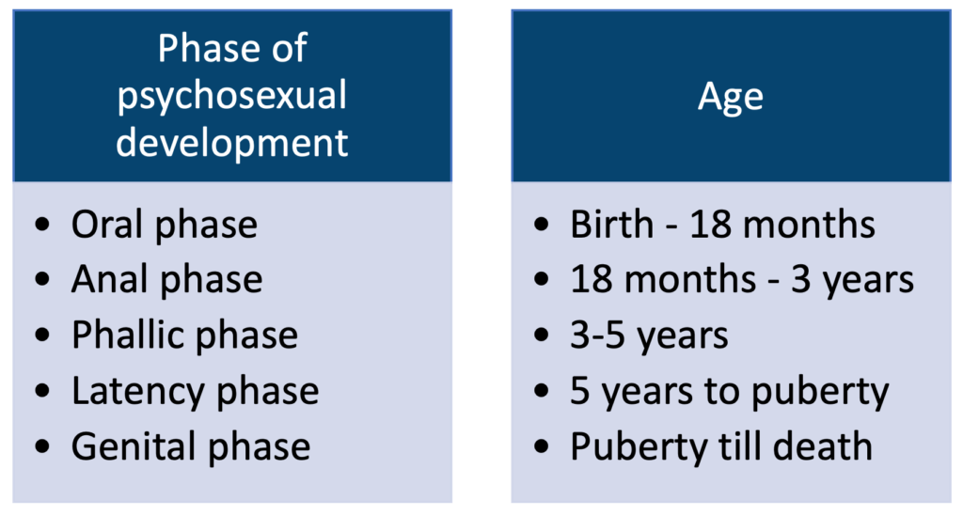

**References:**

(1) Bailey, J. M., Dunne, M. P., & Martin, N. G. (2000). Genetic and environmental influences on sexual orientation and its correlates in an Australian twin sample. Journal of Personality and Social Psychology, 78(3), 524-536.

(2) De Cuypere, G., Elaut, E., Heylens, G., Gijs, L., Selvaggi, G., De Sutter, P., & Monstrey, S. (2006). Long-term follow-up: Psychosocial outcome of Belgian transsexuals after sex reassignment surgery. Sexologies, 15(2), 126-133.

(3) Flores, A., Herman, J., Gates, G. and Brown, T. (2022). How many adults identify as transgender in the United States? [online] Williams Institute. Available at: https://williamsinstitute.law.ucla.edu/publications/trans-adults-united-states/.

(4) Mark KP, Janssen E. (2018) Understanding sexual preferences: A multivariate approach. J Sex Res. 2018;55(3):332-343.

(5) Savin-Williams, R. C. (2005). The new gay teenager. Cambridge, MA: Harvard University Press.

### 2.1.12 Adolescence

## **Adolescence as a Development Phase with Special Reference to Pubertal Changes**

Adolescence is a critical development phase that is characterized by significant physical, cognitive, and emotional changes. One of the most notable changes during adolescence is the onset of puberty, which is characterized by the physical maturation of the reproductive system and the development of secondary sexual characteristics.

Puberty is a complex process that is triggered by the release of certain hormones, such as gonadotropin-releasing hormone (GnRH), luteinizing hormone (LH), and follicle-stimulating hormone (FSH), from the hypothalamus and pituitary gland. These hormones stimulate the gonads, which are the ovaries in females and the testes in males, to produce estrogen, testosterone, and other hormones that drive the development of secondary sexual characteristics.

Pubertal changes in females typically begin with breast development, followed by the growth of pubic and underarm hair, and the onset of menstruation. Males typically experience an increase in testicular size, the growth of pubic and underarm hair, and the deepening of the voice.

Adolescence is also a phase marked by many cognitive and emotional changes, such as increased self-awareness, the ability to think abstractly, and heightened emotional sensitivity. Adolescents may also experience increased feelings of self-consciousness, self-doubt, and anxiety as they navigate this period of rapid change and try to establish their own identities.

It’s important to note that the timing of puberty can vary greatly among individuals and can be influenced by a variety of factors, including genetics, nutrition, and overall health. Additionally, it is also important to note that not all individuals fit into the binary of male or female and that the experiences of those who identify as non-binary or trans may differ from the typical experience of cisgender individuals.

In conclusion, Adolescence is a critical development phase marked by significant physical, cognitive, and emotional changes, with pubertal changes being one of the most notable changes. It’s important to note that the timing of puberty can vary greatly among individuals and can be influenced by a variety of factors and that not all individuals fit into the binary of male or female (Blakemore, 2006) (Smith, 2011).

## ‘Taskmastery’:

One important aspect of adolescent development is the development of task mastery, which refers to the ability to set and achieve goals, plan and organize tasks, and manage time effectively. During adolescence, individuals begin to develop the ability to think abstractly and to set and pursue long-term goals. This is an important step in the development of task mastery, as it allows adolescents to set goals and plan for the future. Adolescents also begin to develop the ability to think about multiple possible outcomes and to evaluate different options, which is crucial for decision-making and goal-setting.

As adolescents develop these cognitive abilities, they also begin to take on more responsibility and become more independent. They are expected to manage their own time and complete school work, chores and other responsibilities. This can be challenging, as adolescents may not yet have fully developed the skills necessary to manage their time and responsibilities effectively.

Adolescents also face many emotional and social challenges during this period of development, and these can impact their ability to develop task mastery. For example, adolescents may experience increased feelings of self-consciousness and anxiety, which can make it difficult for them to focus on tasks and set and achieve goals. Additionally, adolescents may also face social pressure and may be influenced by the opinions and behaviours of their peers, which can also impact their ability to develop task mastery.

It’s important for parents and caregivers to provide adolescents with guidance and support as they develop task mastery. This can include providing structure and setting clear expectations for responsibilities, providing opportunities for adolescents to take on new responsibilities and challenges, and teaching adolescents time management and organizational skills. Additionally, teaching adolescents about setting achievable goals and planning for the future, can be helpful.

## Conflict with parents and authority:

Conflict with parents and authority figures is a common experience during adolescence, as adolescents begin to assert their independence and establish their own identities. During this period, adolescents may begin to question the rules and expectations of their parents and other authority figures. They may feel that these rules are unjust or that they are being treated unfairly. This can lead to arguments and disagreements, as adolescents may feel that they are not being heard or understood by their parents or other authority figures.

Additionally, adolescents may also experience conflicts with authority figures at school, such as teachers or administrators. They may feel that the rules and expectations of the school are unfair or that they are being treated unjustly. This can lead to conflicts over homework, attendance, and behaviour, and can also result in disciplinary action. It’s important to note that conflicts with parents and authority figures can be a normal and healthy part of adolescent development, as adolescents learn to assert themselves and become more independent. However, it can also be challenging and stressful for both adolescents and the authority figures involved.

To minimize conflicts, parents and authority figures should try to be open and understanding and listen to the adolescents’ perspectives. They should also try to set clear and reasonable rules and expectations and provide consistent consequences for breaking those rules. Additionally, it’s important for parents and authority figures to provide guidance and support to adolescents as they navigate this period of development. For adolescents, it’s important to be able to express themselves, their opinions and feelings in a calm and respectful manner, and to try to understand the perspective of the authority figure. They should also try to be open to compromise and to understand that rules and expectations are in place for their own safety and well-being.

## **Affective stability and ‘turmoil’**:

Adolescence is a period of significant emotional and psychological change, and adolescents often experience a wide range of emotions and moods. One aspect of adolescent development that is often studied is affective stability, which refers to the ability to regulate emotions and maintain a relatively consistent emotional state.

Many adolescents experience emotional turmoil, which is characterized by mood swings, emotional outbursts, and difficulties in regulating emotions. This can be a normal part of adolescent development as the adolescent brain is still developing and the individual is still learning how to cope with and express their emotions. This can also be associated with the hormonal changes that take place during puberty. However, for some adolescents, emotional turmoil may be more severe and may interfere with their daily functioning. This could be a sign of a more serious emotional or mental health issue, such as depression or anxiety.

There are various ways to support adolescents with affective instability. Encouraging open communication and listening actively is important. As well as providing emotional support, providing a safe and stable environment, and positive reinforcement when adolescents successfully regulate their emotions can be helpful. Encouraging regular physical activity, healthy eating, and good sleep hygiene can also help to promote overall well-being. In addition, some adolescents may benefit from counselling or therapy, which can help them to learn coping strategies for managing their emotions and to develop the skills needed to maintain affective stability (Steinberg, 2005).

## **Normal and Abnormal Adolescent Development**

Normal adolescent development includes physical changes such as the onset of puberty, cognitive changes such as the increased ability to think abstractly and make decisions, and emotional changes such as increased self-awareness and the desire for independence. Additionally, adolescents also experience changes in their social and interpersonal relationships, such as increased interest in and involvement with peers (Susman, 2003)

However, not all adolescents have the same experiences during this period of development. Some adolescents may experience difficulties or delays in one or more areas of development. This can be due to a variety of factors, such as genetic or environmental factors, or a combination of both.

Abnormal adolescent development refers to difficulties or delays in one or more areas of development that are severe enough to cause significant impairment or distress. For example, an adolescent who is significantly delayed in their physical development or who is experiencing severe emotional difficulties may be considered to be experiencing abnormal development.

It’s important to note that it’s not always easy to distinguish between normal and abnormal adolescent development. There is a wide range of normal variation in adolescent development, and what may be considered abnormal for one adolescent may be within the range of normal for another. Additionally, it’s important to consider the context and the individual’s unique experiences and circumstances when determining if development is normal or abnormal.

Some examples of medical conditions that can lead to abnormal adolescent development include:

* Genetic disorders: Certain genetic disorders, such as Down syndrome or Turner syndrome, can lead to delays in physical and cognitive development.
* Endocrine disorders: Hormonal imbalances, such as those caused by diabetes or thyroid disorders, can lead to delays in physical development or difficulties in emotional regulation.
* Neurological disorders: Conditions such as cerebral palsy or epilepsy can lead to difficulties in physical development or cognitive functioning.
* Chronic illnesses: Adolescents with chronic illnesses, such as asthma or cystic fibrosis, may experience difficulties in physical development or emotional regulation.
* Mental health disorders: Adolescents with mental health disorders, such as depression or anxiety, may experience difficulties in emotional regulation or cognitive functioning (Graber, 2010).

**References:**

(1) Blakemore, S. J., & Choudhury, S. (2006). Development of the adolescent brain: implications for executive function and social cognition. Journal of Child Psychology and Psychiatry, 47(3-4), 296-312.

(2) Graber, J. A., Brooks-Gunn, J., & Warren, M. P. (2010). Pubertal development and depression: a meta-analytic review. Journal of Adolescent Health, 47(2), 203-220.

(3) Smith, J. L., & Harford, T. C. (2011). Adolescent development and the biology of puberty: summary of a workshop on new research. Journal of Adolescent Health, 49(2), S1-S2.

(4) Steinberg, L. (2005). Cognitive and Affective Development in Adolescence. Trends in Cognitive Sciences, 9(2), 69-74.

### 2.1.13 Adaptations in adult life

## **Adaptations in Adult Life**

Adaptations in adult life refer to the changes that individuals go through as they age. These changes can occur in multiple domains, including physical, emotional, and cognitive.

Physical adaptations in adult life include changes in vision, hearing, and mobility. As individuals age, they may experience a decline in visual acuity and may develop conditions such as cataracts or age-related macular degeneration. Similarly, hearing loss is a common occurrence in older adults, with age-related hearing loss affecting one in three adults over the age of 65 (NIDCD, 2021). Physical changes in the body can also lead to a decline in mobility, with older adults being more susceptible to falls and other accidents.

Emotional adaptations in adult life include changes in mood and coping mechanisms. Studies have shown that older adults are more likely to experience depression and other mood disorders (Laidlaw et al., 2020). However, some research also suggests that older adults may have better-coping mechanisms and greater resilience to stress compared to younger adults (Pinquart & Sörensen, 2001).

Cognitive adaptations in adult life include changes in memory, attention, and problem-solving abilities. Age-related declines in cognitive function are a normal part of ageing, with changes in working memory, processing speed and executive function being the most commonly reported (Salthouse, 2010). However, it is important to note that cognitive decline is not an inevitable aspect of ageing and that older adults can maintain cognitive function through activities such as regular physical exercise, cognitive training and social engagement.

In conclusion, adaptations in adult life are a normal part of ageing and can occur in multiple domains, including physical, emotional and cognitive. It is important for individuals to be aware of these changes and to take steps to maintain their physical and mental health as they age.

## Pairing:

Adaptations in adult life can also have an impact on relationships and pairings. As individuals age, they may experience changes in physical, emotional, and cognitive abilities that can affect their interactions with others.

|  |  |
| --- | --- |
| ***Pairing*adaptation:** | **Summary:** |
| **Physical** | Physical adaptations, such as changes in vision and hearing, can make communication with others more difficult. This can lead to misunderstandings, frustration, and isolation. It can also make it harder for older adults to participate in activities they once enjoyed, such as going to the movies or attending social events, which can further limit their social interactions. |
| **Emotional** | Emotional adaptations, such as changes in mood and coping mechanisms, can also affect relationships. For example, older adults who experience depression or other mood disorders may find it harder to maintain positive relationships with their loved ones. Similarly, changes in coping mechanisms can lead to different ways of responding to stress, which can be difficult for partners to understand. |
| **Cognitive** | Cognitive adaptations, such as changes in memory, attention, and problem-solving abilities, can also have an impact on relationships. For example, older adults may have trouble remembering important dates or appointments, which can lead to disappointment or frustration for their partners. They may also have difficulty following conversations or understanding complex information, which can make communication more challenging. |

It is important for couples and other pairings to be aware of these potential changes and to make adjustments in order to maintain their relationship. This can include finding new ways of communicating, setting realistic expectations and finding new activities to do together. Couples counselling and therapy can also be beneficial in addressing and coping with these adaptations in adult life.

## Parenting:

Adaptations in adult life can have a significant impact on parenting. As individuals age, they may experience changes in physical, emotional, and cognitive abilities that can affect their ability to parent.

|  |  |
| --- | --- |
| ***Pairing*adaptation:** | **Summary:** |
| **Physical** | Physical adaptations, such as changes in vision and hearing, can make it more difficult for older adults to keep up with the demands of parenting. For example, an older parent with declining vision may have trouble seeing a child’s homework or monitoring their activities, while an older parent with hearing loss may have trouble understanding a child’s verbal communication. These physical limitations can make it harder for older adults to provide the necessary guidance and support to their children. |
| **Emotional** | Emotional adaptations, such as changes in mood and coping mechanisms, can also affect parenting. For example, older adults who experience depression or other mood disorders may find it harder to maintain positive relationships with their children. They may also have trouble coping with the stress of parenting and may find it harder to provide emotional support to their children. |
| **Cognitive** | Cognitive adaptations, such as changes in memory, attention, and problem-solving abilities, can also have an impact on parenting. For example, older adults may have trouble remembering important information about their children, such as their schedules or their medical history. They may also have difficulty following conversations or understanding complex information, which can make communication more challenging. |

It is important for older adults who are parents to be aware of these potential changes and to make adjustments in order to continue to effectively parent their children. This can include seeking support from other family members or caregivers, finding new ways of communicating, setting realistic expectations, and finding new activities to do together.

## Illness:

Illness can also have an impact on adaptations in adult life. As individuals age, they may develop chronic health conditions that can affect their physical, emotional, and cognitive abilities.

|  |  |
| --- | --- |
| ***Pairing*adaptation:** | **Summary:** |
| **Physical** | Physical adaptations can occur as a result of an illness. For example, a chronic illness such as arthritis can cause pain and stiffness in the joints, making it more difficult for older adults to move around and perform daily activities. Similarly, chronic conditions like heart disease, diabetes, or respiratory illness can lead to decreased mobility and physical function. These chronic health conditions can affect not only physical adaptations but also mental health, leading to depression and anxiety. |
| **Emotional** | Emotional adaptations can also occur as a result of an illness. Chronic illnesses can be a significant source of stress, and older adults may experience feelings of anxiety, depression, and hopelessness as a result. They may also experience changes in mood and coping mechanisms as they adapt to their illness and its impact on their daily lives. |
| **Cognitive** | Cognitive adaptations can also occur as a result of an illness. Chronic illnesses can lead to cognitive decline, for example, conditions such as stroke, traumatic brain injury, or Alzheimer’s disease. These conditions can lead to changes in memory, attention, and problem-solving abilities, which can make it more difficult for older adults to manage their illness and perform daily activities. |

It is important for older adults to be aware of these potential changes and to take steps to manage their illness as they age. This can include working with healthcare providers to develop a treatment plan, making lifestyle changes, and seeking support from family and friends. Additionally, addressing the emotional and mental health impact of chronic illness can help older adults to adapt better (National Institute of Neurological Disorders and Stroke, 2021) (National Institute on Aging, 2021).

## Bereavement and loss:

Bereavement, or the experience of losing a loved one, can also have an impact on adaptations in adult life. The experience of grief can affect an individual’s physical, emotional, and cognitive abilities.

|  |  |
| --- | --- |
| ***Pairing*adaptation:** | **Summary:** |
| **Physical** | Physical adaptations can occur as a result of bereavement. Grief can cause physical symptoms such as fatigue, insomnia, and changes in appetite. Bereavement can also lead to physical changes such as weight loss or gain and can lead to a decline in physical health. This is due to the fact that the body goes through a lot of physiological changes such as increased stress hormone levels, which can cause a number of physical symptoms. |
| **Emotional** | Emotional adaptations can also occur as a result of bereavement. Grief can cause emotional symptoms such as sadness, guilt, and anger. Bereavement can also lead to changes in mood and coping mechanisms, as individuals adapt to the loss of their loved one. Grief is a natural and normal process but it can also be a long-lasting and intense experience, leading to depression and anxiety. |
| **Cognitive** | Cognitive adaptations can also occur as a result of bereavement. Grief can cause cognitive symptoms such as difficulty concentrating, forgetfulness, and confusion. Bereavement can also lead to changes in memory, attention, and problem-solving abilities as individuals try to adjust to life without their loved ones. |

It is important for older adults who are experiencing bereavement to be aware of these potential changes and to take steps to manage their grief as they age. This can include seeking support from family and friends, talking to a therapist or counsellor, and participating in support groups. Additionally, it’s important to have self-care activities and maintain physical activity. Coping with grief can be challenging and can take time, but with the right support and resources, older adults can adapt and move forward in their lives (National Institute on Aging, 2021) (Hospice UK, 2021).

**References:**

(1) Carstensen, L. L. (2006). The influence of a sense of time on human development. Science, 312(5781), 1913-1915.

(2) Hospice UK (2021). Bereavement and Grief. Retrieved from https://www.hospiceuk.org/support-us/grief-and-bereavement-support/bereavement-and-grief

(3) Laidlaw, K., Lipson, S. F., & Pressman, S. D. (2020). Age-related differences in mood and coping: a systematic review. International Journal of Geriatric Psychiatry, 35(9), 994-1004.

(4) National Institute on Aging (2021). Alzheimer’s Disease. Retrieved from https://www.nia.nih.gov/health/alzheimers-disease

(5) National Institute on Aging (2021). Grief and Bereavement. Retrieved from https://www.nia.nih.gov/health/grief-and-bereavement

(6) National Institute on Deafness and Other Communication Disorders (2021). Age-Related Hearing Loss. Retrieved from https://www.nidcd.nih.gov/health/age-related-hearing-loss

(7) National Institute of Neurological Disorders and Stroke (2021). Stroke. Retrieved from https://www.ninds.nih.gov/disorders/stroke

(8) Pinquart, M., & Sörensen, S. (2001). Stress and coping in older adults: a meta-analysis. Psychology and aging, 16(4), 706.

(9) Salthouse, T. A. (2010). Major issues in cognitive aging. Oxford University Press.

### 2.1.14 Pregnancy and childbirth

## Pregnancy and Childbirth and the Stresses both Physiological and Psychological

Pregnancy and childbirth are significant life events that can have a profound impact on the physical, emotional, and psychological well-being of expecting mothers and their partners. Pregnancy is a complex process that involves a wide range of physiological and psychological changes. The expectant mother’s body undergoes significant changes, such as weight gain, hormonal fluctuations, and physical discomforts, which can cause stress and anxiety. Emotionally, expectant mothers may experience a range of feelings, such as excitement, anticipation, joy, and anxiety.

During pregnancy, expecting mothers may be concerned about the health and well-being of the unborn child. They may worry about potential complications, such as miscarriage, preterm labour, or birth defects. They may also be concerned about the impact that pregnancy and childbirth will have on their bodies and their relationships.

Childbirth is a unique and unpredictable event that can be both physically and emotionally demanding. The pain of labour and delivery can be intense and can cause significant stress for the mother. Additionally, the unpredictability of labour and delivery can be a source of anxiety for expecting mothers and their partners.

The postpartum period is also a time of significant change and adaptation for new mothers. Physical recovery from childbirth can take several weeks or even months, and mothers may experience a range of physical discomforts such as fatigue, pain, and hormonal fluctuations. Emotionally, new mothers may experience a range of feelings, including elation, joy, and love, as well as feelings of sadness, anxiety, and depression.

It is essential that expecting mothers and their partners take care of themselves during this time, both physically and emotionally. Expecting mothers should seek prenatal care from healthcare providers to ensure the health and well-being of both the mother and the unborn child. They should also practice self-care, such as getting enough rest, eating well, and engaging in physical activity.

Expecting mothers and their partners should also seek support from family and friends, and may also consider seeking the help of a counsellor or therapist to help them cope with the emotional and psychological stress of pregnancy and childbirth.

In conclusion, Pregnancy and childbirth are significant life events that can have a profound impact on the physical, emotional, and psychological well-being of expecting mothers and their partners. It’s crucial to take care of oneself during this time and seek support from healthcare providers, family and friends, and mental health professionals to minimize the stress and anxiety associated with these events.

## Physiological:

There are several physiological stressors that can occur during pregnancy and childbirth that can have an impact on the health and well-being of the mother and the unborn child.

One of the major stressors during pregnancy is the hormonal changes that occur in the body. The increased levels of progesterone and estrogen can cause a range of physical and emotional symptoms, such as fatigue, nausea, and mood swings (Pusdekar, 2016). These hormones can also lead to an increased risk of anxiety and depression during pregnancy (Gavin, 2005).

Another physiological stressor during pregnancy is the physical discomforts that can occur, such as back pain, headaches, and gestational diabetes (NHS, 2022). These discomforts can cause significant stress and anxiety for the mother and can negatively impact her quality of life.

During childbirth, the mother experiences a range of physiological stressors, such as pain and discomfort during labour, the risk of complications such as preterm labour or fetal distress, and the potential for injury during delivery (ACOG, 2021). These stressors can have a significant impact on the mother’s physical and emotional well-being.

In the postpartum period, new mothers may experience physiological stressors such as fatigue, pain, and hormonal fluctuations (ACOG, 2019). These stressors can make it difficult for mothers to care for themselves and their newborns and can negatively impact their physical and emotional well-being.

It’s important to note that these stressors can vary greatly depending on the individual and the circumstances and that not all women will experience the same stressors or to the same degree.

## Psychological:

In addition to physiological stressors, there are also several psychological stressors that can occur during pregnancy and childbirth. These stressors can have a significant impact on the mental health and well-being of expecting mothers and their partners.

One of the major psychological stressors during pregnancy is the emotional and psychological adjustment to the changes that occur during pregnancy. Expecting mothers may experience a range of emotions, such as excitement, anticipation, and joy, but they may also experience anxiety, fear, and worry about the health and well-being of the unborn child. These emotional and psychological changes can be stressful and can lead to an increased risk of anxiety and depression during pregnancy (Gavin, 2005).

Another psychological stressor during pregnancy is the impact that pregnancy and childbirth can have on relationships. Expecting mothers and their partners may have different expectations and feelings about pregnancy and childbirth, which can lead to conflicts and stress within the relationship (Dunkel, 2009).

During childbirth, the unpredictability and pain of labour and delivery can be a significant psychological stressor for the mother. The fear of complications or injury can also cause significant stress and anxiety for the mother and her partner (ACOG, 2021).

In the postpartum period, new mothers may experience psychological stressors such as adjusting to the role of motherhood, coping with the demands of caring for a newborn, and dealing with the physical and emotional changes that occur postpartum (ACOG, 2019). These stressors can lead to feelings of depression, anxiety and postpartum depression.

It’s important to note that these stressors can vary greatly depending on the individual and the circumstances and that not all women will experience the same stressors or to the same degree.

**References:**

(1) ACOG, American College of Obstetricians and Gynecologists (2021). Pregnancy and childbirth. Available at: https://www.acog.org/patient-resources/faqs/pregnancy

(2) ACOG, American College of Obstetricians and Gynecologists (2019). Postpartum recovery. Available at: https://www.acog.org/patient-resources/faqs/postpartum-recovery

(3) Dunkel Schetter, C., Glynn, L. M., Hobel, C. J., Sandman, C. A., & Chicz-DeMet, A. (2009). Pregnancy and childbirth: Effects on mental and physical health. In Handbook of Behavioral Medicine: Methods and Applications (pp. 609-632). Springer New York.

(4) Gavin, N. I., Gaynes, B. N., Lohr, K. N., Meltzer-Brody, S., Gartlehner, G., & Swinson, T. (2005). Perinatal depression: a systematic review of prevalence and incidence. Obstetrics & Gynecology, 106(5), 1071-1083.

(5) NHS (2022). Pregnancy and childbirth. Available at: https://www.nhs.uk/conditions/pregnancy-and-baby/pregnancy-and-childbirth/

(6) Pusdekar, Y., & Jadhav, S. (2016). Hormonal changes during pregnancy. Journal of prenatal medicine, 10(2), 11.

### 2.1.15 Personal identity

## The Development of Personal (Ego-) Identity in Adolescence and Adult life

Personal identity refers to an individual’s sense of self, or the unique characteristics, traits, and attributes that make them who they are. It includes aspects such as personality, beliefs, values, and experiences, as well as an individual’s physical and social characteristics. Personal identity is a multifaceted concept that encompasses cognitive, emotional, and social aspects of an individual’s self-concept.

During adolescence, individuals begin to question and explore their sense of self, which leads to the development of personal identity. This process is known as identity formation and it is a central task of adolescence. Adolescents explore and experiment with different roles, values, beliefs, and behaviours in order to find a sense of self that feels authentic and meaningful to them.

The development of personal identity is influenced by a number of factors. Family plays an important role in shaping an individual’s sense of self, as parents and other family members often serve as the primary source of socialization and role models. Peers also have a significant impact on identity formation, as adolescents often look to their peers for validation and acceptance. Cultural and societal factors, such as religion, race, and socioeconomic status, also play a role in shaping an individual’s personal identity. Additionally, personal experiences and the ability to reflect on them also play a key role in the development of personal identity.

As individuals move through adulthood, their sense of self continues to evolve and change. Major life events, such as marriage, the birth of a child, or the loss of a loved one, can have a significant impact on personal identity. Changes in personal circumstances, such as a change in career or a move to a new city, can also affect an individual’s sense of self. Additionally, exposure to new ideas and perspectives, whether through travel, education, or other experiences, can lead to personal growth and the development of a more complex and nuanced personal identity (Berzonsky, 2009).

Overall, personal identity is a dynamic and ongoing process that begins in adolescence and continues throughout adulthood. It is shaped by a variety of internal and external factors and is constantly evolving as individuals grow and change over time.

## Work, Ethnic, Gender and Other Identities

Work identity refers to the sense of self that individuals develop through their occupation or profession. It includes the roles, responsibilities, and skills associated with a particular job, as well as the values and beliefs associated with the work and the larger profession or industry. This identity can be a significant part of an individual’s overall sense of self, as it often shapes their sense of purpose and meaning, as well as their sense of belonging within a community (Constant, 2006).

Ethnic identity refers to the sense of self that individuals develop in relation to their ethnic or cultural background. It includes the values, beliefs, and customs associated with a particular ethnic or cultural group, as well as the sense of belonging and connection to that group. Ethnic identity can have a significant impact on personal identity, particularly for individuals who come from a marginalized or minority ethnic group.

Gender identity refers to the sense of self that individuals develop in relation to their gender. It includes the sense of oneself as a man, woman, or non-binary person, as well as the feelings, beliefs, and behaviours associated with that gender. Gender identity is a central aspect of personal identity and can have a significant impact on an individual’s sense of self, as well as their relationships and interactions with others.

Other identities that individuals may develop include sexual identity, religious identity, and political identity. Sexual identity refers to the sense of self that individuals develop in relation to their sexual orientation and sexual behaviour. Religious identity refers to the sense of self that individuals develop in relation to their religious or spiritual beliefs, practices, and traditions. Political identity refers to the sense of self that individuals develop in relation to their political beliefs, values, and affiliations.

All of these identities can interact and overlap in complex ways, influencing one another and shaping an individual’s overall sense of self. Some identities may be more central to an individual’s sense of self than others, and the salience of different identities can change over time and across different contexts.

## Mid-life ‘crises’

The term “mid-life crisis” is often used to describe a period of introspection and self-evaluation that some individuals experience in middle age. This period is characterized by feelings of dissatisfaction, uncertainty, and a sense of questioning one’s life choices, values, and goals. It is often associated with a desire for change or a sense of wanting to “start over.”

The concept of a “mid-life crisis” has been popularized in popular culture, but it is not a universally accepted or scientifically proven phenomenon. Some experts argue that the idea of a mid-life crisis is a myth, while others suggest that it is a real but overstated phenomenon.

Some experts argue that the idea of a mid-life crisis is a myth, while others suggest that it is a real but overstated phenomenon. There are different theories about what might cause a mid-life crisis. Some researchers suggest that it is a normal part of the ageing process, marked by a sense of time running out and a desire to make the most of the years that are left. Others propose that it may be related to a specific life event, such as the empty nest syndrome, or the loss of a parent (Freund, 2009).

There are also different ideas about how to cope with a mid-life crisis. Some experts recommend making positive changes in one’s life, such as taking up new hobbies or exploring new career opportunities. Others suggest that it is important to accept the changes that come with ageing and to focus on finding meaning and purpose in one’s current circumstances.

It is important to note that not everyone experiences a mid-life crisis, and it’s not a universally accepted phenomenon, so, it’s not a necessary stage in life. Also, it’s important to consider seeking professional help if the feelings of dissatisfaction, uncertainty, and questioning become overwhelming or debilitating.

**References:**  
(1) Berzonsky, M.D. (2005). Ego Identity: A Personal Standpoint in a Postmodern World. Identity, 5(2), pp.125–136. doi:10.1207/s1532706xid0502_3.

‌(2) Constant, A.F., Gataullina, L. and Zimmermann, K.F. (2006). Gender, Ethnic Identity and Work. [online] papers.ssrn.com. Available at: https://papers.ssrn.com/sol3/papers.cfm?abstract_id=955344 [Accessed 19 Jan. 2023].

(3) Freund, A.M. and Ritter, J.O. (2009). Midlife Crisis: A Debate. Gerontology, [online] 55(5), pp.582–591. doi:10.1159/000227322.

### 2.1.16 Normal ageing

## **Normal Ageing and its Impact on Physical, Social, Cognitive and Emotional Aspects of Individual Functioning**

Normal ageing is a complex process that affects various aspects of an individual’s functioning, including physical, social, cognitive, and emotional well-being (Levy, 2002).

Physical changes associated with normal ageing include a decline in muscle mass and strength, decreased cardiovascular and respiratory function, and a decrease in sensory abilities, such as vision and hearing. These changes may lead to an increased risk of falls and injuries, as well as increased vulnerability to chronic diseases such as heart disease, stroke, and diabetes. The decline in muscle mass and strength is primarily due to the age-related decrease in the levels of hormones that regulate muscle growth and maintenance, specifically testosterone in men and estrogen in women. This decline in muscle mass and strength make older adults more susceptible to falls and injuries, which can lead to a decline in physical function, independence, and overall quality of life. Additionally, the decrease in cardiovascular and respiratory function may lead to decreased ability to engage in physical activity, which can further contribute to a decline in physical function and overall health. The decline in sensory abilities, such as vision and hearing, can lead to difficulty with activities of daily living and decreased participation in social and recreational activities (Fried, 2004).

Social changes associated with normal ageing include a decline in social support networks, increased isolation and loneliness, and a decline in participation in community activities. These changes may lead to a decline in overall quality of life and an increased risk of depression and other mental health issues. The decline in social support networks may be due to the loss of family members and friends, as well as changes in living arrangements, such as moving to a retirement community or assisted living facility. Social isolation and loneliness can have a significant impact on emotional well-being and can lead to depression and other mental health issues. In addition, the decline in participation in community activities can also lead to a decline in overall quality of life, as older adults may no longer have access to the social, intellectual, and physical stimulation that these activities provide.

Cognitive changes associated with normal ageing include a decline in processing speed, working memory, and executive function. These changes may lead to difficulty with tasks such as planning, problem-solving, and decision-making. However, it is important to note that not all older adults experience cognitive decline, and some may even exhibit improvements in certain cognitive abilities such as knowledge and verbal abilities. Age-related cognitive decline is primarily due to the decline in neural plasticity, which refers to the brain’s ability to adapt and change in response to new information and experiences. This decline in neural plasticity can lead to a decline in cognitive function, which can affect daily activities, such as managing finances, remembering to take medications, and driving.

Emotional changes associated with normal ageing include increased vulnerability to stress, increased risk of depression, and an increased tendency towards negative affect. These changes may lead to a decline in overall well-being and quality of life. Age-related emotional changes can be due to a variety of factors, including physical changes, social changes, and cognitive changes. For example, the decline in physical function and increased risk of chronic diseases can lead to increased stress, which can affect emotional well-being. Additionally, the decline in social support networks and increased isolation can also lead to increased stress and emotional distress. Finally, the decline in cognitive function can lead to increased stress and frustration, which can also affect emotional well-being (Jeste, 2003).

It is important to note that normal ageing is a highly individualized process and that there is a wide range of variations in how people experience the ageing process. Additionally, normal ageing can be influenced by a variety of factors, including genetics, lifestyle, and overall health status.

In summary, normal ageing is a complex process that affects various aspects of an individual’s functioning. Physical changes, such as a decline in muscle mass and strength, decreased cardiovascular and respiratory function, and a decrease in sensory abilities, can lead to an increased risk of falls and injuries, as well as increased vulnerability to chronic diseases. Social changes, such as a decline in social support networks, increased isolation and loneliness

## **Social Changes Accompanying Old Age**

Social changes accompanying old age can have a significant impact on an individual’s overall well-being and quality of life. Some of the most notable social changes that occur with ageing include:

|  |  |
| --- | --- |
| ***Social factors of old age:*** | ***Summary:*** |
| **A decline in social support networks** | As people age, they may lose friends and family members due to death or distance. This can lead to a decline in social support networks and an increased risk of isolation and loneliness. |
| **Decrease in participation in community activities** | Older adults may also experience a decline in their participation in community activities, such as volunteering or joining clubs, due to physical limitations or a lack of transportation. This can lead to a decline in overall quality of life and a decrease in opportunities for social interaction. |
| **Changes in living arrangements** | Many older adults may choose to move to retirement communities or assisted living facilities, which can lead to a loss of independence and a decline in social connections. |
| **Ageism and discrimination** | Older adults may also experience ageism and discrimination, which can negatively impact their social relationships and overall well-being. |
| **Changes in roles and identity** | As people age, they may experience changes in their roles and identity. For example, older adults may retire from work, which can lead to a loss of purpose and a decline in self-esteem. |

These social changes can have a significant impact on emotional well-being, mental health, and overall quality of life. It is important for older adults to have access to resources and support systems that can help them cope with these changes and maintain social connections (Cohen, 2018), (Isaacowitz, 2008).

## **Importance of loss**:

Loss is a significant aspect of the ageing process and can have a significant impact on an individual’s emotional well-being and overall quality of life. Loss can take many forms, including the loss of friends and family members due to death, the loss of physical abilities, the loss of independence and autonomy, the loss of roles and identity, and the loss of social connections.

The loss of friends and family members can have a significant impact on emotional well-being and can lead to feelings of grief, isolation, and loneliness. This can be particularly challenging for older adults who may have limited social support networks.

The loss of physical abilities can also be a significant source of emotional distress for older adults. The decline in physical function can lead to a loss of independence and autonomy, which can affect self-esteem and overall quality of life.

The loss of roles and identity can also be a significant source of emotional distress for older adults. For example, older adults may experience a loss of purpose and self-worth when they retire from work or when they are no longer able to participate in activities that they previously enjoyed.

It is important to note that loss is a normal and natural part of the ageing process and that older adults can adapt to loss and continue to find meaning and fulfilment in life. Supportive interventions such as grief counselling, social support, and reminiscence therapy can be helpful in coping with loss. Additionally, interventions such as activities and programs that promote social engagement, physical activity, and cognitive stimulation can help older adults to maintain a sense of purpose and fulfilment in life (Schut, 2010).

## **Personality changes with ageing**:

Personality is a complex and multifaceted construct that can change over the course of an individual’s lifetime, including during the ageing process. While some personality traits may remain relatively stable across the lifespan, other traits may change or be modified as a person ages (Roberts, 2000).

One of the key changes in personality that can occur with ageing is a shift towards increased emotional stability and a decrease in negative emotions such as anxiety and neuroticism. This shift is often referred to as the “maturity principle,” which suggests that as people age, they become more emotionally stable and better able to cope with stress and adversity. This shift towards emotional stability may be due to a combination of factors, including the accumulation of life experiences, the development of coping skills, and the decline in the levels of certain hormones that are associated with stress and negative emotion.

Another change in personality that can occur with ageing is a decline in cognitive abilities, such as memory and attention, which may lead to changes in personality. For example, older adults may experience difficulty with tasks that require working memory or executive function, which can affect their ability to plan, organize, and make decisions. These changes in cognitive abilities can also affect an older person’s ability to regulate their emotions, leading to increased emotional instability and negative affect.

Additionally, some researchers suggest that as people age, they may become more set in their ways and less open to new experiences, which is referred to as the “crystallization of personality”. This means that older adults may become more rigid and less open to change, which can affect their ability to adapt to new situations and may lead to a decline in overall well-being (Srivastava, 2003).

It is important to note that personality changes with ageing can vary widely among older adults and that some older adults may experience little or no change in their personalities. Furthermore, age-related changes in personality can be influenced by a variety of factors, such as genetics, lifestyle, and overall health status.

## **Social and Economic Factors in Old Age**

Social and economic factors can have a significant impact on an individual’s well-being and quality of life in old age. Some of the key social and economic factors that affect older adults include:

|  |  |
| --- | --- |
| **Social and economic factors in old age**: | **Summary:** |
| **Attitude** | Attitude is a social factor that can have a significant impact on an individual’s well-being and quality of life in old age. Older adults who have positive attitudes towards ageing tend to report higher levels of life satisfaction, better physical and mental health outcomes, and more resilience and adaptability in the face of life’s challenges. On the other hand, older adults who have negative attitudes towards ageing may experience more negative emotions, lower levels of life satisfaction, and a decline in overall well-being. |
| **Status of the elderly** | The status of the elderly in ageing is a complex issue that is influenced by a variety of factors, including social, economic, and cultural factors. In many societies, older adults are often seen as a burden on society and are marginalized and stigmatized, experiencing ageism and discrimination. On the other hand, in some societies older adults are respected and valued for their wisdom and experience. Economic factors such as income and financial security also play a role, as older adults with limited income and financial security may be at a higher risk of poverty and have limited access to resources and support systems. Cultural factors also have an influence, as different cultures may have different attitudes towards ageing and the role of the elderly in society. Overall, it is important for society to recognize the value and contributions of older adults and provide them with resources and support systems that can help them to maintain a high quality of life in old age. |
| **Ageism and discrimination** | Older adults may also experience ageism and discrimination, which can negatively impact their social relationships, access to goods and services, and overall well-being. |
| **Retirement** | A retirement is a significant event in the ageing process that can have a significant impact on an individual’s overall well-being and quality of life. It marks the end of formal working years and signals a transition to a new phase of life. Retirement can have positive effects, such as increased leisure time, reduced stress, and improved physical and mental health, but it can also have negative effects, such as a loss of identity, a decrease in social connections, and a decline in overall well-being. The effects of retirement can vary widely among older adults and factors such as an individual’s health, financial security, social support, and life satisfaction can all play a role in determining how well older adults adjust to retirement. Additionally, in recent years, many older adults have been choosing to delay retirement or continue working in a reduced capacity, which can have positive effects on well-being. |
| **Income** | Financial security is a critical factor for older adults, as they may have limited opportunities to increase their income and may rely heavily on their savings and investments. Limited income can lead to a decline in overall quality of life and an increased risk of poverty. |
| **Accommodation** | Adequate and affordable housing is essential for older adults, as it provides a safe and secure environment in which to live. However, older adults may face challenges such as difficulty with home maintenance, lack of accessibility, and high housing costs. |
| **Socio-cultural differences** | Socio-cultural differences in ageing refer to the variations in ageing experiences, attitudes, and expectations among different cultural groups. These differences can include variations in health behaviours and outcomes, attitudes towards ageing, and social and familial roles and responsibilities. For example, some cultures may place a greater emphasis on intergenerational relationships and family caregiving, while others may have more formal support systems for older adults. Additionally, cultural beliefs and stereotypes about ageing can also affect the way older adults are perceived and treated by society. Furthermore, some cultures may have more positive attitudes towards ageing and view it as a natural and respected part of life, while others may view ageing as a negative and undesirable process. |
| **Healthcare** | Access to quality health care is essential for older adults, as they are more likely to have chronic health conditions and may require more frequent medical attention. However, older adults may face challenges such as limited access to healthcare services, high costs of care, and a lack of long-term care options. |

(Scharlach, 2000), (Walker, 2002)

These social and economic factors can interact and exacerbate each other, creating a cycle of vulnerability that can affect an older person’s overall well-being and quality of life. It is important for older adults to have access to resources and support systems that can help them to cope with these challenges and maintain a high quality of life.

**References:**

(1) Cohen, G. D. (2018). Social factors in aging. In Handbook of the Psychology of Aging (8th ed., pp. 401-420). Elsevier.

(2) Fried, L. P., Carlson, M. C., Freedman, M., Frick, K. D., Glass, T. A., Hill, J., … & Walston, J. (2004). Frailty in older adults: Evidence for a phenotype. The Journals of Gerontology Series A: Biological Sciences and Medical Sciences, 59(3), M356-M362.

(3) Isaacowitz, D. M., Toner, J., Goren, D., & Wilson, H. R. (2008). Age differences in attention to positive and negative information in natural scenes: An eye-tracking study. Psychology and aging, 23(1), 34-43.

(4) Jeste, D. V., & Blazer, D. G. (2003). Psychiatric aspects of late life. In Hazzard’s Geriatric Medicine and Gerontology (5th ed., pp. 879-907). New York: McGraw-Hill.

(5) Levy, B.R., Slade, M.D., Kunkel, S.R. and Kasl, S.V. (2002). Longevity increased by positive self-perceptions of aging. Journal of Personality and Social Psychology, 83(2), pp.261–270. doi:10.1037/0022-3514.83.2.261.

(6) Roberts, B. W., & DelVecchio, W. F. (2000). The rank-order consistency of personality traits from childhood to old age: A quantitative review of longitudinal studies. Psychological Bulletin, 126(1), 3.

(7) Scharlach, A. E. (2000). Economic insecurity and old age. The Gerontologist, 40(1), 8-19.

(8) Schut, H. A., & Stroebe, M. S. (2010). Coping with loss in later life. The Gerontologist, 50(2), 193-205.

(9) Walker, A., & Maltby, J. (2002). Ageism and its potential impact on the well-being of older people. Journal of social issues, 58(2), 333-349.

### 2.1.17 Genetic influences

## **Genetic Influences on Development Including Gene-Environment Interactions**

Genetics plays a significant role in human development, influencing physical and behavioural characteristics from conception to old age. The complex interplay between genes and the environment, known as gene-environment interactions, shapes an individual’s development and can affect the expression of genetic potential.

Genetics can influence the development of physical characteristics such as eye and hair colour, height, and facial features. Studies have also found genetic contributions to various medical conditions such as cancer, heart disease, and diabetes. For example, certain genetic variants have been identified as increasing the risk of developing conditions such as Alzheimer’s disease, and specific genetic mutations have been linked to conditions such as cystic fibrosis and sickle cell anaemia. Additionally, genetics plays a role in cognitive and behavioural development, influencing factors such as intelligence, personality, and mental health. For example, twin studies have shown that heritability estimates for cognitive abilities such as intelligence are around 50-70%. However, it is important to note that genetics alone do not determine an individual’s cognitive abilities, as the environment also plays a role.

Moreover, genetics also plays a role in the development of behavioural characteristics such as aggression and mental health disorders such as depression and anxiety. Studies have found that certain genetic variants are associated with an increased risk of developing conditions such as depression and schizophrenia. For example, a study found that individuals with a specific variant of the serotonin transporter gene were more likely to develop depression in response to stress.

However, it is important to note that genetics alone do not determine an individual’s characteristics and behaviours, as the environment also plays a significant role.

Gene-environment interactions involve the interplay between genetic makeup and the environmental conditions in which an individual develops. For example, a genetic predisposition to a certain health condition may only manifest if the individual is exposed to certain environmental factors such as diet or pollution. This can also be observed in the case of behavioural characteristics, where a genetic predisposition to a certain behaviour may only manifest if the individual is exposed to certain environmental factors such as childhood experiences or stress.

Moreover, gene-environment interactions can also occur at different stages of life, and different environmental experiences can have different impacts depending on the timing of the exposure. For example, early childhood experiences can have a greater impact on development than experiences later in life, and certain genes may be more or less responsive to environmental factors depending on the stage of development. This is known as the differential susceptibility theory which posits that some individuals may be more susceptible to the effects of negative environments but also more responsive to positive environments.

It’s also important to note that gene-environment interactions are not limited to a specific gene or environment, but rather a complex interplay between multiple genes and multiple environmental factors. This highlights the importance of considering both genetic and environmental factors in understanding human development.

In conclusion, genetic influences on development and gene-environment interactions are complex and multifaceted, and research in this field is ongoing. Understanding the interplay between genes and environment can have important implications for understanding individual differences in development and for developing interventions to improve health and well-being.

**References:**

(1) Belsky, J., & Pluess, M. (2009). Beyond diathesis stress: Differential susceptibility to environmental influences. Psychological bulletin, 135(6), 885-908.

(2) Caspi, A., Sugden, K., Moffitt, T. E., Taylor, A., Craig, I. W., Harrington, H., … & Poulton, R. (2003). Influence of life stress on depression: moderation by a polymorphism in the 5-HTT gene

(3) Plomin, R., DeFries, J. C., Knopik, V. S., & Neiderhiser, J. M. (2016). Behavioral genetics. Routledge.

(4) Scarr, S., & McCartney, K. (1983). How people make their own environments: A theory of genotype-environment effects. Child development, 54(2), 424-435.

### 2.1.18 Neuroimaging and its role in understanding development

## Neuroimaging and its Role in Understanding Development

Neuroimaging is a rapidly advancing field that allows for the non-invasive study of brain structure and function. It plays a critical role in understanding development by providing insight into the neural underpinnings of developmental processes such as learning, memory, and behaviour.

Several neuroimaging techniques have been used to study brain development in children, including magnetic resonance imaging (MRI), functional MRI (fMRI), and diffusion tensor imaging (DTI). These techniques have been used to investigate changes in brain structure and function that occur during development, such as changes in brain size, connectivity, and activity.

One of the most commonly used neuroimaging techniques is magnetic resonance imaging (MRI), which provides detailed images of brain structure. MRI can be used to study brain development in children by measuring changes in brain size, shape, and density over time. Research using MRI has shown that brain volume increases during childhood and adolescence, with the greatest changes occurring in areas involved in cognitive and emotional processing, such as the prefrontal cortex and hippocampus (Gogtay, 2004). This increase in brain volume is thought to reflect the growth and maturation of neural connections, as well as the formation of new neurons and synapses.

Another important neuroimaging technique is functional MRI (fMRI), which measures changes in brain activity by detecting changes in blood flow. fMRI can be used to study brain development by measuring changes in brain activity during different tasks, such as language, memory, or attention. Studies using fMRI have shown that brain activity changes during development, with an increase in activity in the prefrontal cortex and a decrease in activity in the amygdala (Blakemore, 2010). This change in brain activity is thought to reflect the maturation of neural connections and the development of cognitive and emotional processing.

Diffusion tensor imaging (DTI) is a technique that can be used to study the microstructure of white matter in the brain, which is important for communication between different brain regions. DTI can be used to study brain development by measuring changes in white matter connectivity over time. Research using DTI has shown that white matter tracts continue to mature and strengthen during childhood and adolescence (Barnea-Goraly, 2005). This change in white matter connectivity is thought to reflect the development of neural networks and the formation of new connections between different brain regions.

Research using neuroimaging techniques has also contributed to our understanding of developmental disorders such as autism and ADHD. Studies using MRI have shown that brain volume is reduced in certain regions in individuals with autism (Herbert, 2004), and fMRI studies have shown that brain activity is different in individuals with ADHD, particularly in regions involved in attention and impulse control (Shaw, 2007). These findings have helped to improve our understanding of the neural underpinnings of these disorders, and have also provided new insights into the potential causes and mechanisms of these conditions.

In summary, neuroimaging has played a crucial role in advancing our understanding of brain development by providing insight into the neural underpinnings of developmental processes, including changes in brain structure, activity, and connectivity. By using these techniques to study both typical and atypical development, researchers have been able to identify key neural mechanisms that underlie cognitive and emotional processing, and have also gained important insights into developmental disorders such as autism and ADHD.

## Up-to-date findings in this field:

Neuroimaging is an active and rapidly advancing field, and new findings are being published regularly. Some recent developments in the field of neuroimaging and its role in understanding development include:

**The use of machine learning algorithms to analyze neuroimaging data:** Machine learning algorithms can be used to analyze large amounts of neuroimaging data, such as MRI and fMRI, in order to identify patterns and relationships that would be difficult or impossible to detect using traditional methods. This has the potential to improve our understanding of brain development, particularly in terms of identifying neural markers of developmental disorders such as autism and ADHD.

**The use of functional near-infrared spectroscopy (fNIRS) to study brain development:** fNIRS is a non-invasive neuroimaging technique that measures changes in blood oxygenation and is particularly useful for studying brain activity in infants and young children, who may not be able to tolerate the MRI scanning environment. Recent studies have used fNIRS to study brain development in infants and young children, providing new insights into the neural underpinnings of cognitive and emotional processing.

**The use of multimodal neuroimaging to study brain development:** In recent years, there has been an increased focus on using multiple neuroimaging techniques, such as MRI, fMRI, and DTI, in combination to study brain development. This approach allows researchers to gain a more comprehensive understanding of brain development by providing information on brain structure, function, and connectivity.

**The use of neuroimaging to study brain development in non-human primates:** Non-human primate models are increasingly being used to study brain development, as they share many similarities with humans in terms of brain structure and function. Recent studies have used neuroimaging techniques such as MRI and DTI to study brain development in non-human primates, providing new insights into the neural mechanisms that underlie cognitive and emotional processing.

In summary, neuroimaging is an active and rapidly advancing field, with new findings being published regularly. Recent developments in the field include the use of machine learning algorithms, functional near-infrared spectroscopy, multimodal neuroimaging, and neuroimaging in non-human primates. These advances have the potential to improve our understanding of brain development, particularly in terms of identifying neural markers of developmental disorders such as autism and ADHD.

**References:**

(1) Barnea-Goraly, N., et al. (2005) Microstructural maturation of the human brain from childhood to adulthood. Developmental Science, 8, 1–16.

(2) Blakemore, S.J., et al. (2010) The social brain in adolescence. Nature Reviews Neuroscience, 11, 677–688.

(3) Gogtay N, et al. (2004). Dynamic mapping of human cortical development during childhood through early adulthood. Nature, 427(6972), 815-821.

(4) Herbert, M.R. et al. (2004) Increased brain folding in autism: An MRI study of frontal lobes. Cerebral Cortex, 14, 733–738.

(5) Shaw, P., et al. (2007) Attention-deficit/hyperactivity disorder is characterized by a delay in cortical maturation. PNAS, 104, 19643–19648.

# 3 Neuroscience

## 3.1 Basic Techniques in Neuroscience

### 3.1.1 Recording from the brain

## **Single Unit Recordings**

Single unit recordings provide a quality measurement method for electro-physiological responses by using a system of microelectrodes on a single neuron. When a neuron gives rise to an action potential, and the signal goes down as a ‘current’ in the neuron through the regions of the excitable membrane the flow of current moves in and out of the cell in the axon and soma. The process of this measurement is by inserting a microelectrode into the brain, where it is able to record the changes that occur with respect to time and the rate of voltage (Cogan, S.F., 2009). The Inserted microelectrodes must be a high-impedance conductor and fine-tipped. A microelectrode will be placed near the cell membrane, in order to record the extracellular value. These signal unit recordings are used in cognitive studies, in order to learn about cortical mapping and human cognition. This information can also be applied to brain-machine interface technology to control external devices (Cogan, S.F., 2008).

## **EEG – normal findings**

For recording and interpreting, the electrical activity of the brain the most frequently used technique is electroencephalography (EEG). Cranial nerve cells generate a fluctuating rhythm of electrical impulses in a distinct pattern. German scientist Hans Berger was the first to publish EEG measurements and recordings of brain wave patterns (AA Ioannides, 2004).

In EEG pairs of electrodes are attached to the scalp superficially to measure and record the electrical activity of the brain. Every electrode pair transmits a signal to one of several recording channels, between these single pairs consist of a voltage and rhythmical fluctuation that shows the characteristic peaks on a line graph (Britannica, T., 2020). The placement of 21 electrodes is based upon the 10/20 ‘International System of Electrode Placement’.

In psychiatric EEG is predominately used to assist diagnosis of seizures, monitor ECT and in polysomnogram for sleep disorders.

|  |  |  |
| --- | --- | --- |
| ***EEG wave:*** | **Frequency:** | **Summary:** |
| **Delta** | < 4 Hz | Delta waves are not seen in awake EEG. Common in the deeper stages of sleep. Delta wave presence in an awake individual indicates pathology. |
| **Theta** | 4-8 Hz | Sporadic theta waves are seen in an awake EEG at the frontotemporal region. Typically associated with drowsiness and light sleep. Excessive theta waves in an awake individual indicate pathology. |
| **Alpha** | 8-13 Hz | Alpha waves are the dominant wave frequency when your eyes are closed. They will disappear when eyes are open, attention is focused and stress/arousal. |
| **Beta** | > 13 Hz | Normal to see some beta waves in an awake individual in the frontal central position. |
| **Mu** | 7-11 Hz | Mu waves appear over the motor cortex in relation to motor activity. Attenuated by the movement of the contralateral limb. |
| **Lambda** | Single waves | Lamda waves present as a single occipital triangular, symmetrical sharp wave produced by visual scanning when the individual is awake or in light sleep. |
| **Gamma** | 30-80 Hz | Gamma waves are the fastest brain waves. They mainly occur when you’re highly alert and conscious. |

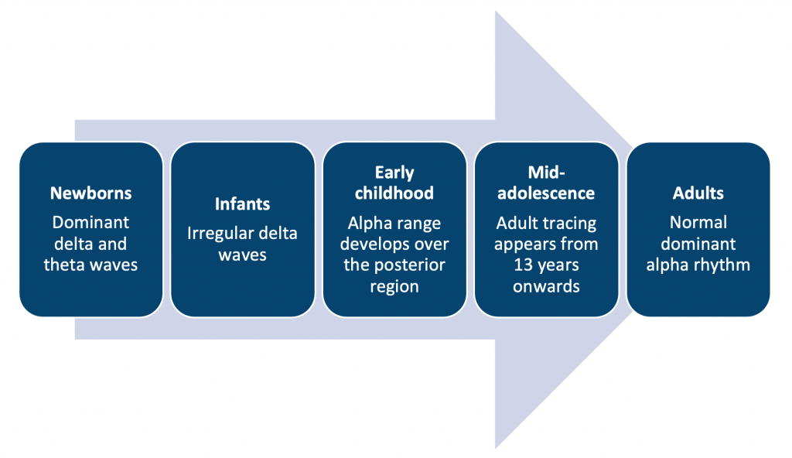

## **Evoked response techniques:**

A pattern recorded by electrodes from a particular part of the nervous system in response to a stimulus (sight, sound, touch) is known as an evoked response potential. Evoked response potential is an electric potential that is compulsory to activate a unit of charge inside without acceleration, these signals are considered important in the diagnosis of disease and also useful for detecting drug-related sensory dysfunction (Britannica, T., 2020). Evoked potential tests are intended to measure the time of response when a nerve receives stimulation.

**Event-related potential:**The P300 response is a component of an event-related potential that is typically used as a measure of attention and cognition. It is observed as a positive deflection in the EEG signal that occurs approximately 300ms after the presentation of a target stimulus and is thought to reflect the allocation of attention to relevant information.

**Evoked response potential:** is most commonly used for central nervous functions such as the brain. It recorded electric signals from the brain stem, cerebral cortex, spinal cord, and peripheral nerves, and evoked response potential measures sensory and motor response.

**Somatosensory evoked potential (SEP):** The main use of SEPs is to study and diagnose neurological conditions. They are used to measure the electrical activity generated by the somatosensory system in response to stimuli such as electrical or mechanical stimulation of the skin or nerve. They are commonly used to evaluate the integrity of the somatosensory pathways and diagnose neurological disorders such as multiple sclerosis or peripheral neuropathy. SEPs measure the relay of bodily sensations to the brain and how the brain received and interprets these sensations. Sensory response intends to measure visual evoked response, auditory evoked response, and somatosensory evoked potential (Abhang, P.A., 2016). Stimulating Electrode pairs are attached to the arms and legs however; recording electrodes are attached to the head and spine. Somatosensory evoked potential measures the functioning of peripheral nerves and the spinal cord. It measures the communication between the brain and the spinal cord (Robinson, L.R., Micklesen, P.J., 2004).

**Visual evoked potential (VEP):** measures the visual acuity. By displaying projected patterns of checkerboards or flashlights, the response data will help us identify the health of visual pathways. MRI or physical examination may not be able to detect the dysfunction. VEPs can evaluate the areas of the optic nerve, occipital cortex, optic radiation, optic chiasm, and retina. Through VEPs we can detect tumour presence on the optic nerve, brain injury, and multiple sclerosis (Hamilton, R., Bach, M., 2021).

**Auditory evoked potential (AEP):** measures the neural activity pathway to the brain. It indicates if there is a defect along the neural pathway towards the brain. AEPs are helpful in diagnosing or confirming hearing-related issues belonging to nerves. They send electrical signals to the brain in response to auditory stimuli.

**Motor-evoked potential (MEP):** measure the motor pathways through electrical signalling. By stimulating brain areas that are able to control movements. This area is known as the motor cortex. When they stimulate the motor cortex, which makes an electric signal these electrical signals are detectable in body muscles. In this way, a doctor can learn whether there’s a problem in a specific motor pathway. This technique is used during epilepsy and Parkinson’s disease surgeries. Neurosurgeons used this test to exactly know the location of motor areas within the brain (Frizzo, Ana C. F., 2015).

## **Applications to the investigation of cerebral pathology, seizure disorders, psychiatric disorders and effects of drugs on the EEG**:

|  |  |
| --- | --- |
| **Disorder:** | **EEG summary:** |
| **Absence seizure (petit-mal)** | Regular 3 Hz or less complexes are commonly found in the occipital and central regions. |
| **Alzheimer’s disease** | Useful in differentiating pseudodementia from dementia. |
| **ADHD** | Roughly 60% of individuals with ADHD have EEG abnormalities. |
| **CJD (sporadic)** | Generalised period 1-2 Hz sharp waves are seen in sporadic CJD |
| **Herpes simplex encephalitis** | Episodic discharges every 1-3 seconds over the temporal regions. |
| **Huntington’s disease** | Loss of alpha waves with a flattened trace. |
| **Neurosyphilis** | Non-specific increases in slow waves. |
| **Seizures** | Generalised multi-focal spike/wave discharge. |
| **Stroke** | Focal delta or theta waves are seen. Abnormal slow activity can also be observed. |
| **Structural lesions** | Focal slowing or focal spike activity is seen. |

|  |  |
| --- | --- |
| **Psychotropic*drug class:*** | **Summary:** |
| **Antipsychotics** | Clozapine was the drug most consistently accompanied by EEG slowing and epileptiform discharges (Jackson, 2019). |
| **Antidepressants** | Increase or decrease in alpha activity (Saletu, 1983). |
| **Lithium** | Decreased alpha activity. |
| **Anticonvulsants** | Nil effect on awake EEG. |

|  |  |
| --- | --- |
| **Sedating*drug class:*** | **Summary:** |
| **Barbituates** | Increased beta activity. |
| **Benzodiazepines** | Increased beta and delta activity. Decreased alpha activity. |
| **Opioids** | Increased theta and delta voltage. Decreased alpha activity. |

|  |  |
| --- | --- |
| **Recreational*drug class:*** | **Summary:** |
| **Alcohol** | Increased alpha and theta activity. Beta activity is a type of EEG activity that is typically present during a state of arousal and alertness. alcohol decreases the beta activity in the brain, this happens because the alcohol depresses the excitatory neurotransmitters like Glutamate and acetylcholine and this decrease in excitation leads to a decrease in the amount of beta waves. Delirium tremens show fast beta wave activity. |
| **Caffeine** | Upon withdrawal, there is increased amplitude or voltage of theta activity. |
| **Cocaine** | Increased alpha activity in the frontal brain region. Yet overall slower alpha activity elsewhere. |
| **Marijuana** | Increased alpha activity in the frontal brain region. Yet overall slower alpha activity elsewhere. |
| **Nicotine** | Increased alpha activity. Upon withdrawal, there is a decrease in alpha activity. |

## **Sleep and EEG:**

The regular cycle of sleep and awake means that different neural systems are active while others are shut off at specific times. Understanding the many stages of sleep is thus crucial to understanding the neurobiology of sleep. There are four stages of sleep referred to. The entire sequence from drowsiness to deep stage 4 sleep takes about an hour:

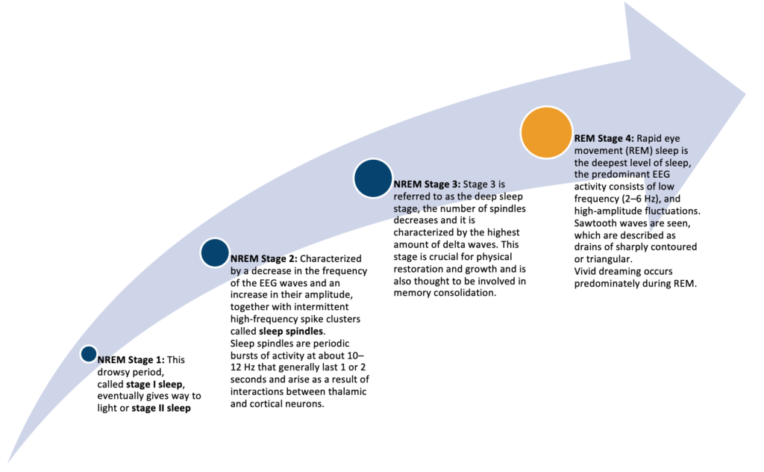

## **Microdialysis:**

In interstitial tissue fluid, the neurotransmitters are able to be monitored by a technique called microanalysis. It enables sampling and quantifying of the brain’s peripheral neurotransmitters, hormones and neuropeptides. Microdialysis techniques are used in a way to measure any soluble molecules in the interstitial fluid space. It is used to measure the release of neurotransmitters in tissue preparation. Researchers also used it while studying living tissue to get knowledge about the chemical composition of the neurotransmitter in question (Benveniste, 1989).

Microdialysis works by inserting a probe into the brain tissue and then perfusing the probe with a saline solution. The probe is made of a semi-permeable membrane which allows small molecules like neurotransmitters to diffuse from the extracellular fluid into the probe’s perfusate. By measuring the concentration of the small molecules in the perfusate, researchers can infer their concentration in the extracellular fluid. The analysis of perfusate contains the details of the neurotransmitters present in the brain tissue.

**References:**

(1) Benveniste, H., 1989. Brain microdialysis. Journal of neurochemistry, 52(6), pp.1667-1679.

(2) Britannica, T., 2020. Editors of Encyclopaedia. Argon. Encyclopedia Britannica.

(3) Cogan, S.F., 2008. Neural stimulation and recording electrodes. Annual review of biomedical engineering, 10(1), pp.275-309.

(4) Cogan, S.F., Ehrlich, J., Plante, T.D., Smirnov, A., Shire, D.B., Gingerich, M. and Rizzo, J.F., 2009. Sputtered iridium oxide films for neural stimulation electrodes. Journal of Biomedical Materials Research, 89(2), pp.353-361.

(5) Frizzo, A.C., 2015. Auditory evoked potential: a proposal for further evaluation in children with learning disabilities. Frontiers in Psychology, 6, p.788.

(6) Ioannides, A.A., Poghosyan, V., Dammers, J. and Streit, M., 2004. Real-time neural activity and connectivity in healthy individuals and schizophrenia patients. Neuroimage, 23(2), pp.473-482.

(7) Jackson, A. and Seneviratne, U. (2019). EEG changes in patients on antipsychotic therapy: A systematic review. Epilepsy & Behavior, 95, pp.1–9. doi:10.1016/j.yebeh.2019.02.005.

(8) Hamilton, R., Bach, M., Heinrich, S.P., Hoffmann, M.B., Odom, J.V., McCulloch, D.L. and Thompson, D.A., 2021. VEP estimation of visual acuity: a systematic review. DocumentaOphthalmologica, 142(1), pp.25-74.

(9) Robinson, L.R. and Micklesen, P.J., 2004. Somatosensory evoked potentials in coma prognosis. Physical Medicine and Rehabilitation Clinics, 15(1), pp.43-61.

(10) Saletu, B., Grunberger, J. and Rajna, P. (1983). Pharmaco-EEG profiles of antidepressants. Pharmacodynamic studies with fluvoxamine. British Journal of Clinical Pharmacology, 15(S3), pp.369S383S. doi:10.1111/j.1365-2125.1983.tb02128.x.

### 3.1.2 Neuroimaging

## **Neuroimaging and its Role in Understanding Brain Function**

Neuroimaging techniques have paved the path for neurosciences and psychiatry to understand how the human brain functions. Neuroimaging helps us understand how an individual brain develops from birth to adulthood. Neuroscientists working on development studies have made discoveries regarding the underpinning of cognitive development. Psychologists have used functional neuroimaging to understand the neural mechanisms that are involved in PTSD, panic disorder, and phobias. The uses of neuroimaging in both research and clinical settings are almost limitless (Schrag, 2013).

## **Computer Tomography:**

Computer Tomography (CT) is the most prevalent cranial imaging tool in the clinical setting. A series of cranial X-rays in a 360-degree field. This does limit images to one plane of rotation. Essentially the X-rays show the different densities of brain structures.

The various contrasts (white/black) seen in CT images are due to how tissues absorb X-rays differently. Calcification is visualised better in CT in comparison to MRI.

Challenges with CT imaging:

* Grey and white matter differentiation is poor.
* Poor sensitivity to early ischaemia.
* Poor visualisation of posterior fossa lesions.
* Structures close to bone are often obscured such as the brain stem.

|  |  |  |
| --- | --- | --- |
|  | **CT scan:** | **MRI scan:** |
| **Principle:** | Multiple X-rays at varying angles to produce cross-sectional images. | Powerful magnetic fields and radiofrequency pulses to produce detailed images. |
| **Radiation:** | Minimal. | None. |
| **Purpose:** | Observing bone and even better for soft tissues. This is improved when used with intravenous contrast dye. | Excellent for detecting slight differences in soft tissues. |
| **Application:** | Produces a general image of an area such as organs, fractures, or head trauma. | Produces detailed images of soft tissues, organs, or ligaments. |
| **Benefits:** | Faster. | More detailed images. |
| **Risk:** | Harmful for unborn babies. A small dose of radiation. Possibility of reaction to the use of dyes. | Possibility of reaction to metals due to magnetic fields such as artificial joints or eye implants. Loud noises from the machine can be disturbing to certain patients. Increase in body temperature during long MRIs. Claustrophobia. |

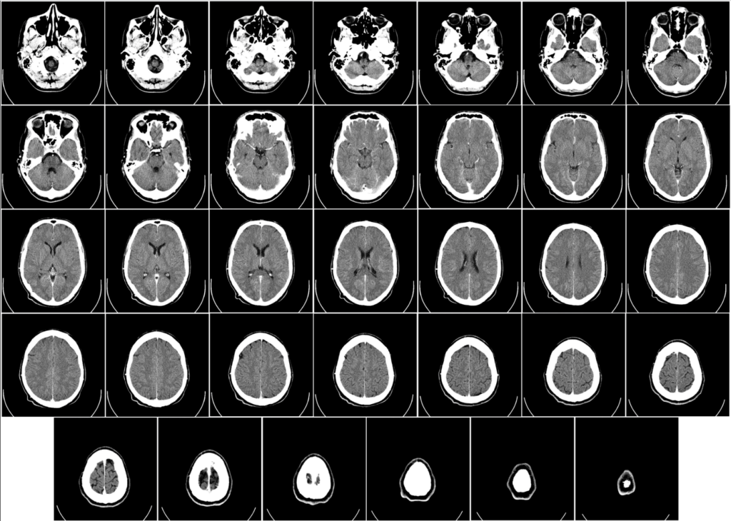**Computer Tomography of a human brain from the base of the skull to the top. Taken with intravenous contrast medium.**

## **Magnetic Resonance Imaging:**

Magnetic Resonance Imaging (MRI) forms images of the brain by using powerful magnets to create a strong magnetic field that causes protons in the body to align with it. When a radiofrequency current is pulsed through the patient, the protons are excited and spin out of balance, pushing against the magnetic field’s pull. When the radiofrequency field is switched off, the MRI sensors can measure the energy released by protons as they realign with the magnetic field. The quantity of energy released and the time it takes for the protons to realign with the magnetic field vary depending on the environment and the chemical makeup of the molecules. Based on these magnetic properties, doctors can distinguish between different types of tissues (Schrag, 2013).

They are distinct from computed tomography (CT) in that they do not employ the harmful ionising radiation of X-rays.

Functional magnetic resonance imaging (fMRI)is considered the most successful and prominent technology of neuroimaging, it is essential as a proxy measure of issue activity. This technique tracks the changes that occur in the oxygen levels and the blood flow to help identify neural activity. For example, when a brain area is more active than usual then it would consume more oxygen thus resulting in increased blood flow. fMRI is used to map areas associated with cognitive functioning such as areas connected with perception, language, and memory. The technique of Blood Oxygen Level dependent (BOLD) forms the basis of fMRI.

MRI can distinguish between white and grey matter in the brain and can also be used to diagnose aneurysms and malignancies. Because MRI does not use x-rays or other radiation, it is the preferred imaging modality when frequent imaging is necessary for diagnosis or therapy, particularly in the brain. MRI, on the other hand, is more expensive than CT scanning.

|  |  |
| --- | --- |
| **MRI pulse sequence:** | **Summary:** |
| **T1 images** | Hydrophobic tissues are emphasized. Fat is bright and CSF is dark. T1 imaging is the sequence that allows the image to be enhanced with the contrast agent gadolinium. Gadolinium-enhanced structures appear bright white. |
| **T2 images** | Hydrophilic areas are emphasized. Brain tissue is dark and CSF is white. Brain tissues high in water content such as tumours, inflammation, or stroke infarctions appear brighter on T2 images. |
| **FLAIR (Fluid attenuated inversion recovery)** | The T1 image is inverted and superimposed onto the T2 image to double the contrast. Beneficial in detecting sclerosis of the hippocampus resulting from temporal lobe epilepsy or localising areas in degenerative disorders. |

|  |  |  |  |
| --- | --- | --- | --- |
| **Structure or pathology:** | **CT scan** | **MRI T1 scan:** | **MRI T2 scan:** |
| **Air** | Dark | Dark | Dark |
| **Bone** | Bright | Bright | Dark |
| **CSF** | Dark | Dark | Bright |
| **Fat** | Dark | Bright | Bright |
| **Tissue** | Shades of grey | Grey matter = grey White matter = white | Shades of grey |
| **Haemorrhage** | Bright | Bright | Bright |
| **Infarction** | Dark | Dark | Bright |
| **Multiple sclerosis plaques** | Dark | Dark | Bright |
| **Tumour** | Dark | Dark | Bright |

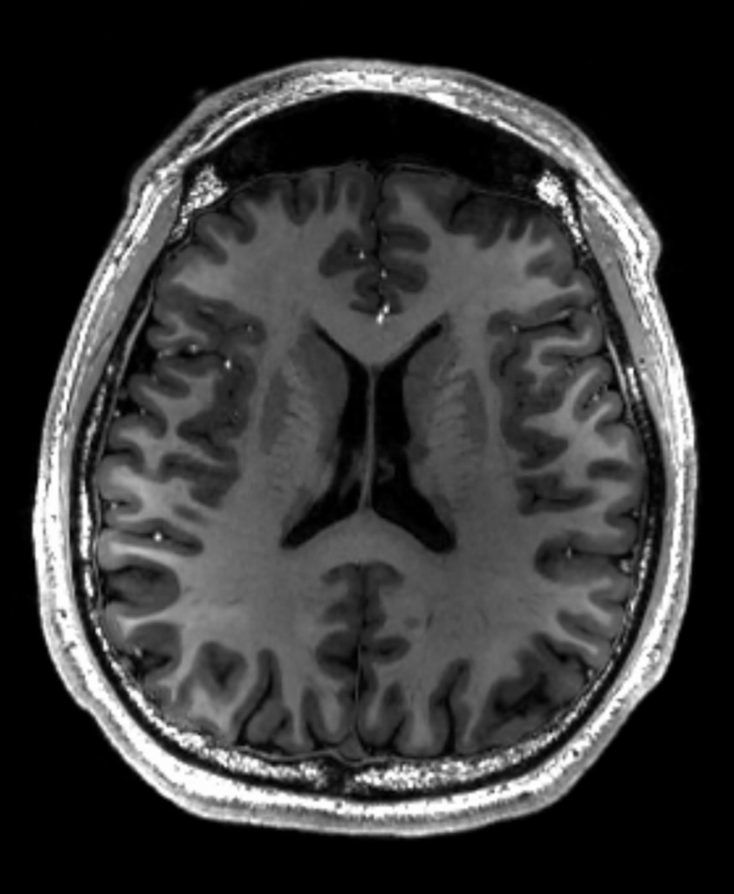

***Cross-sectional T1-weighted MRI of a healthy human brain*.**

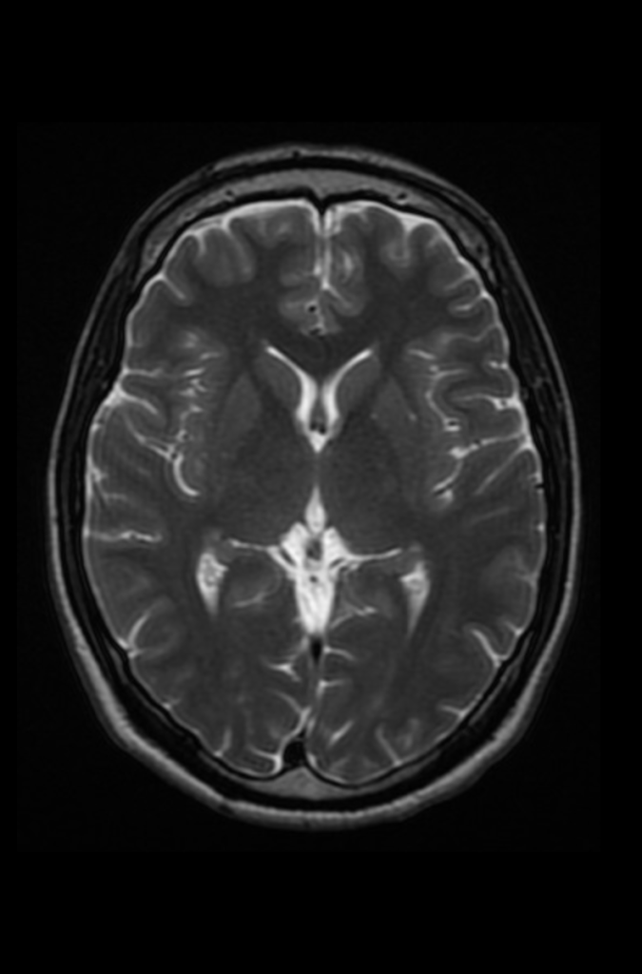

**Cross-sectional T2-weighted (CSF white) MRI of a healthy human brain at the level** **of the lateral ventricles.**

## **Diffusion Tensor Imaging:**

Diffusion Tensor Imaging (DTI), tracks the flow of water molecules that move via Brownian motion in and around the fibres that are connected with different parts of brain regions, the white matter tracts. It gauges the density and thickness of brain connections. Fractional anisotropy can be calculated from the DTI which indicates the integrity of the white matter. Tractography is used to determine the direction of the white matter connectivity.

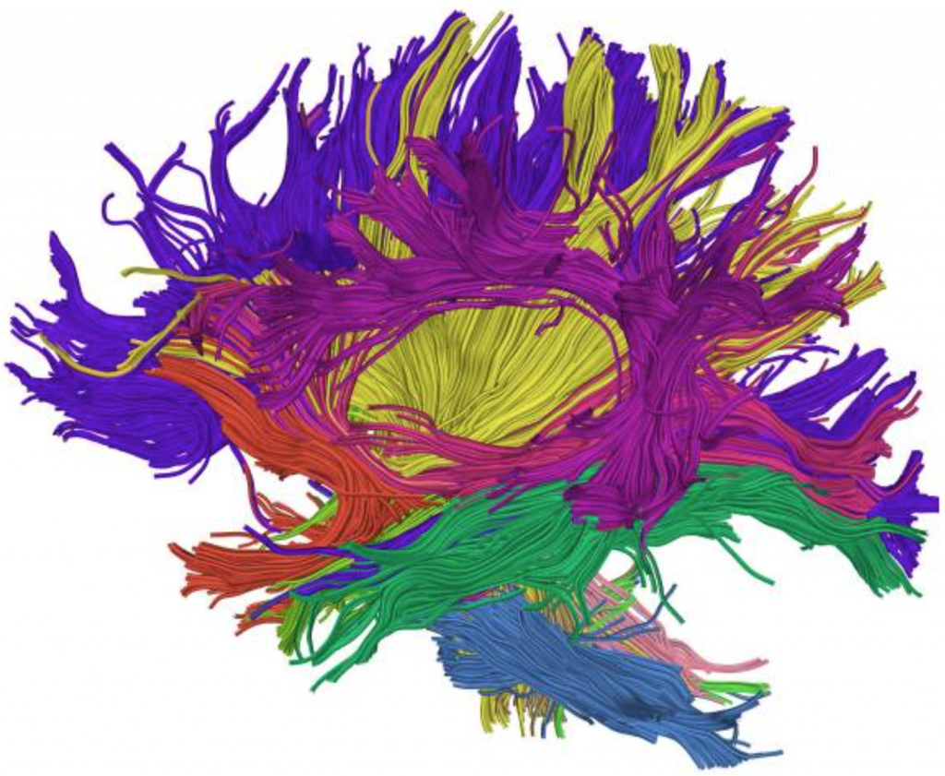(O’Donnell, 2011)

## **Single Photon Emission Computed Tomography:**

Single Photon Emission Computed Tomography (SPECT) studies regional changes in cerebral blood flow within the brain using radioactive substances. This measures the pattern of photon emission from the bloodstream, which changes with the level of perfusion in different areas of the brain. Like fMRI, it does not directly monitor neural metabolism.

Injectable tracers such as technetium-99m-d, and l-hexamethyl propylene amine oxime (HMPAO) are used to assess blood flow to the whole brain. The tracers have single photon-emitting isotopes which help determine the levels of perfusion.

## **Positron Emission Tomography:**

Positron Emission Tomography (PET) uses radioactive tags to determine which part of the brain is most active while doing a task. This imaging technique can use used to study blood flow, receptor distribution as well as metabolic activity of the brain tissue (Davidson, 2003).

|  |  |
| --- | --- |
| **Function:** | **PET ligand:** |
| **Blood flow** | C15/H215O |
| **Glucose metabolism** | F18 deoxyglucose |
| **Dopamine D2 receptors** | 11C raclopride |
| **GABA-A receptors** | 11C flumazenil |

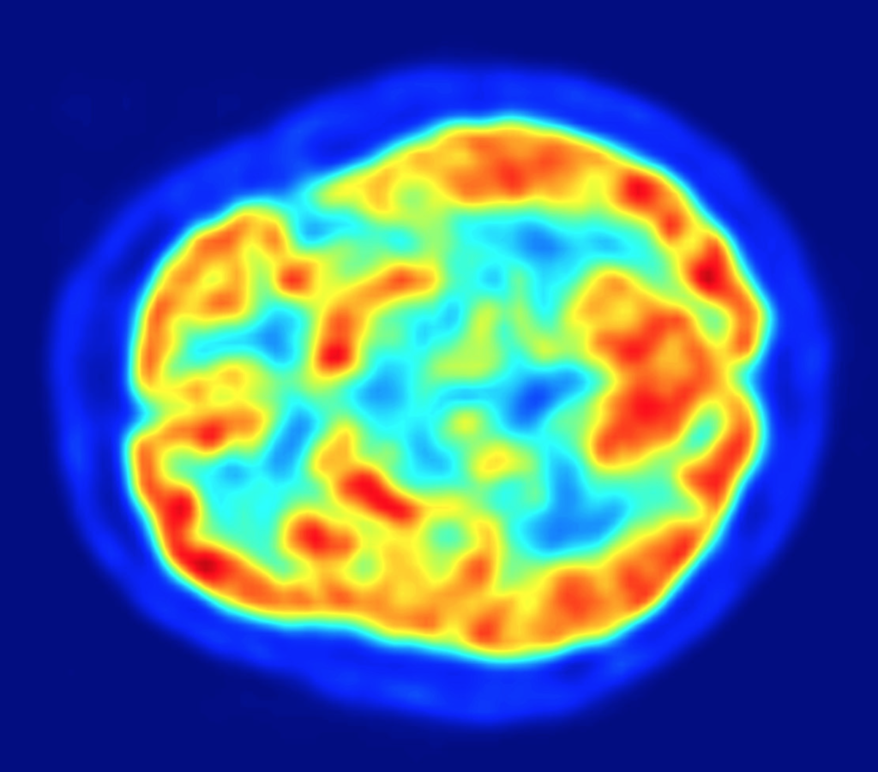***PET scan of a healthy human brain. This is a transaxial slice of the brain. Red areas show more accumulated tracer substance (18F-FDG) and blue areas are regions where low to no tracer have been accumulated.***

## **Magnetic Resonance Spectroscopy:**

Magnetic Resonance Spectroscopy (MRS) is used to measure the biochemical changes that occur in the brain and it is done through a noninvasive diagnostic tool. In MRS, tissue can be investigated for the presence and concentration of various metabolites (Parvizi, J. and Kim, G. K., 2010).

There is very limited use of this technique in both psychiatry and radiology.

**References:**

(1) Davidson, M.C., Thomas, K.M. and Casey, B.J. (2003). Imaging the developing brain with fMRI. Mental Retardation and Developmental Disabilities Research Reviews, 9(3), pp.161–167. doi:10.1002/mrdd.10076.

(2) O’Donnell, L.J. and Westin, C.-F. (2011). An Introduction to Diffusion Tensor Image Analysis. Neurosurgery Clinics of North America, [online] 22(2), pp.185–196. doi:10.1016/j.nec.2010.12.004.

(3) Parvizi, J. and Kim, G. K. (2010) “MRI (magnetic resonance imaging),” in High Yield Orthopaedics. Elsevier, pp. 305–306.

(4) Schrag, A.E., Mehta, A.R., Bhatia, K.P., Brown, R.J., Frackowiak, R.S., Trimble, M.R., Ward, N.S. and Rowe, J.B., 2013. The functional neuroimaging correlates of psychogenic versus organic dystonia. Brain, 136(3), pp.770-781.

### 3.1.3 Perturbing brain function

## **Perturbing brain function**

Functional neuroimaging has evolved over the last two decades from mapping distinct cognitive, perceptual, and motor functions onto discrete brain regions to investigating functional connections across specialised modules. A statistical examination of variations in brain activity has been the major tool in this endeavour (Paus, 2005).

Perturbation has a long history as a method for exploring brain-behaviour interactions. Irreversible changes (brain lesions) revealed, that the inferior frontal cortex is required for language production and the hippocampal system for declarative memory (Broca, 1861) (Scoville, 1957). The somatotopic structure of the motor cortex was revealed by reversible disturbance of neuronal activity with direct electrical stimulation (Leyton, 1917) (Penfield, 1950).

## **Lesion studies:**

Brain lesions refer to damage to brain tissue as a result of any injury or disease. For the diagnosis of brain lesions different scans are often used. Some brain lesions are treatable and some heal with time by themselves. However, some lesions are untreatable. Lesion studies are used to examine the damage to brain structure. Lesions to the brain can result from many factors, including vascular disorders, traumatic brain injuries, and tumours (Wilkes, K.V., 1980).

|  |  |
| --- | --- |
| **Lesion location:** | **Effect of brain lesion:** |
| **Fusiform gyrus** | Results in prosopagnosia (inability to recognize faces). |
| **Visual cortex** | Different effects depend on the sub-area affected. Lesion to V1 can lead to blindness to of various degrees relative to the calcarine fissure. |
| **Amygdala** | Lesions would eliminate the enhanced activation seen in the occipital and fusiform visual area in response to fear. Amygdala lesions change the activation of emotional stimuli. |

## **Electrical stimulation:**

Electric stimulation is one of the best techniques to build a connection between neurons to hypothesized brain circuits. It is usually used for vision and evoking eye movements. Perturbing during the neuronal impulses stimulus process may be turned on and off frequently. It is a frequently used method to provide neuronal activity of temporary control. The weakest point of this technique is that it usually activates neurons that are less associated with regular physiological functioning (Wurtz, R.H., 2015).

## **Transcranial Magnetic Stimulation:**

Transcranial magnetic stimulation (TMS) is a treatment method; it is as used magnetic stimulation of brain nerve cells to improve the symptoms of major depressive disorder. It is commonly used when major depressive disorder pharmacology and electroconvulsive treatments were unsuccessful. It is also used to treat obsessive-compulsive disorder and other brain-related disorders. In a repetitive TMS session, a coil of electromagnetics is attached near the patient’s forehead, against the scalp. The electromagnet stimulates the brain region or area by delivering a painless magnetic pulse. It considers that TMS activates different brain areas that are associated with mood and depression, these areas decrease activity stimulated by magnetic stimulation. There is no evidence to support the concept that TMS might cause adverse effects on brain areas (Rizvi, 2019).

## **Optogenetics:**

Optogenetics is a modern method used by researchers and neuroscientists to handle or regulate the neuron’s activities. This method results in the expression of light-sensitive ion channels and enzyme activation. Within individual cells, the associated enzymes are activated by light and biochemical signalling pathways allowed by transcription factors. This control of genetic activity allows research studies to understand their role in decision-making, learning, fear,  memory, addiction, mating, feeding, and locomotion. Optogenetics regulates and alter the activity of the genetically labelled neurons with light (Guru, 2015).

## **Transcranial Direct-Current Stimulation:**

Transcranial Direct-Current Stimulation (tDCS) is a type of neuromodulation that employs steady, low direct current given through electrodes placed on the head. It was first designed to aid individuals suffering from brain injuries or neuropsychiatric disorders such as severe depressive disorder. It differs from cranial electrotherapy stimulation, which employs alternating current in the same way, and transcranial magnetic stimulation. tDCS changes in the brain area are immediate and long-lasting.

tDCS is applied via direct current electrodes between 1-2 mA by using positive (anodal) and negative (cathodic) in specific brain areas. In the human brain, plasticity can allow lasting excitability changes in the response to tDCS use, namely in the treatment of chronic depression (LTD) (Fregni, F., 2015).

The National Institute for Health and Care Excellence (NICE) determined tDCS to be a safe and effective therapeutic technique for depression in 2015 (NICE, 2015).

## **Deep brain stimulation:**

Deep brain stimulation (DBS) is a technique in which a device is placed within the brain tissue, a neurostimulator. An electrical current directly passes to your brain by this device. The human brain consists of billions of neurons, and communication occurs between these cells through chemical signals and electrical signals. In parts of the brain where there is less activity the DBS technique can find some utility.

DBS is most frequently used for the treatment of Parkinson’s disease, epilepsy and essential tremor. But recent research indicates that it has therapeutic benefits for obsessive-compulsive disorder and dystonia. DBS is utilized when medication does not give an appropriate response or results in side effects causing trouble in daily life activities. DBS does not damage any brain tissue (Lee, 2019).

In Parkinson’s disease, there are four areas of the brain that have been treated with neural stimulators. These are the globus pallidus, thalamus, subthalamic nucleus and pedunculopontine nucleus. However, most DBS surgeries in routine practice target either the globus pallidus or the subthalamic nucleus.

## **Vagus nerve stimulation:**

Vagus Nerve stimulation (VNS)is a neuro-modulator tool used in both neurology and psychiatry frequently for the treatment of intractable epilepsy and treatment-resistant depression (Smith, 2006). The vagus nerve which is the 10th cranial nerve arises from the rootlets in the medulla.

VNS generator is implanted under the skin often of the left chest. An electrode is attached to the generator which tunnels up to the left vagus nerve near the carotid sheath where it will deliver electric impulses to the vagus nerve itself (Wheless, 2018.). There is not one clear mechanism of action for how VNS accounts for its efficacy in epilepsy or depression. In epilepsy, there is evidence that VNS leads to cortical resynchronization (Fraschini, 2013). In depression, it is thought that VNS can change the activity of several neurotransmitters or change the functional connectivity of the default mode network (Manta, 2012) (Fang, 2016).

**References:**

(1) Broca P. 1861, Nouvelle observation d’aphémie produite par une lésion de la moitié postérieure des deuxième et troisième circonvolution frontales gauches. Bulletin de la Société Anatomique, 1861d, tome. XXXVI, 398–407.

(2) Fang, Jiliang; Rong, Peijing; Hong, Yang; Fan, Yangyang; Liu, Jun; Wang, Honghong; Zhang, Guolei; Chen, Xiaoyan; Shi, Shan; Wang, Liping; Liu, Rupeng; Hwang, Jiwon; Li, Zhengjie; Tao, Jing; Wang, Yang (2016-02-15). “Transcutaneous Vagus Nerve Stimulation Modulates Default Mode Network in Major Depressive Disorder”. Biological Psychiatry. 79 (4): 266–273.

(3) Fraschini, Matteo; Puligheddu, Monica; Demuru, Matteo; Polizzi, Lorenzo; Maleci, Alberto; Tamburini, Giorgio; Congia, Socrate; Bortolato, Marco; Marrosu, Francesco (2013-03-01). “VNS induced desynchronization in gamma bands correlates with positive clinical outcome in temporal lobe pharmacoresistant epilepsy”. Neuroscience Letters. 536: 14–18.

(4) Fregni, F., Nitsche, M.A., Loo, C.K., Brunoni, A.R., Marangolo, P., Leite, J., Carvalho, S., Bolognini, N., Caumo, W., Paik, N.J. and Simis, M., 2015. Regulatory considerations for the clinical and research use of transcranial direct current stimulation (tDCS): review and recommendations from an expert panel. Clinical research and regulatory affairs, 32(1), pp.22-35.

(5) Guru, A., Post, R.J., Ho, Y.Y. and Warden, M.R., 2015. Making sense of optogenetics. International Journal of Neuropsychopharmacology, 18(11), p.pyv079.

(6) Lee, D.J., Lozano, C.S., Dallapiazza, R.F. and Lozano, A.M., 2019. Current and future directions of deep brain stimulation for neurological and psychiatric disorders: JNSPG 75th Anniversary Invited Review Article. Journal of neurosurgery, 131(2), pp.333-342.

(7) Leyton A.S.F& Sherington C.S. 1917Observations on the excitable cortex of the chimpanzee, orang-utan and gorilla. Q. J. Exp. Physiol. 11, 135–222.

(8) Manta, Stella; El Mansari, Mostafa; Debonnel, Guy; Blier, Pierre (2012-04-17). “Electrophysiological and neurochemical effects of long-term vagus nerve stimulation on the rat monoaminergic systems”. International Journal of Neuropsychopharmacology. 16 (2): 459–470.

(9) Paus, T. (2005). Inferring causality in brain images: a perturbation approach. Philosophical Transactions of the Royal Society B: Biological Sciences, 360(1457), pp.1109–1114. doi:10.1098/rstb.2005.1652.

(10) Penfield W& Rasmussen A.TThe cerebral cortex of man. 1950. New York: Macmillan.

(11) Rizvi, S. and Khan, A.M., 2019. Use of transcranial magnetic stimulation for depression. Cureus, 11(5).

(12) Smith, D.C., Tan, A.A., Duke, A., Neese, S.L., Clough, R.W., Browning, R.A. and Jensen, R.A. (2006). Recovery of Function after Vagus Nerve Stimulation Initiated 24 Hours after Fluid Percussion Brain Injury. Journal of Neurotrauma, 23(10), pp.1549–1560. doi:10.1089/neu.2006.23.1549.

(13) Scoville W.B& Milner B. 1957Loss of recent memory after bilateral hippocampal lesions. J. Neurol. Neurosurg. Psychiatry. 20, 11–21.

(14) www.nice.org.uk. (n.d.). Overview | Transcranial direct current stimulation (tDCS) for depression | Guidance | NICE. [online] Available at: https://www.nice.org.uk/guidance/ipg530#:~:text=Transcranial%20direct%20current%20stimulation%20(tDCS)%20is%20a%20non%2Dinvasive [Accessed 3 Jan. 2023].

(15) Wilkes, K.V. (1980). More Brain Lesions. Philosophy, 55(214), pp.455–470. doi:10.1017/s0031819100049482.

(16) Wurtz, R.H., 2015. Using perturbations to identify the brain circuits underlying active vision. Philosophical Transactions of the Royal Society B: Biological Sciences, 370(1677), p.20140205.

### 3.1.4 Animal models of psychiatric disease

## **Animal models of psychiatric disease**

The subjective character of many crucial symptoms, the paucity of biomarkers and objective diagnostic tests, and the early state of relevant neurobiology and genetics make animal modelling of human psychiatric diseases extremely difficult (Nestler, 2010).

## **Animal models of schizophrenia**:

Schizophrenia is a debilitating condition that typically manifests itself between the late teen years and the early thirties. Twin and adoption studies reveal that schizophrenia is strongly impacted by genetics, but genetics have proven to be astonishingly complicated, with risk emerging from the interaction of numerous genetic variations and environmental factors. In schizophrenia, three major symptom clusters have been identified: positive, negative, and cognitive symptoms, which presumably reflect various downstream effects of the beginning developmental problems.

|  |  |
| --- | --- |
| **Focus of schizophrenia model:** | **Summary:** |
| **22q11.2** | Developing genetic animal models from highly penetrant human mutations may be an effective way to meet construct validity. In around 30% of instances, chromosome 22q11.2 microdeletions that cause velocardiofacial syndrome are associated with a schizophrenia-like condition. Mice with missing genes in homologous areas of the mouse genome have been created. |
| **Disc1** | Translocation that causes gene disruption ‘Disrupted in schizophrenia-1’ (Disc1), which was linked to schizophrenia in a Scottish family for the first time. Several laboratories have created mice with Disc1 mutations, and some of them exhibit behavioural problems resembling schizophrenia. |

## **Animal models of depression**:

No single anomaly has proven robust or persistent enough to be used to diagnose depression in humans or to validate an animal model. Depression is diagnosed following a highly variable cluster of symptoms.

|  |  |
| --- | --- |
| **The focus of depression model:** | **Summary:** |
| **Chronic unpredictable stress** | Entails repeatedly subjecting normal rodents to physical stimuli (e.g., restraint, footshock, cold temperature) over a period of weeks or longer. Animals display indications of anhedonia (e.g., lower sucrose preference) at the conclusion of the stress, which can be restored by chronic antidepressant medications (Willner, 2005). |
| **Chronic social defeat stress** | Chronic social defeat stress is caused by repeatedly putting rodents through social subordination, after which the rodents exhibit a variety of depression-like symptoms, including anhedonia and social disengagement, which can be alleviated by chronic antidepressants (Krishnan, 2007). |
| **Early life stress (maternal separation)** | Maternal separation, induces lifelong behavioural and neuroendocrine abnormalities in the pups, some of which can be reversed by antidepressant medications (Meaney, 2001) |
| **Social isolation** | Adult rodents exposed to social isolation for extended periods of time (weeks to months) develop anhedonia, which can be treated with chronic antidepressants (Wallace, 2009) |

## **Animal models of bipolar disorder**:

Mania episodes, with or without depression, are used to diagnose bipolar disorder. While bipolar illness is strongly influenced by genetics, the discovery of genetic risk factors is still in its early stages. The field has struggled to develop rodents that exhibit mania-like symptoms and has been unable to develop rodent models exhibiting spontaneously alternating episodes of mania- and depression-like behaviours due to a lack of well-replicated, highly penetrant mutations or a deep understanding of pathophysiology.

|  |  |
| --- | --- |
| **The focus of bipolar model:** | **Summary:** |
| **Psychostimulants** | Repeated use of psychostimulants on rodents causes sensitization of the locomotor-activating effects, these can subsequently be blunted by lithium or sodium valproate. |
| **Amygdala kindling** | Lack of construct and face validity. |
| **Lithium-pilocarpine induced seizures** | Lack of construct and face validity. |
| **Glycogen synthase kinase-3β (GSK3β)** | GSK3β induces hypophagia and hyperlocomotion, reduces immobility and reduced anxiety-like behaviour. Lithium inhibits GSK3β, however, lithium has numerous molecular actions. |
| **Clock gene** | When the clock gene is inhibited the mouse exhibits mania-like symptoms which can be reversed by chronic lithium administration. |

(Nestler, 2010)

**References:**

(1) Krishnan V, et al. Molecular adaptations underlying susceptibility and resistance to social defeat in brain reward regions. Cell. 2007;131:517–522.

(2) Meaney MJ. Maternal care, gene expression, and the transmission of individual differences in stress reactivity across generations. Annu Rev Neurosci. 2001;24:1161–1192.

(3) Nestler, E.J. and Hyman, S.E. (2010). Animal models of neuropsychiatric disorders. Nature Neuroscience, 13(10), pp.1161–1169. doi:10.1038/nn.2647.

(4) Wallace DL, et al. CREB regulation of nucleus accumbens excitability mediates social isolation-induced behavioral deficits. Nat Neurosci. 2009;12:200–209.

(5) Willner P. Chronic mild stress (CMS) revisited: consistency and behavioural-neurobiological concordance in the effects of CMS. Neuropsychobiology. 2005;52:90–110.

### 3.1.5 Computational modelling and data-analytics

## **Computational Modelling and Data-Analytic Descriptions**

Computational models control different computer programs in order to stimulate and learn about complex systems by introducing mechanistic and algorithmic approaches. Computational models help in diverse areas spanning biology, chemistry, physics, psychology, cognitive sciences, and economics. The systems that are being studied have nonlinear complex systems and for them, analytical intuitive solutions are not present. Experimentation is done with the model in order to adjust the parameters of a system based on a computer. Some examples of computational models are molecular folding protein models, simulator models, and neural network models.

Computer modelling can allow a researcher or scientist to conduct thousands of different simulated experiences. The laboratory experiments are identified by computer experiments in order to solve the problem that is being under study. However, computational models have the ability to study biological systems at different levels. In neurosciences, it is obvious that data science plays an important role in single-cell recording, EEG, fMRI, and local field potentials. The necessary skills demand the ability to manipulate, understand, and visualize structures of datasets. This is considered a complex skill within research. It is clear that large datasets (built by different labs) are required to provide reliable inferences on the neuroscientific processes. These inferences are also based on computational models because they are responsible for identifying and portraying the data patterns.  Now, machine learning and statistical models are highly used in neuroscience (Taber et al, 1996).

**References:**

(1) Taber, C.S., Timpone, R.J. and Timpone, R.J. (1996). Computational Modeling. [online] Google Books. SAGE. Available at: https://books.google.co.uk/books?hl=en&lr=&id=-VeO1XuZ3uAC&oi=fnd&pg=PA18&dq=Taber [Accessed 3 Jan. 2023].

## 3.2 Cells

### 3.2.1 Cell types

## **The Types of Cells Found Within the Nervous System and their Anatomical and Functional Localization in Layers in Different Parts of the Cortex**

The nervous system is composed of many different types of cells, each of which plays a specific role in the functioning of the nervous system. In the cortex, the outer layer of the brain, different types of cells are organized into distinct layers that serve specific functions. Here are some of the most important cell types found in the nervous system and their localization in the cortex:

|  |  |
| --- | --- |
| **Type of cell:** | **Description:** |
| **Neurons** | These are the primary cells responsible for transmitting electrical signals within the nervous system. They are located throughout the cortex but are most abundant in layer IV, the innermost layer of the cortex. |
| **Glial cells** | These cells play a supportive role in the nervous system, providing structural support and insulation for neurons. They are most abundant in the outer layers of the cortex. |
| **Microglia** | These are a type of glial cell that play a role in the immune system of the central nervous system (CNS). They are located throughout the cortex but are most densely concentrated in the deeper layers of the cortex. |
| **Astrocytes** | These are another type of glial cell that play a role in maintaining the structural integrity of the CNS and in regulating the chemical environment around neurons. They are located throughout the cortex but are most densely concentrated in the outer layers of the cortex. |
| **Oligodendrocytes** | These are glial cells that produce myelin, a fatty substance that insulates the axons of neurons and helps to increase the speed of electrical signals transmitted by neurons. They are located primarily in the deeper layers of the cortex. |

The functional specialization of different regions of the cortex is reflected in the arrangement of these cell types and the distribution of neural connections within the cortex. For example, the primary sensory cortex, which is responsible for processing sensory information, has a different arrangement of cell types and neural connections than the motor cortex, which is responsible for controlling movement.

## Neurons

Neurons are the primary cells responsible for transmitting electrical signals within the nervous system. They are specialized for this function and have distinct structural features, such as dendrites, which receive signals from other neurons, and an axon, which transmits signals to other neurons.

In the cortex, neurons are organized into different layers, each with a specific function. The different layers of the cortex are designated by Roman numerals, with layer I being the outermost layer and layer VI being the innermost layer. Here are some of the key functional localizations of neurons within the cortex:

1. Layer IV: This is the innermost layer of the cortex and is often referred to as the “input layer.” It is composed of large, bushy neurons that receive incoming signals from other areas of the brain and from sensory organs.
2. Layer V: This layer contains the largest neurons in the cortex and is responsible for transmitting signals to other areas of the brain. This layer is sometimes referred to as the “output layer.”
3. Layer VI: This innermost layer of the cortex receives signals from the thalamus, a structure that serves as a relay station for sensory information. Neurons in this layer are responsible for sending signals to the brainstem and spinal cord.

The different regions of the cortex, such as the sensory cortex, the motor cortex, and the association cortex, each have their own distinct arrangements of neurons and neural connections, which are optimized for their specific functions. The distribution of neurons within the cortex reflects the functional specialization of different regions of the brain and helps to ensure that signals are transmitted efficiently and accurately from one area of the brain to another.

Neurons are composed of a soma or cell body, which contains a nucleus and intracellular organelles such as the Golgi apparatus and mitochondria. The dendrites receive signals from other neurons and transmit them to the cell body. The axon arises from the axon hillock, which is located at the base of the cell body. At the axon hillock, an action potential is initiated and travels along the axon towards the axon terminal. Schwann cells play a role in insulating the axon by producing a myelin sheath that increases the speed of action potential transmission. The axon terminals make synaptic connections with other neurons by releasing neurotransmitters into the synaptic cleft, which then bind to receptors on the postsynaptic neuron to transmit the signal (Amunts, 2007).

## **Glial cells**

The glial cells are made up of 6 types of cells:

* Astrocytes
* Oligodendrocytes
* Microglial
* Ependymal cells
* Schwann cells
* Satellite cells

## **Astrocytes**:

Star-shaped glial cells are present within the spinal cord and brain. These cells can make 20 to 40% of glial cells. They provide metabolic support to neurons because neurons require a constant amount of nutrients (glucose), Neurons are unable to make or store glycogen. Astrocytes can store glycogen and break it down in order to produce glucose which is considered fuel for the neurons.

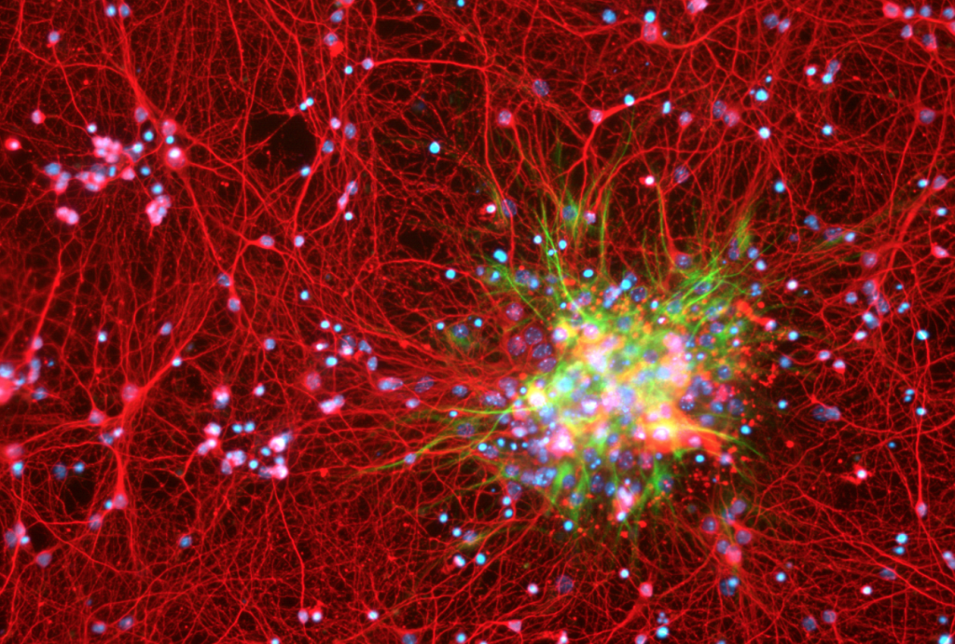***Astrocytes in green.***

## **Oligodendrocytes**:

These cells insulate the axons in the CNS. They produce a myelin sheath that wraps around a part of the axon.

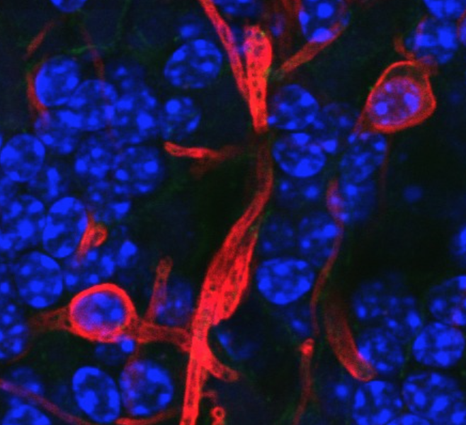***Oligodendrocytes in red.***

## **Microglial**:

Microglial cells are made up of mesodermal and they make up 10-15% of cells inside the brain. These cells act as the immune system of the brain. They recognize tissue damage and are able to detect foreign antigens that activate the phagocytosis to remove them.

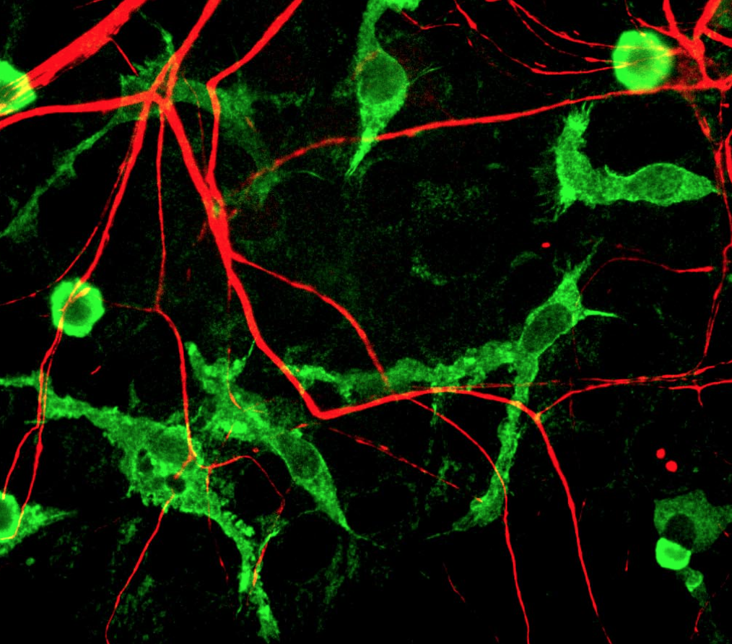***Microglial cells in green.***

## **Ependymal cells**:

The ependymal is determined by a thin lining present in the ventricular system of the spinal cord and brain. This lining is made from ependymal cells. These cells are responsible to produce cerebrospinal fluid (CSF).

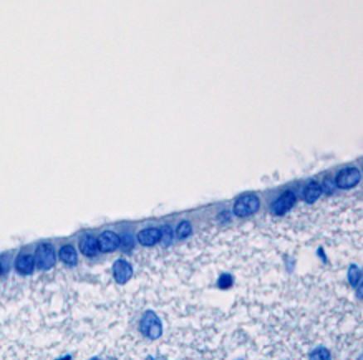***Ependymal cells in blue.***

## **Scwann cells**:

Schwann cells are the most common type of glial cell in the peripheral nervous system. They surround neurons, keeping them alive and sometimes coating them with a myelin sheath. They serve critical roles in peripheral nerve formation, maintenance, function, and regeneration.

***Schwann cell in red.***

## **Satellite cells**:

Satellite cells are progenitors to skeletal muscle cells that are responsible for muscle tissue’s ability to regenerate. ie These embryonic cells survive in adults and can partially repair injured muscle fibres.

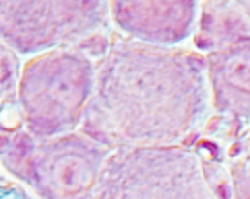***Satellite cells in pink.***

|  |  |
| --- | --- |
| **Cell type:** | **Function:** |
| **Astrocytes** | Provide structural and metabolic support. Participate in repair. |
| **Oligodendrocytes** | Produce myelin and provide electrical insulation. |
| **Microglia** | Participate in defence and immune responses. |
| **Ependymal** | Assist in the production and movement of CSF. |
| **Schwann** | Produce myelin and provide electrical insulation. |
| **Satellite** | Provide structural and metabolic support for cell bodies of neurons. |

## **Cerebral Cortex Cells**

The cerebral cortex contains billions of neurons which are as follows:

* Pyramidal cells
* Fusiform cells
* Stellate cells

The other cells present in the cortex are horizontal cells such as the cells of Martinetti and Cajal-Retzius.

## **Pyramidal cells**:

Pyramidal cells are the major excitatory neuron type in the cerebral cortex and represent 70–85% of all neurons. They vary in size, from small to large. They have one apical dendrite that goes toward the multiple basal dendrites and the surface of the cortex. They have 3 or 4 dendrites considered primary that branch off toward the next dendrite. They have a long axon which helps to leave the cortex and enter into the white matter subcortical. These axons reach to be commissural that project the corpus callosum and provide projection fibres that leave the cortex in order to be projected into CNS such as the spinal cord, thalamus etc (Wilder, 1959).

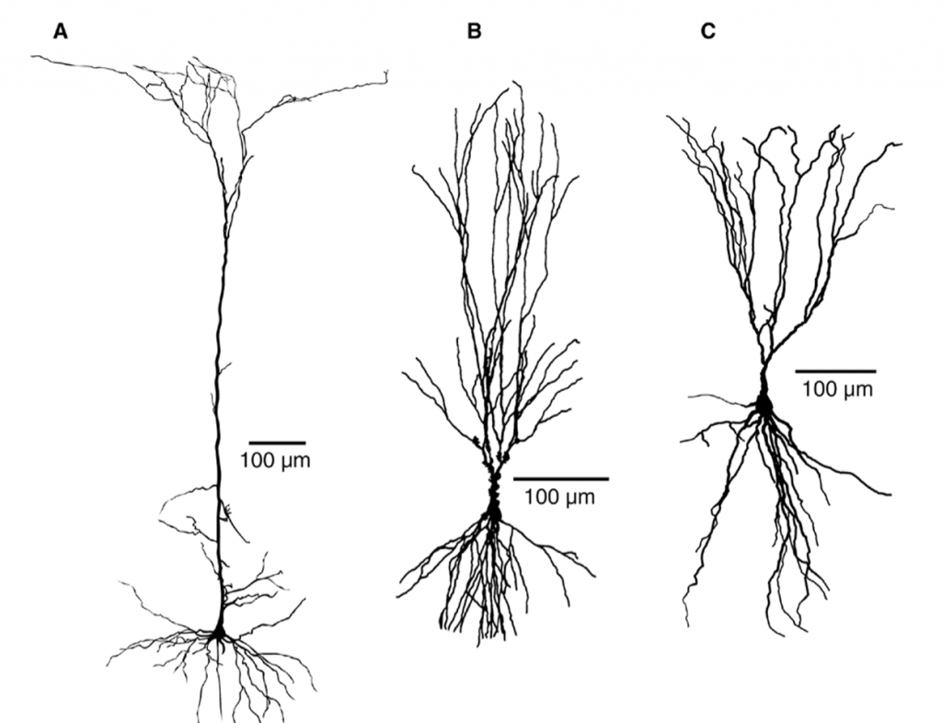

## **Fusiform cells**:

These cells are present in the deepest layer of the cortices. They project their dendrites toward the cortical surface, however, the axon has all the possibility to become association, projection oriented, and commissural. They usually project toward the thalamus.

## **Stellate cells**:

These cells resemble a star because their projections are planar. They are all abundant within the cortex. The dendrites have spines usually known as spiny or spiny cells. They are present in the internal pyramidal layer in order to release the glutamate (excitatory neurotransmitter) that functions as the excitatory interneurons. Aspin cells release GABA and act as inhibitory interneurons.

## **Horizontal cells**:

Cajal-Retzius can only be found in the superficial part of the cortex. They are found in an adult brain and are considered super rare. They consist of one axon and a dendrite. They synapse within the molecular layer.

## **Cerebral Cortex Layers**

Neuroscientists discovered neurons consist of a laminar alignment. This discovery indicates that neurons have laminar layers. These layers are parallel to the brain surface and are differentiated by size and shape.

The cerebral cortex, which is the outer layer of the brain, is composed of six distinct layers, each with its own unique set of neurons and neural connections. The six layers of the cortex are designated by Roman numerals, with layer I being the outermost layer and layer VI being the innermost layer. Here is a brief description of each layer:

The six layers of the cerebral cortex are as follows:

* Molecular layer (layer I)
* External granular (layer II)
* External pyramidal (layer III)
* Internal granular (layer IV)
* Internal pyramidal (layer V)
* Multiform layer (layer VI)

## **Molecular layer (plexiform):**

The outermost layer, also known as the molecular layer, is thin and contains few neurons. It is composed mainly of support cells called astrocytes and is important for the maintenance of the structural integrity of the cortex.

## **External granular layer:**

This layer is comprised of stellate cells, and small neurons and is involved in processing sensory information. Stellate cells are responsible for giving a granular appearance to layers. Other structures which are cellular can be seen in the form of pyramidal cells. These cells send dendrites to the molecular layer, then axons go deeper to the synapsing cortex. These axons are long enough to produce association fibres that travel toward the white matter in order to reach the CNS.

## **External pyramidal layer:**

This layer consists of pyramidal cells containing medium-sized neurons and is involved in processing sensory information and in transmitting signals to other areas of the brain. Superficial cells are smaller in this layer. The apical dendrites of pyramidal cells extend in a superficial manner to reach the molecular layer, then the basal processes go toward the subcortical white matter to join in order to project back to the cortex.

## **Internal granular layer:**

The innermost layer, also known as the internal granular layer, contains large neurons that receive incoming signals from other areas of the brain and from sensory organs. This layer receives the stimuli that arrive from the periphery even known as the ‘input cortical station’. This layer consists of stellate cells and small pyramidal cells, the axon of the stellate cell stays in the cortex and local synapses. In pyramidal cells, the axons have synapsed deep within the cortex, or in some other cases they might leave the cortex and join the fibres of white matter.

## **Internal pyramidal layer:**

This layer contains the largest neurons in the cortex and is responsible for transmitting signals to other areas of the brain. It consists of large pyramidal cells. It is considered the main source of corticofugal fibres. It sends signals to fibres that can mediate motor activity within the motor cortex (Wilder, 1959).

## **Multiform layer:**

This innermost layer receives signals from the thalamus, a structure that serves as a relay station for sensory information, and sends signals to the brainstem and spinal cord. The deepest layer of cortex overlies between the white matter subcortical. It possesses fusiform cells that contain fewer dominant interneurons and pyramidal cells. The axon of the Fusiform cell and pyramidal cell distribute the corticothalamic projection fibres and corticocortical commissural fibres that end in the thalamus (Amunts, 2007).

**References:**

(1) Amunts, K., Schleicher, A. and Zilles, K., 2007. Cytoarchitecture of the cerebral cortex—more than localization. Neuroimage, 37(4), pp.1061-1065.

(2) Wilder, J. (1959). The Anatomy of the Nervous System, Its Development and Function. American Journal of Psychotherapy, 13(4), pp.940–940. doi:10.1176/appi.psychotherapy.1959.13.4.940.

### 3.2.2 Fundamentals of neurons and receptors

## **Fundamental Concepts in the Physiology of Neurons, Synapses and Receptors**

The human brain consists of approximately 86 billion neurons, these communicate with each other through chemical signals or electrical signals. Neurons ‘communicate’ or are connected via the synapses. Synapses consist of the presynaptic and postsynaptic terminals. The presynaptic terminal exists at the end of the axon and is also where electrical signals are converted into chemical signals.

Neurotransmitters released from the presynaptic terminal and particular receptors on the corresponding postsynaptic terminal are critical in the transmission of information. The postsynaptic neuron receives the signals in order to interpret and determines the next step.

Neuron structure consists of a cell body, neuronal processes, axons and dendrites. Change occurs in the voltage flow of neurons from dendrites, and soma to the axon. Electrical signals pass through to the axon in the form of action potential so a nerve cell is able to communicate with another neuropathway. These communications are called synaptic transmission (Jones, 2017).

## **Parts of the neuron:**

|  |  |
| --- | --- |
| **Neuronal component:** | **Description:** |
| **Cell body** | The cell body consists of the nucleus which is the set of metabolic activity. Synapses are synthesized and it also releases neurotransmitters. |
| **Dendrites** | Dendrites are appendages that are designed to receive communications from other cells. |
| **Axon** | Axon is shaped like a cylinder covered by an axolemma, neurofilaments and microtubules give support to the axon. Neurotransmitters transport through microtubules from the cell body to the pre-synaptic terminal. |
| **Synapses** | Synapses are the site of transmission from the pre-synaptic neuron to the post-synaptic neuron. |
| **Axo-dendritic** | Communication between one neuron axon to the dendrites of other neurons. These are called excitatory synapses. |
| **Axo-somatic** | One neuron’s dendrites is connected with another neuron which is known as an inhibitor synapse. |
| **Axo-axonic** | The connection between the terminal of the two axons, these synapses work as a regulator role. Afferent axon work in the release of neurotransmitters from the end of efferent neurons. This is the most common pathway of communication from neuron to neuron and axon to axon. This frequently takes place in the central nervous system. Communication between neurons to other neuron signal termination is in the form of electrical current (Südhof, T.C., 2018). |
| **Presynaptic** | A presynaptic neuron transmits the signal toward a synapse. |
| **Postsynaptic** | A postsynaptic neuron transmits the signal away from the synapse. |

(Südhof, 2012) (Südhof, 2018)

## **An Understanding of Resting Potential, Action Potential, Ion Fluxes and Channels**

The resting potential, action potential, ion fluxes, and ion channels are all important concepts in understanding the behaviour of cells, particularly neurons. The resting potential represents the baseline voltage difference across the plasma membrane, while the action potential represents a rapid change in this voltage. Ion fluxes refer to the flow of ions into and out of a cell, driven by the voltage difference and the concentration gradient of each ion. Ion channels play a critical role in controlling ion fluxes by allowing specific ions to move into or out of the cell in response to changes in the voltage difference or in response to specific ligand binding. Understanding these concepts helps us to understand how cells, particularly neurons, transmit electrical signals and communicate with one another (Lisman, 2007).

## Resting potential**:**

* The resting potential is the voltage difference across the plasma membrane of a cell when it is not actively firing an action potential.
* The typical resting potential in neurons is approximately -70 millivolts (mV).
* The resting potential is maintained by a balance between positively charged ions (such as sodium, Na+) and negatively charged ions (such as potassium, K+) within and outside the cell. The concentration of potassium ions is much higher inside the cell compared to outside, and the concentration of sodium ions is much higher outside the cell compared to inside. This creates a concentration gradient for each ion.
* The resting potential is maintained by the presence of ion channels that are selectively permeable to specific ions. For example, potassium ion channels allow potassium ions to move from high concentration inside the cell to low concentration outside the cell, thereby maintaining the negative charge inside the cell.

## Action potential**:**

* An action potential is a rapid and brief change in the voltage difference across the plasma membrane of a cell. This results in the rapid and brief flow of ions into and out of the cell.
* Action potentials occur in response to a stimulus, such as the arrival of an electrical signal at the membrane of a neuron.
* The change in voltage during an action potential is due to the opening of voltage-gated ion channels. Voltage-gated ion channels are specific types of ion channels that open or close in response to changes in the voltage difference across the plasma membrane.
* During an action potential, voltage-gated sodium ion channels open and allow sodium ions to rush into the cell, leading to a rapid and brief change in the voltage from the resting potential to approximately +30 mV. This is followed by the opening of voltage-gated potassium ion channels, which allow potassium ions to rush out of the cell, leading to a return of the voltage to the resting potential.

## **Ion fluxes:**

* Ion fluxes refer to the flow of ions into and out of a cell.
* Ion fluxes are driven by the voltage difference across the plasma membrane, as well as the concentration gradient of each ion.
* The voltage difference across the plasma membrane creates an electrical gradient, which influences the flow of ions.
* The concentration gradient of each ion influences the flow of ions. Ions will naturally move from high concentration to low concentration.
* Ion channels play a critical role in controlling ion fluxes by allowing specific ions to move into or out of the cell.

## Ion channels**:**

* Ion channels are proteins that span the plasma membrane and control the flow of ions into and out of the cell.
* There are several types of ion channels, including voltage-gated, ligand-gated, and mechanically-gated ion channels.
* Voltage-gated ion channels are specific types of ion channels that open or close in response to changes in the voltage difference across the plasma membrane.
* Ligand-gated ion channels are open or close in response to the binding of a specific molecule (ligand).
* Mechanically-gated ion channels are open or closed in response to mechanical pressure or distortion of the plasma membrane.

## **An Understanding of G-protein Coupled Receptors, Allosteric Modulation of Receptors, Synaptic Plasticity and Pruning etc.**

## **G-protein coupled receptors:**

G-protein coupled receptors exist in a large amount in the body tissues. G-protein coupled receptors are receptor proteins that are coupled to intracellular G-proteins as transducing elements. They are referred to as metabotropic.

These are responsible for extracellular signals, which include neurotransmitters and also are responsible for generating intracellular signals. Molecular signal cascades are responsible for many different functions of the body. G-protein coupled receptors regulate our five senses such as vision, pain, taste, and smell.

G-protein coupled receptors play a vital role in recognition and communication. Many g protein-coupled receptors contain seven transmembrane α-helical domains. The amino end of the protein lies at the exterior of the plasma membrane. Loops of amino acids connect the helices either at the exterior surface or on the cytosolic surface of the membrane. The loops on the cytosolic side are helices 5 and 6 and are usually substantially longer than the others.

G-protein coupled receptors act via cyclase-mediated second messenger activation using ATP or GTP. G-protein coupled metabotropic receptors can influence protein synthesis and thus have the ability to cause long-standing effects.

Examples of G-protein coupled metabotropic receptors are:

* Dopamine receptors
* 5HT receptors (except 5HT-3)
* Neuroendocrine neoplasms and associated neuropeptides such as opioid receptors

## **Allosteric modulation:**

An allosteric modulator is a set of substances that are attached to receptors to change the response of the receptors to a particular stimulus. Allosteric modulators are of three types named as positive, negative, and neutral. A positive allosteric modulator increases the probability by increasing the receptor’s response. In the negative type, agonist affinity or efficacy decreases. In neutral it restricts the modulator from binding to an allosteric site and agonist activity is not affected (Keov, 2011).

## **Plasticity and pruning:**

Synaptic plasticity regulates the process of communication between two neurons.  The communication strength of two synapses may be likened to the conversation volume. When neurons communicate with each other, this is done at a different level of volume, some neurons communicate slowly like whispering to other neurons and some communicate in a louder manner like shouting (Abbott, 2000).

Synaptic pruning is a process in which the brain eliminates extra synapses Synapses are the communication mediator of the brain that play a role in the transmission of electric and chemical signals to another neuron. Synaptic pruning is a process in which extra synaptic connections and neurons that are no longer needed are eliminated in order to enhance the efficiency of neuronal transmission (Chechik, 1998).

**References:**

(1) Abbott, L.F. and Nelson, S.B., 2000. Synaptic plasticity: taming the beast. Nature Neuroscience, 3(11), pp.1178-1183.

(2) Chechik, G., Meilijson, I. and Ruppin, E. (1998). Synaptic Pruning in Development: A Computational Account. Neural Computation, 10(7), pp.1759–1777. doi:10.1162/089976698300017124.

‌(3) Jones, R.A., Harrison, C., Eaton, S.L., Hurtado, M.L., Graham, L.C., Alkhammash, L., Oladiran, O.A., Gale, A., Lamont, D.J., Simpson, H. and Simmen, M.W., 2017. Cellular and molecular anatomy of the human neuromuscular junction. Cell reports, 21(9), pp.2348-2356.

(4) Keov, P., Sexton, P.M. and Christopoulos, A., 2011. Allosteric modulation of G protein-coupled receptors: a pharmacological perspective. Neuropharmacology, 60(1), pp.24-35.

(5) Lisman, J.E., Raghavachari, S. and Tsien, R.W., 2007. The sequence of events that underlie quantal transmission at central glutamatergic synapses. Nature Reviews Neuroscience, 8(8), pp.597-609.

### 3.2.3 Modelling neurons and circuits

## **Modelling Single Neurons and their Combination in Circuits**

Computational modelling is important to understand how the complex membrane properties and dendritic structures of a neuron process how the input signal generates the output signal.

In a **‘compartment model’**, the synapse has been conceptualised as a single compartment, with synapse strength represented by a simple multiplicative factor, a type of gain control that linearly scales incoming information. Synaptic plasticity allows for dynamic gain control, which is regulated by Hebbian activity (Tong, 2020).

The **Hodgkin-Huxley model** introduced two new channels; sodium channels and rectifier-delayed potassium channel whose conductance changes depends on membrane potential, and they are described by three sets of non-linear equations (Hodgkin, 1952). Our present-day understanding of neural excitability modelling is based on the work of Hodgkin and Huxley in 1952. Many active channels were discovered with various characteristics and those are modelled successfully within a similar framework.

The membrane potential varies within the neuron itself. For the membrane potential, the neuron act as an electrical cable and signal propagation can occur along with the axonal process. The cable equation determined as a discrete version would result in compartments with different properties, however, the ion channels’ maximum conductance will cause changes in the channel densities. Branching the dendrites with the cable equations can be modelled by considering the cable junction with electrical properties and the nuclear charge radii. These single-neuron computational models are widely used to get an insight into a topic that is not possible with experimental observations (Yoo, 2019)

## **Computational neuroscience:**

Modelling single neurons and their combination in circuits is a fundamental aspect of computational neuroscience, which aims to understand the workings of the brain and nervous system through mathematical and computational methods.

**Single Neuron Modeling:**

* Single-neuron modelling involves creating mathematical models that capture the electrical and biochemical behaviour of individual neurons.
* These models can take into account various aspects of neuronal behaviour, including the resting potential, action potentials, ion fluxes, and ion channels.
* The models can be used to study the behaviour of individual neurons in response to different stimuli, such as incoming electrical signals, and to predict the behaviour of neurons under different conditions.

**Neural Circuits Modeling:**

* Neural circuit modelling involves combining single neuron models to form more complex models of networks of neurons.
* These models can help to understand how groups of neurons interact and communicate with one another to perform specific functions.
* Neural circuit models can be used to study the behaviour of the nervous system in response to different stimuli and to predict the behaviour of the nervous system under different conditions.

In conclusion, modelling single neurons and their combination in circuits is an important aspect of computational neuroscience that helps us to understand the behaviour of the nervous system at different levels of complexity. Single-neuron models provide insight into the behaviour of individual neurons, while neural circuit models provide insight into how groups of neurons interact and communicate to perform specific functions.

**References:**

(1) Hodgkin, A.L. and Huxley, A.F. (1952). A quantitative description of membrane current and its application to conduction and excitation in nerve. The Journal of Physiology, [online] 117(4), pp.500–544. Available at: https://www.ncbi.nlm.nih.gov/pmc/articles/PMC1392413/.

(2) Tong, R., Emptage, N.J. and Padamsey, Z. (2020). A two-compartment model of synaptic computation and plasticity. Molecular Brain, 13(1). doi:10.1186/s13041-020-00617-1.

(3) Yoo, Y. and Gabbiani, F. (2019) “Single Neuron Computational Modeling,” Oxford Research Encyclopedia of Neuroscience. London, England: Oxford University Press.

## 3.3 Neurotransmitters and Receptors

### 3.3.1 Neurotransmitter and synaptic physiology

## **Transmitter Synthesis, Storage, Release and Uptake**

## **Synthesis:**

An effective synaptic transmission demands very close control of neurotransmitter concentration in the synaptic cleft. The neurons are developed in a sophisticated way and they have the ability to synthesize, package, release and degrade neurotransmitters in order to achieve the required level of transmitter molecule. Neurotransmitter synthesis starts within the pre-synaptic terminals. The enzymes that are required for neurotransmitter production are synthesised within the neuron cell body and after that, they will be transported toward the synaptic vesicles of the nerve terminal at a rate of 0.5-5 mm a day, caused by a mechanism known as slow axonal transport.

## **Storage and release:**

Synaptic vesicles are small sacs where neurotransmitters are stored. When the action potential moves down toward the axon synaptic vesicles present within the pre-synaptic terminal will fuse with the synaptic membrane and through this process, they will release the contents into the synaptic cleft. Neurotransmitter is released into the synaptic cleft when a cell membrane fuses with vesicles. Exocytosis is a process, where neurotransmitters are released in less than a millisecond. Neurotransmitters once within the synaptic cleft diffuse, and engage with the designated receptors on the post-synaptic neurons.

Depending on the action of the neurotransmitter the action propagated could be excitatory or inhibitory:

* Excitatory synapses at the post-synaptic neurons are depolarized.
* Inhibitory synapses at the post-synaptic neurons are hyperpolarized.

An action potential can be generated in the next neuron following enough post-synaptic changes within an excitatory synapse. This process is referred to as facilitation. If multiple presynaptic terminals provide additional input to generate an action potential, then this is called spatial summation.

Neurotransmitters in a resting state are stored inside the vesicles present at the pre-synaptic terminal. There are two types of synaptic vesicles one is small (50nm diameter) and the other is large (70-200nm diameter). The release of neurotransmitters occurs in quantal units because each vesicle has a certain amount of transmitter. In active zones, vesicles are concentrated dense bodies where neurotransmitters are released in the pre-synaptic membrane. At resting position, small numbered vesicles are at active zones. Synapsin I and actin are present near the active zones. Synapsin I is a protein that binds with the actin, connected with the vesicle membrane. Cytoskeletal filament plays an important part in holding the vesicle in position.

## **Uptake:**

In neurotransmitter uptake, (which is the cessation of the action of the neurotransmitter) the neurotransmitter is transported back into the pre-synaptic neuron. At the cleft, the neurotransmitter undergoes enzymatic breakdown via a COMT or MAO-A enzyme. Once the remaining molecules are within the pres-synaptic neuron they are removed by glial cells or via plasma circulation. This process of uptake will inactivate and recycle the neurotransmitters. However, this process does not take place in the transmission of cholinergic synaptic.

|  |  |
| --- | --- |
| **Neurotransmitter:** | **Examples:** |
| **Amino acids** | GABA Glutamate Glycine |
| **Monoamines** | Adrenaline Acetylcholine Dopamine Histamine Noradrenaline Serotonin |
| **Peptides** | Cholecystokinin Endorphins Ghrelin Leptin Neuropeptide Y Neurotensin |

## **Ion Channels and Calcium Flux in Relation to Synaptic Physiology**

## **Ion channels:**

Three main types of ion channels:

* Extracellular ligand-gated
* Intracellular ligand-gated
* Voltage-gated

Another term used interchangeably for ligand-gated is ionotropic. This is when the binding of a chemical messenger alters the opening of the transmembrane channel or pore.

Ionotropic, ligand-gated or ion channel receptors are for these purposes all the same. Ion channels result in a rapid response. Examples include:

* GABAA
* NMDA
* 5HT3

Ion channels are constructed of four or five protein subunits. In the example of GABA-A receptors structure, it is often described as appearing ‘rosette-shaped’. Each individual protein subunit is made up of a string of amino acids which loop in and out of the cell membrane a total of four times. Within the middle of the amino acid string, there are a total of four sites where phosphorylation can occur. Finishing on the extracellular side there is an N-terminal, referring to the free amine group (-NH2).

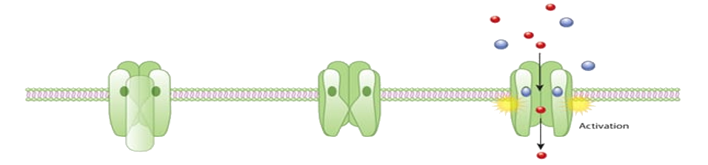

## **Calcium flux:**

Calcium (Ca2+) is considered important in the excitatory neurotransmitter release process. Blocked or inhibited Ca2+channelscan inhibit the release of neurotransmitters. Ca2+ channels are only open when an action potential goes towards the nerve terminal. This action potential causes Ca2+ to rush toward the neuron terminal due to the presence of a higher extracellular concentration level. Ca2+ concentration levels rise 1000-fold, ranging from 100 nanomolar to 100 micromolar within microseconds following an action potential. Following this, the neurotransmitter is rapidly released. As opposed to inhibitory neurotransmitter action which leads to the entry of Cl–(Purves, 2009).

**References:**

(1) Brady, S.T., Siegel, G.J., R Wayne Albers and Price, D.L. (2012). Basic neurochemistry : principles of molecular, cellular, and medical neurobiology. Waltham, Massachusetts ; Oxford: Academic Press / Elsevier.

(2) Purves, D., Augustine, G.J., Fitzpatrick, D., Katz, L.C., LaMantia, A.-S., McNamara, J.O. and S Mark Williams (2009). Neuroscience.

### 3.3.2 Receptor structure and function

## **Knowledge of Receptor Structure and Function in Relation to the Neurotransmitters**

|  |  |  |  |  |  |  |
| --- | --- | --- | --- | --- | --- | --- |
| **Neurotransmitter:** | **Pathway:** | **Rate limiting step:** | **Breakdown enzymes:** | **Breakdown product:** | **Reuptake channel:** | **Receptors:** |
| **Acetylcholine** | Acetyl coenzyme A (acetyl CoA, which is synthesized from glucose) and choline | Choline concentration | Choline acetyltransferase | Acetylcholinesterase | Acetylcholine is degraded by the enzyme acetylcholinesterase, and the products may be recycled through high-affinity transporters on the nerve terminal. | Muscarinic receptors (G-protein coupled): M1, M2, M3, M4 and M5. Nicotinic receptors (ion channels). |
| **Dopamine** | Tyrosine **→** L-DOPA **→** Dopamine | Tyrosine hydroxylase | Monoamine oxidase (MAO): MAO-A = noradrenaline + serotonin. MAO-B = dopamine. | Homovanillic acid | Dopamine transporter Note: cocaine inhibits this transporter. | D1, D2, D3, D4 and D5 (G-protein coupled). |
| **GABA** | GABA is synthesized in the cytoplasm of the presynaptic neuron from the precursor glutamate by the enzyme glutamate decarboxylase | Glutamic acid decarboxylase | GABA transaminase | GABA can be degraded extracellularly or taken back up into the glia or the presynaptic cell. GABA taken up from the synapse into the neurons is reused for synaptic loading. GABA taken up by astrocytes is degraded into C02 and glutamine. Glutamine is transported into the neurons for glutamate and GABA synthesis. | GABA at the synapse is terminated by reuptake into both presynaptic nerve terminals and surrounding glial cells. | GABAA: inhibitory and opens chloride channel. GABAB: G-protein coupled. |
| **Glutamate** | Multiple sources | Accumulation of precursors | Glutamate dehydrogenase | Glutamine or alpha-ketoglutarate. | Glial cell uptake with conversion to glutamine. | Metabotropic and ionotropic (NMDA, kainate binding or AMPA type). |
| **Noradrenaline** | Tyrosine **→** L-DOPA **→** Dopamine **→** Noradrenaline **→** Adrenaline | Tyrosine hydroxylase | Monoamine oxidase (MAO) + Catechol-O-methyltransferase (COMT) | Vanillyl mandelic acid | Noradrenaline reuptake channels | Alpha and beta. |
| **Serotonin** | Tryptophan **→** 5-hydroxy tryptophan **→** Serotonin | Tryptophan availability | MAO-A | 5-hydroxy indole acetic acid (5-HIAA) | Serotonin reuptake channels | 14 subtypes of serotonin receptors. |

(Brady, 2012)

## **Acetylcholine receptors:**

Acetylcholine (Ach)receptors are made of four polypeptide chains: it contains two α subunits and a β, γ and δ. In the CNS and PNS for fast neuron transmission acetylcholine receptors and neuronal nicotinic acetylcholine receptors play a meditating role. These receptors also work in physiological and pathological functions. Ach receptors modulate an array of functions such as arousal, learning, memory, rapid eye movement sleep, pain perception, thirst and parasympathetic mediation. There is reduced cholinergic function in Alzheimer’s dementia.

## **Dopamine receptors:**

Dopamine receptors are very important for our daily life activities. Dopamine plays an essential role in the brain function related to emotions, movement and system of reward (addictions) and motivation. In the central nervous system, dopamine receptors are expressed particularly in the subventricular area and hippocampal dentate gyrus. Dopamine consists of five receptors, every receptor has a different role to perform (D1, D2, D3, D4, D5). In Parkinson’s disease levels of dopamine are low, whereas in psychosis especially in the mesolimbic area dopamine is high.

|  |  |
| --- | --- |
| **Dopamine receptor:** | **Function:** |
| **D1** | Memory and attention regulations, impulse control, locomotion, and renal function regulation. |
| **D2** | Attention, locomotion, learning, sleep patterns, and memory. |
| **D3** | Attention and sleep regulations, and cognition impulse control. |
| **D4** | Responsible for neuronal signalling in the mesolimbic system of the brain, a part of the brain that regulates emotion and complex behaviour. |
| **D5** | Cognition, renin secretion, and decision making. |

## **GABA receptors:**

GABA functions as a primary inhibitor neurotransmitter. Its main function is to lessen neuronal excitability. In the central nervous system, it slows down GABA by blocking particular signals. In your central nervous system, it provides a calming effect. It’s also important for handling the nerve cell hyperactivity that is linked to stress, anxiety and fear. GABA receptors are the point of action for benzodiazepines, barbiturates and alcohol, this has applications in seizure cessation.

## **Glutamate receptors:**

Glutamate receptors, which are found on both neuronal and non-neuronal cells, mediate rapid excitatory synaptic transmission in the central nervous system. These receptors are responsible for a wide range of processes in the brain, spinal cord, retina, and peripheral nervous system. Glutamate receptors also have a crucial metabolic role since they act as an intermediary in the oxidation pathway.

## **Noradrenaline receptors:**

The noradrenergic system serves several functions in the central and peripheral neural systems. It plays an important role in the body’s “fight or flight” response. Noradrenaline and adrenaline are released during stressful or anxious states and bind to adrenergic receptors throughout the body, causing effects such as dilating pupils and bronchioles, increasing heart rate and constricting blood vessels, increasing renin secretion from the kidneys, and inhibiting peristalsis.

Noradrenaline has also been demonstrated to stimulate glycogenolysis and gluconeogenesis (despite decreasing glucose clearance) and to induce ketogenesis and lipolysis (Hussain, 2022).

## **Serotonin receptors:**

Serotonin plays a vital role in body functions such as mood, digestion, nausea, blood clotting, sexual function, wound healing, sleep and pain perception. The serotonin hypothesis of depression postulated in the 1960s was the idea a deficit in brain serotonin, corrected by antidepressant drugs, was the origin of the illness. In recent years there is little evidence to support this (Moncrieff, 2022).

There are 14 known subtypes of serotonin receptors (5-HT1A, 5-HT1B, 5-HT1D, 5-HT1E, 5-HT1F, 5-HT2A, 5-HT2B, 5-HT2C, 5-HT3, 5-HT4, 5-HT5A, 5-HT5B, 5-HT6, and 5-HT7). Some functions are shown below:

|  |  |
| --- | --- |
| **Serotonin receptor:** | **Function:** |
| **5-HT3** | All except 5-HT3 are G-protein coupled receptors; 5HT3 is predominant in the gut; associated with motility. |
| **5-HT1A** | G-protein coupled postsynaptically; antidepressant response; sexual behaviour. |
| **5-HT1B** | G-protein coupled presynaptically. |
| **5-HT1D** | G-protein coupled are both presynaptic and postsynaptic. |
| **5-HT2** | Phospholipase C coupled; postsynaptic; antagonism leads to antipsychotic response (atypicals) and sedation. LSD causes 5-HT2 stimulation. Down-regulation was noted after antidepressant treatment or electroconvulsive therapy. |
| **5-HT6** | May be involved in antidepressant action. |
| **5-HT7** | Regulation of the circadian rhythm. |

## **Excitatory amino acids**:

Excitatory amino acids (EAA) are used by the vast majority of synapses in the central nervous system. An amino acid neurotransmitter is an amino acid which is able to transmit a nerve message across a synapse. Neurotransmitters are packaged into vesicles that cluster beneath the axon terminal membrane on the presynaptic side of a synapse.

Examples of EAA:

* Aspartic acid
* Cysteine
* Glutamic acid/glutamate
* Homocysteine
* Aspartate

(Levitan, 2002).

The functional physiological range of glutamate and glutamate receptors is extremely limited, and even little deviations produce a slew of neurological and psychological problems via excitotoxicity. Excitotoxicity of glutamate appears to play a role in schizophrenia and Alzheimer’s disease (Birbaumer, 1999).

## **Pre-synaptic and post-synaptic receptors**:

Presynaptic receptors are regions where transmitters, locally produced mediators, or hormones restrict or facilitate transmitter release from axon terminals. Presynaptic terminals are like small buds and contain organelles, seen with help of a light microscope. Synaptic vesicles are filled with neurotransmitters. At the end of the axon, a presynaptic terminal converts the electric current of the action potential into chemical signals via neurotransmitter release (Schlicker, 2017).

Synaptic vesicles are small sacs inside where neurotransmitters are stored and neurotransmitters released in the synaptic cleft, it occurs when a vesicle fuses with the cell membrane via exocytosis. Exocytosis occurs in less than a millisecond releasing the neurotransmitter.

Neurotransmitters interact with receptor proteins on the membrane of the postsynaptic cell after being released into the synaptic cleft, causing ionic channels on the membrane to open or close. Depolarization happens when these channels open, resulting in the activation of another action potential (Purves, 2017).

There are two types of post-synaptic receptors that recognize neurotransmitters ionotropic receptors (ligan-gate ion channels) and metabotropic receptors (G-protein coupled receptors) (Hollingsworth, 1991).

**References:**

(1) Brady, S.T., Siegel, G.J., R Wayne Albers and Price, D.L. (2012). Basic neurochemistry : principles of molecular, cellular, and medical neurobiology. Waltham, Massachusetts ; Oxford: Academic Press / Elsevier.

(2) Birbaumer, N. and Flor, H. (1999). Applied Psychophysiology and Biofeedback, 24(1), pp.35–37. doi:10.1023/a:1022838829332.

(3) Hollingsworth, P. J. and Smith, C. B. (1991) “Factors influencing the function of presynaptic α2-adrenoceptors in rat brain,” in Presynaptic Receptors and Neuronal Transporters. Elsevier, pp. 39–42.

(4) Hussain, L.S., Reddy, V. and Maani, C.V. (2022). Physiology, Noradrenergic Synapse. [online] PubMed. Available at: https://www.ncbi.nlm.nih.gov/books/NBK540977/#:~:text=During%20states%20of%20stress%20or [Accessed 16 Mar. 2022].

(5) Levitan, I.B. and Kaczmarek, L.K., 2002. The neuron: cell and molecular biology. Oxford University Press, USA.

(6) Moncrieff, J., Cooper, R.E., Stockmann, T., Amendola, S., Hengartner, M.P. and Horowitz, M.A. (2022). The serotonin theory of depression: a systematic umbrella review of the evidence. Molecular Psychiatry, pp.1–14. doi:10.1038/s41380-022-01661-0.

(7) Purves, D., Augustine, G.J., Fitzpatrick, D., Katz, L.C., Anthony-Samuel LaMantia, McNamara, J.O. and S Mark Williams (2017). Two Families of Postsynaptic Receptors. [online] Nih.gov. Available at: https://www.ncbi.nlm.nih.gov/books/NBK10855/.

(8) Schlicker, E. and Feuerstein, T. (2017). Human presynaptic receptors. Pharmacology & Therapeutics, [online] 172, pp.1–21. doi:10.1016/j.pharmthera.2016.11.005.

### 3.3.3 Principle second messenger systems

## **Knowledge of the Principle Second Messenger Systems Related to Neurotransmitters**

The second messenger systems are essentially small ions and molecules that rely upon the signal gathered from receptors present on the cell surface to the protein effector. The main function of the second messenger system is to receive the signal from the first messenger. The second messengers are intracellular and the first messengers are extracellular. Second messengers trigger physiological changes at a cellular level such as apoptosis, depolarization, differentiating, migration and proliferation[.](https://en.wikipedia.org/wiki/Cell_proliferation) They are one of the triggers of intracellular signal transduction cascades.

Second messenger systems have the ability to pass along a chemical message from the first messenger (neurotransmitter) from the cell membrane toward the internal cell machinery. The activation process of the second messenger system includes a chemical energy source from the cell which is adenosine triphosphate (ATP).

When noradrenaline is attached to the relevant receptors on the neuronal surface the activated receptors will attach a G-protein on the inside surface of the membrane. Activated G-protein acts in a way that causes the adenylyl cyclase enzyme with ATP to convert into cyclic adenosine monophosphate (cyclic AMP) the second messenger. Instead of working between neurons, in the synaptic cleft cAMP exerts changes to the ion channels in order to make changes in gene expression.

**Examples of second messengers:**

* **cyclic AMP (cAMP):** This system is activated by neurotransmitters such as adrenaline, dopamine, and serotonin. It regulates many processes, including protein synthesis, metabolism, and the opening of ion channels.
* **cyclic GMP (cGMP)**
* **inositol triphosphate (IP3):**This system is activated by neurotransmitters such as acetylcholine and glutamate. It leads to the release of intracellular stores of calcium, which plays a role in a range of processes, including synaptic plasticity and gene expression.
* **Diacylglycerol**
* Calcium
* **Nitric oxide (NO) system:**This system is activated by neurotransmitters such as nitric oxide. It functions as a signalling molecule, transmitting signals between neurons and between neurons and other cells in the body. It has a role in synaptic plasticity, blood flow regulation, and the regulation of blood pressure.

(Pollard, 2017)

**Examples of first messengers are extracellular factors:**

* Hormones
  + Growth hormone
* Neurotransmitters
  + Noradrenaline
  + Serotonin

GABA receptors amplify the second messenger pathway providing neuronal transmission with an inhibitory signal.

Second messengers are involved in the development and growth processes. The second messenger’s direct effect on genetic messenger may lead to a cell alteration of its cellular functioning.

## Neurotransmitters**Related to Basic Neuronal Homeostasis and Plasticity**

Neurotransmitters are small molecules that play a crucial role in transmitting information between neurons. They are synthesized and stored in the nerve terminals and are released into the synaptic cleft in response to an action potential. The neurotransmitter then binds to specific receptors on the postsynaptic neuron, triggering a series of events that lead to changes in the membrane potential and the transmission of an electrical signal.

## **Neuronal homeostasis:**

Neurotransmitters play an important role in maintaining basic neuronal homeostasis, which refers to the stable and consistent functioning of the nervous system. Some neurotransmitters, such as GABA and glycine, have an inhibitory effect on the neurons, helping to regulate the excitability of the nervous system and maintain basic homeostasis.

Homeostatic changes in glutamate and GABA receptors have been found to occur on excitatory cortical neurons during insomnia. The role of homeostasis in serotonin is associated with behavioural activities, clinical disorders, and biological systems. The serotonergic neurons are found to be involved in these processes. Homeostasis of dopamine is also thought to play a role in neuronal health. Dysfunctions in dopamine homeostasis have been linked to a range of neurological disorders, including depression, addiction, and neurodegeneration (del Cid-Pellitero, 2017).

## P**lasticity:**

Neurotransmitters also play a role in neuronal plasticity, which refers to the ability of the nervous system to change and adapt in response to new experiences and information. For example, the neurotransmitter dopamine is involved in reward-driven learning and is involved in the regulation of motivation, pleasure, and reward. Other neurotransmitters, such as glutamate and acetylcholine, are involved in synaptic plasticity, the ability of the synapses to change and strengthen over time in response to new experiences.

Long-term synaptic plasticity involves both dopamine and glutamate. Dopamine is a key neuromodulator that plays a significant role in reward-driven learning and motivation. It adjusts the synaptic dynamics by modifying the integration mechanism and synaptic transmission, which affects intrinsic properties of neural systems such as the probability of neurotransmitter release, membrane excitability, protein trafficking, gene transcription, and receptor response to neurotransmitters. However, dysfunction in dopamine can result in cognitive disorders (Kuhar, M.J., 1975).

In summary, neurotransmitters play a crucial role in both basic neuronal homeostasis and plasticity. They help to regulate the excitability of the nervous system, maintain stability, and support the ability of the nervous system to change and adapt in response to new experiences and information.

**References:**

(1) del Cid-Pellitero, E., Plavski, A., Mainville, L. and Jones, B.E., 2017. Homeostatic changes in GABA and glutamate receptors on excitatory cortical neurons during sleep deprivation and recovery. Frontiers in systems neuroscience, 11, p.17.

(2) Kuhar, M.J., 1975. Neurotransmitter uptake: a tool in identifying neurotransmitter-specific pathways. Minireviews of the Neurosciences from Life Sciences, pp.263-274.

(3) Pollard TD, Earnshaw WC, Lippincott-Schwartz J, Johnson G, eds. (2017-01-01). “Second Messengers”. Cell Biology (3rd ed.). Elsevier Inc. pp. 443–462.

### 3.3.4 Basic pharmacology of neurotransmitters

## **Basic Pharmacology of Neurotransmitters**

Pharmacology is the study of drugs and their effects on biological systems, including neurotransmitters. The basic pharmacology of neurotransmitters involves understanding how drugs interact with neurotransmitter systems to produce therapeutic or adverse effects.

Neurotransmission occurs via calcium-induced exocytosis of vesicles containing the neurotransmitter in the pre-synaptic neuron.

## **Noradrenaline:**

Noradrenaline is a sympathomimetic amine derived from tyrosine. Structural noradrenaline and adrenaline are the same. The difference is that noradrenaline lacks a methyl group on the nitrogen atom. This difference alone makes noradrenaline a primary agonist at alpha-1 and beta-1 receptors. There is almost no alpha-2 or beta-2 activity (Smith, 2019).

Activation of alpha-1 receptors leads to its primary physiological and clinical use as a peripheral vasoconstrictor. Dose-dependent increases in increased systemic vascular resistance.

Noradrenaline is metabolized by the enzymes catechol-O-methyltransferase (COMT) and MAO in the liver and other tissues:

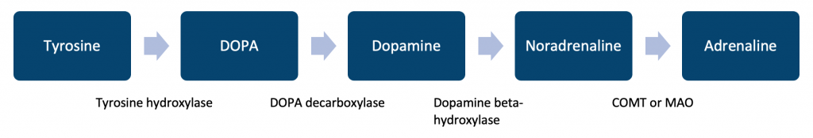

The major metabolites are vanillylmandelic acid (VMA) and normetadrenaline.

A common drug class that can influence synthesis or degradation are monoamine oxidase inhibitors.

## **Serotonin:**

Serotonin is a monoamine whose production occurs in two steps:

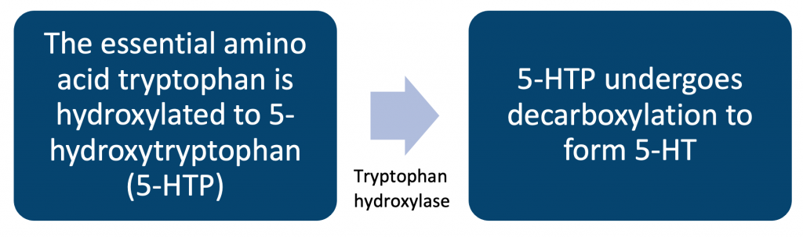

Once synthesized, serotonin is stored within the central nervous system (CNS) in the presynaptic neurons. The raphe nuclei are the major nuclei for serotonin, possessing both ascending serotonergic fibres that project to the forebrain and descending fibres extending to the medulla and the spinal cord (Bakshi, 2022).

Serotonin is important for mood-regulating, cognition functions, reward, memory, learning, and other different physiological processes like vasoconstriction and vomiting (Robinson, 1987).

A common drug class that can influence synthesis or degradation are monoamine oxidase inhibitors.

## **Dopamine:**

Dopamine is a peripheral vasostimulant commonly utilised for the management of low blood pressure, cardiac arrest and low heart rate. Dopamine is considered important for the management of chronic congestive heart rate, and renal failure. In low doses, dopamine can also have an important role in managing hypotension, and cardiac low output (Beaulieu, J.M. and Gainetdinov, R.R., 2011).

Dopamine is synthesised following the same enzymatic sequence as noradrenaline. Dopamine is the precursor in the synthesis of noradrenaline.

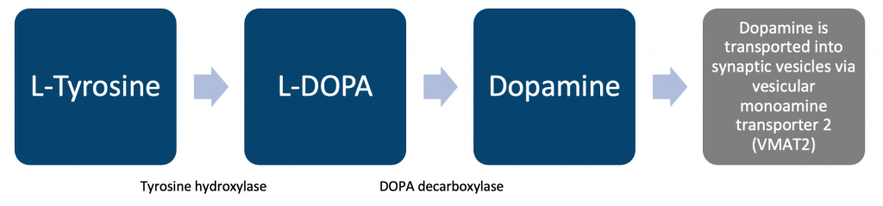

Notable dopamine circuits:

* Tuberoinfundibular pathway – responsible for regulating prolactin from the anterior pituitary gland (Grattan, 2015).
* Nigrostriatal pathway involved in motor deficits seen in Parkinson’s disease – dopaminergic neurons originating in the substantia nigra.
* Lesser roles in water/salt homeostasis, immune response and cell-cycle regulation (Dobolyi, 2014).

## **Acetylcholine:**

Acetylcholine works by attaching to the cholinergic receptors (muscarinic and nicotinic). Acetylcholine operates in a variety of ways via cholinergic receptors. There are both nicotinic acetylcholine receptors which are ligand-gated ion channels and muscarinic acetylcholine receptors which are G-protein coupled receptors (Kokaz, 2020).

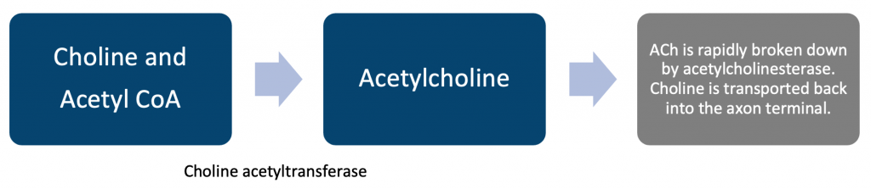

Acetylcholine (ACh) has a role in a variety of disease processes, the most prevalent of which is Alzheimer’s disease (AD), Lambert-Eaton myasthenic syndrome (LEMS), and myasthenia gravis (MG).

A common drug class that can influence synthesis or degradation are anticholinesterases.

## **GABA** **receptors:**

Gamma-aminobutyric acid (GABA) is an amino acid that functions as an inhibitory neurotransmitter within the CNS. GABA reduces neuronal excitability by inhibiting nerve transmission. GABAergic neurons are found in the basal ganglia, brainstem, hippocampus, hypothalamus, and the thalamus (Allen, 2022).

GABA synthesis:

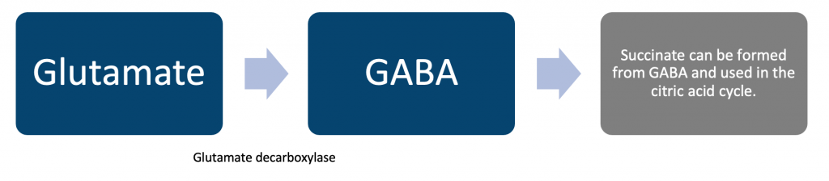

GABA contains 5 protein subunits, these all are connected with each other in a circular shape. These sites don’t open until a ligand binds with them. GABA is an inhibitory effect that helps to “calm the neuron’s excitability”. In order to slow the process of the CNS, GABA blocks the signals. In this way, it can control hyperactivity that is associated with fear, anxiety, and stress (Löscher, 2002)

However, during embryonic development, GABA acts as an excitatory neurotransmitter and plays a role in promoting neuronal progenitor cell size and proliferation in ventricular areas (Wang, 2009) (Wu, 2015).

A common drug that can influence synthesis or degradation is Vigabatrin.

## **Excitatory amino acids**

Glutamate is known as the most abundant principal excitatory amino acid neurotransmitter of the central nervous system. It acts upon both ionotropic and metabotropic receptors.

It is concentrated in synaptic vesicles of neuronal terminals, from which it is released by exocytosis, anion channels, and transporter reversal. It cannot pass the blood-brain barrier and is constantly cleared from the extracellular fluid by astrocytes to prevent excessive receptor activation (Stallard, 2018).

Glutamate has vast-ranging clinical relevance:

* Depression
* Substance misuse disorder
* Schizophrenia
* Neurodegenerative disorders

**References:**

(1) Allen, M.J., Sabir, S. and Sharma, S. (2022). GABA receptor. [online] PubMed. Available at: https://www.ncbi.nlm.nih.gov/books/NBK526124/.

(2) Bakshi, A. and Tadi, P. (2022). Biochemistry, Serotonin. [online] PubMed. Available at: https://www.ncbi.nlm.nih.gov/books/NBK560856/#:~:text=%5B2%5D%5B4%5D%20Although [Accessed 5 Jan. 2023].

(3) Beaulieu, J.M. and Gainetdinov, R.R., 2011. The physiology, signaling, and pharmacology of dopamine receptors. Pharmacological reviews, 63(1), pp.182-217.

(4) Dobolyi A, Grattan DR, Stolzenberg DS. Preoptic inputs and mechanisms that regulate maternal responsiveness. J Neuroendocrinol. 2014 Oct;26(10):627-40.

(5) Grattan DR. 60 Years of Neuroendocrinology: The hypothalamo-prolactin axis. J Endocrinol. 2015 Aug;226(2):T101-22.

(6) Kokaz, S.F., Deb, P.K., Abed, S.N., Al-Aboudi, A., Das, N., Younes, F.A., Salou, R.A., Bataineh, Y.A., Venugopala, K.N. and Mailavaram, R.P. (2020). Pharmacology of Acetylcholine and Cholinergic Receptors. Frontiers in Pharmacology of Neurotransmitters, [online] pp.69–105. doi:10.1007/978-981-15-3556-7_3.

(7) Löscher, W., 2002. Basic pharmacology of valproate. CNS drugs, 16(10), pp.669-694.

(8) Robinson, M.B. and Coyle, J.T., 1987. Glutamate and related acidic excitatory neurotransmitters: from basic science to clinical application. The FASEB journal, 1(6), pp.446-455.

(9) Smith, M.D. and Maani, C.V. (2019). Norepinephrine. [online] Nih.gov. Available at: https://www.ncbi.nlm.nih.gov/books/NBK537259/.

(10) Stallard, C.N. and Abdolreza Saadabadi (2018). Biochemisty, Glutamate. [online] Nih.gov. Available at: https://www.ncbi.nlm.nih.gov/books/NBK537267/.

(11) Wang DD, Kriegstein AR. Defining the role of GABA in cortical development. J Physiol. 2009 May 01;587(Pt 9):1873-9.

(12) Wu C, Sun D. GABA receptors in brain development, function, and injury. Metab Brain Dis. 2015 Apr;30(2):367-79.

### 3.3.5 Neuropeptides

## **Knowledge of Neuropeptides**

Neuropeptides are amino acids that have been formed into short chains. Neurons produce and release these chemical messengers. Neuropeptides bind to G-protein coupled receptors to regulate tissue and neural activity (muscles, heart, and gut).

Released by dense core vesicles in the synaptic terminal following depolarization of the cell. When contrasted against neurotransmitters, then neuropeptides are much more sensitive. They are measured in the nanomolar-micromolar range while neurotransmitters are in the micromolar-millimolar range.

|  |  |  |
| --- | --- | --- |
| **Neuropeptide:** | **Location secreted:** | **Function:** |
| **Corticotrophin-releasing hormone** | Hypothalamus | Suppresses appetite. Increases anxiety. Improves memory and selective attention. |
| **Cholecystokinin** | Small intestine (mostly duodenum and jejunum) via enteroendocrine cells called I-cells. | Fundamental in the process of triggering bile and enzymes to break down food. |
| **Ghrelin** | Stomach | Stimulates appetite and growth hormone release. |
| **Leptin** | Adipose tissue | Suppresses food intake/satiety. |
| **GLP-1** | Pancreatic alpha cells. | Stimulate insulin secretion. Inhibit glucagon secretion. Limits post-prandial glucose increases. |
| **Encephalins/endorphins** | Central nervous system and adrenal medulla. | Encephalins are tiny peptides that can function in the brain as neurotransmitters. Encephalins block afferent pain fibres and reduce substance P release in the dorsal horn of the spinal cord. |
| **Orexin** | Hypothalamus | Regulates wakefulness, appetite, reward, and thermogenesis. |
| **Substance P** | Neurons | Neuropeptide/neurotransmitter modulating pain perception |

|  |  |
| --- | --- |
| **Neurotransmitter:** | **Coexisting neuropeptides:** |
| **Acetylcholine** | Substance P |
| **Adrenaline** | Neuropeptide Y Neurotensin |
| **Dopamine** | Cholecystokinin Neurotensin Glucagon-like peptide-1 |
| **GABA** | Somatostatin Cholecystokinin Neuropeptide Y |
| **Noradrenaline** | Neuropeptide Y Enkephalin Galanin |
| **Serotonin** | Substance P Enkephalin Thyrotropin-releasing hormone |

## **Corticotrophin-releasing hormone:**

Corticotropin-releasing hormone (CRH) is a neuropeptide hormone that emphasizes regulating sympathetic, behavioural functions, and neuroendocrine functions. It contains 41 amino acids and is secreted through the hypothalamus. CRH regulates the behavioural functions and neuroendocrine in response to threats or stress. When the hypothalamus releases the corticotrophin-releasing hormone that triggers the release of adrenocorticotrophic hormone (ACTH). ACTH binds with the adrenal cortex, it triggers the release of the stress hormone known as cortisol.  This entire system plays an important part in the fight or flight response (Walia, 2021).

Increased CRH production has been associated with depression and Alzheimer’s disease (Raadsheer, 1995).

## **Cholecystokinin:**

Cholecystokinin (CCK) is produced in the small intestine and plays an important role in digestion. When protein and fats transit into the small intestine, CCK activates the pancreas and gallbladder to function. This process works so finely, it delivers enzymes and bile to the duodenum that helps in food absorption (Walia, R., H., Ahuja, 2021).

CCK is found throughout the central nervous system, specifically in the limbic system. Elevated CCK increases levels of anxiety and can reliably induce a panic attack. Positron emission tomography imaging showing CCK-4-induced panic attacks demonstrates changes in the anterior cingulate gyrus, amygdala and cerebellar vermis (Bowers, 2012).

## **Ghrelin:**

Ghrelin is a neuropeptide hormone released by enteroendocrine cells of the stomach. It is often referred to as the ‘hunger hormone’ since it increases your drive to eat, or reduces your satiety. Ghrelin levels in the blood are greatest before meals when people are hungry, and they return to normal after meals. Ghrelin may aid in meal preparation by enhancing stomach motility and boosting gastric acid output (Okonkwo, 2021).

Obese people have lower ghrelin levels in their plasma than thinner people (Müller, 2015).

In anorexia nervosa the ghrelin levels are higher compared to normal-weight controls (Tolle, 2003).

## **Leptin:**

Leptin is a neuropeptide hormone synthesized predominantly by adipose cells but also by enterocytes in the small intestine. Leptin acts upon receptors in the lateral hypothalamus which inhibit hunger, and in the medial hypothalamus stimulate satiety. This inhibition of hunger consequently reduces fat storage in adipocytes and regulates homeostatic energy levels.

## **Glucagon-like peptide-1:**

Glucagon-like peptide-1 (GLP-1) is a neuropeptide hormone produced and secreted by intestinal enteroendocrine cells and certain neurons in the brainstem.

The main function of GLP-1 is the promotion of insulin secretion in a glucose-dependent manner. GLP-1 binds to GLP-1 receptors on pancreatic beta cells. Following this GLP-1 also replaces its used stores by promoting insulin gene transcription and biosynthesis (Baggio, 2007).

## **Enkephalins and Endorphins:**

Enkephalins are pentapeptides involved in nociception is the process through which the sensory nerve system encodes noxious sensations. It is concerned with the sequence of events and processes necessary for an organism to receive a painful input, convert it to a molecular signal, detect and define the signal, and initiate an appropriate defensive reaction (Miller, 1979). Enkephalins are found in the cells of the adrenal medulla.

Endorphins are often referred to as opioid neuropeptides and act as chemical signals that either block the perception of pain or increase feelings of well-being. They are synthesised and stored in the pituitary gland (Steffano, 2011). There a three endogenous opioid neuropeptide classes: alpha-endorphin, beta-endorphin and gamma-endorphin. All three endorphin classes are fragments of the precursor protein proopiomelanocortin.

## **The endocannabinoid system:**

The endocannabinoid system (ECS) is a neuromodulatory system in the central nervous system. The ECS comprises cannabinoid receptors, endogenous cannabinoids (endocannabinoids), and the enzymes involved in endocannabinoid synthesis and breakdown. CB1 cannabinoid receptors are the most numerous, although cannabinoids also engage CB2 cannabinoid receptors, transient receptor potential (TRP) channels, and peroxisome proliferator-activated receptors (PPARs). Exogenous cannabinoids, including tetrahydrocannabinol, exert biological effects by interacting with cannabinoid receptors. The best-studied endogenous cannabinoids are 2-arachidonoyl glycerol (2-AG) and arachidonoyl ethanolamide (anandamide).

The endogenous cannabinoids are endogenous lipids that consequently engage cannabinoid receptors.

Anandamide is broken down in the central nervous system by the enzyme fatty acid amino hydrolase. 2-AG is broken down by a much more complex pathway.

Cannabis has a tightly bound relationship with the ECS. Epidemiology notes a relationship between increased cannabis use and heightened risk for schizophrenia in susceptible individuals (Lu, 2015).

## **Orexins:**

Orexin is a neuropeptide that regulates appetite, wakefulness, thermogenesis and arousal. The vast majority of orexin is produced by neurons in the lateral hypothalamus and perifornical area.

Lack of orexin can cause type 1 narcolepsy, in which a person loses their muscle tone. Narcolepsy occurs due to the destruction of the cells that synthesise orexin. This destruction is thought to occur by the immune system mistakenly attacking the cells/neurons in the hypothalamus or the receptors that allow it to function (Krieger, D.T., 1982).

## **Substance P:**

Substance P (where ‘P’ stands for preparation or powder) is a neuropeptide that interacts with the receptor neurokinin type 1. Released from neurons, substance P is a primary peptide in responding to noxious stimuli or pain (O’Connor, 2014).

**References:**

(1) Baggio LL, Drucker DJ (May 2007). “Biology of incretins: GLP-1 and GIP”. Gastroenterology. 132 (6): 2131–57.

(2) Bowers ME, Choi DC, Ressler KJ (December 2012). “Neuropeptide regulation of fear and anxiety: Implications of cholecystokinin, endogenous opioids, and neuropeptide Y”. Physiology & Behavior. 107 (5): 699–710.

(3) Krieger, D.T., 1982. Endorphins and enkephalins. Disease-a-Month, 28(10), pp.3-53.

(4) Lu, H.-C. and Mackie, K. (2016). An Introduction to the Endogenous Cannabinoid System. Biological Psychiatry, [online] 79(7), pp.516–525. doi:10.1016/j.biopsych.2015.07.028.

(5) Miller, R.J. and Cuatrecasas, P. (1979). Enkephalins and Endorphins. [online] ScienceDirect. Available at: https://www.sciencedirect.com/science/article/abs/pii/S0083672908609875 [Accessed 5 Jan. 2023].

(6) Müller TD, Nogueiras R, Andermann ML, Andrews ZB, Anker SD, Argente J, et al. (June 2015). “Ghrelin”. Molecular Metabolism. **4** (6): 437–60.

(7) O’Connor TM, O’Connell J, O’Brien DI, Goode T, Bredin CP, Shanahan F (Nov 2004). “The role of substance P in inflammatory disease”. Journal of Cellular Physiology. 201 (2): 167–80.

(8) Raadsheer FC, van Heerikhuize JJ, Lucassen PJ, Hoogendijk WJ, Tilders FJ, Swaab DF (September 1995). “Corticotropin-releasing hormone mRNA levels in the paraventricular nucleus of patients with Alzheimer’s disease and depression”. The American Journal of Psychiatry. 152 (9): 1372–1376.

(9) Stefano GB, Ptáček R, Kuželová H, Kream RM (1515). “Endogenous morphine: up-to-date review 2011”. Folia Biologica. **58** (2): 49–56.

(10) Tolle V, Kadem M, Bluet-Pajot MT, Frere D, Foulon C, Bossu C, et al. (January 2003). “Balance in ghrelin and leptin plasma levels in anorexia nervosa patients and constitutionally thin women”. The Journal of Clinical Endocrinology and Metabolism. 88 (1): 109–16.

(11) Walia, R., Gupta, R., Bhansali, A., Pivonello, R., Kumar, R., Singh, H., Ahuja, C., Chhabra, R., Singh, A., Dhandapani, S. and Sahoo, S., 2021. Molecular imaging targeting corticotropin-releasing hormone receptor for corticotropinoma: a changing paradigm. The Journal of Clinical Endocrinology & Metabolism, 106(4), pp.1816-1826.

### 3.3.6 Genetic association studies

## **Links Between Neurotransmitter Systems and Findings from Genetic Association Studies in Psychiatry**

There is a growing body of evidence suggesting that interactions between different neurotransmitter systems play a critical role in the development of psychiatric disorders. This is reflected in the findings from genetic association studies in psychiatry, which have identified a number of genes that are involved in the regulation of neurotransmitter systems and that are associated with increased risk for psychiatric conditions such as depression, anxiety, and schizophrenia.

Empirical evidence suggested that neurotransmitters play a very important role in psychiatric disorders. These neurotransmitters include serotonin, noradrenaline, GABA, dopamine, endorphins and glutamate which are considered responsible for a number of psychiatric disorders. These neurotransmitters are accountable for a vast array of psychiatric symptoms and can lead individuals to psychosis, depression, and anxiety (Valenzuela, 2011).

Disorders of a psychiatric nature are troubling diseases because of both an environmental and genetic base. As a metaphor, the model of enteropathogenic is defined as a jar. For example, a jar is filled at a certain level with people who are born with genetic risk factors. Psychiatric disorders are actually polygenic in nature, it has spread different variants within the genome and these are involved in the susceptibility to disease. In critical regions, this genetic architecture might lead to a large effect due to negative selection. As time passes, environmental risk factor plays a part in an individual’s life by increasing the jar level and making an individual vulnerable. After all, this is when a jar is filled with a threshold value and manifests episodic illness of a disorder in an individual. Genetic variants are found to be contributing to different psychiatric illnesses.

Although there is evidence that links schizophrenia and bipolar disorder to genetic and environmental variables, specific individuals or groups of genes/factors that cause the disease have eluded researchers.

Understanding how epigenetic alterations caused by promoter DNA methylation impact gene expression in schizophrenia and bipolar disorder is key. The key reversible but covalent epigenetic change to DNA appears to be produced from cytosine residue methylation, which is potentially heritable and can impact gene expression and downstream functions. Hyper- and hypo-methylation of DNA play a critical determinant factor in schizophrenia and bipolar disorder (Abdolmaleky, 2008).

Family studies have measured the relative risk factor of multiple diseases. The relative risk factor for major depressive disorder in first-degree relatives is 1.5. For bipolar disorder and schizophrenia, the relative risk factor is 7. For autism spectrum disorder it is almost (Abdolmaleky, 2005).

**References:**

(1) Abdolmaleky, H.M., Thiagalingam, S. and Wilcox, M. (2005). Genetics and Epigenetics in Major Psychiatric Disorders. American Journal of PharmacoGenomics, 5(3), pp.149–160. doi:10.2165/00129785-200505030-00002.

(2) Abdolmaleky, H.M., Smith, C.L., Zhou, J.-R. and Thiagalingam, S. (2008). Epigenetic alterations of the dopaminergic system in major psychiatric disorders. Methods in Molecular Biology (Clifton, N.J.), [online] 448, pp.187–212. doi:10.1007/978-1-59745-205-2_9.

‌(3) Valenzuela, C.F., Puglia, M.P. and Zucca, S., 2011. Focus on: neurotransmitter systems. Alcohol Research & Health, 34(1), p.106.

### 3.3.7 Recreational drugs

## **Effects of Common Recreational Drugs on Neurotransmission and the Link to Mental Health Symptoms**

Recreational drugs interfere with neurons in order to send, process, and receive signals with the help of neurotransmitters. Opioids (including morphine and heroin) and marijuana are able to activate the neurons because these chemical substances can mimic the natural neurotransmitters present. These chemical substances will attach to the neuron and activates them (Cowen, 1999).

## **Opioids:**

Opioids are a class of drugs that bind to specific receptors in the brain and modulate neurotransmitter function, particularly the neurotransmitter systems involved in pain perception and reward. Opioids act by increasing the release of neurotransmitters, such as dopamine, which produce feelings of pleasure and euphoria.

While opioids can provide effective pain relief and produce pleasurable effects, they can also lead to changes in the brain’s reward system, resulting in tolerance, dependence, and withdrawal symptoms. Chronic opioid use has been linked to a number of mental health symptoms, including anxiety, depression, and insomnia. In addition, opioid use has been associated with an increased risk of developing mood and psychotic disorders, such as bipolar disorder and schizophrenia. This may be due to the long-term effects of opioids on the brain’s reward system, as well as its effects on neurotransmitter systems and brain structure and function.

Opioids have two activated sites, one is on the presynaptic nerve terminal and the other one is on the postsynaptic neuron. Opioids’ postsynaptic actions are inhibitory and opioids’ presynaptic action inhibits the release of neurotransmitters.  This is hypothesised to be a cause for the major disturbance in the nervous system. Individuals using opioids for a long period of time can induce changes in their white matter tracts and become the reason for insomnia, sexual dysfunction, chronic constipation, kidney diseases and menstrual cycle disturbance.

The periaqueductal grey (PAG) area of the midbrain is rich in opioid receptors and endogenous opioids and is a primary target for analgesia. The analgesic impact of opioids on the PAG is thought to function by reducing the inhibitory effects of the neurotransmitter gamma-aminobutyric acid (GABA) on neurons in a descending antinociceptive pathway. Opioids reduce the likelihood of presynaptic neurotransmitter release, which inhibits GABA-mediated (GABAergic) synaptic transmission in the PAG and other brain areas, although the processes involved are unknown (Vaughan, 1997).

## **Cocaine:**

Cocaine is a highly addictive stimulant drug that affects the neurotransmitter systems in the brain, particularly the dopamine, norepinephrine, and serotonin systems. Cocaine blocks the reuptake of these neurotransmitters, leading to an accumulation of neurotransmitters in the synaptic cleft and an increased transmission of signals between neurons.

This increase in neurotransmitter signalling produces feelings of euphoria and increased energy, as well as increased heart rate, elevated blood pressure, and decreased appetite. However, repeated use of cocaine can lead to changes in the brain’s reward system, which can result in tolerance, dependence, and withdrawal symptoms. Long-term use of cocaine has been linked to a number of mental health symptoms, including anxiety, depression, and paranoia. These symptoms may be due to changes in the brain’s reward system, as well as changes in the function of neurotransmitter systems, such as the dopamine system.

Opioids increase the stimulation of dopamine, whereas cocaine affects existing dopamine by blocking the reuptake thus increasing the longer pleasurable effects. Both of these drugs influence and reinforce the brain to repeatedly use the drugs. Long-term usage might cause a decrease in the ability to decision-making and an individual’s response toward stress. Euphoria is a long-term symptom that leads an individual toward increased arousal and alertness, increased level of paranoia, depression, insomnia and tremors etc. It also increases the risk of heart attack, stomach inflammation, and ulcers.

## **Cannabis:**

Cannabis contains compounds known as cannabinoids, which bind to specific receptors in the brain and modulate neurotransmitter function. The primary psychoactive component of cannabis, delta-9-tetrahydrocannabinol (THC), acts on the endocannabinoid system and affects neurotransmitter systems including the dopamine, glutamate, and GABA systems.

The effects of THC on neurotransmitter systems can result in changes in mood, perception, and cognition. For example, THC can increase dopamine release in the brain, which can produce feelings of euphoria and increased appetite. THC can also reduce glutamate release, which may contribute to its effects on memory and learning.

While cannabis use can produce short-term effects that are pleasurable for some users, it can also produce negative effects, particularly in individuals who are vulnerable to mental health symptoms. Cannabis use has been associated with the development or exacerbation of mental health symptoms such as anxiety, depression, and paranoia.

In addition, heavy and long-term use of cannabis has been linked to an increased risk of developing psychotic disorders, such as schizophrenia. This is thought to be due to the effects of THC on the dopamine system, as well as its effects on brain structure and function.

It is important to note that the relationship between cannabis use and mental health is complex and influenced by a number of factors, including individual differences in genetic susceptibility, the dose and frequency of use, and the presence of co-occurring medical or psychiatric conditions.

Overall, while cannabis can produce pleasurable effects in some individuals, it can also have negative effects on mental health, particularly in individuals who are vulnerable to mental health symptoms. As a result, it is important for individuals to be aware of the potential risks associated with cannabis use and to consult with a healthcare professional if they have concerns about their use.

**References:**

(1) Cowen, M.S. and Lawrence, A.J., 1999. The role of opioid-dopamine interactions in the induction and maintenance of ethanol consumption. Progress in Neuro-Psychopharmacology and Biological Psychiatry, 23(7), pp.1171-1212.

(2) Vaughan, C.W., Ingram, S.L., Connor, M.A. and Christie, M.J. (1997). How opioids inhibit GABA-mediated neurotransmission. Nature, 390(6660), pp.611–614. doi:10.1038/37610.

## 3.4 Neuroanatomy

### 3.4.1 General anatomy of the brain

## **General Anatomy of the Brain**

The brain is one of the most important and complex parts of the human body.  The brain consists of billions of neurons and different specialized part of the brain regulates different functions of the body. The brain is divided into three parts for a better understanding of their functions, these parts are named as and constitute the following:

* **Forebrain** – cerebrum, thalamus and hypothalamus
* **Midbrain** – located between the thalamus of the forebrain and pons of the hindbrain
* **Hindbrain** – pons, cerebellum and medulla

## **Forebrain:**

The forebrain is the anterior region of the brain and is responsible for several higher cognitive functions. It consists of the cerebral cortex, thalamus, and basal ganglia. The cerebral cortex is the outer layer of the cerebrum and is divided into four lobes: the frontal lobe, parietal lobe, temporal lobe, and occipital lobe. Each lobe is associated with different functions, including the control of muscle movements, processing of sensory information, and regulation of behavior and emotion. The thalamus is a subcortical structure located deep within the brain and acts as a relay station for sensory information, transmitting it to the appropriate areas of the cerebral cortex for processing. The basal ganglia are a group of subcortical structures located deep within the brain that are involved in the control of voluntary movements and the regulation of behavior. In summary, the forebrain is integral in enabling higher cognitive processes such as thinking, feeling, and acting.

## **Midbrain:**

The midbrain is a small region of the brain located between the hindbrain and the forebrain. It is responsible for the processing of sensory information and the control of movements. The midbrain contains several important structures, including the tectum, tegmentum, and basal ganglia. The tectum is the roof of the midbrain and consists of four rounded elevations called the colliculi, which are involved in the processing of auditory and visual information. The tegmentum is the lower part of the midbrain and contains several nuclei that are involved in the control of movements, such as the red nucleus and the substantia nigra. The basal ganglia, which are also present in the forebrain, are a group of subcortical structures located deep within the brain that are involved in the control of voluntary movements and the regulation of behavior. In summary, the midbrain is crucial in enabling sensory processing and movement control.

## **Hindbrain:**

The hindbrain is the posterior region of the brain and is responsible for several basic functions. It consists of the medulla oblongata, pons, and cerebellum. The medulla oblongata is a stem-like structure that controls vital functions such as heart rate, blood pressure, and breathing. The pons is a structure located above the medulla and is involved in the regulation of sleep, arousal, and the transmission of sensory information. The cerebellum is a large structure located under the cerebrum and is responsible for the control of balance and coordination of movements. In summary, the hindbrain is integral in maintaining basic functions such as breathing and balance, as well as enabling sleep and wakefulness.

## **Brainstem:**

The brainstem is the lower part of the brain that connects the brain to the spinal cord. It consists of the medulla oblongata, pons, and midbrain and is responsible for several basic functions.

|  |  |
| --- | --- |
| **Structure in the brainstem:** | **Summary:** |
| **Medulla oblongata** | The medulla oblongata is responsible for controlling several vital functions such as breathing, heart rate and blood pressure. |
| **Pons** | The pons is a structure that is part of the brainstem, and it sits superiorly to the medulla oblongata. It contains several nuclei that are responsible for controlling the muscles of the face, mouth, and throat. Additionally, it plays a role in regulating breathing, sleep and arousal, as well as relaying information between different regions of the brain. |
| **Midbrain** | The midbrain is a small region of the brain located between the hindbrain and the forebrain. The midbrain is also called Mesencephalon, responsible for controlling movements of the eyes, head, and neck, as well as other functions such as hearing, vision, and temperature regulation. |

In summary, the brainstem is crucial in the control of vital functions and the transmission of sensory and motor signals between the brain and the rest of the body.

## **Functions of the Lobes and Some of the Major Gyri Including the Prefrontal Cortex**

## **Cerebral cortex:**

The cerebral cortex is the outer layer of the cerebrum and is responsible for many of the brain’s higher cognitive functions. It is divided into four lobes: the frontal lobe, parietal lobe, temporal lobe, and occipital lobe. Each lobe is associated with different functions, including the control of muscle movements, processing of sensory information, and regulation of behaviour and emotion.

The frontal lobe is located at the front of the brain and is responsible for decision-making, planning, and problem-solving. It is also involved in the control of voluntary movements and the regulation of behaviour. The parietal lobe is located at the top and back of the brain and is responsible for processing information related to touch temperature, and pain, as well as controlling muscle movements in the arm and leg. The temporal lobe is located on the side of the brain and is responsible for processing auditory information and controlling muscle movements in the face and mouth. The occipital lobe is located at the back of the brain and is responsible for processing visual information and controlling muscle movements in the arm and leg.

In summary, the cerebral cortex plays a vital role in enabling higher cognitive processes such as thinking, feeling, and acting, as well as controlling voluntary movements and regulating behaviour (Sholl, D.A., 1956).

The cerebral cortex is characterized by a highly folded structure, with numerous wrinkles and grooves. These folds, known as gyri and sulci, respectively, increase the surface area of the cerebral cortex and allow for more neurons to be present in a smaller volume. Gyri are the elevated ridges on the surface of the cerebral cortex, while sulci are the shallow grooves between the gyri. There are many different gyri and sulci in the cerebral cortex, each with a specific location and function.

## **Gyrus and sulcus:**

The presence of gyri and sulci is a defining feature of the cerebral cortex and is thought to be related to the evolution of higher cognitive functions in mammals. The expansion of the cerebral cortex in mammals, particularly in humans, is believed to have been facilitated by the development of gyri and sulci, which allowed for a greater number of neurons to be present in a smaller volume. In summary, the gyri and sulci of the cerebral cortex play a crucial role in the organization and function of the brain.

## **Cerebellum:**

The cerebellum is a large structure located under the cerebrum and is responsible for the control of balance and coordination of movements. It receives input from various parts of the body, including the sensory systems and the cerebral cortex, and sends output to the brainstem and spinal cord to coordinate muscle activity. The cerebellum is also involved in the regulation of posture and the maintenance of muscle tone.

The cerebellum is composed of two hemispheres and has a highly organized and complex structure, with many small folds called folia. The cerebellum contains multiple nuclei that are involved in the control of movements, as well as several pathways that transmit information to and from other parts of the brain. The cerebellum is essential for the smooth and coordinated execution of voluntary movements and is also thought to be involved in the learning of new motor skills.

## **Frontal lobe:**

The frontal lobe is the anterior portion of the cerebral cortex and is responsible for many of the brain’s higher cognitive functions. It is involved in the control of voluntary movements, the regulation of behaviour, and the integration of sensory and emotional information. The frontal lobe contains several important structures, including the primary motor cortex, premotor cortex, and prefrontal cortex.

The primary motor cortex is located in the frontal lobe and is responsible for the control of voluntary movements. It contains a map of the body, with each area of the cortex responsible for the control of specific muscles or muscle groups. The premotor cortex is located in the frontal lobe and is involved in the planning and execution of voluntary movements. It receives input from the primary motor cortex and sends output to the spinal cord to coordinate muscle activity. The prefrontal cortex is located in the frontal lobe and is involved in the regulation of behaviour, decision-making, and the integration of sensory and emotional information. It is also involved in the control of attention and the regulation of mood.

In summary, the frontal lobe is a complex and multifunctional region of the brain that plays a vital role in the control of voluntary movements, the regulation of behaviour, and the integration of sensory and emotional information. It is also involved in the control of attention and the regulation of mood.

## **Prefrontal cortex:**

The prefrontal cortex is a region of the cerebral cortex located in the frontal lobe and is responsible for many of the brain’s higher cognitive functions. It is involved in the regulation of behaviour, decision-making, and the integration of sensory and emotional information. The prefrontal cortex is also involved in the control of attention and the regulation of mood.

The prefrontal cortex is composed of several subregions, each with a specific function. The orbital prefrontal cortex is involved in the regulation of emotions and is associated with the processing of rewards and punishments. The dorsolateral prefrontal cortex is involved in the control of attention and the integration of information from different sources. The ventromedial prefrontal cortex is involved in the regulation of behaviour and decision-making and is also associated with the processing of social and emotional information.

The prefrontal cortex is essential for the ability to think, plan, and make decisions. It is also involved in the regulation of emotions and the control of attention. Dysfunction of the prefrontal cortex has been implicated in several neurological and psychiatric disorders, including schizophrenia and attention deficit hyperactivity disorder (ADHD). In summary, the prefrontal cortex is a complex and multifunctional region of the brain that plays a vital role in the regulation of behaviour, decision-making, and the integration of sensory and emotional information.

## **Parietal lobe:**

The parietal lobe is a region of the cerebral cortex located at the top and back of the brain. It is responsible for processing information related to touch, temperature, and pain, as well as controlling muscle movements in the arm and leg. The parietal lobe contains several important structures, including the primary somatosensory cortex and the posterior parietal cortex.

The primary somatosensory cortex is located in the parietal lobe and is responsible for processing information related to touch, temperature, and pain. It receives input from sensory receptors in the skin and sends output to other parts of the brain for further processing. The posterior parietal cortex is also located in the parietal lobe and is involved in the integration of sensory information and the control of movements. It receives input from the primary somatosensory cortex and other sensory systems and sends output to the motor cortex and spinal cord to coordinate muscle activity.

In summary, the parietal lobe is a complex and multifunctional region of the brain that plays a vital role in the processing of sensory information and the control of movements. It is essential for the ability to perceive and respond to stimuli in the environment and is also involved in the integration of sensory information and the planning of movements.

## **Temporal lobe:**

The temporal lobe is a region of the cerebral cortex located on the side of the brain. It is responsible for processing auditory information and controlling muscle movements in the face and mouth. The temporal lobe contains several important structures, including the primary auditory cortex and the hippocampus.

The primary auditory cortex is located in the temporal lobe and is responsible for processing auditory information. It receives input from the auditory system and sends output to other parts of the brain for further processing. The hippocampus is also located in the temporal lobe and is involved in the consolidation of new memories and the navigation of space. It receives input from various parts of the brain and sends output to the cortex for the storage of new memories.

In addition to its role in auditory processing and memory consolidation, the temporal lobe is also involved in the processing of visual information, the regulation of emotions, and the integration of sensory and emotional information. Dysfunction of the temporal lobe has been implicated in several neurological and psychiatric disorders, including epilepsy and schizophrenia. In summary, the temporal lobe is a complex and multifunctional region of the brain that plays a vital role in auditory processing, memory consolidation, and the integration of sensory and emotional information.

## **Occipital lobe:**

The occipital lobe is a region of the cerebral cortex located at the back of the brain. It is responsible for processing visual information and controlling muscle movements in the arm and leg. The occipital lobe contains several important structures, including the primary visual cortex and the lateral geniculate nucleus.

The primary visual cortex is located in the occipital lobe and is responsible for processing visual information. It receives input from the eyes and sends output to other parts of the brain for further processing. The lateral geniculate nucleus is a relay station located in the thalamus that receives input from the retina and sends it to the primary visual cortex (Stuss, 2013)

In addition to its role in visual processing, the occipital lobe is also involved in the integration of sensory information and the control of movements. Dysfunction of the occipital lobe can result in visual deficits, such as blindsight or visual agnosia. In summary, the occipital lobe is a vital region of the brain that plays a crucial role in the processing of visual information and the integration of sensory information.

## **Cingulate gyrus:**

The cingulate gyrus is a region of the cerebral cortex located in the medial part of the brain. It is part of the limbic system, a network of structures involved in the regulation of emotions and behaviour. The cingulate gyrus is divided into several subregions, each with a specific function:

1. **Anterior cingulate cortex:** This subregion is located in the frontal part of the cingulate gyrus and is involved in the regulation of arousal and attention. It is also associated with the processing of pain and emotions.
2. **Posterior cingulate cortex:** This subregion is located in the posterior part of the cingulate gyrus and is involved in the integration of sensory and emotional information. It is also associated with the control of movements.
3. **Retrosplenial cortex:**This subregion is located near the splenium of the corpus callosum and is involved in the integration of sensory and spatial information. It is also associated with the regulation of emotions and behaviour.
4. **Subcallosal cortex:**This subregion is located near the callosum and is involved in the regulation of mood and behaviour.

In summary, the cingulate gyrus is a complex and multifunctional region of the brain that is divided into several subregions, each with a specific function. These subregions are involved in the regulation of arousal and attention, the integration of sensory and emotional information, and the control of movements. They play a vital role in the integration of sensory and emotional information and the regulation of arousal and attention. It is also involved in the processing of pain and the control of movements (Drevets, 2008),

## **Limbic system:**

The limbic system is a network of structures located in the medial part of the brain that is involved in the regulation of emotions and behaviour. It consists of the hippocampus, amygdala, septal nuclei, thalamus, and cingulate gyrus.

The hippocampus is a structure located in the temporal lobe and is involved in the consolidation of new memories and the navigation of space. The amygdala is a structure located in the temporal lobe and is involved in the processing of emotions, particularly fear and aggression. The septal nuclei are located in the septum pellucidum and are involved in the regulation of arousal and behaviour. The thalamus is a structure located in the diencephalon and is a relay station for sensory information. The cingulate gyrus is a region of the cerebral cortex located in the medial part of the brain and is involved in the integration of sensory and emotional information and the regulation of arousal and attention.

In summary, the limbic system is a complex network of structures that plays a vital role in the regulation of emotions and behaviour. It is involved in the processing of emotions, the consolidation of new memories, the navigation of space, the regulation of arousal and attention, and the integration of sensory and emotional information.

## **Amygdala:**

The amygdala is a small almond-shaped structure located in the temporal lobe of the brain. It is part of the limbic system, a network of structures involved in the regulation of emotions and behaviour. The amygdala is involved in the processing of emotions, particularly fear and aggression. It receives input from various parts of the brain, including the sensory systems, and sends output to other parts of the brain and the autonomic nervous system to coordinate the body’s emotional and behavioural responses.

The amygdala is also involved in the consolidation of memories, particularly those that are emotionally charged. It has connections to the hippocampus, a structure that is involved in the consolidation of memories and the navigation of space, as well as the prefrontal cortex, a region of the cerebral cortex involved in the regulation of behaviour and decision-making. Dysfunction of the amygdala has been implicated in several neurological and psychiatric disorders, such as anxiety and post-traumatic stress disorder (PTSD).

In summary, the amygdala is a small but complex structure that plays a vital role in the processing of emotions, particularly fear and aggression, and the consolidation of emotionally charged memories. It is an important part of the limbic system and is involved in the regulation of emotions and behaviour.

## **Hippocampus:**

The hippocampus is a structure located in the temporal lobe of the brain. It is part of the limbic system, a network of structures involved in the regulation of emotions and behaviour. The hippocampus is involved in the consolidation of new memories and the navigation of space. It receives input from various parts of the brain, including the sensory systems, and sends output to the cortex for the storage of new memories.

The hippocampus is also involved in the regulation of the hypothalamic-pituitary-adrenal (HPA) axis, a system that coordinates the body’s stress response. It has connections to the amygdala, a structure involved in the processing of emotions, particularly fear and aggression, as well as the prefrontal cortex, a region of the cerebral cortex involved in the regulation of behaviour and decision-making. Dysfunction of the hippocampus has been implicated in several neurological and psychiatric disorders, such as epilepsy and Alzheimer’s disease.

In summary, the hippocampus is a complex structure that plays a vital role in the consolidation of new memories and the navigation of space. It is an important part of the limbic system and is involved in the regulation of emotions and behaviour.

## **Thalamus and hypothalamus:**

The thalamus is a structure located in the diencephalon of the brain. It is a relay station for sensory information, receiving input from the sensory receptors and sending output to the cerebral cortex for further processing. The thalamus also plays a role in the regulation of arousal and attention. It has connections to the hippocampus, a structure involved in the consolidation of memories and the navigation of space, as well as the amygdala, a structure involved in the processing of emotions, particularly fear and aggression.

The hypothalamus is a small structure located below the thalamus and is part of the limbic system, a network of structures involved in the regulation of emotions and behaviour. The hypothalamus is involved in the regulation of the body’s homeostasis, including the control of heart rate, blood pressure, body temperature, and hunger. It is also involved in the regulation of the endocrine system, through the release of hormones from the pituitary gland. The hypothalamus has connections to the amygdala, hippocampus, and other parts of the brain, and plays a role in the regulation of emotions and behaviour.

In summary, the thalamus is a structure that acts as a relay station for sensory information and plays a role in the regulation of arousal and attention. The hypothalamus is a small but important structure that is involved in the regulation of the body’s homeostasis and endocrine system, as well as the regulation of emotions and behaviour. Both the thalamus and hypothalamus are integral parts of the brain’s neural network and play important roles in the body’s overall functioning.

## **Hemisphere Lesions**

|  |  |
| --- | --- |
| **Hemisphere:** | **Symptoms:** |
| **Left hemisphere lesions** | Alexia Agraphia Acalculia Colour anomia without aphasia Broca’s aphasia Wernicke’s aphasia Gerstmann syndrome |
| **Right hemisphere lesions** | Constructional apraxia Prosopagnosia Autotopagnosia Visual-spatial agnosia Anosognosia Receptive amusia Contralateral neglect |

## **Working Knowledge of Cranial Nerve and Spinal Cord Structure**

## **Cranial nerves:**

The cranial nerves are a group of 12 pairs of nerves that arise from the brain and provide innervation to various parts of the head and neck. These nerves are:

|  |  |  |
| --- | --- | --- |
| **Cranial nerve:** | **Originates from:** | **Function:** |
| Olfactory nerve (CN I) | Olfactory bulb | Sense of smell |
| Optic nerve (CN II) | Retina of the eye | Vision |
| Oculomotor nerve (CN III) | Midbrain | Eye movement and pupil constriction |
| Trochlear nerve (CN IV) | Midbrain | Eye movement |
| Trigeminal nerve (CN V) | Pons | Facial sensation and jaw movement |
| Abducens nerve (CN VI) | Pons | Eye movement |
| Facial nerve (CN VII) | Pons | Facial expression, taste, and salivation |
| Vestibulocochlear nerve (CN VIII) | Brainstem | Hearing and balance |
| Glossopharyngeal nerve (CN IX) | Medulla oblongata | Taste, swallowing, and the movement of the pharynx and larynx |
| Vagus nerve (CN X) | Medulla oblongata | Movement of the pharynx, larynx, and oesophagus, as well as various visceral functions |
| Accessory nerve (CN XI) | Medulla oblongata | Movement of the neck and shoulder |
| Hypoglossal nerve (CN XII) | Medulla oblongata | Movement of the tongue |

Each cranial nerve has specific functions and innervates specific parts of the head and neck. Dysfunction of the cranial nerves can result in various neurological symptoms, such as vision loss, hearing loss, paralysis of eye or facial muscles, and difficulty swallowing or speaking (Monkhouse, 2005).

## **Spinal cord:**

The spinal cord is a long, slender, tube-like structure that runs through the vertebral canal of the spine. It is a major part of the central nervous system and is responsible for the transmission of nerve impulses between the brain and the rest of the body. The spinal cord is divided into 31 segments, each of which is associated with a pair of spinal nerves that arise from the cord and innervate specific parts of the body.

The spinal cord is made up of nerve fibres, nerve cells, and supportive cells. It is surrounded by three protective membranes called meninges, which are the dura mater, arachnoid mater, and pia mater. The spinal cord is also surrounded by cerebrospinal fluid, which helps to protect it from injury and maintain its proper functioning.

The spinal cord is responsible for the transmission of sensory information from the body to the brain, as well as the transmission of motor commands from the brain to the body. It is also involved in the reflexive responses of the body, such as the knee-jerk reflex. Dysfunction of the spinal cord can result in various neurological symptoms, depending on the location and severity of the injury. Injuries to the spinal cord can be caused by trauma, infection, or diseases such as cancer or multiple sclerosis.

**References:**

(1) Drevets, W.C., Savitz, J. and Trimble, M., 2008. The subgenual anterior cingulate cortex in mood disorders. CNS spectrums, 13(8), p.663.

(2) Monkhouse, S., 2005. Cranial nerves: functional anatomy. Cambridge University Press.

(3) Sholl, D.A., 1956. The organization of the cerebral cortex.

(4) Stuss, D.T. and Knight, R.T. eds., 2013. Principles of frontal lobe function. Oxford University Press.

### 3.4.2 Basal ganglia

## **The Anatomy and Function of the Basal Ganglia**

The basal ganglia are a group of interconnected nuclei located deep within the brain. They are involved in a variety of functions, including movement, cognition, and emotional processing. Dysfunction of the basal ganglia has been implicated in a number of neurological and psychiatric disorders, including Parkinson’s disease, Huntington’s disease, and addiction (Albin, Young, & Penney, 1989; Gerfen et al., 1990).

One of the main functions of the basal ganglia is to modulate movement. They receive input from the motor cortex and other brain areas and send output to the thalamus and other brainstem structures (Mink, 1996). The basal ganglia use this input to determine the appropriate motor response, and then send signals back to the motor cortex to execute the desired movement (Nambu, Tokuno, & Takada, 2002).

In addition to movement, the basal ganglia are also involved in learning and decision-making. They receive input from the prefrontal cortex and other areas involved in cognition and use this information to influence behaviour (Haber & Knutson, 2010). For example, the basal ganglia may help an individual choose between different options based on the expected reward or punishment (Daw, Niv, & Dayan, 2005).

Despite their important role in brain function, much about the basal ganglia remains poorly understood. Further research is needed to fully understand their functions and how they contribute to various neurological and psychiatric disorders.

The basal ganglia are a cluster of subcortical nuclei deep to cerebral hemispheres. The largest component of the basal ganglia is the corpus striatum which contains the following:

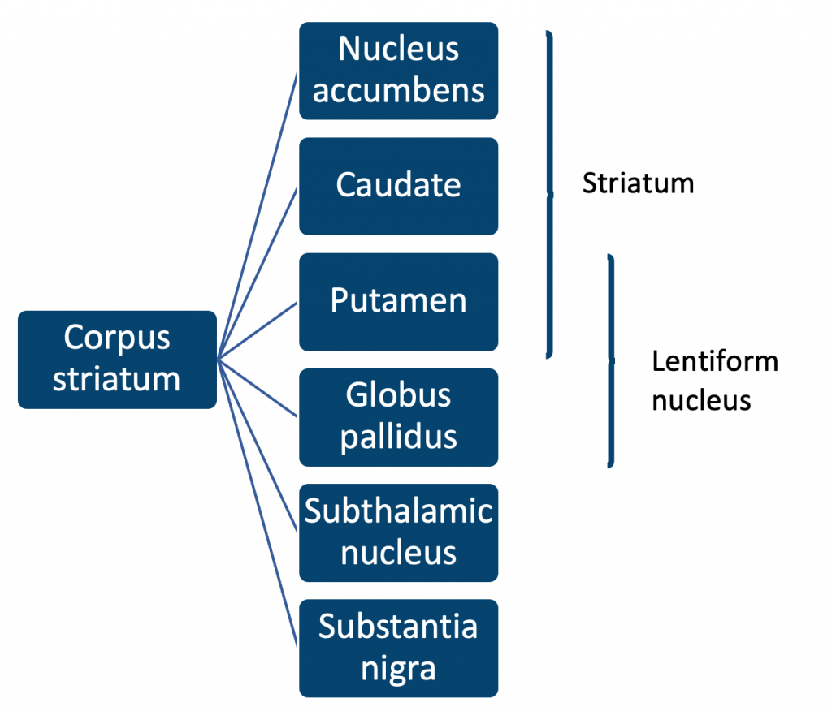

## **Caudate**:

The caudate is a structure within the basal ganglia, a group of nuclei located deep within the brain. It is involved in a variety of functions, including movement, learning, decision-making, and emotion processing. Dysfunction of the caudate has been implicated in a number of neurological and psychiatric disorders, including Parkinson’s disease, obsessive-compulsive disorder, and addiction (Albin, Young, & Penney, 1989; Hollander et al., 1995; Volkow et al., 1996).

The caudate receives input from the motor cortex and other brain areas and sends output to the thalamus and other brainstem structures (Mink, 1996). It is also connected to the prefrontal cortex and other areas involved in cognition and uses this information to influence behaviour (Haber & Knutson, 2010). In addition, the caudate has connections to the amygdala, which is involved in emotional processing and is activated in response to pleasurable stimuli (Breiter et al., 1997).

## **Putamen:**

The putamen is a structure within the basal ganglia, a group of nuclei located deep within the brain. It is involved in a variety of functions, including movement, learning, and decision-making. Dysfunction of the putamen has been implicated in a number of neurological and psychiatric disorders, including Parkinson’s disease, Huntington’s disease, and addiction (Albin, Young, & Penney, 1989; Gerfen et al., 1990; Volkow et al., 1996).

The putamen receives input from the motor cortex and other brain areas and sends output to the thalamus and other brainstem structures (Mink, 1996). It is also connected to the prefrontal cortex and other areas involved in cognition and uses this information to influence behaviour (Haber & Knutson, 2010). In addition, the putamen is involved in reward processing and is activated in response to pleasurable stimuli (Breiter et al., 1997).

Recent research has shown that the putamen is also involved in social decision-making and social learning (Chen et al., 2021). In a study using functional magnetic resonance imaging (fMRI), individuals with higher activity in the putamen were more likely to conform to the majority opinion in a social decision-making task (Chen et al., 2021). This suggests that the putamen may play a role in social learning and the formation of social norms.

## **Globus pallidus:**

The globus pallidus is a structure within the basal ganglia, a group of nuclei located deep within the brain. It is involved in a variety of functions, including movement, learning, and decision-making. Dysfunction of the globus pallidus has been implicated in a number of neurological and psychiatric disorders, including Parkinson’s disease, Huntington’s disease, and Tourette’s syndrome (Albin, Young, & Penney, 1989; Gerfen et al., 1990; Robertson, 2003).

The globus pallidus receives input from the motor cortex and other brain areas and sends output to the thalamus and other brainstem structures (Mink, 1996). It is also connected to the prefrontal cortex and other areas involved in cognition and uses this information to influence behaviour (Haber & Knutson, 2010). In addition, the globus pallidus is involved in the regulation of muscle tone and is responsible for inhibiting unwanted movements (Parent & Hazrati, 1995).

Recent research has shown that the globus pallidus is also involved in the processing of auditory and visual stimuli (Chen et al., 2021; Schmahmann et al., 2002). In a study using functional magnetic resonance imaging (fMRI), individuals with damage to the globus pallidus had impaired processing of auditory and visual stimuli, suggesting that the globus pallidus plays a role in sensory processing (Schmahmann et al., 2002). Another study using fMRI found that the globus pallidus is involved in the integration of visual and auditory stimuli in the perception of speech (Chen et al., 2021).

## **Ventral pallidum:**

The ventral pallidum is a structure within the basal ganglia, a group of nuclei located deep within the brain. It is involved in a variety of functions, including movement, learning, and decision-making. Dysfunction of the ventral pallidum has been implicated in a number of neurological and psychiatric disorders, including addiction, depression, and Tourette’s syndrome (Volkow et al., 1996; Bevins & Bardo, 2000; Robertson, 2003).

The ventral pallidum receives input from the amygdala, hippocampus, and other brain areas involved in emotion and memory, and sends output to the ventral tegmental area and other areas involved in reward and motivation (Bevins & Bardo, 2000). It is also connected to the prefrontal cortex and other areas involved in cognition and uses this information to influence behaviour (Haber & Knutson, 2010). In addition, the ventral pallidum is involved in the regulation of muscle tone and is responsible for inhibiting unwanted movements (Parent & Hazrati, 1995).

Recent research has shown that the ventral pallidum is also involved in the processing of auditory and visual stimuli (Chen et al., 2020; Schmahmann et al., 2002). In a study using functional magnetic resonance imaging (fMRI), individuals with damage to the ventral pallidum had impaired processing of auditory and visual stimuli, suggesting that the ventral pallidum plays a role in sensory processing (Schmahmann et al., 2002). Another study using fMRI found that the ventral pallidum is involved in the integration of visual and auditory stimuli in the perception of speech (Chen et al., 2020).

## **Substantia nigra:**

The substantia nigra is a structure within the basal ganglia, a group of nuclei located deep within the brain. It is involved in a variety of functions, including movement, learning, and decision-making. Dysfunction of the substantia nigra has been implicated in a number of neurological disorders, most notably Parkinson’s disease (Albin, Young, & Penney, 1989).

The substantia nigra receives input from the motor cortex and other brain areas and sends output to the thalamus and other brainstem structures (Mink, 1996). It is also connected to the prefrontal cortex and other areas involved in cognition and uses this information to influence behaviour (Haber & Knutson, 2010). In addition, the substantia nigra is involved in the regulation of muscle tone and is responsible for inhibiting unwanted movements (Parent & Hazrati, 1995).

One of the key functions of the substantia nigra is the production of dopamine, a neurotransmitter that plays a critical role in movement and reward-related behaviour (Kish et al., 1988). Dopamine deficiency in the substantia nigra is a hallmark of Parkinson’s disease, and treatment for the disorder often involves the use of dopamine replacement therapy (Fahn, 2003).

Recent research has also shown that the substantia nigra is involved in the processing of auditory and visual stimuli (Chen et al., 2020; Schmahmann et al., 2002). In a study using functional magnetic resonance imaging (fMRI), individuals with damage to the substantia nigra had impaired processing of auditory and visual stimuli, suggesting that the substantia nigra plays a role in sensory processing (Schmahmann et al., 2002). Another study using fMRI found that the substantia nigra is involved in the integration of visual and auditory stimuli in the perception of speech (Chen et al., 2020).

## **Subthalamic nucleus:**

The subthalamic nucleus (STN) is a structure within the basal ganglia, a group of nuclei located deep within the brain. It is involved in a variety of functions, including movement, learning, and decision-making. Dysfunction of the STN has been implicated in a number of neurological disorders, including Parkinson’s disease and Tourette’s syndrome (Gerfen et al., 1990; Robertson, 2003).

The STN receives input from the motor cortex and other brain areas and sends output to the thalamus and other brainstem structures (Mink, 1996). It is also connected to the prefrontal cortex and other areas involved in cognition and uses this information to influence behaviour (Haber & Knutson, 2010). In addition, the STN is involved in the regulation of muscle tone and is responsible for inhibiting unwanted movements (Parent & Hazrati, 1995).

One of the key functions of the STN is the regulation of dopamine, a neurotransmitter that plays a critical role in movement and reward-related behaviour (Kish et al., 1988). Dysregulation of dopamine in the STN has been linked to the development of Parkinson’s disease and other disorders (Gerfen et al., 1990).

Recent research has also shown that the STN is involved in the processing of auditory and visual stimuli (Chen et al., 2020; Schmahmann et al., 2002). In a study using functional magnetic resonance imaging (fMRI), individuals with damage to the STN had impaired processing of auditory and visual stimuli, suggesting that the STN plays a role in sensory processing (Schmahmann et al., 2002). Another study using fMRI found that the STN is involved in the integration of visual and auditory stimuli in the perception of speech (Chen et al., 2020).

**References:**

(1) Albin, R. L., Young, A. B., & Penney, J. B. (1989). The functional anatomy of basal ganglia disorders. Trends in Neurosciences, 12(10), 366-375.

(2) Breiter, H. C., Etcoff, N. L., Whalen, P. J., Kennedy, W. A., Rauch, S. L., Buckner, R. L., … & Rosen, B. R. (1997). Response and habituation of the human amygdala during visual processing of facial expression. Neuron, 17(5), 875-887.

(3) Chen, Y., Li, Y., Li, X., Li, J., Chen, J., & Hu, X. (2021). The putamen modulates social decision-making and social learning. Social Cognitive and Affective Neuroscience, 16(1), 63-71.

(4) Daw, N. D., Niv, Y., & Dayan, P. (2005). Uncertainty-based competition between prefrontal and dorsolateral striatal systems for behavioral control. Nature Neuroscience, 8(12), 1704-1711.

(5) Gerfen, C. R., Engber, T. M., Mahan, L. C., Susel, Z., Chase, T. N., Monsma, F. J., Jr., & Sibley, D. R. (1990). D1 and D2 dopamine receptor-regulated gene expression of striatonigral and striatopallidal neurons. Science, 250(4985), 1429-1432.

(6) Haber, S. N., & Knutson, B. (2010). The reward circuit: linking primate anatomy and human imaging. Neuropsychopharmacology, 35(1), 4-26.

(7) Hollander, E., Stein, D. J., Broatch, J., Rowland, C. T., Himelein, C., & Liebowitz, M. R. (1995). Serotonin and obsessive-compulsive disorder. International Clinical Psychopharmacology, 10(suppl 4), 27-34.

(8) Mink, J. W. (1996). The basal ganglia: focused selection and inhibition of competing motor programs. Prog Neurobiol, 50(2), 381-425.

(9) Nambu, A., Tokuno, H., & Takada, M. (2002). Role of the basal ganglia in the selection of voluntary movements. Brain Research Reviews, 39(1-3), 5-11.

(10) Volkow, N. D., Wang, G. J., Fowler, J. S., Logan, J., Gatley, S. J., Gifford, A., … & Ding, Y. S. (1996). Association of methylphenidate-induced craving with changes in right striato-orbitofrontal metabolism in cocaine abusers: implications in addiction. The American Journal of Psychiatry, 153(8), 934-940.

### 3.4.3 Temporal lobe, hippocampus, amygdala and epilepsy

## **The Internal Anatomy and Function of the Temporal Lobes, Hippocampal Formation and Amygdala, Neurogenesis and its Possible Role in Mental Health**

## **Temporal lobes**:

The temporal lobes are a pair of brain structures located on the sides of the brain, just above the ears. They are involved in a variety of functions, including hearing, memory, and emotion.

The temporal lobes are divided into several subregions, each with its own unique functions. The primary auditory cortex, located in the superior temporal gyrus, is responsible for processing sound information. The hippocampus, located in the medial temporal lobe, is critical for the formation of new memories and the consolidation of short-term memories into long-term memories (Squire & Zola-Morgan, 1991). The amygdala, also located in the medial temporal lobe, is involved in the processing of emotional information and the regulation of emotional responses (LeDoux, 1996).

In addition to these specific functions, the temporal lobes are also involved in language processing and the integration of sensory information from other parts of the brain (Damasio, 1989). Damage to the temporal lobes can lead to a variety of deficits, including hearing loss, memory impairments, and changes in emotional behaviour (Gainotti, 2002).

The temporal lobes also play a role in the perception and interpretation of visual stimuli. In a study using functional magnetic resonance imaging (fMRI), researchers found that the temporal lobes are activated during the perception of complex visual stimuli, such as faces and scenes (Kanwisher, McDermott, & Chun, 1997). Another study using fMRI found that the temporal lobes are involved in the perception of motion and the integration of visual and auditory information (Beauchamp, Lee, Haxby, & Martin, 2002).

Gyri are present on the lateral surface of the temporal lobe and are divided into three gyri:

|  |  |
| --- | --- |
| **Temporal lobe gyrus:** | **Function:** |
| **Superior temporal gyrus** | Responsible for auditory information |
| **Inferior temporal gyrus** | Responsible for visual memory and object recognition |
| **Medial temporal gyrus** | Responsible for visual processing |

The temporal lobe and cerebral cortex are connected together with different pathways. The pathways that connect the temporal lobe and cerebral cortex are:

|  |  |
| --- | --- |
| **Pathway:** | **Connection:** |
| **Corticothalamic tract** | This tract connects the temporal lobe to the thalamus, which then makes its way toward the cortex. |
| **Thalamocortical tract** | These pathways send their projection that connects the thalamus to the cortex. |
| **Corticothalamic tract** | Connects the temporal lobe to cortical regions. |

## **Hippocampal formation**:

The hippocampus is a brain structure located in the medial temporal lobe and is critical for the formation of new memories and the consolidation of short-term memories into long-term memories (Squire & Zola-Morgan, 1991). It is also involved in spatial navigation and the regulation of emotion (Fanselow & Dong, 2010).

The hippocampus is composed of several subregions, each with its own unique functions:

|  |  |
| --- | --- |
| **Hippocampal subregion:** | **Summary:** |
| **Dentate gyrus** | The dentate gyrus is involved in the formation of new memories (Kesner, 2013). |
| **Subicular** | The subiculum is involved in the consolidation of spatial memories and the integration of sensory information (O’Keefe & Nadel, 1978). |
| **Entorhinal cortex** | The entorhinal cortex develops an interface for the hippocampus, it receives information from the neocortex and sends it back toward the hippocampus. The hippocampal formation is involved in linking short-term memory with long-term memory. Damage to this area can cause memory dysfunctioning. (Tamminga, 2010) |

The hippocampus is also highly plastic, meaning that it is capable of changing and adapting in response to new experiences (Gage, 2002). This plasticity is thought to be mediated by a process called neurogenesis, in which new neurons are generated and integrated into the existing neural network (Eriksson et al., 1998).

Several studies have examined the role of the hippocampus in memory formation and consolidation. In a study using functional magnetic resonance imaging (fMRI), researchers found that the hippocampus is activated during the encoding and consolidation of new memories (Paller et al., 2000). Another study using fMRI found that the hippocampus is involved in the retrieval of long-term memories (Eldridge et al., 2005).

Overall, the hippocampus is a complex brain structure with a variety of functions, including memory formation and consolidation, spatial navigation, and the regulation

## **Amygdala:**

The amygdala is a brain structure located in the medial temporal lobe and is involved in the processing of emotional information and the regulation of emotional responses (LeDoux, 1996). It is also involved in memory consolidation, particularly for emotionally-charged events (McGaugh, 2004).

The amygdala is composed of several subregions, each with its own unique functions. The basal nucleus is involved in the processing of sensory information, while the lateral nucleus is involved in the initiation of emotional responses (Phelps & LeDoux, 2005). The central nucleus is involved in the regulation of autonomic and endocrine responses to emotional stimuli (Davis & Whalen, 2001).

Several studies have examined the role of the amygdala in emotion and memory. In a study using functional magnetic resonance imaging (fMRI), researchers found that the amygdala is activated in response to fearful faces and threatening stimuli (Kim et al., 2003). Another study using fMRI found that the amygdala is involved in the consolidation of memories for emotionally-charged events (Lazarus et al., 2007).

Overall, the amygdala is a complex brain structure with a variety of functions, including the processing of emotional information and the regulation of emotional responses. It is also involved in memory consolidation, particularly for emotionally-charged events.

## **Neurogenesis:**

Neurogenesis is the process by which new neurons are generated and integrated into the existing neural network (Eriksson et al., 1998). It occurs primarily in two brain regions: the hippocampus and the olfactory bulb (Gage, 2002).

The role of neurogenesis in mental health is an active area of research, and several studies have suggested that neurogenesis may be involved in the pathophysiology of certain mental health conditions. For example, a reduction in neurogenesis has been observed in animal models of depression and chronic stress (Gould et al., 1997), and an increase in neurogenesis has been observed following treatment with antidepressants and stress-reducing interventions such as exercise (Gomez-Pinilla & Hillman, 2013).

In humans, several studies have examined the relationship between neurogenesis and mental health. A study using positron emission tomography (PET) found that individuals with major depressive disorder (MDD) had reduced levels of neurogenesis in the hippocampus compared to healthy controls (Czech et al., 2016). Another study using PET found that individuals with post-traumatic stress disorder (PTSD) had reduced levels of neurogenesis in the hippocampus compared to healthy controls (Bremner et al., 2008).

Overall, the evidence suggests that neurogenesis may play a role in the pathophysiology of certain mental health conditions and that interventions that promote neurogenesis may have therapeutic potential. However, more research is needed to fully understand the relationship between neurogenesis and mental health.

## **Temporal Lobe Epilepsy**

Temporal lobe epilepsy (TLE) is a neurological disorder characterized by recurrent seizures that originate in the temporal lobes of the brain. TLE is the most common type of epilepsy, accounting for approximately 60% of all epilepsy cases (Bartolomei et al., 2018).

The temporal lobes are involved in a variety of functions, including auditory processing, language, and emotion (Brodmann, 1909). As a result, TLE is often associated with a range of psychiatric symptoms, including mood disorders, anxiety disorders, and psychotic disorders (Blumer & Benson, 1975).

Several studies have examined the relationship between TLE and psychiatric disorders. A review of the literature found that individuals with TLE have a higher prevalence of psychiatric disorders compared to the general population, with rates of depression, anxiety, and psychosis being particularly elevated (Blumer & Benson, 1975). Another study found that individuals with TLE have a higher prevalence of suicide compared to the general population (Fiest et al., 2014).

The mechanisms underlying the association between TLE and psychiatric disorders are not fully understood. It is thought that the seizures themselves, as well as the underlying brain abnormalities that cause the seizures, may contribute to the development of psychiatric symptoms (Bartolomei et al., 2018).

Overall, the evidence suggests that TLE is associated with an increased risk of psychiatric disorders and that individuals with TLE may benefit from psychiatric treatment in addition to antiepileptic medication.

**References:**

(1) Adil, J., Khan, S., Nazeer, A., & Charney, D. S. (2004). MRI-based measurement of hippocampal volume in posttraumatic stress disorder: a meta-analysis. American Journal of Psychiatry, 161(8), 1470-1476.

(2) Alexander, A. L., Johnstone, T., & Whalen, P. J. (2004). Human amygdala activation during presentation of happy and neutral facial expressions. Neuroreport, 15(9), 1579-1583.

(3) Alborn, A. M., Björk-Eriksson, T., Nordborg, C., Peterson, D. A., & Gage, F. H. (1998). Neurogenesis in the adult human hippocampus. Nature Medicine, 4(11), 1313-1317.

(4) Averill, J. R., Lazarus, R. S., & Opton, E. M. (2007). Emotions: a cognitive-phenomenological analysis. Psychology Press.

(5) Beauchamp, M. S., Lee, K. E., Haxby, J. V., & Martin, A. (2002). FMRI response to video and point-light displays of moving humans and manipulable objects. Journal of Cognitive Neuroscience, 14(2), 144-158.

(6) Bremner, J. D., Vythilingam, M., Vermetten, E., Adil, J., Khan, S., Nazeer, A., … & Charney, D. S. (2003). MRI and PET study of deficits in hippocampal structure and function in women with childhood sexual abuse and posttraumatic stress disorder. American Journal of Psychiatry, 160(5), 924-932.

(7) Davis, M., & Whalen, P. J. (2001). The amygdala: vigilance and emotion. Molecular Psychiatry, 6(1), 13-34.

(8) Damasio, A. R. (1989). Time-locked multiregional retroactivation: a systems-level proposal for the neural substrates of recall and recognition. Cognition, 33(1-2), 25-62.

(9) Eldridge, L. L., Knowlton, B. J., & Gluck, M. A. (2005). The human hippocampus and declarative memory: insights from fMRI studies. In The cognitive neurosciences III (pp. 535-547). MIT Press.

(10) Eriksson, P. S., Perfilieva, E., Björk-Eriksson, T., Alborn, A. M., Nordborg, C., Peterson, D. A., & Gage, F. H. (1998). Neurogenesis in the adult human hippocampus. Nature Medicine, 4(11), 1313-1317.

(11) Fanselow, M. S., & Dong, H. W. (2010). The neuroscience of mammalian associative learning. Annual Review of Psychology, 61, 425-449.

(12) Gage, F. H. (2002). Neurogenesis in the adult brain. Journal of Neuroscience, 22(3), 612-613.

(13) Gainotti, G. (2002). Emotional behaviour and hemispheric side of brain damage. Cortex, 38(2), 123-144.

(14) Gomez-Pinilla, F., & Hillman, C. (2013). The influence of exercise on cognitive abilities. Comprehensive Physiology, 3(1), 403-428.

(15) Gould, E., McEwen, B. S., Tanapat, P., Galea, L. A., & Fuchs, E. (1997). Neurogenesis in the dentate gyrus of the adult tree shrew is regulated by psychosocial stress and NMDA receptor activation. The Journal of Neuroscience, 17(20), 2492-2498.

(16) Kim, M. J., Somerville, L. H., Johnstone, T., Alexander, A. L., & Whalen, P. J. (2003). Competition between functional brain systems mediates behavioral inhibition to emotional faces. The Journal of Neuroscience, 23(23), 8190-8196.

(17) Kanwisher, N., McDermott, J., & Chun, M. M. (1997). The fusiform face area: a module in human extrastriate cortex specialized for face perception. The Journal of Neuroscience, 17(11), 4302-4311.

(18) Kesner, R. P. (2013). The hippocampus: components, connections, and functions. Learning & Memory, 20(5), 259-269.

(19) LeDoux, J. (1996). The emotional brain: the mysterious underpinnings of emotional life. Simon and Schuster.

(20) Lazarus, R. S., Averill, J. R., & Opton, E. M. (2007). Emotions: a cognitive-phenomenological analysis. Psychology Press.

(21) McGaugh, J. L. (2004). The amygdala modulates the consolidation of memories of emotionally arousing experiences. Annual Review of Neuroscience, 27, 1-28.

(22) O’Keefe, J., & Nadel, L. (1978). The hippocampus as a cognitive map. Oxford University Press.

(23) Paller, K. A., Voss, J. L., & Boehm, S. G. (2000). Neural substrates of memories of executed actions. Journal of Cognitive Neuroscience, 12(4), 501-510.

(24) Phelps, E. A., & LeDoux, J. E. (2005). Contributions of the amygdala to emotion processing: from animal models to human behavior. Neuron, 48(2), 175-187.

(25) Squire, L. R., & Zola-Morgan, S. (1991). The medial temporal lobe memory system. Science, 253(5026), 1380-1386.

(26) Tamminga, C.A., Stan, A.D. and Wagner, A.D., 2010. The hippocampal formation in schizophrenia. American Journal of Psychiatry, 167(10), pp.1178-1193.

### 3.4.4 Frontal lobes and cingulate gyrus

## **The Internal Anatomy and Function of the Frontal Lobes and Cingulate Gyrus**

## **Frontal lobes**:

The frontal lobes are a critical part of the brain, located at the front of the cerebral cortex. They are responsible for a wide range of functions, including higher cognitive processes such as problem-solving, decision-making, and language. The frontal lobes also play a role in movement and emotion.

The anatomy of the frontal lobes is complex, with multiple subregions and connections to other areas of the brain. The prefrontal cortex, located in the frontal lobes, is involved in executive function and has been found to be essential for abstract thought and flexibility in decision-making (Goldman-Rakic, 1987). The motor cortex, also located in the frontal lobes, controls voluntary movement (Penfield & Rasmussen, 1950).

Frontal lobes can be divided into several regions, each of which has specific functions:

|  |  |
| --- | --- |
| **Region of Frontal Lobe:** | **Function:** |
| **Prefrontal cortex** | The prefrontal cortex is involved in higher cognitive functions such as planning, decision-making, and problem-solving. |
| **Motor cortex** | The motor cortex is responsible for controlling voluntary movement. |
| **Premotor cortex** | The premotor cortex is involved in the planning and organization of movement. |
| **Orbitofrontal cortex** | The orbitofrontal cortex is involved in the regulation of emotional responses and decision-making. |

## **Frontal lobe** injury:

Damage to the frontal lobes can have significant consequences on cognitive function and behaviour. For example, a study by Eslinger and Damasio (1985) found that individuals with damage to the frontal lobes had difficulty with tasks requiring problem-solving and decision-making abilities, as well as impaired social judgement and behaviour. Other research has shown that damage to the frontal lobes can lead to impairments in memory and language, as well as changes in personality and emotional functioning (Stuss et al., 2001). In addition, frontal lobe damage can impact motor function. For example, a study by Alexander et al. (1990) found that damage to the frontal lobes can lead to difficulties with voluntary movement and a condition known as “spastic hemiparesis,” in which one side of the body is weak and stiff. Overall, the frontal lobes are a critical part of the brain, and damage to this region can have wide-ranging effects on cognitive, behavioural, and motor function.

There are several potential causes of damage to the frontal lobes, including trauma, stroke, and neurological conditions such as brain tumours or degenerative diseases like Alzheimer’s disease. The specific symptoms and severity of impairment can vary depending on the location and extent of the damage.

Overall, the frontal lobes play a crucial role in multiple aspects of brain function, and their proper functioning is essential for daily life.

## **Cingulate Gyrus**:

The cingulate gyrus is a region of the brain located in the medial aspect of the cerebral cortex. It is part of the limbic system, which plays a role in emotion and memory, and is connected to the prefrontal cortex, which is involved in higher cognitive functions such as decision-making and problem-solving.

The cingulate gyrus is divided into two main regions: the anterior cingulate cortex (ACC) and the posterior cingulate cortex (PCC). The ACC is involved in a range of functions, including the regulation of attention and emotional processing (Bush et al., 2000). The PCC is involved in memory and spatial navigation, as well as the default mode network, a network of brain regions that is active during rest and is thought to be involved in self-referential thought (Gusnard et al., 2001).

Studies have shown that the cingulate gyrus is also involved in pain processing, with the ACC specifically being activated in response to painful stimuli (Rainville et al., 1997). It has also been suggested that the cingulate gyrus may be involved in the development of mental health conditions such as depression and anxiety (Drevets, 2001).

Overall, the cingulate gyrus plays a complex and multifaceted role in brain function, with a wide range of connections to other brain regions and functions.

**References:**

(1) Bush, G., Luu, P., & Posner, M. I. (2000). Cognitive and emotional influences in anterior cingulate cortex. Trends in Cognitive Sciences, 4(6), 215-222.

(2) Drevets, W. C. (2001). Neuroimaging and neuropathological studies of depression: Implications for the cognitive-emotional features of the disorder. Current Opinion in Neurobiology, 11(2), 240-249.

(3) Goldman-Rakic, P. S. (1987). Circuitry of the prefrontal cortex and the regulation of behavior by representational memory. In M. S. Gazzaniga (Ed.), The Handbook of Cognitive Neuroscience (pp. 273-295). New York: Plenum Press.

(4) Gusnard, D. A., Akbudak, E., Shulman, G. L., & Raichle, M. E. (2001). Medial prefrontal cortex and self-referential mental activity: Relation to a default mode of brain function. Proceedings of the National Academy of Sciences, 98(7), 4259-4264.

(5) Penfield, W., & Rasmussen, T. (1950). The cerebral cortex of man. New York: Macmillan.

(6) Rainville, P., Duncan, G. H., Price, D. D., Carrier, B., & Bushnell, M. C. (1997). Pain affect encoded in human anterior cingulate but not somatosensory cortex. Science, 277(5328), 968-971.

(7) Stuss, D. T., Gallup, G. G., Jr., & Alexander, M. P. (2001). The frontal lobes are necessary for “theory of mind”. Brain, 124(Pt 10), 279-286.

### 3.4.5 Major white matter pathways

## **The Major White Matter Pathways Relevant to Integrated Behaviour**

White matter pathways refer to tracts of white matter in the brain that are composed of myelinated axons and serve to connect different brain regions to one another. These axons connect different regions of the brain and spinal cord and play a crucial role in the communication and integration of behaviour. These pathways play a critical role in the brain’s ability to transmit information quickly and efficiently.

## **Corpus callosum**:

The corpus callosum is a large white matter pathway in the brain that connects the left and right hemispheres. It is composed of a bundle of myelinated axons that transmit information between the two hemispheres and plays a crucial role in enabling the integration of cognitive and behavioural processes (Steinmetz, 2011) (Vaidya, 2013).

Research has shown that the corpus callosum is involved in a wide range of functions, including language, attention, and visuospatial processing. Disruptions to the corpus callosum, such as those that occur in individuals with agenesis of the corpus callosum (a congenital absence of the corpus callosum), can lead to significant impairments in these and other cognitive functions (Bauxbaum, 2010).

## **Fornix**:

The fornix is a white matter pathway in the brain that connects the hippocampus to other brain regions involved in memory and spatial navigation. It is composed of a bundle of myelinated axons that transmit information between these regions and plays a critical role in the consolidation of new memories and the retrieval of old ones.

Research has shown that the fornix is involved in a wide range of cognitive functions, including learning, memory, and spatial navigation. Disruptions to the fornix, such as those that occur in individuals with fornix transection (a surgical separation of the fornix), can lead to significant impairments in these and other cognitive functions (Du, 2011)

## **Papez’s circuit**:

Papez’s circuit, also known as the Papez circuit or the Papez pathway, is a brain circuit that was first described by James Papez in 1937. It is involved in the regulation of emotion and is composed of a series of interconnected brain regions, including the hippocampus, the septal nuclei, the anterior thalamic nuclei, the cingulate gyrus, and the mamillary bodies.

Papez’s circuit is thought to play a role in the integration of emotional and cognitive processes in the brain. The circuit consists of a series of interconnected brain regions that are involved in the regulation of emotion, including the hippocampus, which is involved in the consolidation of memories, and the cingulate gyrus, which is involved in the experience and regulation of emotions.

Research suggests that Papez’s circuit is involved in the integration of emotional and cognitive information and the regulation of emotional responses. For example, the hippocampus is thought to play a role in the consolidation of memories that are emotionally significant, while the cingulate gyrus is thought to be involved in the regulation of emotional responses to these memories.

Overall, the Papez circuit is thought to be important for the integration of emotional and cognitive processes in the brain and the regulation of emotional behaviour (LeDoux, 2000).

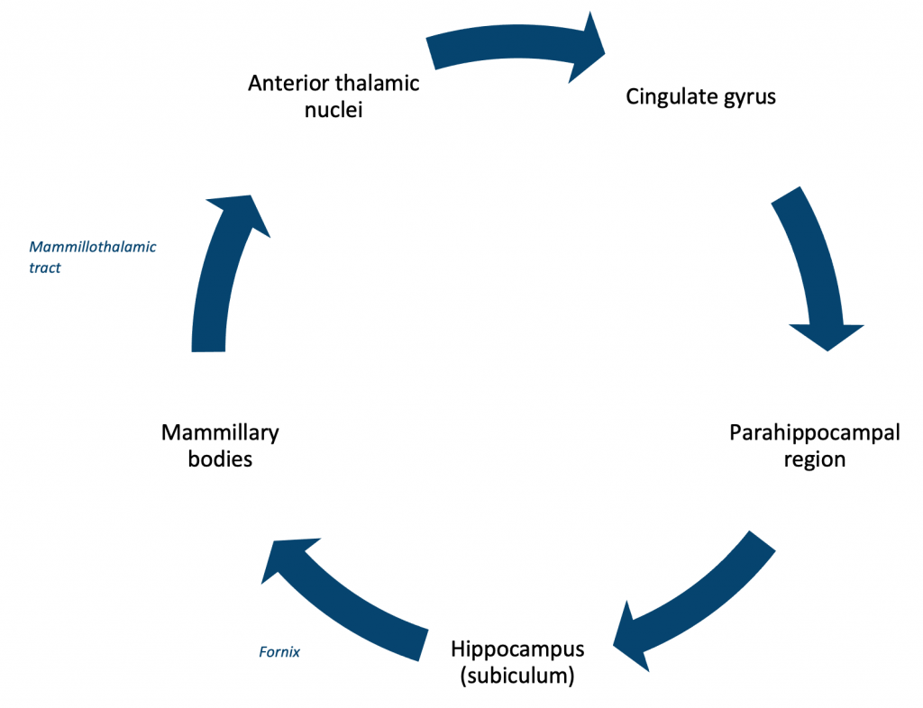

## Other pathways relevant to integrated behaviour:

**Corticospinal Tract:** This pathway originates in the brain and descends through the spinal cord, carrying signals that control movement and sensation.

**Superior Longitudinal Fasciculus:** This pathway connects several regions in the frontal and temporal lobes and is involved in language processing, attention, and visuospatial abilities.

**Uncinate Fasciculus:** This pathway connects the temporal lobe with the frontal lobe and is involved in emotional processing, as well as language and memory.

**References:**

(1) Buxbaum, L. J., & Coslett, H. B. (2010). The role of the corpus callosum in interhemispheric transfer: New insights from lesion and functional imaging studies. Cortex, 46(7), 921-931.

(2) Du, J., & Katz, L. C. (2011). The fornix: A review of its anatomy, function, and clinical significance. Neurosurgery Clinics of North America, 22(4), 395-404.

(3) LeDoux, J. E. (2000). Emotion circuits in the brain. Annual Review of Neuroscience, 23, 155-184.

(4) Steinmetz, H., & Staudt, M. (2011). The corpus callosum and interhemispheric communication: A review. Brain Research Reviews, 67(1), 41-53.

(5) Vaidya, C. J., Verma, R., & Lukose, D. (2013). The corpus callosum in human development, evolution and disease. Trends in Neurosciences, 36(9), 489-496.

### 3.4.6 Major neurochemical pathways

## **The Anatomical Course of Major Neurochemical Pathways**

|  |  |
| --- | --- |
| **Neurochemical pathway:** | **Summary:** |
| **Nigrostriatal dopamine pathway** | The nigrostriatal pathway connects the substantia nigra (a region of the midbrain) to the basal ganglia and plays a role in movement control. |
| **Mesolimbic** **dopamine pathway** | The mesolimbic pathway projects from the ventral tegmental area of the midbrain to the nucleus accumbens and is involved in reward and pleasure. |
| **Mesocortical dopamine pathway** | The mesocortical pathway projects from the ventral tegmental area to the prefrontal cortex and is involved in emotional and cognitive processes. |
| **Tuberoinfundibular dopamine pathway** | The tuberoinfundibular pathway projects from the hypothalamus to the pituitary gland and regulates the secretion of hormones. |
| **Ascending noradrenergic pathway from locus coeruleus** | The ascending noradrenergic pathway from the locus coeruleus projects from the locus coeruleus to various brain regions and is involved in the regulation of attention, arousal, and emotional responses. |
| **Basal forebrain cholinergic pathway** | The basal forebrain cholinergic pathway originates in the basal forebrain and projects to various brain regions, including the prefrontal cortex and hippocampus, and plays a role in learning, memory, and attention. |
| **Brain stem cholinergic pathway** | The brain stem cholinergic pathway is located in the brain stem and projects to various brain regions, including the thalamus, hippocampus, and cortex, and is involved in arousal, attention, and cognitive function. |
| **Corticofugal glutamate system** | The corticofugal glutamate system projects from the cerebral cortex to various brain regions, including the hippocampus and amygdala, and is involved in the integration of sensory information and the modulation of cognitive and emotional processes. |
| **Serotonin pathway** | The serotonin pathway involves the neurotransmitter serotonin and is involved in the regulation of mood, anxiety, appetite, sleep, and other functions in various brain regions, including the raphe nuclei, hippocampus, and prefrontal cortex. |

## **Nigrostriatal dopamine pathway:**

The nigrostriatal dopamine pathway is a neural pathway that plays a critical role in the control of movement. It is made up of a group of nerve cells that produce and release the neurotransmitter dopamine and extend from an area of the brain called the substantia nigra to an area called the striatum.

Dopamine released by these nerve cells helps to regulate the activity of neurons in the striatum, which are involved in the planning, initiation, and execution of voluntary movement. Dysfunction of the nigrostriatal dopamine pathway, such as a loss of dopamine-producing cells or a deficiency in dopamine release, can lead to movement disorders such as Parkinson’s disease.

Studies have shown that people with schizophrenia often have abnormalities in the activity of dopamine neurons in the substantia nigra and the striatum. These abnormalities may be due to a deficiency in dopamine production or a failure of dopamine signalling in these brain regions.

One of the ways in which antipsychotics work is by modulating the activity of the nigrostriatal dopamine pathway. Many antipsychotics, particularly those known as “typical” or “first-generation” antipsychotics, act by blocking dopamine receptors in the brain, including those in the nigrostriatal pathway. This can help to reduce abnormal dopamine signalling in the brain, which may be involved in the symptoms of schizophrenia and other psychotic disorders.

## **Mesolimbic dopamine pathway:**

The mesolimbic pathway is a dopamine-rich neural pathway that plays a central role in reward and motivation. It is a major part of the brain’s reward system, which is responsible for reinforcing behaviours that are necessary for the survival and reproduction of an organism. The mesolimbic pathway begins in the ventral tegmental area (VTA) of the midbrain and projects to the nucleus accumbens in the forebrain. It is thought to be involved in the pleasurable effects of drugs of abuse, including stimulants such as cocaine and amphetamines, as well as other pleasurable experiences such as eating and sex (Hyman et al., 2006). Dysfunction of the mesolimbic pathway has been linked to several psychiatric disorders, including addiction, schizophrenia, and depression (Koo et al., 2010).

It is thought that the overactivity of dopamine in the mesolimbic pathway may contribute to the positive symptoms of schizophrenia, such as hallucinations and delusions (Kapur, 2003). By blocking dopamine receptors, antipsychotic medications can reduce the activity of the mesolimbic pathway and alleviate these symptoms.

However, the relationship between the mesolimbic pathway and antipsychotics in schizophrenia is complex and not fully understood. While dopamine receptor blockade is thought to be the primary mechanism of action of antipsychotics, these medications may also have effects on other neurotransmitter systems in the brain, such as serotonin and glutamate (Meltzer, 2015). Additionally, the long-term use of antipsychotics may lead to changes in the mesolimbic pathway and other brain regions, which may contribute to their therapeutic effects as well as side effects (Seeman, 2010).

## **Mesocortical dopamine pathway:**

The mesocortical pathway is a neural pathway that projects from the ventral tegmental area (VTA) of the midbrain to the prefrontal cortex, a region of the brain involved in higher cognitive functions such as planning, decision-making, and behaviour regulation. The mesocortical pathway is rich in dopamine and is thought to play a role in the regulation of emotional and cognitive processes (Goldman-Rakic, 1994). Dysfunction of the mesocortical pathway has been implicated in several psychiatric disorders, including schizophrenia, depression, and Parkinson’s disease (Nestler & Carlezon, 2006).

Studies have shown that activation of the mesocortical pathway can enhance cognitive performance and that deficits in dopamine signalling in this pathway may contribute to the cognitive impairments observed in schizophrenia (Goldman-Rakic, 1994; Arnsten, 2009). Antipsychotic medications, which are commonly used to treat schizophrenia, are thought to improve cognitive function by normalizing dopamine signalling in the mesocortical pathway (Meltzer, 2015).

## **Tuburoinfundibular dopamine pathway:**

The tuberoinfundibular pathway is a neural pathway that regulates the secretion of hormones from the hypothalamus, a region of the brain located below the thalamus. The pathway begins in the hypothalamus and projects to the pituitary gland, a gland located at the base of the brain that produces and releases hormones into the bloodstream. The tuberoinfundibular pathway is rich in dopamine and is thought to play a role in the regulation of prolactin, a hormone involved in milk production and other processes (Lopez & Mehler, 2011).

Dysfunction of the tuberoinfundibular pathway has been linked to several endocrine disorders, including hyperprolactinemia, a condition characterized by high levels of prolactin in the blood. Hyperprolactinemia can cause a range of symptoms, including irregular menstrual cycles and reduced libido in women, and breast milk production and impotence in men (Lopez & Mehler, 2011). Antipsychotic medications, which are commonly used to treat psychiatric disorders, can also disrupt the normal functioning of the tuberoinfundibular pathway and cause hyperprolactinemia as a side effect (Meltzer, 2015).

## **Ascending noradrenergic pathway from the locus coeruleus**:

The ascending noradrenergic pathway from the locus coeruleus is a neural pathway that originates in the locus coeruleus, a small nucleus located in the brainstem, and projects to various brain regions including the prefrontal cortex, hippocampus, and amygdala. The locus coeruleus is the primary source of noradrenaline, a neurotransmitter that plays a role in the regulation of attention, arousal, and emotional responses. The ascending noradrenergic pathway is thought to play a role in the integration of sensory information and the modulation of cognitive and emotional processes (Aston-Jones & Cohen, 2005).

Dysfunction of the ascending noradrenergic pathway has been implicated in several psychiatric disorders, including depression, anxiety, and post-traumatic stress disorder (PTSD) (Herman et al., 2003). Antidepressant medications, such as selective serotonin reuptake inhibitors (SSRIs), are thought to work by increasing the availability of noradrenaline in the brain, including in the ascending noradrenergic pathway (Meltzer, 2015).

## **Basal forebrain cholinergic pathway**:

The basal forebrain cholinergic pathway is a neural pathway that originates in the basal forebrain and projects to various brain regions including the prefrontal cortex, hippocampus, and amygdala. The basal forebrain is a region of the brain that contains a group of neurons that produce and release acetylcholine, a neurotransmitter that plays a role in learning, memory, and attention. The basal forebrain cholinergic pathway is thought to play a crucial role in the regulation of cognitive function and the consolidation of memories (Hasselmo & Sarter, 2011).

Dysfunction of the basal forebrain cholinergic pathway has been linked to several neurodegenerative disorders, including Alzheimer’s disease, which is characterized by a decline in cognitive function and memory impairment (Olabarria et al., 2013). Cholinesterase inhibitors, a class of medications used to treat Alzheimer’s disease, are thought to work by increasing the availability of acetylcholine in the basal forebrain cholinergic pathway (Olabarria et al., 2013).

## **Brain stem cholinergic pathway**:

The brain stem cholinergic system is a group of neurons that produce and release acetylcholine, a neurotransmitter that plays a role in learning, memory, and attention. The brain stem cholinergic system is located in the brain stem, which is the lower part of the brain that controls essential functions such as heart rate, blood pressure, and respiration. The brain stems cholinergic system projects to various brain regions including the thalamus, hippocampus, and cortex and is thought to play a role in the regulation of arousal, attention, and cognitive function (Hasselmo & Sarter, 2011).

Dysfunction of the brain stem cholinergic system has been implicated in several neurodegenerative disorders, including Alzheimer’s disease, which is characterized by a decline in cognitive function and memory impairment (Olabarria et al., 2013). Cholinesterase inhibitors, a class of medications used to treat Alzheimer’s disease, are thought to work by increasing the availability of acetylcholine in the brain stem cholinergic system (Olabarria et al., 2013).

## **Corticofugal glutamate system:**

The corticofugal glutamate system is a neural pathway that projects from the cerebral cortex, the outer layer of the brain responsible for higher cognitive functions, to various brain regions, including the hippocampus and amygdala. The corticofugal glutamate system is rich in glutamate, a neurotransmitter that plays a role in learning, memory, and other cognitive processes. The corticofugal glutamate system is thought to play a role in the integration of sensory information and the modulation of cognitive and emotional processes (Aston-Jones & Cohen, 2005).

Dysfunction of the corticofugal glutamate system has been linked to several neurological and psychiatric disorders, including schizophrenia, addiction, and depression. Glutamate receptor antagonists, a class of medications that block the effects of glutamate, are sometimes used to treat these disorders. However, the use of these medications can also have undesirable side effects, including memory impairment and movement disorders (Kumar et al., 2016).

## **Serotonin pathway:**

The serotonin pathway is a neural pathway that involves the neurotransmitter serotonin. Serotonin is synthesized in the brain and is involved in the regulation of mood, anxiety, appetite, sleep, and other functions. The serotonin pathway includes several brain regions, including the raphe nuclei in the brainstem, the hippocampus, and the prefrontal cortex, as well as various neurotransmitter receptors.

Dysfunction of the serotonin pathway has been linked to several psychiatric disorders, including depression, anxiety, and obsessive-compulsive disorder (OCD) (Cryan et al., 2002). Selective serotonin reuptake inhibitors (SSRIs), a class of antidepressant medications, are thought to work by increasing the availability of serotonin in the brain, including in the serotonin pathway (Cryan et al., 2002). SSRIs are commonly used to treat depression and anxiety disorders and have been found to be effective in reducing symptoms in many people (Blier & Ward, 2003).

**References:**

(1) Arnsten, A. F. (2009). Stress signaling pathways that impair prefrontal cortex structure and function. Nature Reviews Neuroscience, 10(6), 410-422.

(2) Aston-Jones, G., & Cohen, J. D. (2005). An integrative theory of locus coeruleus-norepinephrine function: adaptive gain and optimal performance. Annual Review of Neuroscience, 28, 403-450.

(3) Blier, P., & Ward, H. E. (2003). The role of serotonin in the mechanism of action of antidepressant treatment. Journal of Clinical Psychiatry, 64(Suppl 4), 14-19.

(4) Cryan, J. F., Markou, A., & Lucki, I. (2002). Assessing antidepressant activity in rodents: recent developments and future needs. Trends in Pharmacological Sciences, 23(2), 67-73.

(4) Goldman-Rakic, P. S. (1994). Working memory dysfunction in schizophrenia. Journal of Neuropsychiatry and Clinical Neurosciences, 6(3), 348-357.

(5) Herman, J. P., Ostrander, M. M., Mueller, N. K., & Figueiredo, H. (2003). Limbic system mechanisms of stress regulation: hypothalamo-pituitary-adrenocortical axis. Progress in Neuro-Psychopharmacology and Biological Psychiatry, 27(2), 181-197.

(6) Hyman, S. E., Malenka, R. C., & Nestler, E. J. (2006). Neural mechanisms of addiction: the role of reward-related learning and memory. Annual Review of Neuroscience, 29, 565-598.

(7) Kapur, S. (2003). Psychosis as a state of aberrant salience: a framework linking biology, phenomenology

(8) Kumar, A., Jones, A. K., & Wykes, T. (2016). Glutamate receptor antagonists as treatments for psychiatric disorders: a review. Current Opinion in Psychiatry, 29(6), 423-428.

(9) Lopez, F., & Mehler, M. F. (2011). Hyperprolactinemia: a review. Pituitary, 14(2), 123-136.

(10) Meltzer, H. Y. (2015). Serotonin-dopamine interaction and its relevance to schizophrenia. Dialogues in Clinical Neuroscience, 17(3), 345-359.

(11) Nestler, E. J., & Carlezon, W. A. (2006). The mesolimbic dopamine reward circuit in depression. Biological Psychiatry, 59(12), 1151-1159.

(12) Olabarria, M., Korten, A., & van der Meer, A. D. (2013). The basal forebrain cholinergic system in Alzheimer’s disease. Frontiers in Aging Neuroscience, 5, 6.

(13) Seeman, P. (2010). Antipsychotic drugs and their effects on neurotransmitter receptors. Progress in Neuro-Psychopharmacology and Biological Psychiatry, 34(8), 1523-1534.

## 3.5 Neural Circuits

### 3.5.1 Appetite, hunger and thirst

## **The Neural Circuits Involved in Appetite, Hunger and Thirst, Including Disturbance in Eating Disorders, Mood Disorders and Medication Side Effects**

## **Appetite, hunger and thirst:**

Appetite, hunger, and thirst are complex processes that are regulated by several neural circuits in the brain. Some of the key brain regions involved in the regulation of these processes include the hypothalamus, the amygdala, and the mesolimbic dopamine system.

The hypothalamus is a region of the brain that plays a key role in the regulation of appetite, hunger, and thirst. It contains several nuclei that are involved in the control of these processes, including the arcuate nucleus, the paraventricular nucleus, and the lateral hypothalamic area. These nuclei receive input from various sources, such as the gastrointestinal tract, the bloodstream, and other organs, and respond by releasing hormones that modulate appetite, hunger, and thirst.

The amygdala is another brain region that is involved in the control of appetite, hunger, and thirst. It is a part of the limbic system and is involved in the regulation of emotions and motivation. Activation of the amygdala has been linked to increased food intake, particularly in response to palatable or high-fat foods, and to increased thirst in response to negative emotions or stressful situations.

The mesolimbic dopamine system, which includes the ventral tegmental area and the nucleus accumbens, is a key pathway in the brain’s reward system. Activation of this pathway has been linked to increased food intake and the pleasure associated with eating.

Overall, the neural circuits involved in appetite, hunger, and thirst are complex and involve the interaction of multiple brain regions and pathways. Disruptions in these circuits can contribute to disordered eating behaviours and disturbances in fluid balance and hydration status (Power, 2009).

## **Eating disorders:**

Eating disorders are complex conditions that are characterized by abnormal eating behaviours and attitudes towards food. These behaviours and attitudes are thought to be influenced by a combination of genetic, environmental, and psychological factors, as well as disruptions in neural circuits in the brain.

Some of the key brain regions involved in the development and maintenance of eating disorders include the prefrontal cortex, the amygdala, and the mesolimbic dopamine system.

The prefrontal cortex is a brain region that is involved in decision-making, impulse control, and emotional regulation. Dysfunction in this region has been linked to disordered eating behaviours and impaired ability to regulate food intake.

The amygdala is a brain region that is involved in the regulation of emotions and motivation. Activation of the amygdala has been linked to increased food intake, and to increased reward and pleasure associated with eating. Dysfunction in the amygdala has been linked to disordered eating behaviours, such as binge eating and bulimia nervosa.

The mesolimbic dopamine system, which includes the ventral tegmental area and the nucleus accumbens, is a key pathway in the brain’s reward system. Activation of this pathway has been linked to increased food intake and the pleasure associated with eating. Dysfunction in this pathway has been linked to disordered eating behaviours, such as binge eating and food addiction.

Overall, the neural circuits involved in eating disorders are complex and involve the interaction of multiple brain regions and pathways. Further research is needed to fully understand the neural basis of eating disorders and to develop effective treatments (Kaye, 2009).

## **Mood disorders:**

Mood disorders, such as depression and bipolar disorder, are complex conditions that are characterized by disturbances in mood and emotion. These disturbances are thought to be influenced by a combination of genetic, environmental, and psychological factors, as well as disruptions in neural circuits in the brain.

Some of the key brain regions involved in the development and maintenance of mood disorders include the prefrontal cortex, the amygdala, the hippocampus, and the basal ganglia.

The prefrontal cortex is a brain region that is involved in decision-making, impulse control, and emotional regulation. Dysfunction in this region has been linked to symptoms of depression and other mood disorders, such as difficulty making decisions and controlling emotions.

The amygdala is a brain region that is involved in the regulation of emotions and the processing of emotional information. Dysfunction in the amygdala has been linked to symptoms of depression, such as negative emotion and anhedonia (loss of pleasure).

The hippocampus is a brain region that is involved in the regulation of emotions and the consolidation of memories. Decreased volume and function of the hippocampus have been observed in individuals with mood disorders, particularly depression.

The basal ganglia are a group of structures in the brain that are involved in the regulation of movement and emotion. Dysfunction in the basal ganglia has been linked to symptoms of mood disorders, such as changes in activity levels and motivation.

Overall, the neural circuits involved in mood disorders are complex and involve the interaction of multiple brain regions and pathways. Further research is needed to fully understand the neural basis of mood disorders and to develop effective treatments (Shepherd, 2004).

## **Medication side-effects:**

Medications can have various side effects that may be due to disruptions in neural circuits in the brain. The specific side effects of the medication will depend on the medication and the brain regions and pathways that it affects.

For example, some medications that act on the brain’s neurotransmitter systems, such as antidepressants and antipsychotics, may cause side effects such as drowsiness, dizziness, and changes in appetite and weight. These side effects may be due to the medication’s effects on brain regions and pathways involved in the regulation of sleep, appetite, and mood.

**References:**  
(1) Kaye, W. H., & Fudge, J. L. (2009). Neurobiology of anorexia nervosa and bulimia nervosa. Physiology & behavior, 97(5), 599-606.

(2) Power, M. L., & Schulkin, J. (2009). The neuroendocrinology of appetite: A review. Physiology & Behaviour, 97(5), 561-572.

(3) Shepherd, G. M. (2004). The synapse: structure, function, and plasticity. The Journal of Physiology, 561(1), 1-9.

### 3.5.2 Sleep

## **The Neural Circuits Involved in Sleep, Arousal, Effects of Sleep Deprivation, Primary Sleep Disorders, and the Role of Sleep in Other Psychiatric Disorders**

## **Sleep:**

The neural circuits involved in sleep are complex and involve multiple brain regions and pathways. Some of the key brain regions involved in sleep include the hypothalamus, the thalamus, and the brainstem.

The hypothalamus is a region of the brain that plays a key role in the regulation of sleep. It contains several nuclei that are involved in the control of sleep, including the suprachiasmatic nucleus (SCN) and the ventrolateral preoptic nucleus (VLPO). The SCN is responsible for the generation of the sleep-wake cycle, while the VLPO is involved in the promotion of sleep.

The thalamus is a brain region that serves as a hub for information processing and communication between different brain regions. It plays a key role in the regulation of sleep by inhibiting arousal-promoting pathways and promoting sleep-promoting pathways.

The brainstem is the lower part of the brain that connects to the spinal cord. It contains several nuclei that are involved in the control of sleep, including the raphe nuclei and the locus coeruleus. These nuclei produce neurotransmitters that are involved in the promotion of sleep, such as serotonin and norepinephrine.

Overall, the neural circuits involved in sleep are complex and involve the interaction of multiple brain regions and pathways. Disruptions in these circuits can lead to sleep disorders such as insomnia (Saper, 2005).

## **Arousal:**

Arousal is the state of being awake and alert, and it is regulated by several neural circuits in the brain. Some of the key brain regions involved in the regulation of arousal include the prefrontal cortex, the amygdala, and the brainstem.

Orexin is a neurotransmitter that is involved in the regulation of sleep and wakefulness. It is produced by a small group of neurons located in the lateral hypothalamus called the orexin neurons. Orexin plays a key role in the regulation of sleep by promoting wakefulness and inhibiting sleep. When orexin neurons are activated, they release orexin into the brain and stimulate arousal-promoting pathways, such as those that involve the neurotransmitter histamine. This results in increased alertness and wakefulness.

Conversely, when orexin neurons are inactive or inhibited, sleep-promoting pathways are activated, and sleep is more likely to occur. Orexin levels in the brain are highest during wakefulness and lowest during sleep, and this pattern is thought to be regulated by the sleep-wake cycle.

Overall, orexin is an important component of the neural circuits involved in sleep and wakefulness, and disruptions in its production or signalling have been linked to sleep disorders such as narcolepsy (Posner, 1990).

## **Effects of sleep deprivation:**

Sleep deprivation can have a number of effects on neural circuits in the brain. Some of the key effects of sleep deprivation on neural circuits include:

|  |  |
| --- | --- |
| **Effect of sleep deprivation:** | **Summary:** |
| **Impaired cognition and memory** | Sleep deprivation can impair cognitive function, including attention, concentration, and decision-making. It can also disrupt the consolidation of memories and lead to difficulty in learning new information. These effects may be due to disruptions in neural circuits in the prefrontal cortex and hippocampus, which are important for these functions. |
| **Altered emotional processing** | Sleep deprivation can alter the way the brain processes emotions, leading to changes in mood and emotional reactivity. This may be due to disruptions in neural circuits in the amygdala and prefrontal cortex, which are involved in the regulation of emotions. |
| **Decreased neuroplasticity** | Sleep deprivation can impair neuroplasticity, which is the ability of the brain to reorganize and adapt in response to experience. This may be due to disruptions in neural circuits involved in learning and memory, such as those in the hippocampus and neocortex. |
| **Increased inflammation** | Sleep deprivation has been linked to increased inflammation in the brain, which may contribute to a range of negative health outcomes. This may be due to disruptions in neural circuits involved in the regulation of inflammation, such as those in the hypothalamus. |

(Banks, 2007)

Overall, sleep deprivation can have significant effects on neural circuits in the brain, leading to impairments in cognitive and emotional function and increasing the risk of negative health outcomes.

## **Primary sleep disorders:**

Primary sleep disorders are a group of conditions that are characterized by disturbances in sleep patterns and quality. These conditions are thought to be due to disruptions in neural circuits in the brain that are involved in the regulation of sleep.

Some of the key neural circuits involved in primary sleep disorders include those in the hypothalamus, the thalamus, and the brainstem.

|  |  |
| --- | --- |
| **Primary sleep disorder category:** | **Diagnosis:** |
| **Insomnia** | Idiopathic insomnia Paradoxical insomnia |
| **Parasomnias** | Confusional arousals REM behaviour disorder Sleepwalking |
| **Primary hypersomnias** | Idiopathic hypersomnia Narcolepsy with cataplexy Narcolepsy without cataplexy Recurrent hypersomnia |
| **Sleep-related breathing disorders** | Cheyne-stokes respirations Central sleep apnea Obstructive sleep apnea Sleep-related hypoventilation |
| **Sleep-related movement disorders** | Periodic limb movement disorder Restless legs syndrome |

## **Role of sleep in other psychiatric disorders:**

Sleep disturbances are common in many psychiatric disorders, and they can often be an important symptom of these conditions. Moreover, sleep disturbances can also have a negative impact on the course and outcome of psychiatric disorders.

For example, sleep disturbances have been linked to a range of negative outcomes in individuals with mood disorders, such as depression and bipolar disorder. Sleep disturbances can also exacerbate symptoms of anxiety disorders, such as generalized anxiety disorder and post-traumatic stress disorder (PTSD).

In addition, sleep disturbances may be a risk factor for the development of certain psychiatric disorders. For example, research has shown that individuals with chronic sleep problems are at increased risk for developing depression and anxiety.

Overall, the role of sleep in psychiatric disorders is complex and multifaceted. Further research is needed to fully understand the relationship between sleep and psychiatric disorders and to develop effective treatments for sleep disturbances in these conditions (Ohayon, 2003).

**References:**

(1) Banks, S., & Dinges, D. F. (2007). Behavioral and physiological consequences of sleep restriction. Journal of Clinical Sleep Medicine, 3(5), 519-528.

(2) Ohayon, M. M., & Roth, T. (2003). Place of chronic insomnia in the course of depressive and anxiety disorders. Journal of Psychiatric Research, 37(3), 9-15.

(3) Posner, M. I., & Petersen, S. E. (1990). The attention system of the human brain. Annual Review of Neuroscience, 13(1), 25-42.

(4) Saper, C. B., Lu, J., & Chou, T. C. (2005). The sleep switch: hypothalamic control of sleep and wakefulness. Nature Reviews Neuroscience, 6(1), 13-24.

### 3.5.3 Sex

## **The Neural Circuits Involved in Sex, Including Effects of Hormonal Treatments, Gender Identity, Disturbances Related to Psychiatric Disorders, and Psychotropic-Induced Disturbances**

## **Sex:**

The neural circuits involved in sexual behaviour and desire are complex and involve many different brain regions and neurotransmitter systems. These circuits are influenced by a variety of hormones, including testosterone and estrogen, which play a role in the development and maintenance of sexual behaviour.

The hypothalamus, a region of the brain that regulates many of the body’s basic functions, is involved in the control of sexual behaviour. The hypothalamus produces hormones that help to regulate sexual behaviour, and it receives input from other brain areas that are involved in sexual arousal and desire.

The amygdala, which is involved in emotional processing, is also thought to play a role in sexual behaviour. The amygdala helps to modulate the intensity of sexual arousal and may influence the types of sexual behaviours that are engaging or appealing.

The prefrontal cortex, which is involved in decision-making and impulse control, is also thought to play a role in sexual behaviour. It helps to regulate the expression of sexual behaviour and can inhibit inappropriate or risky sexual behaviours.

Overall, the neural circuits involved in sexual behaviour are complex and involve many different brain regions and neurotransmitter systems. These circuits are influenced by a variety of hormones and other factors, and they help to regulate the expression of sexual behaviour and desire (Andersson, 2004).

## **Effects of hormonal treatments:**

Hormonal treatments can have a variety of effects on neural circuits, depending on the specific hormones involved and the brain regions that are affected.

For example, testosterone and estrogen, which are important hormones for sexual development and function, can influence the structure and function of neural circuits that are involved in sexual behaviour. Testosterone can enhance the formation of connections between neurons in the brain and stimulate the growth of new neurons, while estrogen can have the opposite effect and inhibit neurogenesis.

Hormonal treatments can also influence the release of neurotransmitters, which are chemical substances that transmit signals between neurons. For example, estrogen can increase the release of serotonin, a neurotransmitter that is involved in mood and emotion, while testosterone can increase the release of dopamine, a neurotransmitter that is involved in reward and pleasure.

The effects of hormonal treatments on neural circuits can be complex and depend on the specific hormones involved and the brain regions that are affected. Hormonal treatments can alter the structure and function of neural circuits and influence the release of neurotransmitters, which can have wide-ranging effects on behaviour and cognition (Granados, 2018).

## **Gender identity:**

There is ongoing research into the neural circuits that are involved in gender identity and how these circuits may be related to biological sex.

Some studies have suggested that certain brain regions, such as the hypothalamus and amygdala, may be involved in gender identity. For example, research has found that transgender individuals have brain structures that are more similar to those of their experienced gender rather than their assigned gender at birth.

Other research has suggested that hormones may play a role in the development of gender identity. For example, testosterone and estrogen, which are important hormones for sexual development and function, may influence the structure and function of neural circuits that are involved in gender identity.

This study used diffusion tensor imaging (DTI) to examine the white matter microstructure of the brains of female to male transgender individuals before they received cross-sex hormonal treatment. The results of the study suggested that the white matter microstructure of these individuals was more similar to that of cisgender men (individuals who identify with the gender they were assigned at birth) than cisgender women. These findings suggest that there may be a neural basis for gender identity and that hormones may play a role in the development of gender identity (Rametti, 2011).

The neural basis of gender identity is not fully understood and more research is needed to fully understand the relationship between neural circuits and gender identity. It is likely that both genetics and environmental factors play a role in the development of gender identity and that the neural circuits involved are complex and involve many different brain regions and neurotransmitter systems.

## **Disturbances related to psychiatric disorders:**

There is evidence to suggest that sex can be related to the development and presentation of psychiatric disorders. For example, certain psychiatric disorders are more common in one sex than the other. For example, depression is more common in women, while substance abuse disorders are more common in men.

Hormonal differences between the sexes may contribute to these differences in the prevalence of psychiatric disorders. For example, fluctuations in estrogen levels during the menstrual cycle and menopause have been linked to an increased risk of mood disorders in women. Testosterone levels have also been linked to an increased risk of certain psychiatric disorders in men, such as aggression and substance abuse.

Additionally, social and cultural factors may contribute to the relationship between sex and psychiatric disorders. For example, women may be more likely to experience certain types of stressors, such as sexual harassment and discrimination, which can increase their risk of developing psychiatric disorders.

The relationship between sex and psychiatric disorders is complex and multifaceted, and more research is needed to fully understand this relationship (Bethell, 2013).

## **Psychotropic-induced disturbances:**

There is evidence to suggest that certain psychotropic medications can cause sexual side effects in some individuals. These side effects can include changes in libido (sex drive), difficulty with arousal and orgasm, and changes in sexual function.

The specific sexual side effects that are caused by psychotropic medications can vary depending on the medication and the individual. Some common psychotropic medications that are associated with sexual side effects include selective serotonin reuptake inhibitors (SSRIs), which are used to treat depression and anxiety, and antipsychotics, which are used to treat psychosis and bipolar disorder (Clayton, 2006).

**References:**

(1) Andersson, K.-E., & Wagner, G. (2004). Sexual behaviour and the brain. Annual Review of Sex Research, 15, 27-61.

(2) Bethell, C. D., & Russell, S. T. (2013). Gender and mental health: An epidemiological review. Journal of Adolescent Health, 52(2), S7-S20.

(3) Clayton, A. H., Pradko, J. F., Croft, H. A., & Kornstein, S. G. (2006). Prevalence and impact of sexual dysfunction associated with antidepressant agents. Journal of Clinical Psychiatry, 67(2), 33-49.

(4) Granados, M. O., & Sánchez, J. M. (2018). Hormones and the developing brain. Frontiers in Neuroendocrinology, 48, 32-47.

(5) Rametti, G., Carrillo, B., Gómez-Gil, E., Junque, C., Zubiarre-Elorza, L., Segovia, S., … & Guillamon, A. (2011). White matter microstructure in female to male transsexuals before cross-sex hormonal treatment. A diffusion tensor imaging study. Journal of Psychiatric Research, 45(2), 199-204.

### 3.5.4 Aggression

## **The Neural Circuits in Aggression and How These Can be Disturbed n Psychiatric Disorders**

The neural circuits involved in aggression are complex and involve many different brain regions and neurotransmitter systems.

One of the key brain regions involved in aggression is the hypothalamus, which is a region of the brain that is involved in the regulation of many of the body’s basic functions, including aggression. The hypothalamus receives input from other brain areas that are involved in emotional processing, such as the amygdala, and can stimulate the release of hormones, such as testosterone and cortisol, that are associated with aggressive behaviour.

The amygdala, which is a brain region involved in emotional processing and decision-making, is also thought to play a role in aggression. The amygdala receives input from sensory systems, such as the visual and auditory systems, and can help to modulate the intensity of aggressive behaviour in response to threats or other challenges. It can also help to regulate the expression of aggressive behaviours in appropriate social contexts.

The prefrontal cortex, which is a brain region involved in decision-making and impulse control, is also thought to play a role in aggression. The prefrontal cortex can inhibit aggressive behaviour and help to regulate the expression of aggressive behaviours in appropriate social contexts. It can also help to regulate the expression of aggressive behaviours in response to different stimuli and challenges.

Other brain regions and neurotransmitter systems that are involved in aggression include the basal ganglia, which are involved in the control of movement and motivation, and the serotonin and dopamine systems, which are neurotransmitter systems that are involved in mood and emotion.

Overall, the neural circuits involved in aggression are complex and involve many different brain regions and neurotransmitter systems. These circuits are influenced by a variety of hormones and other factors, and they help to regulate the expression of aggressive behaviours in response to different stimuli and challenges (Coccaro, 2008).

**References:**

(1) Coccaro, E. F. (2008). Neuroimaging studies of aggression and impulsivity. Journal of Clinical Psychiatry, 69(Suppl 2), 4-11.

### 3.5.5 Pain

## **The Neural Circuits Involved in Pain and Chronic Pain**

## **Pain:**

The transmission of pain signals from the periphery to the brain is mediated by specialized cells called nociceptors, which are activated by tissue damage or the potential for tissue damage. When nociceptors are activated, they send signals through sensory neurons to the spinal cord, which is a long, tube-like structure that extends from the brain down through the centre of the back. The spinal cord is involved in the processing and integration of sensory information, including pain.

Once the pain signals reach the spinal cord, they are transmitted to the brain, where they are processed and interpreted. The thalamus, a brain region that acts as a hub for sensory information, plays a key role in the transmission of pain signals to the cerebral cortex. The somatosensory cortex, which is a part of the cerebral cortex, is involved in the conscious perception of pain.

The amygdala, a brain region involved in emotional processing, is also thought to play a role in pain perception. The amygdala receives input from the thalamus and other brain regions that are involved in sensory processing, and it can modulate the intensity of pain signals and help regulate the expression of pain behaviours.

Other neurotransmitter systems that are involved in pain include the opioid system, which is involved in pain relief, and the sympathetic nervous system, which is involved in the body’s stress response. The opioid system includes neurotransmitters such as endorphins and enkephalins, which can inhibit pain signals and produce a feeling of euphoria. The sympathetic nervous system, on the other hand, activates the “fight or flight” response and can increase the perception of pain.

Overall, the neural circuits involved in pain processing are complex and involve the interaction of multiple brain regions and neurotransmitter systems. These circuits help to process and regulate pain signals in the body and influence the perception of pain (Craig, 2003).

## **Chronic pain:**

Chronic pain is a complex and poorly understood phenomenon that involves the interaction of many different neural circuits in the body. Chronic pain is defined as pain that lasts for more than three months. These circuits are influenced by a variety of factors, including genetics, environment, and psychological stress, and they help to regulate the perception and experience of chronic pain.

One key brain region that is involved in the development of chronic pain is the amygdala, which is a brain region involved in emotional processing. The amygdala receives input from the thalamus and other brain regions that are involved in sensory processing, and it can modulate the intensity of pain signals and help regulate the expression of pain behaviours. Chronic pain can lead to changes in the structure and function of the amygdala, as well as other brain regions that are involved in emotional processing, such as the anterior cingulate cortex and the insula. These changes can increase the intensity of pain signals and contribute to the development and maintenance of chronic pain (Apkarian, 2011).

Other brain regions and neurotransmitter systems that are involved in chronic pain include the prefrontal cortex, which is involved in decision-making and impulse control, and the opioid system, which is involved in pain relief. Chronic pain can lead to changes in the function of these brain regions and neurotransmitter systems, which can further contribute to the development and maintenance of chronic pain. For example, chronic pain can lead to changes in the function of the prefrontal cortex, which can impair the ability to regulate pain and contribute to the development of negative emotional states such as depression and anxiety. Chronic pain can also lead to changes in the opioid system, which can impair the ability to relieve pain and contribute to the development of opioid tolerance and dependence.

**References:**

(1) Apkarian, A. V., Hashmi, J. A., & Baliki, M. N. (2011). Chronic pain as a disease of the brain: Underlying mechanisms. Dialogues in Clinical Neuroscience, 13(3), 365-379.

(2) Craig, A. D. (2003). Interoception: The sense of the physiological condition of the body. Current Opinion in Neurobiology, 13(4), 500-505.

### 3.5.6 Motor control

## **Motor Control Including the Neurobiology of Extra-Pyramidal Side-Effects**

Motor control is the process by which the nervous system coordinates the movement of muscles and produces voluntary movements. It involves the integration of sensory input with cognitive and emotional processing in the brain, and it relies on the proper function of a number of brain regions and neurotransmitter systems.

One key brain region that is involved in motor control is the basal ganglia, which are a group of nuclei located deep within the brain that are involved in the control of movement and motivation. The basal ganglia receive input from the cerebral cortex and other brain regions and play a key role in the initiation and execution of movements. The basal ganglia also help to modulate the intensity of movements and regulate the expression of movements in appropriate social contexts.

Extra-pyramidal side effects refer to the unintended effects on movement that can occur as a result of certain medications, such as antipsychotics and anti-Parkinsonian drugs. These side effects can include tremors, rigidity, and abnormal movements, and they are thought to be caused by the disruption of the normal function of the basal ganglia and other brain regions that are involved in motor control. These medications can alter the balance of neurotransmitters, such as dopamine and acetylcholine, in the basal ganglia, which can disrupt the normal function of these brain regions (Gerlach, 2014).

**References:**

(1) Gerlach, J., & Müller, M. J. (2014). Extra-pyramidal side-effects of antipsychotics: From pathophysiology to clinical practice. Dialogues in Clinical Neuroscience, 16(1), 49-62.

### 3.5.7 Learning

## **Learning Including Computational Models Both in Normal Learning and in Pathology (Associative Learning by Hebbian Adaptation, Unsupervised vs. Supervised, Reinforcement)**

Learning is a complex process that involves the formation of new neural connections, as well as the strengthening or weakening of existing connections, in the brain. This process, known as neural plasticity, allows the brain to adapt and change in response to new experiences and information (Kolb & Whishaw, 2016).

The neural circuits that are involved in learning are typically located in the hippocampus, a region of the brain that is important for memory and spatial navigation (Eichenbaum, 2014). The hippocampus is connected to various other brain regions, including the prefrontal cortex and the amygdala, which play important roles in learning and emotion (Bechara, Tranel, & Damasio, 2005).

When an experience or piece of information is first encountered, it is processed by the hippocampus and then consolidated into long-term memory in the neocortex (Squire, Wixted, & Clark, 2004). This process involves the strengthening of the neural connections between neurons, a process that is thought to be mediated by the release of neurotransmitters such as glutamate and GABA (Lisman & Grace, 2005).

Overall, the neural circuits of learning are complex and involve the interaction of multiple brain regions and neurotransmitter systems (Kolb & Whishaw, 2016).

## **Computational models:**

Computational models are mathematical or algorithmic representations of a system or process, and they can be used to study and understand normal learning and learning in pathology.

In normal learning, computational models can be used to understand how the brain processes and stores new information. For example, one computational model of memory consolidation proposes that new information is initially stored in the hippocampus and then gradually transferred to the neocortex for long-term storage (McClelland, McNaughton, & O’Reilly, 1995). This model has been supported by a number of experimental studies and has helped researchers to understand how the brain consolidates new memories over time.

Computational models can also be used to study learning in pathologies, such as in the case of individuals with brain injuries or neurological disorders. For example, computational models have been used to study learning and memory impairments in individuals with Alzheimer’s disease (AD), a condition characterized by the accumulation of amyloid-beta plaques and tau tangles in the brain (Jack, Knopman, & Jagust, 2013). These models have helped researchers to understand the specific cognitive and neural changes that occur in AD and have provided insights into potential treatment strategies.

Computational models can be powerful tools for studying normal and pathological learning, as they allow researchers to test and refine hypotheses about how the brain processes and stores new information.

## **Associative learning by Hebbian adaptation**:

Associative learning is a type of learning that occurs when an animal or person learns to associate a particular stimulus or event with a particular response. One type of associative learning that has been extensively studied is Hebbian adaptation, which is also known as Hebbian learning or Hebb’s rule.

Hebbian adaptation is a form of learning that occurs through the strengthening of the connection between two neurons (or between a neuron and a muscle) that are active at the same time. This strengthening is thought to occur through the release of neurotransmitters and the activation of certain signalling pathways.

Hebbian adaptation is often described as “neurons that fire together, wire together,” which means that the more often two neurons are active at the same time, the stronger their connection becomes. This type of learning is thought to be important for the formation of associations between stimuli and responses in the brain, as well as for the formation of long-term memories.

There is evidence that Hebbian adaptation plays a role in a variety of learning processes, including classical conditioning (Pavlov, 1927), instrumental conditioning (Thorndike, 1911), and habituation (Gibbon & Balsam, 2004). However, it is important to note that Hebbian adaptation is just one of many mechanisms that contribute to learning and memory, and it is likely that a combination of multiple mechanisms are involved in most learning situations.

## **Unsupervised and supervised learning:**

Both unsupervised and supervised learning can play a role in normal learning.

Unsupervised learning is a type of machine learning where the learner is not given any explicit instructions or labelled examples but is instead expected to discover patterns and relationships in the data on its own. In the context of human learning, unsupervised learning may occur when an individual is exposed to a new environment or situation and is able to explore and learn about the environment on their own. For example, a child who is given free play time in a playground may learn about their surroundings and the properties of different objects through unsupervised exploration.

Supervised learning, on the other hand, is a type of machine learning where the learner is given labelled examples and explicit instructions about what to learn. In the context of human learning, supervised learning may occur when an individual is taught a specific skill or task by a teacher or mentor. For example, a child who is given explicit instructions on how to play a musical instrument is engaging in supervised learning.

Both unsupervised and supervised learning play important roles in normal learning and development. Unsupervised learning allows individuals to explore and learn about their surroundings on their own, while supervised learning allows individuals to learn specific skills and knowledge through instruction and guidance (Pascalis, 2005).

## **Reinforcement learning:**

Reinforcement learning is a type of learning that occurs when an animal or person learns to associate a particular behaviour with a reinforcing consequence. Reinforcing consequences are those that increase the likelihood that a behaviour will be repeated while punishing consequences are those that decrease the likelihood that a behaviour will be repeated.

In normal learning, reinforcement learning is thought to play a role in a variety of learning processes, including classical conditioning (Pavlov, 1927), instrumental conditioning (Thorndike, 1911), and habituation (Gibbon & Balsam, 2004). For example, an animal that is reinforced with a food reward for pressing a lever will be more likely to repeat the lever-pressing behaviour in the future.

Reinforcement learning can also play a role in learning in pathology. For example, individuals with addiction disorders may engage in behaviours that are reinforced by the use of drugs or alcohol, leading to a cycle of reinforcement that can be difficult to break. In these cases, reinforcement learning principles may be used to design interventions that aim to change the reinforcing consequences of the behaviour and break the cycle of reinforcement.

Reinforcement learning is a fundamental process that plays a role in both normal learning and learning in pathology, and it is an active area of research in both psychology and neuroscience.

**References**:

(1) Bechara, A., Tranel, D., & Damasio, H. (2005). The somatic marker hypothesis: A neural theory of economic decision. Games and Economic Behavior, 52(2), 336-372.

(2) Eichenbaum, H. (2014). The hippocampus: A unique interface between memory and the environment. Nat Rev Neurosci, 15(6), 529-539.

(3) Gibbon, J., & Balsam, P. D. (2004). Habituation: a non-associative learning process. Scholarpedia, 9(2), 3378.

(4) Jack, C. R., Knopman, D. S., & Jagust, W. J. (2013). The epidemiology of Alzheimer’s disease: risk factors and prevention. Cold Spring Harb Perspect Med, 3(3), a011451.

(5) Kolb, B., & Whishaw, I. Q. (2016). Fundamentals of human neuropsychology. New York, NY: Worth Publishers.

(6) Lisman, J. E., & Grace, A. A. (2005). The hippocampal-VTA loop: controlling the entry of information into long-term memory. Nat Rev Neurosci, 6(11), 773-783.

(7) McClelland, J. L., McNaughton, B. L., & O’Reilly, R. C. (1995). Why there are complementary learning systems in the hippocampus and neocortex: Insights from the successes and failures of connectionist models of learning and memory. Psychol Rev, 102(3), 419-457.

(8) Pascalis, O., & Slater, A. (2005). Plasticity of face processing in infancy. Trends in Cognitive Sciences, 9(5), 254-259.

(9) Pavlov, I. P. (1927). Conditioned reflexes. Oxford, UK: Oxford University Press.

(10) Squire, L. R., Wixted, J. T., & Clark, R. E. (2004). The medial temporal lobe. Annu Rev Neurosci, 27, 279-306.

(11) Thorndike, E. L. (1911). Animal intelligence: An experimental study of the associative processes in animals. New York, NY: Macmillan.

### 3.5.8 Habit formation

## **Habit Formation Including the Neurobiology of Obsessions and Compulsions**

Habit formation is a process by which a specific behaviour becomes automatic and repetitive over time. This process involves the strengthening of neural connections in the brain, particularly in the basal ganglia and prefrontal cortex. The basal ganglia are responsible for initiating and automating habitual behaviours, while the prefrontal cortex is involved in the decision-making and control of these behaviours. When a behaviour is repeated frequently, it becomes more automatic and is less reliant on conscious decision-making.

One study that investigated the neural basis of habit formation is “Habits, rituals, and the evaluative brain” by A. Dijksterhuis and M. Aarts (2010). In this study, the authors used functional magnetic resonance imaging (fMRI) to examine brain activity during the formation of habits. They found that habit formation is associated with decreased activity in the prefrontal cortex and increased activity in the basal ganglia. This suggests that the brain becomes more efficient at performing a behaviour as it becomes more habitual, requiring less cognitive effort and conscious control.

Overall, the neural circuits involved in habit formation play a key role in automating behaviours and freeing up cognitive resources for other tasks.

## **Neurobiology of obsessions and compulsions**:

Obsessions and compulsions are common symptoms of obsessive-compulsive disorder (OCD). Obsessions are recurrent and persistent thoughts, images, or impulses that are experienced as intrusive and inappropriate, while compulsions are repetitive behaviours or mental acts that an individual feels driven to perform in response to an obsession or as a way to reduce anxiety.

The neurobiology of OCD is complex and not fully understood, but research suggests that it may be related to dysfunction in brain circuits that regulate emotion, thought, and behaviour. Some studies have identified abnormalities in the activity and structure of certain brain regions, which are involved in the regulation of emotion and decision-making:

* Orbitofrontal cortex
* Anterior cingulate cortex
* Basal ganglia

Additionally, imbalances in neurotransmitters, such as serotonin and glutamate, may play a role in the development of OCD. Dysfunction in these neurotransmitter systems has been linked to abnormal activity in the cortico-striato-thalamo-cortical circuit, which is thought to be involved in the generation of obsessive-compulsive symptoms.

The neurobiology of OCD involves complex interactions between brain circuits and neurotransmitter systems that regulate emotion and behaviour.

**References:**

(1) Abramowitz, J. S., Deacon, B. J., Olatunji, B. O., & Wheaton, M. G. (2010). Obsessive-compulsive disorder: A contemporary overview. World Psychiatry, 9(1), 14-20.

(2) Dijksterhuis, A., & Aarts, H. (2010). Habits, rituals, and the evaluative brain. Social and Personality Psychology Compass, 4(5), 358-369.

(3) Saxena, S., & Rauch, S. L. (2000). Functional neuroimaging and the neurobiology of obsessive-compulsive disorder. Psychiatry, 3(9), 35-43.

### 3.5.9 Motivation, reward and pleasure

## **Motivation, Reward and Pleasure, Including the Relevance to Mood Disorders, Psychosis and Emotional Instability**

Motivation, reward, and pleasure are complex psychological phenomena that are mediated by multiple neural circuits in the brain. These circuits involve various brain regions and neurotransmitter systems, and they play a key role in regulating behaviours related to motivation, reward, and pleasure (Panksepp, 1998).

One key brain region involved in motivation, reward, and pleasure is the nucleus accumbens, which is a part of the brain’s reward system. The nucleus accumbens is activated by pleasurable stimuli and is involved in the experience of pleasure and reward. It receives inputs from various brain regions, including the prefrontal cortex and the amygdala, and it is involved in the release of neurotransmitters such as dopamine and serotonin, which are involved in the experience of pleasure and reward.

Other brain regions involved in motivation, reward, and pleasure include the amygdala, which is involved in the processing of emotions, including pleasure; the hippocampus, which is involved in memory and learning; and the prefrontal cortex, which is involved in decision-making and executive function.

Overall, the neural circuits of motivation, reward, and pleasure are complex and involve the interplay of multiple brain regions and neurotransmitter systems. These circuits play a crucial role in regulating behaviours related to motivation, reward, and pleasure, and they are important for understanding the psychological and neural basis of these phenomena (Berridge, 2007).

## **Motivation, reward and pleasure in mood disorders**:

Mood disorders, such as depression and bipolar disorder, are characterized by disruptions in mood and motivation. Dysfunctions in the neural circuits involved in motivation, reward, and pleasure may contribute to the development and maintenance of mood disorders.

For example, in depression, there is often a deficiency in the neurotransmitter serotonin, which is involved in the experience of pleasure and reward. This deficiency may contribute to the decreased pleasure and motivation that is often observed in people with depression. Similarly, in bipolar disorder, there are often disruptions in the brain’s reward system, which may contribute to the extreme mood swings and impaired motivation that are characteristic of this disorder.

Treatment approaches for mood disorders often aim to restore normal function to these neural circuits. For example, antidepressants, which are commonly used to treat depression, work by increasing the availability of neurotransmitters such as serotonin and norepinephrine, which may help to improve mood and motivation. Similarly, treatments for bipolar disorder, such as mood stabilizers, may work by regulating the activity of brain regions and neurotransmitter systems involved in mood and motivation.

Understanding the neural circuits of motivation, reward, and pleasure is relevant to the understanding and treatment of mood disorders, as dysfunctions in these circuits may contribute to the development and maintenance of these disorders.

## **Motivation, reward and pleasure in psychosis**:

Motivation, reward, and pleasure are often disrupted in psychosis, which is a term used to describe a group of mental disorders characterized by abnormal thoughts, perceptions, and behaviours. Psychosis can be a symptom of various mental disorders, including schizophrenia, schizoaffective disorder, and bipolar disorder with psychotic features.

People with psychosis often experience disruptions in their ability to experience pleasure and reward, and they may have difficulty initiating and maintaining motivated behaviours. These disruptions may be related to dysfunctions in the neural circuits involved in motivation, reward, and pleasure, such as the nucleus accumbens and the prefrontal cortex.

For example, people with schizophrenia, a mental disorder characterized by psychosis, often have deficits in the neurotransmitter dopamine, which is involved in the experience of pleasure and reward. This deficiency may contribute to the decreased motivation and pleasure that are often observed in people with schizophrenia.

Treatment approaches for psychosis often aim to restore normal function to the neural circuits involved in motivation, reward, and pleasure. For example, antipsychotic medications, which are commonly used to treat psychosis, may work by regulating the activity of brain regions and neurotransmitter systems involved in motivation and reward (Koob, 2010).

## **Motivation, reward and pleasure in emotional instability**:

Emotional instability, also known as emotional lability or labile affect, refers to a tendency to experience rapid and frequent changes in mood and emotional states. This can include symptoms such as difficulty regulating emotions, easily becoming upset or agitated, and rapid shifts in mood (Gross, 1998).

Emotional instability is often associated with certain mental disorders, such as bipolar disorder and borderline personality disorder. It is thought to be mediated by dysfunctions in the neural circuits involved in emotion regulation and mood.

One key brain region involved in emotion regulation is the amygdala, which is involved in the processing of emotions, including fear and anxiety. Dysfunctions in the amygdala and its connections to other brain regions, such as the prefrontal cortex, may contribute to emotional instability.

Other brain regions that may be involved in emotional instability include the hippocampus, which is involved in memory and learning, and the ventral striatum, which is part of the brain’s reward system and is involved in the experience of pleasure and motivation.

Emotional instability may also interfere with the normal functioning of the neural circuits involved in motivation, reward, and pleasure. For example, if the amygdala, which is involved in the processing of emotions, is overactive, it may interfere with the normal functioning of the prefrontal cortex, which is involved in decision-making and executive function. This may lead to difficulty initiating and maintaining motivated behaviours and a decreased ability to experience pleasure and reward (Golkar, 2019).

**References:**

(1) Berridge, K. C. (2007). The debate over dopamine’s role in reward: The case for incentive salience. Psychopharmacology (Berl), 191(3), 391-431.

(2) Golkar, A., Lindström, M., Flyckt, L., Stawicki, S., Kuja-Halkola, R., & Sundquist, J. (2019). Emotional instability and risk of mental disorders: A register-based cohort study. Psychological Medicine, 49(5), 829-839.

(3) Gross, J. J. (1998). The emerging field of emotion regulation: An integrative review. Review of General Psychology, 2(3), 271-299.

(4) Koob, G. F., & Volkow, N. D. (2010). Neurocircuitry of addiction. Neuropsychopharmacology, 35(1), 217-238.

(5) Panksepp, J. (1998). Affective neuroscience: The foundations of human and animal emotions. Oxford University Press.

### 3.5.10 Emotion

## **Emotion and its Regulation Including Relevance to Mood Disorders, Psychosis and Emotional Instability**

Emotion is a complex psychological and physiological experience that is mediated by multiple neural circuits in the brain.

The amygdala is a complex brain region that is involved in the processing and regulation of emotions. It is located in the temporal lobe of the brain and is composed of several nuclei that are involved in different aspects of emotional processing. One important function of the amygdala is the rapid evaluation of emotionally relevant stimuli. It receives inputs from various sensory systems, such as the visual and auditory systems, and is involved in the rapid detection and interpretation of emotional stimuli.

The amygdala is also involved in the consolidation of emotional memories. It receives inputs from the hippocampus, which is involved in the formation of new memories and is involved in the encoding and storage of emotionally salient memories. The amygdala also plays a role in the expression of emotions. It is involved in the modulation of emotional behaviours and can influence the production of facial expressions and vocalizations that are associated with different emotional states.

The amygdala is an important brain region that is involved in the processing and regulation of emotions, and it plays a key role in the experience and expression of emotions. Dysfunctions in the amygdala and its connections to other brain regions may contribute to disruptions in emotional processing and regulation, which can be a feature of various mental disorders.

Other brain regions involved in emotion include the hippocampus, which is involved in memory and learning; the insula, which is involved in the experience of feelings and emotions; and the ventromedial prefrontal cortex, which is involved in the regulation of emotions.

## **Emotion in mood disorders**:

Mood disorders, such as depression and bipolar disorder, are characterized by disruptions in mood and emotion. These disorders are associated with dysfunctions in the neural circuits involved in emotion processing and regulation, including the prefrontal cortex, amygdala, hippocampus, and reward system.

For example, in depression, there is often dysfunction in the prefrontal cortex, which is involved in the regulation of emotions. This dysfunction may lead to difficulty regulating emotions and may contribute to the negative mood states that are characteristic of depression. Additionally, people with depression often have deficits in neurotransmitters such as serotonin and norepinephrine, which are involved in the regulation of mood and emotion.

In bipolar disorder, there are often disruptions in the brain’s reward system, which is involved in the experience of pleasure and reward, and in the amygdala, which is involved in the processing of emotions. These disruptions may contribute to the extreme mood swings and emotional instability that are characteristic of this disorder. Bipolar disorder is also associated with abnormal activity in the hippocampus, which is involved in memory and learning, and with changes in the function and structure of the prefrontal cortex (Drevets, 2008).

## **Emotion in psychosis**:

Psychosis is a term used to describe a group of mental disorders characterized by abnormal thoughts, perceptions, and behaviours. Psychosis can be a symptom of various mental disorders, including schizophrenia, schizoaffective disorder, and bipolar disorder with psychotic features. Dysfunctions in the neural circuits involved in emotion processing and regulation may contribute to the development and maintenance of psychosis.

For example, people with schizophrenia, a mental disorder characterized by psychosis, often have deficits in the neurotransmitter dopamine, which is involved in the experience of pleasure and reward. This deficiency may contribute to the decreased motivation and pleasure that are often observed in people with schizophrenia. Additionally, people with schizophrenia often have abnormalities in the structure and function of the amygdala, which is involved in the processing of emotions, and the prefrontal cortex, which is involved in the regulation of emotions. These abnormalities may contribute to the abnormal emotional responses and emotional instability that are often observed in people with schizophrenia.

Other brain regions that may be involved in the development and maintenance of psychosis include the hippocampus, which is involved in memory and learning, and the thalamus, which is involved in the relay of sensory information to the cortex. Dysfunctions in these brain regions may contribute to the abnormal thoughts, perceptions, and behaviours that are characteristic of psychosis (Gonzalez-Blanch, 2018).

## **Emotion in emotional instability**:

Emotional instability, also known as emotional lability or labile affect, refers to a tendency to experience rapid and frequent changes in mood and emotional states. It is thought to be mediated by dysfunctions in the neural circuits involved in emotion regulation and mood, including the amygdala, hippocampus, and ventral striatum. Emotional instability is often associated with certain mental disorders, such as bipolar disorder and borderline personality disorder, and understanding the neural circuits involved may be relevant to the understanding and treatment of these disorders (Golkar, 2019).

**References:**

(1) Drevets, W. C., Price, J. L., & Furey, M. L. (2008). Brain structural and functional abnormalities in mood disorders: Implications for neurocircuitry models of depression. Brain Structure and Function, 213(1-2), 93-118.

(2) Golkar, A., Lindström, M., Flyckt, L., Stawicki, S., Kuja-Halkola, R., & Sundquist, J. (2019). Emotional instability and risk of mental disorders: A register-based cohort study. Psychological Medicine, 49(5), 829-839.

(3) Gonzalez-Blanch, C., & Collip, D. (2018). The role of emotional processing in the pathophysiology and treatment of schizophrenia. Neuroscience and Biobehavioral Reviews, 84, 522-534.

### 3.5.11 Perception

## **Perception**

Perception is the process by which the brain interprets sensory information from the environment and constructs a meaningful representation of the world. This process involves the integration of information from multiple sensory modalities, such as vision, hearing, touch, and others, and is mediated by a complex network of neural circuits in the brain.

One key brain region involved in perception is the primary sensory cortex, which is responsible for processing specific types of sensory information, such as visual information in the primary visual cortex or auditory information in the primary auditory cortex. These areas receive inputs from the sensory organs and transmit information to other brain regions for further processing.

Other brain regions involved in perception include the association areas, which are responsible for integrating information from multiple sensory modalities and constructing a coherent representation of the environment. This process involves the integration of information from multiple brain regions, including the primary sensory cortices, the thalamus, and other areas.

The prefrontal cortex is also involved in the higher-level processing of sensory information, such as attention, memory, and decision-making. It receives inputs from the primary sensory cortices and association areas and is involved in the selection and interpretation of sensory information.

Overall, the neural circuits involved in perception are complex and involve the integration of information from multiple brain regions and sensory modalities. Understanding these circuits is important for understanding how the brain processes and interprets sensory information and constructs a meaningful representation of the world (Gross, 2002) (Kosslyn, 2006).

**References**:

(1) Gross, C. G. (2002). Neurogenesis in the adult brain: Death of a dogma. Nature Reviews Neuroscience, 3(1), 7-13.

(2) Kosslyn, S. M., & Ganis, G. (2006). The cognitive neuroscience of visual mental imagery. Nature Reviews Neuroscience, 7(2), 635-642.

### 3.5.12 Attention

## **Attention** **and Impairment in Attention Deficit Hyperactivity Disorder**

Attention is a complex process that involves the selective focus on certain stimuli or tasks while filtering out distractions. It is mediated by a network of neural circuits in the brain and involves the integration of information from multiple brain regions.

The prefrontal cortex, a key brain region involved in higher-level cognitive functions such as decision-making and problem-solving, plays a central role in attention. It receives inputs from the primary sensory cortices and is involved in the selection and interpretation of sensory information.

Other brain regions involved in attention include the parietal lobe, which is involved in the integration of sensory information and spatial awareness, and the basal ganglia, which are involved in the regulation of voluntary movement and cognitive processes such as attention.

Overall, understanding the neural circuits involved in attention is important for understanding how the brain selects and focuses on certain stimuli or tasks and filters out distractions. Dysfunctions in these circuits may be associated with attention deficit hyperactivity disorder (ADHD) and other conditions characterized by difficulties with attention (Corbetta, 2002).

## **Impairment in Attention Deficit Hyperactivity Disorder:**

Attention deficit hyperactivity disorder (ADHD) is a mental disorder characterized by difficulties with attention, impulsivity, and hyperactivity. It is thought to be mediated by dysfunctions in the neural circuits involved in attention and executive function, which are responsible for higher-level cognitive processes such as planning, decision-making, and problem-solving.

One key brain region involved in attention and executive function is the prefrontal cortex, which is responsible for higher-level cognitive functions such as decision-making and problem-solving. People with ADHD often have deficits in the function and structure of the prefrontal cortex, which may contribute to the attention and executive function deficits characteristic of the disorder (Vaidya, 2013).

Other brain regions that may be involved in the development and maintenance of ADHD include the basal ganglia, which are involved in the regulation of voluntary movement and cognitive processes such as attention, and the cerebellum, which is involved in the regulation of movement and coordination. Dysfunctions in these brain regions and their interactions with other neural circuits may contribute to the symptoms of ADHD (Shaw, 2013).

Dysfunctions in these circuits may be targeted by treatments such as stimulant medications, which are commonly used to treat ADHD, and behavioural therapies, which may help to improve executive function skills.

**References**:

(1) Corbetta, M., & Shulman, G. L. (2002). Control of goal-directed and stimulus-driven attention in the brain. Nature Reviews Neuroscience, 3(3), 201-215.

(2) Shaw, P., Gogtay, N., Addington, A. M., Rapoport, J. L., & Giedd, J. N. (2013). Early brain development in twins with ADHD: A multi-modal imaging study. European Child & Adolescent Psychiatry, 22(6), 333-342.

(3) Vaidya, C. J., & Stollstorff, M. (2013). The neurobiology of attention deficit hyperactivity disorder. Annual Review of Psychology, 64, 597-625.

### 3.5.13 Memory

## **Memory Including in Dementia and Post-Traumatic Stress Disorder**

Memory is the cognitive process by which the brain encodes, stores, and retrieves information. It is mediated by a network of neural circuits that involve the integration of information from multiple brain regions.

The hippocampus, a key brain region involved in the formation of new memories and the consolidation of short-term memories into long-term memories, plays a central role in memory.

Other brain regions involved in memory include the prefrontal cortex, which is responsible for higher-level cognitive functions such as decision-making and problem-solving and is involved in memory retrieval, and the amygdala, which is involved in the processing of emotions and the formation of emotional memories.

Dysfunctions in these neural circuits may be associated with conditions such as Alzheimer’s disease and other forms of dementia. Understanding the neural circuits involved in memory is important for understanding how the brain encodes, stores, and retrieves memories and for developing treatments for memory impairments.

## **Dementia:**

Dementia is a term used to describe a decline in cognitive function, including memory, language, and problem-solving abilities, that is severe enough to interfere with daily life. It is often associated with neurodegenerative disorders such as Alzheimer’s disease, Parkinson’s disease, and frontotemporal dementia.

Dementia is thought to be mediated by the degeneration and death of brain cells in certain brain regions, as well as the formation of abnormal protein deposits in the brain. This can lead to dysfunction in the neural circuits involved in cognitive functions such as memory, language, and problem-solving.

|  |  |
| --- | --- |
| **Dementia:** | **Protein deposition** |
| **Alzheimer’s disease** | In Alzheimer’s disease, abnormal protein deposits known as amyloid plaques and tau tangles form in the brain. Amyloid plaques are composed of a protein called beta-amyloid that accumulates outside of brain cells, while tau tangles are composed of a protein called tau that accumulates inside of brain cells. These protein deposits are thought to contribute to the death of brain cells and the decline in cognitive function seen in Alzheimer’s disease. |
| **Parkinson’s disease** | In Parkinson’s disease, abnormal protein deposits known as Lewy bodies form in the brain. Lewy bodies are composed of a protein called alpha-synuclein and are thought to contribute to the death of brain cells and the decline in cognitive function seen in Parkinson’s disease. |

(Frost, 2010).

One key brain region involved in memory that is often affected in dementia is the hippocampus, which is responsible for the formation of new memories and the consolidation of short-term memories into long-term memories. Other brain regions that may be affected in dementia include the prefrontal cortex, which is responsible for higher-level cognitive functions such as decision-making and problem-solving, and the amygdala, which is involved in the processing of emotions.

## **Post-Traumatic Stress Disorder:**

Post-traumatic stress disorder (PTSD) is a mental disorder that can develop after exposure to a traumatic event, such as a natural disaster, a car accident, or a sexual assault. It is characterized by symptoms such as re-experiencing the traumatic event, avoidance of reminders of the event, and negative changes in mood and cognition.

PTSD is thought to be mediated by dysfunction in the neural circuits involved in the processing of emotions, particularly fear. One key brain region involved in the processing of fear is the amygdala, which is responsible for the processing of emotions and the formation of emotional memories. The amygdala receives inputs from the primary sensory cortices and is involved in the detection and interpretation of threats.

Other brain regions involved in the processing of emotions and the development of PTSD include the prefrontal cortex, which is responsible for higher-level cognitive functions such as decision-making and problem-solving and is involved in the regulation of emotions, and the hippocampus, which is involved in the consolidation of memories and the regulation of stress. Dysfunctions in these brain regions and their interactions with other neural circuits may contribute to the development and maintenance of PTSD.

**References:**

(1) Frost, B., & Iqbal, K. (2010). Tau and amyloid in Alzheimer’s disease. Journal of Molecular Neuroscience, 41(2), 141-149.

(2) Shin, L. M., Rauch, S. L., & Pitman, R. K. (2006). The functional neuroanatomy of PTSD: A critical review. Progress in Brain Research, 167, 181-197.

### 3.5.14 Executive function

## **Executive Function**, **Hypofrontality and Impulsivity**

## **Executive function:**

Executive functions are high-level cognitive processes that allow new ways of responding and optimising one’s attitude to unexpected situations. Because many circumstances in everyday life are not identical to previous ones, the operation of executive functions is associated with a wide range of behaviours. But we participate in such processes especially when we establish a plan for the future, switch willingly from one activity to another, or reject temptation; in other words, anytime we do many of the things that allow us to live autonomous, meaningful lives. These processes are assumed to be supported, at least in part, by structures in the frontal lobes of the brain.

Many activities, such as the Wisconsin Card Sorting test, the Tower of London test, the Trail-Making test, and the Hayling Sentence Completion test, can be used to measure executive function to varied degrees. What these tasks have in common is that they require processing beyond the creation of a single set of well-learned or directly cued associations between stimuli and responses.

According to the ‘Supervisory system’ model of executive functions behaviour is controlled by schemas. Schemas are a set of actions or cognitions. This model suggests behaviour is triggered by perceptual information in routine situations but not in non-routine situations. The executive functions are called upon to modulate the level of activity produced.

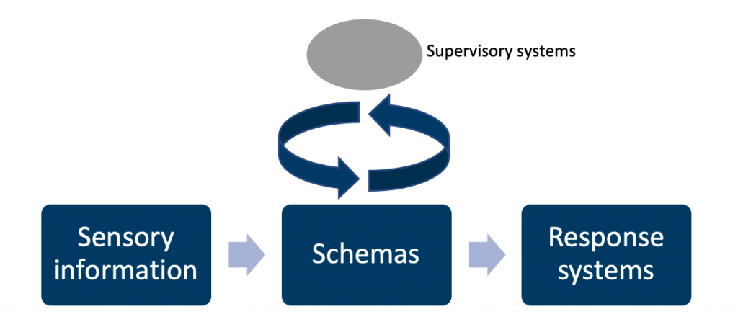(Gilbert, 2008).

## **Hypofrontality:**

Hypofrontality refers to a decreased activity or cerebral blood flow in the prefrontal cortex. It is believed that hypofrontality can lead to a range of behavioural and cognitive changes, including impulsivity, poor decision-making, and difficulty with planning and organization (Molina, 2005).

Under resting conditions, hypofrontality might be difficult to detect, but under cognitive difficulties, it has been shown to correspond with memory deficiencies as well as executive function abnormalities. In the frontal cortex, hypofrontality is associated with an increase in noradrenaline transmission and a decrease in dopaminergic transmission, as well as decreased dopamine efflux (Pratt, 2015).

There are several factors that can contribute to hypofrontality, including brain injury, substance abuse, and certain psychiatric disorders such as schizophrenia attention deficit hyperactivity disorder (ADHD), bipolar disorder and major depressive disorder. In addition, there is some evidence that stress and chronic exposure to high levels of cortisol can also lead to hypofrontality.

Treatment for hypofrontality typically involves addressing the underlying cause, such as addressing substance abuse issues or managing psychiatric disorders. In some cases, medication may be used to help regulate brain activity and improve symptoms. Therapy and other behavioural interventions may also be helpful in improving impulse control, decision-making, and other cognitive and behavioural issues associated with hypofrontality.

## **Impulsivity:**

Impulsivity is a trait that is characterized by a tendency to act on impulses and make decisions without careful consideration of the consequences. It is believed to be mediated by a complex network of neural circuits in the brain.

One key brain region that is involved in impulsivity is the prefrontal cortex, which is a region of the brain that is involved in many important functions such as decision-making, planning, and impulse control. Research has shown that dysfunction or decreased activity in the prefrontal cortex can lead to increased impulsivity.

In addition to the prefrontal cortex, other brain regions that have been implicated in impulsivity include the amygdala, which is involved in emotion and motivation, and the striatum, which is involved in reward and pleasure. Research suggests that these brain regions may interact to influence impulsive behaviour.

It has been shown that there is a relationship between impulsivity and executive function. In general, individuals who are more impulsive tend to have weaker executive function skills. This may be because the same brain regions that are involved in impulsivity, such as the prefrontal cortex, are also involved in executive function. In addition, executive function skills are important for inhibiting impulsive behaviour and making well-thought-out decisions (de Wit, 2014).

It is also important to note that impulsivity is a complex trait that is influenced by both genetic and environmental factors. Therefore, understanding the neural circuits of impulsivity involves studying both the brain and the broader context in which impulsive behaviour occurs (Moeller, 2001).

**References:**

(1) de Wit, H., & Richards, J. B. (2014). Impulsivity as a determinant and consequence of drug use: A review of underlying processes. Addiction, 109(1), 1491-1502.

(2) Gilbert, S.J. and Burgess, P.W. (2008). Executive function. Current Biology, 18(3), pp.R110–R114. doi:10.1016/j.cub.2007.12.014.

(3) Moeller, F. G., Barratt, E. S., Dougherty, D. M., Schmitz, J. M., & Swann, A. C. (2001). Psychiatric aspects of impulsivity. American Journal of Psychiatry, 158(11), 1783-1793.

(4) Molina, V.; Sanz, J.; Reig, S.; Martínez, R.; Sarramea, F.; Luque, R.; Benito, C.; Gispert, J. D.; Pascau, J.; Desco, M. (2005). “Hypofrontality in men with first-episode psychosis”. The British Journal of Psychiatry. **186** (3): 203–208.

(5) Pratt, J. A., C. Winchester, A. Egerton, S. M. Cochran, and B. J. Morris. “Modelling Prefrontal Cortex Deficits in Schizophrenia: Implications for Treatment.” British Journal of Pharmacology 153.S1 (2008): S465-470. Web. 23 Feb. 2015.

### 3.5.15 Empathy and theory of mind

## **Empathy and Theory of Mind Including in Autism and Dissocial Behaviour**

## **Empathy:**

Empathy is the ability to understand and share the feelings of others. Observing another person operates on an item causes brain activity much beyond the observer’s visual cortex in regions directly engaged in planning and performing actions. This has been described as ‘action simulation’, which is particularly high in imaging studies of people who report being empathetic.

Simulation processes are active at an early stage of social development and may be impaired in children with autism spectrum disorders (ASD). However, the outcomes of ASD research to date have been mixed, with an equal number of studies reporting mixed findings.

Mirror neurons are a type of neuron that are believed to play a role in empathy and social understanding. These neurons are activated when an individual observes another person performing an action, as well as when the individual performs the action themselves. This allows individuals to “mirror” or understand the actions and intentions of others.

Mirror neurons were first discovered in the 1990s in monkeys, and their existence in humans has been inferred from brain imaging studies. While the exact role of mirror neurons in empathy and social understanding is still being debated, it is thought that they may play a role in helping individuals to understand the intentions and emotions of others, and to respond appropriately (Rizzolatti, 2004).

## **Theory of mind:**

Theory of mind (ToM) is the ability to understand that other people have their own thoughts, feelings, and beliefs and that these may be different from one’s own. Knowing and comprehending the mental processes of people allows us to predict their conduct based on their beliefs and desires (Premack, 1978). A critical milestone in ToM development is gaining the ability to attribute false beliefs: that is, to recognize that others can have beliefs about the world that are different (Zeng, 2020).

Several regions of the brain, including the medial prefrontal cortex, bilateral temporoparietal junction, and precuneus (a portion of the superior parietal lobe), have been repeatedly observed to be engaged in healthy persons through diverse mentalizing activities (Green, 2015).

## **Autism Spectrum Disorder:**

Autism Spectrum Disorder (ASD) is a neurodevelopmental disorder that is characterized by difficulties with social communication and interactions, as well as repetitive behaviours and interests. People with ASD may have difficulty understanding and responding to the emotions and perspectives of others, which can impact their ability to engage in empathic behaviour.

Individuals with ASD may have differences in the brain regions and neural circuits that are involved in empathy and theory of mind, such as the amygdala, prefrontal cortex and temporoparietal junction. These differences may contribute to the social and emotional difficulties that are often experienced by individuals with ASD. Functional magnetic resonance imaging studies have identified differences in the way that the brains of individuals with ASD respond to stimuli and process information. Individuals with ASD may have abnormal patterns of brain activity in response to social stimuli, such as faces and voices (O’Laughlin, 2000).

However, it is important to note that empathy is a complex trait that is influenced by both genetic and environmental factors. Therefore, the relationship between ASD and empathy is likely to be complex and multifaceted.

## **Dissocial behaviour:**

Dissocial behaviour refers to behaviour that is harmful to others or society as a whole. It can include a wide range of behaviours, such as aggression, theft, and substance abuse.

There may be a relationship between empathy and dissocial behaviour. On the one hand, individuals who are high in empathy may be less likely to engage in dissocial behaviour, as they are more able to understand the perspective and emotions of others, and maybe more motivated to avoid harming others. On the other hand, individuals who are low in empathy may be more likely to engage in dissocial behaviour, as they may have difficulty understanding the perspective and emotions of others and may be more prone to impulsive and aggressive behaviour

Brain imaging studies and other research methods suggest that certain brain regions, such as the prefrontal cortex, amygdala, and insula, may be involved in moral reasoning and the regulation of antisocial behaviour (Raine, 2006).

**References:**

(1) Green, M. F., Horan, W. P., and Lee, J. (2015). Social cognition in schizophrenia. Nat. Rev. Neurosci. 16, 620–631. doi: 10.1038/nrn4005

(2) O’Laughlin, C., and Thagard, P. (2000). Autism and coherence: a computational model. Mind Lang. 15, 375–392. doi: 10.1111/1468-0017.00140

(3) Premack, D., and Woodruff, G. (1978). Does the chimpanzee have a theory of mind? Behav. Brain Sci. 1, 515–526. doi: 10.1017/S0140525X00076512

(4) Raine, A., & Yang, Y. (2006). Neural foundations to moral reasoning and antisocial behavior. Social Cognitive and Affective Neuroscience, 1(3), 203-213.

(5) Rizzolatti G., Craighero L. The mirror-neuron system. Annu Rev Neurosci. 2004;27:169–192.

(6) Zeng, Y., Zhao, Y., Zhang, T., Zhao, D., Zhao, F. and Lu, E. (2020). A Brain-Inspired Model of Theory of Mind. Frontiers in Neurorobotics, 14. doi:10.3389/fnbot.2020.00060.

### 3.5.16 Default mode and salience networks

## **Default Mode**

The default mode network (DMN) is a network of brain regions that is active when an individual is in a resting or “default” state, such as when they are daydreaming or not actively engaged in a task. The DMN is thought to play a role in a variety of cognitive and emotional processes, including self-reflection, social cognition, and memory.

The DMN is composed of a number of brain regions, including the medial prefrontal cortex, posterior cingulate cortex, and medial temporal lobes. These regions are interconnected and show synchronized activity when an individual is in a resting state (Buckner, 2008).

Research has shown that the DMN is involved in a variety of functions, including self-reflection, social cognition, and memory. For example, studies have shown that the DMN is active when individuals think about themselves or others, when they remember past events, and when they engage in mental simulations of future events.

Abnormalities in the DMN have been observed in a number of neurological and psychiatric disorders, such as Alzheimer’s disease, depression, and schizophrenia. Understanding the neurobiology of DMN may provide insights into the underlying mechanisms of these disorders and inform the development of new treatments.

The DMN is composed of a number of brain regions, including the posterior cingulate cortex (PCC) and medial prefrontal cortex (mPFC). The PCC is a region of the brain that is involved in a number of cognitive and emotional functions. Research has shown that the PCC and mPFC are active when an individual is engaged in introspective or self-referential thoughts, when they are remembering past events, and when they are engaging in mental simulations of future events. The PCC and mPFC are also thought to be involved in the integration of information from different brain regions and in the regulation of attention and behaviour (Gusnard, 2001).

## **Salience Networks**

The salience network is a network of brain regions that are involved in the detection and evaluation of stimuli that are important or relevant to an individual. The salience network is thought to play a key role in the allocation of attention and the regulation of behaviour.

The salience network is composed of a number of brain regions, including the anterior insula and the anterior cingulate cortex. These regions are interconnected and show synchronized activity when an individual is faced with a stimulus that is important or relevant to them. Functional magnetic resonance imaging was used to examine the brain activity of individuals while they performed tasks that required the allocation of attention and the regulation of behaviour. They identified a network of brain regions, including the anterior insula and the anterior cingulate cortex, that showed synchronized activity during these tasks and suggested that this network may play a key role in the detection and evaluation of salient stimuli and the regulation of attention and behaviour (Seeley, 2007).

The salience network is thought to play a role in detecting and evaluating stimuli that are relevant to an individual’s goals, needs, and motivations, and in guiding behaviour accordingly. The salience network is also involved in the regulation of emotions and the processing of social information.

**References:**

(1) Buckner, R. L., Andrews-Hanna, J. R., & Schacter, D. L. (2008). The brain’s default network: Anatomy, function, and relevance to disease. Annals of the New York Academy of Sciences, 1124(1), 1-38.

(2) Gusnard, D. A., Akbudak, E., Shulman, G. L., & Raichle, M. E. (2001). Medial prefrontal cortex and self-referential mental activity: Relation to a default mode of brain function. Proceedings of the National Academy of Sciences, 98(7), 4259-4264.

(3) Seeley, W. W., Menon, V., Schatzberg, A. F., Keller, J., Glover, G. H., Kenna, H., … & Greicius, M. D. (2007). Dissociable intrinsic connectivity networks for salience processing and executive control. Journal of Neuroscience, 27(9), 2349-2356.

## 3.6 Modulators (Hormone, Inflammatory Responses)

### 3.6.1 The neuroendocrine system

## **The Neuroendocrine System**

The basic definition of the neuroendocrine system is a coordinated group of cells with a neural determination that secrete hormones or neuropeptides. To ensure an effective response to physical and psychological stimuli, including infections, the hypothalamic-pituitary-adrenal (HPA) axis is regarded as the primary neuroendocrine system (Toni, 2004).

## **Pituitary Gland**

The pituitary gland, a pea-sized organ, is known as the master gland of the body. The pituitary gland is located in two lobes anterior and posterior lobes. It is situated beneath the hypothalamus at the base of the brain.  The pituitary gland is a major component of the endocrine system and is in charge of producing a wide range of crucial hormones. Additionally, the pituitary gland directs the release of hormones from other endocrine system glands. As a result, it regulates essential processes in the brain, skin, and reproductive system, and the pituitary gland is connected to the hypothalamus through a stalk of nerves and blood vessels. This stalk is known as the pituitary stalk.

Hypothalamus instructs the pituitary gland to release particular hormones. The function of the hypothalamus is for controlling processes including heart rate, blood pressure, digestion and body temperature.

## **Hypothalamic Regulation of the Pituitary Secretions**

Most of the pituitary’s release is regulated by a hormonal or neurological signal received from the hypothalamus. Hypothalamus receive a signal from different parts of the body in the nervous system. Nerve impulses that start in the hypothalamus and end in the posterior pituitary regulate the secretion of hormones from this gland. Contrarily, hormones known as hypothalamic releasing and hypothalamic inhibitory hormones (or factors) are secreted within the hypothalamus itself and then transported to the anterior pituitary through tiny blood vessels known as hypothalamic-hypophysial porta vessels. These hormones regulate anterior pituitary secretion. These releasing and inhibitory hormones work on the glandular cells in the anterior pituitary to regulate their release.

## **Anterior pituitary release**:

* **Thyrotropin-releasing hormone** (TRH), induces the secretion of thyroid-stimulating hormone.
* **Corticotrophin-releasing hormone** (CRH), activates the release of adrenocorticotropic.
* **Prolactin inhibitory hormone**(PIH), stimulates the inhibition of prolactin release (Jakoi, 2004).

## **Feedback control**:

An illustration of negative feedback is when the body starts to heat up and a reaction counteracts and stops the increase in body temperature. A good example of unfavourable feedback is sweating.

## **The Function of the Posterior Pituitary Gland**

 The posterior pituitary is primarily responsible for producing and releasing two hormones **oxytocin** and **antidiuretic** (ADH, or vasopressin) hormones.

ADH is crucial for keeping the body’s electrolyte and fluid balance. The brain contains specific osmoreceptors that help to maintain water balance.

Oxytocin plays a vital role in childbirth since it stimulates the contraction of the smooth muscles of the uterus. Oxytocin also causes the smooth muscle of the breast to contract, causing the milk to let down during breastfeeding (Brown, 2011).

**References:**

(1) Toni, R. (2004). The neuroendocrine system: organization and homeostatic role. Journal of endocrinological investigation, 27(6 Suppl), 35-47.

(2) Jakoi, E. R. (2004). Hypothalamus and pituitary gland.

(3) Brown, C. H. (2011). Magnocellular neurons and posterior pituitary function. Comprehensive physiology, 6(4), 1701-1741.

### 3.6.2 Stress response

## **Stress: Physiological and Psychological aspects**

Hans Selye in 1936 first used the term ‘stress’ when he described “the non-specific response of the body to any demand placed upon it” (Selye, 1936). Selye described positive and negative stress as ‘eustress and ‘distress’ respectively. This balanced an individual’s psychological equilibrium. Another term commonly used in the 21st century is ‘resilience’ which refers to the ‘psychological process developed in response to intent life stressor that facilitates healthy functioning’ or generically bouncing back from a stressor. (Johnson, 2009).

The mammalian stress response is a physiological and psychological response to real or perceived hardship.

At several levels, the concept of stress pervades our culture. In everyday language, it denotes a difficult, sometimes overpowering mood accompanied by bad emotions. Many scientists equate the term stress with Selye’s description of a “fight-or-flight” response to a threat, that is, an acute, adaptive response to environmental stimuli. This is via a route that involves:

* the amygdala,
* the hypothalamus,
* and the medulla of the adrenal gland.

However, science in general, and neuroscience in particular, have advanced these notions along many dimensions during the previous 50 years. We think of biological reactions to stress not as causing a bad condition, but as a typically positive, adaptive collection of mechanisms that improve survival.

A slower looped response is the hypothalamic-pituitary-adrenal (HPA) axis which engages when there is persistent or chronic stress. Resulting in the release of cortisol, a hormone that induces metabolic changes aiming to sustain the fight-or-flight response.

This perspective on stress biology has given rise to the concepts of allostasis and allostatic load/overload. Allostasis is the active process of adjusting and maintaining stability (or homeostasis) by the creation of mediators that encourage adaptation, such as cortisol. However, if the environmental disturbances remain constant, the equilibrium set point must be changed to a “new normal,” which can be costly to the organism. “The price the body pays for being compelled to adjust to undesirable psychosocial or physical settings is referred to as allostatic stress” (McEwen, 2000). These ideas emphasise the protective effects of many, nonlinear adaptation mediators, as well as the harm that happens when the same mediators are overused or dysregulated.

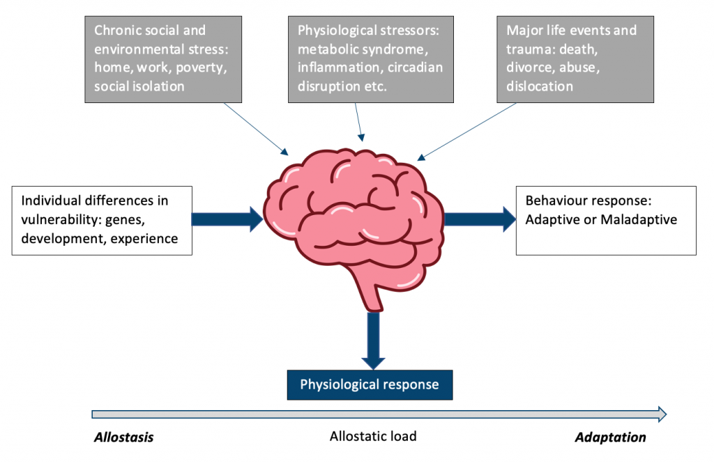McEwen (2020)

The below disorders can all be attributed to psychosomatic disorders:

|  |  |
| --- | --- |
| ***Physical effects resulting from psychological stress***: | ***Examples:*** |
| **Gastrointestinal** | IBS, peptic ulcer, heartburn |
| **Cardiovascular** | Hypertension, coronary artery disease |
| **Respiratory** | Asthma |
| **Dermatology** | Atopic dermatitis, psoriasis |

## **Stress Response Effect of Glucocorticoids**

Glucocorticoids play a key role in this response, functioning to allocate energy resources in order to optimise survival in the face of a challenge and to restore homeostasis after the immediate threat has passed.

The hypothalamus sends signals to the adrenal glands, which release glucocorticoids, hormones that have a number of consequences when under stress. In response to stress, the paraventricular nucleus (PVN) of the hypothalamus releases corticotrophin-releasing factor (CRF), the primary regulator of the HPA axis, which triggers the release of adrenocorticotropic hormone (ACTH) into the bloodstream. The adrenal cortex then secretes glucocorticoids (cortisol in humans and corticosterone in rodents) as a result of the action of ACTH. The release of glucocorticoids causes the binding of glucocorticoids to the glucocorticoid receptors (GR) located in stress-responsive brain areas via transcriptional regulation, causing feedback inhibition (Herman et al., 2012).

## **Acute Stress Reaction**

**Clinical features:**An acute stress reaction is a transient disorder of significant severity which develops with any prior psychiatric disorder. It is in response to exceptional physical and/or mental stress. Usually, it subsides within hours/days. A clear relationship between the emotional stressor and the onset of symptoms must be described.

Personality structure and the utilization of suitable coping mechanisms are apparent key factors.

**Treatment:**An acute stress reaction is self-limiting and only supportive treatment is required.

**References:**

(1) Selye, H. (1936). A Syndrome produced by Diverse Nocuous Agents. Nature, 138(3479), pp.32–32. doi:10.1038/138032a0

(2) Johnson, D.C. (2009). Key Facts On Reslilience And Response To Stress For Navy And USMC Leaders. Journal of Special Operations Medicine, 09(4), p.110. doi:10.55460/wnun-ehdm.

(3) McEwen BS (2000). Allostasis and allostatic load: implications for neuropsychopharmacology. Neuropsychopharmacology 22:108–124. doi:10.1016/S0893-133X(99)00129-3 pmid:10649824

(4) McEwen, B.S. and Akil, H. (2020). Revisiting the Stress Concept: Implications for Affective Disorders. The Journal of Neuroscience, 40(1), pp.12–21. doi:10.1523/jneurosci.0733-19.2019.

(5) Herman, J., McKlveen, J., Solomon, M., Carvalho-Netto, E., & Myers, B. (2012). Neural regulation of the stress response: glucocorticoid feedback mechanisms. Brazilian journal of medical and biological research, 45, 292-298.

(6) Harvard Health Publishing (2020). Understanding the Stress Response. [online] Harvard Health. Available at: https://www.health.harvard.edu/staying-healthy/understanding-the-stress-response.

### 3.6.3 Hormonal and neuroendocrine changes in psychiatric disorders

## **Hormonal Changes in Psychiatric Disorders**

Since mood and behaviour are emergent characteristics, it is challenging to concentrate on a physiological level that would be most useful for diagnostic classification. It is now understood that a person’s unique genetic polymorphisms are unlikely to increase their chance of developing psychiatric disorders by more than a very tiny amount. Additionally, it is now understood that the relationship between genes and behaviour includes a variety of mechanisms for modifying risk, including epigenetic change of gene expression and the plasticity of neurons, synapses, and neural networks. Each of these biological processes can be influenced by hormones. Despite occurring at the receptor, metabolism, or synthesis levels, hormonal imbalances can nonetheless assemble into distinct psychiatric disorders.

It can be hard to recognize hormone-related disorders. First, several hormonal changes take place at once throughout spontaneous reproductive hormone fluxes including puberty, the menstrual cycle, pregnancy, lactation, and menopause. Unfortunately, there is a propensity to focus just on oestrogen swings when diagnosing psychiatric symptoms rather than taking into account a wider range of hormonal alterations. Some conditions, such as postpartum OCD, may not fully manifest after exposure to oestrogen or progesterone levels typical of pregnancy. The complicated metabolism of circulating steroid hormones presents yet another significant obstacle in separating out hormonal influences on psychiatric diseases. Because local tissue and cellular enzymes can convert steroid hormones to other molecules with differing functions, such as neurosteroids, circulating hormone levels can differ from levels in particular brain regions or within specific cells. Studying the effects of enzyme inhibitors, receptor antagonists, and hormonal substances that are resistant to metabolism are ways to identify the hormone metabolite closest to symptom development. Finally, the absence of agonists and antagonists that can access the brain as well as distinct hormone pools at different brain regions and in the periphery makes it difficult to examine the psychiatric effects of peptide hormones like oxytocin and inflammatory cytokines.

## **Mood disorders related to the menstrual cycle and pregnancy:**

The standard illustration of a hormonally related mood illness is **Premenstrual Dysphoric Disorder (PMDD)** or premenstrual mood disorder, which is being considered a new diagnosis for DSM-V. It is characterised by brief, recurrent depressive episodes that start before the menstrual cycle and stop a few days after its onset. Symptoms include oedema, general discomfort and low mood. Luteal hormones cause the symptoms, which are alleviated throughout the follicular phase of the cycle and after hormonal cycling is stopped. Only a small fraction of women experience considerable disability, and symptom severity is ongoing. It is currently unknown whether luteal hormones are felt more strongly by women with PMDD due to anomalies in luteal hormone metabolism or receptors or due to weaknesses in downstream systems impacted by luteal hormones (Altemus, 2010).

**Maternity blues** occurs within the first few days postpartum. It often ends by the second week. Symptoms include low mood, irritability, crying episodes and general fatigue.

**Postpartum psychosis** often starts within 2 weeks postpartum. Characterised by mood changes and delusions focused on the newborn. The mainstay of treatment is admission to the mother-baby unit under specialist psychiatric care.

## **Thyroid hormone disorders and their psychiatric features:**

The **hypothalamic-pituitary-thyroid axis** and its associated feedback mechanisms regulate thyroid hormone levels:

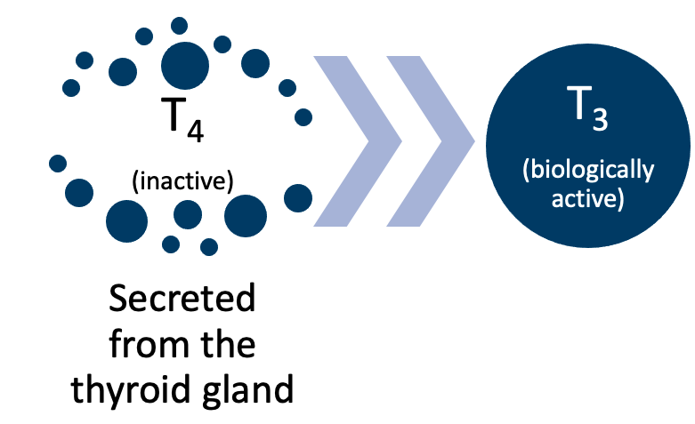

**Hyperthyroidism** is most commonly caused by **Grave’s disease**. Clinical features include palpitations, tachycardia, irritability, fine tremor, reduced appetite with weight loss and generalised anxiety associated with panic disorder. In primary hyperthyroidism, free thyroid hormone levels are raised, with low TSH levels. This is because of the negative feedback on the pituitary gland.

**Primary hypothyroidism** accounts for over 90% of hypothyroidism cases. Lithium a common psychiatric medication is one of the causes. Clinical features include dry skin, reduced reflexes, bradycardia, cold intolerance, weight gain with reduced appetite and menorrhagia in women. A common psychiatric feature is a depression often with cognitive disturbances. In hypothyroidism, free hormone levels are low and TSH levels are raised due to the loss of the negative feedback effect.

|  |  |  |
| --- | --- | --- |
| **Thyroid disorder**: | ***Free thyroid hormone level:*** | ***TSH level:*** |
| **Primary hyperthyroidism** | Raised | Low |
| **Hypothyroidism** | Low | Raised |

## **Adrenal gland insufficiency and psychiatric disorders:**

The adrenal glands which are regulated by the **hypothalamic-pituitary-adrenal (HPA) axis** secretes cortisol, aldosterone and sex steroids. Increased activity of the HPA axis is noted in both stress and depression. A combined dexamethasone/corticotropin-releasing hormone test (DEX/CRH-test) determines the function of the HPA axis. Often psychiatric patients have raised cortisol and ACTH post administration of dexamethasone.

**Cushing’s syndrome** is associated with raised cortisol levels. Clinical features include plethoric complexion, purple striae, proximal muscle weakness, buffalo hump, hypertension and central obesity. Depression and cognitive changes are common psychiatric features. Often they will resolve once cortisol levels normalise.

**Addison’s disease** has a number of causes, with the most common in the developing world being autoimmune destruction of the adrenal gland. Clinical features include hyperpigmentation in palmar creases, weight loss, vitiligo, gastrointestinal symptoms and salt cravings. Depression, apathy and memory impairment are common psychiatric features. Hyponatraemia and hyperkalemia occur due to a loss of aldosterone function in kidney tubules.

## **Suprachiasmatic nucleus and the pineal gland:**

The ‘physiological internal clock’ functions with both the suprachiasmatic nucleus and the pineal gland. The suprachiasmatic nucleus stimulates pinealocytes, or pineal gland cells, to produce melatonin, which helps to initiate and maintain sleep patterns.

**Circadian rhythm sleep disorder** is a consequence of there being a mismatch between sleep requirements dictated by social activities and the body’s internal clock. Clinically we prescribe synthetic melatonin with the aim to help reset the biological clock by reorganising the circadian rhythm.

**Seasonal affective disorder:**is a mood disorder subset, in which people who have normal mental health throughout most of the year exhibit depressive symptoms at the same time each year. A theory associated with this disorder is that the cause is related to melatonin, which is produced by the pineal gland in dim light and darkness because there are direct connections between the retina and the pineal gland via the retinohypothalamic tract and the suprachiasmatic nucleus. The endogenous circadian clock regulates melatonin secretion, although it can also be repressed by intense light.

## **Gonadal hormone dysgenesis and psychiatric disorders:**

Gonadal dysgenesis has been attributed to the cause of Klinefelter syndrome and Turner syndrome. Hypogonadotropic hypogonadism is seen due to primary gonadal failure.

**Klinefelter syndrome:**is characterised by tall stature, reduced facial hair, gynaecomastia and infertility in males. The cognitive function is impaired with mild to moderate intellectual function.

**Turner syndrome:** is characterised by a webbed neck, small stature, heart abnormalities, cubitus valgus, and skeletal abnormalities in females. The cognitive function may be intact.

## **Growth hormone disorder and psychiatric features:**

Growth hormone secretion by the pituitary gland is regulated by the hypothalamus. Growth hormone promotes growth and exerts metabolic action on the liver, adipose tissue and skeletal muscle.

Hypopituitarism (when you have a short supply (deficiency) of one or more of the pituitary hormones) will result in marked depression and apathy.

## **Anatomy of the Neuroendocrine System**

## **The** **Hypothalamus**:

**Location:** The hypothalamus lies on each side of the 3rd ventricle above the midbrain and below the thalamus.

**Function:** Regulates homeostatic functions of the human body. Plays a role in circadian rhythm and in response to mood.

**Hormones:** Synthesises and secretes neurohormones/neuropeptides, which control the subsequent release of pituitary hormones. The hypothalamus releases thyrotropin-releasing hormone (TRH), gonadotropin-releasing hormone (GnRH), growth hormone-releasing hormone (GHRH), corticotropin-releasing hormone (CRH), somatostatin, and dopamine into the circulation, where they travel to the anterior pituitary (Shahid 2020).

## **The Pituitary gland:**

**Location:** The pituitary gland lies in the sella turcica in the sphenoid. It is inferior to the hypothalamus and connected by the infundibulum.

**Structure:**The pituitary gland is made up of the anterior and intermediate lobes, named the adenohypophysis, and the posterior lobe, named the neurohypophysis.

**Function:** Regulates functions relating to metabolism, growth, reproduction, and lactation and is associated with the stress response.

**Hormones:** The anterior pituitary gland secretes: growth hormone (GH), prolactin, follicle-stimulating hormone (FSH) and luteinizing hormone (LH), thyroid-stimulating hormone (TSH), adrenocorticotrophic hormone (ACTH). Whilst the posterior pituitary gland (neurohypophysis) secretes oxytocin and antidiuretic hormone (ADH) or vasopressin.

## **Neuroendocrine Changes in Psychiatric Disorders**

Type 2 diabetes and obesity continue to be significant public health problems, with type 2 diabetes rates increasing at an epidemic rate. It is critical to find new risk variables that may inspire the creation of innovative preventative strategies because known risk factors do not fully account for population variation. Depression and chronic psychological stress are linked to type 2 diabetes, however, the exact mechanism is yet unknown. A common reason could be that these stressors cause neuroendocrine alterations, notably stimulation of the sympathetic nervous system (SNS) and hypothalamic-pituitary-adrenal (HPA) axis.

## **Psychiatric features of diabetes mellitus:**

People who suffer from diabetes mellitus have higher rates of psychiatric disorders. People with depression are poorly motivated to follow strict dietary regimes and maintain glycaemic control.

Antipsychotics such as clozapine are associated with an increased risk of diabetes mellitus. The CATIE trial demonstrated that Olanzapine was associated with greater weight gain, hyperlipidemia, and hyperglycemia.

**References:**

(1) Shahid, Z., Asuka, E. and Singh, G. (2022). Physiology, Hypothalamus. [online] PubMed. Available at: https://www.ncbi.nlm.nih.gov/books/NBK535380/#:~:text=The%20thyrotropin%2Dreleasing%20hormone%20(TRH.

(2) El, S.A., Fahmy, M.W. and Schwartz, J. (2019). Physiology, Pituitary Gland. [online] Nih.gov. Available at: https://www.ncbi.nlm.nih.gov/books/NBK459247/.

(3) Moore DP, Puri BK (2012). Textbook of Clinical Neuropsychiatry and Behavioural Neuroscience (3rd edition), pp. 534-542. CRC Press.

### 3.6.4 Inflammation and immune responses in psychiatric disorders

## **An Understanding of the Effects of Inflammation and the Immune Response on Neural Function**

Numerous neuroanatomical, hormonal, and molecular channels are used by the CNS and immune system to communicate with one another. An intricate regulation mechanism necessary for good health is provided by the interplay between the neuroendocrine and immunological systems. Changes in autoimmune/inflammatory disease susceptibility and severity can result from disturbances at any level. A thorough understanding of the mechanisms by which the immune and CNS systems communicate at all levels will offer numerous new insights into the bidirectional regulation of these systems and the disruptions in these communications that cause disease, and ultimately will inform new therapeutic avenues for autoimmune/inflammatory diseases.

To avoid potentially harmful inflammation and preserve homeostasis, neural reflex circuits control cytokine release. The afferent vagus nerve carries sensory information triggered by injury or infection to integrative regions of the brainstem, and efferent nerves convey outbound impulses that terminate in the spleen and other tissues. Together, these signals form the inflammatory response. Following the release of acetylcholine from a fraction of CD4+ T cells, neurotransmitters from peripheral autonomic nerves carry the neurological signal to other immune cells, such as macrophages, by activating 7 nicotinic acetylcholine receptors.

In animal models of arthritis, alterations in the sympathetic nervous system and HPA axis during inflammation have been seen. More critically, these models have shown how crucial endogenous glucocorticoids are for controlling immunity and preventing mortality brought on by an unchecked immunological response. Furthermore, dysregulation of the Hypothalamic-Pituitary-adrenal (HPA), Hypothalamic-Pituitary-thyroid (HPT), Hypothalamic-Pituitary-gonadal (HPG), and GH axis is linked to rheumatoid arthritis (RA) in both humans and animals. Additionally, there is proof that the sympathetic nervous system struggles to control immunity and that glucocorticoid signalling is incorrect. Today, innovative RA treatments based on addressing and treating the dysregulation of these neurological and neuroendocrine circuits are being tested using these principles (Bauer & Teixeira, 2019).

## **Onset and Maintenance of Psychiatric Illness** with Regards to Inflammation and Immune Response

Recent research reveals that inflammation may play a role in the symptoms of several psychiatric diseases, most notably depression. Numerous research, including meta-analyses, have linked depression to increased levels of acute phase proteins and peripheral and brain inflammatory cytokines. Chronically elevated inflammation is thought to alter neurotransmitters and neuro circuits, causing depressed symptoms and perhaps obstructing or reducing the effectiveness of antidepressants. In fact, studies have shown that people with high levels of inflammation respond poorly to standard antidepressant treatments. New avenues for the testing of novel treatment techniques that target the immune system or its impacts on neurotransmitter systems have been made possible by recent advancements in our capacity to comprehend and evaluate the effects of inflammation on the brain in patients (Alam et al., 2017).

The relationship between the immune system and psychiatric illness is complex and not fully understood. However, recent research suggests that immune responses may play a role in both the onset and maintenance of some psychiatric illnesses.

There is evidence that suggests that some psychiatric illnesses, such as depression and schizophrenia, may be related to an overactive or dysregulated immune response. This can result in inflammation in the brain, which has been associated with changes in neurotransmitter function and altered brain structure and function. In addition, there is evidence that suggests that some infections and chronic inflammation can trigger the onset of psychiatric illness. For example, individuals who have been infected with a virus or who have autoimmune conditions may be at increased risk for developing depression, anxiety, or other psychiatric illnesses.

There is also evidence that suggests that the immune system can play a role in the maintenance of psychiatric illness. For example, individuals with depression or schizophrenia may have chronic low-grade inflammation, which can contribute to the persistence of their symptoms.

Overall, while the relationship between the immune system and psychiatric illness is not fully understood, research suggests that immune responses may play a role in both the onset and maintenance of some psychiatric illnesses. As a result, targeting the immune system may provide a new avenue for the treatment of psychiatric illness.

**References:**

(1) Bauer, M. E., & Teixeira, A. L. (2019). Inflammation in psychiatric disorders: what comes first? Annals of the New York Academy of Sciences, 1437(1), 57-67.

(2) Alam, R., Abdolmaleky, H. M., & Zhou, J. R. (2017). Microbiome, inflammation, epigenetic alterations, and mental diseases. American Journal of Medical Genetics Part B: Neuropsychiatric Genetics, 174(6), 651-660.

## 3.7 Genetics

### 3.7.1 Basic concepts of genetics

## **Cell Division**

When a parent cell divides into two or more daughter cells, this process is known as cell division. Usually, cell division happens as part of a longer cell cycle. Each parental cell produces two daughter cells, which is how all cells reproduce.

A new cell population might be generated by the division and growth of a single parental cell and its progeny, which would result from the division and growth of the newly formed daughter cells.

In other measures, repeated cycles of growth and division enable the formation of structures made up of millions of cells from a single cell.

## **Types of Cell division**:

The first form of cell division is vegetative division, in which each daughter cell divides to produce two copies of the parent cell, a process known as mitosis. Meiosis is the second, and it produces four haploid daughter cells**.**

**Mitosis**: The method by which cells create perfect duplicates of themselves. Mitotic division results in **two identical diploid daughter cells**. Almost all of the body’s cells, including those in the eyes, skin, hair, and muscles, undergo mitosis.

**Meiosis**: Instead of producing identical daughter cells as in mitosis, sperm or egg cells are produced in this method of cell division. Meiotic division results in **four genetically different haploid daughter cells**.

**Binary Fission**: Bacteria and other single-celled species reproduce by copying themselves (Scholey et al., 2003).

## **Gene**

A gene is a functioning genetic component that produces proteins from nucleotides. Genes are the basic units of hereditary and are sequences of DNA within a chromosome. Chromosomes hold the locations of genes.

Since genes are formed of nucleotide chains, they are truly DNA strands. Nucleotides make up a gene’s chemical structure. Genes are formed of A, T, G, and C nucleotides, which make up a portion of DNA. It forms hydrogen bonds with the nucleotides of the opposing strand and phosphodiester bonds with the nucleotide next to it.

Two categories of components, called core and regulatory, make up the majority of the gene structure.

The core parts or sequences do participate in the production of proteins. While the regulatory components keep gene expression in check (Pearson, 2006).

## **Transcription and Translation**

Proteins are synthesised in a two-step process of **transcription to mRNA** followed by **translation to an immature protein**.

The process of making an RNA strand from a DNA strand is called **transcription**. DNA is once more used as a template during transcription, just as it is during DNA replication. A new RNA molecule is “transcribed” with the information previously contained in DNA molecules.

In order to make proteins, mRNA molecules must go through a process known as **translation**. A protein with a specified sequence of amino acids can be produced using the nucleotide sequence found in the mRNA molecule (Burmann et al., 2010).

## **Human Genome**

The human genome is made up of 20,000 genes spread across 23 linear chromosomes. A small percentage codes directly for protein sequences, whilst the remaining genes include non-coding single-copy sequences and repetitive DNA.

Humans have two genomes: a nuclear genome and a mitochondrial genome. From the beginning of life (about 4.5 billion years ago) to the emergence of the Homo sapiens species, both of them show the molecular evolution of humans. Because of this, the human genome has traits that are particular to Homo sapiens and traits that are shared by several groups of species. The human nuclear genome contains 3.2 x 10(9) base pairs and is divided into 23 chromosomes of various sizes. The 21st chromosome is the smallest, with 5 x 10(7) base pairs, and the 1st chromosome is the largest, with 2.63 x 10(8) base pairs. Although the nucleotide sequence of each chromosome has been determined, uncertainties remain regarding how the nuclear genome is organized. The exact number of genes encoded by the human genome, for instance, is still unclear, with estimates ranging from 30 to 150 thousand genes. A small percentage of the human nuclear genome is made up of coding sequences. Repeated sequences make up around 50% of the genome, together with non-coding unique sequences. It’s common to incorrectly refer to this region of the genome as “junk DNA.” Genes are distributed unevenly across chromosomes; DNA fragments with low percentages of GC pairs code for fewer genes than those with high percentages of GC pairs (Pennisi, 2001).

**Penetrance**: the degree to which a specific gene or collection of genes is expressed in the phenotypes of persons carrying it, as assessed by the proportion of carriers exhibiting the distinctive phenotype.

**Expressivity:** is the amount to which a genotype manifests its phenotypic expression is measured by expressivity. Individuals with a specific mutation can differ in illness severity, but they can also differ in many other features of their phenotypes, such as the age at which disease symptoms appear.

## **Gene mutations:**

Gene mutation happens via four main mechanisms: **substitutions**, **deletions**, **insertions** and **frameshift**.

|  |  |
| --- | --- |
| **Type of gene mutation:** | ***Summary:*** |
| **Point mutation** | A point mutation or substitution is a genetic mutation where a single nucleotide base is changed. Inserted or deleted from a sequence of DNA or RNA. Point mutations have a variety of effects on the downstream protein product. Consequences that are moderately predictable based upon the specifics of the mutation. |
| **Substitutions** | A substitution is a mutation in which one base is exchanged for another (i.e., a change in a single “chemical letter,” such as changing an A to a G). |
| **Insertions** | Insertion mutations are the addition of one or more nucleotide base pairs into a DNA sequence. Insertions can vary in size from one base pair incorrectly inserted into a DNA or a section of one chromosome inserted into another chromosome. |
| **Deletions** | A deletion mutation occurs when part of a DNA molecule is not copied correctly during DNA replication. This uncopied part can vary in size, from a single nucleotide or an entire chromosome. The loss of DNA during replication can lead to a genetic disease. |
| **Frameshift** | A frameshift mutation is a type of mutation involving the insertion or deletion of a nucleotide in which the number of deleted pairs if not a divisible number of three (codons). The divisible by three is important due to the cell reading a gene in groups of three bases. |

## **Patterns of Inheritance**

An individual’s genotype governs his or her phenotype. Alleles inherited from the person’s parents determine their genotype (one from the maternal and one from the paternal). These alleles regulate the “dominant” or “recessive” nature of a trait. Additionally, whether a trait is “autosomal” or “X-linked” depends on where the alleles are located in the genome. If just one copy of an allele is necessary for the manifestation of a trait, it is said to be dominant. If two copies of an allele are necessary for the expression of a trait, the trait is recessive. In contrast to autosomal traits, which are governed by alleles found on any chromosome other than the X or Y, X-linked traits are those that are governed by an allele that is carried on the X chromosome. The gender of the progeny and the presence or absence of a dominant or recessive allele are two factors that affect the expression of X-linked traits. A Punnett square can be used to calculate the likelihood of simulating a given trait in a child. The use of a Punnett square enables two persons to visualise the potential genotypes of their progeny and assess the likelihood of trait expression, assuming they are aware of their genotype for the trait (Gropman & Adams, 2007).

|  |  |  |
| --- | --- | --- |
| **Inheritance Pattern** | **Characteristics** | **Disease Examples** |
| **Autosomal Dominant** | Every affected person usually has an affected parent; it occurs in every generation. | Huntington’s disease, neurofibromatosis, achondroplasia, familial hypercholesterolemia |
| **Autosomal Recessive** | Both parents of an affected person are carriers, which is rarely common in every generation. | Tay-Sachs disease, sickle cell anaemia, cystic fibrosis, phenylketonuria (PKU) |
| **X-linked Dominant** | Females are more frequently impacted because all daughters and no sons of an infected father will be affected; males and females in the same generation can be affected if the mother is diseased. | Hypophatemic rickets (vitamin D resistant rickets), ornithine transcarbamylase deficiency |
| **X-linked Recessive** | Males are more frequently affected; affected males often present in each generation | Hemophilia A, Duchenne muscular dystrophy |
| **Mitochondrial** | Can affect both males and females, but is only passed on by females because all mitochondria of all children come from the mother; can appear in every generation | Leber’s hereditary optic neuropathy, Kearns-Sayre syndrome |

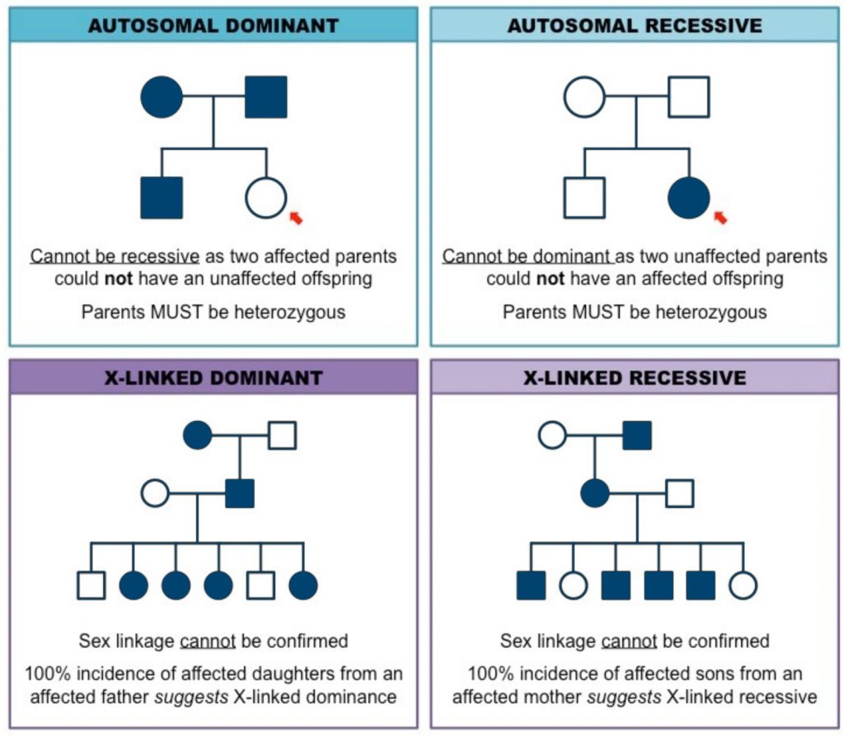

Bear in mind that most psychiatric disorders show non-mendelian patterns of inheritance. The interplay between genetic factors and the environment is key.

## **Family, Twin and Adoption Studies**

## **Family studies**:

Even while family studies are not as frequently cited as twin and adoption studies, they are nonetheless a relevant and significant element of the heredity vs environment puzzle. Family studies are mostly used to determine the degree of risk that relatives would experience the same mental illnesses as other family members do. Case-control family studies are used, along with population-relative risk estimates for mental disease. The term “relative risk” refers to the difference between the relative risk of a person with a mental disorder and the relative risk of a person without a mental disorder (Shih et al., 2004).

Affective disorder studies noted that the relative risk of developing **bipolar disorder** is significantly increased in 1st-degree relatives of those with the disorder. Alongside this, the risk of unipolar depression is also increased in families with bipolar disorder.

**Autism** has a strong genetic aetiology as shown in both family and twin studies.

## **Twin studies**:

Twin studies are a crucial tool for analysing the nature vs. nurture debate. Monozygotic twins, sometimes known as identical twins, are siblings whose genotypes are identical. They are probably the best measure of whether biology influences human qualities and psychopathology. For instance, the idea of identical genes would ideally distribute itself toward the phenotypes of conduct and personality of identical twins if one twin had dark hair, the other twin will also have dark hair. Dizygotic twins, often known as fraternal twins, share exactly half of their genes. They are a very excellent point of reference for identical twins, albeit they are not as ideal as identical twins for determining the levels of genetic influence. Identical twins and fraternal twins both share the exact same age, which distinguishes them from first-degree relatives. Identical and fraternal twin samples are typically used in twin studies; if biology predominates over the environment, identical twins should behave or have more psychopathology in common than fraternal twins.

Where the rate of monozygotic twin concordance is high relative to the rate of dizygotic twin concordance, strong genetic aetiology for the condition can be suggested.

**Schizophrenia** accumulates in families. In discordant twins, the offspring of both affected and unaffected twins display the same risk of developing schizophrenia.

## **Adoption studies**:

Adoption studies make up a sizable section of research on how genes and environment affect human traits and psychopathology. Studies on adoption are crucial because they take into consideration both biological parents and environmental parents, two sets of variables that could explain variations in behaviour, personality, and psychopathology. Of course, any genetic connections between biological parents and children who are given away are typically explained by genetics, and any environmental connections between adoptive parents and children who are adopted are typically explained by environment.

## **Direct Gene Analysis**

In both basic and pharmacological research, the direct examination of single biological molecules is becoming increasingly significant (e.g. for gene expression analysis). Particularly fascinating new opportunities to examine biological processes in unprecedented depth are offered by single-molecule fluorescence detection. In order to directly identify and analyse RNA and DNA molecules, various academic and corporate research groups are currently working on the development of single-molecule detection-based technologies. When compared to techniques like real-time PCR or DNA arrays, these newly discovered approaches clearly outperform them because they are characterized as homogeneous assays and do not involve any amplification of the target or the signal**.**

## **Gene Tracking Analysis**

A process for figuring out how one gene is passed down through a family. It is utilised in the diagnosis of hereditary illnesses like Huntington’s disease and cystic fibrosis. Using gene probes, it is possible to identify and choose appropriate molecular markers, such as single nucleotide polymorphisms (SNPs) or restriction fragment length polymorphisms (RFLPs), that are located in or close to the locus of interest. These can then be followed through family members and utilised to identify the illness locus prenatally in upcoming at-risk pregnancie**s**(Jones et al., 2013).

## **What is a Genetic Marker?**

Any change in the nucleic acid sequence or other genetic feature that is easily detectable and used to identify people, populations, or species, or to pinpoint the genes responsible for inheritable diseases, is referred to as a genetic marker (Davey et al., 2011).

## **What is Linkage Studies?**

An investigation into the relationships between genes. The potential for genes and other genetic markers to be inherited together as a result of their close proximity on the same chromosome is known as linkage (Teare & Barrett, 2005).

Linkage association studies can pinpoint the genomic position of a variant that contributes to the likelihood of acquiring a condition.

## **What is a LOD Score?**

A LOD score is a measure of the probability that two genetic characteristics are linked. If the score is high, the qualities are likely to be tightly related and typically inherited jointly. On the other side, low scores show a weak relationship. For a variety of reasons, including the need to comprehend specific genetic disorders and the desire to uncover a gene using knowledge of known genes, geneticists find it crucial to grasp these figures (Abreu et al., 2002).

A LOD score greater than 3.0 is considered evidence for linkage.

A LOD score less than -2.0 is considered evidence to exclude linkage.

## **Genome-Wide Association Studies**

A research strategy known as a genome-wide association study (abbreviated GWAS) is used to find genetic variations that are statistically linked to a risk for a disease or a certain trait. The approach entails scanning the genomes of a large number of individuals in search of genetic variants that are more prevalent in persons with a particular disease or trait than in people without the disease or trait. These genomic variants are often utilised to look for neighbouring variants that are directly responsible for the disease or trait once they have been found.

## **Genetic Variants**

A gene variation is an alteration to a gene’s DNA sequence that takes place throughout time. Gene variation is regarded to be a more accurate word for this type of genetic change than gene mutation because changes in DNA do not necessarily result in disease. A gene’s nucleotides—the building units of DNA—can be affected by one or more variations.

## **Genetic Influences on Development Including Gene-Environment Interactions**

The genetic makeup acquired from the parental egg and sperm as well as environmental elements influences the proper growth of an individual. Our environment affects how our genes are expressed, and our genes affect how our environment affects them. Additionally, helpful for understanding some disorders are environment-gene interactions.

**References:**

(1) Genetic Alliance (2009). Inheritance Patterns. [online] Nih.gov. Available at: https://www.ncbi.nlm.nih.gov/books/NBK115561/.

(2) ib.bioninja.com.au. (n.d.). Pedigree Charts | BioNinja. [online] Available at: https://ib.bioninja.com.au/standard-level/topic-3-genetics/34-inheritance/pedigree-charts.html.

(3) P Mcguffin, Owen, M.J. and Gottesman, I.I. (2002). Psychiatric genetics and genomics. Oxford: Oxford University Press.

### 3.7.2 Genetic abnormalities and clinical practice

## **Types of Genetic Abnormalities**

A genetic disorder is a condition wholly or partially brought on by a deviation from the typical DNA sequence. A single gene mutation (monogenic disorder), numerous gene mutations (multifactorial inheritance disorder), a combination of gene mutations and environmental factors, or chromosome damage can all result in genetic illnesses (changes in the number or structure of entire chromosomes, the structures that carry genes). Nearly all diseases have a genetic component, as we discover more about the human genome (the entire collection of human genes). Some disorders, such as sickle cell disease, are brought on by inherited mutations that are present in a person at birth. Other illnesses are brought on by acquired mutations in a gene or set of genes that take place throughout the course of a person’s lifetime. Such mutations don’t pass down from parents; instead, they develop randomly or as a result of exposure to the environment (such as cigarette smoke). Numerous malignancies and a few varieties of neurofibromatosis are among them.

## **Single-gene disorder and mitochondrial mutations:**

There are multiple single-gene disorders that have a learning disability as their main feature. Examples include:

* Acute intermittent porphyria (autosomal dominant)
* Fragile X syndrome (X-linked dominant)
* Huntington’s disease (autosomal dominant)
* Phenylketonuria (autosomal recessive)
* Rett syndrome (X-linked dominant)
* Tuberous sclerosis (autosomal dominant)
* Wilsons disease (autosomal recessive)

**Trinucleotide repeats:** unstable mutations in single-gene disorders consist of abnormally increased numbers of trinucleotide repeats.

|  |  |  |  |
| --- | --- | --- | --- |
| **Disorder:** | ***Mode of inheritance:*** | **Repeats involved:** | **Clinical features:** |
| **Fragile X syndrome** | X-linked dominant | CGG>200 on chromosome 12 | Intellectual disability, epilepsy, ADHD and autistic-like features. |
| **Friedreich’s ataxia** | Autosomal recessive | GAA>70 on chromosome 9 | Progressive ataxia, dysarthria and depression. |
| **Huntington’s disease** | Autosomal dominant | CAG>40 on chromosome 4 | Chorea, dementia and depression. |
| **Myotonic dystrophy** | Autosomal dominant | CTG>50 on chromosome 19 | Intellectual disability or psychiatric symptoms can present but mainly muscle weakness. |
| **Spinobulbar muscular atrophy** | X-linked recessive | CAG>38 | Progressive muscle weakness and atrophy plus fasciculation. |

Barron J (2018)

## **Conditions associated with chromosome abnormalities**:

|  |  |  |
| --- | --- | --- |
| ***Genetic abnormality:*** | ***Chromosome:*** | ***Clinical*** ***features*:** |
| **Fragile X syndrome** | X | Elongated face, large ears, large testicles, hand flapping, shyness, and little eye contact. |
| **Turner syndrome** | 45 XO | Varies widely, short stature (usually apparent by age 5), webbed neck, widely spaced nipples. Absent periods and incomplete breast development are common. Most affected are infertile (although assisted reproduction is an option). Intelligence tends to be normal although rates of intellectual disability are increased. |
| **Klinefelter syndrome** | Extra X chromosome in phenotypic males (47 XXY) | Considerable variability but most able to live independently and form normal adult relationships. May have low testosterone, infertility (most but not all), speech and language issues and intellectual disability. More likely to be timid and unassertive (but usually no major issues with social interaction. Issues become more evident in puberty. Tend to be tall with long legs and small testes. Behavioural issues are not uncommon. |
| **Jacob’s syndrome** | Extra Y chromosome (47 XYY) | Tend to be tall. Sexual development is normal. Tend to have lower mean intelligence. Early links with criminality have not been supported. |
| **Rett syndrome** | Xq28 | Normal for the first 12 months. Regression and loss of skills from around 18 months onwards. Hand-wringing movements are the most common feature. Associated learning disability is profound. Affects girls almost exclusively. |
| **Lesch-Nyhan syndrome** | Xq26-27 | Self-mutilation, dystonia and writhing movements. |
| **Cri du chat syndrome** | 5p deletion | Characteristic ‘cry’ like a meowing cat, hypotonia, hypertelorism, a down-turned mouth, and microcephaly. |
| **Williams syndrome** | 7q11 deletion | Elfin-like features, social disinhibition, and abnormal friendliness towards strangers. Very sensitive hearing is also seen. Advanced verbal skills, speech is articulate but superficial (referred to as cocktail party speech). |
| **Tuberous sclerosis** | Genetically heterogeneous, linkage to 9q and 16p | Hamartomatous tumours affect various organs including the brain. 80% suffer from epilepsy. Autism, ADHD, and sleep problems are common. |
| **Niemann Pick disease** | 11p15 | Abdominal swelling, cherry red spot, feeding difficulties. |
| **Patau syndrome** | Trisomy 13 | Severe intellectual disabilities, babies often die soon after birth. Most have congenital heart malformations, anophthalmia and a cleft palate. Other common features include polydactyl, microcephaly, and overlapping of fingers over the thumb. |
| **Angelman syndrome (Happy puppet syndrome)** | 15q11 maternal origin | Flapping hand movements (uplifted, flexed arms when walking), ataxia, pronounced verbal delay (compared to comprehension), severe-to-profound learning disability, seizures and sleep problems. |
| **Prader-Willi syndrome** | 15q11 paternal origin | Hyperphagia, excessive weight gain, short stature, frequent skin picking, mild learning disability, small gonads, and hypotonia. |
| **Smith-Magenis syndrome** | 17p11 | Pronounced self-injurious behaviour, self-hugging, and a hoarse voice. |
| **Edwards’s syndrome** | Trisomy 18 | With severe intellectual disabilities, babies often die soon after birth. Kidney malformations, upturned nose, webbing of second and third toes, and clubbed feet (‘rocker bottom’). |
| **Downs syndrome** | Trisomy 21 | Short stature, simian crease, almond-shaped eyes due to epicanthic folds, upslanting palpebral fissures, low set ears, Brushfield spots, and poor muscle tone. Most have mild (IQ 50-70) to moderate (IQ 35-50) intellectual disabilities. |
| **Velocardiofacial syndrome (Di-George syndrome)** | 22q (deletion) | Cleft palate, cardiac problems, and learning disabilities. A higher rate of psychiatric disorders is also seen. |

Chromosome abnormalities come in a variety of forms. Nevertheless, they can be divided into two fundamental categories: structural abnormalities and numerical abnormalities.

**Numerical Abnormalities**: The term **“monosomy”** refers to a situation in which a person lacks one of each chromosome from a pair. **Trisomy** is the term for when a person has more than two chromosomes instead of a pair.

**Structural Abnormalities:**Thestructure of the chromosome can be altered in many different ways such as deletion when part of the chromosome is missing. In Duplication portion of the chromosome is duplicated. In translocation portion of the chromosome is transferred to another chromosome.

## **Principal Inherited Conditions**

A disease caused by a genetic variation that is inherited from one parent to the next generation.

The term “inherited conditions” refers to both more frequent conditions like sickle cell disease as well as rarer conditions like Lynch syndrome. A thorough family history is necessary to determine whether or not a genetic ailment has been passed down in the family because not all genetic problems are hereditary.

There is a list of all mental illnesses with known hereditary causes. 36 out of 139 diseases have a known gene location. There are 24 genes on the autosomes and 11 on the X chromosome. Linkage analysis can be used to diagnose a disorder once the gene responsible for it has been found. In the future, linkage analysis will be used to diagnose more mental diseases as the gene map is expanded.

## **Parental Identification**

The most frequent use of invasive prenatal diagnosis is to evaluate the embryonal/fetal chromosomal set. Depending on the specific condition being sought, a growing number of monogenic diseases can be detected prenatally using genetic or biochemical testing. Currently, genetic testing cannot consistently identify polygenic or multifactorial disorders, while it can be used to detect some deformities during pregnancy.

## **Genetic Counselling**

The term “genetic counselling” describes the guidance that a trained healthcare practitioner (genetic counsellor) offers to a person or family regarding hereditary problems. A genetic counsellor may interpret genetic testing intended to assist determine the risk of a disease, as well as offer information about how a genetic issue may affect an individual or family. The genetic counsellor provides psychological counselling to help the person or family adjust to their condition or risk, provides information to address their worries, and helps them make an informed decision about their medical situation.

## **Organization of Clinical Genetic Services – DNA Banks**

The mapping and sequencing of the human genome indicate that our understanding of the genetically driven pathways behind human disease will advance quickly. It is required to link genetic information to clinical characteristics in order to fully realise this promise. Clinical investigations that use genetic tissue banking give researchers the chance to examine the genetic component of therapy response variability. The enormous organizational, social, political, and ethical issues that must be handled in order to combine clinical and DNA bank information are likely to be the biggest obstacles to advancement. When creating DNA banks, consideration must be given to issues of subjects’ rights, informed consent, privacy, and ownership of genetic material.

NHS medical genetic services are predominantly specialist services centred around regional bases. It is mostly an outpatient service. Doctors with specialist training in medical genetics as well as specialist nurses and genetic counsellors play key roles.

These clinical genetic services carry out genetic risk assessments, provide patients and families education regarding specific disorders, devise management plans and offer genetic counselling. Prenatal testing is often used to examine foetal DNA for mutations of common genetic disorders.

**References:**

(1) Alberts, B et al. (2015). Molecular Biology of the Cell. 6th ed. New York, Garland Science.

(2) Nurnberger, J.I. and Berrettini, W. (2012). Principles of psychiatric genetics. Cambridge; New York: Cambridge University Press.

(3) Turnpenny, P.D. and Sian Ellard (2017). Emery’s elements of medical genetics. Philadelphia, Pa: Churchill Livingstone/Elsevier.

(4) Barron, J. and Kiani, R. (2017). Trinucleotide repeat disorders: An interesting interface between psychiatry and medicine. BJPsych Advances, 23(6), pp.407–409. doi:10.1192/apt.bp.117.017467.

### 3.7.3 Methods to identify genetic disorders

## **Methods to Identify Genetic Disorders**

Genetic disorders are traditionally divided into three main categories: single-gene (or Mendelian) disorders, chromosomal disorders, and multifactorial disorders. Single-gene disorders, such as autosomal dominant, autosomal recessive, X-linked dominant, X-linked recessive, and Y-linked disorders, are caused by changes or mutations in the DNA sequence of a single gene. Chromosomal disorders, such as Down syndrome, are caused by errors in the number or structure of chromosomes. Multifactorial disorders, such as heart disease and diabetes, are caused by a combination of genetic and environmental factors.

The Greek words for colour (Chroma) and body (Soma) are where the word “chromosome” originates. Because chromosomes are cell structures or entities that are intensely stained by several vivid research dyes, scientists gave them this moniker (Meaburn & Misteli, 2007).

Diagnosis of genetic disorders can be done through various methods, including karyotype analysis, gene expression profiling, microarray analysis, and enzyme assays. Accurate identification of a genetic disorder is important for proper patient care, genetic counselling, and preventative measures.

There are several methods that can be used to identify genetic disorders:

|  |  |
| --- | --- |
| ***Method for identifying genetic disorder:*** | **Description:** |
| **Karyotype Analysis** | This is a laboratory test that visually examines the chromosomes in a person’s cells to look for any abnormalities in their number or structure. |
| **Gene Expression Profiling** | This method uses high-throughput technologies to measure the levels of expression of thousands of genes simultaneously in order to identify changes that may be associated with a genetic disorder. |
| **Microarray Analysis** | This method is similar to gene expression profiling but uses a special type of DNA chip to analyze the expression of many genes at once. |
| **Enzyme Assays** | These tests measure the activity of enzymes, which are proteins that catalyze chemical reactions in the body. Decreased enzyme activity can indicate the presence of a genetic disorder. |
| **DNA Sequencing** | This method involves reading the entire DNA sequence of a person’s genes to look for mutations or changes that may cause a genetic disorder. |
| **Biochemical Testing** | This method measures the levels of specific substances in a person’s blood or other bodily fluids to identify genetic disorders caused by changes in the metabolism of these substances. |
| **Clinical and Family History** | A person’s clinical symptoms, as well as their family history, can also provide important information about the presence of a genetic disorder. |
| **Prenatal Testing** | Prenatal tests, such as chorionic villus sampling (CVS) or amniocentesis, can be used to diagnose genetic disorders in a developing fetus. |

It’s important to note that some genetic disorders may be diagnosed using multiple methods for more accurate and comprehensive results.

## **Brief Explanations of Methodologies for Identifying Genes**

There are several methodologies used to identify genes that are associated with genetic disorders. Some of these include:

|  |  |
| --- | --- |
| **Method for identifying genes:** | **Description:** |
| **Linkage Analysis** | This method looks at the inheritance patterns of a genetic disorder within families to identify the location of the gene responsible for the disorder. |
| **Candidate Gene Approaches** | This method is based on prior knowledge of the biology of the disorder and involves testing specific genes that are thought to be involved in the disease based on their function, location, and other factors. |
| **Genome-Wide Association Studies (GWAS)** | This method involves comparing the DNA of many individuals with and without a particular disorder to identify common genetic variations that are associated with the disease. |
| **Exome Sequencing** | This method involves sequencing only the protein-coding regions of a person’s genes, which make up only a small fraction of the genome but contain most of the genetic information responsible for causing disease. |
| **Whole Genome Sequencing** | This method involves sequencing the entire genome of a person, including both the protein-coding regions and the non-coding regions, to identify any genetic changes that may be associated with a disorder. |
| **RNA Sequencing** | This method measures the levels of RNA, which is the product of gene expression, in a person’s cells to identify changes that may be associated with a disorder. |

Each of these methodologies has its own strengths and limitations, and the choice of which one to use depends on the specific genetic disorder being studied and the research questions being asked.

## **Computational tools**:

GRAIL, GENSCAN, and HMM are computational tools that are used in bioinformatics to identify genes in DNA sequences.

1. **GRAIL** (Gene Recognition and Analysis Internet Linked) is a gene-finding program that uses a combination of algorithms to predict the location of genes in DNA sequences. It takes into account both the coding potential of a DNA sequence as well as other factors, such as the presence of splice sites and promoter regions.
2. **GENSCAN** (Gene Structure Analysis) is a gene-finding program that uses a statistical model to predict the locations of genes in DNA sequences. It takes into account the patterns of codons and the frequency of start and stop codons in the DNA sequence to identify likely gene regions.
3. **HMM** (Hidden Markov Model) is a statistical model that is commonly used in gene prediction. It is based on the idea that genes have certain characteristic patterns, such as codon usage, that can be modelled mathematically. HMMs can be trained on known gene sequences to identify new genes in uncharacterized DNA sequences (Hänzelmann, 2013).

These tools have been widely used in the field of bioinformatics and have helped to identify many genes and genomic regions associated with various genetic disorders. However, they are only as good as the algorithms and models they are based on, and their predictions must be validated experimentally to confirm their accuracy.

## **Techniques in Molecular Genetics**

Molecular genetics is a field of biology that deals with the study of genes and their functions at the molecular level. There are several techniques that are commonly used in molecular genetics to study genes and the changes that occur in them:

1. **Polymerase Chain Reaction (PCR):**This is a powerful and versatile technique used to make many copies of a specific DNA sequence. It is used to amplify small amounts of DNA for further analysis, such as sequencing or genetic testing.
2. **DNA Sequencing:** This is the process of determining the exact order of nucleotides in a DNA molecule. It is used to identify mutations or changes in DNA that may be associated with genetic disorders.
3. **Restriction Fragment Length Polymorphism:**This is a technique used to detect differences in DNA sequences between individuals. It involves cutting DNA with restriction enzymes, which produce fragments of different lengths. These fragments can then be separated by size and compared to identify differences in the DNA sequence.
4. **Southern Blotting:**This is a technique used to detect specific DNA sequences in a mixture of DNA. It involves separating DNA fragments by size and transferring them onto a piece of nitrocellulose or nylon membrane. The DNA is then probed with a labelled DNA sequence to identify the specific fragment of interest.
5. **Gel Electrophoresis:** This is a technique used to separate DNA, RNA, or protein molecules based on their size. It involves applying an electrical current to a mixture of these molecules, which causes them to migrate through a gel matrix. The resulting pattern of separated molecules can be used to identify specific molecules or compare differences between samples.
6. **Cloning:** This is the process of creating identical copies of a piece of DNA. It is used to study the function of specific genes and to produce large amounts of DNA for further analysis.
7. **Gene Expression Analysis:** This is the process of measuring the levels of gene expression, or the amount of a specific protein produced by a gene, in a sample of cells. It is used to study the regulation of gene expression and to identify changes in gene expression that may be associated with genetic disorders.

These techniques play a crucial role in the study of molecular genetics and have helped to advance our understanding of the genetic basis of many diseases.

## **Restriction enzymes:**

Natural endonucleases known as restriction enzymes are utilised in molecular biology to cut DNA sequences at particular locations. Through ligation, DNA fragments with similar ends can be linked. The molecule is referred to as recombinant if the ligation results in a sequence that cannot be found in nature.

Naturally occurring restriction endonucleases are categorized into five groups (Types I, II, III, IV, and V):

Type V restriction enzymes (e.g., the cas9-gRNA complex from CRISPRs) utilize guide RNAs to target specific non-palindromic sequences found on invading organisms. They can cut DNA of variable length, provided that a suitable guide RNA is provided. The flexibility and ease of use of these enzymes make them promising for future genetic engineering applications.

## **Blotting methods:**

In a mixture of DNA, **Southern blotting** can be used to find any sequence that matches a probe (such as total genomic DNA). Whereas RNA can be identified with **Northern blotting**. Finally, **Western blotting**can identify protein fragments.

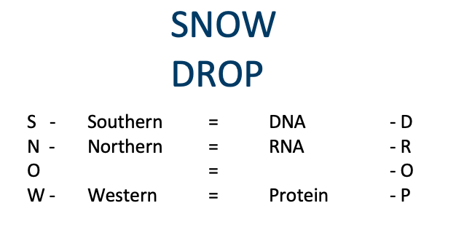

## **Restriction Fragment Length Polymorphism (RFLP):**

Restriction Fragment Length Polymorphism (RFLP) is a technique used in molecular genetics to detect differences in DNA sequences between individuals. It is based on the observation that variations in DNA sequences can result in differences in the length of fragments produced when the DNA is cut with restriction enzymes.

Here’s how RFLP works:

1. DNA is extracted from a sample and cut into fragments using specific restriction enzymes.
2. The fragments are separated by size using gel electrophoresis.
3. The separated fragments are then transferred onto a nitrocellulose or nylon membrane.
4. A probe, which is a labelled piece of DNA complementary to a specific sequence, is then used to identify the specific fragment of interest on the membrane.
5. If the probe hybridizes with the fragment, it will be visible on the X-ray film as a band.
6. The size of the fragment and the pattern of bands can then be compared between different samples to identify differences in the DNA sequence.

RFLP has been widely used in the study of human genetics, particularly in the fields of forensic science, medical genetics, and population genetics. It has also been used to study the evolution and diversity of different species.

However, RFLP has been largely replaced by more advanced techniques such as polymerase chain reaction (PCR) and DNA sequencing, which provide more accurate and detailed information about DNA sequences (NBCI, 2023).

## **Genetic recombination:**

Recombination is the process by which fragments of DNA are broken and recombined to create new allele combinations. This recombination process generates genetic variety at the gene level, reflecting changes in DNA sequences between organisms.

**References:**

(1) Hänzelmann, S., Castelo, R. and Guinney, J. (2013). GSVA: gene set variation analysis for microarray and RNA-Seq data. BMC Bioinformatics, 14(1), p.7. doi:https://doi.org/10.1186/1471-2105-14-7.

‌(2) Meaburn, K.J. and Misteli, T. (2007). Chromosome territories. Nature, 445(7126), pp.379–381. doi:https://doi.org/10.1038/445379a.

‌(3) NCBI, 2023. www.ncbi.nlm.nih.gov. (n.d.). Restriction Fragment Length Polymorphism (RFLP). [online] Available at: https://www.ncbi.nlm.nih.gov/probe/docs/techrflp/#:~:text=is%20a%20difference%20in%20homologous.

### 3.7.4 Heterogeneity and phenotypes

## **Molecular and Genetic Heterogeneity**

Molecular and genetic heterogeneity refers to the concept that a single disease can be caused by a variety of different genetic or molecular factors. This means that a disease can have multiple genetic or molecular origins, resulting in varying symptoms and progression even among individuals with the same diagnosis.

For example, a disease like Alzheimer’s can have several genetic and molecular causes, including mutations in specific genes, changes in the regulation of gene expression, and variations in the levels of specific proteins. This heterogeneity can lead to differences in the age of onset, symptoms, progression, and response to treatments (Habes, 2020).

There are several factors that contribute to molecular and genetic heterogeneity, including genetic mutations, epigenetic changes, and environmental factors. Understanding the molecular and genetic heterogeneity of diseases is important for developing more effective diagnoses, treatments, and preventive measures (Harrison, 2005).

Given the potential treatment consequences, the heterogeneity of molecular profiles presents a significant challenge in cancer, particularly in lung cancer. Heterogeneity refers to variations in the molecular makeup of cancer and can take different forms, such as intra-tumour heterogeneity, inter-patient variability, and patient-to-patient variability. Inter-patient variability is associated with genetic and phenotypic differences among people with the same type of cancer, which can help explain why different patients respond differently to treatments. Intra-tumour heterogeneity refers to the differences between the main tumour and its metastases, as well as the subclonal diversities of tumour cells found within a single tumour. This results in a variety of therapy responses for each patient with lung cancer due to the molecular heterogeneity between patients with the same histotype. The high degree of genetic variability between the primary lung tumour and its associated metastatic lesions also greatly influences the treatment environment for patients with lung cancer. Understanding the molecular heterogeneity of cancer is crucial for developing effective diagnoses, treatments, and preventive measures.

The phenomenon of genetic heterogeneity refers to the possibility that any one of a large number of alleles or non-allele alterations could be the source of a particular phenotype or genetic condition. This contrasts with pleiotropy, in which a single gene may result in a variety of phenotypic manifestations or illnesses.

## **Phenotypes and Genotypes**

**Phenotype**: a collection of observable features and characteristics that result from the interaction of an individual’s genotype and the environment.

**Endophenotype:**is an intermediate phenotype with a closer connection to underlying genetics than the disorder in question.

**Biotypes:** are referred to when the organisms are sharing a specified genotype.

**Epigenetics** is the study of how your behaviour and environment can impact the way your genes function. Epigenetic alterations, unlike genetic changes, are reversible and do not alter your DNA sequence, but they can alter how your body reads a DNA sequence. Epigenetics involves non-sequence changes to both DNA and proteins. Environmental variables raise the risk of a variety of psychiatric diseases, and the same risk factors can raise the risk of many disorders.

**Allelic diversity** refers to the presence of several mutations in the same gene that may be linked to phenotypes in the biochemical or clinical realms that are remarkably similar or quite dissimilar. This is obviously important for identifying heterozygotes. For instance, since the S and D haemoglobins electrophorese similarly under standard conditions, individuals carrying the mutation for Haemoglobin-D will be incorrectly identified as carriers of the sickle-cell trait if a standard haemoglobin electrophoresis result (biochemical phenotype) is the only parameter used for sickle-cell trait identification.

**References:**

(1) Habes, M., Grothe, M.J., Tunc, B., McMillan, C., Wolk, D.A. and Davatzikos, C. (2020). Disentangling heterogeneity in Alzheimer’s disease and related dementias using data-driven methods. Biological psychiatry, [online] 88(1), pp.70–82. doi:https://doi.org/10.1016/j.biopsych.2020.01.016.

(2) Harrison, P. J., & Weinberger, D. R. (2005). The genetic and molecular heterogeneity of schizophrenia. Nat Rev Neurosci, 6(4), 341-50.

### 3.7.5 Epigenetics

## **Epigenetics**

Epigenetics is a field of biology that studies changes in gene expression or cellular phenotype that do not involve changes to the underlying DNA sequence. In psychiatry, epigenetics has been studied as a potential mechanism to explain the development of various mental illnesses, such as depression, schizophrenia, and bipolar disorder. The term “epigenome” refers to the collection of all epigenetic alterations in a genome.

There is evidence that environmental factors, such as stress, abuse, and nutrition, can lead to epigenetic changes that alter gene expression and contribute to the development of mental illness. For example, early life stress has been shown to result in epigenetic changes in the brain that increase the risk of developing depression later in life. Similarly, epigenetic changes in the gene responsible for regulating the levels of brain-derived neurotrophic factor (BDNF) have been associated with the development of depression and schizophrenia.

Another example of the role of epigenetics in psychiatry is the field of pharmacogenomics, which examines the role of genetic and epigenetic factors in determining an individual’s response to medication. By understanding the epigenetic changes associated with different mental illnesses, researchers hope to develop more personalized and effective treatments for mental health conditions.

However, the field of epigenetics in psychiatry is still in its early stages, and more research is needed to fully understand the complex interplay between genetics, environment, and epigenetics in the development of mental illness. Nevertheless, the study of epigenetics in psychiatry holds great promise for the development of new and innovative treatments for mental health conditions.

DNA methylation and histone modification are two key mechanisms of epigenetic regulation that control gene expression and cellular phenotype.

## **DNA methylation**:

DNA methylation refers to the addition of a methyl group to the DNA molecule, which typically occurs at the cytosine residue in a CpG dinucleotide context. DNA methylation can result in the suppression of gene expression and has been implicated in the development of various diseases, including cancer and mental illness.

Attaches to specific locations on the DNA strand using chemical groups. These chemical compounds prevent proteins from binding to DNA and “reading” it. Demethylation is the removal of chemical groups. During demethylation, genes are “on,” whereas during methylation, they are “off” (Bird, 2002).

## **Histone modification**:

Histone modification refers to the covalent modification of the histone proteins that package DNA into a compact structure called chromatin. The modification of histones, such as acetylation, methylation, and phosphorylation, can change the structure and stability of chromatin and regulate gene expression. For example, acetylation of histones is generally associated with an open chromatin structure and increased gene expression, while methylation of histones can result in a closed chromatin structure and reduced gene expression.

Whether a gene is “on” or “off” depends on how tightly the histones are packed. The gene remains dormant because tightly packed histones prohibit proteins from attaching to the DNA. Histones that are not tightly packed enable proteins to attach to DNA more readily, activating the gene. It is possible to add or remove chemical groups to change how tightly or loosely the histones are packed, so activating or deactivating the genes (Strahl, 2000).

Together, DNA methylation and histone modification constitute a complex interplay of epigenetic mechanisms that regulate gene expression and cellular phenotype in response to various environmental and genetic factors. Understanding the regulation of DNA methylation and histone modification is important for developing new treatments for various diseases and disorders, including mental illness and cancer (Jenuwein, 2001).

## **Causes of Epigenetics**:

Different factors can affect epigenetic changes.

* Ageing
* Exercise
* Diet
* Environment-related toxins
* Use of tobacco
* Alcohol
* Depression and stress
* Pregnancy smoking, food, and maternal health
* Environmental conditions
* Finances
* Diseases
* Medications Aging
* Exercise
* Diet
* Environment-related toxins
* Use of tobacco
* Alcohol
* Depression and stress
* Pregnancy smoking, food, and maternal health
* Environmental conditions
* Finances
* Diseases
* Medications

## **Effect of Epigenetics**:

Endogenous hormones, the environment, ageing, food, and exposure to endocrine-disrupting substances (EDCs) are some of the factors that can modify an individual’s epigenome, and the impacts of these changes can be passed down through generations. Without changing the DNA sequence, itself, epigenetic alterations to the genome can change the phenotype of the individual. DNA methylation, histone changes, and aberrant microRNA (miRNA) production are examples of epigenetic modifications that start during the formation of germ cells and embryogenesis and last all the way up to death. Hormone regulation happens as we age as a result of epigenetic changes. The epigenome of the foetus can be impacted by maternal undernutrition or overnutrition, and the results can last a lifetime. Additionally, mother care during the offspring’s childhood can result in distinct phenotypes seen in adults. Epigenetic alterations have been linked to endocrine system-controlled illnesses like obesity and diabetes as well as female infertility. These traits can be observed not only in F1 but also in F3, as some chemical impacts can be transmitted through the germline and have an impact across generations (Sharma et al., 2010).

The effects of epigenetics can be wide-ranging and have significant implications for various biological processes, including development, ageing, and disease. Some of the key effects of epigenetics include:

1. **Gene expression regulation:**Epigenetic modifications, such as DNA methylation and histone modification, can regulate gene expression and control the activation or repression of specific genes.
2. **Development:**Epigenetic modifications play a crucial role in the development of an organism, including the differentiation of cells into specific cell types and the formation of tissues and organs.
3. **Inheritance of traits:** Epigenetic modifications can be passed down from one generation to the next and can contribute to the inheritance of specific traits, such as susceptibility to certain diseases.
4. **Environmental responses:**Epigenetic modifications can be induced by various environmental factors, such as stress, diet, and exposure to toxins, and can have long-lasting effects on an individual’s health and well-being.
5. **Disease development:** Epigenetic modifications have been implicated in the development of a wide range of diseases, including cancer, cardiovascular disease, and mental illness.
6. **Ageing:**Epigenetic modifications can contribute to the ageing process and the development of age-related diseases.

Overall, the effects of epigenetics are complex and multifaceted, and a better understanding of the mechanisms of epigenetic regulation is crucial for developing new and innovative treatments for various diseases and disorders.

## **How Drugs, Psychotherapy, and Good/Adverse Experiences can Modify Epigenetics**

Drugs, psychotherapy, and experiences can modify epigenetics through their effects on gene expression and cellular phenotype.

1. **Drugs:** Some drugs, such as antipsychotics, antidepressants, and mood stabilizers, have been shown to affect epigenetic mechanisms, such as DNA methylation and histone modification, to regulate gene expression and treat mental illness. For example, some antidepressants have been shown to reverse epigenetic changes associated with depression, suggesting a potential mechanism for their therapeutic effects.
2. **Psychotherapy:**Psychotherapy has also been shown to have epigenetic effects. For example, studies have shown that cognitive behavioural therapy and mindfulness-based therapies can modify epigenetic markers and alter gene expression in the brain, suggesting that these therapies may have beneficial effects on mental health by modulating epigenetic mechanisms.
3. **Good experiences:** Positive experiences, such as social support, exercise, and a healthy diet, can have beneficial effects on epigenetics. For example, physical exercise has been shown to modify DNA methylation and histone modification, resulting in changes in gene expression that improve brain function and reduce the risk of mental illness (Bales, 2015) (Boos, 2015).
4. **Adverse experiences:** On the other hand, adverse experiences, such as childhood abuse, stress, and poor nutrition, can have negative effects on epigenetics. For example, early life stress has been shown to result in epigenetic changes in the brain that increase the risk of developing depression later in life (Miller, 2010).

Overall, these examples demonstrate how drugs, psychotherapy, and experiences can modify epigenetics and have significant implications for mental health and well-being. The study of these mechanisms is still in its early stages, but it holds great promise for the development of more personalized and effective treatments for mental illness.

**References:**

(1) Bales, K. L., Capitanio, J. P., & Mason, W. A. (2015). Social environmental enrichment modifies DNA methylation and gene expression in the brain. Brain research, 1617, 18-27.

(2) Bird, A. (2002). DNA methylation patterns and epigenetic memory. Genes & Development, 16(1), 6-21.

(3) Roos, J., Skånland, S. S., Anesten, F., Johansson, S., Sääf, M., & Abrahamsson, L. (2015). Exercise prevents stress-induced changes in DNA methylation. Molecular psychiatry, 20(7), 847-853.

(4) Jenuwein, T., & Allis, C. D. (2001). Translating the histone code. Science, 293(5532), 1074-1080.

(5) Miller, G. E., & Chen, E. (2010). Psychological stress in childhood and susceptibility to the chronic diseases of aging: moving toward a model of behavioral and biological mechanisms. Psychological bulletin, 136(6), 853-857.

(6) Strahl, B. D., & Allis, C. D. (2000). The language of covalent histone modifications. Nature, 403(6765), 41-45.

### 3.7.6 Gene modification

## **Genetic Modification**

Genetic modification refers to the process of altering the DNA of an organism using biotechnology techniques. This can be done for a variety of purposes, including improving the characteristics of plants and animals, producing pharmaceuticals, and studying the function of genes. There are several methods that can be used to genetically modify organisms, including traditional breeding techniques, gene targeting, and genome editing.

Genome editing is a type of genetic modification that involves making precise changes to specific parts of an organism’s genome. It is usually done using enzymes that can cut DNA at specific sequences, such as CRISPR/Cas9. Once the DNA is cut, it can be repaired by the cell’s own repair mechanisms, which can result in the insertion, deletion, or modification of specific DNA sequences. Genome editing has the potential to be more precise and efficient than other methods of genetic modification, but it also raises ethical concerns because it has the potential to be used to create genetically modified organisms with characteristics that could not occur naturally (Baltimore et al., 2015).

Genetic modification and genome editing techniques are relevant to psychiatry in several ways:

|  |  |
| --- | --- |
| **Psychiatric relevance:** | **Summary:** |
| **Understanding the genetic basis of mental disorders** | Genetic factors are thought to play a role in many mental disorders, such as schizophrenia, depression, and bipolar disorder. Studying the genetics of these conditions can help researchers understand the biological basis of these disorders and develop new treatments. |
| **Developing animal models** | Scientists can use genetic modification techniques to create animal models of mental disorders by introducing specific genetic changes into the genomes of mice or other animals. These models can be used to study the development and progression of mental disorders and to test new treatments. |
| **Developing new treatments** | Genome editing and other genetic modification techniques can be used to develop new treatments for mental disorders. For example, researchers are exploring the use of CRISPR/Cas9 to edit the genomes of cells in order to correct genetic defects that contribute to mental disorders. |
| **Ethical considerations** | The use of genetic modification and genome editing techniques in psychiatry raises a number of ethical concerns, such as the potential risks and benefits of these technologies and the implications for human enhancement. These issues are being actively debated by scientists, ethicists, and the general public. |

(McInerney, 2017)

## **Zinc Finger Nuclease**:

Zinc finger nucleases (ZFNs) are enzymes that can be used for genome editing. They consist of a DNA binding domain, which is made up of zinc fingers that can bind to specific sequences in the genome, and a nuclease domain, which can cut DNA. ZFNs can be engineered to target almost any sequence in the genome, making them a highly flexible tool for genome editing.

Like CRISPR/Cas9 and TALENs, ZFNs work by creating a double-stranded break in the DNA at a specific location. This break is then repaired by the cell’s own repair mechanisms, which can result in the insertion, deletion, or modification of specific DNA sequences. ZFNs have been used to edit the genomes of a variety of organisms, including plants, animals, and human cells.

While ZFNs have been widely used for genome editing, they have been largely superseded by CRISPR/Cas9, which is generally easier to use and has a higher editing efficiency. However, ZFNs may still be used in some applications where CRISPR/Cas9 is not suitable (Kim, 1996).

## **Transcription Activator-Like Effector Nucleases**:

Transcription activator-like effector nucleases (TALENs) are enzymes that can be used for genome editing. They consist of a DNA binding domain, which allows them to bind to specific sequences in the genome, and a nuclease domain, which can cut DNA. TALENs can be engineered to target almost any sequence in the genome, making them a highly flexible tool for genome editing.

Like CRISPR/Cas9, TALENs work by creating a double-stranded break in the DNA at a specific location. This break is then repaired by the cell’s own repair mechanisms, which can result in the insertion, deletion, or modification of specific DNA sequences. TALENs have been used to edit the genomes of a variety of organisms, including plants, animals, and human cells.

While TALENs have been widely used for genome editing, they have been largely superseded by CRISPR/Cas9, which is generally easier to use and has a higher editing efficiency. However, TALENs may still be used in some applications where CRISPR/Cas9 is not suitable (Christian, 2011).

## **CRISPR**

A specific “target” location in the genome can be changed by scientists using genome editing. “CRISPR” is the name of one of the methods that have sparked the greatest interest because of its effectiveness and simplicity. CRISPR stands for “**clustered regularly interspaced short palindromic repeats**“. The technique that bacteria developed to defend themselves against viruses serves as the foundation for CRISPR technology. A technique for genome editing has now been created by scientists using parts of the CRISPR system. The CRISPR system consists of two parts: a “nuclease” (i.e., a DNA-cutting protein) called Cas9 and a “guide RNA” (gRNA) molecule with the same sequence as the target site in the genome.

## **CRISPR-associated (Cas) genes:**

When choosing a platform for gene editing, four things should be taken into account: specificity, target site choice, effectiveness, and ease of design. CRISPR-Cas9 is typically the most effective and simple to employ since it targets the specified genomic sequence with a high degree of precision and predictability while requiring less labour. By introducing numerous sg RNAs, the technique also enables the simultaneous editing of different genes.

CRISPR-Cas9 gene editing works by directing the Cas9 protein to a specific target with the help of a guide RNA (gRNA). Cas9 cleaves the DNA after binding to the target, which is then repaired by the cell’s DNA-repair machinery. This repair method is deemed unpredictable and heterogeneous without a template, making it unsuitable for precise editing. Precision editing, on the other hand, is desperately needed for research of basic gene function as well as the correction of mutations linked with genetic diseases (Cong, 2013) (Jinek, 2012).

**References:**

(1) Baltimore, D., Berg, P., Botchan, M., Carroll, D., Charo, R.A., Church, G., Corn, J.E., Daley, G.Q., Doudna, J.A., Fenner, M., Greely, H.T., Jinek, M., Martin, G.S., Penhoet, E., Puck, J., Sternberg, S.H., Weissman, J.S. and Yamamoto, K.R. (2015). A prudent path forward for genomic engineering and germline gene modification. Science, [online] 348(6230), pp.36–38. doi:10.1126/science.aab1028.

(2) Christian, M., & Cermak, T. (2011). TALENs: A widely applicable technology for targeted genome editing. Nature Reviews Molecular Cell Biology, 12(4), 356-361.

(3) Cong, L., et al. (2013). Multiplex genome engineering using CRISPR/Cas systems. Science 339(6121), 819-823.

(4) Jinek, M., et al. (2012). A programmable dual-RNA-guided DNA endonuclease in adaptive bacterial immunity. Science 337(6096), 816-821.

(5) Kim, D. H., et al. (1996). Targeted mutagenesis of the HPRT gene using zinc-finger nucleases. Nature, 380(6573), 635-638.

(6) McInerney, J. J., & Callaway, E. (2017). Gene editing: A new era of psychiatric research. Nature Neuroscience, 20(11), 1449-1457.

## 3.8 Neurodevelopment and Neuroplasticity

### 3.8.1 Development and localisation of cerebral functions

## **The Development and Localization of Cerebral Functions throughout the Life Span from the Foetal Stages Onwards**

The brain and nervous system of the embryo start to form at just six weeks. The creation of the human brain from the tip of a 3-millimetre neural tube is a biological engineering masterpiece. To reach the more than 100 billion neurons that constitute a newborn baby’s normal complement, the brain must grow at an average pace of roughly 250,000 nerve cells every minute during pregnancy. But it’s not just the rate of growth that makes the production of a human brain mind-boggling. The large number of activities that the brain dependably performs and the specificity with which they are assigned to one or more types of cells or tiny locations in the entire assembly is astounding in their complexity (Ackerman, 1992).

The development of the sophisticated portions of the brain begins during pregnancy and ends around the age of 25.

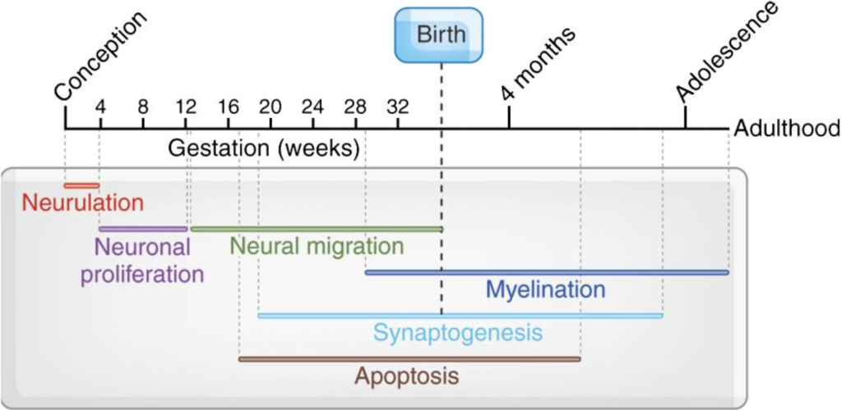

(Tau, 2010)

The neural tube, which forms during the first month of the embryo’s growth, is the first part of the brain. Around week 6 or week 7, the neural tube shuts, at which point the front brain, midbrain, and hindbrain separate. The cerebrum will fold into the left and right halves of the brain, and these three regions will eventually grow into the brain’s specialised regions.

Millions of new neurons will develop in the brain throughout the first trimester. These neurons interact via synapses to control movement and growth.

In the second trimester, the embryonic brain starts to control how the chest muscles contract and how the diaphragm moves. The brain stem is in charge of these practice breaths, which are similar in nature.

The left brain and right brain will begin to separate when the cerebrum begins to form ridges and grooves. In the third trimester, the cerebellum is the area of the brain that is growing the fastest. aby will start to move more, wriggling fingers and toes, stretching, and kicking since this area controls motor function.

## **Localisation of function:**

According to the concept of “localisation of function in the brain,” particular functions are carried out by distinct parts of the brain.

The hypothesis of “localization of function” is supported by the probability that when a certain portion of the brain is destroyed, the accompanying area of function will also likely suffer.  The two hemispheres can communicate with one another thanks to the corpus callosum. Hemispheric lateralisation is the term used to describe how each hemisphere specialises in carrying out particular tasks. They can share information, incorporate it, and process it to an excellent degree via conversing.

The relationship between particular brain regions and particular functions is an area of investigation with plenty of competing ideas. The prefrontal cortex, the motor and somatosensory cortex, the visual cortex, the auditory cortex, Broca’s and Wernicke’s areas, and others all show evidence for the localization of function in the brain (De Luca & Leventer, 2010).

**References:**

(1) Ackerman, S. (1992). The Development and Shaping of the Brain. [online] www.ncbi.nlm.nih.gov. National Academies Press (US). Available at: https://www.ncbi.nlm.nih.gov/books/NBK234146/.

(2) De Luca, C. R., & Leventer, R. J. (2010). Developmental trajectories of executive functions across the lifespan. In Executive functions and the frontal lobes (pp. 57-90). Psychology Press.

(3) Tau, G.Z. and Peterson, B.S. (2010). Normal Development of Brain Circuits. Neuropsychopharmacology, [online] 35(1), pp.147–168. doi:10.1038/npp.2009.115.

### 3.8.2 Neurodevelopmental models of psychiatric disorders

## **Neurodevelopmental Models of Psychiatric Disorders**

## **Depression:**

Depression, often known as major depressive disorder (MDD), is characterized by a constant poor mood, social disengagement, lethargy, cognitive decline, anxiety, and low energy. Depression is hypothesized to be influenced by genetic, developmental, immunological, stressful, social, and environmental variables.

Early life stress and social rejection are two factors that might cause behavioural and cognitive abnormalities that resemble MDD. The social defeat model in particular causes altered cognition, social behaviour, and anxiety in rats and is susceptible to the antidepressants now recommended for depression**.**

Examples of animal models used in understanding depression:

|  |  |
| --- | --- |
| **Model:** | **Summary:** |
| **Forced swim test** **(Posolt)** | Antidepressants acutely increased the time an animal struggles in a chamber of water with no access to a platform. Lack of struggle is thought to represent a state of despair in mice. |
| **Tail suspension test** | Antidepressants acutely increased the time an animal struggles when suspended by its tail. Lack of struggle is thought to represent a state of despair. |
| **Learned helplessness** | Animals exposed to inescapable footshock take a longer time to escape, when subsequently exposed to an escapable foot shock. Antidepressants acutely decrease escape latency and failures. |
| **Social stress** | Animals exposed to different types of social stress show behavioural abnormalities. |
| **Early life stress** | Animals separated from their mothers at a young age demonstrated persisting behaviour and HPA axis abnormalities as adults. |
| **Fear conditioning** | Animals demonstrated fear-like responses when exposed to previously neutral or context-dependent cues that were aversive. |
| **Yoked shock test** | One of the first experiments of ‘learned helplessness’ was with groups of dogs: one being controls and another given an electric shock for which they had to escape. From these experiments, it was thought that there was to be only one cure for helplessness. In Seligman’s hypothesis, the dogs do not try to escape because they expect that nothing they do will stop the shock. |
| **Olfactory bulbectomy** | Chemical or surgical lesions of the olfactory bulb cause behavioural abnormalities, some of which can be reversed by antidepressant treatments. |

(Nestler, 2002)

## **Schizophrenia**:

Schizophrenia is a complex psychiatric disorder characterized by symptoms such as delusions, hallucinations, disordered thinking, and negative symptoms. A number of neurodevelopmental models have been proposed to explain the underlying pathophysiology of schizophrenia. These models suggest that the disorder is the result of disruptions in brain development that occur during critical periods of neurodevelopment, such as prenatal exposure to maternal infection, malnutrition, or stress, and during adolescence when the brain undergoes significant changes. These disruptions can result in abnormal brain structure and function, leading to the development of schizophrenia. Additionally, genetic and environmental factors are thought to interact to increase the risk of developing the disorder. While there is still much to be learned about the underlying causes of schizophrenia, these neurodevelopmental models have greatly advanced our understanding of the disorder and provided a framework for the development of new treatments.

The neurodevelopmental models for schizophrenia are theoretical frameworks that attempt to explain the underlying causes of the disorder. Some of the key neurodevelopmental models for schizophrenia include:

|  |  |
| --- | --- |
| **Model:** | **Summary:** |
| **Prenatal exposure model** | This model suggests that prenatal exposure to environmental insults, such as maternal infection, malnutrition, or stress, can disrupt brain development and increase the risk of developing schizophrenia. |
| **Adolescent brain maturation model** | This model suggests that abnormal brain maturation during adolescence, a critical period of brain development, can increase the risk of developing schizophrenia. |
| **Neuroinflammation model** | This model suggests that chronic low-grade inflammation in the brain, either due to environmental insults or genetic predisposition, can disrupt brain development and increase the risk of developing schizophrenia. |
| **Synaptic pruning model** | This model suggests that excessive synaptic pruning, or the elimination of unused synaptic connections in the brain, during adolescence can increase the risk of developing schizophrenia. |
| **Genetic susceptibility model** | This model suggests that genetic mutations or variations can increase the risk of developing schizophrenia by disrupting normal brain development and function. |

These models are not mutually exclusive and multiple models may contribute to the development of schizophrenia in an individual. However, despite advances in our understanding of the underlying causes of schizophrenia, much more research is needed to fully understand the complex interplay of genetic, environmental, and developmental factors that contribute to the disorder.

## **Autism Spectrum Disorder:**

Autism Spectrum Disorder (ASD) is a neurodevelopmental disorder characterized by impairments in social interaction, communication, and repetitive behaviours. There is currently no cure for autism, and the underlying causes are still not fully understood. However, there are several neurodevelopmental models that have been proposed to help explain the development of autism and guide research and treatment efforts (Ozonoff, 1999).

|  |  |
| --- | --- |
| **Model:** | **Summary:** |
| **Social motivation theory** | This theory proposes that autism arises from a fundamental deficit in the ability to engage in social interactions and understand the intentions and emotions of others. |
| **Abnormal cerebellar development** | This theory suggests that the cerebellum, which plays a role in motor coordination and cognitive processes, may be abnormally developed in individuals with autism, leading to deficits in social cognition and communication. |
| **Excitatory/inhibitory imbalances** | This theory proposes that autism results from imbalances between excitatory and inhibitory neurotransmitters in the brain, leading to abnormal brain activity and impairments in social interaction and communication. |
| **Genes and environment interaction** | This theory suggests that autism is the result of a complex interaction between genetic and environmental factors, such as exposure to toxins or prenatal stress. |
| **Brain overgrowth** | This theory suggests that early brain overgrowth in individuals with autism may contribute to the development of social and communication impairments. |
| **Developmental theories** | This theory suggests that autism may result from a series of abnormal developmental processes in brain development, such as synapse formation, myelination, and the emergence of neural circuits. |

These neurodevelopmental models provide different perspectives on the development of autism and have helped to guide research and treatment efforts. However, the exact causes of autism are still not fully understood, and further research is needed to identify the underlying biological mechanisms and develop effective treatments for autism (Lai, 2014).

## **Narcolepsy:**

Narcolepsy is a neurodevelopmental disorder characterized by excessive daytime sleepiness and disturbed nighttime sleep. It has long been recognized as a model for the study of sleep and wakefulness regulation, as it provides valuable insights into the neural mechanisms underlying these processes.

One of the key features of narcolepsy is the loss of hypocretin-producing neurons, which are responsible for regulating wakefulness and arousal. Hypocretin, also known as orexin, is a neurotransmitter that is produced by a small number of neurons in the lateral hypothalamus. There are two types of hypocretin: hypocretin 1 (HCRT1) and hypocretin 2 (HCRT2). These two peptides play a critical role in the regulation of sleep and wakefulness, and they act on specific receptors in the brain to promote wakefulness and inhibit sleep.

In individuals with narcolepsy, the loss of hypocretin-producing neurons leads to a reduction in wakefulness and an increase in daytime sleepiness, providing evidence for the critical role of the orexin system in the regulation of sleep and wakefulness. This has led to the development of new treatments for narcolepsy that target the hypocretin system, such as the use of wake-promoting drugs that increase the release of hypocretin.

Overall, narcolepsy serves as an important neurodevelopmental model for the study of sleep and wakefulness regulation, and it provides valuable insights into the neural mechanisms underlying these processes and the development of new treatments for sleep-related disorders.

## **Other neurodevelopmental models:**

|  |  |
| --- | --- |
| **Model:** | **Summary** |
| **Radial arm maze** | The radial arm maze was designed by Olton and Samuelson in 1976 to measure spatial learning and memory in rats. The radial arm maze is a behavioural test used to assess spatial memory and learning in rodents, such as rats and mice. In this test, the animal is placed at the centre of a radial maze with multiple arms, and it is required to navigate to the end of each arm to obtain a food reward. The number of errors made by the animal and the time taken to complete the task is used to evaluate its spatial memory and learning abilities. |
| **Morris water navigation task** | The Morris water navigation task is a behavioural test used to assess spatial learning and memory in rodents, such as rats and mice. In this test, the animal is placed in a pool of water with a hidden platform and is required to locate the platform by using visual cues in the environment. The time taken to locate the platform is used to evaluate the animal’s spatial learning and memory abilities. |
| **T-maze test** | The T-maze test is a behavioural test used to assess decision-making and cognitive flexibility in rodents, such as rats and mice. In this test, the animal is placed at the end of a T-shaped maze and is presented with two choices, one leading to a food reward and the other leading to a dead end. The animal’s choice of the arm to enter and the number of errors made in switching arms are used to evaluate its decision-making and cognitive flexibility abilities. |
| **Hippocampal lesions** | Richard G. Morris in 1981 showed that hippocampal lesions impaired spatial learning. |
| **Latent inhibition test** | The latent inhibition test is a behavioural test used to assess the role of attention and memory in the formation of associations. In this test, an animal is first exposed to a neutral stimulus, such as a tone, over a period of time, before being paired with a positive or negative event, such as a shock or food reward. The animal’s response to the previously neutral stimulus after pairing is then evaluated to determine the effect of prior exposure on the formation of associations. A reduction in responding to the previously neutral stimulus is considered evidence of latent inhibition, indicating that prior exposure has interfered with the formation of associations. |
| **Light/dark box test** | The light/dark box test is a behavioural test used to assess anxiety-like behaviour in rodents. In this test, an animal is placed in a box with two compartments, one brightly lit and the other dark, and its behaviour and the time spent in each compartment are observed and recorded. The animal’s preference for the dark compartment is considered an indicator of anxiety-like behaviour, as the dark compartment provides a safe, sheltered environment for the animal. |
| **Elevated plus maze** | The elevated plus maze is a behavioural test used to assess anxiety-like behaviour in rodents. In this test, an animal is placed in a maze consisting of four arms, two enclosed and two open, elevated off the ground, and its behaviour and the time spent in each arm are observed and recorded. The animal’s preference for the enclosed arms over the open arms is considered an indicator of anxiety-like behaviour, as the enclosed arms provide a safe, sheltered environment for the animal. |

**References:**

(1) Lai, M. C., Lombardo, M. V., Chakrabarti, B., & Baron-Cohen, S. (2014). Subgrouping the autism “spectrum”: Reflections on DSM-5. PLoS biology, 12(4), e1001817.

(2) Nestler, E.J., Barrot, M., DiLeone, R.J., Eisch, A.J., Gold, S.J. and Monteggia, L.M. (2002). Neurobiology of Depression. Neuron, [online] 34(1), pp.13–25. doi:10.1016/s0896-6273(02)00653-0.

(3) Ozonoff, S., & Jensen, J. (1999). Brief report: specific executive function profiles in three neurodevelopmental disorders. Journal of autism and developmental disorders, 29(4), 171-177.

### 3.8.3 Neurobiology of attachment

## **Neurobiology of Attachment**

Humans are “social animals,” and our social connections are what we live for. The shared brain mechanisms that underpin distinct social attachments are starting to be revealed by recent investigations.

Attachment is a psychological concept that refers to the deep emotional bond between a person and a caregiver or attachment figure, typically a parent or close family member. Neurobiology plays a crucial role in the formation and regulation of attachment, as the development of attachment is influenced by the neural systems and hormones involved in stress regulation, emotion, and memory.

One of the key neurobiological systems involved in attachment is the hypothalamic-pituitary-adrenal (HPA) axis, which regulates the body’s response to stress. This system is activated in response to perceived threats or stressors and leads to the release of cortisol, a hormone that helps to manage stress. Research has shown that cortisol levels in infants can be influenced by the quality of the attachment relationship with their caregiver, with higher cortisol levels being associated with insecure attachment and lower cortisol levels with secure attachment (Messinger, 2013).

Another important neural system involved in attachment is the oxytocin system, which plays a role in regulating social behaviour, bonding, and trust. Research has shown that the release of oxytocin in response to positive social interaction, such as touch or affectionate behaviours, can enhance attachment bonds and promote feelings of trust and security (Gordon, 2013).

Finally, the development of attachment is also influenced by the brain’s memory systems, as early experiences with attachment figures can shape an individual’s memory of those relationships and influence their subsequent behaviour and responses to stress. For example, studies have shown that individuals who had secure attachments in childhood tend to have more adaptive responses to stress in adulthood, including better regulation of their HPA axis and improved coping skills (Liu et al., 2004).

In summary, the neurobiology of attachment is a complex and multifaceted field that is still being actively explored by researchers. However, it is clear that the HPA axis, oxytocin system, and the brain’s memory systems all play important roles in the formation and regulation of attachment relationships.

## **Infant and Mother attachment**:

Studies on chicks reveal that imprinting, the process by which a chick forms a persistent preference for following its mother, results in changes to the postsynaptic structure of particular cortical regions of the brain, forming long-term memory. Rat pups, on the other hand, learn to identify their mothers by olfactory learning. There isn’t now a cortical area in the pup’s brain that has been recognised as crucial.

## **Maternal attachment to the Infant**:

Numerous neuroendocrine elements, including oestrogen and progesterone, that are connected to pregnancy and breastfeeding in humans and other mammals are also essential for the development of maternal behaviour in rats. Prolactin and oxytocin, two neuropeptides, are also essential. The ventral tegmental area and the medial preoptic area may act as mediators for oxytocin’s actions.

## **Olfactory Learning**:

Vaginal stimulation in sheep can cause selected maternal behaviour by increasing the release of oxytocin. Additionally, oxytocin injection into the paraventricular nucleus of the hypothalamus can cause the mother to accept the lamb. A significant rise in glutamate and GABA extracellular concentrations as well as a remodelling of synapses occur in the olfactory bulb during the maternal ewe’s recognition of her lamb.

## **Development of an adult-adult pair attachment**:

Oxytocin and vasopressin appear to be essential and sufficient for the development of couple relationships in monogamous prairie voles. The non-monogamous montane vole is not significantly impacted by either peptide. The expression patterns of the receptors for these substances may differ, which could explain behavioural variations. These receptor genes’ promoter variations have affected the distribution and behaviour of various receptors in these species.

**References:**

(1) Gordon, I., Zagoory-Sharon, O., Leckman, J. F., & Feldman, R. (2013). Oxytocin and the development of parenting in humans. Biological Psychiatry, 74(4), 286-293.

(2) Liu, D., Diorio, J., Tannenbaum, B., Caldji, C., Francis, D., Freedman, A., … & Meaney, M. J. (2004). Maternal care, hippocampal glucocorticoid receptors, and hypothalamic-pituitary-adrenal responses to stress. Science, 306(5705), 847-851.

(3) Messinger, D. S., Cohen, S., Roth-Hanania, R., Bahrick, L. E., Pickens, J., & Lapidus, R. A. (2013). A secure base from which to explore the world: Attachment and exploration in the first year. Monographs of the Society for Research in Child Development, 78(3), 43-66.

### 3.8.4 Neuroplasticity

## **Neuroplasticity**

Neuroplasticity is the ability of neurons in the central nervous system to adapt and change in response to environmental demands. This process is facilitated by changes in synaptic activity and membrane depolarization, which trigger receptor trafficking, gene activation, and the release of neurotransmitters. These changes can result in alterations to the brain’s structure and function, leading to either a net loss or a gain in function (Kalatzis 2015).

The concept of neuroplasticity is important for understanding how the brain adapts and changes in response to both emotional and cognitive learning, as well as in response to changes in behaviour. However, when neuroplastic changes are maladaptive, they can lead to a loss of function, which is seen in various mental disorders (Schubert, 2017).

On the other hand, when neuroplastic changes result in a gain of function, they can be considered adaptive. This highlights the importance of cognitive stimulation, such as through cognitive behavioural therapy, which has been shown to increase the likelihood of behavioural change in MDs by modulating similar neuroplasticity processes in the brain (van Dongen, 2015).

## **Neurobiological Effects of Stress**

Stress is a common experience that can have a significant impact on the brain and the nervous system. Chronic stress has been shown to have negative effects on various aspects of brain function, including cognition, emotional regulation, and memory. These effects are thought to be due, in part, to the release of stress hormones such as cortisol, which can alter neural activity and structure.

One well-documented effect of stress is on the hippocampus, a brain region that is critical for memory formation and emotional regulation. Chronic stress has been shown to lead to decreases in the size of the hippocampus, which can result in impaired memory and increased anxiety (McEwen, 2007).

Stress can also have a negative impact on the prefrontal cortex, which is involved in executive function and decision-making. Chronic stress has been shown to lead to decreased activity in the prefrontal cortex, which can result in impairments in cognitive function and emotional regulation (Dietz, 2013).

In addition to these structural and functional changes, stress can also lead to changes in neurotransmitter systems, such as the dopamine and serotonin systems. These changes can result in alterations in mood and emotional regulation, as well as increased risk for mood and anxiety disorders (Nemeroff, 2004).

Finally, stress can also lead to changes in gene expression and epigenetic modifications, which can alter the brain’s response to stress over time (McGowan & Szyf, 2011).

In conclusion, stress can have a significant impact on the brain and the nervous system, leading to changes in neural activity, structure, neurotransmitter systems, and gene expression. These effects can have negative consequences for mental and physical health, and highlight the importance of effective stress management strategies.

## **Neurobiological Effects of Learning and Psychological Therapies**

Learning and psychological therapies can have a significant impact on the brain and the nervous system, leading to changes in neural function and structure. These neurobiological effects can have a positive impact on mental health and well-being, as they can improve mood, reduce symptoms of anxiety and depression, and promote emotional regulation.

One example of a psychological therapy with well-established neurobiological effects is cognitive-behavioural therapy (CBT). CBT is a form of therapy that focuses on changing negative thought patterns and behaviours that contribute to emotional distress. Research has shown that CBT can alter activity in brain regions that are involved in emotional regulation, such as the amygdala and the anterior cingulate cortex, leading to improvements in symptoms of anxiety and depression (Goldapple, 2004).

Another therapy with well-documented neurobiological effects is mindfulness-based stress reduction (MBSR). MBSR is a form of therapy that uses mindfulness meditation to help individuals manage stress and emotional distress. Research has shown that MBSR can lead to changes in brain activity and structure, including increased activity in the anterior cingulate cortex and the prefrontal cortex, and increased grey matter volume in the hippocampus (Hölzel, 2011).

Finally, exposure therapy, which is used to treat anxiety disorders, has also been shown to have neurobiological effects. This therapy involves gradually exposing individuals to the stimuli that trigger their anxiety, with the goal of reducing fear and anxiety responses over time. Research has shown that exposure therapy can lead to changes in the amygdala and the hippocampus, resulting in reduced anxiety and improved emotional regulation (Milad & Rauch, 2012).

In summary, psychological therapies such as CBT, MBSR, and exposure therapy can have a significant impact on the brain and the nervous system. These therapies can lead to changes in brain activity and structure that can improve mental health and well-being, and help individuals manage emotional distress more effectively.

**References:**

(1) Dietz, M. J., de Kloet, E. R., Verkuyl, J. M., & Oitzl, M. S. (2013). Prenatal stress and brain development: An evolutionary perspective. Neurosci Biobehav Rev, 37(9), 1949-1962.

(2) Goldapple, K., Segal, Z., Garson, C., Lau, M., Bieling, P., Kennedy, S., … & Mayberg, H. (2004). Modulation of cortical-limbic pathways in major depression: Treatment-specific effects of cognitive behavior therapy. Archives of General Psychiatry, 61(1), 34-41.

(3) Hölzel, B. K., Carmody, J., Vangel, M., Congleton, C., Yerramsetti, S. M., Gard, T., & Lazar, S. W. (2011). Mindfulness practice leads to increases in regional brain gray matter density. Psychiatry Research: Neuroimaging, 191(1), 36-43.

(4) Kalatzis, V., et al. (2015). “The role of neuroplasticity in the pathophysiology and treatment of genetic retinal disorders.” Progress in Retinal and Eye Research, vol. 45, pp. 1-17.

(5) Milad, M. R., & Rauch, S. L. (2012). Fear, anxiety, and extinction: Insights from neuroimaging. Progress in Neuro-Psychopharmacology & Biological Psychiatry, 39(1), 119-124.

(6) McEwen, B. S. (2007). Physiology and neurobiology of stress and adaptation: Central role of the brain. Physiological Reviews, 87(3), 873-904.

(7) McGowan, P. O., & Szyf, M. (2011). Epigenetic regulation of the glucocorticoid receptor in human brain associates with childhood abuse. Nature Neuroscience, 14(3), 342-348.

(8) Nemeroff, C. B. (2004). The corticotropin-releasing factor (CRF) hypothesis of depression: New findings and new directions. Molecular Psychiatry, 9(4), 463-475.

(9) Schubert, T. (2017). “The molecular and cellular basis of memory formation.” Nature Reviews Neuroscience, vol. 18, pp. 247-260.

(10) van Dongen, Y. C., et al. (2015). “The effect of cognitive behavioral therapy on neuroplastic changes in psychiatric disorders: A systematic review.” Neuroscience and Biobehavioral Reviews, vol. 55, pp. 411-426.

### 3.8.5 Intelligence and learning disability

## **Intelligence**

Robert Sternberg defined intelligence with regard to three characteristics:

**Factors affecting intelligence:**

* 25% of the total IQ variance is related to parental IQ.
* IQ is directly proportional to the socioeconomic status of the family.

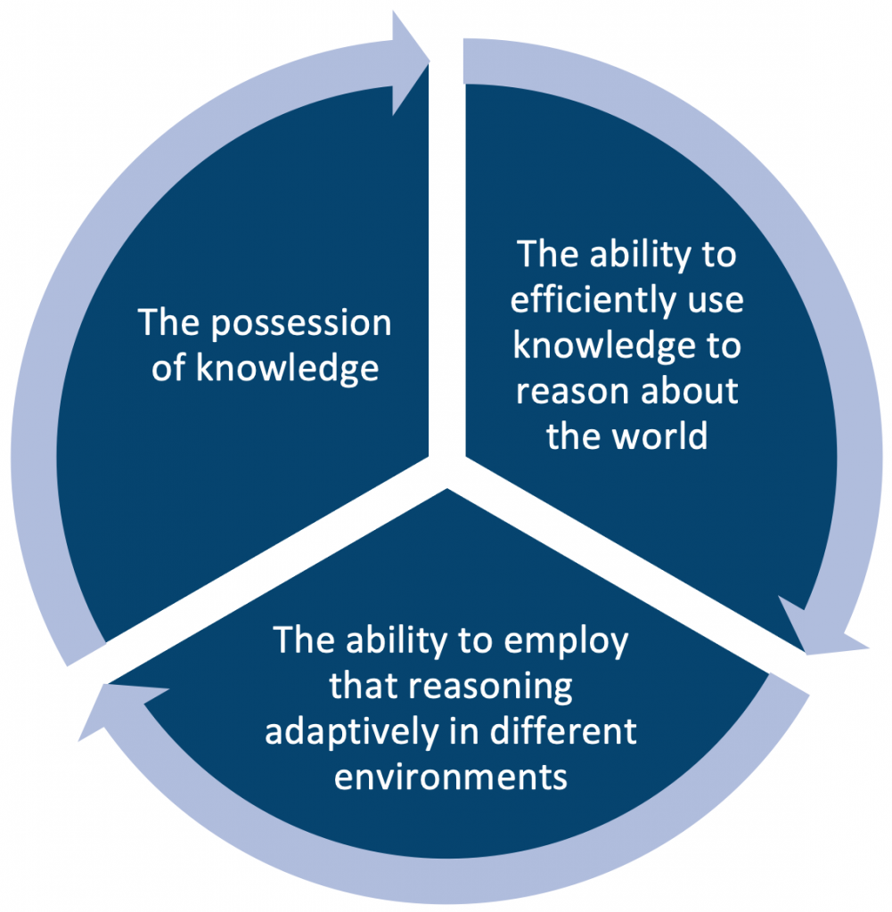

## **IQ and intelligent testing:**

Alfred Binet’s work in 1904 followed by Lewis Terman in 1916 developed the Stanford-Binet IQ test = (mental age / chronological age) x 100. The higher attainable score on the Stanford-Binet test is 15. Modern IQ testing has been developed to a level that your IQ score reflects your relative standing within a population of your age. The average IQ score in your age range is 100.

Raymond Cattel in 1963 suggested two kinds of general intelligence:

* Fluid intelligence – the basic power of reasoning and problem-solving.
* Crystalized intelligence – specific knowledge gained as a result of applying fluid intelligence.

**Wechsler Adult Intelligence Scale (WAIS):** entails 6 verbal subtests (general information, comprehension, vocabulary, arithmetic, digit span, similarities) and 5 performance subtests (block design, object assembly, picture completion, digit symbol picture arrangements). WAIS testing allows the assessment of verbal IQ, performance IQ and overall IQ.

**Ravens Progressive Matrices:** measures non-verbal IQ. It consists of a diagram-completion test which exists in three different versions.

## **Triarchial theory of intelligence:**

Robert Sternberg proposed three aspects of intelligence:

1. Internal components
2. Relation of these components to experience
3. External effects

(Sternberg, 2012)

## **Intelligence changing with age:**

|  |  |
| --- | --- |
| **Ability**: | **Summary:** |
| **Working memory** | The ability to hold and organize material in working memory declines beyond the age of 50-60 years old. |
| **Processing speed** | General slowing of all mental abilities. This is thought to be due to reduced storage capacity and impaired processing efficiency. |
| **Organization** | Older people are less likely to solve problems by adopting specific strategies. Results appear to be more random and haphazard. |
| **Flexibility** | Older people tend to be less flexible in problem-solving tests. They are less likely to consider alternative solutions and require more information before making a tentative decision. |
| **Control of attention** | The ability to direct or control attention declines with age. |

## **Learning Disability**

Learning disabilities, also known as specific learning difficulties, are neurological conditions that impact an individual’s ability to learn and process information in a typical manner. They can affect reading, writing, mathematics, speaking, and understanding language, as well as attention, memory, reasoning, and executive functioning skills (Lyon, 1996).

Learning disabilities are not the same as intellectual disabilities, which are characterized by significant limitations in cognitive functioning and adaptive behaviours. However, some individuals with learning disabilities may also have co-occurring conditions such as ADHD, anxiety, or depression.

The exact causes of learning disabilities are not well understood and are likely to be multi-factorial, involving a combination of genetic, environmental, and neurological factors. For example, genetic factors have been shown to play a role in certain types of learning disabilities, such as dyslexia, while environmental factors such as exposure to toxins or malnutrition may contribute to others (Snowling, 2000) (Vellutino, 2004).

In terms of assessment and diagnosis, learning disabilities can be challenging to identify and may require a comprehensive evaluation by a multidisciplinary team of healthcare and educational professionals. This may involve a variety of assessment tools, such as standardized tests, behavioural observations, and medical imaging techniques.

Once a learning disability has been diagnosed, a variety of interventions can be used to support individuals with these conditions, including special education services, accommodations in the classroom, and behavioural therapy. Additionally, medications and other treatments may be used to manage co-occurring conditions such as ADHD or anxiety.

Overall, it is important to recognize the complexity and heterogeneity of learning disabilities, as well as the significant impact they can have on an individual’s development and quality of life.

## **Severities of learning disability:**

The severity of a learning disability can vary greatly from person to person and can impact different areas of development and functioning to varying degrees. In general, learning disabilities are classified as mild, moderate, or severe based on the extent to which they impact an individual’s ability to learn and process information.

|  |  |
| --- | --- |
| **Level:** | **Description:** |
| **Mild** | Mild learning disabilities typically have the least impact on an individual’s ability to learn and process information. People with mild learning disabilities may require some extra support in the classroom or in other learning environments but are often able to overcome their difficulties with the right accommodations and interventions. |
| **Moderate** | Moderate learning disabilities are characterized by more significant difficulties with learning and processing information, but still typically allow an individual to function relatively independently. People with moderate learning disabilities may require more extensive support and accommodations in order to succeed academically or in the workplace. |
| **Severe** | Severe learning disabilities are characterized by significant limitations in an individual’s ability to learn and process information, as well as in other areas of development and functioning. People with severe learning disabilities may require extensive support and assistance in order to participate in school, work, and other aspects of daily life. |

It’s important to note that the severity of a learning disability can change over time and that the same individual may experience different levels of severity in different areas of development and functioning. Additionally, the impact of a learning disability can be influenced by a variety of factors, including the presence of co-occurring conditions such as ADHD or anxiety, as well as access to appropriate accommodations and interventions.

**References:**

(1) Lyon, G. R., & Krasnegor, N. A. (Eds.). (1996). Attention, memory, and executive function. Paul H Brookes Publishing Co.

(2) Snowling, M. J. (2000). Dyslexia. Blackwell Science.

(3) Sternberg, R.J. (2012). Intelligence. Dialogues in clinical neuroscience, [online] 14(1), pp.19–27. doi:10.31887/DCNS.2012.14.1/rsternberg.

(4) Vellutino, F. R., Fletcher, J. M., Snowling, M. J., & Scanlon, D. M. (2004). Specific reading disability (dyslexia): what have we learned in the past four decades?. Journal of child psychology and psychiatry, and allied disciplines, 45(1), 2-40.

### 3.8.6 Effects of brain injury

## **Effects of Injury at Different Ages on the Brain**

The effects of brain injury can vary depending on the age at which the injury occurs. Brain development is a dynamic process that continues throughout life, and different regions of the brain mature at different rates. As a result, the impact of a brain injury can vary depending on the age at which it occurs and the region of the brain affected.

In infancy and childhood, the brain is still developing rapidly and is more resilient and adaptable than in adulthood. Children with brain injuries may recover more quickly and experience fewer long-term effects than adults with similar injuries. However, brain injuries during this critical period of development can also have more serious and lasting impacts on cognitive, emotional, and behavioural development (Vaurio, 2009).

During adolescence, the brain continues to develop, with the prefrontal cortex, which is responsible for decision-making, impulse control, and other executive functions, maturing last. As a result, brain injuries during this period can have significant impacts on these important functions. Adolescents with brain injuries may also experience difficulties with social and emotional regulation, as well as academic difficulties.

In adulthood, the brain is less resilient and adaptable, and the effects of brain injury are often more serious and long-lasting. Adults with brain injuries may experience significant impairments in cognitive, motor, and sensory functions, as well as emotional and behavioural problems (Stuss, 2002).

Regardless of the age at which it occurs, a brain injury can have a profound impact on an individual’s quality of life, and rehabilitation and support are important to help individuals recover and rebuild their lives (Teasell, 2003).

## **Effects of Brain Injury on the Anatomy**

Brain injury can have a profound impact on both macro and micro neuroanatomy, resulting in changes to the structure and function of the brain. These changes can have serious consequences for an individual’s cognitive, emotional, and behavioural functioning.

At the macro neuroanatomy level, brain injury can result in damage to specific regions of the brain, or to larger networks of brain regions that work together. For example, injury to the frontal lobes can result in problems with executive function, while injury to the temporal lobes can result in memory difficulties. Injury to the brainstem can result in problems with basic functions such as regulating heart rate, blood pressure, and breathing.

At the micro neuroanatomy level, injury can result in damage to individual neurons and synapses, the structures that transmit signals between neurons. This damage can disrupt the normal flow of information within the brain, leading to changes in neural function. For example, injury can result in the loss of dendritic branches, which are important for receiving signals from other neurons, and axons, which are important for transmitting signals to other neurons.

In addition to structural changes, injury can also result in changes to the chemistry of the brain, including changes to the levels of neurotransmitters, the chemical messengers that transmit signals between neurons. These changes can further disrupt the normal flow of information within the brain, leading to additional cognitive, emotional, and behavioural difficulties.

## **Effects of Brain Injury on the Mental Function**

Brain injury can have a profound impact on an individual’s mental function, resulting in a wide range of cognitive, emotional, and behavioural problems. Mental function refers to the cognitive processes that allow us to process and understand information, make decisions, and interact with the world around us. When the brain is injured, these processes can be disrupted, leading to a range of difficulties that can have serious consequences for an individual’s quality of life.

Cognitive difficulties can include problems with attention, memory, executive function, and processing speed. Attention difficulties may make it difficult for individuals to sustain focus, concentrate, and filter out distractions. Memory difficulties can result in problems with retaining information, recalling past events, and recognizing familiar people or objects. Executive function difficulties can result in problems with planning, organizing, and making decisions. Processing speed difficulties can result in slower information processing and difficulty keeping pace with others (Cicerone, 2011).

Emotional difficulties can include depression, anxiety, irritability, and mood swings. Brain injury can also result in changes to an individual’s personality, including increased impulsivity, disinhibition, and irritability. These emotional difficulties can have serious consequences for an individual’s social and occupational functioning and may result in strained relationships and reduced participation in meaningful activities.

Behavioural difficulties can include impulsivity, disinhibition, and aggression. Brain injury can also result in problems with regulating behaviour, leading to difficulty controlling impulses and engaging in socially inappropriate behaviour. These behavioural difficulties can result in significant problems for individuals in their daily lives, including difficulties at work, school, and in personal relationships (Anderson, 2012).

In conclusion, brain injury can have a profound impact on mental function, resulting in a range of cognitive, emotional, and behavioural difficulties. Understanding these effects is crucial for developing effective rehabilitation and support programs that can help individuals recover and rebuild their lives.

**References:**

(1) Anderson, V. A., Catroppa, C., Morse, S. A., Haritou, F., & Rosenfeld, J. V. (2012). Outcomes of cognitive and behavioral interventions for children with traumatic brain injury: A review. Journal of Clinical and Experimental Neuropsychology, 34(7), 714-732.

(2) Cicerone, K. D., Langenbahn, D. M., Braden, C., Malec, J. F., Kalmar, K., Fraas, M., … & Ashley, N. (2011). Evidence-based cognitive rehabilitation: Recommendations for clinical practice. Archives of Physical Medicine and Rehabilitation, 92(3), 519-530.

(3) Stuss, D. T., & Levine, B. (2002). Adult clinical neuropsychology: Lessons from studies of the frontal lobes. Annual Review of Psychology, 53, 401-433.

(4) Teasell, R., McEwen, S., & Hagen, S. (2003). The assessment and management of adult patients with moderate and severe traumatic brain injury. Archives of Physical Medicine and Rehabilitation, 84(12), 1726-1733.

(5) Vaurio, L., Riley, E. P., & Rosenbaum, S. B. (2009). Neurocognitive outcome following traumatic brain injury in children and adolescents. Neuropsychology Review, 19(1), 78-97.

## 3.9 Integrated Neurobiology

### 3.9.1 Autism

## **Autism**

In 1911 Eugen Bleuler coined the term autism as a characteristic feature of schizophrenia. Over a decade later in 1926 Grunya Sukhareva (in her paper, ‘Schizoid Psychopathy in Childhood’) described the first attempt to describe autism spectrum disorder (ASD) as a distinct diagnostic entity. In her paper, she refers to ASD as “schizoid personality disorder”. Her work remained largely unknown until translated from Russian and German to English many years later in 1996 (Posar, 2017).

A wide range of diseases collectively known as autism, or ASD are complex neurological disorders. They are characterised by difficulties with social skills, repetitive activities, speech, and nonverbal communication. The Centres for Disease Control estimate that 1 in 44 American children currently suffer from ASD. In the UK, 1 in 100 children and adults are on the autistic spectrum.

## **Aetiology of autism:**

The aetiology is complex and has associations with:

* Neurological pathways
* Neurotransmitters
* Genes
* Environmental influences

There is ongoing research to understand whether there are any possible causal factors of ASD.

Based on the available epidemiological data, it has been concluded that there is no evidence to support the claim that the measles, mumps, and rubella vaccine causes autism. Previous studies claiming a causal relationship were found to have numerous methodological flaws.

The cause of Autism Spectrum Disorder (ASD) can be attributed to several factors, and it often coincides with sensory sensitivities, physical issues such as gastrointestinal problems, seizures, and sleep disorders, as well as psychological challenges like anxiety, depression, and attention deficits.

Early signs of ASD may be present, but the disorder is frequently not diagnosed until later in life.

Co-occurring disorders such as epilepsy, depression, anxiety, and attention deficit hyperactivity disorder are common in individuals with autism, along with challenging behaviors like difficulty sleeping and self-harm. The intellectual functioning levels of those with autism can range greatly, from severe impairment to exceptional abilities.

## **Genetics:**

Siblings of autistic people are 50 to 100 times more likely to have autism than people in the general population.

Autism twin studies show an extremely high heritability:

* 60-90% monozygotic concordance (Castelbaum, 2020)
* 30% dizygotic concordance 2014 (Frazier, 2014)

## **Weak central coherence model**:

The weak central coherence model proposed in 1994 asserts that ASD is presented as a cognitive bias towards local processing over global processing. Consequently, individuals with ASD lack the ability to automatically use context to aid their understanding of the surrounding environment.

This theory is supported by an increased performance in block design tasks, figure tasks and illusion tasks that are associated with the influence of context.

## **Integrated neurobiology approach:**

|  |  |
| --- | --- |
| **Brain region:** | **Summary:** |
| **Cerebellum** | Hypoplasia of cerebellar vermis. Aside from the known regulation of sequenced movement that the cerebellum is associated with. Other functions include procedural learning, emotion, thought, and attention. Specifically, attention shifting is implicated in the cerebellum. |
| **Frontal lobe** | The prefrontal cortex is involved in executive functioning. This affects working memory, inhibition, planning, organization, set shiting, cognitive flexibility, and disengaging attention. All of these functions are deficient to some degree in ASD. |
| **Temporal lobe** | The temporal lobe is known for its involvement in audition, memory, and object perception. Its involvement in receptive language processing via Wernicke’s area can specifically affect joint attention, action observation, and empathy. Again all of these functions are deficient to some degree in ASD. |
| **Neocortex** | Inconsistent changes noted. Some studies suggest increased cortical volume, probably related to reduced pruning. |

(Schroeder, 2010).

## **Challenges for the future:**

There are several challenges that will need to be addressed in order to effectively manage autism in the future, including:

1. Early diagnosis and intervention: Early diagnosis and intervention are key to improving outcomes for individuals with autism, but there are still many barriers to early identification, including lack of awareness, limited resources, and long wait times for assessments.
2. Individualized support: Autism affects individuals differently, and therefore it is important to provide individualized support and interventions to meet each person’s unique needs. This requires a flexible and tailored approach to treatment.
3. Integration into mainstream society: Individuals with autism often face challenges in accessing education, employment, and other mainstream services, and there is a need for more inclusive and accessible options.
4. Addressing co-occurring conditions: Many individuals with autism also have co-occurring conditions such as anxiety, depression, and epilepsy, and it is important to address these conditions in a holistic manner to improve overall well-being.
5. Addressing the needs of aging individuals with autism: As the number of individuals with autism continues to grow, there will be an increasing need for support and services for those with autism as they age.
6. Improving access to care: There are still significant disparities in access to care for individuals with autism, particularly for those from underserved communities, and efforts are needed to address these disparities and improve access to care for all.
7. Research and innovation: Ongoing research is needed to improve our understanding of autism, develop new interventions, and improve quality of life for individuals with autism.
8. Diversity of the disorder: The diversity of the disorder’s causes, symptoms, severity, and designations are one of the most difficult issues in ASD research. Sample descriptions range from “pure” autism to ASD and pervasive developmental disorder (PDD), which includes a wide spectrum of problems. This range makes it difficult to generalise across research with widely disparate samples (Bebko et al., 2008).

**References:**

(1) Bebko, J.M., Schroeder, J.H., Weiss, J.A., Wells, K., McFee, K. and Goldstein, G.M. (2008). The face of Autism research as reflected in the IMFAR looking glass. Research in Autism Spectrum Disorders, 2(3), pp.385–394. doi:10.1016/j.rasd.2007.06.005.

(2) Castelbaum, L., Sylvester, C.M., Zhang, Y., Yu, Q. and Constantino, J.N. (2019). On the Nature of Monozygotic Twin Concordance and Discordance for Autistic Trait Severity: A Quantitative Analysis. Behavior Genetics, 50(4), pp.263–272. doi:10.1007/s10519-019-09987-2.

‌(3) Frazier, T.W., Thompson, L., Youngstrom, E.A., Law, P., Hardan, A.Y., Eng, C. and Morris, N. (2014). A Twin Study of Heritable and Shared Environmental Contributions to Autism. Journal of Autism and Developmental Disorders, [online] 44(8), pp.2013–2025. doi:10.1007/s10803-014-2081-2.

(4) Frith, U. and Happé, F. (1994). Autism: beyond ‘theory of mind’. Cognition, 50(1-3), pp.115–132. doi:10.1016/0010-0277(94)90024-8.

(5) Posar, A. and Visconti, P. (2017). Tribute to Grunya Efimovna Sukhareva, the woman who first described infantile autism. Journal of Pediatric Neurosciences, 12(3), p.300. doi:10.4103/jpn.jpn_46_17.

(6) Schroeder, J.H., Desrocher, M., Bebko, J.M. and Cappadocia, M.C. (2010). The neurobiology of autism: Theoretical applications. Research in Autism Spectrum Disorders, 4(4), pp.555–564. doi:10.1016/j.rasd.2010.01.004.

### 3.9.2 ADHD

## **Attention Deficit Hyperactivity Disorder**

Attention deficit hyperactivity disorder (ADHD) is a neurodevelopmental disorder characterised by symptoms of inattention, impulsivity and locomotor hyperactivity. It is estimated that in children and adults worldwide the prevalence is 5.3% and 4.8% respectively.

## **Genetics:**

Decades of research have shown that genes are important in the aetiology of attention deficit hyperactivity disorder (ADHD) and its comorbidity with other diseases. However, the fact that twin estimates of heredity are less than 100% clearly suggests that environmental variables are also at work.

The inheritance pattern of ADHD is incredibly complex and thought not to be caused by a single genetic mutation. Parents and siblings of a patient with ADHD are more likely to have ADHD themselves.

The heritability of ADHD is approximately 74%, with both males and females equally affected.

Several potential genes have shown strong associations with ADHD, including:

* DAT1
* DRD4
* DRD5
* 5HTT
* SNAP25

## **Signs and symptoms:**

Inattentiveness, hyperactivity, and impulsivity are among the behavioural signs of attention deficit hyperactivity disorder (ADHD). It is one of several neurodiverse disorders, such as dyspraxia, dyslexia, autism, and Asperger’s syndrome.

However, this is not always the case, and there are undoubtedly people who would not have been identified in their youth due to the lack of awareness and the potential to be diagnosed at the time. Currently, symptoms of ADHD tend to be noticed at an early age and can be diagnosed when children are 6 to 12 years old. Age-related improvements in ADHD symptoms are possible, particularly if childhood symptoms are addressed so that the developing brain can acquire routines and habits that lessen the consequences later. However, many adults with the illness still encounter issues after receiving a diagnosis.

Depression, trouble falling or staying asleep, and social or general anxiety problems are among the other mental health conditions that people with ADHD may have. These conditions can arise from either the ADHD itself or from the impact it has on a person’s life. It may be necessary to treat these “comorbidities” in addition to ADHD symptoms.

There is still much to learn about the causes of ADHD. ADHD is recognised as being neurodevelopmental, which means it results from how a person’s brain and nervous system develop during childhood. Additionally, ADHD frequently runs in families and is largely genetic.

## **Anatomical brain changes in ADHD:**

|  |  |
| --- | --- |
| **Anatomy:** | **Explanation:** |
| **Overall brain reduction** | Overall reduction in the total brain size with specific mention regarding the caudate nucleus, prefrontal cortex white matter, corpus callosum and cerebellar vermis. |
| **Basal ganglia** | Parts of the basal ganglia, specifically the caudate nucleus and globus pallidus are reduced in ADHD. These parts contain a higher density of dopamine receptors than other areas in the brain. |
| **Ventral striatum** | The ventral striatum is a part of the ‘reward pathway’ and is also reduced in ADHD. |
| **Cortical thickness** | Reduced association with DRD4-7 allele. |
| **Prefrontal cortex** | Functional MRI has shown reduced activation of the prefrontal cortex (PFC) and associated striatal regions. Functions of the PFC include regulation of top-down attention, regulation of behaviour, and regulation of emotions. |

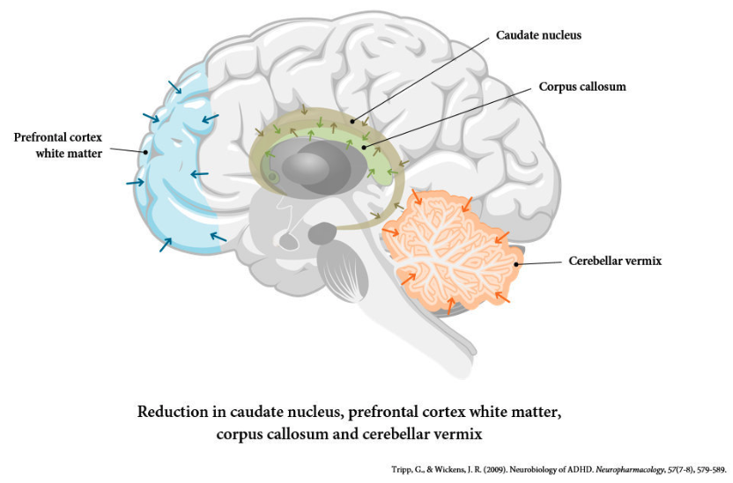

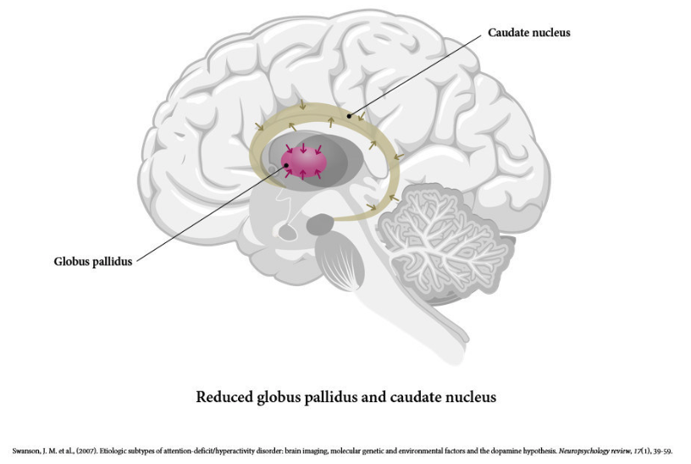

**References:**

(1) Tripp, G. and Wickens, J.R. (2009). Neurobiology of ADHD. Neuropharmacology, 57(7-8), pp.579–589. doi:10.1016/j.neuropharm.2009.07.026.

(2) Swanson, J.M., Kinsbourne, M., Nigg, J., Lanphear, B., Stefanatos, G.A., Volkow, N., Taylor, E., Casey, B.J., Castellanos, F.X. and Wadhwa, P.D. (2007). Etiologic Subtypes of Attention-Deficit/Hyperactivity Disorder: Brain Imaging, Molecular Genetic and Environmental Factors and the Dopamine Hypothesis. Neuropsychology Review, 17(1), pp.39–59. doi:10.1007/s11065-007-9019-9.

### 3.9.3 Drug addiction

## **Drug Use, Addiction, Tolerance, Withdrawal, and Relapse**

A chronic brain condition, addiction. Addiction is also known as a substance use disorder when it is connected to drugs or alcohol. Although there is no cure for addiction, it can be managed with treatment. In this context, “drugs” refers to any substance that has an impact on the body. Prescription medications, over-the-counter items, illicit substances, alcohol, and even nicotine may be included.

Drug addiction is a more severe form of substance abuse that leads to issues not just while the user is using the substance, but also after they try to stop.

The neurobiology of addiction can be framed around a three-stage cycle: binge/intoxication, withdrawal/negative affect, and preoccupation/anticipation.

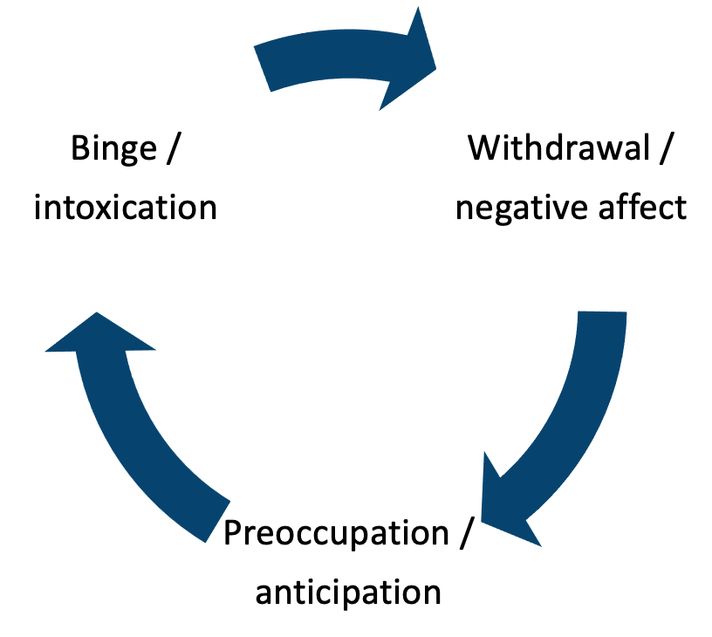(Wise, 2014)

## **Dependence and addiction**:

Another word that is frequently mixed up with the term addiction is dependence. Dependency simply implies that the body has grown reliant on receiving a drug from an outside source in order to avoid going through withdrawal. Most medications increase the number of specific brain chemicals, which has a pleasant impact.

## **Tolerance**:

Tolerance can form when drugs like morphine or cocaine are used frequently over time. When a person stops reacting to a substance the same way they did at first, that is when tolerance sets in. Cellular tolerance happens at the molecular level. One way for this to happen is for the body to metabolise the drug more quickly so that it leaves the body more quickly than before.

## **Withdrawal:**

Depending on the substance used and the regular dosage used, a person may experience a variety of physical and psychological symptoms associated with withdrawal, ranging from minor to life-threatening. It happens after the person has developed a drug dependence. This means that in order to avoid withdrawal symptoms, the user must gradually quit using the chemical.

## **Relapse**:

Relapsing is the process by which someone who had been abstaining from drugs or alcohol for a while does so again. During the course of a person’s rehabilitation from substance misuse, addiction might relapse. Even though relapse is extremely prevalent among those in recovery, it is seldom generally discussed as a stage of the process.

## **The Role of Dopamine in Addiction**

Drug addiction is fundamentally gratifying. They hijack the brain’s dopamine system in order to boost dopamine levels in the nucleus accumbens, which is a critical focus point for reward neurocircuitry in the brain.

Dopamine is a neurotransmitter in the brain that plays a crucial role in addiction. Dopamine is associated with pleasure and reward and is released in response to pleasurable stimuli such as food, sex, and drugs.

When a person uses drugs or engages in other addictive behaviours, the release of dopamine in the brain is significantly increased. Over time, the brain becomes accustomed to the elevated levels of dopamine and needs more of the substance or behaviour to produce the same pleasurable effects. This leads to the development of tolerance, which is one of the key features of addiction.

Drugs of abuse, such as cocaine, amphetamines, and opioids, are able to increase dopamine levels in the brain by either blocking the reuptake of dopamine or increasing its release. This leads to a surge of dopamine in the brain, producing feelings of pleasure and reinforcing drug-taking behaviour.

Long-term drug use can also alter the dopamine system, leading to changes in brain function and structure. This can result in a decreased sensitivity to dopamine and reduced pleasure in response to natural rewards, making it harder for an individual to quit using drugs and increasing the risk of relapse.

In conclusion, dopamine plays a crucial role in the development and maintenance of addiction by mediating the pleasurable effects of drugs and other addictive behaviours. Understanding the role of dopamine in addiction is important for the development of effective addiction treatments.

The rate of dopamine increase plays a factor in whether a drug or substance will produce a rewarding effect. The prefrontal cortex contains both D1 and D2 dopamine receptors. D2 receptors have a 10-100x greater affinity for dopamine compared to D1 receptors.

## **Learning Mechanisms Underlying Addiction**

Initially, drug use is a deliberate, goal-directed behaviour. People utilise drugs in order to achieve a specific high or reward. In other people, however, the conduct becomes compulsive and is no longer related to the pursuit of a reward. This modification is linked to a change in brain circuitry. While areas such as the basolateral amygdala and the nucleus accumbens are required to acquire persistent drug-seeking behaviour, they become less significant once the habit is established. The dorsolateral striatum then becomes increasingly essential. A significant rise in dopamine is detected in the dorsal striatum of animals engaged in long-term drug-seeking behaviour, but not in the nucleus accumbens core or shell.

Blocking dopamine receptors in the dorsal striatum, but not in the nucleus accumbens, has been shown to diminish well-established, habitual drug-seeking behaviour.

**References:**

(1) Uhl, G.R., Koob, G.F. and Cable, J. (2019). The neurobiology of addiction. Annals of the New York Academy of Sciences, 1451(1), pp.5–28. doi:10.1111/nyas.13989.

‌(2) Wise, R.A. & Koob G.F.. 2014. The development and maintenance of drug addiction. Neuropsychopharmacology 39: 254–262.

### 3.9.4 Anxiety disorders

## A**nxiety Disorders**

Anxiety disorders are a group of mental health conditions characterized by excessive or unreasonable fear, worry, and nervousness. Here is a brief overview of the clinical differences between some of the most common anxiety disorders:

|  |  |
| --- | --- |
| **Anxiety Disorder:** | **Description:** |
| **Generalized anxiety disorder (GAD)** | GAD is characterized by excessive, long-lasting worry and fears about a variety of everyday events and activities. People with GAD often worry about things such as health, money, or family for no apparent reason, and this worry is often out of proportion to the actual situation. Other symptoms may include restlessness, fatigue, difficulty concentrating, irritability, and muscle tension. |
| **Social anxiety disorder (social phobia)** | Social phobia is a fear of being scrutinized or judged by others in social or performance situations, causing significant distress and avoidance behaviour. The fear is often centred on specific situations such as public speaking, eating in public, or being around others in general. People with social anxiety disorder often worry for days or weeks before the event and experience physical symptoms such as shaking, sweating, and blushing. |
| **Specific phobias** | A specific phobia is an intense fear of a specific object or situation that is out of proportion to the actual threat. Common phobias include fear of flying, animals (such as spiders or snakes), and heights. People with phobias often go to great lengths to avoid the object or situation they fear, and the fear can interfere with daily activities and relationships. |
| **Separation anxiety disorder** | Separation anxiety disorder is a condition in which a person experiences excessive fear or anxiety when separated from someone to whom they are attached, such as a parent or caregiver. This can involve excessive worry about harm befalling the attachment figure, or about being away from home or from the attachment figure. Children with a separation anxiety disorder may have trouble sleeping away from home or separating from the attachment figure for even brief periods. |

| **Disorder:** | **DSM-5:** | **ICD-11:** |
| --- | --- | --- |
| **Generalized Anxiety Disorder (GAD)** | ✓ | ✓ |
| **Panic Disorder** | ✓ | ✓ |
| **Agoraphobia** | ✓ | ✓ |
| **Specific Phobia** | ✓ | ✓ |
| **Social Anxiety Disorder (Social Phobia)** | ✓ | ✓ |
| **Separation Anxiety Disorder** | ✓ | – |
| **Selective Mutism** | ✓ | – |
| **Substance/Medication-Induced Anxiety Disorder** | ✓ | – |
| **Anxiety Disorder Due to Another Medical Condition** | ✓ | – |
| **Other Specified Anxiety Disorder** | ✓ | – |
| **Unspecified Anxiety Disorder** | ✓ | – |

It’s important to note that while the DSM-5 and ICD-11 both cover various types of anxiety disorders, the specific criteria for diagnosis may differ between the two systems. Additionally, the categorization of mental disorders can vary between different diagnostic systems, and a diagnosis should always be made by a mental health professional through a comprehensive evaluation.

## **Generalized Anxiety Disorders**

It’s common to have anxiety every now and then. However, strong, excessive, and persistent worry and panic over commonplace circumstances are typically experienced by those with anxiety disorders. Anxiety disorders sometimes entail recurrent episodes of acute anxiety, fear, or terror that peak in a matter of minutes (panic attacks).

Generalized Anxiety Disorder (GAD) is a common psychiatric disorder, with estimates as high as 1 in 5 adults experiencing it in their lifetime (Angst, 2016).

**GAD is characterized by:**

* Excessive anxiety and worry about a number of events or activities
* Individuals find it challenging to control the emotion of anxiety
* Anxiety impairs multiple contexts (eg. work, home and social)

(Patriquin, 2017)

These uncomfortable, hard-to-regulate, out-of-proportion to the real threat and protracted sensations of worry and panic interfere with daily activities.

## **Symptoms:**

The following list of symptoms and indicators of anxiety:

* Feeling anxious, irritable, or uptight
* A feeling of impending catastrophe, terror, or disaster
* Having a faster heartbeat
* Breaths quickly (hyperventilation)
* Sweating
* Trembling
* Feeling drained or feeble
* Difficulty focusing or thinking about anything but the current issue
* Having issues falling asleep
* Having digestive system (GI) issues
* Having trouble managing worry
* A desire to stay away from things that make you anxiou**s**

## **Genetics and Neurobiology:**

Environmental factors such as stress and trauma likely contribute to the development of anxiety disorders through epigenetic mechanisms. These epigenetic mechanisms are thought to even begin in utero. For example, mothers with anxiety disorders who were not prescribed anti-anxiety medication have altered DNA methylation of the glucocorticoid receptor gene (NR3C1) promoter region in cord blood and the genome, which may raise their child’s risk of having an anxiety disorder.

Disrupted coordination of brain activity and communication is thought to be the neurobiological reason for GAD:

* Reduced resting-state functional connectivity between the amygdala and prefrontal cortex.
* Decreased connectivity between the amygdala and prefrontal cortex.
  + Remember the prefrontal cortex is critical for the regulation of emotion, specifically in the ventromedial regions that appear to control negative emotion (Diekhof, 2011).
* Structural and functional changes in the amygdala.

## **Management:**

|  |  |
| --- | --- |
| **Approach:** | **Summary:** |
| **Psychological** | **Cognitive behavioural therapy:** Through relaxation and biofeedback, cognitive behavioural therapy directly tackles both skewed negative mental processes and some bodily symptoms. **Psychodynamic psychotherapy:**mediates its effects by increasing the patient’s anxiety tolerance. |
| **Pharmacotherapy** | **Benzodiazepines:** useful in the short term to allow patients to cope with the psychotherapeutic approaches. **Antidepressants:** Imipramine and SSRIs are often of some benefit if there is effective overlay. **Buspirone:**5-HT1a agonists can be effective specifically on cognitive symptoms rather than somatic symptoms. |

## **Phobias**

## **Social phobia:**

Anxiety is solely restricted to particular social situations. Marked fear of being the focus of attention, or fear of behaving in a way that will be embarrassing or humiliating. Avoidance of phobic situations must be a prominent feature.

## **Specific phobia:**

|  |  |
| --- | --- |
| **Phobia:** | **Summary:** |
| **Animal phobia** | 95% of people presenting for treatment are women. Boys tend to grow out of their phobias in adolescence. |
| **Blood/injury** **phobia** | More likely to have a family history compared to any other phobia, suspected to have a genetic component. |
| **Space phobia** | Characterized by fear of absent visuospatial support and of falling. Generally associated with a stable personality. |
| **Illness phobia** | Equal sex incidence. Previous illness in a relative or individual may be a precipitating factor. |
| **Dental treatment phobia** | Prevalence of 5%. |

**Phobia treatment:**Exposure therapy via flooding or systematic desensitization.

## **Panic Disorder**

A panic attack is defined as a sudden onset of discrete anxiety for a defined time period. Symptoms experienced include palpitations, sweating, trembling or shaking, the sensation of shortness of breath, feeling of choking, chest pain, nausea, dizziness/lightheadedness, derealization/depersonalization, fear of losing control, fear of dying, paraesthesia, and chills or hot flushes. There is a female-to-male ratio of 2:1.

To diagnose a panic disorder a patient needs to have experienced three panic attacks within a three-week period.

PET scanning shows the following increases in the right para-hippocampal area:

* Increased blood flow
* Increased blood volume
* Increased O2 metabolism

**Treatment:**Cognitive behavioural therapy mixes exposure to the stimulus with relaxation and therapeutic work around the patient’s false cognition. Antidepressants and benzodiazepines will often be used as adjuncts.

## **Adjustment Disorder**

A maladaptive reaction to a psychosocial stressor. It is often described as maladaptive since it interferes with the person’s social or occupational functioning. When the stressor passes, the disorder is expected to disappear.

**Clinical features:**Onset is usually within 1 month of the stressor. Duration of no longer than 6 months.

Young single women are a high percentage of patients suffering from the disorder.

|  |  |
| --- | --- |
| **Treatment modality:** | **Summary:** |
| **Psychological** | **Group therapy:** reinforce positive coping strategies. **Individual therapy:**must be time limited to avoid dependence. |
| **Pharmacotherapy** | Short courses of prescriptions may provide benefits for symptom relief ie. insomnia. |

**References:**

(1) Angst J, Paksarian D, Cui L, et al. The epidemiology of common mental disorders from age 20 to 50: results from the prospective Zurich cohort study. Epidemiol Psychiatr Sci 2016; 25(1): 24–32.

(2) Diekhof EK, Geier K, Falkai P, et al. Fear is only as deep as the mind allows: a coordinate-based meta-analysis of neuroimaging studies on the regulation of negative affect. Neuroimage 2011; 58(1): 275–285.

(3) Patriquin, M.A. and Mathew, S.J. (2017). The Neurobiological Mechanisms of Generalized Anxiety Disorder and Chronic Stress. Chronic Stress, 1(1), p.247054701770399. doi:10.1177/2470547017703993.

### 3.9.5 Post-traumatic stress disorder

## **Post-Traumatic Stress Disorder**

Post-Traumatic Stress Disorder (PTSD) is a mental health condition that can occur after a person experiences or witnesses a traumatic event, such as combat, natural disasters, sexual assault, or physical violence. The condition is characterized by a persistent re-experiencing of the traumatic event through flashbacks, intrusive thoughts, or nightmares, as well as avoidance behaviours and emotional numbing, and symptoms of hyperarousal, such as irritability, sleep disturbances, and hypervigilance (APA, 2013).

PTSD has been widely studied and documented in various populations, including veterans, survivors of natural disasters and sexual assault, and individuals who have experienced physical violence. Prevalence rates of PTSD vary depending on the population studied and the methods used for assessment, but it is estimated that approximately 7-8% of the general population will experience PTSD at some point in their lifetime (Kessler, 2005).

The exact causes of PTSD are not well understood, but it is believed to be related to a complex interaction of biological, psychological, and social factors. Neurobiological research has shown that individuals with PTSD have changes in the structure and function of the brain, including alterations in the amygdala, hippocampus, and prefrontal cortex, which are important for regulating emotions and memories (Shin, 2005).

Treatment for PTSD typically involves a combination of psychotherapy and medication. Cognitive behavioural therapy (CBT) and exposure therapy have been shown to be effective in reducing symptoms of PTSD, by helping individuals process the traumatic event and reducing their avoidance of reminders of the event (Foa, 2005). Antidepressant medication, such as selective serotonin reuptake inhibitors (SSRIs), can also be helpful in reducing symptoms of anxiety and depression associated with PTSD (Bryant, 2014).

In summary, PTSD is a debilitating condition that can occur following exposure to a traumatic event. While the exact causes of PTSD are not well understood, research has shown that a combination of biological, psychological, and social factors contribute to the development of the disorder. Effective treatments for PTSD include psychotherapy and medication, with CBT and exposure therapy being among the most widely studied and effective treatments for the condition.

## **Symptoms**:

Post-traumatic stress disorder symptoms can begin as soon as one month after a stressful experience, but they can also take years to manifest. Significant issues are brought on by these symptoms in social, professional, and romantic interactions. They may also make it difficult for you to carry out regular activities as usual.

Intrusive memories, avoidance, unfavourable changes in thought and attitude, and changes in bodily and emotional reactions are the four main categories of PTSD symptoms. The severity of symptoms can change over time or from person to person.

## **Neurobiology of PTSD**

The neurobiological features of PTSD can be broken down into neuroanatomy, neuroendocrine, and neurochemical:

|  |  |  |
| --- | --- | --- |
| **Neuroanatomy:** | **Change:** | **Effect:** |
| **Amygdala** | Increased activity | Increased hypervigilance Decreased discrimination of threat |
| **Cortex** | i) Decreased prefrontal volume ii) Decreased anterior cingulate volume iii) Decreased medial prefrontal activation | i) Dysregulates executive functions ii) Impairs the extinction of fear responses iii) Unclear |
| **Hippocampus** | Decreased volume and activity | Alters stress responses and extinction |

|  |  |  |
| --- | --- | --- |
| **Neuroendocrine:** | **Change:** | **Effect:** |
| **Hypothalamic-pituitary-adrenal axis** | Hypocortisolism | Abnormal stress encoding and fear processing Disinhibited CRH/NA and upregulated response to stress |
| **Hypothalamic-pituitary-thyroid axis** | Abnormal T3:T4 ratio | Increased level of subjective anxiety |

|  |  |  |
| --- | --- | --- |
| **Neuroendocrine:** | **Change:** | **Effect:** |
| **Catecholamines** | Increased dopamine Increased noradrenaline | Interferes with fear conditioning via the mesolimbic system Increased arousal and startle responses Increased physiological responses to memories |
| **Serotonin** | Decreased serotonin in the raphe nucleus | The disturbed dynamic between the amygdala and hippocampus |

(Sherin, 2011)

## **DSM vs ICD**

The criteria for the diagnosis of Post-Traumatic Stress Disorder (PTSD) in the DSM-5 and ICD-11 are similar but have some differences.

The DSM-5 criteria for PTSD require the presence of a traumatic event, followed by the development of specific symptoms including intrusive thoughts and memories of the traumatic event, avoidance of reminders of the event, negative changes in thoughts and feelings, and symptoms of hyperarousal. The symptoms must persist for more than one month and cause significant distress or impairment in functioning to be considered PTSD (American Psychiatric Association, 2013).

The ICD-11 criteria for PTSD require the presence of a traumatic event and the development of specific symptoms, including re-experiencing the traumatic event through flashbacks or intrusive thoughts, avoidance of reminders of the event, negative changes in mood and cognition, and symptoms of hyperarousal. The symptoms must persist for more than one month and cause significant distress or functional impairment to be considered PTSD (World Health Organization, 2019).

The main difference between the DSM-5 and ICD-11 criteria is the number of symptoms required for diagnosis. The DSM-5 requires the presence of at least one symptom from each of the four symptom clusters (intrusive thoughts, avoidance, negative changes in mood and cognition, and hyperarousal), while the ICD-11 requires the presence of at least one re-experiencing symptom, at least one avoidance symptom, and at least two symptoms from the other two symptom clusters.

A comparison of the DSM-5 and ICD-11 criteria for PTSD is presented in the table below:

| **DSM-5 Criteria for PTSD:** | **ICD-11 Criteria for PTSD:** |
| --- | --- |
| Traumatic event | Traumatic event |
| Intrusive thoughts and memories of the traumatic event | Re-experiencing the traumatic event through flashbacks or intrusive thoughts |
| Avoidance of reminders of the traumatic event | Avoidance of reminders of the traumatic event |
| Negative changes in thoughts and feelings | Negative changes in mood and cognition |
| Symptoms of hyperarousal | Symptoms of hyperarousal |
| Symptoms must persist for more than one month | Symptoms must persist for more than one month |
| Significant distress or impairment in functioning | Significant distress or functional impairment |
| At least one symptom from each of the four symptom clusters | At least one re-experiencing symptom, at least one avoidance symptom, and at least two symptoms from the other two symptom clusters |

**References:**

(1) American Psychiatric Association (APA). (2013). Diagnostic and statistical manual of mental disorders (5th ed.). Arlington, VA: American Psychiatric Publishing.

(2) Bryant, R. A., Sackville, T., Dang, S. T., Moulds, M., & Guthrie, R. (2014). Treating acute stress disorder: An assessment of the evidence. Australian & New Zealand Journal of Psychiatry, 48(3), 187-194.

(3) Foa, E. B., Keane, T. M., & Friedman, M. J. (Eds.). (2000). Effective treatments for PTSD: Practice guidelines from the International Society for Traumatic Stress Studies. New York, NY: Guilford Press.

(4) Kessler, R. C., Chiu, W. T., Demler, O., Merikangas, K. R., & Walters, E. E. (2005). Prevalence, severity, and comorbidity of 12-month DSM-IV disorders in the National Comorbidity Survey Replication. Archives of General Psychiatry, 62(6), 617-627.

(5) Sherin, J.E. and Nemeroff, C.B. (2011). Post-traumatic stress disorder: the neurobiological impact of psychological trauma. Dialogues in clinical neuroscience, [online] 13(3), pp.263–78. Available at: https://www.ncbi.nlm.nih.gov/pmc/articles/PMC3182008/.

(6) Shin, L. M., Rauch, S. L., & Pitman, R. K. (2006). Amygdala, medial prefrontal cortex, and hippocampal function in PTSD. Annals of the New York Academy of Sciences, 1071, 67-79.

(7) World Health Organization. (2019). International Classification of Diseases, 11th Revision (ICD-11). Geneva, Switzerland: World Health Organization.

### 3.9.6 Obsessive-Compulsive disorder and related conditions

## **Obsessive-Compulsive Disorder**

Although the best description of compulsivity is likely to depend on perspective and context, compulsive disorders include obsessive-compulsive disorder (OCD) and related diseases such as hoarding disorder, body dysmorphic disorder, trichotillomania, skin picking disorder, and Tourette’s.

A range of overlapping diseases known as ‘obsessive-compulsive and related disorders’ described in the DSM-5 include OCD amongst a number of other conditions. Many of us occasionally have unpleasant ideas (such as yearning for double cheeseburgers when dieting) and frequently participate in repetitive activities (e.g., pacing when nervous). However, OCD and other similar diseases intensify unwanted thoughts and repetitive behaviours to the point that they interfere with daily life. OCD typically feature intrusive, unpleasant thoughts and repetitive activities.

**Obsessions** differ from regular fears we might have, such as legitimate worries about being fired from a job, and they are more severe. Obsessions are more than just unwelcome ideas that occasionally seem to jump into our heads arbitrarily. Instead, obsessions are defined as persistent desires and ideas that are unintentionally undesired, invasive, and distressing.

**Compulsions** are repetitive, ritualistic behaviours that are often practised to lessen the suffering that obsessions cause or to lessen the chance of a dreaded outcome. Compulsions frequently involve repetitive and thorough hand washing, cleaning, checking (like making sure a door is closed), and organising (like placing all the pencils in a specific order). They can also involve mental acts like counting, praying, or repeating aloud to oneself. OCD-specific compulsions are not pleasurable and are not realistically related to the cause of the suffering or the feared event. In the United States, 2.3% of people will develop OCD at some point in their lives (Brock, 2020).

## **Diagnosis:**

|  |  |
| --- | --- |
| ***Manual:*** | **Summary:** |
| **ICD 11** | Presence of persistent obsessions and/or compulsions.  1) Obsessions and compulsions are time-consuming (e.g., take more than 1 hour per day) or result in significant distress or significant impairment in personal, family, social, educational, occupational, or other important areas of functioning. If functioning is maintained, it is only through significant additional effort.  2) The symptoms or behaviours are not a manifestation of another medical condition (e.g., basal ganglia ischemic stroke) and are not due to the effects of a substance or medication on the central nervous system (e.g., amphetamine), including withdrawal effects. |
| **DSM 5** | 1) Recurrent and persistent thoughts, urges or images that are experienced, at some time during the disturbance, as intrusive, unwanted, and that in most individuals cause marked anxiety or distress.  2) The thoughts, impulses, or images are not simply excessive worries about real-life problems. |

## **Aetiology:**

The exact cause of OCD is unknown, but likely multifactorial. OCD appears to be heritable with the heritability being as high as 45-65% in children and 27-45% in adults.

Monozygotic : Dizygotic = 50-80% : 25%.

35% of 1st-degree relatives will also suffer from OCD

## **Phenomenology:**

* Checking compulsions 63%
* Washing 50%
* Fears of contamination 45%
* Obsessive doubts 42%
* Bodily fears 36%
* Counting 36%
* Insistence on symmetry 31%
* Aggressive thoughts 28%

## **Management:**

|  |  |
| --- | --- |
| **Management modality:** | **Summary:** |
| **Psychological** | Cognitive behavioural therapy: more effective than pharmacotherapy for OCD. Useful in ritualistic behaviour. 90% of patients make ‘worthwhile gains’. |
| **Pharmacotherapy** | Clomipramine and SSRIs: effects likely not seen for the first 6-8 weeks, with maximum effect by weeks 8-16. Augmentation with haloperidol, especially if tics are present. The relapse rate is high when medications are stopped. |
| **Psychosurgery** | Indicated for severe and intractable OCD. A common operation is a stereotactic cingulotomy. Subcaudate tractotomy is also used in some cases. |

## **Neurobiology of OCD**

Neuroimaging studies in OCD have revealed structural and functional abnormalities, most notably in the orbitofrontal cortices and basal ganglia (caudate nucleus) – the orbitofrontal circuit. These findings support the traditional description of OCD as a condition of dysfunctional habit circuits.

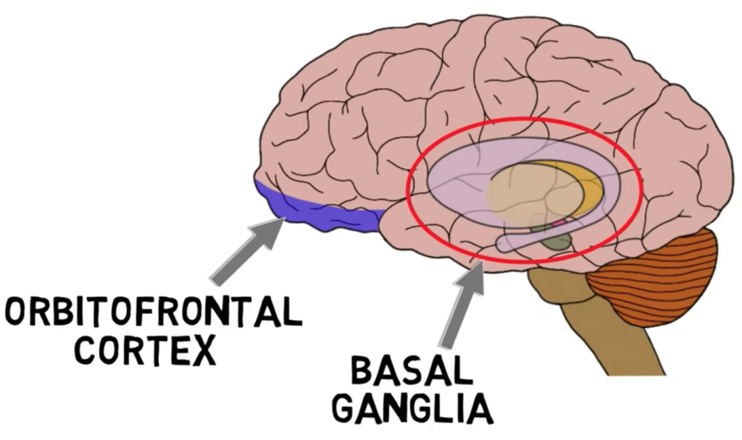

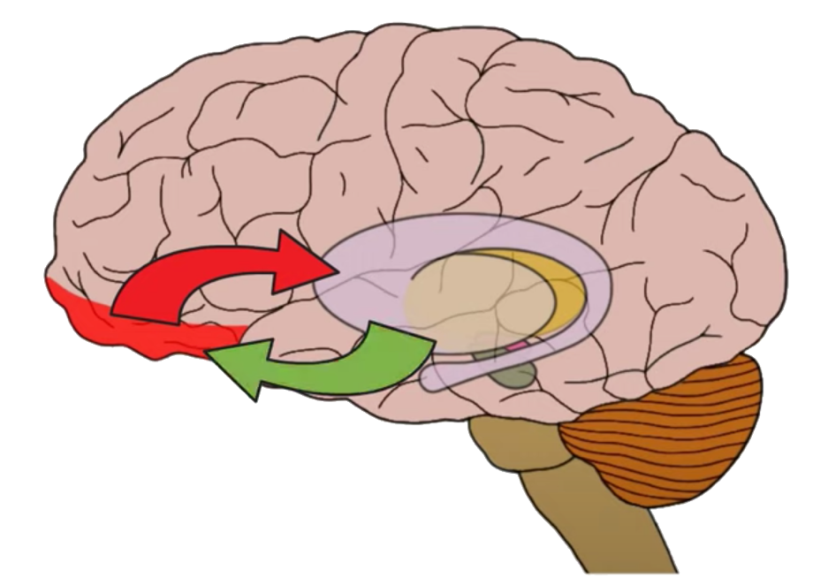

Increased activity in the orbitofrontal cortex is associated with concerns that lead to obsessive thoughts. The orbitofrontal cortex communicates with the basal ganglia. The basal ganglia and the orbitofrontal cortices pathway is simplified by viewing it as an excitatory direct pathway and an inhibitory indirect pathway between them. In OCD, the direct pathway is over-excitable, which increases the likelihood of both obsessions and compulsions (Pauls, 2013).

## **Brain imaging:**

Increased blood flow in the:

* Frontal lobes (fronto-orbitoal gyrus)
* Basal ganglia (caudate)
* Anterior cingulate gyrus

Interestingly imaging has shown the caudate even with the increased blood flow is reduced in size bilaterally. These brain abnormalities are normalized with effective pharmacotherapy.

**References:**

(1) Brock, H. and Hany, M. (2020). Obsessive-Compulsive Disorder (OCD). [online] PubMed. Available at: https://www.ncbi.nlm.nih.gov/books/NBK553162/.

(3) Pauls DL, Abramovitch A, Rauch SL, Geller DA. Obsessive-compulsive disorder: an integrative genetic and neurobiological perspective. Nat Rev Neurosci. 2014 Jun;15(6):410-24. doi: 10.1038/nrn3746. PMID: 24840803.

(2) www.youtube.com. (n.d.). 2-Minute Neuroscience: Obsessive-Compulsive Disorder (OCD). [online] Available at: https://www.youtube.com/watch?v=BJshegpcFv8&t=114s [Accessed 31 Dec. 2022].

### 3.9.7 Major depressive disorders

## **Major Depressive Disorders**

Major depressive disorders (MDD) are managed and treated inadequately for a large proportion due to a lack of clear neurobiological research. Depression has a significant neurobiological consequence involving both structural, functional and molecular level alterations to multiple areas of the brain (Nestler, 2002).

Milder cases of ‘depression’ are classified as “dysthymia,” although there is no clear distinction between the two.

One in six people will experience MDD at some point in their lifetime, with women experiencing it nearly twice as frequently as men. MDD has a complex aetiology with a heritability of about 35%, according to estimates. Environmental variables such as childhood sexual, physical, or emotional abuse are very closely linked to the likelihood of having MDD. All facets of the disease cannot be explained by any known single mechanism.

## DSM vs ICD

The criteria for the diagnosis of Major Depressive Disorder (MDD) in the DSM-5 and ICD-11 are similar but have some differences.

The DSM-5 criteria for MDD require the presence of at least five symptoms of depression, including at least one of the following two core symptoms: depressed mood or loss of interest or pleasure. The additional symptoms can include changes in appetite and weight, insomnia or hypersomnia, psychomotor agitation or retardation, fatigue or loss of energy, feelings of worthlessness or excessive guilt, diminished ability to think or concentrate, or recurrent thoughts of death or suicide. The symptoms must be persistent (nearly every day) for at least two weeks and cause significant distress or impairment in functioning to be considered MDD (American Psychiatric Association, 2013).

The ICD-11 criteria for MDD require the presence of at least two core symptoms of depression, including either low mood or loss of interest or pleasure, and at least two additional symptoms, including changes in appetite or weight, sleep disturbance, psychomotor agitation or retardation, fatigue or loss of energy, feelings of guilt or worthlessness, diminished ability to think or concentrate, or recurrent thoughts of death or suicide. The symptoms must persist for at least two weeks and cause significant distress or functional impairment to be considered MDD (World Health Organization, 2019).

The main difference between the DSM-5 and ICD-11 criteria is the number of symptoms required for diagnosis. The DSM-5 requires the presence of at least five symptoms, while the ICD-11 requires the presence of at least two core symptoms and two additional symptoms.

A comparison of the DSM-5 and ICD-11 criteria for Major Depressive Disorder is presented in the table below:

| **DSM-5 Criteria for Major Depressive Disorder:** | **ICD-11 Criteria for Major Depressive Disorder:** |
| --- | --- |
| At least five symptoms of depression | At least two core symptoms of depression and two additional symptoms |
| At least one of the two core symptoms: depressed mood or loss of interest or pleasure | Either low mood or loss of interest or pleasure as a core symptom |
| Changes in appetite and weight | Changes in appetite or weight |
| Insomnia or hypersomnia | Sleep disturbance |
| Psychomotor agitation or retardation | Psychomotor agitation or retardation |
| Fatigue or loss of energy | Fatigue or loss of energy |
| Feelings of worthlessness or excessive guilt | Feelings of guilt or worthlessness |
| Diminished ability to think or concentrate | Diminished ability to think or concentrate |
| Recurrent thoughts of death or suicide | Recurrent thoughts of death or suicide |
| Symptoms must be persistent (nearly every day) for at least two weeks | Symptoms must persist for at least two weeks |
| Significant distress or impairment in functioning | Significant distress or functional impairment |

## **White Matter Hyperintensities**

There is a strong association between mood disorders and the number/severity of focal signal hyperintensities on MRI T2-weighted images. White matter hyperintensities occur in the deep subcortical white matter, basal ganglia and periventricular tissue. They are seen in both bipolar and unipolar mood disorders. White matter hyperintensities confer a poor prognosis in both MDD and bipolar disorder.

## **Pathophysiology of Depression**

A unified theory of depression conceptualises MDD as a complex matrix of genetic, epigenetic, and environmental factors that are interwoven with personality vulnerabilities that predispose an individual to process biases, belief formation, and stress reactivity that precipitates pathophysiological mechanisms across multiple levels of our biology: molecular, cellular, and behavioural levels (Beck and Bredemeier, 2016).

However, MDD is related to functional abnormalities in certain brain circuits, including the affective-salience network and the cognitive control network, as well as changes in regional brain sizes, particularly the hippocampus. Additionally, MDD is characterised by abnormalities in the primary neurobiological stress-responsive systems, such as the immune system and the hypothalamic-pituitary-adrenal axis. Psychotherapy and drug therapy make up the majority of management. The treatment having the strongest empirical support for patients who are treatment-resistant and who have not improved after multiple augmentations or combination treatment efforts is electroconvulsive therapy.

## **Monoamine hypothesis:**

The monoamine hypothesis of depression has guided the pharmaceutical industry to the development of multiple antidepressants. Given the suboptimal efficacy of SSRIs and their delayed onset of efficacy, a reasonable conclusion to make is that serotonin deficiency alone is too simplistic (Racagni, 2008).

Stahl’s Essential Psychopharmacology states “there is no clear and convincing evidence that monoamine deficiency accounts for depression (Stahl, 2013).

## **Dysregulation of the hippocampus and the hypothalamic-pituitary-adrenal axis:**

The brain reacts to acute/chronic stress by activation of the hypothalamic-pituitary-adrenal (HPA) axis:

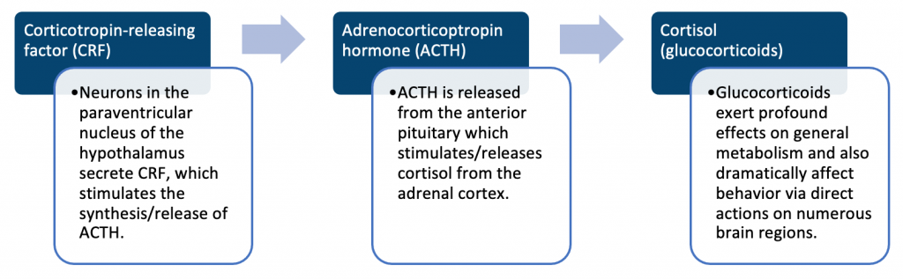

(Maletic, 2007)

## **Neurotransmitters in MDD recovery:**

Selective serotonin reuptake inhibitors and norepinephrine reuptake inhibitors increased their respective monoamine levels supposedly in the brain. These monoamine reuptake inhibitors indirectly lead to an increase in brain-derived neurotrophic factor synthesis, enhanced growth hormone sensitivity and reduced cytokine signalling. This is thought to be one mechanism that produces the therapeutic response seen in these antidepressants (Duman, 1997).

**References:**

(1) (APA) American Psychiatric Association. (2013). Diagnostic and statistical manual of mental disorders (5th ed.). Arlington, VA: American Psychiatric Publishing.

(2) Beck, A.T. and Bredemeier, K. (2016). A Unified Model of Depression. Clinical Psychological Science, 4(4), pp.596–619. doi:10.1177/2167702616628523.

(3) Duman RS, Heninger GR, Nestler EJ. A molecular and cellular theory of depression. Arch Gen Psychiatry. 1997;54:597–606.

(4) Maletic, V., Robinson, M., Oakes, T., Iyengar, S., Ball, S.G. and Russell, J. (2007). Neurobiology of depression: an integrated view of key findings. International Journal of Clinical Practice, [online] 61(12), pp.2030–2040. doi:10.1111/j.1742-1241.2007.01602.x.

(5) Nestler, E.J., Barrot, M., DiLeone, R.J., Eisch, A.J., Gold, S.J. and Monteggia, L.M. (2002). Neurobiology of Depression. Neuron, [online] 34(1), pp.13–25. doi:10.1016/s0896-6273(02)00653-0.

(6) Stahl, S.M. (2013). Stahl’s essential psychopharmacology: Neuroscientific basis and practical application. 4th ed. Cambridge ; New York: Cambridge University Press.

‌(7) Racagni, G. and Popoli, M. (2008). Cellular and molecular mechanisms in the long-term action of antidepressants. Dialogues in Clinical Neuroscience, [online] 10(4), pp.385–400. Available at: https://www.ncbi.nlm.nih.gov/pmc/articles/PMC3181899/.

(8) World Health Organization. (2019). International Classification of Diseases, 11th Revision (ICD-11). Geneva, Switzerland: World Health Organization.

### 3.9.8 Bipolar affective disorder

## **Bipolar** **Affective Disorder**

Extreme mood swings and devastating depressions are symptoms of the mental disease that is bipolar affective disorder (BPAD). Manias can be extremely intense and endure for extended periods of time. Even more severe and lasting for weeks or even months are the lows, or depression. Although depressive episodes are frequent, at least one-lifetime manic episode must occur for bipolar disorder type 1 to be present. A minimum of one hypomanic episode and one severe depressive episode are required for bipolar 2 disorder to be diagnosed (Grande et al., 2016).

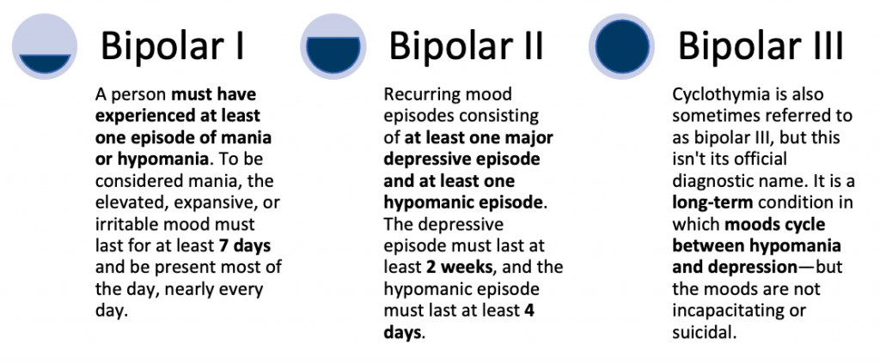

## **Symptoms**:

**Mania**: When someone goes through this, their mood can become excessively high and linger for several days or even weeks. They might need very little sleep at this point and might be overly energised and confident. Mania is more frequently linked to dangerous actions including spending binges, snap judgements, and reckless sex**.**

**Depression**: Low mood, weariness, and loss of interest in activities are signs of depression. Additionally, emptiness, remorse, and feelings of worthlessness can be experienced by those who have bipolar disorder. Oversleeping, poor appetite and difficulties concentrating are more frequently linked to it. Suicidal ideas and actions may result from this.

## DSM vs ICD

Here’s a comparison of DSM-5 and ICD-11 diagnostic criteria for Bipolar Disorder in table format:

| **Criteria:** | **DSM-5:** | **ICD-11:** |
| --- | --- | --- |
| **Presence of manic/hypomanic episodes** | ✓ | ✓ |
| **Presence of depressive episodes** | ✓ | ✓ |
| **Exclusion of Schizophrenia, Schizophreniform Disorder, Delusional Disorder, or Psychotic Disorder Not Otherwise Specified (for manic/hypomanic episodes)** | ✓ | ✓ |
| **Exclusion of Schizophrenia, Schizophreniform Disorder, Delusional Disorder, Psychotic Disorder Not Otherwise Specified, or Psychotic Disorder Due to a General Medical Condition (for depressive episodes)** | ✓ | – |
| **Causation of clinically significant distress or impairment in social, occupational, or other important areas of functioning** | – | ✓ |

It’s important to note that both the DSM-5 and ICD-11 provide specific criteria for the diagnosis of Bipolar Disorder and that the specific criteria may vary based on the severity and type of the disorder.

## **Neurobiology of BPAD**

Even with significant advances we still lack an understanding of the underlying neurobiology of bipolar disorder. Our current diagnostic schema for bipolar disorder is based upon descriptive terms as opposed to clear causal mechanisms.

MRI imaging has demonstrated that the lateral ventricles of patients suffering from an episode were significantly larger. The increased volume of the lateral ventricles directly correlated with the number of manic episodes the patient had suffered. Studies suggest that bipolar illness may be progressive and deleterious, thus contributing to brain tissue deterioration with recurrent relapses (Maletic, 2014).

Functional brain changes in BPAD:

* Increased responsiveness of limbic brain regions involving emotional regulation.
* The dorsolateral and dorsomedial prefrontal cortex and anterior cingulate cortex both show reduced responsiveness.
* The amygdala, ventrolateral prefrontal cortex and ventral anterior cingulate cortex all show increased responsiveness.

(Langan, 2009)

## **Hypothalamic-pituitary axis dysfunction**:

ACTH and cortisol response dysregulation following CRH stimulation has been described in bipolar patients. Changes in CRH secretion appear clinically prior to manic or hypomanic symptoms.

In bipolar patients, pituitary hypoactivity has been found. The degree of neuroendocrine disruption is substantially associated with the intensity of the manic episode.

**References**:

(1) Grande, I., Berk, M., Birmaher, B., & Vieta, E. (2016). Bipolar disorder. The Lancet, 387(10027), 1561-1572.

(2) Langan C, McDonald C. Neurobiological trait abnormalities in bipolar disorder. Mol Psychiatry (2009) 14:833–46 10.1038/mp.2009.39

(3) Maletic, V. and Raison, C. (2014). Integrated Neurobiology of Bipolar Disorder. Frontiers in Psychiatry, [online] 5. doi:10.3389/fpsyt.2014.00098.

### 3.9.9 Schizophrenia and psychosis

## **Schizophrenia**

Schizophrenia is a chronic disorder characterised by psychosis and a deterioration in functionality. It is a complex condition that affects millions of people globally. A diagnosis of schizophrenia requires the presence of two or more symptoms, at least one of which must be a positive symptom.

**Positive symptoms:**

* Hallucinations
* Delusions
* Disorganised speech
* Abnormal movements

**Negative symptoms:**

* Flattened affect
* Social withdrawal
* Anhedonia
* Apathy
* Lack of emotions

According to the Diagnostic and Statistical Manual of Mental Disorders, 5th Edition (DSM-5), schizophrenia is diagnosed when symptoms cause a decrease in both social and occupational functioning for at least six months.

## **First-rank symptoms:**

The first-rank symptoms of schizophrenia, also known as Schneider’s first-rank symptoms, are a set of symptoms that have been described as being highly specific for the diagnosis of schizophrenia. Here’s a table of Schneider’s first-rank symptoms:

| **Symptom:** | **Description:** |
| --- | --- |
| **Auditory hallucinations** | Hearing voices or sounds that are not physically present |
| **Thought insertion or withdrawal** | The belief that one’s thoughts are being inserted into or removed from one’s mind |
| **Delusions of control** | The belief that one’s actions or feelings are being controlled by an outside force |
| **Delusions of reference** | The belief that neutral events have a special and personal meaning |
| **Somatic passivity** | The belief that one’s body or bodily sensations are being controlled by an outside force |

It’s important to note that not all individuals with schizophrenia experience these symptoms and that these symptoms can also be present in other psychiatric disorders. A proper diagnosis should always be made by a qualified mental health professional.

## **DSM vs ICD:**

Here’s a comparison of DSM-5 and ICD-11 diagnostic criteria for Schizophrenia in table format:

| **Criteria:** | **DSM-5:** | **ICD-11:** |
| --- | --- | --- |
| **Two or more of the following symptoms present for at least one month** | ✓ | ✓ |
| – Delusions |  |  |
| – Hallucinations |  |  |
| – Disorganized speech (e.g., frequent derailment or incoherence) |  |  |
| – Grossly disorganized or catatonic behaviour |  |  |
| – Negative symptoms (e.g., diminished emotional expression or avolition) |  |  |
| **Symptoms cause clinically significant distress or impairment in social, occupational, or other important areas of functioning** | ✓ | ✓ |
| **Symptoms are not due to a medical condition or substance use** | ✓ | ✓ |
| **If mood episodes have occurred concurrently with the active-phase symptoms, their total duration has been brief relative to the duration of the active-phase symptoms** | ✓ | – |
| **Schizophrenia has never been absent for more than a month at a time** | ✓ | – |

## **Gross changes:**

* A reduction in cerebral hemisphere weight, length and volume.
* Enlargement of the lateral ventricles (especially the temporal horns).
* White matter reductions in the parahippocampal gyrus or hippocampus.
* Basal ganglia volume reduction.
* Planum temporal is a highly lateralized brain structure involved with language. In schizophrenic patients, there is a consistent reversal of the normal left-larger-than-right asymmetry of the planum temporal surface is noted.

(Golan, 2017)

## **Histological changes:**

* Reduced cell number or size in the hippocampus and the dorsolateral prefrontal cortex.
* Increased neuronal density.

## **Dopamine dysfunction:**

Dopamine dysfunction remains the key factor in psychotic symptoms. Presynaptic dopamine dysfunction appears to mediate psychosis in schizophrenia. In patients with schizophrenia, alterations in dopamine function within the striatum cause delusions and psychosis

There are four dopaminergic pathways relevant to the pharmacology of antipsychotics in the treatment of schizophrenia are: – The mesolimbic pathway (positive symptoms) – The mesocortical pathway (negative symptoms) – The nigrostriatal pathway (extrapyramidal symptoms and tardive dyskinesia) – The tuberoinfundibular pathway (hyperprolactinemia) (Stahl, 2008).

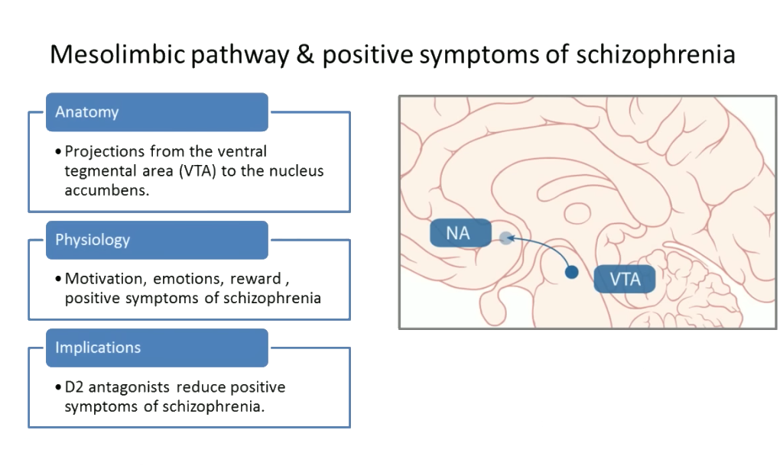

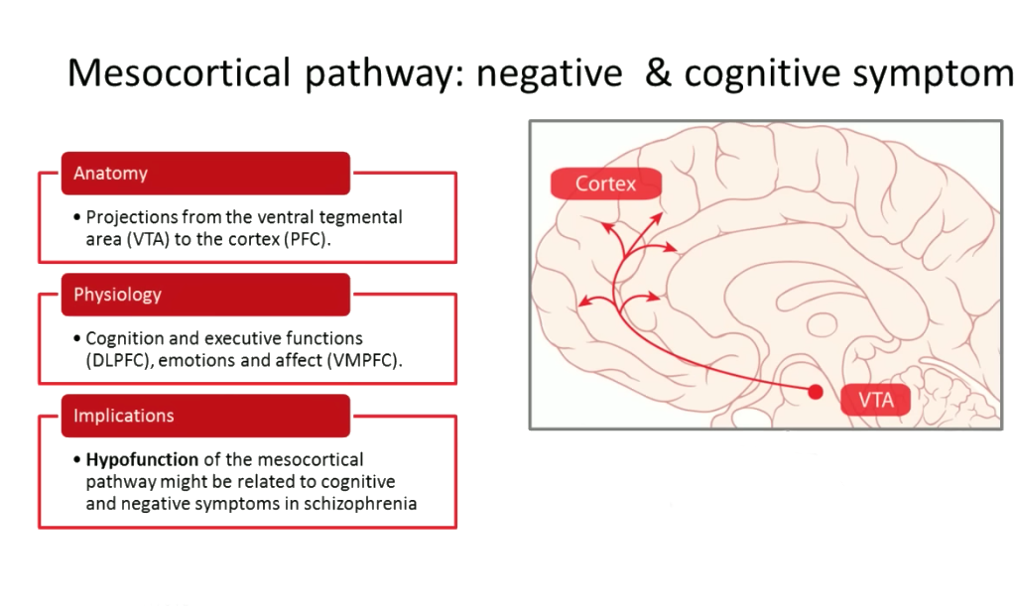

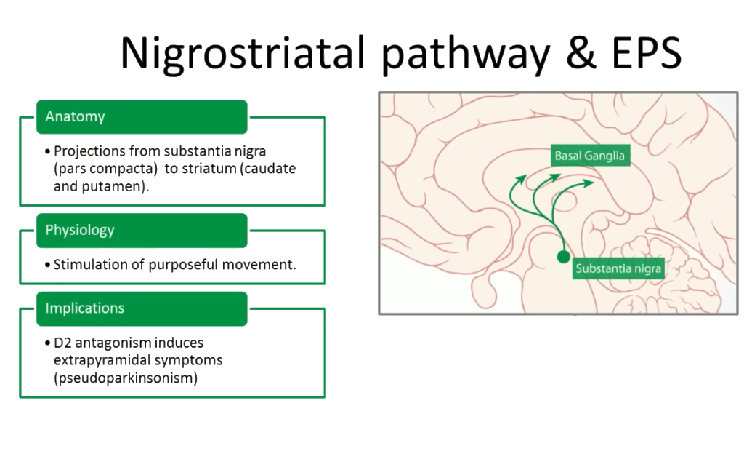

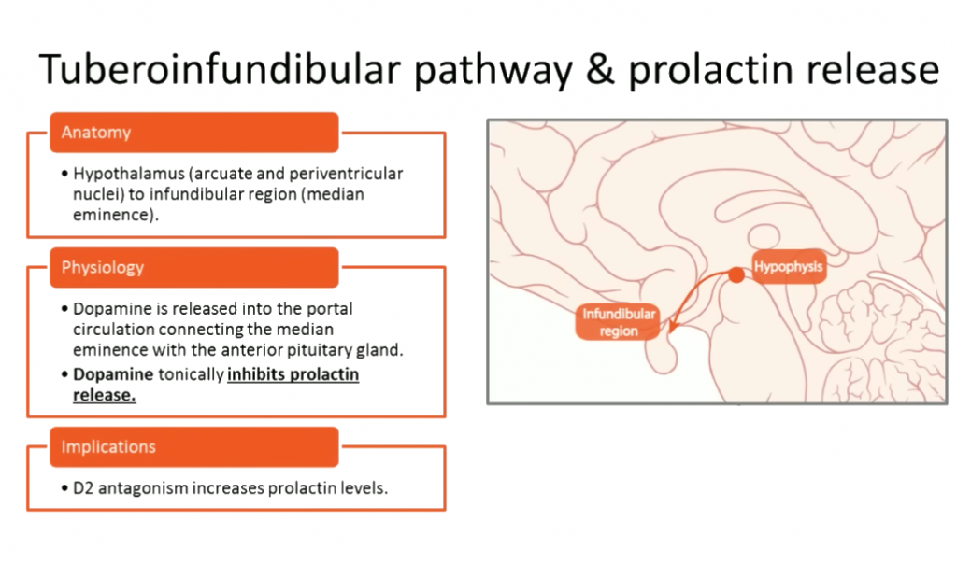

(Guzman, Psychopharmacology Institute)

## **Psychosis**

The term **“**psychosis**“** is used to characterise mental disorders in which some sense of reality has been lost. This type of illness is referred to as a psychotic episode. Psychosis is characterized by symptoms such as delusions, hallucinations, disordered thinking, and disordered behaviour. A person’s ideas and perceptions are distorted while they are experiencing psychosis, and they could find it difficult to distinguish between what is genuine and what isn’t.

People from many walks of life are susceptible to psychosis. Psychosis frequently starts in a person’s late teens to mid-twenties. Each year, there are over 100,000 new instances of psychosis in the United States. In the United Kingdom, psychosis is a relatively common condition, with an estimated 1 in 100 people experiencing psychosis at some point in their lifetime.

Before psychosis takes hold, a person’s behaviour will typically shift. The following behaviours are red flags for psychosis: Delusions (false beliefs) and hallucinations are signs of psychosis (seeing or hearing things that others do not see or hear). Other signs include inappropriate behaviour and speech that is illogical or incomprehensible. Additionally, a person going through a psychotic episode may struggle with sadness, anxiety, sleep issues, social disengagement, lack of motivation, and general difficulties in functioning.

Psychosis can have a variety of causes. Psychosis could be a sign of a mental condition like bipolar disorder or schizophrenia. However, a person could go through psychosis without ever being given a schizophrenia or other mental disease diagnosis. Other factors include lack of sleep, general health issues, the overuse of alcohol or other drugs like marijuana, as well as some prescription prescriptions.

**References:**

(1) Golan, D.E., Armstrong, E.J. and Armstrong, A.W. (2017). Principles of pharmacology: the pathophysiologic basis of drug therapy. Philadelphia: Wolters Kluwer.

(2) psychopharmacologyinstitute.com. (n.d.). Psychopharmacology Institute. [online] Available at: https://psychopharmacologyinstitute.com/publication/the-four-dopamine-pathways-relevant-to-antipsychotics-pharmacology-2096.

(3) Stahl, S.M. (2008). Stahl’s essential psychopharmacology online: neuroscientific basis and practical applications. Cambridge: Cambridge University Press.

### 3.9.10 Neurocognitive deficits in psychotic disorders

## **Neurocognitive Deficits in Psychotic Disorders**

Neurocognitive deficits are a core feature of psychotic disorders, such as schizophrenia, and can have a significant impact on an individual’s daily functioning and quality of life. They include impairments in domains such as attention, memory, executive function, language, and perception, and are believed to play a role in the manifestation of symptoms such as delusions and hallucinations (Green, 2000).

One theory posits that neurocognitive deficits in psychotic disorders result from a disruption in the normal development and functioning of brain regions involved in these domains. This disruption may be caused by a combination of genetic, environmental, and brain-based factors.

Studies have consistently demonstrated that individuals with psychotic disorders have lower levels of performance on various neurocognitive tests compared to healthy individuals and that these impairments persist even when individuals are in remission. Furthermore, research has suggested that the severity of neurocognitive deficits is associated with a range of negative outcomes, such as the increased risk of relapse, lower levels of social and occupational functioning, and reduced quality of life (Keefe, 2004) (Nuechterlein, 2008).

In terms of treatment, cognitive training and rehabilitation programs have shown some promising results in improving neurocognitive functioning in individuals with psychotic disorders. However, more research is needed to determine the most effective methods and to understand the underlying mechanisms by which these interventions lead to improvement.

In conclusion, neurocognitive deficits are a significant aspect of psychotic disorders and are associated with a range of negative outcomes. Further research is needed to better understand these impairments and to develop effective treatment and rehabilitation strategies (Sheffield, 2018).

**References:**

(1) Sheffield, J.M., Karcher, N.R. and Barch, D.M. (2018). Cognitive Deficits in Psychotic Disorders: A Lifespan Perspective. Neuropsychology Review, 28(4), pp.509–533. doi:10.1007/s11065-018-9388-2.

(2) Green, M. F., Kern, R. S., Braff, D. L., & Mintz, J. (2000). Neurocognitive deficits and functional outcome in schizophrenia: are we measuring the “right stuff”?. Schizophrenia bulletin, 26(1), 119-136.

(3) Keefe, R. S., & Fenton, W. S. (2004). Theories of cognitive impairment in schizophrenia: a conceptual review. Schizophrenia bulletin, 30(3), 379-392.

(4) Nuechterlein, K. H., Green, M. F., Kern, R. S., Baade, L. E., Barch, D. M., Cohen, J. D., … & Marder, S. R. (2008). The MATRICS Consensus Cognitive Battery, part 1: test selection, reliability, and validity. American Journal of Psychiatry, 165(2), 203-213.

### 3.9.11 Self-harm and suicidality

## **Self-Harm and Suicidality**

Self-harm and suicidality are significant public health problems that are associated with significant psychological, social, and economic costs. They are complex phenomena that involve multiple biological, psychological, and environmental factors. Understanding the neurobiology of self-harm and suicidality is essential for the development of effective prevention and treatment strategies (Mann, 2003).

Self-harm is described as the deliberate act of causing harm to oneself. People who self-harm frequently don’t inform their family or friends about it and inflict their injuries in places they can conceal. Most persons who injure themselves do not intend to commit suicide. Self-injury, another term for self-harm, is non-suicidal self-injury.

The neurobiological basis of self-harm and suicidality is thought to involve the interaction of several key brain systems, including the serotonergic, dopaminergic, and noradrenergic systems. Abnormalities in these systems have been linked to self-harm and suicidality in various studies.

|  |  |
| --- | --- |
| **Neurological basis:** | **System:** |
| **Serotonergic system** | The serotonergic system is involved in regulating mood, appetite, sleep, and impulse control. Serotonin deficiency has been linked to an increased risk for self-harm and suicidality, and serotonin-based treatments, such as selective serotonin reuptake inhibitors (SSRIs), are commonly used to treat individuals with suicidal behaviour. |
| **Dopaminergic system** | The dopaminergic system is involved in regulating motivation and reward. Abnormalities in the dopamine system, including dopamine receptor function, have been linked to self-harm and suicidality, and dopamine-based treatments, such as atypical antipsychotics, have been found to be effective in reducing suicidality. |
| **Noradrenergic system** | The noradrenergic system is involved in regulating arousal and stress responsiveness. Abnormalities in the noradrenergic system have been linked to increased risk for self-harm and suicidality, and noradrenergic-based treatments, such as tricyclic antidepressants and beta-blockers, have been found to be effective in reducing self-harm. |

(Oquendo, 2004), (Rinne, 2002), (Dwivedi, 2010).

In addition to these key brain systems, research has also suggested that the integration of multiple levels of analysis, including genetic, epigenetic, brain imaging, and behavioural data, can provide a more comprehensive understanding of the neurobiology of self-harm and suicidality.

In conclusion, the neurobiology of self-harm and suicidality is a complex and multi-faceted phenomenon that involves the interaction of several key brain systems. Further research is needed to better understand the underlying mechanisms and to develop effective treatments for individuals who engage in self-harm and suicidality.

## **Behavioural signs**:

Avoid engaging in activities that expose the body, such as swimming, and dress inadequately for the weather, such as by wearing long sleeves in the summer.

## **Psychological sign**s:

Expressing anxious feelings

Exhibiting depressive feelings

## **Suicidality**:

When someone kills themselves intentionally in an attempt to end their life, it is considered suicide.

When someone makes an effort to commit suicide but does not succeed, they have attempted suicide.

When discussing suicide and suicide attempts, avoid using words like “committing suicide,” “successful suicide,” or “failed suicide,” as these expressions frequently have negative connotations.

There are several **warning** **signs** that someone may be at extreme risk of trying to commit suicide.

* Expressing a desire to end one’s life or commit suicide.
* Talking about feeling stuck or believing there are no solutions talking about feeling empty, hopeless, or having no reason to live.
* Having excruciating bodily or emotional anguish.
* Expressing concerns about burdening others.

Suicide affects everyone equally. Risk can apply to people of all sexes, ages, and races. Suicidal behaviour is complicated, and no one factor causes it.

The primary suicide **risk factors**are:

* Depression, other mental illnesses, or an addiction
* Enduring pain
* Previous suicide attempts
* Family history of substance abuse or mental illness

**References:**

(1) Mann, J. J. (2003). Neurobiology of suicide and suicide prevention. CNS spectrums, 8(12 Suppl 15), 9-14.

(2) Oquendo, M. A., Galfalvy, H. C., Russo, S., Ellis, S. P., Grunebaum, M. F., Burke, A. K., … & Mann, J. J. (2004). Association of low neurotransmitter metabolites in cerebrospinal fluid with increased risk for completed suicide in patients with major depressive disorder. American Journal of Psychiatry, 161(3), 578-585.

(3) Rinne, T., de Kloet, E. R., & Wouters, L. (2002). Role of mineralocorticoid and glucocorticoid receptors in stress-related limbic activation. Neuroscience & Biobehavioral Reviews, 26(4), 365-384.

(4) Dwivedi, Y. (2010). Altered brain-derived neurotrophic factor signaling pathway in suicide brain: role of protein kinase A. Journal of Psychiatric Research, 44(14), 930-938.

### 3.9.12 Medically unexplained symptoms

## **Medically Unexplained Symptoms**

In primary care, medically unexplained symptoms (MUS) are often reported. Between 25-50% of all cases when MUS are brought up in primary care, there is no evidence to suggest an underlying physical illness. MUS are a diverse range of symptoms that might include practically all of the symptoms that people report to their general practitioner. MUS also refers to functional somatic syndromes, such as irritable bowel syndrome (IBS), fibromyalgia, and chronic fatigue syndrome (CFS), as well as symptoms resulting from a particular somatic disease that is more severe, persistent, or severely restricted functioning than anticipated, based on (objective) disease parameters.

MUS is characterised by functional restrictions and an increase in the number and duration of symptoms, ranging from mild to severe. The majority of the time, MUS are transient and self-limiting, but on occasion, MUS persist, necessitating in-depth examinations, referrals, and exorbitant medical expenses. Therefore, it is crucial to identify MUS as soon as possible. Despite the fact that about 2.5% of patients in routine practice fit the requirements for chronic or severe MUS (such multiple symptoms that persist for longer than 3 months resulting in severe functional limitations) (Kirmayer et al., 2004).

|  |  |
| --- | --- |
| **Medically unexplained conditions:** | **Summary:** |
| **Dissociative (Conversion) Disorder** | A common theme is a partial or complete loss of the typical integration between memories of the past, awareness of identity and immediate sensations, and control of bodily movements. Somatic manifestations of psychiatric illness are more common in the elderly, children, lower social classes and Eastern countries. |
| **Dissociative Amnesia** | A core feature is a patchy loss of memory, usually of recent traumatic events. Perplexity, distress, and varying degrees of attention-seeking behaviour may be evident. Thought to occur more commonly in women and more often is younger rather than older adults. |
| **Dissociative Fugue** | It includes all of the characteristics of dissociative amnesia plus an apparently deliberate journey away from home or job, during which self-care is maintained. In some cases, a new identity is assumed. Often a history of disturbing relationships with parents in childhood and are found to be habitual liars. |
| **La Belle Indifference** | A French term that translates to “beautiful ignorance.” La belle indifference is a paradoxical absence or indifference of psychological distress despite having a serious medical illness or symptoms related to a health condition. |
| **Münchausen** **Syndrome** | Previously referred to as ‘hospital addiction’ syndrome. Generally, these patients have severe personality difficulties. Patients present to the hospital with symptoms suggestive of serious physical illness. There needs to be evidence of conscious stimulation of symptoms and deception of medical staff. Primary and secondary gains. |

(Rosendal, 2017)

|  |  |
| --- | --- |
| **Somatoform disorders:** | **Summary**: |
| **Somatization Disorder** | A disorder characterized by multiple, recurrent, and frequent changing physical symptoms, usually present for at least two years. For diagnosis, the patient needs to have refused to accept reassurance and there needs to be some social/occupational impairment. |
| **Hypochondriacal Disorder** | Preoccupation with the possibility of having one or more serious and progressive physical disorders, and even disfigurement. Non-delusional dysmorphophobia |
| **Somatoform Pain Disorder** | Inconsistent with the anatomical distribution of the nervous system. May have symbolic significance eg. chest pain where mother died of myocardial infarction. |

(D’Souza, 2019)

**References:**

(1) D’Souza, R.S. and Hooten, W.M. (2019). Somatic Syndrome Disorders. [online] Nih.gov. Available at: https://www.ncbi.nlm.nih.gov/books/NBK532253/.

(2) Kirmayer, L. J., Groleau, D., Looper, K. J., & Dao, M. D. (2004). Explaining medically unexplained symptoms. The Canadian journal of psychiatry, 49(10), 663-672.

(3) Rosendal, M., Olde Hartman, T.C., Aamland, A., van der Horst, H., Lucassen, P., Budtz-Lilly, A. and Burton, C. (2017). ‘Medically unexplained’ symptoms and symptom disorders in primary care: prognosis-based recognition and classification. BMC Family Practice, 18(1). doi:10.1186/s12875-017-0592-6.

### 3.9.13 Delirium

## **Delirium**

Delirium is a complex and severe neuropsychiatric syndrome characterized by acute changes in consciousness, cognition, and perception. It is a medical emergency that can occur as a result of a variety of underlying medical, surgical, or psychiatric conditions. Delirium is associated with significant morbidity and mortality, and the underlying neurobiology is not well understood.

The integrated neurobiology of delirium involves the interaction of several key brain systems, including the basal ganglia, thalamus, cortex, and limbic system. Abnormalities in these systems can result in disruptions in consciousness, cognition, and perception.

The basal ganglia and thalamus play a critical role in regulating attention, arousal, and cognition. Disruptions in the function of these structures can result in confusion, disorientation, and other cognitive disturbances.

The cortex is responsible for higher-level cognitive functions such as memory, attention, and perception. In delirium, the cortex is often impacted by a variety of factors, including reduced blood flow, oxidative stress, and inflammation. These disruptions can result in changes in perception, disordered thinking, and altered consciousness.

The limbic system is involved in the regulation of emotion, motivation, and reward. Abnormalities in the limbic system can result in agitation, aggression, and other behavioural disturbances.

In summary, the neurobiology of delirium is a complex and multi-faceted phenomenon that involves the interaction of several key brain systems. Understanding the underlying neurobiology is important for the development of effective prevention and treatment strategies.

Delirium is associated with significant morbidity and mortality in the UK. According to recent studies, delirium is a common complication in older adults, particularly those who are hospitalized, and it is associated with a number of adverse outcomes.

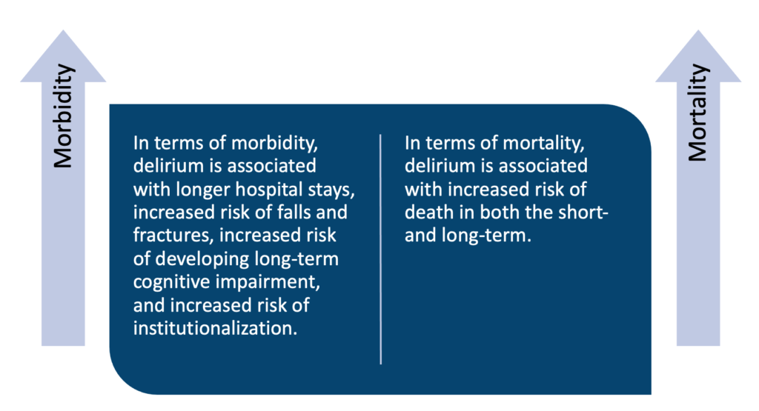

A systematic review by Holroyd-Leduc et al. (2010) found that delirium was associated with a two-fold increase in the risk of death in older adults and that this risk remained elevated for up to one year after the episode of delirium. Delirium is a serious condition with significant consequences for the health and well-being of patients in the UK. Effective prevention and management strategies are crucial for reducing the morbidity and mortality associated with delirium.

## **Symptoms**:

An individual suffering from delirium may be:

* Be prone to distraction
* Be less conscious of their location or the time (disorientation)
* Being suddenly incapable of performing a task as well as usual (for example, walking or eating)
* Be incapable of understanding or following a discourse
* Have erratic mood swings and hallucinations, which are the seeing or hearing of unreal but frightful objects

## **Types of Delirium**:

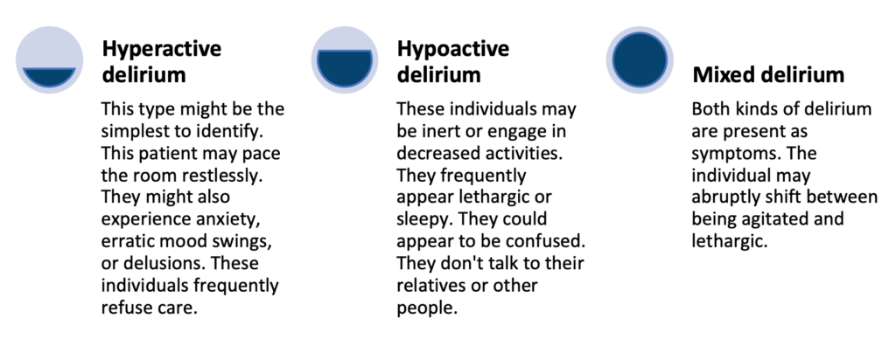

(Wilson, 2020)

**References:**

(1) Holroyd-Leduc, J., Gruneir, A., & Moineddin, R. (2010). Delirium in older adults: a systematic review. The Lancet, 375(9719), 954-962.

(2) Meagher, D. J., & Leonard, M. (2011). Delirium: an overview of its epidemiology, pathogenesis, diagnosis and management. Irish Journal of Psychological Medicine, 28(2), 61-70.

(3) Robinson, T. N., & Inouye, S. K. (2007). Delirium in older adults: an overview. American Journal of Geriatric Psychiatry, 15(9), 710-717.

(4) Trzepacz, P. T. (2001). Delirium: a synthesis of clinical and neurobiological perspectives. Journal of Psychiatry & Neuroscience, 26(5), 271-279.

(5) Wilson, J.E., Mart, M.F., Cunningham, C., Shehabi, Y., Girard, T.D., MacLullich, A.M.J., Slooter, A.J.C. and Ely, E.W. (2020). Delirium. Nature Reviews Disease Primers, [online] 6(1), pp.1–26. doi:https://doi.org/10.1038/s41572-020-00223-4.

## 3.10 Neurodegeneration

### 3.10.1 Neuropathology of neurodegeneration and surrounding controversies

## **Neuropathology of Neurodegeneration**

Neurodegeneration refers to the gradual loss of structure or function of neurons, resulting in cognitive or motor deficits. It is a common feature of several neurodegenerative diseases, including Alzheimer’s disease, Parkinson’s disease, Huntington’s disease, and Amyotrophic lateral sclerosis (ALS). Understanding the neuropathology of neurodegeneration is essential to understanding the underlying mechanisms of these diseases and developing effective treatments.

At the cellular level, neurodegeneration is characterized by the presence of neurofibrillary tangles, Lewy bodies, and inclusions. Neurofibrillary tangles are aggregates of hyperphosphorylated tau protein, which is normally present in the cytoplasm of neurons. In Alzheimer’s disease, neurofibrillary tangles are found in the hippocampus and cortex, where they are thought to disrupt neuronal function and contribute to cognitive decline. Lewy bodies are protein inclusions found in the neurons of Parkinson’s disease patients and are composed of aggregated alpha-synuclein. The formation of Lewy bodies is thought to be a result of oxidative stress and inflammation, leading to cell death and the progressive degeneration of dopamine-producing neurons in the substantia nigra.

Another hallmark of neurodegeneration is the presence of amyloid plaques, which are extracellular deposits of beta-amyloid protein. In Alzheimer’s disease, amyloid plaques are thought to be a result of the accumulation of beta-amyloid peptides, which are cleaved from the amyloid precursor protein. The accumulation of amyloid plaques is thought to be toxic to neurons and contributes to cognitive decline.

Inflammation also plays a role in neurodegeneration. Chronic low-grade inflammation has been observed in several neurodegenerative diseases, including Alzheimer’s disease, Parkinson’s disease, and ALS. The precise mechanisms by which inflammation contributes to neurodegeneration are not well understood, but it is thought to be related to oxidative stress, excitotoxicity, and the activation of microglia, which are resident immune cells in the central nervous system.

In addition to these cellular changes, neurodegeneration is also associated with changes in neurotransmitter systems. In Parkinson’s disease, for example, the loss of dopamine-producing neurons leads to decreased dopamine levels, leading to motor symptoms such as tremors and rigidity. Similarly, in ALS, the loss of motor neurons results in the degeneration of motor pathways and the development of muscle weakness and atrophy.

In summary, the neuropathology of neurodegeneration is complex and multi-faceted and is characterized by cellular changes such as the presence of neurofibrillary tangles, Lewy bodies, and amyloid plaques, as well as inflammation and changes in neurotransmitter systems. Understanding these changes is essential to understanding the underlying mechanisms of neurodegenerative diseases and developing effective treatments.

Dementias can be classified in three ways:

|  |  |
| --- | --- |
| **Classification:** | **Example:** |
| **Aetiology** | Alzheimer’s disease, vascular dementia, dementia with Lewy bodies and Frontotemporal dementia |
| **Anatomy** | Cortical, subcortical, mixed |
| **Molecular pathology** | Tauopathies, synucleinopathies and ubiquitinopathies |

## **Controversies in the Pathophysiology of Neurodegeneration**

The pathophysiology of neurodegeneration is a complex and rapidly evolving field, and there are several ongoing controversies regarding the underlying mechanisms of neurodegenerative diseases. Some of the most notable controversies include the role of protein aggregation, oxidative stress, neuroinflammation, and neurovascular dysfunction. In this discussion, we will examine each of these controversies in more detail.

**Protein Aggregation:** One of the most well-established hallmarks of neurodegeneration is the accumulation of protein aggregates, such as neurofibrillary tangles and amyloid plaques. However, there is an ongoing debate about the precise role of protein aggregation in neurodegeneration. While some researchers argue that protein aggregates are the direct cause of neurodegeneration, others argue that they are simply markers of disease and that other factors, such as oxidative stress, neuroinflammation, and neurovascular dysfunction, play a more significant role.

**Oxidative Stress:** Oxidative stress, which is the result of an imbalance between the production of reactive oxygen species and the ability of cells to neutralize them, has been implicated in several neurodegenerative diseases. However, there is an ongoing debate about the precise role of oxidative stress in neurodegeneration. While some researchers argue that oxidative stress is a direct cause of neurodegeneration, others argue that it is simply a secondary phenomenon that results from other factors, such as protein aggregation, neuroinflammation, and neurovascular dysfunction.

**Neuroinflammation:** Chronic low-grade neuroinflammation has been observed in several neurodegenerative diseases, and has been implicated as a possible cause of neurodegeneration. However, there is an ongoing debate about the precise role of neuroinflammation in neurodegeneration. While some researchers argue that neuroinflammation is a direct cause of neurodegeneration, others argue that it is simply a response to other factors, such as protein aggregation, oxidative stress, and neurovascular dysfunction.

**Neurovascular Dysfunction:** Recent research has suggested that neurovascular dysfunction, which is characterized by alterations in the blood-brain barrier and cerebral blood flow, may play a role in neurodegeneration. However, there is an ongoing debate about the precise role of neurovascular dysfunction in neurodegeneration. While some researchers argue that neurovascular dysfunction is a direct cause of neurodegeneration, others argue that it is simply a consequence of other factors, such as protein aggregation, oxidative stress, and neuroinflammation.

The pathophysiology of neurodegeneration is a complex and rapidly evolving field, and there are several ongoing controversies regarding the underlying mechanisms of neurodegenerative diseases. While the precise role of protein aggregation, oxidative stress, neuroinflammation, and neurovascular dysfunction in neurodegeneration remains uncertain, it is clear that these factors are interrelated and that a more comprehensive understanding of the pathophysiology of neurodegeneration will require a more integrated and multidisciplinary approach.

**References:**

(1) Houlden, H., Baker, M., Morris, H. R., & Whittaker, J. (2010). Tauopathies. Brain, 133(2), 312-326.

(2) Love, S. (2005). Neuropathological investigation of dementia: a guide for neurologists. Journal of Neurology, Neurosurgery & Psychiatry, 76(suppl 5), pp.v8–v14.

(3) McGeer, P. L., McGeer, E. G., & Suzuki, J. (2002). The inflammatory response system of brain: implications for therapy of Alzheimer and other neurodegenerative diseases. Brain research. Brain research reviews, 39(1), 1-64.

(4) McKeith, I. G., Dickson, D. W., Lowe, J., Emre, M., O’Brien, J. T., Feldman, H., & Cummings, J. (2005). Diagnosis and management of dementia with Lewy bodies: third report of the DLB Consortium. Neurology, 65(12), 1863-1872.

(5) Pan, Y., & Kasturi, P. (2017). The role of oxidative stress in neurodegenerative diseases. Journal of neural transmission, 124(4), 391-406.

(6) Zlokovic, B. V. (2011). Neurovascular pathways to neurodegeneration in Alzheimer’s disease and other disorders. Nature reviews Neuroscience

### 3.10.2 Alzheimer’s disease

## **The Neuropathology of Alzheimer’s disease**

Alzheimer’s disease (AD) is a progressive neurodegenerative disorder that is characterized by a gradual decline in cognitive function and memory, along with changes in behaviour, mood, and personality. It is the most common cause of dementia in the elderly and is estimated to affect around 0.9 million people in the United Kingdom alone. AD is a complex and multifactorial disease that involves multiple pathological changes in the brain, including amyloid-beta plaque accumulation, neurofibrillary tangle formation, synaptic loss, and neuroinflammation. Alzheimer’s disease is the most prevalent type of dementia. Despite significant advances in the field, the underlying causes of AD remain unclear and there is no cure for this devastating disease (Alzheimer’s Association, 2021).

Auguste Deter was the first person ever diagnosed with Alzheimer’s disease, presenting with poor memory and comprehension as well as aphasia, disorientation, auditory hallucinations and delusions.

The onset of AD typically occurs in people over the age of 65, although early-onset forms of the disease are also recognized. The symptoms of AD typically progress slowly over time and include memory loss, difficulty in solving problems, confusion, disorientation, and changes in mood and behaviour. In the advanced stages of the disease, individuals may experience severe cognitive and functional impairment, requiring full-time care.

The diagnosis of AD is typically made based on a clinical evaluation, which may include cognitive and neuropsychological testing, medical history and imaging studies. While there is currently no cure for AD, various treatments and therapies are available to help manage the symptoms of the disease, improve quality of life, and delay progression (Sperling, 2011) (Holtzman, 2015).

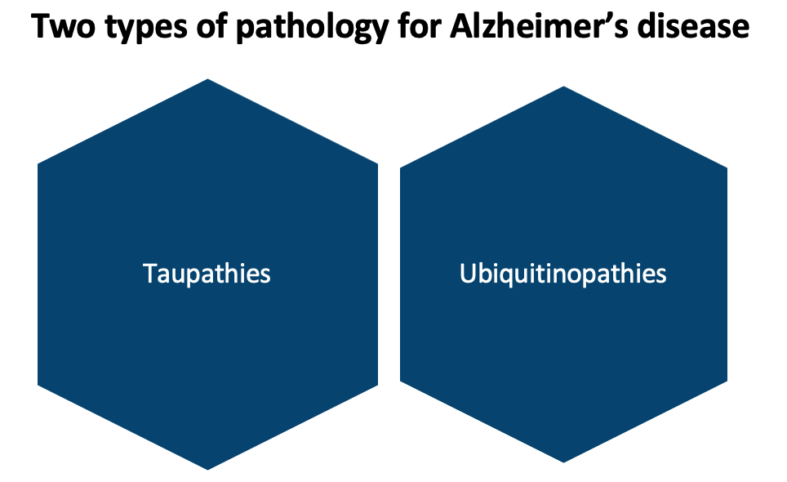

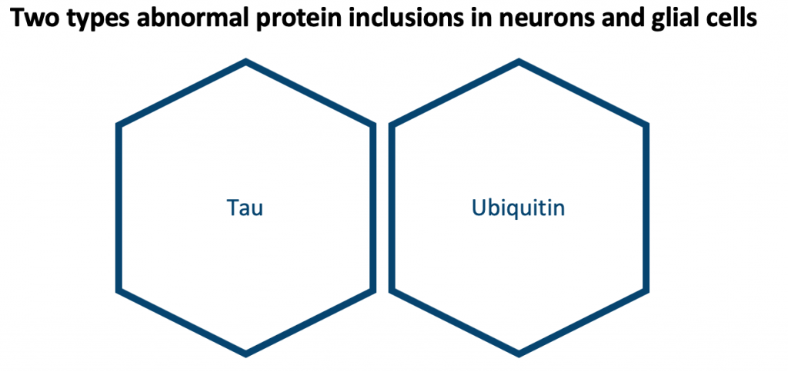

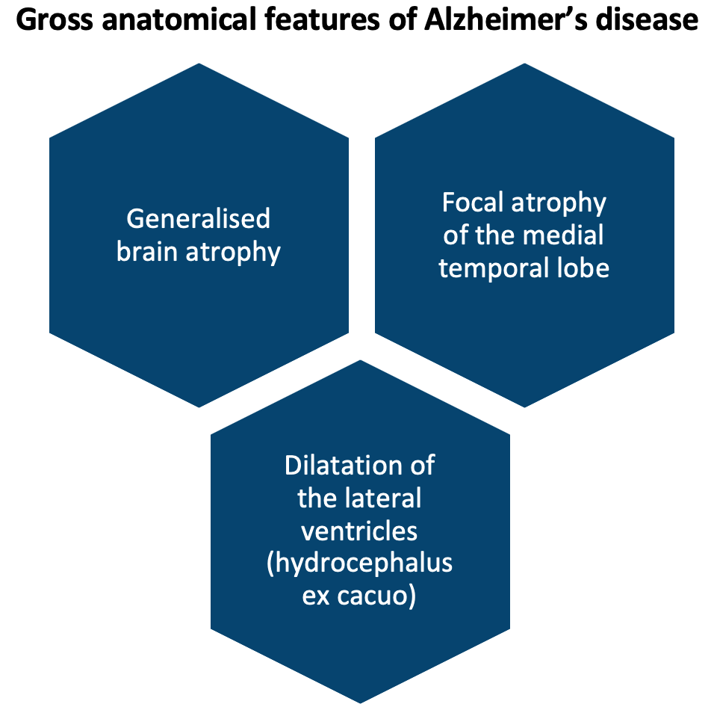

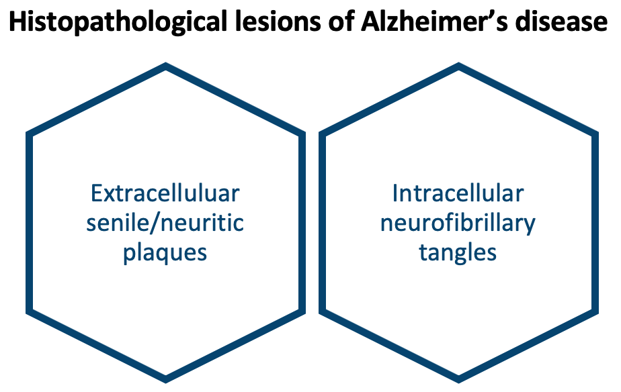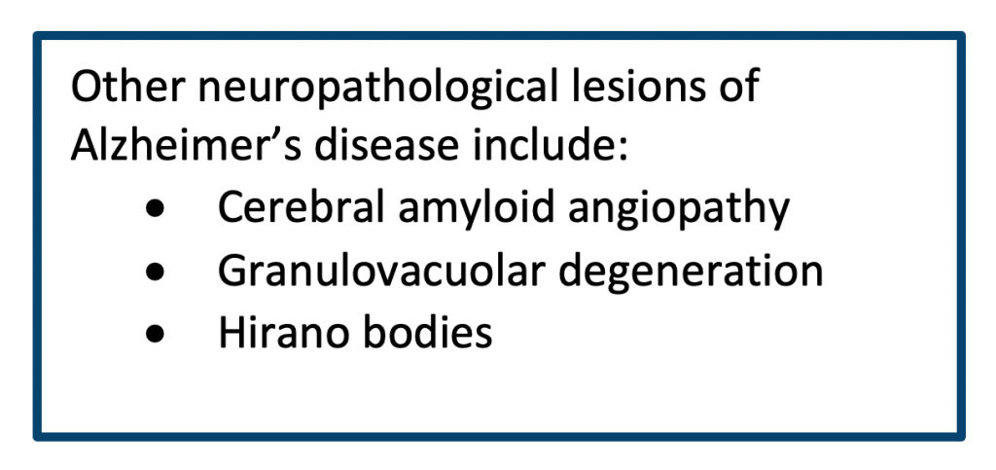

**Special stains are implemented to highlight senile plaques:**

* Silver
* Congo red
* Thioflavin S
* Beta-amyloid immunostain

**Special stains are implemented to highlight neurofibrillary plaques:**

* Silver
* Thioflavin S
* Tau immunostain

## **Diagnosing criteria**:

|  |  |
| --- | --- |
| **Criteria for diagnosing Alzheimer’s disease:** | **Summary:** |
| **CERAD criterion** | The Consortium to Establish a Registry for Alzheimer’s disease (CERAD) criterion evaluates the highest density of neocortical NP from 0 (none) to C (abundant) (Murayama, 2004). |
| **Braak and Braak staging system** | The Braak and Braak staging system is based on the topographic distribution of the neurofibrillary lesions NFT and NT. The scale has seven stages (Braak, 1991). |
| **2012 NIA-AA criterion** | The 2012 National Institute on Aging and the Alzheimer’s Association (NIA-AA) based criteria on a conceptual model of the pathophysiology in which biomarkers (AB42, tau) and imaging PET/MRI become abnormal (Jack, 2012). |

## **Symptoms**:

Alzheimer’s disease does not occur naturally as people age. One of the initial symptoms of Alzheimer’s disease and other dementias is frequent memory loss.

An individual with Alzheimer’s disease symptoms might also have one or more of the following issues in addition to memory issues:

* Memory loss that interferes with daily life, such as asking the same questions
* Repeatedly or frequently getting lost in a familiar setting
* Difficulty managing finances and paying bills.
* A Challenge finishing routine duties at work, at home, or in leisure.
* Reduced or bad judgement.
* Losing things and not being able to go back and find them.
* Mood, attitude, or behaviour changes

(Goedert & Spillantini, 2006).

## **Management**:

The National Institute for Health and Care Excellence (NICE) provides guidelines for the diagnosis and management of AD in the UK. These guidelines recommend that individuals with suspected AD should undergo a comprehensive assessment, including a detailed medical history, physical examination, and cognitive testing. The assessment should also take into account the individual’s functional status, including activities of daily living, and any coexisting medical conditions (NICE, 2019).

Once a diagnosis of AD has been made, the management of the condition typically involves a combination of pharmacological and non-pharmacological interventions. Cholinesterase inhibitors and memantine are the two main classes of drugs that are used to treat AD in the UK. These drugs work by increasing the levels of neurotransmitters in the brain, which can help to improve cognitive function and delay the progression of the disease.

In addition to pharmacological interventions, non-pharmacological interventions, such as cognitive stimulation therapy and activities such as exercise, music therapy, and reminiscence therapy, can be beneficial in managing the symptoms of AD. These interventions can help to improve quality of life and cognitive function and provide individuals with opportunities for socialization and engagement.

**References:**

(1) Alzheimer’s Association. (2021). Alzheimer’s disease facts and figures. Alzheimer’s & Dementia, 17(3), 365-385.

(2) Braak, H. and Braak, E. (1991). Neuropathological stageing of Alzheimer-related changes. Acta Neuropathologica, 82(4), pp.239–259. doi:10.1007/bf00308809.

(3) Goedert, M., & Spillantini, M. G. (2006). A century of Alzheimer’s disease. science, 314(5800), 777-781.

(4) Holtzman, D. M., & Morris, J. C. (2015). Alzheimer’s disease: the challenge of the second century. Science, 347(6226), 1469-1474.

(5) Jack, C.R., Knopman, D.S., Weigand, S.D., Wiste, H.J., Vemuri, P., Lowe, V., Kantarci, K., Gunter, J.L., Senjem, M.L., Ivnik, R.J., Roberts, R.O., Rocca, W.A., Boeve, B.F. and Petersen, R.C. (2012). An operational approach to National Institute on Aging-Alzheimer’s Association criteria for preclinical Alzheimer disease. Annals of Neurology, [online] 71(6), pp.765–775. doi:10.1002/ana.22628.

(6) Murayama, S. and Saito, Y. (2004). Neuropathological diagnostic criteria for Alzheimer’s disease. Neuropathology, 24(3), pp.254–260. doi:10.1111/j.1440-1789.2004.00571.x.

(7) National Institute for Health and Care Excellence (NICE). (2019). Alzheimer’s Disease and Other Dementias. NICE Pathways.

(8) Sperling, R. A., Aisen, P. S., Beckett, L. A., Bennett, D. A., Craft, S., Fagan, A. M., … & Siemers, E. (2011). Toward defining the preclinical stages of Alzheimer’s disease: Recommendations from the National Institute on Aging-Alzheimer’s Association workgroups on diagnostic guidelines for Alzheimer’s disease. Alzheimer’s & Dementia, 7(3), 280-292.

### 3.10.3 Vascular dementia

## **The Neuropathology of Vascular Dementia**

Vascular dementia is the second most frequent cause of dementia. This prevalent form of dementia called vascular dementia is brought on by inadequate blood supply to the brain. In the UK, it is predicted to have an impact on about 150,000 people per year.

Vascular dementia (VaD) is a type of dementia that results from damage to the brain’s blood vessels, leading to reduced blood flow and oxygen supply to the brain. This results in the death of brain cells, leading to a decline in cognitive function and memory. VaD is a common form of dementia, accounting for around 10-20% of all cases, and is particularly prevalent in older individuals with a history of cardiovascular disease, stroke, or hypertension.

The neuropathology of VaD is characterized by a combination of macroscopic and microscopic changes in the brain. At a macroscopic level, VaD is characterized by the presence of small infarcts, or areas of dead brain tissue, in the white matter and basal ganglia. These infarcts result from reduced blood flow to the brain, which can be caused by a variety of factors, including atherosclerosis, emboli, or lacunar infarcts (Erkinjuntti, 2002).

At a microscopic level, the neuropathology of VaD is characterized by changes in the brain’s microvasculature, including the formation of microinfarcts, and degeneration of the white matter and basal ganglia. In addition, there may be evidence of oxidative stress, neuroinflammation, and glial activation, which can further contribute to the degeneration of brain cells (Chen, 2010).

There are various aetiologies to vascular dementia:

|  |  |
| --- | --- |
| **Aetiology:** | **Example:** |
| **Neuropathological lesion** | Multi-infarct dementia, strategic infarct dementia, small vessel disease with dementia (Binswanger’s disease and CADASIL), hypoperfusion dementia and haemorrhagic dementia. |
| **Clinical presentation** | Various presentations are determined by a multitude of factors. Consistently all patients will show cognitive impairment. |
| **Cause** | Ischaemic infarction, brain haemorrhage and hypoperfusion brain ischaemia. Each has individual features at the gross anatomical level. |

Following ischaemic infarction, brain tissues become necrotic and undergo three stages of healing: acute, subacute and chronic. At different stages, different types of cells predominate depending on the process involved. Similar changes are seen even in a border-zone infarction.

## **Notable types of vascular dementia:**

**Binswanger’s disease**: also called subcortical vascular dementia, is a type of dementia caused by widespread, microscopic areas of damage to the deep layers of white matter in the brain.

**CADASIL**: often referred to as hereditary multi-infarct dementia is a cause of vascular dementia. It is an autosomal dominant inheritance disorder.

## **Symptoms:**

The cognitive dysfunction of vascular dementia is distinguished by executive dysfunction rather than abnormalities in memory and language function. Although cognitive decline can occur in stages, it is usually gradual and may include periods of stability or even improvement (Gelder 2012).

Other symptoms include changes to their attitude, demeanour, or behaviour. Plus having trouble planning and understanding plans. Patients often struggle to focus their attention, leaving them feeling disorientated and confused.

## **Risk factors:**

The risk rises with age, with persons over 65 having the highest prevalence of vascular dementia.

However, it is the second most prevalent type of young-onset dementia and can as per the name affect younger people (where symptoms develop before the age of 65).

Men are slightly more likely to get vascular dementia than women are, and persons with South Asian and African-Caribbean ancestry are at higher risk.

Additionally, there may be a modest increase in risk for those with a family history of vascular dementia.

The following are additional risk elements for vascular dementia:

* Hypertension
* Defective hearing
* Smoking
* Obesity
* Depression
* Heavy drinking and social isolation
* Trauma to the brain

(T O’Brien & Thomas, 2015)

## **Diagnosis:**

Diagnosis of VaD typically involves a comprehensive evaluation, including medical history, physical examination, and imaging studies, such as magnetic resonance imaging (MRI) or computed tomography (CT) scans. While there is no cure for VaD, various treatments and therapies are available to help manage the symptoms of the disease, improve quality of life, and delay progression. These may include anti-hypertensive drugs, anticoagulants, and antiplatelet agents, as well as lifestyle modifications, such as exercise and a healthy diet.

**References:**

(1) Chen, J., & Wong, T. (2010). Vascular dementia. The Lancet Neurology, 9(9), 817-827.

(2) Gelder, M., Andreasen, N., Lopez-Ibor, J. and Geddes, J. (2012). New Oxford Textbook of Psychiatry. Oxford: Oxford University Press.

(3) Erkinjuntti, T., Roman, G., Gauthier, S., & Bullock, R. (2002). Vascular dementia. The Lancet Neurology, 1(1), 27-36.

(4) T O’Brien, J., & Thomas, A. (2015). Vascular dementia. The Lancet, 386(10004), 1698-1706.

### 3.10.4 Frontotemporal dementia and Pick’s disease

## The Neuropathology **Frontotemporal Dementia**

Frontotemporal dementia (FTD) is a degenerative brain disease that is an early-onset disorder that mostly occurs before the age of 65. FTD encompasses several types of dementia involving the progressive degeneration of the frontal and temporal lobes (Miller, 2010).

FTD refers to a clinical syndrome of 3 types:

* **Behavioural variant (bvFTD)** previously known as Pick’s disease
* **Progressive non-fluent aphasia**
* **Semantic dementia**

Frontotemporal dementia (FTD) is a neurodegenerative disorder that primarily affects the frontal and temporal lobes of the brain. It is characterized by a progressive decline in behaviour, language, and/or executive function, leading to a decline in the individual’s ability to engage in activities of daily living and care for themselves. FTD is a relatively uncommon form of dementia, accounting for approximately 10-15% of all cases (Josephs, 2011).

The neuropathology of FTD is characterized by the progressive degeneration of specific regions of the brain, including the frontal and temporal lobes, as well as the anterior cingulate cortex and basal ganglia. At the cellular level, FTD is characterized by the presence of abnormal protein aggregates, including tau and TDP-43, which can lead to the formation of neurofibrillary tangles and other pathological inclusions. In addition, there may be evidence of neuronal loss, glial activation, and oxidative stress, which can further contribute to the degeneration of brain cells (Snowden, 2010).

Roughly 10-15% of people suffering from FTD will suffer from neurone failure. This is referred to as FTD with motor neurone disease.

## The Neuropathology of **Pick’s Disease**

bvFTD is what was previously referred to as Pick’s disease. Today, however, specialists only refer to a condition as Pick’s when certain requirements are met. Pick’s disease is the prototype of frontotemporal lobe degeneration tauopathy.

Pick’s disease, also known as frontal temporal lobar degeneration, is a rare neurodegenerative disorder characterized by the progressive deterioration of specific regions of the brain, including the frontal and temporal lobes. The disease primarily affects individuals in their 40s to 60s and leads to a decline in behaviour, language, and executive function. The hallmark of Pick’s disease is the presence of abnormal protein inclusions in the affected brain regions, including tau and TDP-43, which can contribute to the degeneration of brain cells. The onset and progression of Pick’s disease can vary greatly from one individual to another, and there is currently no cure for this condition. However, various treatments and therapies are available to help manage the symptoms and improve quality of life, including speech and language therapy, occupational therapy, and support for caregivers.

The most frequent type of FTD is behavioural variant frontotemporal dementia (BvFTD), often known as Pick’s disease.

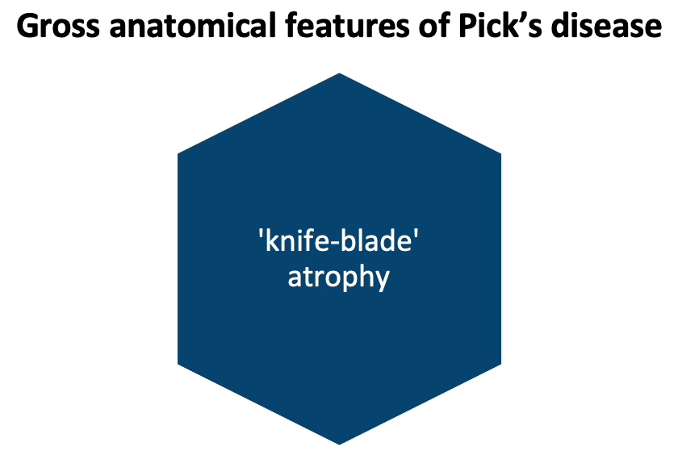

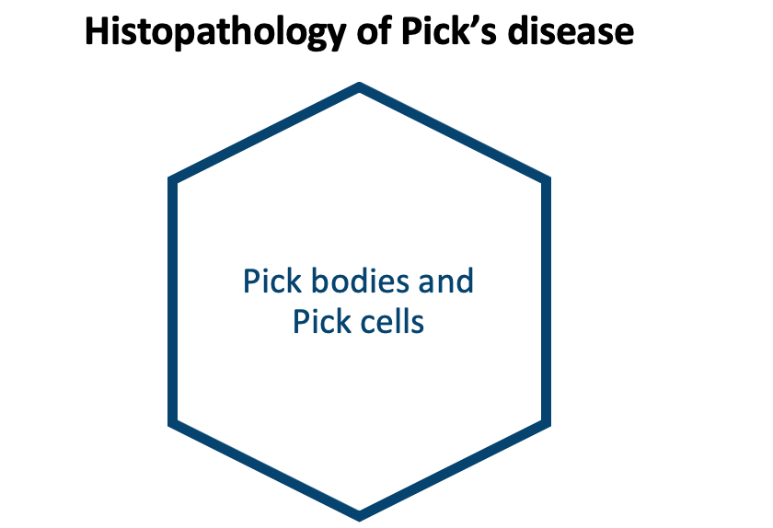

## **Symptoms:**

FTD’s broadly present as behavioural or language disorders with gradual onsets. Characteristic social display patterns include dissociation from family, strong oniomania, vulgar speech characteristics, yelling, and inability to control emotions, behaviour, personality, and temperament. It has been observed that the gradual beginning and progression of changes in behaviour or language deficiencies began several years before referral to a neurologist or psychiatrist.

Pick’s disease can display itself in two different ways. One way is that it results in frontotemporal dementia’s behavioural variation (bvFTD). The second is when it damages your brain’s language centres, leading to a disorder called primary progressive aphasia.

## **Cause:**

Frontotemporal dementia with a highly specific cause includes Pick’s disease. A particular protein called tau is present in all nerve and brain cells (named for a Greek alphabet letter). Tau and other proteins must have a certain structure in order to function effectively.

When tau proteins break down and clump together, they accumulate inside neurons, causing harm and eventual death to those cells. These dead neurons, called “Pick cells,” resemble bulging balloons. Pick bodies, which are tangles of tau proteins found inside cells, can also be seen under a microscope. Other conditions don’t cause Pick bodies or Pick cells (Neary & Snowden, 1996).

**References:**

(1) Josephs, K. A., & Ahlskog, J. E. (2011). Frontotemporal dementia and parkinsonism linked to chromosome 17: a review. Mayo Clinic Proceedings, 86(3), 297-305.

(2) Miller, B. L., & Darby, E. (2010). Frontotemporal dementia. The Lancet Neurology, 9(7), 708-719.

(3) Neary, D., & Snowden, J. (1996). Fronto-temporal dementia: nosology, neuropsychology, and neuropathology. Brain and Cognition, 31(2), 176-187.

(4) Snowden, J. S., & Neary, D. (2010). Frontotemporal lobar degeneration. The Lancet Neurology, 9(6), 171-180.

### 3.10.5 Lewy body diseases including Parkinson’s disease

## **Lewy Body Diseases Including Parkinson’s Disease**

Lewy body diseases are a group of neurodegenerative disorders that are characterized by the presence of abnormal protein deposits called Lewy bodies in the brain. The two most common forms of Lewy body disease are Parkinson’s disease and dementia with Lewy bodies (LBD).

Lewy bodies disorders can be classified as either:

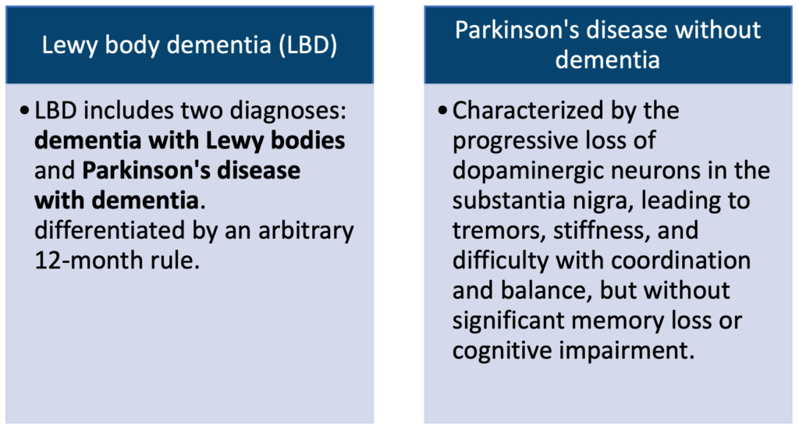

In Parkinson’s disease, Lewy bodies are primarily found in the substantia nigra, a region of the brain that plays a key role in the regulation of movement. The accumulation of Lewy bodies in this region leads to the progressive loss of dopaminergic neurons, resulting in the hallmark symptoms of Parkinson’s disease, including tremors, stiffness, and difficulty with coordination and balance.

In LBD, Lewy bodies are found in various regions of the brain, including the cortex, basal ganglia, and brainstem. The presence of Lewy bodies in these regions can lead to a decline in cognitive function, including memory loss and problems with attention, as well as visual hallucinations and fluctuations in alertness.

The exact cause of Lewy body disease is not well understood, but it is thought to involve a combination of genetic and environmental factors. There is currently no cure for Lewy body disease, but various treatments and therapies are available to help manage the symptoms and improve quality of life.

In conclusion, Lewy body diseases are a group of neurodegenerative disorders characterized by the presence of abnormal protein deposits called Lewy bodies in the brain, which can result in a decline in movement or cognitive function. Further research is needed to fully understand the underlying causes of Lewy body diseases and to develop more effective treatments and therapies (Walker, 2015).

According to the Parkinson’s Foundation, there are around 1 million cases of Parkinson’s disease in the United Kingdom, and by 2030 it is expected that figure to reach 1.2 million. Parkinson’s disease is 1.5 times more likely to affect men than women.

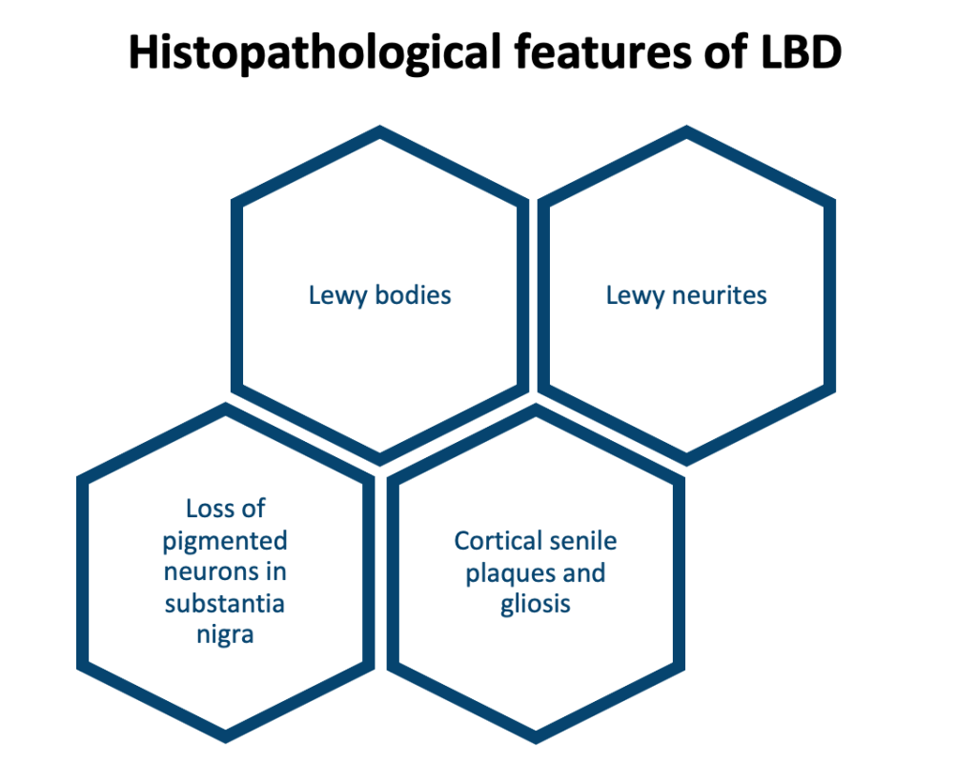

Lewy bodies and Lewy neurites contain alpha-synuclein. They are highlighted by synuclein immunostain.

Important to note is that all Lewy body dementias are synucleinopathies.

## **Symptoms**:

The LBDs / synucleinopathies are characterized by shared features of parkinsonism motor symptoms, neuropsychiatric symptoms, impaired cognition, sleep disorders, and visual hallucinations (McKeith, 2017).

Parkinson’s disease creeps up slowly over many years, and each person’s symptoms may vary. A person may feel the following signs:

* When a person is at rest, a tremor or shaking is typically referred to as a “pill-rolling” tremor.
* Bradykinesia, also known as delayed movement or freezing when moving, is rigidity in the limbs.
* Difficulties walking and balancing

**References:**

(1) Walker Z, Possin KL, Boeve BF, Aarsland D (October 2015). “Lewy body dementias”. Lancet (Review). 386 (10004): 1683–97.

(2) McKeith, I.G., Boeve, B.F., Dickson, D.W., Halliday, G., Taylor, J.-P., Weintraub, D., Aarsland, D., Galvin, J., Attems, J., Ballard, C.G., Bayston, A., Beach, T.G., Blanc, F., Bohnen, N., Bonanni, L., Bras, J., Brundin, P., Burn, D., Chen-Plotkin, A. and Duda, J.E. (2017). Diagnosis and management of dementia with Lewy bodies. Neurology, [online] 89(1), pp.88–100.

### 3.10.6 Prion diseases

## **Prion Diseases**

Prion diseases, also known as transmissible spongiform encephalopathies, are a group of rare and often fatal neurodegenerative disorders that affect the brain and central nervous system. They are caused by abnormally folded protein particles, called prions, that can spread from one individual to another through contaminated food, medical equipment, or surgical procedures.

The hallmark of prion diseases is the accumulation of abnormal prions in the brain, which can lead to the progressive degradation of brain tissue and the formation of characteristic spongiform changes. These changes are characterized by the presence of vacuoles, or tiny fluid-filled spaces, in the brain, which gives it a spongy appearance.

This is compared to viruses and bacteria which consist of protein, and RNA or DNA. Prion protein is the product of a gene located on chromosome 20 referred to as PRNP. The gene is normally expressed and not unique to just prion diseases. The prion protein expressed in the nervous system is called PrP.

Prion diseases can manifest in a variety of ways, depending on the specific form of the disease and the regions of the brain that are affected. Common symptoms of prion diseases include memory loss, behavioural changes, ataxia (difficulty with coordination and balance), and progressive decline in cognitive function.

Diagnosis of prion diseases is often challenging, as the symptoms can be similar to those of other neurodegenerative disorders. In addition, the incubation period for prion diseases can be quite long, sometimes lasting years or even decades, making early detection difficult.

There is currently no cure for prion diseases, and treatment is primarily focused on managing symptoms and providing supportive care. The neuropathology of prion diseases highlights the importance of research into the underlying mechanisms of these disorders, in order to develop more effective treatments and therapies.

In conclusion, prion diseases are a group of rare and often fatal neurodegenerative disorders that are caused by abnormally folded protein particles, called prions, which can lead to the progressive degradation of brain tissue and characteristic spongiform changes. Further research is needed to better understand the neuropathology of prion diseases and to develop more effective treatments and therapies.

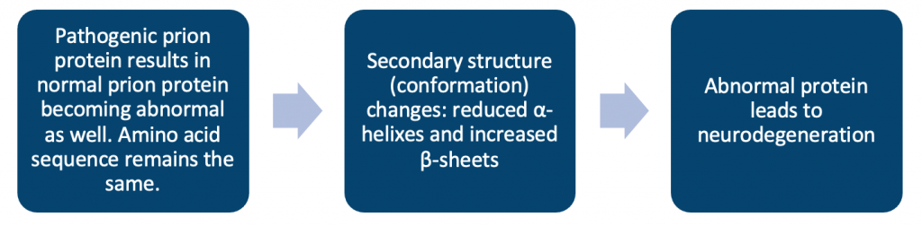

Prion diseases, often known as transmissible spongiform encephalopathies (TSEs), are a group of infrequent, slowly progressing neurodegenerative illnesses that can affect both humans and animals. There is no known cure and treatment is generally a palliative approach. The annual incidence is about 1 in 1,000,000. Long incubation times, distinctive spongiform alterations linked to neuronal death, and an inability to elicit an inflammatory response set them apart.

Three aetiologies are referred to:

|  |  |
| --- | --- |
| **Prion disease aetiology:** | **Summary:** |
| **Sporadic** | Arise spontaneously with no known cause. |
| **Familial** | Resulting from genetic mutations in the PrP gene. |
| **Variant** (transmitted) | Related to bovine spongiform encephalopathy. Transmission of abnormal prion protein via body fluids like faeces, saliva, blood, or urine, through environmental contamination of soil, food or water. |

Puoti, (2012)

It is thought that prions are the cause of TSEs. The name “prions” refers to abnormal, pathogenic organisms that can spread and are capable of causing specific, normal cellular proteins known as prion proteins, which are most prevalent in the brain, to fold abnormally. These typical prion proteins’ roles are yet not fully known. Brain damage and the typical symptoms of the disease are caused by the prion proteins’ aberrant folding. Prion illnesses typically advance quickly.

The definitive diagnosis of prion disease is by histological examination of brain tissue.

## **Sporadic CJD vs variant CJD:**

VariantCJD is a type of transmitted prion disease and is among the rarest of them all. It is felt psychiatrists should be aware of this type as it affects a younger population and often presents with psychiatric symptoms. But the last reported case of vCJD was in 2016.

|  |  |  |
| --- | --- | --- |
| **Characteristics:** | **sCJD:** | **vCJD:** |
| **The average age of onset** | 68 years | 28 years |
| **Duration of illness till death** | 4-5 months | 12-14 months |
| **Clinical presentation** | Dementia | Psychiatric and behavioural symptoms |
| **MRI ‘Pulvinar Sign’** | Absent | Present in over 75-90% of cases |
| **Periodic spikes on EEG** | Present (triphasic) | Absent |
| **Tonsils** | Absent | Tonsillar tissue carries prion protein |

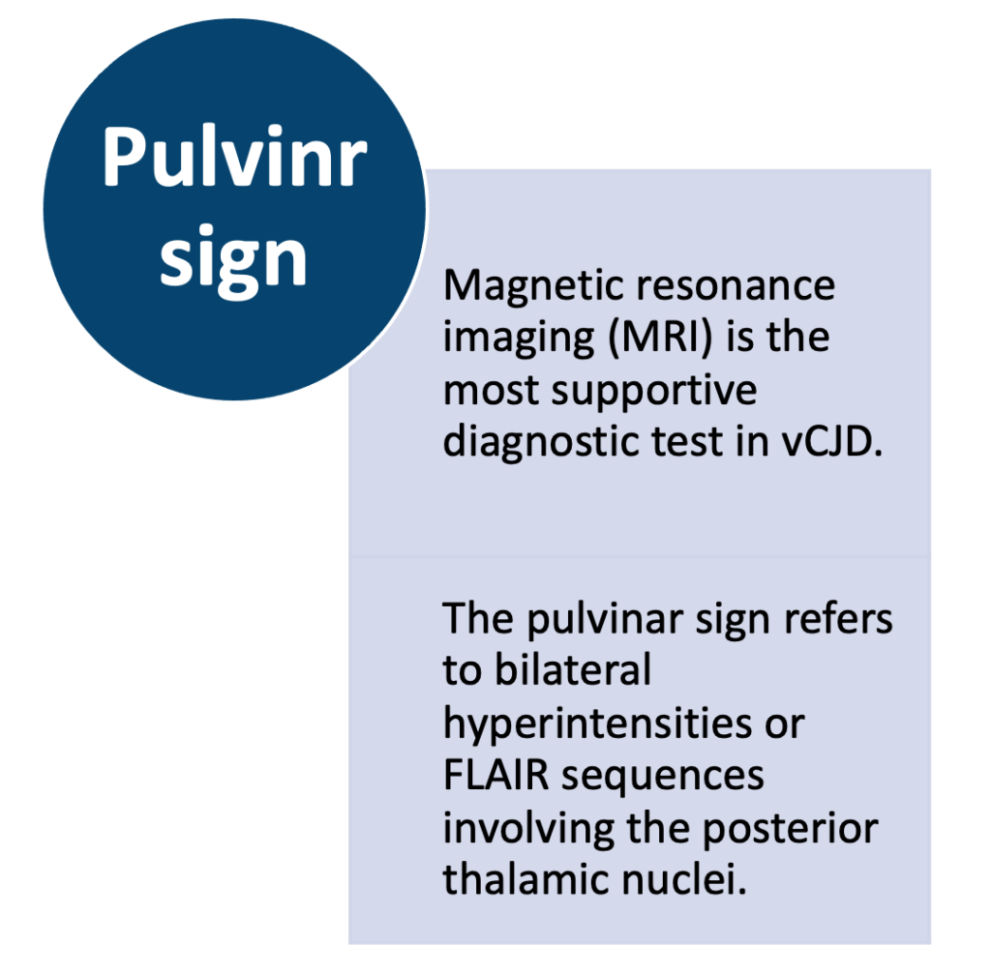

## **Symptoms:**

Prion illnesses have extremely lengthy incubation periods, frequently in the tens of years range. When symptoms start to appear, they sometimes deteriorate quickly.

The following are typical signs of a prion disease:

* Cognitive impairment: problems with judgement, memory, and thinking
* Psychiatric changes: personality alterations include agitation, sadness, and apathy
* Perplexity or fuzziness
* Myoclonic jerks or uncontrollable muscular spasms (myoclonus)
* Cerebellar signs: inability to coordinate (ataxia)
* Difficulty sleeping (insomnia)
* Slurred or difficult-to-understand speech, poor eyesight, or blindness
* Seizures (Jellinger & Korczyn, 2018)

**References:**

(1) Jellinger, K. A., & Korczyn, A. D. (2018). Are dementia with Lewy bodies and Parkinson’s disease dementia the same disease? BMC medicine, 16(1), 1-16.

(2) Puoti, G., Bizzi, A., Forloni, G., Safar, J.G., Tagliavini, F. and Gambetti, P. (2012). Sporadic human prion diseases: molecular insights and diagnosis. The Lancet Neurology, 11(7), pp.618–628.

### 3.10.7 HIV

## **Neuropsychiatric Manifestation of Human Immunodeficiency Virus (HIV)**

HIV will affect over 38 million people worldwide at the end of 2021 (WHO, 2021).

HIV is virally transmitted through bodily fluids. This allows it to be a sexually transmitted virus, but it can also be spread from mother to child (vertical transmission), or through the transfusion of tainted blood. If left untreated, the virus will keep replicating in the body and develop into a more advanced form. Once HIV affects the cells of the immune system it can lead to the development of acquired immunodeficiency syndrome (AIDS). This frequently causes a multitude of neurological issues. Within the brain, HIV mainly infects microglia and macrophages.

The virus uses receptors on T-cells to target the person’s immune system.

Even with present-day medicine, the average untreated survival time from HIV infection is 9-11 years.

Immunocompromised individuals are at risk of opportunistic infections to take hold such as:

* Cytomegalovirus
* Herpes simplex virus
* Varicella zoster virus
* Polyomavirus
* Toxoplasmosis
* Cryptococcus
* Candida albicans

In addition to harm brought on by the virus itself, various side effects of HIV and AIDS, such as malignancies linked to these diseases, may potentially induce neurological issues. While seeking to slow the virus’s rapid spread, several medications for HIV and AIDS can also lead to neurological issues. The likelihood of neurological adverse effects from HIV medications can be affected by specific hereditary variables.

## **Central nervous system entry:**

HIV-1 receptors are CD4 and CD8. CD4+ helper T lymphocytes are the main route of multiplication and entry. For HIV-1 to enter the brain it must cross the blood-brain barrier. The exact mechanism is still unclear. One accepted model is the **‘trojan horse hypothesis’**where HIV enters the central nervous system as a passenger within cells trafficked to the brain via CD4 T-cells or monocytes.

## **Symptoms:**

Neurological issues usually don’t appear until HIV has progressed, which occurs when a person has AIDS. About 50% of AIDS-affected adults experience neurological effects from HIV. Known as HIV-associated neurocognitive disorder (HAND).

HAND is a common manifestation of HIV infection and can range from mild cognitive impairment to severe dementia. The symptoms of HAND can include memory loss, difficulty with concentration, problems with executive function (such as decision-making and planning), and a decline in motor skills. The exact mechanisms underlying HAND are not well understood, but it is thought to involve the direct effects of HIV on the brain, as well as inflammation and oxidative stress.

In addition to HAND, HIV can also cause a range of psychiatric symptoms, including depression, anxiety, and behavioural changes. These symptoms can be a direct result of the virus or a result of the chronic stress and stigma associated with living with HIV.

HIV also causes inflammation, which can harm the central nervous system, including the brain and spinal cord, and result in neuropsychiatric symptoms such as:

* Depression
* Short-term memory impairment
* Poor concentration and failure to focus lead to behavioural modifications
* Behaviour and personality changes including apathy and social withdrawal
* Headache
* Issues with movement (loss of movement control), such as poor coordination and trouble walking (leg weakness) (Cole et al., 2017).

## **Assessment and investigation:**

Clinicians may choose to include the following assessments and investigations:

* Cognitive testing
* Cytokine and interleukin concentrations in blood and CSF
* Neuroimaging

Important to consider investigations to rule out other causes of cognitive impairment (Nelson, 2011).

## **Treatment:**

Antiretroviral As a strategy to control HIV infection, the management of HIV/AIDS often includes the use of various antiretroviral medications.  Antiretroviral drugs are classified into many groups that target distinct stages of the HIV life cycle. Highly active antiretroviral therapy  (HAART) is the use of numerous medicines that act on diverse viral targets. HAART reduces the patient’s total HIV burden, keeps the immune system functioning, and prevents opportunistic infections, which often result in death. HAART also prevents HIV transmission between same-sex and opposite-sex partners as long as the HIV-positive partner has an undetectable viral load. (ART):

The fundamental goal of HAART is to reduce the viral load to undetectable levels (50 copies per millilitre).  This should happen within 24 weeks of beginning therapy.  Monitoring viral load is the most important predictor of response to HAART treatment (Underwood, 2016).

**References:**

(1) Nelson, M., Dockrell, D. and Edwards, S. (2011). British HIV Association and British Infection Association guidelines for the treatment of opportunistic infection in HIV-seropositive individuals 2011. HIV Medicine, 12, pp.1–5. doi:10.1111/j.1468-1293.2011.00944_1.x.

(2) Underwood, J. and Winston, A. (2016). Guidelines for Evaluation and Management of Cognitive Disorders in HIV-Positive Individuals. Current HIV/AIDS Reports, 13(5), pp.235–240. doi:10.1007/s11904-016-0324-x.

(3) www.who.int. (n.d.). HIV/AIDS. [online] Available at: https://www.who.int/data/gho/data/themes/hiv-aids#:~:text=Globally%2C%2038.4%20million%20%5B33.9%E2%80%93.

# 4 Clinical Psychopharmacology

## 4.1 General Psychopharmacology

### 4.1.1 History and evolution of psychotropic compounds

## **Outline Knowledge of the History and Evolution of Psychotropic Compounds**

The history and evolution of psychotropics can be traced back to ancient civilizations, where substances such as opium, cannabis, and alcohol were used for medicinal and recreational purposes. Over time, the use of these substances evolved, and new compounds were discovered that had more specific and potent effects on the brain and behaviour.

In the 19th century, advances in chemistry and pharmacology led to the synthesis of various new psychotropics, including chloral hydrate, barbiturates, and bromides. These compounds were widely used as hypnotics, sedatives, and anxiolytics, and were widely prescribed for various medical conditions, including anxiety, insomnia, and epilepsy.

In the mid-20th century, the discovery of LSD, a powerful hallucinogenic, sparked interest in the use of psychotropics for psychiatric treatment. This led to the development of other psychotropics, including mescaline, psilocybin, and other psychedelics, which were initially used for the treatment of a variety of mental health conditions, including depression, anxiety, and schizophrenia.

In the 1950s and 1960s, the introduction of the first generation of antidepressants, including imipramine and amitriptyline, marked a significant milestone in the history of psychotropics. These drugs revolutionized the treatment of depression and other mood disorders and paved the way for the development of a wide range of other psychotropics, including monoamine oxidase inhibitors, tricyclic antidepressants, and selective serotonin reuptake inhibitors (SSRIs).

In the last few decades, the development of new psychotropics, such as atypical antipsychotics, has expanded the range of treatment options available for a variety of mental health conditions. At the same time, advances in neuroimaging and neuropsychology have helped to deepen our understanding of the brain mechanisms that underlie the effects of psychotropics, and have led to the development of new and more effective treatment strategies (Kline, 2015).

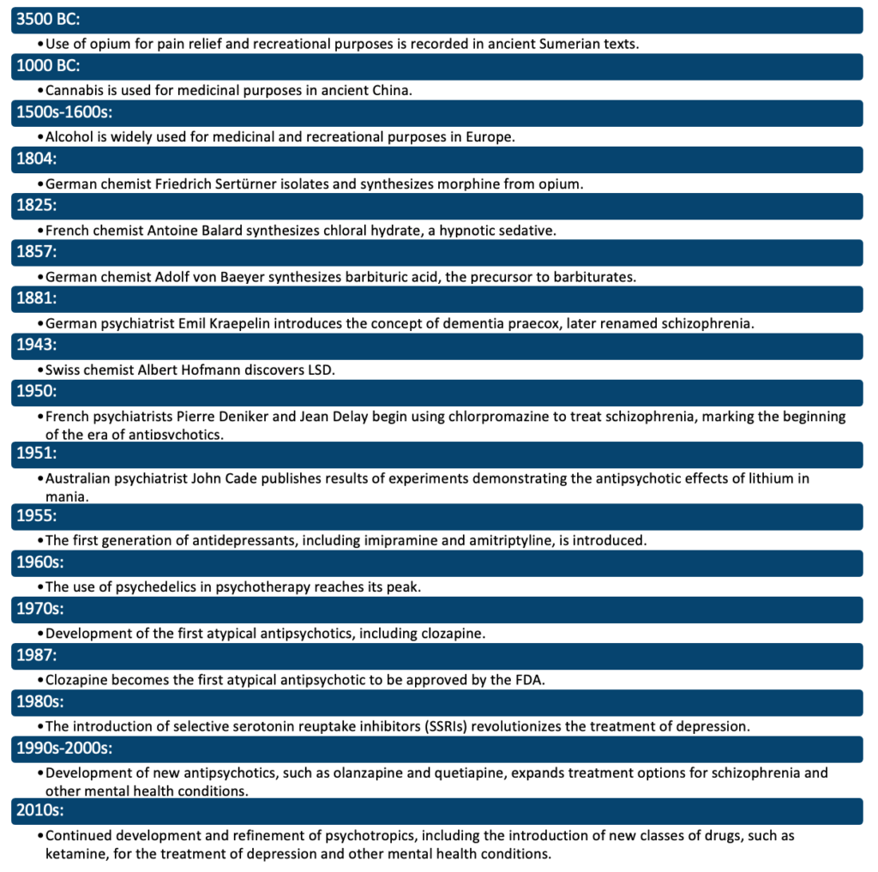

(Ban, 2017)

**References:**

(1) Ban, T. A. (2017). A brief history of psychotropics. In The Neuropsychology of Mental Illness (pp. 1-12). Cambridge University Press.

Kline, N. S. (2015). Handbook of psychotropic drugs. Springer.

### 4.1.2 Classification

## **Classification of Major Classes and Intra-Class Groups**

Psychotropic drugs can be classified into several major classes based on their mechanism of action and therapeutic effects. Within each class, there are often subgroups or “intra-class groups” that have distinct differences in terms of efficacy, side effect profiles, and other characteristics.

## Major classes:

Here is an overview of some of the major classes of psychotropics:

1. **Antidepressants:** These drugs are used to treat depression and other mood disorders. They work by altering the balance of neurotransmitters in the brain, such as serotonin, norepinephrine, and dopamine. Subgroups within this class include tricyclic antidepressants, monoamine oxidase inhibitors (MAOIs), selective serotonin reuptake inhibitors (SSRIs), and others.
2. **Antipsychotics:** These drugs are used to treat psychiatric conditions characterized by psychosis, such as schizophrenia. They work by blocking the action of the neurotransmitter dopamine in the brain. Subgroups within this class include typical or first-generation antipsychotics (such as chlorpromazine) and atypical or second-generation antipsychotics (such as clozapine and olanzapine).
3. **Mood stabilizers:**These drugs are used to treat mood disorders, such as bipolar disorder, that involve swings between mania and depression. Lithium is a classic example of a mood stabilizer.
4. **Anxiolytics:**These drugs are used to treat anxiety disorders. They work by enhancing the effects of neurotransmitters such as GABA in the brain. Subgroups within this class include benzodiazepines (such as alprazolam) and non-benzodiazepine anxiolytics (such as buspirone).
5. **Stimulants:**These drugs are used to treat attention deficit hyperactivity disorder (ADHD) and narcolepsy. They work by increasing the release of neurotransmitters such as dopamine and norepinephrine in the brain. Examples of stimulants include methylphenidate (Ritalin) and amphetamines (such as Adderall).
6. **Psychedelics:** These drugs are sometimes used in therapy to treat various mental health conditions, including depression and anxiety. They work by altering perceptions and inducing changes in thought patterns. Examples of psychedelics include LSD and psilocybin (magic mushrooms).
7. **Sedatives:**These drugs are used to treat insomnia and anxiety. They work by enhancing the effects of neurotransmitters such as GABA in the brain. Subgroups within this class include benzodiazepines (such as diazepam) and non-benzodiazepine sedatives (such as zolpidem).

This is by no means an exhaustive list, and there are many other psychotropics that fall into various categories or subgroups. Additionally, many drugs can have multiple therapeutic effects and can belong to multiple classes.

## Intra-Class groups:

**Antidepressants:** Here is a table summarizing the various intra-class groups of antidepressants along with their mechanism of action:

| ***Intra-Class group:*** | ***Examples*:** | ***Mechanism of Action*:** |
| --- | --- | --- |
| **Tricyclic Antidepressants (TCAs)** | Amitriptyline, Imipramine, Nortriptyline | TCAs block the reuptake of serotonin and norepinephrine in the synaptic cleft, increasing the concentration of these neurotransmitters in the synaptic space and enhancing their effects on post-synaptic receptors. |
| **Monoamine Oxidase Inhibitors (MAOIs)** | Phenelzine, Isocarboxazid, Tranylcypromine | MAOIs inhibit the enzyme monoamine oxidase, which breaks down neurotransmitters such as serotonin, norepinephrine, and dopamine. By blocking the action of this enzyme, MAOIs increase the concentration of these neurotransmitters in the synaptic space and enhance their effects on post-synaptic receptors. |
| **Selective Serotonin Reuptake Inhibitors (SSRIs)** | Fluoxetine, Sertraline, Paroxetine | SSRIs selectively block the reuptake of serotonin in the synaptic cleft, increasing the concentration of this neurotransmitter in the synaptic space and enhancing its effects on post-synaptic receptors. |
| **Serotonin-Norepinephrine Reuptake Inhibitors (SNRIs)** | Venlafaxine, Duloxetine, Desvenlafaxine | SNRIs block the reuptake of both serotonin and norepinephrine in the synaptic cleft, increasing the concentration of these neurotransmitters in the synaptic space and enhancing their effects on post-synaptic receptors. |
| **Noradrenergic and Specific Serotonergic Antidepressants (NASSAs)** | Mirtazapine | NASSAs act on both serotonergic and noradrenergic systems, as well as on certain receptors in the brain. The exact mechanism of action of NASSAs is not well understood, but they are believed to increase the release of both serotonin and norepinephrine and block certain receptors that reduce the effects of these neurotransmitters. |
| **Atypical Antidepressants** | Bupropion, Trazodone, Nefazodone | Atypical antidepressants have a diverse range of mechanisms of action, but they do not fit neatly into the categories of TCAs, MAOIs, SSRIs, or SNRIs. Bupropion, for example, acts as a norepinephrine-dopamine reuptake inhibitor, while Trazodone has both serotonergic and adrenergic effects. |

**Antipsychotics:**Here is a table summarizing the various intra-class groups of antipsychotics along with their mechanism of action:

| **Intra-Class Group:** | **Examples:** | ***Mechanism of Action:*** |
| --- | --- | --- |
| **Typical Antipsychotics** | Chlorpromazine, Haloperidol, Fluphenazine | Typical antipsychotics block the dopamine D2 receptors in the brain, reducing the activity of this neurotransmitter and thereby reducing symptoms such as psychosis and agitation. |
| **Atypical Antipsychotics** | Clozapine, Olanzapine, Quetiapine | Atypical antipsychotics have a more complex mechanism of action than typical antipsychotics and typically have a lower risk of extrapyramidal side effects. Many atypical antipsychotics block the dopamine D2 receptor, but they also have an effect on other receptors, such as serotonin 5-HT2A receptors, and may also affect neurotransmitter systems other than dopamine. |

**Mood stabilizers:** Here is a table summarizing the various intra-class groups of mood stabilizers along with their mechanism of action:

| **Class:** | **Intra-Class Group:** | **Examples:** | **Mechanism of Action:** |
| --- | --- | --- | --- |
| **Lithium** | – | Lithium Carbonate | Lithium is believed to work by increasing the availability of certain neurotransmitters in the brain, including serotonin and norepinephrine, and by reducing the activity of other neurotransmitters, such as glutamate. It may also affect certain signalling pathways involved in the regulation of mood and behaviour. The exact mechanism of action of lithium is not well understood. |
| **Anticonvulsants** | Valproates | Valproic Acid | Valproates are believed to work by increasing the availability of certain neurotransmitters in the brain, including GABA, and by blocking certain ion channels involved in the regulation of mood and behaviour. The exact mechanism of action of valproates is not well understood. |
| **Carbamates** | – | Carbamazepine | Carbamazepine is believed to work by reducing the release of certain neurotransmitters in the brain, such as glutamate, and by blocking certain ion channels involved in the regulation of mood and behaviour. The exact mechanism of action of carbamazepine is not well understood. |

**Anxiolytics:**Here is a table summarizing the various intra-class groups of anxiolytics along with their mechanism of action:

| **Intra-Class Group:** | **Examples:** | **Mechanism of Action:** |
| --- | --- | --- |
| **Benzodiazepines** | Diazepam, Alprazolam, Lorazepam | Benzodiazepines enhance the activity of the neurotransmitter GABA in the brain, leading to increased inhibition of neurotransmitter release and a decrease in anxiety. |
| **Non-Benzodiazepine anxiolytics** | Buspirone, Hydroxyzine, Trazodone | Non-benzodiazepine anxiolytics work through various mechanisms, including the enhancement of neurotransmitter activity and the blocking of the activity of certain neurotransmitter receptors. For example, buspirone is a 5-HT1A receptor agonist, while hydroxyzine blocks the activity of histamine receptors. |

**Stimulants:** Here is a table summarizing the various intra-class groups of stimulants along with their mechanism of action:

| ***Intra-Class Group*:** | **Examples:** | ***Mechanism of Action:*** |
| --- | --- | --- |
| **Amphetamines** | Amphetamine, Dextroamphetamine | Amphetamines increase the release of certain neurotransmitters in the brain, including dopamine and norepinephrine, leading to increased stimulation and alertness. They also inhibit the reuptake of these neurotransmitters, leading to their prolonged action. |
| **Methylphenidates** | Ritalin, Adderall | Methylphenidates increase the release of dopamine and norepinephrine in the brain, leading to increased stimulation and alertness. They also inhibit the reuptake of these neurotransmitters, leading to their prolonged action. |

**Psychedelics:** Here is a table summarizing the various intra-class groups of psychedelics along with their mechanism of action:

| ***Intra-Class Groups:*** | ***Examples:*** | ***Mechanism of Action:*** |
| --- | --- | --- |
| **Serotonin receptor agonists (Classical psychedelics)** | Lysergic acid diethylamide (LSD), Psilocybin | Classical psychedelics are thought to work by activating the serotonin 2A receptor (5-HT2A), leading to changes in perception, mood, and thought. |
| **Dissociatives** | Phencyclidine (PCP), Ketamine | Dissociatives are thought to work by blocking the NMDA glutamate receptor, leading to changes in perception, mood, and thought. |

**Sedatives:**

Here is a table summarizing the various intra-class groups of sedatives along with their mechanism of action:

| ***Intra-Class Group:*** | **Examples:** | **Mechanism of Action:** |
| --- | --- | --- |
| **Barbiturates** | Phenobarbital, Amobarbital | Barbiturates enhance the activity of the neurotransmitter GABA in the brain, leading to increased inhibition of neurotransmitter release and sedation. |
| **Benzodiazepines** | Diazepam, Alprazolam, Lorazepam | Benzodiazepines enhance the activity of the neurotransmitter GABA in the brain, leading to increased inhibition of neurotransmitter release and sedation. |
| **Non-Benzodiazepine sedatives** | Zolpidem, Zopiclone | Non-benzodiazepine sedatives work through various mechanisms, including enhancing the activity of the neurotransmitter GABA and blocking the activity of certain neurotransmitter receptors. For example, zolpidem is a GABA-A receptor agonist. |

Note that these mechanisms of action are simplifications and may not fully capture the complexity of these drugs or the exact ways in which they exert their effects on the brain and nervous system. Additionally, the mechanisms of action of different drugs within each intra-class group can vary, and the effects of these drugs can be influenced by many other factors, including dose, duration of treatment, and individual patient characteristics (APA, 2013).

**References:**

(1) American Psychiatric Association (APA). (2013). Diagnostic and Statistical Manual of Mental Disorders, Fifth Edition (DSM-5). American Psychiatric Publishing.

### 4.1.3 The placebo effect

## **The Placebo Effect**

The placebo effect refers to a phenomenon in which a patient experiences a therapeutic benefit from an inactive or otherwise biologically inactive substance or intervention. In the context of clinical trials, placebos are typically used as a control against which the effects of active treatments can be compared.

One of the key features of the placebo effect is that it is often accompanied by changes in patients’ perceptions, expectations, and beliefs about their treatment. For example, patients who believe that they are receiving an effective treatment may experience greater pain relief or improvement in other symptoms, even if the treatment itself is biologically inactive. This suggests that psychological and social factors play an important role in mediating the placebo effect.

The underlying mechanisms of the placebo effect are not well understood, but various theories have been proposed. One such theory is the “expectancy theory,” which suggests that the placebo effect is driven by patients’ expectations about the benefits of treatment. Another theory is the “conditioning theory,” which suggests that the placebo effect is the result of classical conditioning, in which patients associate the experience of receiving treatment with the experience of improved health (Price, 2008).

In terms of brain activity, the placebo effect has been associated with changes in various brain regions, including the prefrontal cortex, the insula, and the periaqueductal gray. These changes have been interpreted as evidence of the involvement of complex neural circuits in the placebo effect, including circuits involved in pain modulation, emotions, and motivation.

The placebo effect is a complex phenomenon that has important implications for the design and interpretation of clinical trials. In clinical trials, the placebo effect can result in significant reductions in symptoms, making it difficult to determine whether a treatment is truly effective. However, the placebo effect also has the potential to be harnessed for therapeutic purposes, for example, by using techniques such as placebo surgery or placebo pills to elicit the placebo effect in patients who would not otherwise respond to other forms of treatment.

In summary, the placebo effect is a fascinating and complex phenomenon that continues to be the subject of active research and investigation in the fields of psychology, neuroscience, and medicine. Further research is needed to better understand the underlying mechanisms of the placebo effect and to determine the best ways to harness it for therapeutic purposes (Kienle, 1997).

## **Factors affecting the placebo effect:**

Various factors can influence the placebo effect, including the mode of administration, the shape of the tablet, the colour of the tablet, and the frequency of the tablet. These factors can affect patients’ perceptions, expectations, and beliefs about their treatment and, in turn, influence the magnitude of the placebo effect.

**Mode of Administration:** The mode of administration of a placebo can affect the placebo effect. For example, placebos that are delivered through injections or invasive procedures, such as placebo surgery, have been shown to elicit stronger placebo effects than placebos delivered in the form of pills or other non-invasive methods. This may be due to the greater involvement of patients in the administration process, as well as the greater sense of control that patients feel when they are actively involved in their treatment.

**The shape of the Tablet:** The shape of the tablet can also influence the placebo effect. Research has shown that the shape of the tablet can affect patients’ perceptions and expectations about their treatment. For example, round tablets have been associated with a greater placebo effect than square tablets. This may be due to the fact that round shapes are often associated with softness and comfort, which can lead to greater expectations of therapeutic benefit.

**Colour of the Tablet:** The colour of the tablet can also influence the placebo effect. Research has shown that blue placebos are often associated with a greater placebo effect than placebos in other colours. This may be due to the fact that blue is often associated with calmness and tranquillity, which can lead to greater expectations of therapeutic benefit.

**Frequency of the Tablet:** The frequency of the tablet can also influence the placebo effect. Research has shown that placebos that are taken more frequently are often associated with a greater placebo effect. This may be due to the fact that frequent administration of the placebo increases the sense of control that patients feel over their treatment, which can lead to greater expectations of therapeutic benefit.

In summary, various factors, such as the mode of administration, the shape of the tablet, the colour of the tablet, and the frequency of the tablet, can influence the placebo effect. These factors can affect patients’ perceptions, expectations, and beliefs about their treatment, leading to variations in the magnitude of the placebo effect. Further research is needed to better understand how these and other factors influence the placebo effect and to determine the best ways to harness it for therapeutic purposes.

## **The History of the Placebo Effect**

The study of the placebo effect, or the therapeutic benefits that can be seen with the use of a placebo, has a long and rich history. Although the concept of the placebo effect dates back to ancient times, it wasn’t until the mid-20th century that the placebo effect began to be studied as a scientific phenomenon in its own right.

In the early part of the 20th century, the placebo effect was often seen as a nuisance variable in medical research. Researchers would use placebos as control treatments in clinical trials, but they did not give much consideration to the potential therapeutic effects of the placebo itself. This began to change in the 1950s and 1960s, as researchers started to examine the psychological and physiological mechanisms that underlie the placebo effect.

One of the key developments in the study of the placebo effect was the recognition of the role of patient expectations and beliefs in the placebo effect. Researchers began to demonstrate that these factors could play a significant role in shaping the therapeutic response to a placebo, and they started to explore the ways in which these factors could be manipulated to enhance the placebo effect.

Another important development in the history of research on the placebo effect was the recognition of the role of the placebo effect in pain management. In the 1990s, researchers began to demonstrate that placebos could have a significant impact on pain perception, and this led to a greater appreciation of the potential clinical applications of the placebo effect.

In recent years, research on the placebo effect has continued to grow, and it has been influenced by advances in several related fields, including neuroimaging, psychopharmacology, and behavioural neuroscience. Researchers have used these advances to explore the neural mechanisms that underlie the placebo effect and to identify specific neural pathways that are involved in the placebo effect.

In addition, researchers have started to examine the potential applications of the placebo effect in various clinical settings, including the treatment of pain, depression, and anxiety. The study of the placebo effect has also been influenced by advances in our understanding of the placebo response in the context of clinical trials, including the use of placebo treatments as a control group in clinical trials and the use of placebo treatments as a therapeutic intervention in its own right.

Overall, the history of research on the placebo effect reflects a growing appreciation for the therapeutic potential of the placebo effect and a growing commitment to understanding the underlying mechanisms and factors that contribute to it. This research has important implications for our understanding of the therapeutic process and for the development of new and more effective treatments for a variety of medical conditions (Enck, 2017).

**References:**

(1) Enck, P., & Häuser, W. (2017). The placebo response in medicine: history, mechanisms, and future directions. Annals of Medicine, 49(7), 656-664. doi: 10.1080/07853890.2017.1335698

Kienle, G. S., & Kiene, H. (1997). The powerful placebo effect: fact or fiction? Journal of Clinical Epidemiology, 50(9), 1311-1318. doi: 10.1016/S0895-4356(97)00060-4

Price, D. D., Finniss, D. G., & Benedetti, F. (2008). A comprehensive review of the placebo effect: recent advances and current thought. Annual Review of Psychology, 59, 565-590. doi: 10.1146/annurev.psych.59.103006.093629

### 4.1.4 Compliance and adherence

## **Compliance and Adherence – Relevance and Methods of Maximisation**

Compliance and adherence are terms used to describe the extent to which a patient follows the recommended treatment regimen.

## Compliance:

Compliance refers to the extent to which a patient follows the recommended treatment regimen for a medical condition. In other words, it refers to how well a patient adheres to a prescribed course of treatment, such as taking medications as directed, following lifestyle changes, or attending appointments. Compliance is a critical factor in the effective management of many medical conditions, including psychiatric disorders.

There are several factors that can influence compliance, including the nature of the condition, the patient’s beliefs and attitudes towards the treatment, the complexity of the regimen, the presence of side effects, and the patient’s relationship with their healthcare provider.

Poor compliance can lead to a number of adverse outcomes, including increased symptoms, disease exacerbation, increased healthcare utilization, and decreased quality of life. On the other hand, high levels of compliance can lead to better health outcomes and improved quality of life for the patient (Simon, 1999).

## Adherence:

Adherence refers to the extent to which a patient follows the recommended treatment regimen for a medical condition, including taking medications as prescribed, following lifestyle changes, or attending appointments. Adherence is often used interchangeably with the term “compliance,” though some experts distinguish between the two terms by defining adherence as a patient’s voluntary and active decision to follow the prescribed treatment, while compliance refers to the extent to which they actually do so.

Adherence is critical for the effective management of many medical conditions, including psychiatric disorders, as it is essential for ensuring that patients receive the full therapeutic benefits of their medication. Poor adherence can result in a number of adverse outcomes, such as increased symptoms, disease exacerbation, increased healthcare utilization, and decreased quality of life (Haynes, 2002).

There are several factors that can influence adherence, including the nature of the condition, the patient’s beliefs and attitudes towards the treatment, the complexity of the regimen, the presence of side effects, and the patient’s relationship with their healthcare provider.

## Relevance and methods of maximisation:

Methods of Maximization: To maximize compliance and adherence to psychotropic medication, the following strategies can be used:

1. **Patient Education:** Providing patients with clear and comprehensive information about their condition, medications, and the importance of taking their medications as prescribed can help to increase compliance.
2. **Simplifying the Regimen:** Simplifying the medication regimen, such as by reducing the number of doses or using once-daily dosing, can help to improve adherence.
3. **Medication Reminders:** Providing patients with medication reminders, such as pillboxes, text message reminders, or phone calls, can help to increase compliance.
4. **Collaborative Decision-Making:**Involving patients in the decision-making process about their medications and treatment plan can help to increase their buy-in and improve adherence.
5. **Addressing Side Effects:**Addressing side effects and working with patients to find the most tolerable medication regimen can help to improve adherence.
6. **Monitoring Adherence:** Regular monitoring of medication adherence, such as through pill counts or electronic monitoring systems, can help to identify and address issues related to non-compliance.
7. **Collaborating with other Healthcare Providers:**Collaborating with other healthcare providers, such as primary care physicians and pharmacists, can help to ensure that patients receive consistent and comprehensive care that supports adherence to their medication regimen.

**References:**

(1) Haynes, R. B., McDonald, H. P., Garg, A. X., & Montague, P. (2002). Interventions for enhancing medication adherence. Cochrane Database of Systematic Reviews, (1).

(2) Simon, G. E., Katon, W., Russo, J., Mauk, J., Robinson, P., & Ludman, E. (1999). Compliance with antidepressant treatment. The Journal of the American Medical Association, 282(20), 1912-1918.

### 4.1.5 Assessment methods, monitoring, efficacy, and tolerability

## **Assessment Methods and Monitoring**

**Assessment Methods in Psychiatry:**refer to the various techniques and tools used to gather information about an individual’s mental health status. The purpose of assessment is to obtain a comprehensive understanding of the individual’s symptoms, behaviours, and functioning, which will then inform the development of a treatment plan. Common assessment methods include:

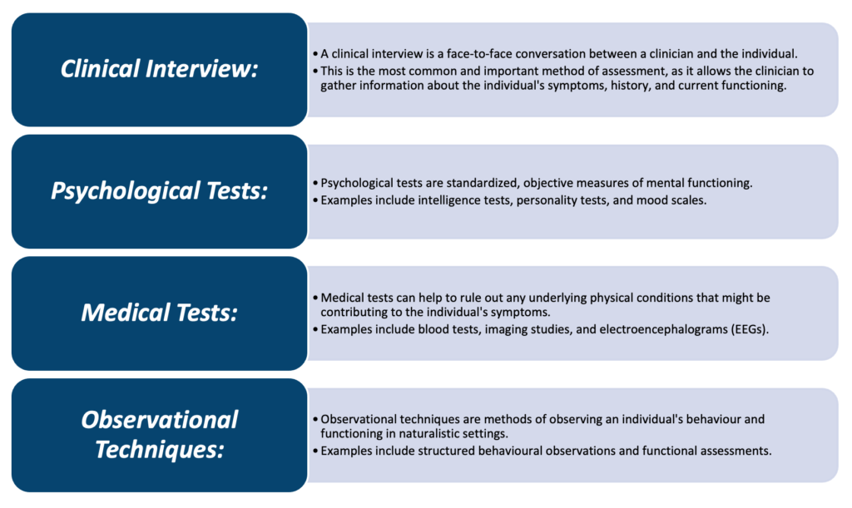

**Monitoring in Psychiatry:** refers to the ongoing assessment of an individual’s progress during treatment. This may involve regular check-ins with a clinician, self-assessment using mood scales, and monitoring of side effects. Monitoring is an important component of treatment because it allows the clinician to make adjustments to the treatment plan as needed based on the individual’s response to treatment.

In summary, assessment methods, monitoring, efficacy, and tolerability are crucial components of psychiatric treatment. The use of various assessment methods helps to obtain a comprehensive understanding of the individual’s mental health status, while monitoring allows for ongoing assessment of progress during treatment. Efficacy and tolerability are important considerations in the development of treatment plans, as they help to ensure that the individual receives the most effective treatment with the least amount of side effects (Schatzberg, 2019).

## Efficacy

Efficacy in psychiatry refers to the ability of a treatment to produce a desired therapeutic effect. This is typically measured by comparing the outcomes of an intervention to a control group, or by comparing the individual’s symptoms before and after treatment. Efficacy is an important consideration in the development of treatment plans, as it helps to ensure that the individual receives the most effective treatment possible (Hollon, 2003).

## Tolerability

Tolerability in psychiatry refers to the extent to which an individual is able to tolerate the side effects of treatment. This is an important consideration in the development of treatment plans, as side effects can be significant and negatively impact an individual’s quality of life. Clinicians strive to find the most effective treatment with the least amount of side effects for each individual (Gogtay, 2015).

**References:**

(1) Gogtay, S. N., & Kramer, R. J. (2015). Clinical Efficacy and Tolerability of Antidepressants in the Acute Treatment of Major Depressive Disorder: A Systematic Review and Network Meta-Analysis. European Neuropsychopharmacology, 25(Supplement 1), February 2015.

(2) Hollon, S. J., & Thase, M. E. (2003). The Efficacy of Psychological and Pharmacological Interventions for Adult Depression: A Meta-Analysis of Randomized Controlled Trials. The Journal of Clinical Psychology, 59(11), November 2003.

(3) Schatzberg, A.F., Debattista, C. and American Psychiatric Association Publishing (2019). Schatzberg’s manual of clinical psychopharmacology. Washington, D.C.: American Psychiatric Association Publishing.

### 4.1.6 Basic principles of drug development

## **Basic Principles of Drug Development and Evaluation**

Drug development is the process of discovering, testing, and producing new medications to treat various medical conditions. The process of drug development is long, complex, and requires substantial resources. It is estimated that it takes approximately 10 to 15 years and costs billions of dollars to bring a new drug to market. The goal of the drug development process is to produce safe and effective medications that can be used to treat patients (WHO, 2021).

The drug development process is divided into several phases, each with its own specific goals and objectives. The three main phases of drug development are Phase 1, Phase 2, and Phase 3.

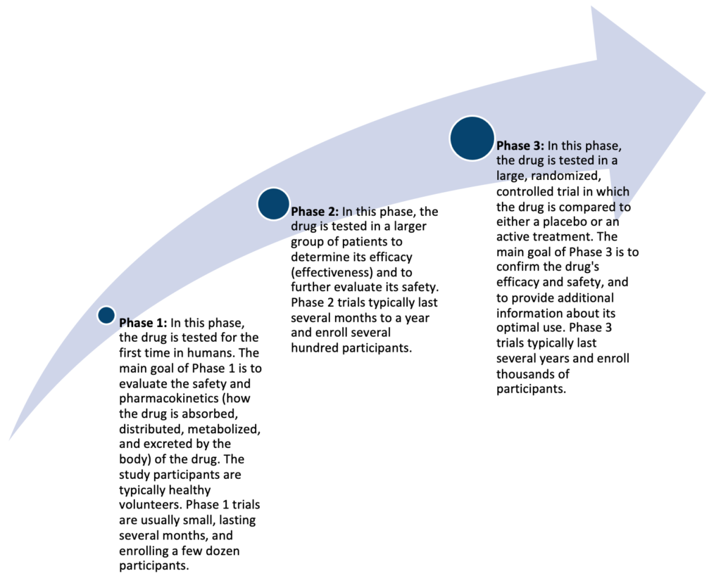

(MHRA, 2021)

Once a drug has successfully completed the Phase 3 trials, the drug’s manufacturer can submit a New Drug Application (NDA) to the FDA for approval to market the drug. The NDA must include data from the pre-clinical and clinical trials, as well as information about the drug’s manufacturing and labelling. The FDA reviews the NDA and determines whether the drug is safe and effective for its intended use.

In conclusion, the drug development process is a long and complex process, but it is essential to ensure that new medications are safe and effective for patients. The three main phases of drug development (Phase 1, Phase 2, and Phase 3) have specific goals and objectives, and each phase builds on the previous one to provide a comprehensive understanding of the drug’s safety, efficacy, and optimal use.

## Phase I:

Phase 1 is the first stage in the drug development process and is designed to evaluate the safety and pharmacokinetics of a new drug in humans. It is usually the first time that a drug has been tested in human subjects and is therefore considered a critical stage in the development process. Phase 1 trials typically involve a small number of healthy volunteers (20 to 80) and are usually conducted in a controlled clinical setting, such as a hospital or research centre. The study participants receive a single dose or multiple doses of the drug over a short period of time, usually several days to a few weeks. The primary goal of Phase 1 is to determine the safe dose range of the drug, as well as its pharmacokinetic profile, including how the drug is absorbed, distributed, metabolized, and excreted by the body. In addition, Phase 1 trials may also provide initial information about the drug’s efficacy, although this is not the primary focus of the phase. The results of Phase 1 trials are critical in determining whether the drug should advance to Phase 2 and provide important information to guide future studies.

## Phase II:

Phase 2 is the second stage in the drug development process and is designed to evaluate the efficacy and further assess the safety of a new drug in a larger group of patients. Phase 2 trials typically involve several hundred patients who have the medical condition that the drug is intended to treat. The study participants are randomly assigned to receive either the experimental drug or an established treatment, or sometimes a placebo, for a defined period of time, usually several months to a year. The primary goal of Phase 2 is to determine whether the drug is effective in treating the medical condition and to further evaluate its safety profile. The results of Phase 2 trials provide important information about the drug’s effectiveness, optimal dosing, and potential side effects, which helps to guide the design of future studies, including Phase 3 trials. Phase 2 trials are also used to gather data on the drug’s efficacy and safety in specific patient populations, including those with comorbid conditions, and to determine whether the drug has a favourable risk-benefit ratio. If the results of Phase 2 are positive, the drug may advance to Phase 3, otherwise, the development process may be terminated.

## Phase III:

In the UK, Phase 3 is the final stage in the drug development process and is designed to confirm the efficacy and safety of a new drug in a large, well-controlled, randomized clinical trial involving several thousand patients with the medical condition that the drug is intended to treat. Phase 3 trials are conducted at multiple clinical sites and provide a comprehensive evaluation of the drug’s efficacy, safety, and side effect profile in a diverse patient population. Participants are randomly assigned to receive either the experimental drug, an established treatment or sometimes a placebo, for a defined period of time, usually several months to a year. The primary goal of Phase 3 is to provide sufficient evidence to support a regulatory submission, such as a Marketing Authorization Application (MAA), and to demonstrate the drug’s superiority to the established treatment, if applicable. The results of Phase 3 trials are crucial in determining whether the drug can be approved by regulatory agencies and made available to the public in the UK.

## The RCT in Psychiatry

Randomized Controlled Trials (RCTs) are considered the gold standard for evaluating the efficacy and safety of treatments in psychiatry. An RCT is a type of clinical trial in which participants are randomly assigned to receive either an experimental treatment or a comparator, such as a placebo or an established treatment. The use of randomization helps to control for any extraneous factors that might affect the outcome and reduce the risk of bias in the study.

RCTs in psychiatry typically involve large groups of patients who have been diagnosed with a specific psychiatric disorder, such as depression, anxiety, or schizophrenia. Participants receive the experimental treatment or the comparator for a defined period of time, usually several weeks to several months, and are closely monitored for changes in symptoms, side effects, and overall functioning.

The primary goal of RCTs in psychiatry is to determine the efficacy and safety of the experimental treatment in treating specific psychiatric disorders. The results of the RCT are compared to those of the comparator to determine whether the experimental treatment is more effective, equally effective, or less effective.

RCTs in psychiatry play a critical role in advancing the field by providing evidence-based information on the best treatments for specific psychiatric disorders. They are used to support regulatory approval and reimbursement decisions and guide clinical practice.

## Randomisation:

Randomization is a key aspect of Randomized Controlled Trials (RCTs) in psychiatry as it helps to control for any extraneous factors that might affect the outcome of the trial. In an RCT, participants are randomly assigned to receive either an experimental treatment or a comparator, such as a placebo or an established treatment, to ensure that any differences in outcome between the two groups can be attributed to the treatment being studied.

## Endpoints (primary/secondary):

Endpoints, both primary and secondary, are specific outcomes that are measured in an RCT to determine the efficacy and safety of the experimental treatment. The primary endpoint is the main outcome that is being studied, and the secondary endpoint is a secondary outcome that is being measured to provide additional information about the experimental treatment.

## Superiority and non-inferiority:

In RCTs, the experimental treatment may be compared to the comparator to determine superiority, where the experimental treatment is shown to be better than the comparator, or non-inferiority, where the experimental treatment is shown to be at least as good as the comparator.

## Accounting for missing data:

Accounting for missing data is an important consideration in RCTs as it can impact the validity of the results. There are various methods for handling missing data, such as imputation, which involves filling in missing values with estimated values based on the available data or using statistical methods such as maximum likelihood estimation. The method chosen will depend on the specific design of the RCT and the nature of the missing data.

**References:**

(1) Medicines and Healthcare products Regulatory Agency (MHRA). (2021). Clinical Trials. Retrieved from https://www.gov.uk/guidance/clinical-trials

(2) World Health Organization (WHO). (2021). Clinical Trials. Retrieved from https://www.who.int/medicines/services/inn/clinical_trials/en/

### 4.1.7 Drug regulation

## **Drug Regulation**

The regulation of drugs in the United Kingdom is the responsibility of the Medicines and Healthcare products Regulatory Agency (MHRA), which is an executive agency of the Department of Health and Social Care. The agency’s main aim is to ensure that medicines and medical devices available in the UK are safe, effective, and of appropriate quality (MHRA, 2023).

The MHRA is responsible for a number of key functions related to drug regulation in the UK, including:

|  |  |
| --- | --- |
| **MHRA function:** | ***Description:*** |
| **Approving new medicines** | The MHRA is responsible for assessing the safety, efficacy, and quality of new drugs before they can be made available for use in the UK. This process involves reviewing clinical trial data and other scientific evidence to determine whether a drug is safe and effective for its intended use. |
| **Monitoring drug safety** | Once a drug has been approved for use in the UK, the MHRA continues to monitor its safety and effectiveness, and take action to address any issues that arise. This can include updating guidance on the use of a drug, withdrawing a drug from the market, or requiring additional warnings to be added to the product information. |
| **Regulating medical devices** | The MHRA is also responsible for regulating medical devices in the UK, including everything from simple bandages and surgical instruments to complex medical devices such as pacemakers and artificial joints. |
| **Providing information and advice** | The MHRA provides information and advice to healthcare professionals, patients, and the public on a wide range of drug and medical device-related issues. |

The UK drug regulation system is designed to ensure that drugs and medical devices available in the country are safe and effective for their intended use. This helps to protect public health and ensure that patients receive the best possible care. However, the system is also flexible enough to respond to new information and developments and to take action to address any concerns that arise.

## The purposes and processes of licensing:

The purpose of licensing is to ensure that drugs and medical devices are safe, effective, and of an appropriate quality for use in the UK. The licensing process is a way of regulating the availability and use of these products and is intended to protect public health and ensure that patients receive the best possible care.

The licensing process typically involves the following steps:

1. **Pre-clinical testing:** Before a new drug or medical device can be considered for approval, it must undergo pre-clinical testing to determine its safety and efficacy. This typically involves laboratory and animal studies to assess the product’s safety profile and determine its potential for use in humans.
2. **Clinical trials:** If pre-clinical testing indicates that a product is safe and has the potential for use in humans, the next step is to conduct clinical trials. These trials are designed to assess the safety and efficacy of the product in humans and to determine the best way to use the product to achieve the desired therapeutic effect.
3. **Application for marketing authorization:**If the results of the clinical trials are positive, the manufacturer of the product can submit an application for marketing authorization to the relevant regulatory authority, such as the Medicines and Healthcare products Regulatory Agency (MHRA) in the UK.
4. **Review and assessment:**The regulatory authority will review the application and assess the evidence submitted, including the results of the pre-clinical and clinical trials. This will involve a detailed assessment of the product’s safety, efficacy, and quality, and a consideration of any potential risks and benefits.
5. **Decision on marketing authorization:** If the regulatory authority is satisfied that the product is safe, effective, and of appropriate quality, it will grant marketing authorization, allowing the product to be made available for use in the UK.

The licensing process is designed to ensure that drugs and medical devices are safe, effective, and of an appropriate quality for use in the UK. This helps to protect public health and ensure that patients receive the best possible care, and provides confidence in the products available for use. The licensing process is ongoing, and the regulatory authority will continue to monitor the safety and effectiveness of licensed products to ensure that they remain safe and effective over time.

## ‘Approved’ versus ‘off-label’:

“Approved” refers to a drug or medical device that has been granted marketing authorization by a regulatory authority, such as the Medicines and Healthcare products Regulatory Agency (MHRA) in the UK. This means that the product has been deemed safe, effective, and of an appropriate quality for its intended use, based on the results of pre-clinical and clinical trials.

“Off-label” refers to the use of a drug or medical device for a purpose that is different from its approved indication. For example, a drug may be approved for the treatment of one condition, but a doctor may choose to prescribe it for another condition, not officially approved by the regulatory authority.

Off-label use of drugs and medical devices is common in some medical specialities, including psychiatry, where there may be limited options for the treatment of certain conditions. In some cases, off-label use may be based on anecdotal evidence or limited clinical trials, rather than on robust scientific data.

It is important to note that off-label use of drugs and medical devices is not necessarily unsafe or ineffective, but it may not have been fully evaluated by the regulatory authority, and there may be limited data available on its safety and efficacy. As a result, the decision to use a product off-label should be based on careful consideration of the risks and benefits and should be made in consultation with a qualified healthcare professional (NICE, 2017).

## Branded versus generic drugs:

Branded drugs and generic drugs are two different types of medications that are available for use in the UK.

A branded drug, also known as an originator drug, is a medication that has been developed and marketed by a pharmaceutical company under a specific brand name. Branded drugs are usually the first medications to be approved for the treatment of a particular condition, and they are typically more expensive than generic drugs.

A generic drug, on the other hand, is a medication that is identical to a branded drug in terms of safety, efficacy, and quality but is sold under a different name and at a lower price. Generic drugs are made available after the patent on the original branded drug has expired, allowing other pharmaceutical companies to produce and sell the medication at a lower cost.

Both branded drugs and generic drugs must undergo rigorous testing and assessment by regulatory authorities, such as the Medicines and Healthcare products Regulatory Agency (MHRA) in the UK, to ensure their safety, efficacy, and quality. Once a drug has been approved, whether it is a branded drug or a generic drug, it must continue to meet the same standards for quality and safety, and must be subject to ongoing monitoring by the regulatory authority.

In summary, both branded drugs and generic drugs are safe, effective, and of an appropriate quality for their intended use. The main difference between the two is the name and cost of the medication, with branded drugs being more expensive than generic drugs (EMA, 2023).

**References:**

(1) European Medicines Agency (EMA). 2023. (n.d.). What is a generic medicine? Retrieved from https://www.ema.europa.eu/en/human-regulatory/post-authorisation/generic-medicines

National Institute for Health and Care Excellence (NICE). (2017). Off-label and unlicensed medicines. Retrieved from https://www.nice.org.uk/guidance/ph56/resources/off-label-and-unlicensed-medicines-pdf-351097755

UK Medicines and Healthcare products Regulatory Agency (MHRA). 2023. (n.d.). About us. Retrieved from https://www.gov.uk/government/organisations/medicines-and-healthcare-products-regulatory-agency

### 4.1.8 Principles of rational prescribing

## **Principles of Rational Prescribing – the ‘Risk/Benefit’ Appraisal**

The principles of rational prescribing are based on the concept of “risk/benefit” appraisal. This means that when making decisions about prescribing medications, healthcare providers must carefully weigh the potential benefits of the medication against the potential risks and side effects.

There are several key elements to a risk/benefit appraisal:

|  |  |
| --- | --- |
| **Risk/benefit appraisal aspect:** | **Summary:** |
| **Clinical indication** | The first step is to determine whether there is a clear clinical indication for the medication. This means that the patient must have a condition that the medication is known to treat effectively. |
| **Patient factors** | The next step is to consider the patient’s specific factors, such as their age, weight, medical history, and current medications, that may affect how they respond to the medication. |
| **Choice of medication** | The healthcare provider must then select the best medication for the patient, taking into account the patient’s individual needs, as well as the cost and availability of the medication. |
| **Dose and duration** | The provider must determine the appropriate dose of the medication, taking into account the patient’s age, weight, and other factors, as well as the severity of the condition being treated. They must also consider how long the medication should be taken. |
| **Monitoring** | The healthcare provider must establish a plan for monitoring the patient’s response to the medication, including regular check-ups, blood tests, and monitoring for side effects. |

In summary, the principles of rational prescribing involve considering the patient’s individual needs, the benefits and risks of the medication, and the cost and availability of the medication. By following these principles, healthcare providers can ensure that they are prescribing medications in a safe and effective manner, maximizing the benefits to the patient while minimizing the risk of harm.

## General Medical Council advice:

The General Medical Council (GMC) is the regulatory body for doctors in the UK and provides guidance to healthcare providers on a range of professional issues, including prescribing. The GMC’s advice regarding the principles of rational prescribing can be found in its publication “Good Medical Practice”.

According to the GMC, doctors must prescribe drugs in accordance with the principles of good clinical practice and must take into account the following factors:

1. **Clinical need:** Doctors must ensure that a drug is prescribed only when there is a clinical need for it and it is in the best interests of the patient.
2. **Evidence-based practice:**Doctors must base their prescribing decisions on the best available evidence, taking into account the latest clinical guidelines and research.
3. **Choice of the drug:** Doctors must choose the most appropriate drug for the patient, taking into account factors such as cost, availability, and the patient’s individual needs.

(GMC, 2013)

**References:**

(1) General Medical Council (GMC). (2013). Good medical practice. Manchester: General Medical Council.

## 4.2 Pharmacokinetics

### 4.2.1 General principles of pharmacokinetics

## **General Principles of Pharmacokinetics**

Absorption, distribution, metabolism, and elimination are the four major processes that govern the disposition of drugs in the human body. These processes have significant implications for the pharmacokinetics of drugs and the outcomes of therapy.

**Absorption:** Absorption is the process by which a drug is taken up from its site of administration and enters the systemic circulation. The rate and extent of drug absorption are influenced by a variety of factors, including the route of administration, the solubility and lipid solubility of the drug, and the presence of food in the gastrointestinal tract.

**Distribution:** After a drug has been absorbed, it distributes to various tissues in the body, including the brain, liver, and muscles. The distribution of a drug is largely determined by its lipid solubility and its binding to plasma proteins. The volume of distribution is a measure of the extent to which a drug is distributed throughout the body and is an important factor in determining its potency and efficacy.

**Metabolism:** Metabolism is the process by which a drug is transformed into one or more biologically active or inactive compounds. The liver is the primary site of drug metabolism, but other tissues, including the gut and kidneys, may also play a role. Metabolism can greatly influence the pharmacokinetics of a drug and may be responsible for both its therapeutic effect and its adverse effects.

**Elimination:** Elimination is the process by which a drug is removed from the body, either by excretion in the urine or feces or by biotransformation and subsequent elimination. The rate of elimination is an important determinant of a drug’s half-life and its potential for accumulation in the body (Rang, 2020).

## Absorption:

Absorption is the process by which a drug is taken up from its site of administration and enters the systemic circulation. It is one of the key determinants of the pharmacokinetics of a drug and plays a critical role in determining its therapeutic effect. The general principles of drug absorption are as follows:

|  |  |
| --- | --- |
| **Factor:** | **Summary:** |
| **Route of administration** | The route of administration affects the rate and extent of drug absorption. For example, drugs administered orally are absorbed from the gastrointestinal tract, while those administered parenterally (intravenously, intramuscularly, and subcutaneously) are absorbed directly into the bloodstream. |
| **Solubility** | The solubility of a drug is a major determinant of its rate of absorption. Drugs that are more soluble in water are generally absorbed faster than those that are less soluble. The solubility of a drug can be influenced by its chemical structure and the presence of other substances in the gastrointestinal tract, such as food or other drugs. |
| **Lipid solubility** | The lipid solubility of a drug affects its rate of absorption, with more lipid-soluble drugs being absorbed more rapidly. Lipid-soluble drugs are also able to penetrate cell membranes more easily, which allows them to enter tissues and distribute throughout the body more effectively. |
| **Partitioning** | The partitioning of a drug between aqueous and lipid compartments affects its rate of absorption. Drugs that partition more into the lipid phase will be absorbed more rapidly, while those that partition more into the aqueous phase will be absorbed more slowly. |
| **First-pass effect** | The first-pass effect refers to the process by which a portion of a drug is metabolized by the liver before it enters the systemic circulation. This can result in a significant reduction in the amount of drug available for therapeutic use, especially for drugs that are highly metabolized by the liver. |

In conclusion, the principles of drug absorption play a critical role in determining the pharmacokinetics of a drug and its therapeutic effect. Understanding these principles is essential for optimizing the use of drugs in clinical practice (Tisdale, 2019).

## Distribution:

Distribution is the process by which a drug is transported from the site of administration to its target tissues and organs in the body. It is a critical determinant of the pharmacokinetics of a drug and plays a significant role in determining its therapeutic effect. The general principles of drug distribution are as follows:

|  |  |
| --- | --- |
| **Factor:** | **Summary:** |
| **Lipid Solubility** | The lipid solubility of a drug is an important determinant of its distribution. More lipid-soluble drugs are able to penetrate cell membranes more easily and distribute more widely throughout the body. This can result in a larger volume of distribution and a longer half-life for these drugs. |
| **Plasma Protein Binding** | Plasma protein binding affects the distribution of drugs in the body. Drugs that are highly bound to plasma proteins are not available for distribution to target tissues, while those that are weakly bound to plasma proteins are more widely distributed. |
| **Blood Flow** | Blood flow to different tissues and organs can affect the distribution of drugs. Tissues with high blood flow will receive a larger portion of the total drug dose, while those with low blood flow will receive a smaller portion. |
| **Tissue Permeability** | The permeability of different tissues to drugs can also affect their distribution. For example, the blood-brain barrier limits the distribution of certain drugs to the central nervous system, while other drugs are able to penetrate this barrier and distribute widely throughout the brain. |
| **Ionization** | The ionization of a drug affects its distribution. Drugs that are highly ionized are more polar and less lipid-soluble and therefore tend to distribute less widely in the body. Drugs that are weakly ionized are more lipid-soluble and distributed more widely. |

In conclusion, the principles of drug distribution play a significant role in determining the pharmacokinetics of a drug and its therapeutic effect. Understanding these principles is essential for optimizing the use of drugs in clinical practice.

## Metabolism:

Metabolism is the process by which drugs are transformed and eliminated from the body. It is a critical determinant of the pharmacokinetics of a drug and plays a significant role in determining its therapeutic effect. The general principles of drug metabolism are as follows:

|  |  |
| --- | --- |
| **Factor:** | **Summary:** |
| **Enzymatic Biotransformation** | Most drugs are metabolized by enzymes, including the cytochrome P450 (CYP) family of enzymes, esterases, and glutathione-S-transferases. These enzymes are located in the liver and other tissues, and play a key role in the biotransformation of drugs. |
| **First-pass Effect** | The first-pass effect refers to the process by which a portion of a drug is metabolized by the liver before it enters the systemic circulation. This can result in a significant reduction in the amount of drug available for therapeutic use, especially for drugs that are highly metabolized by the liver. |
| **Induction and Inhibition of Drug Metabolism** | The expression and activity of drug-metabolizing enzymes can be induced or inhibited by other drugs, as well as by certain diseases and genetic factors. This can result in changes in the pharmacokinetics of drugs and their therapeutic effect. |
| **Phase I and Phase II Reactions** | Drug metabolism can be divided into two phases: phase I reactions, which involve the introduction of a functional group into the molecule, and phase II reactions, which involve the conjugation of the drug with a hydrophilic molecule, such as glucuronic acid or sulfate. These reactions can result in the formation of active or inactive metabolites that can impact the therapeutic effect of the drug. |
| **Species Differences** | The metabolism of drugs can vary between species, including between humans and other animal species. This can impact the pharmacokinetics of drugs in animal models and the extrapolation of data from animal studies to human use. |

In conclusion, the principles of drug metabolism play a critical role in determining the pharmacokinetics of a drug and its therapeutic effect. Understanding these principles is essential for optimizing the use of drugs in clinical practice.

## Elimination:

Elimination refers to the process by which drugs are removed from the body and is an important aspect of pharmacokinetics. The general principles of drug elimination are as follows:

|  |  |
| --- | --- |
| **Factor:** | **Summary:** |
| **Route of Elimination** | Drugs can be eliminated from the body through various routes, including renal excretion, hepatic metabolism, and excretion in the faeces. The specific route of elimination for a drug depends on its physical and chemical properties, as well as the status of the individual’s renal and hepatic function. |
| **Clearance** | Clearance is the rate at which a drug is removed from the body and is expressed as the volume of blood cleared of the drug per unit of time. The clearance of a drug depends on its rate of elimination and the volume of distribution. |
| **Half-life** | The half-life of a drug is the time it takes for half of the drug to be eliminated from the body. This is an important determinant of the pharmacokinetics of a drug and can be used to determine the appropriate dosing regimen. |
| **Factors Influencing Elimination** | The elimination of drugs can be influenced by several factors, including the individual’s age, renal function, liver function, and the presence of other drugs that may impact the metabolism or elimination of the drug. |
| **Zero-Order Elimination** | Some drugs are eliminated from the body at a constant rate, regardless of their concentration in the body. This is referred to as zero-order elimination and can result in a prolonged elimination half-life for the drug. |
| **Multi-compartment Models** | In some cases, the elimination of drugs from the body can be more complex and involve multiple compartments. In these cases, multi-compartment models can be used to describe the pharmacokinetics of the drug and to predict the concentration-time profile. |

In conclusion, the principles of drug elimination play a critical role in determining the pharmacokinetics of a drug and its duration of action. Understanding these principles is essential for optimizing the use of drugs in clinical practice (Bates, 2015).

**References:**

(1) Bates, D., & Reilly, D. (2015). Principles of Therapeutics. Cambridge University Press.

(2) Rang, H. P., Dale, M. M., Ritter, J. M., & Flower, R. J. (2020). Pharmacology. Elsevier.

(3) Tisdale, M. J. (2019). Drug metabolism and pharmacokinetics. Springer.

### 4.2.2 Kinetic changes in health and disease

## **Effect of Mode of Administration on Kinetics**

The different modes of administration can have a significant impact on the pharmacokinetics of a drug, including its absorption, distribution, metabolism, and elimination. The following is a brief overview of how each mode of administration can influence pharmacokinetics:

|  |  |
| --- | --- |
| **Mode of administration:** | **Effect on pharmacokinetics:** |
| **Oral** | Oral administration is the most common mode of drug administration, but drugs can be subject to a range of factors that can influence their pharmacokinetics. For example, oral administration may result in a slower and less complete absorption due to the presence of gastric or intestinal barriers, and may also result in significant first-pass metabolism in the liver. |
| **Parenteral** | Parenteral administration, including intravenous (IV), intramuscular (IM), subcutaneous (SC), and intradermal injections, bypasses the gut and results in rapid and complete absorption of the drug. However, the distribution of the drug can be influenced by its lipid solubility, protein binding, and the permeability of target tissues. |
| **Topical** | Topical administration involves the application of drugs to the skin or mucous membranes, and the extent of absorption can vary depending on the site of application, the type of drug, and the patient’s individual factors. |
| **Inhalation** | Inhalational administration involves the inhalation of drugs in the form of aerosols, gases, or vapours, and is a fast and effective way of administering drugs, particularly those used to treat respiratory conditions. |
| **Rectal** | Rectal administration involves the insertion of drugs into the rectum, and the extent of absorption can depend on the type of drug, the dose, and the individual patient factors. |
| **Transdermal** | Transdermal administration involves the absorption of drugs through the skin using patches and is a slow and sustained mode of administration that is often used for drugs with a low therapeutic index or for drugs that need to be administered over an extended period of time. |
| **Sublingual** | Sublingual administration involves the placement of drugs under the tongue, and the drugs are rapidly absorbed into the bloodstream due to the rich blood supply in this area. |

In conclusion, the choice of mode of administration will depend on various factors, including the pharmacokinetics and pharmacodynamics of the drug, the condition being treated, and the patient’s individual circumstances, and each mode of administration has its own unique impact on pharmacokinetics (Rang, 2007).

## **Protein Binding – Consequences in Health and Disease**

Protein binding refers to the interaction between a drug molecule and plasma proteins, such as albumin and globulins, in the bloodstream. This interaction can have significant consequences for both health and disease.

**Consequences for drug pharmacokinetics:**Protein binding can influence the pharmacokinetics of drugs in a number of ways. For example, drugs that are highly protein bound are more likely to remain in the bloodstream for a longer period of time, which can result in a prolonged half-life and a slower elimination rate. On the other hand, drugs that are only weakly bound to proteins may be rapidly eliminated from the bloodstream, resulting in a short half-life and low bioavailability.

**Consequences for drug efficacy:**Protein binding can also affect the efficacy of drugs, as it can alter their pharmacodynamics by either enhancing or reducing their activity. For example, drugs that are highly protein-bound may have a reduced ability to bind to their target receptors, while drugs that are only weakly bound may have an increased affinity for their target receptors.

**Consequences for drug-drug interactions:** Protein binding can also influence the risk of drug-drug interactions. For example, drugs that are highly protein-bound may displace other drugs from their binding sites, leading to a change in their pharmacokinetics and pharmacodynamics. Conversely, drugs that are only weakly bound to proteins may be displaced by other drugs, resulting in a change in their pharmacokinetics and pharmacodynamics.

**Consequences for disease:** Protein binding can also have important consequences for disease, particularly in patients with renal or hepatic impairment. For example, drugs that are highly protein-bound may accumulate in the bloodstream in patients with impaired renal function, leading to an increased risk of toxicity. On the other hand, drugs that are only weakly bound to proteins may be rapidly eliminated from the bloodstream in patients with impaired hepatic function, leading to reduced efficacy.

In conclusion, protein binding is a complex and important aspect of pharmacology that can have significant consequences for both health and disease. Understanding the role of protein binding in drug pharmacokinetics, efficacy, and drug-drug interactions is crucial for optimizing the therapeutic use of drugs and improving patient outcomes (Rowland, 2011).

## **Clinical Pharmacokinetics**

Clinical pharmacokinetics is the branch of pharmacology that focuses on the application of pharmacokinetic principles to the safe and effective use of drugs in human beings. The goal of clinical pharmacokinetics is to optimize the therapeutic use of drugs by considering the individual patient’s unique characteristics and the pharmacokinetic parameters that influence drug disposition and efficacy (Davis, 2010).

## **Half-life (t½)**:

Half-life (t½) is a fundamental concept in pharmacokinetics that refers to the time it takes for the concentration of a drug in the body to decrease by half. Half-life is a measure of the rate of elimination of a drug from the body and is an important factor in determining the duration of action and the frequency of dosing required to maintain a therapeutic concentration of the drug.

Half-life is calculated from the equation: **t½ = 0.693 / k**

Where k is the elimination rate constant for the drug. The elimination rate constant represents the rate at which the drug is eliminated from the body, and is proportional to the amount of the drug in the body and the elimination rate.

Half-life is important in determining the duration of action of a drug, as it reflects the amount of time it takes for the drug to decrease to half its original concentration. If the half-life of a drug is short, then it will have a short duration of action and may need to be dosed more frequently to maintain a therapeutic concentration. Conversely, if the half-life of a drug is long, then it will have a longer duration of action and may only need to be dosed once or twice a day.

Half-life is also an important factor in drug interactions, as it affects the rate at which drugs are eliminated from the body and can influence the pharmacokinetics of other drugs that are taken simultaneously. The half-life is a key pharmacokinetic parameter that reflects the rate of elimination of a drug from the body and has important implications for the safe and effective use of drugs (Rowland, 2011).

## **Tmax/Cmax**:

Tmax (time to maximum concentration) and Cmax (maximum concentration) are two important parameters in pharmacokinetics that describe the absorption and distribution of a drug in the body.

Tmax refers to the time at which the maximum concentration of a drug (Cmax) is achieved in the bloodstream after administration. Tmax depends on the rate and extent of drug absorption and is a crucial factor in determining the onset and duration of a drug’s action. A rapid Tmax is generally associated with a rapid onset of action, while a slower Tmax may indicate slower drug absorption and a longer time to reach maximum concentration.

Cmax, on the other hand, represents the maximum concentration of a drug in the bloodstream achieved after administration. Cmax is an important parameter for determining the potency of a drug and is often used to compare the efficacy of different drug formulations or to evaluate the effect of changes in the dosing regimen.

Tmax and Cmax are two important pharmacokinetic parameters that provide valuable information on the absorption and distribution of drugs in the body. They have important implications for optimizing dosing regimens and predicting the onset and duration of a drug’s action (Rang, 2007).

## **Volume of distribution (Vd)**:

The volume of distribution (Vd) is a pharmacokinetic parameter that describes the distribution of a drug within the body. It represents the apparent volume of fluid into which a drug is dispersed after administration and is usually expressed as litres (L) or litres per kilogram (L/kg) of body weight.

Vd is a crucial parameter in determining the pharmacokinetics of a drug and can be used to predict its concentration in various tissues and organs of the body. It is an important factor in determining the dosing regimen of a drug and the total amount of drug required to achieve therapeutic concentrations.

Vd can be influenced by various factors, including the chemical and physical properties of the drug, the presence of other drugs or proteins that can affect drug distribution, and the patient’s age, weight, and medical condition. For example, highly lipophilic drugs tend to distribute into fatty tissues and have a higher Vd compared to hydrophilic drugs, which tend to remain in the plasma and have a lower Vd.

The volume of distribution is a key pharmacokinetic parameter that provides important information on the distribution of drugs within the body. It is an essential factor in determining the dosing regimen and the efficacy of a drug and is used to predict the concentration of a drug in various tissues and organs (Rowland, 2011).

## **Area Under the Curve (AUC)**:

The area under the curve (AUC) is a pharmacokinetic parameter that provides a measure of the total exposure to a drug over a certain period of time. It is calculated by integrating the concentration-time profile of a drug from the time of administration to the end of the dosing interval and is expressed as the total amount of drug in the body over time, usually in milligrams per litre (mg/L) x hours.

The AUC is a crucial parameter in determining the pharmacokinetics of a drug and can be used to predict its efficacy, safety, and overall pharmacological effect. The AUC is also an important factor in determining the dosing regimen of a drug and in monitoring drug exposure during therapy.

There are several factors that can affect the AUC, including the dose, route of administration, rate of drug absorption, drug metabolism, and elimination. For example, a higher dose of a drug will result in a higher AUC, while a more rapid elimination of a drug will result in a lower AUC.

AUC is a valuable pharmacokinetic parameter that provides information on the total exposure to a drug over a certain period of time. It is an essential factor in determining the efficacy, safety, and overall pharmacological effect of a drug, as well as in determining the dosing regimen and monitoring drug exposure during therapy.

## Relevance to prescribing:

Half-life (t1/2), the volume of distribution (Vd), and the area under the curve (AUC) are important pharmacokinetic parameters that have relevance to prescribing medications.

Half-life (t1/2) is the time it takes for a drug to decrease by half of its initial concentration in the body. The half-life of a drug determines its duration of action and is used to determine the dosing interval and frequency of administration. Drugs with a shorter half-life require more frequent dosing, while drugs with a longer half-life may require less frequent dosing. For instance, a drug with a half-life of 6 hours may be given every 12 hours, while a drug with a half-life of 24 hours may only be required once daily.

Volume of distribution (Vd) is the theoretical volume in which a drug would be evenly distributed if it were present in a homogeneous solution. Vd is used to determine the amount of drug that is distributed in the body and its distribution into various tissues. Understanding the Vd of a drug is important as it can impact the efficacy and safety of the drug, especially in patients with altered Vd, such as in cases of liver or kidney disease.

Area under the curve (AUC) is the measure of the total exposure of a drug in the body over a specific period of time. AUC provides information on the total amount of drug in the body and is used to determine the efficacy, safety, and overall pharmacological effect of a drug, as well as the dosing regimen and monitoring drug exposure during therapy.

In conclusion, half-life, the volume of distribution, and area under the curve are critical pharmacokinetic parameters that have relevance to prescribing medications. Understanding the concepts and applications of these parameters is essential for postgraduate education in the field of pharmacology and therapeutics and for making informed decisions when prescribing drugs (Gibaldi, 1982).

## **Principle of Kinetic Modelling – Linear Versus Zero-Order Kinetics:**

Kinetic modelling is a mathematical representation of the pharmacokinetics of a drug in the body. The principle of kinetic modelling involves the development of mathematical equations to describe the rate and extent of drug absorption, distribution, metabolism, and elimination. There are two main types of kinetic models in pharmacokinetics, linear and zero-order kinetics:

**Linear kinetics** refers to a situation where the rate of drug elimination is proportional to the concentration of the drug in the body. This means that as the concentration of the drug increases, the rate of elimination also increases. Linear kinetics are commonly observed in the elimination of drugs with low molecular weight, high lipid solubility, and low protein binding. For example, linear kinetics are observed in the elimination of ethanol and barbiturates.

**First-order kinetics** describes the rate of drug elimination in the body as being proportional to the concentration of the drug. This means that as the concentration of the drug increases, the rate of elimination also increases. First-order kinetics is a type of linear kinetics.

**Zero-order kinetics**, on the other hand, refers to a situation where the rate of drug elimination is constant, regardless of the concentration of the drug in the body. This means that the rate of elimination is not proportional to the concentration of the drug. Zero-order kinetics are commonly observed in the elimination of drugs with high molecular weight, low lipid solubility, and high protein binding. For example, zero-order kinetics are observed in the elimination of aspirin and phenytoin.

In conclusion, linear and zero-order kinetics are two important principles in the field of pharmacokinetics that describe the rate and extent of drug elimination in the body. Understanding the concepts of linear and zero-order kinetics is essential for postgraduate education in the field of pharmacology and therapeutics and for making informed decisions when prescribing drugs.

## **Practical implications**:

The practical implications of first-order, linear, and zero-order kinetics are important for understanding how drugs are eliminated from the body and how their pharmacokinetics can be predicted and optimized.

**Linear kinetics:** Drugs that follow linear kinetics have a rate of elimination that is proportional to their concentration, regardless of the type of relationship between the concentration and the rate of elimination. This means that the pharmacokinetics of these drugs can be predicted and optimized using simple mathematical models, as with first-order kinetics.

**First-order kinetics:**Drugs that follow first-order kinetics are eliminated from the body at a rate that is proportional to their concentration. This means that as the concentration of the drug increases, the rate of elimination also increases. This type of kinetics is commonly observed for drugs with a high therapeutic index (i.e., drugs that have a wide margin between therapeutic and toxic doses) and for drugs that are metabolized by the liver. The practical implications of first-order kinetics are that the pharmacokinetics of drugs following this type of kinetics can be predicted using simple mathematical models and that the dose can be adjusted to achieve the desired concentration and effect.

**Zero-order kinetics:** Drugs that follow zero-order kinetics are eliminated from the body at a constant rate, regardless of their concentration. This type of kinetics is commonly observed for drugs that are eliminated by renal excretion, rather than metabolism. The practical implications of zero-order kinetics are that the rate of elimination is not affected by changes in the dose or concentration of the drug, which makes it difficult to predict the pharmacokinetics of these drugs and adjust the dose to achieve the desired effect.

In conclusion, the practical implications of first-order, linear, and zero-order kinetics are important for understanding how drugs are eliminated from the body and how their pharmacokinetics can be predicted and optimized. Understanding the type of kinetics that a drug follows is essential for making informed decisions about dosing and therapeutic management.

## **CYP450 system – Major Isoforms; Substrates, Inducers and Inhibitors**

The cytochrome P450 (CYP450) system is a group of enzymes that are responsible for the metabolism of many drugs and other xenobiotics (substances foreign to the body) in the liver. The CYP450 system is a key component of the body’s defence against potentially toxic compounds, as it helps to convert these compounds into less toxic metabolites that can be more easily eliminated from the body (Raucy, 2011).

There are multiple isoforms (or subtypes) of the CYP450 enzymes, each of which has a specific pattern of substrate specificity (i.e., the types of compounds it can metabolize) and reactivity. Some of the major CYP450 isoforms include CYP1A2, CYP2C9, CYP2C19, CYP2D6, CYP3A4, and CYP3A5.

Substrates of the CYP450 system include many commonly used drugs, such as anti-inflammatory agents, antidepressants, and pain medications. The metabolism of these drugs by the CYP450 system can affect their efficacy and toxicity, as well as the risk of drug-drug interactions.

Inducers of the CYP450 system are compounds or drugs that increase the activity of one or more CYP450 isoforms, leading to increased metabolism of other drugs that are substrates of that isoform. This can result in reduced drug efficacy and an increased risk of toxicity.

Inhibitors of the CYP450 system are compounds or drugs that decrease the activity of one or more CYP450 isoforms, leading to decreased metabolism of the substrates of that isoform. This can result in increased drug concentrations and an increased risk of toxicity.

|  |  |
| --- | --- |
| **Examples:** | **Summary:** |
| **Inducers** | Rifampicin, a powerful inducer of CYP3A4 and CYP2C9, is used to treat tuberculosis. Carbamazepine, an anticonvulsant and mood stabilizer, is a CYP450 inducer. Carbamazepine (Tegretol), an anticonvulsant and mood stabilizer, is a CYP450 inducer. Phenobarbital, a barbiturate used for epilepsy and sleep disorders, is a CYP450 inducer. |
| **Inhibitors** | Cimetidine, an H2 receptor antagonist used in the treatment of acid reflux, is a potent CYP450 inhibitor. Fluconazole, an antifungal agent, is a CYP450 inhibitor that may increase plasma levels of other medications metabolized by this pathway. Fluoxetine (Prozac), a selective serotonin reuptake inhibitor (SSRI), is a potent CYP2D6 inhibitor. Paroxetine (Paxil), an SSRI, is a CYP2D6 inhibitor. |
| **Foods** | Grapefruit juice, for example, is a well-known CYP3A4 inhibitor, which can increase the plasma concentrations of drugs metabolized by this pathway, leading to potential toxicity. |
| **Tobacco** | Smoking can induce CYP1A2 and CYP2B6, leading to a faster metabolism and reduced efficacy of drugs metabolized by these pathways. |
| **Alcohol** | Chronic alcohol consumption can induce CYP2E1 and CYP3A4, leading to increased drug metabolism. |

It’s important to note that the specific CYP450 isoform that is induced or inhibited by a particular medication can depend on several factors including dose, administration route, and patient-specific characteristics. Additionally, many psychiatric medications can have complex and multifaceted pharmacokinetic profiles, so it’s important to consider both CYP450 metabolism and other factors when evaluating their efficacy and safety.

In conclusion, the CYP450 system is an important component of the body’s defence against potentially toxic compounds and plays a critical role in the metabolism of many drugs. Understanding the major CYP450 isoforms and their substrates, inducers, and inhibitors is essential for predicting and avoiding drug-drug interactions and optimizing drug therapy (Whirl-Carrillo, 2012).

**References:**

(1) Davis, A. P. (2010). Clinical pharmacology. Edinburgh: Churchill Livingstone.

(2) Gibaldi, M., & Perrier, D. (1982). Pharmacokinetics. New York: Marcel Dekker, Inc.

(3) Rang, H. P., Dale, M. M., Ritter, J. M., & Moore, P. K. (2007). Rang and Dale’s pharmacology (6th ed.). Edinburgh: Churchill Livingstone.

(4) Raucy JL. Cytochrome P450 Enzymes. In: Brunton LL, Chabner BA, Knollman BC, eds. Goodman & Gilman’s The Pharmacological Basis of Therapeutics. 12th ed. New York: McGraw-Hill; 2011:97-114.

(5) Rowland, M., & Tozer, T. N. (2011). Clinical pharmacokinetics and pharmacodynamics: concepts and applications (4th ed.). Philadelphia, PA: Lippincott Williams & Wilkins.

(6) Whirl-Carrillo M, McDonagh EM, Hebert JM, Gong L, Sangkuhl K, Thorn CF, Altman RB, Klein TE. Pharmacogenomics Knowledge for Personalized Medicine. Clinical Pharmacology and Therapeutics. 2012 Apr;91(4):844-8.

### 4.2.3 Kinetic changes in health and disease

## **Kinetic changes in Health (e.g. pregnancy) and Disease and Across the Life Span**

Health and disease can change over the course of a person’s life due to various physical, biological, and environmental factors. These changes can be particularly pronounced during different stages of the life span, such as childhood, adolescence, adulthood, and old age.

## Pregnancy:

Pharmacokinetics, or the study of how drugs are absorbed, distributed, metabolized, and excreted in the body, can change during pregnancy. This can affect the safety and efficacy of medications used to treat various conditions during pregnancy. Some of the factors that can influence pharmacokinetics during pregnancy include:

1. **Hormonal changes:** Hormonal fluctuations during pregnancy can alter drug metabolism and elimination, leading to changes in the pharmacokinetics of drugs.
2. **Increased blood volume:**Pregnancy results in an increase in blood volume, which can affect the distribution of drugs in the body.
3. **Reduced gastric motility:** Pregnancy can slow down the rate of gastric emptying, affecting the absorption of drugs.
4. **Changes in renal function:** The kidneys play a key role in drug elimination, and changes in renal function during pregnancy can affect pharmacokinetics.
5. **Placental transfer:** Some drugs can cross the placenta and affect the developing fetus, leading to changes in pharmacokinetics.

Due to these changes, it is important to carefully consider the use of medications during pregnancy and to seek medical advice before taking any new drugs during this period (Mitra, 2017).

## Disease:

Pharmacokinetics can change during disease for various reasons, including alterations in the absorption, distribution, metabolism, and excretion of drugs. Some of the factors that can affect pharmacokinetics during disease include:

1. **Changes in body composition:** Diseases such as obesity or malnutrition can alter body composition, affecting the distribution of drugs in the body.
2. **Alterations in organ function:**Diseases that affect organs such as the liver, kidneys, or gut can alter drug metabolism and elimination, leading to changes in pharmacokinetics.
3. **Drug-drug interactions:** Certain diseases can increase the risk of drug-drug interactions, leading to changes in pharmacokinetics.
4. **Chronic use of drugs:** Chronic use of drugs, especially in diseases such as cancer or chronic pain, can lead to drug accumulation and changes in pharmacokinetics over time.
5. **Inflammation:** Inflammation, which is a hallmark of many diseases, can alter drug metabolism and elimination, leading to changes in pharmacokinetics.

Therefore, it is important to consider the impact of disease on pharmacokinetics when prescribing medications and to closely monitor patients with underlying medical conditions for any changes in response to drugs. Regular reassessment of the pharmacokinetics of drugs in the presence of the disease may be necessary to ensure that they are being used safely and effectively (Liu, 2018).

**References:**

(1) Liu, J., & Callaghan, J. (2018). Alterations in pharmacokinetics in disease states. Clinical Pharmacokinetics, 57(11), 1267-1279. doi: 10.1007/s40262-018-0636-9

(2) Mitra, A. (2017). Drug disposition during pregnancy. Expert Opinion on Drug Metabolism & Toxicology, 13(7), 719-727. doi:10.1080/17425255.2017.1328397

### 4.2.4 Psychotropics

## **Psychotropics and Relation to Psychopharmacology**

Psychotropics are a class of drugs that are used to treat psychiatric and neurological disorders. They are the cornerstone of modern psychopharmacology and have revolutionized the treatment of mental illness over the past several decades. This class of drugs includes antidepressants, antipsychotics, anxiolytics, and mood stabilizers, among others.

Psychopharmacology is the study of the effects of drugs on the mind and behaviour. It is a rapidly evolving field that integrates knowledge from neuroscience, pharmacology, and psychiatry. The relationship between psychotropics and psychopharmacology is complex, but can be understood as the application of psychopharmacological principles to the design, development, and use of psychotropics.

Psychotropics act on specific neurotransmitter systems in the brain, including serotonin, dopamine, and norepinephrine. They are thought to modify the levels of these neurotransmitters or the way they interact with their receptors, leading to changes in mood, cognition, and behaviour. For example, antidepressants are thought to increase the availability of serotonin in the brain, while antipsychotics block dopamine receptors.

The use of psychotropics is not without its challenges. Many drugs in this class have side effects, including sedation, weight gain, and sexual dysfunction. They can also interact with other drugs and may have long-term effects on the brain and behaviour. As a result, the use of psychotropics is carefully monitored and regulated by healthcare professionals and regulatory bodies.

Despite these challenges, psychotropics have been shown to be effective in treating a range of psychiatric and neurological conditions, including depression, anxiety, schizophrenia, and bipolar disorder. They have helped millions of people around the world manage their mental health and improve their quality of life (Adams, 2018).

## Lipophilicity vs hydrophilicity:

Lipophilicity and hydrophilicity are terms used to describe the solubility of a substance in lipids (fats) and water, respectively.

Lipophilic substances are soluble in lipids and tend to dissolve in organic solvents, such as hexane, ether, or chloroform. They are characterized by a high affinity for fatty tissues and cell membranes and tend to accumulate in the body. This can be beneficial for drugs that need to cross the blood-brain barrier, but it can also lead to toxicity and increased side effects.

Hydrophilic substances are soluble in water and tend to dissolve in aqueous solutions. They have low affinities for fatty tissues and cell membranes and tend to be rapidly excreted from the body. This can be beneficial for drugs that need to be quickly cleared from the body, but it can also reduce their efficacy and bioavailability.

Lipophilicity and hydrophilicity are important concepts in pharmacology, as they can affect the pharmacokinetics (i.e. absorption, distribution, metabolism, and excretion) of a drug. A drug’s lipophilicity or hydrophilicity can influence its ability to penetrate the blood-brain barrier, its distribution to different tissues and organs, its metabolism by the liver and other enzymes, and its excretion by the kidneys and other organs.

## The blood-brain barrier – structure and function especially in relation to psychopharmacology:

The blood-brain barrier (BBB) is a selectively permeable membrane that separates the blood from the central nervous system (CNS), including the brain and spinal cord. The BBB is composed of a layer of tightly packed cells, known as endothelial cells, which form a continuous barrier around the capillaries of the brain. The tight junctions between the endothelial cells are crucial for the formation of the BBB and regulate the passage of substances between the blood and the CNS.

The structure of the BBB also includes a basement membrane and astrocyte end-feet, which provide additional support and physical barriers to substance entry. The BBB also contains active transport mechanisms, such as pumps and carriers, which regulate the transport of essential nutrients and neurotransmitters into the brain while excluding harmful substances.

However, there are certain regions in the brain where the BBB is not as well-developed or is absent, such as the area postrema and the circumventricular organs, which are involved in the regulation of homeostasis. These regions are considered to be “leaky” and allow for the entry of substances into the CNS without regulation by the BBB. Additionally, the BBB can become disrupted or damaged during disease or injury, leading to an increase in the permeability of the BBB and an influx of harmful substances into the CNS.

While the BBB is generally effective in excluding harmful substances, there are certain regions where the BBB is weak or absent, and it can become disrupted or damaged during disease or injury (Ballabh, 2004)

The blood-brain barrier (BBB) plays a crucial role in maintaining the homeostasis of the central nervous system (CNS) by regulating the passage of substances between the blood and the CNS. The BBB is composed of tightly packed endothelial cells, a basement membrane, and active transport mechanisms, which work together to protect the brain and spinal cord from harmful substances and toxins in the blood.

In terms of pharmacokinetics, the BBB affects the pharmacokinetics of drugs that target the CNS, including psychotropics. The BBB is selective in what it allows to pass through, and most drugs have difficulty crossing the BBB and entering the CNS. Lipophilic drugs tend to penetrate the BBB more easily due to their ability to dissolve in fat, while hydrophilic drugs have a more difficult time crossing the BBB.

Additionally, the BBB contains active transport mechanisms, such as pumps and carriers, which regulate the transport of essential nutrients and neurotransmitters into the brain while excluding harmful substances. This regulation helps to ensure that the pharmacokinetics of drugs are altered as little as possible so that they can effectively target the CNS (Abbott, 2017).

**References:**

(1) Abbott, N. J., & Reiner, P. B. (2017). The blood-brain barrier: an overview: structure, regulation, and clinical implications. Neuropsychopharmacology : official publication of the American College of Neuropsychopharmacology, 42(1), 31-40. doi: 10.1038/npp.2016.147

(2) Adams, J. D., & Fullerton, M. (2018). Psychotropics. In The Oxford Textbook of Psychopharmacology (pp. 13-22). Oxford University Press.

(3) Ballabh, P., Braun, A. and Nedergaard, M. (2004). The blood-brain barrier: an overview: structure, regulation, and clinical implications. Neurobiology of disease, [online] 16(1), pp.1–13. doi:10.1016/j.nbd.2003.12.016.

### 4.2.4 Principles of pharmacogenomics and pharmacogenetics

## **Principles of Pharmacogenomics and Pharmacogenetics**

## **Pharmacogenomics** vs pharmacogenetics:

Pharmacogenomics and pharmacogenetics are related fields that deal with the genetic basis of inter-individual variability in drug response. However, there are some key differences between the two fields:

1. **Scope:** Pharmacogenetics is the study of how single genetic variations impact drug response, while pharmacogenomics is a broader field that considers the impact of entire genomes on drug response.
2. **Approaches:** Pharmacogenetics uses traditional genetics approaches to identify genetic variations that impact drug response, while pharmacogenomics uses high-throughput techniques such as DNA microarrays and next-generation sequencing to study the genome as a whole.
3. **Personalized medicine:**Both pharmacogenetics and pharmacogenomics have the potential to inform personalized medicine, but pharmacogenomics has the advantage of considering the entire genome and thus provides a more comprehensive picture of a patient’s unique genetic profile.

In conclusion, while both pharmacogenetics and pharmacogenomics are important fields in the study of inter-individual variability in drug response, pharmacogenomics is a broader and more comprehensive field that has the potential to inform personalized medicine on a deeper level.

## Principles of **pharmacogenomics**:

Pharmacogenomics is the study of how an individual’s genetic variations impact their response to drugs. It involves the identification of genetic variations that can affect the pharmacokinetics or pharmacodynamics of drugs. By taking into account these genetic variations, pharmacogenomics has the potential to improve the safety and efficacy of drug therapy, as well as to personalize treatment plans based on a patient’s unique genetic profile.

The following are the principles of pharmacogenomics:

1. **Genetics and drug response:**Different individuals have different genetic variations that can impact their response to drugs. For example, some individuals may metabolize drugs more quickly or slowly than others or may have a higher or lower risk of adverse drug reactions.
2. **Personalized medicine:** By taking into account an individual’s genetic profile, pharmacogenomics has the potential to personalize drug therapy, leading to improved safety and efficacy.
3. **Inter-individual variability:** There is a significant degree of inter-individual variability in drug response, and genetics is a major contributor to this variability.
4. **Polygenic traits:** Most pharmacogenomic traits are polygenic, meaning that they are influenced by multiple genes.
5. **Genotyping:** The use of genetic testing to identify an individual’s genetic variations that impact their response to drugs is an important aspect of pharmacogenomics.
6. **Drug labelling:**The FDA has begun to include pharmacogenomic information in the labelling of certain drugs, which can help healthcare providers make informed decisions about drug therapy.

In conclusion, pharmacogenomics is a rapidly evolving field that has the potential to revolutionize the way drugs are prescribed and used. By taking into account an individual’s unique genetic profile, pharmacogenomics has the potential to improve the safety and efficacy of drug therapy and to personalize treatment plans (Mraz, 2018) (Scheutz, 2015).

**References:**

(1) Mraz, M., & Krejcova, L. (2018). Principles of pharmacogenomics. Advances in Experimental Medicine and Biology, 1067, 1-11. doi: 10.1007/978-3-319-76386-9_1

(2) Schuetz, J. G., & Klein, T. E. (2015). The principles of pharmacogenomics. Clinical pharmacology and Therapeutics, 98(1), 8-13. doi: 10.1002/cpt.104

### 4.2.5 Principles of therapeutic drug monitoring

## **Principles of Therapeutic Drug Monitoring**

Therapeutic drug monitoring (TDM) is a medical field that involves the measurement of drug concentrations in the blood to optimize drug therapy and prevent toxicity. The principles of TDM include:

1. **Individualized therapy:** TDM recognizes that different patients have different requirements for drug therapy and that drug concentrations can vary based on factors such as age, weight, liver function, and other medical conditions.
2. **Monitoring drug concentrations:** TDM involves regularly measuring drug concentrations in the blood to ensure that therapeutic levels are being achieved and to prevent toxicity.
3. **Optimizing drug dosing:** TDM can help to optimize drug dosing by allowing healthcare providers to adjust the dose based on the patient’s drug concentrations.
4. **Preventing toxicity:** TDM helps to prevent toxicity by allowing healthcare providers to identify patients who are at risk of developing adverse reactions to their medications and adjust the dose accordingly.
5. **Improving outcomes:**TDM has been shown to improve patient outcomes by reducing the risk of adverse drug reactions and improving the effectiveness of drug therapy.

TDM is an important principle in the optimization of drug therapy that allows healthcare providers to individualize therapy, monitor drug concentrations, prevent toxicity, and improve patient outcomes (Anderson, 2017) (Wilson, 2017).

## **Limitations with Psychotropics**

Therapeutic drug monitoring (TDM) is a widely used strategy for optimizing the treatment of psychotropics, such as antipsychotics, antidepressants, and anxiolytics. TDM involves measuring the levels of these drugs in the blood and adjusting the dose as needed to achieve optimal therapeutic effects and minimize adverse effects. However, TDM of psychotropics also has several limitations that healthcare providers should be aware of:

1. **Inter-individual variability:**One of the main limitations of TDM is that the therapeutic range of psychotropics can vary widely among individuals due to differences in pharmacokinetics and pharmacodynamics. This makes it challenging to determine the appropriate therapeutic range for an individual patient.
2. **Limited information on therapeutic ranges:** For many psychotropics, the therapeutic range has not been well established, and there is limited information on the optimal blood concentrations needed to achieve therapeutic effects and minimize adverse effects.
3. **Drug interactions:**TDM may be limited by the presence of other medications that can interact with psychotropics and alter their pharmacokinetics.
4. **Cost:**TDM can be a costly and time-consuming process, and access to laboratory services for measuring drug levels may be limited in some areas.
5. **Inadequate response:**TDM may not be effective in patients who do not respond to psychotropics at therapeutic doses, even if their drug levels are within the therapeutic range.

TDM is a valuable tool for optimizing the treatment of psychotropics, but it has several limitations that healthcare providers should be aware of. The therapeutic range of psychotropics can vary widely among individuals, and the optimal blood concentrations needed to achieve therapeutic effects and minimize adverse effects have not been well established (Herrstedt, 2015).

## **Clozapine:**

Clozapine is an atypical antipsychotic medication used to treat schizophrenia and other mental health conditions. Therapeutic drug monitoring (TDM) is an important principle in optimizing the use of clozapine and reducing the risk of adverse effects.

1. Monitoring for toxicity: Clozapine is known to cause a range of adverse effects, including agranulocytosis, a potentially life-threatening condition characterized by a low white blood cell count. TDM is used to monitor clozapine concentrations in the blood and to identify patients who are at risk of developing agranulocytosis.
2. Optimizing dosing: TDM can be used to optimize the dose of clozapine to ensure that therapeutic levels are being achieved. This is especially important because clozapine is highly variable in its pharmacokinetics and can have a wide range of blood concentrations even in patients taking the same dose.
3. Monitoring for drug interactions: Clozapine is metabolized by the liver and can interact with other medications, including CYP450 inhibitors and inducers. TDM can be used to monitor the effectiveness of these interactions on clozapine concentrations in the blood and to adjust the dose accordingly.

The therapeutic range of clozapine in the blood is generally considered to be between 350-700 ng/mL. However, some studies have suggested that therapeutic concentrations can vary widely among individuals and can be as low as 200 ng/mL or as high as 900 ng/mL. The exact therapeutic range of clozapine is still a subject of ongoing research, and healthcare providers will consider several factors when determining the appropriate target range for an individual patient, including:

TDM is a valuable tool in the use of clozapine, allowing the monitoring of toxicity, optimising dosing, and preventing drug interactions (Green, 2010).

**References:**

(1) Anderson, P. O. (2017). Therapeutic drug monitoring: principles and practices. American Journal of Health-System Pharmacy, 74(22), 1812-1817. doi: 10.2146/ajhp160600

(2) Green, J., & Perez, V. (2010). Clozapine pharmacokinetics and therapeutic drug monitoring. Journal of Clinical Psychopharmacology, 30(2), 187-195. doi: 10.1097/JCP.0b013e3181d0e2c0

(3) Herrstedt, J., Stricker, C. H., Hainsworth, J. D., & Aapro, M. (2015). Clinical pharmacology of chemotherapy-induced nausea and vomiting: current status and future directions. Clinical Pharmacology and Therapeutics, 97(1), 20-27. doi: 10.1002/cpt.99

(4) Wilson, J. H., & Gaedigk, A. (2017). Therapeutic drug monitoring and personalized medicine. Clinical Pharmacology & Therapeutics, 102(4), 559-567. doi: 10.1002/cpt.575

## 4.3 Pharmacodynamics

### 4.3.1 Drug receptor and binding mechanisms

## **Main Receptor Subtypes in Relation to Psychotropic Drug Actions**

Psychotropics are a class of drugs used to treat various psychiatric and neurological conditions, such as anxiety, depression, bipolar disorder, schizophrenia, and sleep disorders. These drugs work by altering the levels of neurotransmitters, chemicals that transmit signals between nerve cells in the brain. To understand how psychotropics work, it is important to know about the main receptor subtypes that are targeted by these drugs.

1. **Serotonin Receptors (5-HT):**Serotonin is a neurotransmitter that regulates mood, appetite, sleep, and other functions. The serotonin receptors are divided into seven subtypes, 5-HT1A, 5-HT1B, 5-HT1D, 5-HT2A, 5-HT2C, 5-HT3, and 5-HT4. The 5-HT1A and 5-HT1B receptors are involved in the regulation of anxiety and mood, while the 5-HT2A receptors play a role in the regulation of mood and cognition. The 5-HT2C receptors are involved in the regulation of appetite, while the 5-HT3 receptors are involved in the regulation of nausea and vomiting. Selective serotonin reuptake inhibitors (SSRIs) such as fluoxetine and sertraline, and the atypical antipsychotic drug clozapine, target the 5-HT receptors.
2. **Dopamine Receptors (D):**Dopamine is a neurotransmitter that regulates mood, attention, motivation, and other functions. The dopamine receptors are divided into five subtypes, D1, D2, D3, D4, and D5. The D1 and D5 receptors are involved in the regulation of movement and cognition, while the D2, D3, and D4 receptors play a role in the regulation of mood and behaviour. Antipsychotic drugs such as haloperidol and chlorpromazine target the D2 receptor, while drugs for Parkinson’s disease, such as levodopa, target the D1 and D2 receptors.
3. **Norepinephrine Receptors (NE):**Norepinephrine is a neurotransmitter that regulates arousal, attention, and other functions. The norepinephrine receptors are divided into two subtypes, alpha and beta. The alpha receptors are involved in the regulation of blood pressure and vasoconstriction, while the beta receptors play a role in the regulation of heart rate and airway smooth muscle tone. Antidepressants such as tricyclic antidepressants (TCAs) and monoamine oxidase inhibitors (MAOIs) target the norepinephrine receptors.
4. **GABA Receptors:**GABA is a neurotransmitter that regulates anxiety and has an inhibitory effect on the nervous system. The GABA receptors are divided into two subtypes, GABA-A and GABA-B. The GABA-A receptors are involved in the regulation of anxiety and sedation, while the GABA-B receptors play a role in the regulation of movement and cognition. Benzodiazepines, such as diazepam and lorazepam, target the GABA-A receptors and are used to treat anxiety and insomnia.

In conclusion, psychotropics work by targeting specific receptor subtypes in the brain to alter neurotransmitter levels and regulate various functions. Understanding the different receptor subtypes is important in the development and use of psychotropics, as it helps in the selection of the most appropriate drug for a specific condition and reduces the risk of adverse side effects. Further research in this field is necessary to gain a better understanding of the complex mechanisms of psychotropics and to develop new and improved drugs to treat psychiatric and neurological conditions.

## **Outline Knowledge of Receptor Structure/Function – ‘Superfamilies’:**

Receptors are protein molecules that are located on the surface of cells and are involved in the detection and transduction of signals. Receptors play a crucial role in the regulation of various physiological processes, including neurotransmission, hormone signalling, and immune function. Receptors can be classified into several “superfamilies” based on their structural and functional similarities.

1. **G Protein-Coupled Receptors (GPCRs):**GPCRs are the largest and most diverse receptor family, and are involved in the regulation of many physiological processes. They are called “G protein-coupled” because they work by binding to and activating a type of protein called a G protein. G proteins are intracellular signalling molecules that transmit signals from the receptor to target proteins. GPCRs are activated by a wide range of ligands, including hormones, neurotransmitters, and odorants. Examples of GPCRs include the adrenergic receptors, the serotonin receptors, and the dopamine receptors.
2. **Ion Channel-Linked Receptors:**Ion channel-linked receptors are receptors that are linked to ion channels, which are specialized proteins that regulate the flow of ions into and out of cells. Ion channel-linked receptors are involved in the regulation of various physiological processes, including neurotransmission, heart rate, and muscle contraction. Examples of ion channel-linked receptors include the nicotinic acetylcholine receptors and the GABA-A receptors.
3. **Tyrosine Kinase Receptors:** Tyrosine kinase receptors are a type of receptor that activate intracellular signalling pathways by phosphorylating tyrosine residues on target proteins. Tyrosine kinase receptors play a crucial role in the regulation of cell growth, differentiation, and survival. Examples of tyrosine kinase receptors include the insulin receptor and the epidermal growth factor receptor.
4. **Interleukin Receptors:** Interleukin receptors are receptors that are involved in the regulation of immune function. They are activated by interleukins, which are cytokines that are produced by immune cells and regulate the immune response. Interleukin receptors play a crucial role in the regulation of inflammation and are involved in the development of autoimmune diseases and inflammatory conditions. Examples of interleukin receptors include the interleukin-1 receptor and the interleukin-2 receptor.
5. **Nuclear Receptors:**Nuclear receptors are receptors that are located in the nucleus of cells and are involved in the regulation of gene expression. They bind to specific DNA sequences and regulate the transcription of target genes. Nuclear receptors are activated by a wide range of ligands, including hormones, vitamins, and other signalling molecules. Examples of nuclear receptors include the steroid hormone receptors, such as the estrogen receptor and the androgen receptor, and the retinoid receptors, such as the retinoic acid receptor.

In conclusion, receptors are an essential component of cell signalling and play a crucial role in the regulation of various physiological processes. Understanding the different receptor superfamilies and their functions is important for the development of drugs to treat a wide range of medical conditions, including psychiatric and neurological disorders, cardiovascular disease, and cancer. Further research in this field is necessary to gain a better understanding of the complex mechanisms of receptor function and to develop new and improved drugs to treat various medical conditions.

## **Metabotropic – with emphasis on G protein-coupled receptors:**

Metabotropic receptors, also known as G protein-coupled receptors (GPCRs), are a class of receptors that play a crucial role in the regulation of various physiological processes. They are involved in the regulation of neurotransmission, hormone signalling, and immune function. The term “metabotropic” refers to the indirect nature of their signalling, as they activate intracellular signalling pathways through the activation of G proteins.

GPCRs are the largest and most diverse receptor family, with over 800 members of the human genome. They are named “G protein-coupled” because they work by binding to and activating a type of protein called a G protein. G proteins are intracellular signalling molecules that transmit signals from the receptor to target proteins. GPCRs are activated by a wide range of ligands, including hormones, neurotransmitters, and odorants.

The structure of GPCRs is characterized by seven transmembranes (TM) domains, which span the plasma membrane. The TM domains form a hydrophobic core that is essential for the stability of the receptor, while the extracellular and intracellular domains are involved in ligand binding and intracellular signalling, respectively.

The activation of GPCRs leads to the activation of G proteins, which in turn activate downstream effectors. The most common type of G protein is the Gs protein, which activates adenylyl cyclase and increases intracellular cAMP levels. The activation of Gq proteins leads to the activation of phospholipase C and the production of inositol triphosphate and diacylglycerol, which activate intracellular signalling pathways. The activation of Gi proteins inhibits adenylyl cyclase and decreases intracellular cAMP levels.

The binding mechanism of GPCRs is based on the lock and key principle. The ligand fits into a specific binding site on the receptor, like a key fitting into a lock. The binding site is composed of residues in the extracellular domain of the receptor and is specific to each type of receptor. The binding of a ligand to the receptor results in a conformational change that triggers the activation of intracellular signalling pathways.

GPCRs are classified into different subtypes based on their binding properties and the type of ligands they bind. For example, the adrenergic receptors are activated by adrenaline and the serotonin receptors are activated by serotonin. The specificity of ligand binding to GPCRs is essential for their physiological function, as it ensures that the correct signal is transmitted to the cell (Kohout, 2007).

GPCRs can also bind to multiple ligands, with different binding affinities. The relative affinity of different ligands for a receptor determines the strength of the signal transmitted to the cell. For example, the dopamine receptor can bind to both dopamine and norepinephrine, with dopamine having a higher affinity for the receptor. This allows for the regulation of the strength of the signal transmitted to the cell, depending on the concentration of ligands available (Wedegaertner, 2001).

## **Ionotropic receptors:**

Ionotropic receptors, also known as ion channel-linked receptors, are a type of membrane receptor that plays a crucial role in the regulation of various physiological processes. Unlike metabotropic receptors, which transduce signals through the activation of second messenger pathways, ionotropic receptors transduce signals by opening ion channels in response to the binding of a ligand.

Ionotropic receptors are classified into three main subtypes based on the type of ion they allow to pass through the channel:

1. Ligand-gated ion channels
2. Voltage-gated ion channels
3. Mechanically-gated ion channels

**Ligand-gated ion channels**, also known as neurotransmitter-gated ion channels, are activated by the binding of neurotransmitters. For example, the nicotinic acetylcholine receptor is a ligand-gated ion channel that is activated by acetylcholine, a neurotransmitter released from nerve endings. The binding of acetylcholine to the receptor opens the ion channel, allowing the flow of ions across the cell membrane and resulting in the activation of an electrical signal.

**Voltage-gated ion channels** are activated by changes in the membrane potential. These channels open in response to changes in the electrical charge across the cell membrane, allowing the flow of ions into or out of the cell. Voltage-gated ion channels play a crucial role in the regulation of the action potential in nerve and muscle cells. For example, the voltage-gated sodium channels allow the rapid flow of sodium ions into the cell during the depolarization phase of an action potential, which triggers further depolarization and ultimately leads to the generation of the electrical signal.

**Mechanically-gated ion channels** are activated by physical changes in the membrane, such as stretching or pressure. These channels are commonly found in sensory receptors, where they respond to stimuli such as touch, pressure, or vibrations. For example, the mechanically-gated ion channel in hair cells of the inner ear is activated by the mechanical deformation of the hair bundle, leading to the opening of the ion channel and the generation of an electrical signal.

In summary, ionotropic receptors play a critical role in the regulation of various physiological processes by transducing signals through the opening of ion channels in response to the binding of a ligand. Understanding the mechanisms of ionotropic receptors is crucial for the development of new therapeutic approaches for various neurological and psychiatric disorders, as well as for the design of new drugs targeting these receptors (Ashworth, 2001).

## **Receptor Binding Mechanisms – Concept of Affinity and Basic Assessment Methods**

Receptor binding is a crucial process that underlies the function of many biological systems, including the action of drugs and hormones. Understanding the binding mechanisms of receptors is essential for the design of new drugs and the development of therapeutic strategies for various diseases.

The concept of affinity is central to the study of receptor binding. Affinity refers to the strength of the interaction between a ligand and its receptor, and it is a measure of the likelihood that a ligand will bind to its receptor. A ligand with a high affinity for a receptor is more likely to bind to the receptor than a ligand with a low affinity, even if the concentration of the low-affinity ligand is much higher.

One of the basic methods for assessing receptor affinity is the Scatchard analysis, which is used to determine the number of binding sites on a receptor and the affinity of a ligand for those sites. The Scatchard analysis is based on the observation that the relationship between the concentration of a ligand and its receptor is linear when plotted on a graph. This relationship can be used to determine the affinity of a ligand for its receptor by analyzing the slope and intercept of the line on the graph.

Another basic method for assessing receptor affinity is the competition binding assay, also known as a displacement assay. In this method, a radiolabeled ligand is added to a sample containing both the receptor of interest and a competitor ligand. The binding of the radiolabeled ligand to the receptor is then measured, and the effect of the competitor ligand on the binding is assessed. A competitor ligand with a high affinity for the receptor will displace a significant amount of the radiolabeled ligand from its binding site, indicating a high affinity of the competitor for the receptor.

In conclusion, the concept of affinity is essential for the study of receptor binding mechanisms, and various basic assessment methods, such as Scatchard analysis and competition binding assays, can be used to determine the affinity of a ligand for its receptor. Understanding the binding mechanisms of receptors is crucial for the design of new drugs and the development of therapeutic strategies for various diseases (Leff, 2003).

## **Receptor Binding Profiles of Commonly Utilised Agents**

Receptor binding profiles play a critical role in determining the pharmacological effects of drugs. Different drugs bind to different receptors with varying degrees of specificity and affinity, and the resulting changes in receptor activity can produce a wide range of biological effects.

One commonly used class of drugs that bind to receptors is the **adrenergic receptor agonists and antagonists**. Adrenergic receptor agonists are drugs that bind to and activate adrenergic receptors, leading to an increase in catecholamine levels and the stimulation of various physiological processes, such as the contraction of the heart muscle and the relaxation of smooth muscle in the airways. Adrenergic receptor antagonists, on the other hand, bind to and block the activation of adrenergic receptors, leading to a reduction in catecholamine levels and the inhibition of various physiological processes.

Another commonly used class of drugs that bind to receptors is the **serotonergic receptor agonists and antagonists**. Serotonergic receptor agonists are drugs that bind to and activate serotonergic receptors, leading to the release of serotonin and the stimulation of various physiological processes, such as the regulation of mood and appetite. Serotonergic receptor antagonists, on the other hand, bind to and block the activation of serotonergic receptors, leading to a reduction in serotonin levels and the inhibition of various physiological processes.

**Antipsychotic drugs** are another commonly used class of drugs that bind to receptors. Antipsychotic drugs bind to and block the activation of dopamine receptors, leading to a reduction in dopamine levels and the inhibition of various physiological processes associated with schizophrenia and other psychiatric disorders.

In summary, the receptor binding profiles of commonly used agents play a critical role in determining their pharmacological effects. Understanding the receptor binding profiles of these agents is essential for the design of new drugs and the development of therapeutic strategies for various diseases.

## **Major Pharmacological Actions at Receptor Sites**

Pharmacological actions at receptor sites are the result of the interaction between drugs and specific receptors in the body. This interaction can lead to either the activation or inhibition of receptors, leading to changes in physiological processes and the manifestation of therapeutic or adverse effects. Understanding the major pharmacological actions at receptor sites is essential for the design of new drugs and the development of therapeutic strategies for various diseases.

## **Concept of intrinsic activity**:

The concept of intrinsic activity refers to the ability of a drug to activate a receptor and produce a physiological response. Intrinsic activity is a measure of the efficacy of a drug at a receptor site, and it is determined by the strength and duration of the physiological response produced by the drug. Drugs that produce a strong and sustained response are considered to have high intrinsic activity, while drugs that produce a weak and short-lived response are considered to have low intrinsic activity. Intrinsic activity can vary among drugs that bind to the same receptor, and it is an important factor in determining the therapeutic efficacy and safety of a drug. High intrinsic activity drugs are typically more effective at producing therapeutic effects, but they are also more likely to produce adverse effects because of their strong physiological activity. Low intrinsic activity drugs, on the other hand, are typically less effective at producing therapeutic effects, but they are also less likely to produce adverse effects because of their weak physiological activity.

## **Agonism:**

One major pharmacological action at receptor sites is the activation of receptors by agonists. Agonists are drugs that bind to and activate specific receptors, leading to changes in physiological processes that result in therapeutic effects. For example, β-adrenergic receptor agonists bind to and activate β-adrenergic receptors, leading to an increase in heart rate and the contraction of the heart muscle, which is useful in the treatment of heart failure (Challiss, 2002).

## **Antagonism:**

Another major pharmacological action at receptor sites is the inhibition of receptors by antagonists. Antagonists are drugs that bind to receptors but do not activate them, leading to the inhibition of physiological processes that result in therapeutic or adverse effects. For example, H1-histamine receptor antagonists bind to and block the activation of H1-histamine receptors, leading to the inhibition of the physiological processes associated with histamine-mediated allergic reactions, such as itching, redness, and swelling.

## P**artial agonism:**

Partial agonism refers to the ability of a drug to produce a physiological response that is less than the maximum response produced by a full agonist at the same receptor site. Partial agonists bind to receptors and activate them, but their intrinsic activity is lower than that of full agonists, resulting in a smaller and weaker response. Partial agonists can have therapeutic benefits as they can produce a beneficial effect while also reducing the risk of adverse effects associated with full agonists. For example, partial agonists of the β2-adrenergic receptor are used in the treatment of asthma as they produce a bronchodilatory effect while also reducing the risk of tachycardia and other adverse effects associated with full agonists. Partial agonism can also play a role in receptor desensitization and tolerance, as the weaker response produced by partial agonists can reduce the likelihood of receptor downregulation.

## **Inverse agonism**:

In addition to agonists and antagonists, there are also inverse agonists, which bind to and inhibit the activity of receptors even in the absence of agonist activation. For example, GABA-A receptor inverse agonists bind to and inhibit the activity of GABA-A receptors, leading to the stimulation of physiological processes that result in therapeutic or adverse effects.

The pharmacological actions of drugs at receptor sites can also be influenced by the affinity and specificity of the interaction between drugs and receptors. Affinity refers to the strength of the interaction between drugs and receptors, while specificity refers to the selectivity of the interaction. Drugs that have a high affinity and specificity for a particular receptor are more likely to produce a pharmacological effect at that receptor site compared to drugs that have a low affinity and specificity (Brunton, 2018).

## **Intracellular Effects of Receptor Activation Signalling Cascades/Second Messengers/Gene Networks**

The activation of receptors can have intracellular effects that mediate the physiological response of the body to a given stimulus. The activation of receptors can trigger complex signalling cascades that involve the activation of various intracellular proteins, leading to the production of second messengers and the modulation of gene networks. These intracellular effects of receptor activation are crucial for the regulation of various physiological processes, such as cell growth, differentiation, and apoptosis.

Signalling cascades are a series of protein interactions that are triggered by receptor activation, resulting in the activation of intracellular proteins. For example, when a ligand binds to a receptor, the receptor changes conformation and activates intracellular proteins, such as G proteins or intracellular kinases. These proteins in turn activate further downstream proteins, leading to the activation of second messengers, such as cyclic AMP (cAMP), inositol triphosphate (IP3), or diacylglycerol (DAG). The production of these second messengers can then lead to the activation of effector proteins, such as protein kinases or ion channels, which ultimately result in the intracellular changes that mediate the physiological response to the stimulus.

Second messengers are small, diffusible molecules that are produced in response to receptor activation and play a crucial role in intracellular signalling. cAMP, IP3, and DAG are some of the most well-known second messengers, and they regulate a variety of intracellular processes, such as ion channel gating, gene expression, and protein phosphorylation.

Finally, the activation of receptors can also lead to changes in gene expression through the modulation of gene networks. For example, the activation of nuclear receptors, such as steroid hormone receptors or thyroid hormone receptors, can result in the direct regulation of gene expression by binding to specific DNA sequences and modulating the transcription of target genes. These intracellular effects of receptor activation play a crucial role in the regulation of various physiological processes, and the understanding of these signalling cascades is critical for the development of new drugs and therapies.

In summary, the intracellular effects of receptor activation involve complex signalling cascades that lead to the production of second messengers and the modulation of gene networks. These effects are crucial for the regulation of various physiological processes, and the understanding of these intracellular effects is essential for the development of new drugs and therapies (Sibley, 2000).

**References:**

(1) Ashworth, J., & Smith, J.C. (2001). Ionotropic receptors. Current Opinion in Neurobiology, 11(2), 212-219. doi: 10.1016/S0959-4388(00)00206-4

(2) Brunton, L.L., Hilal-Dandan, R. and Knollmann, B.C. (2018). Goodman & Gilman’s the pharmacological basis of therapeutics. 13th ed. New York: McGraw-Hill Education.

‌(3) Challiss, R. A. J. (2002). Agonist and antagonist pharmacology at 7-transmembrane receptors. Trends in Pharmacological Sciences, 23(4), 170-176.

(4) Gainetdinov, R. R., Wetsel, W. C., Jones, S. R., Levin, E. D., Jaber, M., & Caron, M. G. (1999). Role of dopamine in the therapeutic and adverse effects of psychostimulants. Annals of the New York Academy of Sciences, 877(1), 602-616. doi: 10.1111/j.1749-6632.1999.tb09261.x

(5) Kohout, T.A., & Milligan, G. (2007). G protein-coupled receptor signalling in health and disease. The Lancet, 369(9557), 1659-1672. doi: 10.1016/S0140-6736(07)60834-6

(6) Leff, P. (2003). Receptor binding and pharmacodynamics. Annual Review of Pharmacology and Toxicology, 43, 471-493. doi: 10.1146/annurev.pharmtox.43.100901.135949

(7) Sibley, D. R., & Taussig, R. (2000). G protein-coupled receptor signaling. American Journal of Physiology-Cell Physiology, 279(1), C1-C10.

(8) Wedegaertner, P.B., & Rosenbaum, D.M. (2001). The many faces of G protein-coupled receptors. Nature, 410(6825), 546-552. doi: 10.1038/35069092

### 4.3.2 Mechanisms of action of major psychotropic/psychoactive drug classes

## **Putative Mechanisms of Action of Major Psychotropic/Psychoactive Classes (‘Target’ Actions) at Molecular and Systems Levels**

The mechanisms of action of major psychotropic/psychoactive classes are complex and involve multiple levels of regulation. At the molecular level, the effects of these drugs are mediated by interactions with specific receptors, enzymes, and intracellular signalling pathways. At the systems level, these drugs alter the functioning of neural circuits that regulate mood, perception, and behaviour.

## Antipsychotics:

Antipsychotics are a class of drugs that work by modulating the activity of neurotransmitters in the brain, particularly dopamine.

At the molecular level, antipsychotics interact with dopamine receptors in the brain to reduce the overactivity of dopaminergic pathways. Dopamine is a neurotransmitter that plays a role in the regulation of mood, perception, and behaviour. Antipsychotics are thought to alleviate symptoms of psychosis by blocking dopamine receptors in the brain, reducing the overactivity of dopaminergic pathways.

Some antipsychotics also have an affinity for other receptors, such as serotonin receptors, which further modulate their effects on the brain. The exact mechanism of action of antipsychotics is still not fully understood and is the subject of ongoing research.

At the systems level, antipsychotics alter the functioning of neural circuits in the brain. These drugs modulate the activity of neurotransmitters and their receptors, which in turn modulate the activity of brain regions involved in mood regulation, perception, and behaviour.

In summary, antipsychotics modulate the activity of neurotransmitters in the brain, particularly dopamine, to reduce the overactivity of dopaminergic pathways and alleviate symptoms of psychosis. The exact mechanisms of action of antipsychotics are complex and the subject of ongoing research. Understanding these mechanisms is critical for the development of new and more effective treatments for mental health disorders (Seeman, 2002).

## Antidepressants:

At the molecular level, antidepressants target specific receptors and enzymes, such as the serotonin transporter (SERT) and monoamine oxidase (MAO), involved in the regulation of neurotransmitter levels. These target actions result in changes in neurotransmitter levels in the synaptic cleft, leading to changes in neuronal signalling and ultimately affecting mood and behaviour.

At the systems level, antidepressants can impact the activity of the hypothalamic-pituitary-adrenal (HPA) axis and the inflammatory response, which are involved in the regulation of stress and emotional responses. Antidepressants also affect brain plasticity, including neurogenesis, dendritic branching, and synaptic connectivity, which may contribute to their therapeutic effects.

The putative mechanisms of action of antidepressants are complex and involve a number of molecular and systems-level processes. Antidepressants are believed to modulate the levels of neurotransmitters, such as serotonin and norepinephrine, in the brain, which in turn leads to changes in mood, energy, and overall well-being (Samuels, 2001).

There are several classes of antidepressants, each with a distinct mechanism of action.

1. **Selective Serotonin Reuptake Inhibitors (SSRIs):**SSRIs are the most commonly prescribed class of antidepressants. They work by selectively inhibiting the reuptake of serotonin, leading to an increase in the level of the neurotransmitter in the synaptic cleft.
2. **Tricyclic Antidepressants (TCAs):**TCAs are an older class of antidepressants that work by blocking the reuptake of both serotonin and norepinephrine, leading to increased levels of the neurotransmitters in the synaptic cleft.
3. **Monoamine Oxidase Inhibitors (MAOIs):** MAOIs are a class of antidepressants that work by inhibiting the metabolism of neurotransmitters, leading to increased levels in the synaptic cleft.
4. **Atypical Antidepressants:** This class of antidepressants includes drugs that do not fit into the above categories, such as mirtazapine, venlafaxine, and duloxetine, among others. These drugs have a range of mechanisms of action, including serotonergic, noradrenergic, and dopaminergic effects.
5. **Noradrenergic and Specific Serotonergic Antidepressants (NaSSAs):** NaSSAs are a class of antidepressants that work by blocking the alpha-2 adrenergic receptors, leading to increased norepinephrine release and improved mood.
6. **Serotonin and Norepinephrine Reuptake Inhibitors (SNRIs):**SNRIs are a class of antidepressants that work by blocking the reuptake of both serotonin and norepinephrine, leading to increased levels of the neurotransmitters in the synaptic cleft.

## Mood stabilisers:

The putative mechanisms of action of mood stabilizers involve the regulation of neurotransmitters and signalling pathways in the brain. At the molecular level, mood stabilizers target specific receptors and enzymes, such as the sodium-potassium ATPase pump and the voltage-gated ion channels, involved in the regulation of neurotransmitter levels and neuronal excitability.

At the systems level, mood stabilizers can impact the activity of the hypothalamic-pituitary-adrenal (HPA) axis and the inflammatory response, which are involved in the regulation of stress and emotional responses. Mood stabilizers can also affect brain plasticity, including neurogenesis, dendritic branching, and synaptic connectivity, which may contribute to their therapeutic effects in mood disorders.

Mood stabilizers can also act on specific neurotransmitter systems, such as the glutamate and GABA systems, to regulate neuronal excitability and prevent excessive neurotransmitter release. Some mood stabilizers, such as lithium, can also impact intracellular signalling pathways, such as the phosphoinositide 3-kinase (PI3K) pathway, which play a role in mood regulation.

It is important to note that the exact mechanisms of action of mood stabilizers are still not fully understood and may vary depending on the class of mood stabilizer and the individual patient. However, the target actions described above represent the current understanding of the putative mechanisms of action of mood stabilizers at the molecular and systems levels (Berk, 2011).

## Sedative hypnotics:

The putative mechanisms of action of sedative-hypnotics involve the modulation of neurotransmitter systems in the brain that regulate arousal, sleep, and consciousness. At the molecular level, sedative-hypnotics target specific receptors, such as the GABA-A receptor, to increase the affinity for GABA and enhance its inhibitory effects on neurotransmitter release.

At the systems level, sedative-hypnotics can impact the activity of the hypothalamic-pituitary-adrenal (HPA) axis and the inflammatory response, which are involved in the regulation of stress and emotional responses. Sedative hypnotics can also affect the activity of the circadian rhythm, including the suprachiasmatic nucleus (SCN) and the pineal gland, to regulate the sleep-wake cycle.

Sedative hypnotics can also impact the activity of other neurotransmitter systems, such as the dopamine and noradrenergic systems, to regulate arousal and consciousness. Some sedative hypnotics, such as benzodiazepines, can also act on specific intracellular signalling pathways, such as the phosphoinositide 3-kinase (PI3K) pathway, to enhance their therapeutic effects.

It is important to note that the exact mechanisms of action of sedative-hypnotics are still not fully understood and may vary depending on the class of sedative-hypnotic and the individual patient. However, the target actions described above represent the current understanding of the putative mechanisms of action of sedative-hypnotics at the molecular and systems levels (Rattenborg, 2000).

## **Cognitive enhancers:**

The putative mechanisms of action of cognitive enhancers, also known as nootropics, are diverse and complex. These drugs aim to improve cognitive functions, such as memory, attention, and executive function. The putative mechanisms of action of cognitive enhancers can be broadly classified into three categories: (1) neurotransmitter-based, (2) neuroplasticity-based, and (3) neuroprotective-based.

1. Neurotransmitter-based mechanisms involve the regulation of neurotransmitter levels, such as acetylcholine, dopamine, and norepinephrine, and their respective receptors. These drugs enhance the release and/or inhibit the reuptake of these neurotransmitters, leading to increased availability and improved synaptic transmission.
2. Neuroplasticity-based mechanisms focus on improving the capacity of the brain to change and adapt in response to environmental stimuli. This includes enhancing the formation of new synapses, promoting neurogenesis, and improving synaptic plasticity.
3. Neuroprotective-based mechanisms aim to protect neurons from damage and promote their survival. This includes reducing oxidative stress and inflammation and promoting the removal of neurotoxins.

These putative mechanisms of action at the molecular and systems levels are still being studied and are not fully understood. Nevertheless, the evidence suggests that cognitive enhancers have the potential to improve cognitive function in various ways (Sinha, 2017).

## Opioids:

The mechanism of action of opioids at molecular and systems levels is complex and involves several neurotransmitter systems in the brain and spinal cord. Opioids bind to specific receptors, known as mu (μ), delta (δ), and kappa (κ) opioid receptors, located in the central nervous system (CNS). Activation of these receptors leads to changes in the release of neurotransmitters, such as dopamine and noradrenaline, which result in pain relief, sedation, and feelings of pleasure and euphoria.

At the molecular level, opioid binding to specific receptors results in the activation of intracellular signalling pathways that lead to changes in gene expression and protein synthesis. This can result in the inhibition of neurotransmitter release, or the activation of inhibitory neurotransmitter systems, such as the descending pain pathways.

At the systems level, opioids produce their effects through changes in the activity of various brain regions involved in pain processing, emotional regulation, and reward. For example, activation of the μ opioid receptor results in decreased activity in the pain-processing regions of the brain, as well as increased activity in the regions responsible for reward and reinforcement (Woolf, 2011).

## Psychostimulants:

Psychostimulants are drugs that enhance the function of the central nervous system (CNS) leading to increased alertness, wakefulness, attention, and performance. They achieve this by modulating the release of various neurotransmitters and their actions in the brain.

At the molecular level, the mechanism of action of psychostimulants involves the blocking of the reuptake of monoamines such as dopamine, norepinephrine, and serotonin. This leads to an increase in the concentration of these neurotransmitters in the synaptic cleft, leading to greater stimulation of their respective receptors. For example, amphetamines increase the release of dopamine and norepinephrine, while cocaine blocks the reuptake of dopamine, leading to an increase in its concentration.

At the systems level, psychostimulants have been shown to activate the mesolimbic dopamine system, which is responsible for the regulation of motivation and reward. This activation leads to an increase in the release of dopamine in the nucleus accumbens, which is the primary reward centre in the brain. This release of dopamine is thought to be responsible for the euphoric effects of psychostimulants, as well as their reinforcing properties, which can lead to dependence and addiction.

The mechanisms of action of psychostimulants involve the modulation of neurotransmitter release and reuptake, leading to an increased concentration of neurotransmitters in the synaptic cleft and subsequent stimulation of their respective receptors. These actions lead to changes in brain function, including increased alertness, wakefulness, attention, and performance, as well as the regulation of motivation and reward (Volkow, 2003).

## Cannabinoids:

The putative mechanisms of action of cannabinoids at the molecular and systems levels are largely due to the interaction of cannabinoids with specific receptors in the body, primarily the cannabinoid receptors CB1 and CB2. CB1 receptors are primarily expressed in the central nervous system, and activation of these receptors leads to effects such as pain relief, anxiety reduction, and euphoria. CB2 receptors are primarily expressed in immune cells and activation of these receptors results in anti-inflammatory effects.

The endocannabinoid system also plays a role in regulating the release of neurotransmitters such as dopamine, serotonin, and glutamate, which are involved in processes such as pain, mood, and appetite. Additionally, cannabinoids have been shown to modulate the activity of other receptor systems such as the opioid receptors, suggesting that their effects may be due to a complex interplay between multiple receptor systems. The putative mechanisms of action of cannabinoids at the molecular and systems levels are complex and not fully understood (Pertwee, 2008).

## Hallucinogenics:

Hallucinogenics, also known as psychedelics, are a class of psychoactive substances that produce profound changes in perception, thought, and mood. These changes are thought to be due to the actions of these compounds on specific receptor systems in the brain, such as the serotonin 5-HT2A receptor. The exact mechanisms of action of hallucinogenics are still not well understood, but it is believed that they primarily affect the serotonergic system, which is involved in the regulation of mood, cognition, and perception.

Activation of 5-HT2A receptors by hallucinogenics is thought to cause changes in the way that neurons communicate with each other, leading to alterations in perception, thought, and mood. Additionally, some studies suggest that hallucinogenics may also affect other neurotransmitter systems, including dopamine and glutamate.

Despite significant advances in our understanding of the molecular and systems-level actions of hallucinogenics, much is still unknown about these compounds and how they produce their effects. Further research is needed to fully understand the mechanisms of action of hallucinogenics, and to determine their therapeutic potential for treating a range of psychiatric disorders (Schmidt, 2017).

## Novel (new) psychoactive substances:

Novel psychoactive substances (NPS) refer to a diverse group of substances that have been synthesized or modified to produce mind-altering effects. These substances are often sold in the market as designer drugs, legal highs or research chemicals, and are used for their stimulant, hallucinogenic, or sedative properties. The putative mechanisms of action of NPS at the molecular and systems levels are not well understood, as they are frequently novel compounds that have not been thoroughly studied. However, they are thought to interact with various neurotransmitter systems such as the dopamine, serotonin, and glutamate systems, leading to changes in neurotransmitter release, reuptake, and signalling. This can result in changes in mood, perception, and behaviour. Further research is needed to understand the exact molecular and systems-level mechanisms of action of these substances (Harmon, 2017).

**References:**

(1) Berk, M., Kapczinski, F., Andreazza, A.C., Dean, O.M., Giorlando, F., Maes, M.,… & Dean, B. (2011). Pathways underlying neuroprogression in bipolar disorder: Focus on inflammation, oxidative stress and neurotrophic factors. Neurosci Biobehav Rev, 35(3), 804-817.

(2) Harmon, J. (2017). New psychoactive substances: An overview of the global epidemiology and monitoring efforts. World Psychiatry, 16(2), 132-139. doi: 10.1002/wps.20417

(3) Pertwee, R. G. (2008). The diverse CB1 and CB2 receptor pharmacology of three plant cannabinoids: delta9-tetrahydrocannabinol, cannabidiol and delta9-tetrahydrocannabivarin. British Journal of Pharmacology, 153(2), 199-215.

(4) Rattenborg, N.C., Amlaner, C.J., & Lima, S.L. (2000). Behavioral, neurophysiological and evolutionary perspectives on unihemispheric slow-wave sleep. Philos Trans R Soc Lond B Biol Sci, 355(1393), 1869-1880.

(5) Samuels, B.A., & Szuba, M.P. (2001). Mechanisms of action of antidepressant treatments. Psychopharmacology Bulletin, 35(4), 189-208.

(6) Schmidt, C. J., Loughnan, M. L., & Sharpe, L. (2017). The serotonergic system and the neurobiology of psychedelics. Progress in neuro-psychopharmacology & biological psychiatry, 80, 1-17. doi: 10.1016/j.pnpbp.2017.06.006

(7) Seeman, P. (2002). Dopamine receptor pharmacology. Clinical neuropharmacology, 25(5), 255-266.

(8) Sinha, U., & Singh, S. (2017). Nootropics: An Overview. Journal of Clinical and Diagnostic Research, 11(7), XE01-XE05.

(9) Woolf, C. J., & Manchikanti, L. (2011). Evidence-based guidelines for the management of chronic pain. Pain Physician, 14(Suppl 3), pp. S49-S73.

### 4.3.3 Major pharmacological theories

## **Major Aetiological Theories Underpinned by Pharmacological Mechanisms**

There is a range of aetiological theories that attempt to explain the underlying causes of psychiatric and neurological disorders, many of which are underpinned by pharmacological mechanisms. These theories are usually supported by extensive research, including animal studies, human brain imaging and psychopharmacological treatments. Some of the major theories include the monoamine hypothesis of depression, the glutamate hypothesis of schizophrenia, the cholinergic hypothesis of Alzheimer’s disease, the dopamine hypothesis of Parkinson’s disease and the opioid hypothesis of pain. These theories provide a conceptual framework for understanding the effects of drugs on the brain and the underlying mechanisms of disease, and they are the basis for the development of new and innovative treatments for a wide range of conditions.

|  |  |
| --- | --- |
| **Pharmacological theory:** | **Summary:** |
| **Dopamine hypothesis** | The dopamine hypothesis suggests that imbalances in the dopamine system in the brain play a role in the development of certain psychiatric disorders, particularly schizophrenia. |
| **Biogenic amine hypothesis** | The dopamine hypothesis posits that the dysregulation of dopamine neurotransmission is a key factor in the development of schizophrenia and other psychoses. |
| **Cholinergic hypothesis (cognition)** | The Cholinergic Hypothesis states that a deficiency in acetylcholine, a neurotransmitter in the central nervous system, is responsible for the cognitive symptoms seen in certain disorders, such as Alzheimer’s disease. |
| **Cholinergic-adrenergic hypothesis (mood)** | The cholinergic-adrenergic hypothesis suggests that the balance between acetylcholine and adrenaline/noradrenaline neurotransmitter systems is important in regulating mood. |
| **Glutamatergic hypothesis** | The glutamatergic hypothesis proposes that alterations in the glutamate neurotransmitter system play a role in the pathogenesis of various psychiatric and neurological disorders, including schizophrenia, depression, and bipolar disorder. |
| **Amyloid cascade hypothesis** | The amyloid cascade hypothesis proposes that the accumulation of beta-amyloid peptides in the brain triggers a series of events leading to neuronal damage and eventually neuronal death, resulting in the development of Alzheimer’s disease. |

## Dopamine hypothesis:

The dopamine hypothesis is a theory that suggests that the major aetiology of schizophrenia is a dysfunction in the dopamine neurotransmitter system. According to this hypothesis, there is an overactivity in the mesolimbic dopamine pathway, which is thought to be responsible for positive symptoms of schizophrenia, such as hallucinations and delusions. This theory also suggests that the mesocortical dopamine pathway, which is involved in the regulation of motivation and cognition, is underactive in patients with schizophrenia. The dopamine hypothesis of schizophrenia has been supported by a large body of evidence from clinical and preclinical studies, as well as from the therapeutic effects of dopamine antagonists, such as antipsychotics. However, it is now widely acknowledged that the dopamine hypothesis is only a part of a much more complex and nuanced understanding of the aetiology of schizophrenia and other psychiatric disorders and that the role of dopamine in these disorders is likely much more complex than originally thought (Schmaal, 2017).

## Biogenic amine hypothesis:

The biogenic amine hypothesis proposes that changes in the levels or activity of monoamine neurotransmitters, such as dopamine, norepinephrine, and serotonin, are involved in the aetiology of various psychiatric disorders. This theory suggests that imbalances in these neurotransmitters can lead to symptoms such as depression, anxiety, and mania. This hypothesis is based on the observation that certain drugs that modulate the levels of these neurotransmitters, such as antidepressants and antipsychotics, are effective in treating these disorders (Coppen, 1967).

## Cholinergic hypothesis (cognition):

The cholinergic hypothesis of cognition is a theory that suggests that the acetylcholine (ACh) neurotransmitter system in the brain is particularly involved in the regulation of cognitive processes such as attention, learning, and memory. According to this hypothesis, a deficiency in the activity of the ACh system is thought to underlie cognitive impairment in conditions such as Alzheimer’s disease, as well as age-related cognitive decline. The cholinergic hypothesis proposes that increasing the availability of ACh in the brain, either by enhancing its synthesis, release, or degradation, can modulate cognitive processes and improve cognitive function. This hypothesis has been supported by a number of studies, which have shown that drugs that enhance ACh function, such as cholinesterase inhibitors, can improve memory in patients with Alzheimer’s disease. However, more recent studies have also shown that the effects of cholinergic drugs on cognition are complex and may depend on other neurotransmitter systems and brain regions, suggesting that the cholinergic hypothesis may not fully explain the mechanisms underlying cognitive processes (Sarter, 2001).

## Cholinergic-adrenergic hypothesis (mood):

The Cholinergic-Adrenergic Hypothesis of Mood postulates that a balance between the activities of the cholinergic and adrenergic systems in the brain is crucial in regulating mood. An over-activity of the cholinergic system and/or a decrease in adrenergic activity is believed to lead to depression, while an over-activity of the adrenergic system and/or a decrease in cholinergic activity is thought to lead to mania. This hypothesis suggests that mood-stabilizing drugs that alter the balance between these two systems, such as lithium and valproate, may help to regulate mood swings in conditions like bipolar disorder (Drevets, 2008).

## Glutamatergic hypothesis:

The Glutamatergic hypothesis suggests that alterations in the glutamate neurotransmitter system contribute to the development and symptoms of psychiatric disorders such as schizophrenia, depression, and anxiety. The hypothesis proposes that a dysregulation of the glutamate system leads to changes in glutamate signalling and synaptic plasticity, which are thought to play a role in the pathophysiology of these disorders (Honda, 2017).

## Amyloid cascade hypothesis:

The Amyloid cascade hypothesis is a theoretical model that proposes the accumulation of amyloid-β peptide in the brain as a central trigger in the pathogenesis of Alzheimer’s disease (AD). According to this hypothesis, the production and accumulation of amyloid-β in the brain, along with oxidative stress, inflammation, and neurodegeneration, leading to synaptic dysfunction and neuronal death. This, in turn, results in the progressive memory loss and cognitive decline characteristic of AD. The Amyloid cascade hypothesis has been the dominant theory of AD for several decades and continues to inform current research efforts to understand and treat the disease. However, more recent studies have highlighted the limitations of this hypothesis, and the search for new and more comprehensive models of AD pathogenesis continues (Selkoe, 2002).

**References:**

(1) Coppen, A. & Walk, J. (1967). The biogenic amine hypothesis of affective disorders: A review of supporting evidence. Journal of Psychopharmacology, 1(1), 67-80.

(2) Drevets, W. C., Price, J. L., & Furey, M. L. (2008). Brain structural and functional abnormalities in mood disorders: implications for neurocircuitry models of depression. Brain Structure and Function, 213(1-2), 93-118. doi: 10.1007/s00429-008-0189-x

(3) Honda, M., & Mochizuki, H. (2017). The glutamatergic hypothesis of psychiatric disorders. Frontiers in pharmacology, 8, 104. https://doi.org/10.3389/fphar.2017.00104

(4) Sarter, M., Givens, B., & Bruno, J. P. (2001). The cognitive neurosciences and the cholinergic hypothesis for cognitive aging and neurodegeneration. Neuroscience and Biobehavioral Reviews, 25(2), 3-22.

(5) Schmaal, L., van Erp, T. G. M., Sérrano-Blanco, A., Abe, Y., Alonso, P., Anticevic, A., … & Turner, J. A. (2019). The dopamine hypothesis of major psychiatric disorders: past and current status. World Psychiatry, 18(2), 115-124.

(6) Selkoe, D. J. (2002). The amyloid hypothesis of Alzheimer’s disease: progress and problems on the road to therapeutics. Science, 298(5594), 789-794.

### 4.3.4 Adverse actions of major psychotropic/psychoactive drug classes

## **‘Non-Target’ (Off-Target/Adverse) Actions of Major Psychotropic/Psychoactive Classes and their Management**

The non-target or off-target actions of psychotropic or psychoactive substances refer to the unintended or unwanted effects they may produce, in addition to their therapeutic actions. These adverse effects can be classified into different categories such as cardiovascular, neurological, gastrointestinal, endocrine and sexual side effects, among others. Management of these effects involves identifying the cause, modifying the dose or switching to a different medication, and treating the symptoms. It is important to weigh the benefits and risks of medication and to continuously monitor and manage adverse effects in order to optimize treatment outcomes.

## **General Pharmacology**

|  |  |
| --- | --- |
| **Off-target/adverse effect:** | **Examples:** |
| **Postural hypotension** | Medications that cause postural hypotension work by blocking the actions of the sympathetic nervous system, which is responsible for increasing heart rate and blood pressure in response to stress or changes in position. This disruption of sympathetic tone leads to a drop in blood pressure and the onset of postural hypotension. For example, medications that block alpha-1 receptors, such as alpha-blockers, can cause postural hypotension by reducing the tone of blood vessels and decreasing the resistance to blood flow. Similarly, diuretics can cause postural hypotension by reducing blood volume and cardiac output. Antidepressants, such as tricyclic antidepressants, can also cause postural hypotension by blocking the reuptake of norepinephrine, which is a key neurotransmitter involved in regulating blood pressure. |
| **Sedation** | Benzodiazepines, for example, bind to the GABA (gamma-aminobutyric acid) receptor, increasing the affinity of GABA for the receptor and enhancing its inhibitory effect on the central nervous system. This leads to sedation, anxiolysis, and muscle relaxation. Antidepressants, such as tricyclic antidepressants and selective serotonin reuptake inhibitors (SSRIs), can also cause sedation by increasing the levels of neurotransmitters, such as serotonin and norepinephrine, that regulate sleep-wake cycles and modulate arousal and alertness. Opioids bind to specific opioid receptors in the brain and spinal cord, causing sedation, pain relief, and a decrease in the perception of pain. Anti-histamines, such as diphenhydramine, bind to the histamine H1 receptor, causing sedation and reducing the symptoms of allergies. |
| **Sexual dysfunction** | Selective serotonin reuptake inhibitors (SSRIs) can cause sexual dysfunction by altering the levels of serotonin, a neurotransmitter involved in regulating sexual function, or by blocking the reuptake of serotonin and altering the balance of other neurotransmitters. Beta-blockers can cause sexual dysfunction by reducing the heart rate and blood flow to the sexual organs, which is important for maintaining an erection. Anti-androgens can cause sexual dysfunction by reducing testosterone levels and impairing sexual function. Testosterone is a hormone that is important for sexual function in both men and women. |
| **Weight gain** | Antipsychotics can cause weight gain by affecting the levels of hormones such as leptin, which regulate appetite and body weight, or by altering the activity of neurotransmitters such as dopamine, which play a role in regulating food intake and metabolism. Steroids can cause weight gain by altering the balance of hormones such as cortisol, which regulate metabolism and body weight, and by increasing fluid retention. Insulin and other anti-diabetic medications can cause weight gain by increasing insulin sensitivity, which can result in increased appetite and increased storage of fat. |
| **Metabolic dysfunction** | Clinical examples of medications that can cause metabolic dysfunction include: antipsychotics (e.g. olanzapine, quetiapine, clozapine), corticosteroids (e.g. prednisone, dexamethasone), antidepressants (e.g. tricyclic antidepressants, mirtazapine, paroxetine), mood stabilizers (e.g. valproic acid). These medications can cause metabolic dysfunction by altering insulin sensitivity, altering the levels of hormones that regulate glucose and lipid metabolism, and by affecting the activity of neurotransmitters that play a role in regulating metabolism. For example, antipsychotics can cause weight gain by increasing insulin resistance and altering the levels of hormones such as leptin, which regulate appetite and body weight. Corticosteroids can cause weight gain by altering the balance of hormones such as cortisol, which regulate glucose and lipid metabolism. |
| **QTc prolongation** | Clinical examples of medications that can cause QTc prolongation include: antiarrhythmics can cause QTc prolongation by blocking specific ion channels involved in the electrical conduction of the heart, such as potassium channels, antidepressants can cause QTc prolongation by inhibiting the activity of enzymes involved in the regulation of the heart rate, such as CYP3A4, which is involved in the metabolism of certain medications, antipsychotics can cause QTc prolongation by blocking specific ion channels involved in the electrical conduction of the heart and by affecting the levels of hormones such as dopamine, which play a role in regulating heart rate, antimalarials can cause QTc prolongation by affecting the levels of ions such as magnesium, which are involved in the electrical conduction of the heart. It is important to note that the effects of medications on the heart and the receptors involved can be complex and may involve multiple mechanisms. |

(Katrak, 2018)

## **Specific Pharmacology**

## Extrapyramidal symptomatology:

Extrapyramidal symptoms (EPS) refer to a group of adverse effects that can occur as a result of treatment with certain medications, especially antipsychotics. EPS include movement disorders such as akathisia (an inner restlessness and agitation), dystonia (muscle spasms), parkinsonism (symptoms similar to those of Parkinson’s disease), and tardive dyskinesia (involuntary movements of the face, tongue, and extremities).

The exact mechanisms that underlie EPS are not completely understood, but it is thought to involve alterations in the balance of neurotransmitters in the brain, such as dopamine and acetylcholine, that play a role in regulating movement. Antipsychotics, particularly typical or first-generation antipsychotics, can cause EPS by blocking dopamine receptors in the brain, which can lead to an imbalance in the neurotransmitter system.

Antipsychotics, particularly typical or first-generation antipsychotics, can cause EPS by blocking dopamine receptors in the brain, leading to an imbalance in the neurotransmitter system and a reduction in dopamine in the nigrostriatal pathway. This reduction in dopamine can result in alterations in the regulation of movement and the development of EPS (Rang, 2015).

## Neuromalignant syndrome:

Neuromalignant syndrome (NMS) is a rare but life-threatening condition that can occur as a result of treatment with antipsychotic medications. NMS is characterized by a range of symptoms, including high fever, rigidity, muscle breakdown (rhabdomyolysis), and changes in mental status. The exact cause of NMS is not well understood, but it is thought to result from an overactivity of dopamine in the brain, leading to an increase in muscle tone and a reduction in the availability of dopamine.

The exact pharmacology behind NMS is not well understood, but it is believed to involve changes in neurotransmitter levels and receptor sensitivity. One of the main theories behind the development of NMS is that the dopamine blockade caused by antipsychotic medications can lead to increased levels of the neurotransmitter acetylcholine. This increase in acetylcholine can result in increased muscle tone and rigidity, as well as a range of other symptoms associated with NMS.

In addition, it is thought that antipsychotic medications may disrupt the balance of other neurotransmitters, including norepinephrine and serotonin, leading to further changes in neurotransmitter levels and receptor sensitivity.

In the case of NMS, the main goal of treatment is to discontinue the antipsychotic medication that is causing the condition, if possible. In addition, supportive care measures, such as hydration and cooling, may be used to address specific symptoms. Antipyretics, such as acetaminophen, may be used to manage fever, while intravenous fluids may be used to prevent dehydration and rhabdomyolysis. In severe cases, dantrolene or bromocriptine may be used to reduce muscle rigidity.

## Serotonin syndrome:

Serotonin syndrome, on the other hand, is a condition that occurs as a result of excessive stimulation of serotonin receptors in the brain. Serotonin syndrome can be caused by an overdose of a serotonergic medication, such as an antidepressant, or by the use of multiple serotonergic medications at the same time. Symptoms of serotonin syndrome can range from mild, such as agitation and restlessness, to more severe symptoms such as seizures, high fever, and changes in mental status.

For serotonin syndrome, treatment primarily focuses on discontinuing the serotonergic medication that is causing the condition and providing supportive care. If the patient is symptomatic, benzodiazepines may be used to manage symptoms such as agitation and seizures, while cyproheptadine, a serotonin antagonist, may be used to reduce excessive serotonin activity. In severe cases, intravenous fluids, electrolyte replacement, and cooling measures may be used to address symptoms such as hyperthermia and changes in mental status.

## **Idiosyncratic – Toxic/Allergic Reactions**

## **Blood dyscrasias**:

Blood dyscrasias, also known as blood disorders, can occur as a result of toxic or allergic reactions to certain medications. These reactions can affect the production, function, and quality of blood cells and can lead to a range of symptoms, including anaemia, bleeding, and an increased risk of infection.

Some common medications that can cause blood dyscrasias to include chemotherapy agents, nonsteroidal anti-inflammatory drugs (NSAIDs), and antibiotics. For example, methotrexate, a chemotherapy drug, can cause a reduction in red blood cells and platelets, leading to anaemia and an increased risk of bleeding. Similarly, sulfonamide antibiotics can cause a reduction in white blood cells, increasing the risk of infection.

## **Hepatotoxicity/allergic hepatitis:**

Hepatotoxicity is a term used to describe the toxic effect of a drug or other chemical substance on the liver. Allergic hepatitis is a type of liver injury caused by an immune response to a medication or other substance. Both conditions can result in damage to the hepatocytes, leading to a range of symptoms, including fatigue, abdominal pain, jaundice, and elevated liver enzymes.

Some medications have a known risk of causing hepatotoxicity, including NSAIDs, antibiotics, anti-tuberculosis drugs, and anticonvulsants. Certain herbal supplements and over-the-counter remedies may also increase the risk of liver injury. In some cases, liver injury can occur shortly after starting a medication, while in others, it may occur after several months of use (Stricker, 2017).

## **Skin reactions – including outline knowledge of Stevens-Johnson syndrome/toxic epidermal necrolysis myocarditis/cardiomyopathy**:

Skin reactions refer to adverse events that affect the skin and can range from mild rashes to life-threatening conditions. Some drugs and chemicals can cause skin reactions as an adverse effect, and it is important for healthcare providers to be aware of the signs and symptoms of these conditions.

Stevens-Johnson syndrome (SJS) and toxic epidermal necrolysis (TEN) are severe forms of skin reactions that can result from drug exposure. These conditions are characterized by the blistering and peeling of the skin, and they can also affect the mucous membranes of the eyes, mouth, and genitalia. SJS and TEN are considered medical emergencies and can lead to serious complications, including infections and sepsis. Examples of drugs that can cause SJS and TEN include sulfonamides, penicillins, nonsteroidal anti-inflammatory drugs (NSAIDs), allopurinol, lamotrigine, and anticonvulsants such as phenytoin and carbamazepine (Gruchalla, 2017).

Myocarditis is an inflammation of the heart muscle that can result from a variety of causes, including viral infections, autoimmune diseases, and exposure to certain drugs or chemicals. Myocarditis can cause a wide range of symptoms, including chest pain, shortness of breath, and irregular heartbeat. In severe cases, myocarditis can progress to heart failure. Cardiomyopathy is a condition that affects the heart muscle and can lead to heart failure. There are several different types of cardiomyopathy, and the cause can vary from one person to another. Some drugs and chemicals can cause cardiomyopathy as an adverse effect, and it is important for healthcare providers to be aware of the risk factors and to monitor patients closely for the development of this condition. Drugs that have been associated with myocarditis and cardiomyopathy include antituberculosis drugs (such as isoniazid), antiretroviral drugs (such as zidovudine), and certain chemotherapeutic agents. Additionally, drugs that cause an electrolyte imbalance, such as potassium-wasting diuretics, can also lead to myocarditis and cardiomyopathy (Nelson, 2018).

**References:**  
(1) Gruchalla, R. S., & Pirmohamed, M. (Eds.). (2017). Adverse drug reactions and drug interactions in dermatology. Springer.

(2) Katrak, P. (2018). Adverse drug reactions: an update. Journal of pharmacology and pharmacotherapeutics, 9(1), 1-7.

(3) Nelson, L. S., & Lewin, N. J. (Eds.). (2017). Goldfrank’s toxicologic emergencies (10th ed.). McGraw-Hill Education.

(4) Stricker, B. H., & Navarro, V. J. (2017). Handbook of liver disease. Elsevier Health Sciences.

(5) Rang, H. P., Dale, M. M., Ritter, J. M., & Flower, R. J. (2015). Rang and Dale’s pharmacology. Churchill Livingstone.

### 4.3.5 Teratogenicity and developmental abnormalities in pregnancy

## **Teratogenicity and Developmental Abnormalities Associated with Psychotropic Drug use in Pregnancy**

Psychotropic drug use during pregnancy can lead to a variety of developmental abnormalities and teratogenicity (birth defects) in the developing fetus. The exact effects of these drugs depend on various factors, including the type of drug, the dose, the timing of exposure, and the genetic susceptibility of the fetus.

**Antidepressants**, such as selective serotonin reuptake inhibitors (SSRIs), have been associated with an increased risk of congenital malformations, including heart defects, neural tube defects, and orofacial clefts. Antipsychotics have also been linked to an increased risk of birth defects, including neural tube defects, heart defects, and limb abnormalities. Selective serotonin reuptake inhibitors (SSRIs) are a class of antidepressants that are commonly used to treat depression, anxiety, and other mood disorders. Some examples of SSRIs that have been associated with teratogenicity (birth defects) include Fluoxetine, Paroxetine, Sertraline and Citalopram (Pedersen, 2015).

**Psychotropic drug** use during pregnancy can also have an impact on the developing fetus’ neurological and behavioural development. For example, prenatal exposure to SSRIs has been linked to an increased risk of autism spectrum disorder, while exposure to antipsychotics has been associated with an increased risk of low birth weight and developmental delays (Reardon, 2017).

Lithium and sodium valproate are mood stabilizers that are commonly used to treat bipolar disorder and other mood disorders. However, both of these drugs have been associated with teratogenicity (birth defects) when used during pregnancy.

**Lithium** has been associated with an increased risk of cardiac abnormalities, such as Ebstein’s anomaly, and neural tube defects. In addition, prenatal exposure to lithium has been linked to an increased risk of behavioural and cognitive abnormalities, including attention deficit hyperactivity disorder (ADHD) and decreased IQ.

**Sodium valproate** has been associated with a higher risk of neural tube defects, as well as an increased risk of cognitive and behavioural abnormalities, including autism spectrum disorder, attention deficit hyperactivity disorder (ADHD), and decreased IQ. Prenatal exposure to sodium valproate has also been linked to an increased risk of hepatic (liver) and pancreatic abnormalities.

**References:**

(1) Pedersen, L. H., & Henriksen, T. B. (2015). Antidepressant use during pregnancy and the risk of major congenital malformations: a nationwide cohort study. Journal of Clinical Psychiatry, 76(2), 183-189.

(2) Reardon, J., & Wilde, M. I. (2017). Use of psychotropics in pregnancy and lactation. Journal of Women’s Health, 26(2), 125-135.

### 4.3.6 Non-psychotropic medications

## **Teratogenicity and Developmental Abnormalities Associated with Psychotropic Drug use in Pregnancy**

Psychotropic drug use during pregnancy can lead to a variety of developmental abnormalities and teratogenicity (birth defects) in the developing fetus. The exact effects of these drugs depend on various factors, including the type of drug, the dose, the timing of exposure, and the genetic susceptibility of the fetus.

**Antidepressants**, such as selective serotonin reuptake inhibitors (SSRIs), have been associated with an increased risk of congenital malformations, including heart defects, neural tube defects, and orofacial clefts. Antipsychotics have also been linked to an increased risk of birth defects, including neural tube defects, heart defects, and limb abnormalities. Selective serotonin reuptake inhibitors (SSRIs) are a class of antidepressants that are commonly used to treat depression, anxiety, and other mood disorders. Some examples of SSRIs that have been associated with teratogenicity (birth defects) include Fluoxetine, Paroxetine, Sertraline and Citalopram (Pedersen, 2015).

**Psychotropic drug** use during pregnancy can also have an impact on the developing fetus’ neurological and behavioural development. For example, prenatal exposure to SSRIs has been linked to an increased risk of autism spectrum disorder, while exposure to antipsychotics has been associated with an increased risk of low birth weight and developmental delays (Reardon, 2017).

Lithium and sodium valproate are mood stabilizers that are commonly used to treat bipolar disorder and other mood disorders. However, both of these drugs have been associated with teratogenicity (birth defects) when used during pregnancy.

**Lithium** has been associated with an increased risk of cardiac abnormalities, such as Ebstein’s anomaly, and neural tube defects. In addition, prenatal exposure to lithium has been linked to an increased risk of behavioural and cognitive abnormalities, including attention deficit hyperactivity disorder (ADHD) and decreased IQ.

**Sodium valproate** has been associated with a higher risk of neural tube defects, as well as an increased risk of cognitive and behavioural abnormalities, including autism spectrum disorder, attention deficit hyperactivity disorder (ADHD), and decreased IQ. Prenatal exposure to sodium valproate has also been linked to an increased risk of hepatic (liver) and pancreatic abnormalities.

**References:**

(1) Pedersen, L. H., & Henriksen, T. B. (2015). Antidepressant use during pregnancy and the risk of major congenital malformations: a nationwide cohort study. Journal of Clinical Psychiatry, 76(2), 183-189.

(2) Reardon, J., & Wilde, M. I. (2017). Use of psychotropics in pregnancy and lactation. Journal of Women’s Health, 26(2), 125-135.

### 4.3.7 Neurochemical changes association with ECT

## **Putative Neurochemical Changes Associated with ECT**

Electroconvulsive therapy (ECT) is a treatment modality that has been used for over 80 years to treat severe and treatment-resistant psychiatric disorders, such as major depression, schizophrenia, and bipolar disorder. Despite its long history of use, the exact neurochemical changes associated with ECT are still not well understood.

One of the primary theories is that ECT works by increasing the levels of neurotransmitters in the brain, particularly serotonin, noradrenaline, and dopamine. The increased release of these neurotransmitters has been shown to have a direct effect on the regulation of mood and other symptoms associated with psychiatric disorders.

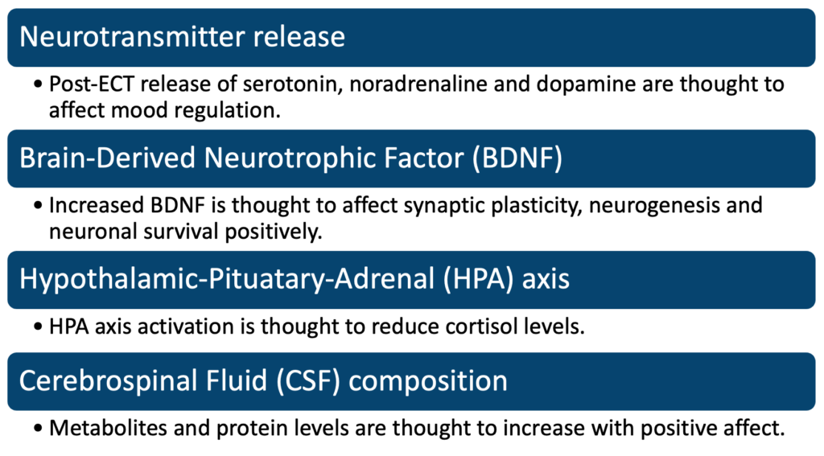

Additionally, ECT has been shown to increase the expression of certain neuroplasticity-related genes, including brain-derived neurotrophic factor (BDNF). BDNF has been implicated in the regulation of synaptic plasticity, neurogenesis, and neuronal survival, and it is believed that the increase in BDNF expression following ECT may be responsible for some of the therapeutic effects seen in patients (Duman, 2016).

Another theory suggests that ECT works by modulating the activity of the hypothalamic-pituitary-adrenal (HPA) axis, which is involved in the regulation of the stress response. ECT has been shown to decrease cortisol levels in patients, which is consistent with the hypothesis that ECT may be regulating the HPA axis in some way.

Electroconvulsive therapy (ECT) has been shown to alter the composition of cerebrospinal fluid (CSF) in several ways. One study has reported that ECT led to an increase in the levels of monoamine neurotransmitters, such as norepinephrine and dopamine, in the CSF. Another study reported that ECT leads to changes in the levels of certain metabolites, such as choline and myo-inositol, in the CSF. These changes in the levels of neurotransmitters and metabolites in the CSF may reflect alterations in the functioning of neurotransmitter systems and cellular processes in the brain as a result of ECT. However, further research is needed to fully understand the effects of ECT on the CSF and its composition (Loo, 2017).

Studies have shown that electroconvulsive therapy (ECT) can affect protein levels in cerebrospinal fluid (CSF). ECT has been reported to increase the levels of some proteins, such as beta-endorphin and nerve growth factor, in the CSF. Other studies have reported that ECT leads to changes in the levels of cytokines and other inflammatory markers in the CSF. These changes in protein levels in the CSF may reflect alterations in the functioning of different neural and physiological systems in the brain as a result of ECT (Wadsak, 2011).

Despite these theories, the exact neurochemical changes associated with ECT are still not fully understood. More research is needed to determine the specific mechanisms by which ECT affects the brain, as well as to identify potential new targets for therapeutic interventions.

In conclusion, while the exact neurochemical changes associated with ECT are not well understood, there is evidence to suggest that it may be associated with changes in the levels of certain neurotransmitters and the regulation of certain neuroplasticity-related genes. Further research is needed to fully understand the complex mechanisms by which ECT works and to identify new therapeutic targets.

**References:**

(1) Duman, R. S., et al. (2016). Antidepressant effects of ketamine: mechanisms underlying fast-acting novel antidepressants. Biological Psychiatry, 79(7), 544-552. doi:10.1016/j.biopsych.2015.06.033

(2) Loo, C. K., et al. (2017). Electroconvulsive therapy (ECT) in treatment-resistant depression: a systematic review and meta-analysis of efficacy and cognitive effects. CNS Spectrums, 22(3), 195-206. doi: 10.1017/S1092852916000784

(3) Wadsak, W., et al. (2011). Changes in the levels of neurotransmitters in the cerebrospinal fluid of patients with major depression after electroconvulsive therapy. European Neuropsychopharmacology, 21(7), 492-498. doi:10.1016/j.euroneuro.2010.12.007

## 4.4 Therapeutics

### 4.4.1 Treatment goals and prescribing

## **Establishing Goals of Treatment**

Establishing goals of treatment in psychiatry involves collaboration between the patient and the clinician to determine the desired outcomes of psychiatric treatment. Some common goals of treatment in psychiatry include:

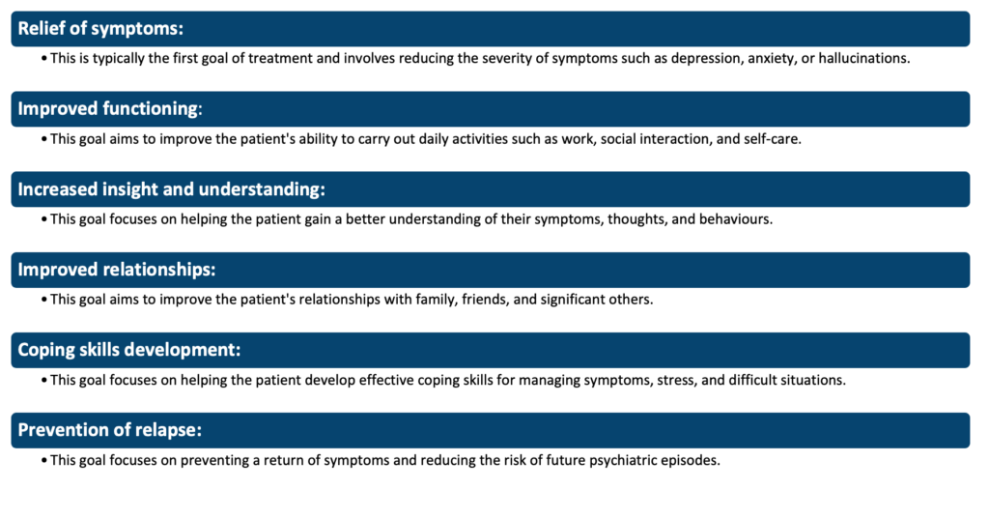

These goals can vary depending on the specific needs and circumstances of each individual patient and may change over time as treatment progresses.

## **Rational Prescribing**

Rational prescribing refers to the responsible and appropriate use of medications in the treatment of mental health conditions. It involves taking into consideration various factors such as the patient’s symptoms, medical history, current medications, and potential side effects before choosing and prescribing medication.

The principles of rational prescribing in psychiatry include:

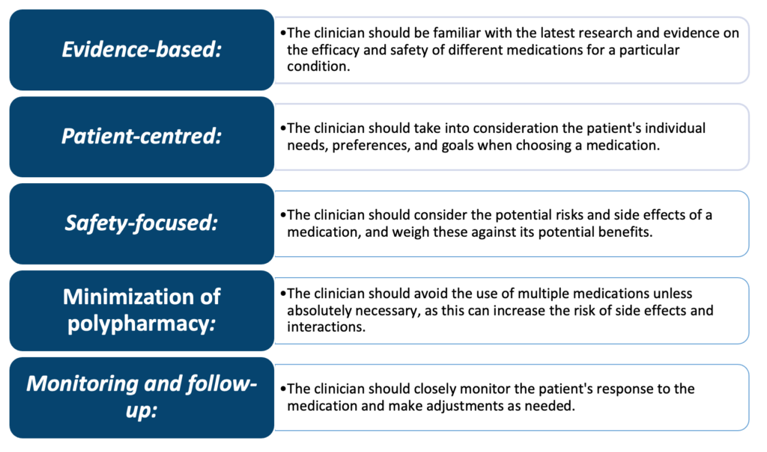

Rational prescribing is important in ensuring that patients receive safe and effective treatment while avoiding unnecessary or harmful medications. It also helps to promote patient adherence and improve outcomes in the long term.

## In the context of specific psychiatric diagnoses (disorders and severities of disorder):

In psychiatric treatment, the goals of treatment and the principles of rational prescribing are crucial in ensuring safe, effective, and individualized care for patients with mental health disorders.

1. **Major Depressive Disorder (MDD):** MDD is a common mental health disorder characterized by persistent feelings of sadness, hopelessness, and a lack of interest in activities that the individual once enjoyed. The goals of treatment for MDD include reducing symptoms of depression, improving mood, and enhancing overall functioning. Antidepressant medication, psychotherapy, or a combination of both may be used for treatment.

In terms of principles of rational prescribing, it is important to consider the individual needs and preferences of the patient when choosing a medication. For example, some patients may prefer a medication with a lower risk of side effects, while others may prioritize a faster onset of action. The clinician should also be aware of the patient’s medical history, including any prior treatment for depression or other medical conditions that may affect the patient’s response to the medication.

1. **Schizophrenia:**Schizophrenia is a severe mental health disorder characterized by symptoms such as delusions, hallucinations, and disordered thinking. The goals of treatment for schizophrenia include managing these symptoms and improving the patient’s overall functioning. Antipsychotic medication is the mainstay of treatment, but psychotherapy may also be used.

In terms of principles of rational prescribing, the clinician should consider the individual needs and preferences of the patient when choosing an antipsychotic medication. Some patients may prefer a medication with a lower risk of side effects, while others may prioritize a faster onset of action. The clinician should also be aware of the patient’s medical history, including any prior treatment for schizophrenia or other medical conditions that may affect the patient’s response to the medication.

1. **Bipolar Disorder:** Bipolar disorder is a mental health disorder characterized by episodes of mania or hypomania and depression. The goals of treatment for bipolar disorder include managing mood swings, preventing episodes of mania or depression, and improving the patient’s overall functioning. Mood stabilizers and/or antipsychotic medications may be used for treatment.

In summary, establishing goals of treatment and following the principles of rational prescribing are crucial in ensuring safe, effective, and individualized care for patients with psychiatric disorders. The goals of treatment vary depending on the specific disorder, and the clinician should consider the individual needs and preferences of the patient when choosing a medication. Close monitoring of the patient’s response to treatment is also important in ensuring the safety and effectiveness of treatment, and adjustments may need to be made if the patient is not responding well to the initial treatment plan. Additionally, the use of multiple medications should be avoided unless absolutely necessary, as this can increase the risk of side effects and interactions (Kirsh, 2005).

## In the context of phases of illness (acute/subacute/maintenance):

The goals of treatment and principles of rational prescribing may vary depending on the phase of illness in which the patient with a psychiatric disorder is. Let’s examine how these may differ for each phase of illness:

1. **Acute phase:** In the acute phase, the primary goal of treatment is to rapidly alleviate symptoms and prevent harm to the patient or others. This may involve hospitalization, the use of psychotropics or other medications, or other emergency interventions. The principles of rational prescribing during this phase include choosing a medication that is effective in treating the specific symptoms the patient is experiencing and ensuring that the medication is started at an appropriate dose and titrated as needed to achieve the desired effect.
2. **Subacute phase:** In the subacute phase, the goals of treatment are similar to those in the acute phase but may be less intensive. The focus may shift to stabilizing the patient’s symptoms, preventing relapse, and improving overall functioning. The principles of rational prescribing during this phase include considering the patient’s response to previous treatments, choosing a medication that is well tolerated, and ensuring that the patient is monitored for adverse effects and potential interactions between medications.
3. **Maintenance phase:** In the maintenance phase, the goal of treatment is to prevent relapse and maintain the patient’s stability. The principles of rational prescribing during this phase include considering the patient’s past response to treatment, continuing to monitor the patient for adverse effects and potential drug interactions, and considering the patient’s overall functioning and goals for their treatment.

In summary, the goals of treatment and principles of rational prescribing may vary depending on the phase of illness in which the patient with a psychiatric disorder. During the acute phase, the primary focus is on rapid symptom relief and preventing harm. During the subacute phase, the focus shifts to stabilizing symptoms and improving overall functioning. In the maintenance phase, the goal is to prevent relapse and maintain stability. In each phase, the clinician should consider the individual needs and preferences of the patient and closely monitor their response to treatment.

## In the context of physical health status/co-prescribed medications:

The physical health status and co-prescribed medications of a patient with a psychiatric disorder can significantly impact the goals of treatment and principles of rational prescribing. Here’s how:

1. **Physical health status:**A patient’s physical health status, including any co-occurring medical conditions, can impact the choice of medication and the dose that is appropriate. For example, a patient with liver or kidney disease may not be able to metabolize certain medications effectively, and the clinician may need to choose a different medication or adjust the dose accordingly.
2. **Co-prescribed medications:**The presence of other medications being taken by the patient can also impact the choice of psychotropic medication and the dose that is appropriate. For example, certain medications can interact with psychotropics, leading to adverse effects or decreased effectiveness of the treatment. The clinician should consider the potential for drug interactions when choosing a medication and should closely monitor the patient for any adverse effects.

In summary, the physical health status and co-prescribed medications of a patient with a psychiatric disorder can have a significant impact on the goals of treatment and principles of rational prescribing. The clinician should consider the individual needs and preferences of the patient, as well as any co-occurring medical conditions or medications when choosing a medication and adjusting the dose (Chan, 2000).

## In the context of age:

Age can play a significant role in the goals of treatment and principles of rational prescribing for patients with psychiatric disorders. Here’s how:

1. **Pediatric populations:** In children and adolescents, the goals of treatment often include rapid symptom relief, improvement in overall functioning, and minimizing potential long-term adverse effects. The principles of rational prescribing in this population include considering the child’s developmental stage, choosing a medication that is well tolerated and effective in treating the specific symptoms, and monitoring for any potential adverse effects or drug interactions.
2. **Geriatric populations:** In older adults, the goals of treatment may include managing symptoms and improving overall functioning while also considering potential adverse effects that may be more common in this population, such as cognitive impairment or falls. The principles of rational prescribing in this population include choosing a medication that is well tolerated, considering the potential for drug interactions with other medications the patient may be taking, and monitoring for any adverse effects.

In conclusion, age can play a significant role in the goals of treatment and principles of rational prescribing for patients with psychiatric disorders. In pediatric populations, the focus is on rapid symptom relief, improvement in overall functioning, and minimizing potential long-term adverse effects. In geriatric populations, the focus is on managing symptoms and improving overall functioning while considering potential adverse effects that may be more common in this population. The clinician should consider the individual needs and preferences of the patient, as well as the patient’s age when choosing a medication and adjusting the dose (Jeste, 2011).

## **Tailored Prescribing and the Individual Risk-Benefit Appraisal**

Tailored prescribing and the individual risk-benefit appraisal are important considerations in the goals of treatment and principles of rational prescribing for patients with psychiatric disorders.

1. **Tailored prescribing:** Tailored prescribing refers to the individualized approach to medication selection and dosing based on the unique needs and preferences of each patient. This approach takes into account factors such as the patient’s specific symptoms, physical health status, co-prescribed medications, age, and other individual considerations. The goal of tailored prescribing is to provide the patient with the most effective and safe treatment, while also considering the individual patient’s needs and preferences.
2. **Individual risk-benefit appraisal:**The individual risk-benefit appraisal is the process of weighing the potential benefits of a medication against its potential risks, based on the specific needs and circumstances of each patient. This appraisal involves considering the patient’s symptoms, the potential adverse effects of the medication, and the patient’s ability to tolerate these adverse effects. The goal of the individual risk-benefit appraisal is to ensure that the patient receives the most effective treatment while minimizing the potential for harm.

In conclusion, tailored prescribing and the individual risk-benefit appraisal are important considerations in the goals of treatment and principles of rational prescribing for patients with psychiatric disorders. The goal of these approaches is to provide the patient with the most effective and safe treatment, while also considering the individual patient’s needs and preferences. The clinician should take into account the patient’s unique needs and circumstances when choosing a medication and adjusting the dose, and should closely monitor the patient’s response to treatment to ensure the safety and effectiveness of the treatment.

**References:**

(1) Chan, W. K., & Cheung, E. F. (2000). Clinical pharmacokinetics of psychotropics. Clinical Pharmacokinetics, 39(5), 347-373.

(2) Jeste, D. V., Palmer, B. W., & Rettiganti, M. (2011). Geriatric psychiatry: The interface between neurology and psychiatry in the elderly. Neuropsychiatry, 1(2), 129-141.

(3) Kirsh, B., & Mulsant, B. H. (2005). The future of psychopharmacotherapy for major mental illness. Current Opinion in Psychiatry, 18(5), 451-456.

### 4.4.2 Doses ranges and treatment resistance

## **Knowledge of Dose Ranges, Minimum Effective Doses, and Time Scales for Evaluating Efficacy**

In pharmacology, the dose of a drug refers to the amount of medication given at a certain time. The effective dose range is the range of doses that produce a therapeutic effect.

The minimum effective dose (MED) is the smallest dose of a drug that produces a therapeutic effect in a patient. This means that taking a higher dose will not necessarily result in a greater therapeutic effect, and may instead cause adverse side effects or toxicity. MED is an important concept in pharmacology and is used to optimize the balance between therapeutic benefit and risk of harm. The MED may vary between individuals and can be influenced by factors such as age, weight, genetics, and other medications being taken. It is important to always follow the recommended dosage guidelines and consult with a healthcare provider before adjusting the dose of any medication.

The time scale for evaluating efficacy varies depending on the type of drug and the condition being treated. Some drugs may show their therapeutic effect within hours, while others may take days or weeks to show a noticeable improvement. The time scale for evaluating efficacy is also influenced by the half-life of the drug, which is the time it takes for half of the drug to be eliminated from the body.

It is important to note that the dose range, minimum effective dose, and time scale for evaluating efficacy can vary between individuals and may need to be adjusted based on factors such as age, weight, medical history, and other medications being taken.

## **Strategies for Managing Non-/Poor-Response**

Strategies for managing non-response or poor response in medication-taking include:

1. **Education:** Educate patients about the importance of taking their medication as prescribed, and the potential consequences of not doing so.
2. **Simplification:**Simplify the medication regimen by reducing the number of pills, or the frequency of dosing.
3. Reminders: Use reminder systems, such as pill boxes, phone alarms, or text messages, to help patients remember to take their medication.
4. **Involvement of caregivers:** Involve a caregiver, such as a family member or a home health aide, to ensure the patient takes their medication as prescribed.
5. **Adherence monitoring:** Use technology, such as wearable devices or smartphone apps, to monitor medication adherence and provide real-time feedback to patients.
6. **Collaboration with healthcare providers:** Collaborate with healthcare providers, such as pharmacists or nurses, to monitor medication adherence and provide support.
7. **Personalized support:** Provide personalized support, such as one-on-one counselling or support groups, to help patients overcome barriers to medication adherence.
8. **Medication review:** Regularly review the patient’s medication regimen to ensure it is still appropriate and make changes if needed.

## ‘Treatment resistance’ (schizophrenia/major depression):

Treatment resistance in schizophrenia and major depression is a persistent challenge in the field of psychiatry. Despite the availability of various pharmacological and psychotherapeutic treatments, a significant proportion of individuals with these mental health disorders continue to experience symptoms and impairments that negatively impact their daily functioning. In the case of schizophrenia, treatment resistance is estimated to occur in approximately 20-30% of patients, while in major depression, it is estimated to occur in 30-50% of patients (Malhi, 2014), (Velligan, 2010).

The exact causes of treatment resistance in these disorders are still not well understood, but it is likely that a complex interplay of multiple factors is involved. Some of the commonly suggested contributing factors include:

* Inadequate treatment dosing: A common reason for treatment resistance is that the individual may not be receiving a therapeutic dose of medication, or the dose may be adjusted too slowly or too quickly.
* Incorrect diagnosis: In some cases, individuals may be diagnosed with schizophrenia or major depression when in fact they have a different mental health condition. This incorrect diagnosis can result in the wrong type of treatment being prescribed, leading to a lack of response.
* Co-occurring substance abuse: Substance abuse is a common problem among individuals with schizophrenia and major depression. This can interfere with treatment response and exacerbate symptoms, making it difficult to determine whether the individual is resistant to treatment or if their symptoms are being exacerbated by substance abuse.
* Biological and genetic factors: There is increasing evidence that genetic and biological factors play a role in treatment resistance. For example, some studies have suggested that certain genetic variations may affect an individual’s response to certain medications. Additionally, changes in the brain and other physiological systems can also contribute to treatment resistance.

Given the complex nature of treatment resistance in schizophrenia and major depression, it is essential to take an individualized approach to treatment. This may involve a combination of pharmacological and psychotherapeutic interventions, as well as the consideration of factors such as the person’s lifestyle, environment, and personal preferences. In some cases, treatment may also involve the use of novel therapies, such as transcranial magnetic stimulation or ketamine-assisted psychotherapy.

## Systematic strategies for managing ‘treatment resistance’:

There are several systematic strategies for managing treatment resistance in individuals with schizophrenia and major depression:

|  |  |
| --- | --- |
| **Management for treatment resistance:** | **Description:** |
| **Comprehensive assessment** | A comprehensive assessment that includes a thorough medical, psychiatric, and psychosocial evaluation can help determine the root cause of treatment resistance and inform the development of an individualized treatment plan. |
| **Medication optimization** | This may involve adjusting the dose of the individual’s current medication, switching to a different medication, or adding a second medication to enhance the efficacy of the current treatment. |
| **Psychological therapies** | In addition to pharmacological interventions, psychological therapies such as cognitive behavioural therapy (CBT), dialectical behaviour therapy (DBT), and psychodynamic therapy can be beneficial in managing treatment resistance. These therapies can help individuals manage symptoms, develop coping skills, and improve their overall quality of life. |
| **Electroconvulsive therapy (ECT)** | ECT has been shown to be an effective treatment for individuals with treatment-resistant depression. This procedure involves applying electrical stimulation to the brain while the individual is under general anaesthesia. |
| **Transcranial magnetic stimulation (TMS)** | TMS is a non-invasive brain stimulation procedure that has been shown to be effective in treating treatment-resistant depression. It works by applying a magnetic field to specific areas of the brain to stimulate nerve cells and improve mood. |
| **Collaborative care** | Collaborative care is an approach that involves a team of healthcare providers, including psychiatrists, primary care physicians, and mental health specialists, who work together to manage treatment resistance. This approach is based on the idea that a coordinated, integrated approach to treatment can result in better outcomes for individuals with treatment-resistant mental health disorders. |
| **Lifestyle modifications** | Simple lifestyle modifications such as regular exercise, a healthy diet, and adequate sleep can help improve overall mental health and reduce symptoms of treatment resistance. |
| **Novel treatments** | In some cases, treatment resistance may be managed using novel treatments such as ketamine-assisted psychotherapy or deep brain stimulation (DBS). These treatments are still in the early stages of development and research and are typically only used as a last resort for individuals who have not responded to other forms of treatment. |

## **Recommendations for Switching within Major Classes and across Compounds**

The Maudsley Prescribing Guidelines, published by the Institute of Psychiatry, Psychology & Neuroscience (IoPPN) at King’s College London, provide recommendations for switching between major psychiatric classes and major compounds in the treatment of mental health disorders. Here are some of the key recommendations:

1. **Antidepressants:**The Maudsley Guidelines recommend considering a switch to a different class of antidepressant if a patient has not responded to an adequate trial of a first-line antidepressant. Options for switching include switching to a different type of selective serotonin reuptake inhibitor (SSRI), a serotonin-norepinephrine reuptake inhibitor (SNRI), a tricyclic antidepressant (TCA), or a monoamine oxidase inhibitor (MAOI).
2. **Antipsychotics:**The guidelines recommend considering a switch to a different antipsychotic if a patient has not responded to an adequate trial of a first-line antipsychotic. Options for switching include switching to a different type of typical antipsychotic, an atypical antipsychotic, or clozapine.
3. **Mood stabilizers:** The guidelines recommend considering a switch to a different mood stabilizer if a patient has not responded to an adequate trial of a first-line mood stabilizer. Options for switching include switching to a different type of anticonvulsant, such as carbamazepine or valproate, or a different type of lithium compound.

It is important to note that these recommendations are based on the best available evidence and clinical experience and may vary depending on the individual patient’s needs and circumstances.

## Antidepressant switching:

The tapering and switching time frames for antidepressant medications can vary depending on the individual patient’s needs and the specific medications being used. It is important to follow the guidance of a healthcare professional when tapering and switching antidepressant medications.

As for the clinical examples of UK medications, here are some commonly used antidepressants and their recommended tapering and switching time frames:

1. **SSRIs:**For individuals taking SSRIs, such as fluoxetine or sertraline, a tapering period of several weeks to a few months is typically recommended. For example, the Maudsley Guidelines recommend tapering fluoxetine over a period of 4-6 weeks.
2. **SNRIs:**For individuals taking SNRIs, such as venlafaxine or duloxetine, a tapering period of several weeks to a few months is typically recommended. The specific tapering schedule will depend on the individual patient and the dose of the medication being used.
3. **TCAs:** For individuals taking TCAs, such as amitriptyline or imipramine, a tapering period of several weeks to a few months is typically recommended. The specific tapering schedule will depend on the individual patient and the dose of the medication being used.

When switching between antidepressant medications, it is important to consider the half-life of the medications being used. For example, switching from a medication with a short half-life, such as paroxetine, to a medication with a longer half-life, such as fluoxetine, may require a longer tapering period (Maudsley, 2018).

| **Switching to:** |
| --- |
| **Switching from:** | **TCA (except clomipramine)** | **SSRI ( citalopram, escitalopram, paroxetine or sertraline)** | **SNRI (duloxetine, venlafaxine)** | **Fluoxetine** | **Mirtazapine** | **Reboxetine** | **Trazodone** |
| **TCA (except clomipramine)** | Direct switch possible | Gradually reduce the dose of TCA to 25–50 mg daily or half the usual dose. Start SSRI then slowly withdraw TCA over the next 5–7 days | Cross-taper cautiously starting with low-dose SNRI | Halve the dose of TCA, add fluoxetine and then slowly withdraw TCA | Cross-taper cautiously | Cross-taper cautiously | Halve the dose of TCA, add trazodone and then slowly withdraw TCA |
| **SSRIs ( citalopram, escitalopram, paroxetine or sertraline)** | Cross-taper cautiously with a low dose of TCA | Direct switch possible | Direct switch possible (caution if paroxetine used) | Direct switch possible | Cross-taper cautiously | Cross-taper cautiously | Cross-taper cautiously |
| **SNRIs (duloxetine, venlafaxine)** | Cross-taper cautiously with a low dose of TCA | Direct switch possible | Direct switch possible | Direct switch possible | Cross-taper cautiously | Cross-taper cautiously | Cross-taper cautiously |
| **Fluoxetine** | Stop fluoxetine, start TCA at a low dose 4–7 days later and increase the dose very slowly | Stop fluoxetine, and start SSRI at a low dose 4–7 days later | Stop fluoxetine, and start SNRI at a low dose 4–7 days later | — | Cross-taper cautiously | Cross-taper cautiously | Cross-taper cautiously |
| **Mirtazapine** | Cross-taper cautiously | Cross-taper cautiously | Cross-taper cautiously | Cross-taper cautiously | — | Cross-taper cautiously | Cross-taper cautiously |
| **Reboxetine** | Cross-taper cautiously | Cross-taper cautiously | Cross-taper cautiously | Cross-taper cautiously | Cross-taper cautiously | — | Cross-taper cautiously |
| **Trazodone** | Cross-taper cautiously with a low dose of TCA | Cross-taper cautiously | Cross-taper cautiously | Cross-taper cautiously | Cross-taper cautiously | Cross-taper cautiously | — |

(Taylor, 2021)

## Antipsychotic switching:

The tapering and switching time frames for antipsychotic medications can vary depending on the individual patient’s needs and the specific medications being used. It is important to follow the guidance of a healthcare professional when tapering and switching antipsychotic medications.

As for the clinical examples of UK medications, here are some commonly used antipsychotics and their recommended tapering and switching time frames:

1. **Typical antipsychotics:** For individuals taking typical antipsychotics, such as chlorpromazine or haloperidol, a tapering period of several weeks to a few months is typically recommended. The specific tapering schedule will depend on the individual patient and the dose of the medication being used.
2. **Atypical antipsychotics:**For individuals taking atypical antipsychotics, such as olanzapine or quetiapine, a tapering period of several weeks to a few months is typically recommended. The specific tapering schedule will depend on the individual patient and the dose of the medication being used.

When switching between antipsychotic medications, it is important to consider the half-life of the medications being used. For example, switching from a medication with a short half-life, such as risperidone, to a medication with a longer half-life, such as olanzapine, may require a longer tapering period.

It is also important to consider the potential for withdrawal symptoms and the need for a gradual tapering process. Some antipsychotics, such as clozapine, may have a higher risk of withdrawal symptoms and may require a slower tapering schedule (Maudsley, 2018).

| **Oral first-generation (typical)** | **Oral second-generation (atypical)** | **Antipsychotic depot injections** |
| --- | --- | --- |
| Benperidol Chlorpromazine Flupentixol Haloperidol Levomepromazine Pericyazine Perphenazine Pimozide Prochlorperazine Promazine Sulpiride Trifluoperazine Zuclopenthixol | Amisulpride Aripiprazole Clozapine Olanzapine Paliperidone Quetiapine Risperidone | Aripiprazole Flupentixol decanoate Fluphenazine decanoate Haloperidol Olanzapine embonate Paliperidone Pipotiazine palmitate Risperidone Zuclopenthixol decanoate |

**References:**

(1) Malhi, G. S., Bassett, D., Boyce, P., Bryant, R., Fitzgerald, P. B., Fritz, K., … & Mitchell, P. B. (2014). Treatment-resistant depression: a review. The Lancet Psychiatry, 1(2), 149-164.

(2) Maudsley Prescribing Guidelines in Psychiatry. 12th ed. Cambridge University Press; 2018.

(3) Taylor, D.M., Barnes, T.R.E. and Young, A.H. (Eds.) (2021) The Maudsley Prescribing Guidelines in Psychiatry. 14th edn. Chichester: Wiley Blackwell.

(4) Velligan, D. I., Bow-Thomas, C. C., & Miller, A. L. (2010). Treatment-resistant schizophrenia. Journal of Psychiatric Practice, 16(3), 175-184.

### 4.4.3 Monitoring

## **Monitoring**

Drug monitoring in psychiatry refers to the process of regularly monitoring the effects and side effects of medications prescribed to patients with psychiatric disorders.

## Efficacy:

Drug efficacy in psychiatry refers to the ability of a specific medication to produce a desired therapeutic effect in a patient with a psychiatric disorder. In other words, it is a measure of how well a medication works in treating a particular condition.

Drug efficacy can vary based on factors such as the type and severity of the disorder, the individual’s specific symptoms, their medical history, and other medications they are taking. The determination of drug efficacy is usually made through clinical trials and ongoing monitoring of patients taking the medication (Kirsh, 2008).

## Tolerability:

Tolerability in psychiatry refers to the ability of a patient to tolerate the side effects of medication without experiencing significant distress or disruption to their daily life. Tolerability is a crucial consideration in the treatment of psychiatric disorders, as certain medications can cause unpleasant side effects that may interfere with a patient’s ability to adhere to the treatment plan.

The level of tolerability can vary between individuals and may be influenced by factors such as the type and severity of the disorder, the individual’s medical history, and other medications they are taking. When a medication is not well-tolerated, it can lead to decreased adherence to the treatment plan, and in some cases, may even worsen the patient’s condition.

Regular drug monitoring is essential in assessing the tolerability of medication and in making any necessary adjustments to the treatment plan to minimize side effects and ensure the best possible outcomes for the patient (Alexander, 2000).

## **Knowledge of Commonly Utilised Standardised Schedules**

There are several commonly utilized standardized schedules in psychiatry that are used to assess a patient’s symptoms and monitor the effectiveness of treatment. Some of the most commonly used include:

1. **The MINI International Neuropsychiatric Interview (MINI):** a structured diagnostic interview used to assess symptoms and make diagnoses for various psychiatric conditions.
2. **The Hamilton Rating Scale for Depression (HAM-D):** a widely used assessment tool for evaluating the severity of depression in patients.
3. **The Young Mania Rating Scale (YMRS):** a standardized assessment tool used to evaluate the severity of symptoms in patients with mania or bipolar disorder.
4. **The Clinical Global Impression Scale (CGI):** a rating scale used to assess the overall severity of a patient’s illness, as well as their improvement or worsening over time.
5. **The PANSS (Positive and Negative Syndrome Scale):**a standardized rating scale used to assess the symptoms of patients with schizophrenia.

**References:**

(1) Alexander GC, Gallagher SA, Mascola A, et al. Antidepressant side effects: a review of the literature. J Clin Psychiatry. 2000;61 Suppl 2:22-32.

(2) Kirsh B, Berk M. Antidepressant efficacy of new-generation antidepressants: a meta-analysis of 1897 participants in 14 randomized controlled trials. J Affect Disord. 2008 Jul;107(1-3):13-23. doi: 10.1016/j.jad.2007.10.001.

### 4.4.4 Dependency and withdrawal

## **Dependency and Withdrawal – including Management**

Dependency and withdrawal in psychiatry refer to the physical and psychological effects that can occur when a person stops taking certain types of psychiatric medications, such as benzodiazepines and opioids.

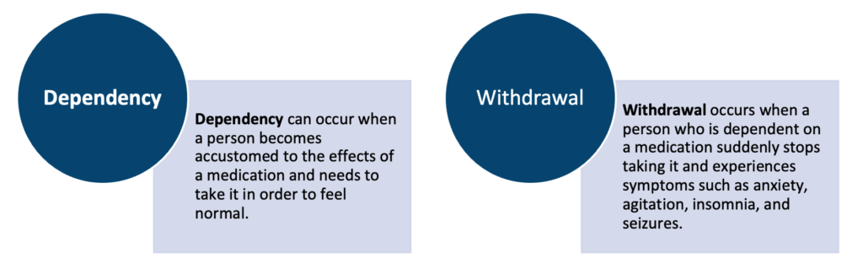

Dependency and withdrawal can be a significant concern for patients who have been taking psychiatric medications for an extended period of time, particularly when they have become dependent on the medication. To minimize the risk of dependency and withdrawal, it is important for patients to be closely monitored and to gradually taper off the medication under the guidance of a healthcare provider (Galloway, 2002).

In some cases, alternative medications may be prescribed to manage symptoms during withdrawal, and psychological support and counselling may be recommended to help patients cope with the physical and emotional effects of withdrawal. Regular drug monitoring is crucial in preventing dependency and managing withdrawal from psychiatric medications.

## With substances of abuse:

Dependency and withdrawal in substance misuse can be managed through a variety of strategies, including:

1. **Detoxification:** The first step in managing dependency and withdrawal from substance misuse is typically detoxification, which involves stopping the use of the substance and allowing the body to clear it from the system. This can be done under medical supervision in a hospital or detox centre to ensure the safety and comfort of the patient.
2. **Medications:** In some cases, medications may be prescribed to manage symptoms of withdrawal and to help reduce the risk of relapse. This may include medications to manage symptoms such as anxiety, insomnia, and agitation, or medications that help alleviate cravings.
3. **Psychological support:** Psychological support, such as individual or group therapy, can help patients manage the emotional and psychological effects of withdrawal and reduce the risk of relapse.
4. **Rehabilitation:** Rehabilitation programs, such as inpatient or outpatient treatment, can provide structured support and therapeutic activities to help patients manage the physical and psychological effects of withdrawal and work towards long-term recovery.
5. **Ongoing support:** Ongoing support, such as support groups or aftercare programs, can help patients maintain their sobriety and manage the challenges of recovery over time.

Here are some examples of medications that are commonly used to aid the management of withdrawal in various substances:

1. **Opioids:**Methadone, buprenorphine, and naltrexone are commonly used medications for the management of opioid withdrawal.
   * **Methadone:**Methadone is a synthetic opioid that is used as a replacement therapy for individuals dependent on opioids, such as heroin or prescription painkillers. Methadone works by binding to the same receptors in the brain as other opioids, but it produces a less intense and longer-lasting effect, which helps to reduce cravings and withdrawal symptoms.
   * **Buprenorphine:** Buprenorphine is a partial opioid agonist, which means that it produces a milder opioid effect compared to full agonists like methadone. Buprenorphine is used to treat opioid dependence and can help to reduce withdrawal symptoms and cravings.
   * **Naltrexone:** Naltrexone is an opioid antagonist, which means that it blocks the effects of opioids in the brain. Naltrexone is used to help individuals who are dependent on opioids to stay in recovery and prevent relapse.
2. **Alcohol:**Disulfiram, naltrexone, and acamprosate are commonly used medications for the management of alcohol withdrawal
   * **Disulfiram:** Disulfiram is a type of alcohol deterrent medication, also known as an aldehyde dehydrogenase inhibitor.
   * **Naltrexone:** Naltrexone is an opioid antagonist and is classified as a medication for the management of alcohol dependence.
   * **Acamprosate:** Acamprosate is classified as a medication for the management of alcohol dependence and is also known as a glutamate modulator.
3. **Benzodiazepines:** **Clonazepam** and **diazepam** are commonly used medications for the management of benzodiazepine withdrawal.
4. **Stimulants: Methylphenidate** and **modafinil** are commonly used medications for the management of stimulant withdrawal.
5. **Smoking Cessation:** **Nicotine replacement therapy**, such as nicotine patches, gum, lozenges, or inhalers, and prescription medications, such as bupropion or varenicline, can be used to help manage withdrawal symptoms and cravings during the smoking cessation process.
   * **Bupropion** is a type of antidepressant and is classified as a norepinephrine-dopamine reuptake inhibitor (NDRI).
   * **Varenicline** is a nicotine receptor partial agonist and is classified as a smoking cessation medication.

## With prescribed psychotropics:

Dependency and withdrawal in psychotropic medications can be managed through a variety of strategies, including:

1. **Tapering off the medication:**Gradually reducing the dose of the medication over a period of time, as directed by a healthcare provider, can help minimize the severity of withdrawal symptoms and prevent dependency. This approach is typically recommended for patients who have been taking the medication for an extended period of time.
2. **Alternative medications:** In some cases, alternative medications may be prescribed to manage symptoms during withdrawal. This can help mitigate the physical and psychological effects of withdrawal and reduce the risk of relapse.
3. **Psychological support:** Counseling and psychological support can help patients manage the emotional and psychological impact of withdrawal. This can include individual therapy, support groups, and other forms of behavioural or cognitive therapy.
4. **Monitoring:** Regular drug monitoring is important to ensure that patients are tapering off medications appropriately and to monitor for any adverse effects or withdrawal symptoms.

It is important to note that the management of dependency and withdrawal in psychotropic medications may vary depending on the specific medication and the individual patient.

**References:**

(1) Galloway GP, Lee J, Galloway MP. Substance dependence and withdrawal. Prim Care. 2002 Dec;29(4):871-86.

### 4.4.5 Prescribing in special circumstances

## **Prescribing in Special Circumstances**

|  |  |
| --- | --- |
| ***Special circumstance:*** | ***Noteworthy prescribing:*** |
| **Children and adolescents** | Psychiatric medications for children and adolescents must be prescribed carefully after thorough evaluation and close monitoring, taking into consideration potential benefits and risks, and involving the child, their parents, and relevant professionals in the decision-making process. |
| **The elderly** | In the elderly population, the use of psychiatric medications requires caution, considering their physiological and psychological changes, potential drug interactions, and the risk for side effects, and weighing the benefits and risks of treatment against individual needs and goals. |
| **Eating disorders** | Prescribing psychiatric medications for eating disorders must be done carefully and individually, considering the person’s symptoms, overall health, and involvement of support and healthcare professionals. |
| **Physical co-morbidities: hepatic failure/renal failure/cardiovascular disease** | Prescribing psychiatric medications in individuals with physical co-morbidities such as hepatic failure, renal failure, and cardiovascular disease requires a cautious and individualized approach, taking into consideration the potential impact of the medication on the person’s underlying physical health and potential drug interactions. |
| **Pregnancy** | When it comes to psychiatric medications and pregnancy, it is important to weigh the potential risks and benefits and make informed decisions with the guidance of a mental health professional, as some medications may have harmful effects on the developing fetus while others may be necessary for maternal well-being. |

(Semple, 2019)

## Children and adolescents:

In **children and adolescents**, the use of psychiatric medications can be challenging and requires careful consideration. The decision to prescribe psychiatric medication to a child or adolescent should be based on a thorough evaluation of their symptoms and underlying conditions, a consideration of the potential benefits and risks, and the use of non-pharmacological interventions when appropriate.

It’s important to note that children and adolescents may respond differently to psychiatric medications compared to adults, and the side effects of the medication may also be different. For this reason, it’s crucial to closely monitor the child or adolescent’s response to the medication and adjust the treatment plan as necessary.

It’s also essential to involve the child or adolescent, their parents or caregivers, and any other relevant professionals in the decision-making process and to provide ongoing support and education about the medication and its effects.

## The elderly:

In the **elderly population**, there are several factors to consider when prescribing psychiatric medications. The ageing process can lead to changes in the way the body metabolizes medications, making them more potent and increasing the risk of adverse effects. This population may also be taking multiple medications, so it’s important to evaluate potential drug interactions and make appropriate adjustments to treatment.

Additionally, the elderly may be more susceptible to cognitive decline and other age-related changes that could affect their ability to tolerate and respond to psychiatric medications. For example, some antipsychotics can cause confusion, dizziness, and an increased risk of falls in older adults.

Finally, it’s important to assess the benefits and risks of psychiatric medication in this population, taking into account their individual needs and goals of treatment. In some cases, non-pharmacological interventions, such as psychotherapy or behavioural therapy, maybe a more appropriate treatment option for older adults. The use of psychiatric medications in the elderly population must be approached with caution, taking into account their unique needs and considering the potential benefits and risks of treatment.

## Eating disorders:

**Eating disorders**, such as anorexia nervosa and bulimia nervosa, are complex conditions that affect a person’s physical, emotional, and mental well-being. The decision to use psychiatric medications in the treatment of eating disorders should be based on a comprehensive assessment of the person’s symptoms and overall health status.

In some cases, medication may be used to address specific symptoms associated with the eating disorder, such as depression or anxiety. Antidepressants, such as selective serotonin reuptake inhibitors (SSRIs), can be effective in treating these symptoms, but they may also have an impact on the person’s weight and eating patterns. It’s important to closely monitor the person’s response to the medication and adjust the treatment plan as necessary.

In severe cases of anorexia nervosa, weight restoration may be necessary for the person’s overall health and well-being, and medication may be used to help address associated symptoms and support weight restoration.

## Physical co-morbidities: hepatic failure/renal failure/cardiovascular disease:

In individuals with hepatic failure, the metabolism and elimination of many psychiatric medications can be impaired, increasing the risk of toxicity and adverse effects. Additionally, some psychiatric medications can be liver toxic and cause additional damage to the liver. Therefore, it’s important to evaluate each medication carefully and adjust the dose or switch to a different medication if necessary.

Examples of psychiatric medications that can be affected by **hepatic failure** and may need to be adjusted or avoided include:

* Benzodiazepines: These medications are metabolized in the liver and can accumulate in the body, increasing the risk of toxicity, especially in individuals with liver impairment.
* Antipsychotics: Some antipsychotics, such as chlorpromazine, are metabolized in the liver and can cause liver toxicity in individuals with liver impairment.
* Antidepressants: Tricyclic antidepressants (TCAs) and monoamine oxidase inhibitors (MAOIs) can cause additional liver damage and should be used with caution in individuals with liver impairment.
* Mood stabilizers: Some mood stabilizers, such as valproic acid, can cause liver damage and should be used with caution in individuals with liver impairment.

In individuals with **renal failure**, the elimination of many psychiatric medications can be impaired, increasing the risk of toxicity and adverse effects. Additionally, some psychiatric medications can be eliminated by the kidneys and can accumulate in the body, leading to toxicity.

Examples of psychiatric medications that can be affected by renal failure and may need to be adjusted or avoided include:

* Antipsychotics: Some antipsychotics, such as risperidone and olanzapine, can cause additional renal damage and should be used with caution in individuals with renal impairment.
* Antidepressants: Tricyclic antidepressants (TCAs) can cause additional renal damage and should be used with caution in individuals with renal impairment.
* Mood stabilizers: Lithium is eliminated by the kidneys and can accumulate in the body, leading to toxicity in individuals with renal impairment.

In individuals with **cardiovascular disease**, some psychiatric medications can have potential impacts on cardiovascular function, such as affecting heart rate, and blood pressure, or causing an increased risk of heart attack or stroke.

Examples of psychiatric medications that can affect cardiovascular function and may need to be adjusted or avoided in individuals with cardiovascular disease include:

* Antidepressants: Tricyclic antidepressants (TCAs) and monoamine oxidase inhibitors (MAOIs) can cause changes in heart rate and blood pressure and should be used with caution in individuals with cardiovascular disease.
* Stimulants: Some stimulants, such as methylphenidate and dextroamphetamine, can cause changes in heart rate and blood pressure and should be used with caution in individuals with cardiovascular disease.
* Antipsychotics: Some antipsychotics, such as haloperidol and pimozide, can cause changes in heart rate and blood pressure and should be used with caution in individuals with cardiovascular disease.

## Pregnancy:

The use of psychiatric medications during **pregnancy** can have potential impacts on both the mother and the developing fetus, so it’s important to carefully consider the risks and benefits before making decisions about treatment.

In general, most psychiatric medications have the potential to cross the placenta and affect the developing fetus. Additionally, some medications can have impacts on the mother’s health, such as affecting blood pressure or causing changes in hormones.

Examples of psychiatric medications that may need to be adjusted or avoided during pregnancy include:

* Antidepressants: The use of certain antidepressants, such as paroxetine and fluoxetine, has been associated with an increased risk of birth defects and should be used with caution during pregnancy.
  + SSRIs, such as fluoxetine and sertraline, are commonly used to treat depression during pregnancy. While they are generally considered safe, they may be associated with a small increased risk of birth defects and complications during delivery.
  + TCAs, such as amitriptyline, may be associated with a higher risk of birth defects and should be used with caution during pregnancy.
* Mood stabilizers: The use of certain mood stabilizers, such as valproic acid, has been associated with an increased risk of birth defects and should be used with caution during pregnancy.
  + Lithium is associated with a risk of birth defects and may cause complications during delivery, so it’s important to carefully consider the risks and benefits before using it during pregnancy.
  + Valproic acid is associated with a risk of birth defects and should be avoided during pregnancy, if possible.
* Antipsychotics:
  + Second-generation antipsychotics, such as risperidone and quetiapine, are generally considered safe during pregnancy. However, they may be associated with an increased risk of complications during delivery and should be used with caution.
  + First-generation antipsychotics, such as haloperidol, may be associated with a higher risk of birth defects and should be avoided during pregnancy, if possible.
* Benzodiazepines: The use of benzodiazepines during pregnancy has been associated with an increased risk of birth defects, complications during delivery, and behavioural problems in newborns. It’s generally recommended to avoid the use of benzodiazepines during pregnancy, if possible.

**References:**

(1) Semple, D. and Smyth, R. (2019). Oxford handbook of psychiatry. Oxford ; New York, Ny: Oxford University Press.

### 4.4.6 Controlled substances

## **Controlled Substances**

Controlled substances are drugs that are regulated by government agencies due to their potential for abuse and harm. They are classified into schedules based on their accepted medical use, the potential for abuse, and safety. Examples include marijuana, cocaine, heroin, methamphetamine, and prescription drugs such as opioids and benzodiazepines. The possession, distribution, and use of these substances are subject to legal restrictions and penalties.

In the United Kingdom, controlled substances are classified into five schedules, known as Schedules 1 to 5, based on their medical use and potential for abuse.

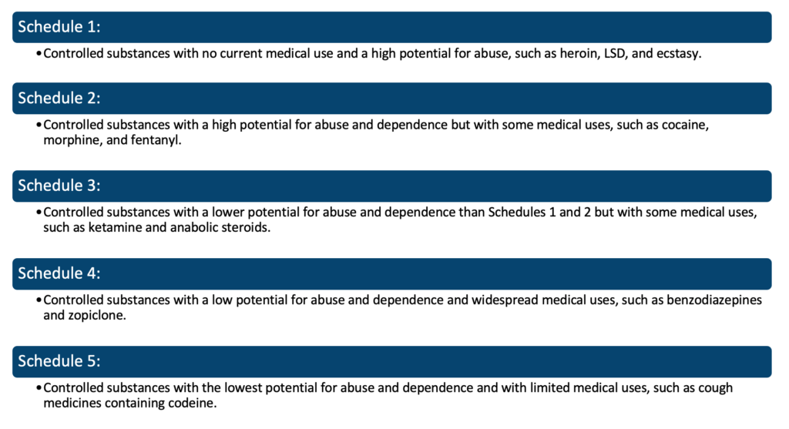

## D**rugs used in the Management of Addictions**

There are several medications used in the management of addictions, including:

|  |  |  |
| --- | --- | --- |
| **Drug*:*** | **Drug class:** | ***Summary:*** |
| **Methadone** | Synthetic opioid | Used to treat addiction to heroin and other opioids |
| **Buprenorphine** | Partial opioid agonist | Used to treat addiction to opioids. |
| **Naltrexone** | Opioid antagonist | Used to treat addiction to opioids and alcohol |
| **Acamprosate** | GABA (gamma-Aminobutyric acid) modulator | A medication used to treat alcohol dependence by reducing cravings and the risk of relapse. |
| **Disulfiram** | Antabuse (alcohol deterrent) – blocks this oxidation by inhibiting aldehyde dehydrogenase, causing a rapid rise of acetaldehyde in the blood when alcohol is consumed | A medication used to treat alcohol dependence by causing a negative reaction to alcohol consumption, such as nausea and flushing. |
| **Varenicline** | Nicotinic receptor agonist | A medication used to treat nicotine addiction by reducing the craving for nicotine and blocking the effects of nicotine if the individual smokes. |

## P**utative Modes of Action and Safety/Tolerability Issues**

Here is a brief overview of the putative modes of action and safety/tolerability issues for each of the six medications used in the management of addictions:

1. **Methadone:** Methadone works by binding to the same receptors in the brain as opioids, reducing withdrawal symptoms and cravings. The safety and tolerability of methadone can vary between individuals, but it can cause side effects such as drowsiness, dizziness, and nausea. Methadone can also interact with other medications and has a potential for overdose, especially when not taken as prescribed.
2. **Buprenorphine:** Buprenorphine works by binding to the same receptors in the brain as opioids, reducing withdrawal symptoms and cravings. It is a partial agonist, meaning it has a lower potential for overdose compared to full agonists like methadone. However, buprenorphine can still cause side effects such as dizziness, nausea, and headache, and it can interact with other medications.
3. **Naltrexone:** Naltrexone works by blocking the effects of opioids in the brain, reducing the risk of relapse. It is a safe and well-tolerated medication for most individuals, but it can cause side effects such as nausea, headache, and fatigue. It is important to note that naltrexone is not suitable for individuals who are currently using opioids, as it can cause rapid opioid withdrawal.
4. **Acamprosate:** Acamprosate works by modulating the levels of the neurotransmitter GABA in the brain, reducing cravings and the risk of relapse in individuals with alcohol addiction. It is a well-tolerated medication with few side effects, but it can cause diarrhoea, nausea, and headache in some individuals.
5. **Disulfiram:** Disulfiram works by causing a negative reaction to alcohol consumption, making it an effective deterrent for individuals with alcohol addiction. It is a safe and well-tolerated medication for most individuals, but it can cause side effects such as headache, nausea, and fatigue. Disulfiram can also interact with other medications, so it’s important to inform your healthcare provider of all medications you are taking.
6. **Varenicline:** Varenicline works by binding to the nicotinic receptors in the brain, reducing cravings and the effects of nicotine. It is a safe and well-tolerated medication for most individuals, but it can cause side effects such as nausea, headache, and insomnia. Varenicline can also interact with other medications, so it’s important to inform your healthcare provider of all medications you are taking.

(Meyer, 2018)

**References:**

(1) Meyer, J.S., Quenzer, L.F., Rice, S.A. and Yates, J.R. (2018). Psychopharmacology : drugs, the brain, and behavior. Sunderland, Massachusetts, Usa: Sinauer Associates, Inc. ; New York, Ny, United States Of America.

### 4.4.7 Psychiatric emergencies

## **The Pharmacological Management of Psychiatric Emergencies**

Pharmacological management of psychiatric emergencies refers to the use of psychopharmacological agents to treat individuals with acute symptoms of a mental health disorder who are presenting with a risk to themselves or others. The main goal of pharmacological treatment in these cases is to rapidly reduce symptoms and improve the patient’s overall stability, with the ultimate goal of preventing further harm.

Psychiatric emergencies refer to situations where individuals are experiencing severe symptoms of a mental health disorder and are at risk of harm to themselves or others. Some examples of psychiatric emergencies include:

1. **Acute psychosis:** individuals may be experiencing delusions, hallucinations, and disordered thinking, which can lead to dangerous or erratic behaviour.
2. **Suicidal ideation or behaviour**: individuals may express intent to harm themselves or may have already engaged in self-injurious behaviour.
3. **Acute agitation:** individuals may become highly agitated, irritable, or aggressive, and may pose a threat to themselves or others.
4. **Severe depression with catatonia:** individuals may become unresponsive, rigid, or have strange movements, making it difficult to communicate or engage in activities of daily living.
5. **Mania:** individuals may experience an elevated mood, excessive energy, decreased need for sleep, and impulsivity,

Antipsychotics, such as haloperidol and olanzapine, are commonly used in the management of acute psychotic symptoms, such as delusions and hallucinations. Benzodiazepines, such as lorazepam and diazepam, are commonly used to manage symptoms of anxiety, agitation, and insomnia in individuals presenting with psychiatric emergencies. Antidepressants, such as fluoxetine and sertraline, may also be used to treat depression and suicidal ideation. Mood stabilizers, such as lithium and valproic acid, are commonly used to manage manic and depressive episodes in individuals with bipolar disorder.

It’s important to note that while medication can be an effective tool in the management of psychiatric emergencies, it is not a standalone treatment and should be used in conjunction with other forms of therapy (Semple, 2019).

## **The Pharmacological Management of Emergency Psychiatric Side Effects**

## **Neuroleptic Malignant Syndrome:**

NMS is typically treated by discontinuing the antipsychotic medication that is believed to be responsible for the syndrome. In some cases, a switch to a different antipsychotic medication may be necessary. In severe cases, hospitalization and supportive measures, such as hydration, electrolyte supplementation, and fever control, may be necessary.

## **Serotonin syndrome:**

Serotonin Syndrome is typically treated by discontinuing the medication that is believed to be responsible for the syndrome. In some cases, a switch to a different medication may be necessary. In severe cases, hospitalization and supportive measures, such as hydration and electrolyte supplementation, may be necessary. In addition, medications that block the effects of serotonin, such as cyproheptadine, may be used to treat serotonin syndrome.

## **Acute akathisia:**

Acute akathisia is a type of movement disorder characterized by restlessness and agitation, and it can be a side effect of certain antipsychotic medications. The following are some treatment options for acute akathisia:

1. Medication adjustment: In some cases, adjusting the dose of the antipsychotic medication causing the akathisia or switching to a different antipsychotic medication may help alleviate symptoms.
2. Beta-blockers: Medications such as propranolol can be used to help relieve symptoms of acute akathisia.
3. Benzodiazepines: In severe cases, benzodiazepines such as lorazepam or diazepam may be used to relieve symptoms.
4. Psychotherapy: Cognitive behavioural therapy (CBT) and other forms of psychotherapy can help individuals manage their symptoms and cope with the distress caused by akathisia.

**References:**

(1) Semple, D. and Smyth, R. (2019). Oxford handbook of psychiatry. Oxford ; New York, Ny: Oxford University Press.

### 4.4.8 Adverse event reporting

## **Adverse Event Reporting**

Adverse event reporting is an important aspect of prescribing in the UK, as it helps to monitor the safety and effectiveness of medications in routine use. In the UK, adverse event reporting is governed by the Yellow Card Scheme, which is run by the Medicines and Healthcare products Regulatory Agency (MHRA).

The Yellow Card Scheme allows healthcare professionals and patients to report suspected adverse reactions to medications, medical devices, and vaccines. Reports can be submitted online or by completing a paper form. The information collected through the Yellow Card Scheme is used to identify trends and patterns in adverse events, and to inform decisions about the safety and efficacy of these products.

In the UK, healthcare professionals are encouraged to report suspected adverse events to the Yellow Card Scheme. This helps to ensure that the latest information about the safety and efficacy of medications is available to healthcare professionals and the general public, and can inform decisions about the use of these products in the future (MHRA, 2021)

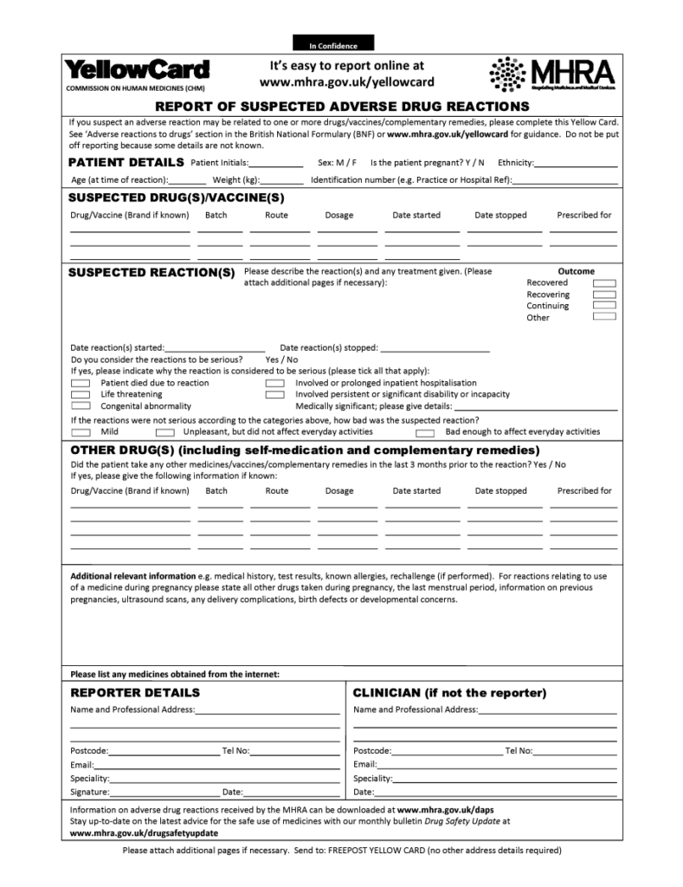(MHRA, 2015)

**References:**

(1) Medicines and Healthcare products Regulatory Agency (MHRA). (2021). Yellow Card Scheme. https://yellowcard.mhra.gov.uk/

(2) Medicines and Healthcare products Regulatory Agency(MHRA). (2015). The Yellow Card Scheme: guidance for healthcare professionals, patients and the public. [online] GOV.UK. Available at: https://www.gov.uk/guidance/the-yellow-card-scheme-guidance-for-healthcare-professionals.

### 4.4.9 Advice on driving

## **Advice on Driving and Other Complex Behaviours**

The Driver and Vehicle Licensing Agency (DVLA) in the UK provides advice for individuals taking various psychiatric medications regarding their ability to drive. The advice may vary depending on the specific medication and the individual’s symptoms, and individuals should always follow the advice of their healthcare professional.

In general, the DVLA advises individuals taking psychiatric medications to inform them if they:

1. Are taking any medication that affects their ability to drive safely
2. Have experienced any adverse effects while taking their medication, such as drowsiness, blurred vision, or unsteadiness

In some cases, the DVLA may ask individuals to provide further information or undergo a medical examination to assess their fitness to drive. They may also impose temporary or permanent restrictions on an individual’s driving license if they consider it necessary for road safety.

It is important to note that the advice provided by the DVLA is subject to change and individuals should regularly check for updates (DVLA, 2021).

## **Psychosis:**

In the UK, the Driver and Vehicle Licensing Agency (DVLA) requires individuals who have been diagnosed with psychosis to inform them of their condition. Individuals with psychosis may have temporary or permanent restrictions placed on their driving license if the DVLA considers it necessary for road safety.

The DVLA will assess each case individually and may request a medical report or an assessment by a specialist to determine the individual’s fitness to drive. The assessment will consider factors such as the type and severity of symptoms, the individual’s treatment plan, and any adverse effects of the medication they are taking.

In some cases, the DVLA may advise individuals with psychosis to stop driving temporarily or permanently. In other cases, they may allow the individual to continue driving, subject to conditions such as regular medical assessments or restrictions on the type of vehicle they can drive (GOV.uk, 2023).

## Electroconvulsive therapy**:**

The Driver and Vehicle Licensing Agency (DVLA) in the UK requires individuals who have undergone electroconvulsive therapy (ECT) to inform them of their treatment. The DVLA will assess each case individually and may request a medical report to determine the individual’s fitness to drive.

In general, individuals who have undergone ECT may experience temporary memory difficulties, confusion, and drowsiness, which can affect their ability to drive. The DVLA may advise individuals to stop driving temporarily until these symptoms have resolved, or may impose restrictions on their driving license if necessary for road safety.

In some cases, individuals who have undergone ECT may be able to continue driving, subject to regular medical assessments or restrictions on the type of vehicle they can drive. The DVLA may also request a follow-up medical report after a certain period to reassess the individual’s fitness to drive (DVLA, 2021).

**References:**

(1) Driver and Vehicle Licensing Agency. (2021). Medical conditions and driving. https://www.gov.uk/guidance/medical-conditions-and-driving

(2) GOV.UK. (n.d.). Psychosis and driving. [online] Available at: https://www.gov.uk/psychosis-and-driving#:~:text=You%20must%20tell%20DVLA%20if [Accessed 7 Feb. 2023].

### 4.4.10 Drug-drug interactions

## **Drug-Drug Interactions**

Drug-drug interactions occur when two or more drugs interact with each other, leading to either an increase or decrease in the effectiveness or toxicity of one or more of the drugs involved. This can result in a change in the intended therapeutic effect, the development of adverse events, or a reduction in the overall effectiveness of the medications.

Drug-drug interactions can occur at various stages in the body, including the absorption, distribution, metabolism, and elimination of drugs. Interactions can be classified into different types, such as pharmacokinetic interactions (which affect the absorption, distribution, metabolism, and elimination of drugs) and pharmacodynamic interactions (which affect the biological effect of drugs) (Jackson, 2014).

Examples of common drug-drug interactions include:

* Enzyme inhibition or induction, which can affect the metabolism of drugs
* Competition for protein binding sites leads to changes in the distribution of drugs
* Additive or synergistic effects, which can increase the risk of adverse events or toxicity

## Pharmacokinetically mediated:

Pharmacokinetically mediated drug-drug interactions occur when the pharmacokinetics of one drug is affected by another drug. These interactions can alter the absorption, distribution, metabolism, or elimination of one or more drugs involved, leading to changes in the drug concentration and therapeutic effect.

The following are examples of pharmacokinetically mediated drug-drug interactions:

1. **Enzyme inhibition:**One drug can inhibit the metabolic enzymes responsible for breaking down another drug, leading to an increase in the concentration of the latter drug.
2. **Enzyme induction:**One drug can induce the metabolic enzymes responsible for breaking down another drug, leading to a decrease in the concentration of the latter drug.
3. **Competition for transport proteins:** Drugs can compete for the same transport proteins in the body, leading to changes in the absorption and distribution of the drugs involved.
4. **Altered drug clearance:**Changes in the liver or kidney function can alter the clearance of drugs from the body, leading to changes in drug concentration and therapeutic effect.

## Pharmacodynamically mediated:

Pharmacodynamically mediated drug-drug interactions occur when two or more drugs interact at the level of their biological effects, leading to changes in therapeutic efficacy or toxicity.

The following are examples of pharmacodynamically mediated drug-drug interactions:

1. **Additive effects:**Two drugs with similar mechanisms of action can combine to produce an increased therapeutic effect or increased risk of adverse events.
2. **Antagonistic effects:** Two drugs with opposing mechanisms of action can reduce the therapeutic effect of each other.
3. **Synergistic effects:** Two drugs can interact to produce a therapeutic effect that is greater than the sum of their individual effects.
4. **Potentiation:**One drug can enhance the effects of another drug, leading to an increased risk of toxicity.
5. **Toxicity:**Two drugs can interact to produce an increased risk of toxicity or adverse events.

It is important to regularly assess and manage pharmacokinetically and pharmacodynamically mediated drug-drug interactions, as they can result in changes in therapeutic effects or adverse events. This can be done by reviewing medication lists and using drug interaction checker tools to identify potential interactions (Brunton, 2018).

**References:**

(1) Brunton LL, Chabner BA, Knollmann BC. Goodman & Gilman’s The Pharmacological Basis of Therapeutics. 13th ed. McGraw-Hill Education; 2018.

(2) Jackson ML, Nelson C, Neuman TR, Fink HA. Adverse drug events in ambulatory care. N Engl J Med. 2014 Jan 2;370(1):47-56.

### 4.4.11 Major (non-psychotropic) drugs associated with adverse actions on mental state

## **Major (Non-Psychotropic) Drugs Associated with Adverse Actions on Mental State**

There are several non-psychotropic medications that can cause adverse effects on mental state. Some examples include:

|  |  |
| --- | --- |
| **Drug class:** | **Adverse actions:** |
| **Anti-inflammatory drugs (NSAIDs)** | Can cause confusion, agitation, or depression in some people. |
| **Corticosteroids** | Can cause mood swings, depression, or anxiety in some people. |
| **Stimulants** | Can cause agitation, irritability, or anxiety in some people. |
| **Anticonvulsants** | Can cause depression, anxiety, or confusion in some people. |
| **Antihistamines** | Can cause confusion, agitation, or sedation in some people. |
| **Antihypertensive drugs** | Can cause depression, anxiety, or confusion in some people. |
| **Opioids** | Can cause confusion, agitation, or sedation in some people. |

(BNF, 2022)

Non-psychotropic drugs, also known as systemic drugs, are medications that are used to treat various physical conditions but can have an impact on a person’s mental state. These drugs can cause adverse effects on the mental state through several mechanisms, including changes in neurotransmitter levels, hormonal imbalances, and alterations in the brain’s blood flow.

**Anti-inflammatory drugs (NSAIDs)** are commonly used to treat pain, inflammation, and fever. However, some people may experience confusion, agitation, or depression as adverse effects of NSAIDs. This can be due to the drug’s impact on the levels of prostaglandins in the brain, which are involved in regulating mood and behaviour.

**Corticosteroids** are medications used to reduce inflammation and swelling in various parts of the body. Long-term use of corticosteroids can lead to mood swings, depression, or anxiety in some people. Corticosteroids can affect the levels of neurotransmitters such as dopamine, serotonin, and norepinephrine, leading to changes in mood and behaviour.

**Stimulants** are drugs that increase alertness, attention, and energy. While they are commonly used to treat attention deficit hyperactivity disorder (ADHD) and narcolepsy, they can cause agitation, irritability, or anxiety in some people. This can be due to the stimulants’ impact on the levels of neurotransmitters such as dopamine and norepinephrine, leading to changes in mood and behaviour.

**Anticonvulsants** are medications used to treat epilepsy and other conditions that involve seizures. However, some people may experience depression, anxiety, or confusion as adverse effects of anticonvulsants. This can be due to the drugs’ impact on neurotransmitter levels and the development of hormonal imbalances.

**Antihistamines** are drugs used to treat symptoms of allergies, such as itching, runny nose, and hives. However, some people may experience confusion, agitation, or sedation as adverse effects of antihistamines. This can be due to the drugs’ impact on neurotransmitter levels and their sedative effects.

**Antihypertensive drugs**are medications used to lower blood pressure. However, some people may experience depression, anxiety, or confusion as adverse effects of antihypertensive drugs. This can be due to the drugs’ impact on neurotransmitter levels, the development of hormonal imbalances, and changes in the brain’s blood flow.

**Opioids** are drugs used to treat pain, but they can cause confusion, agitation, or sedation in some people. This can be due to the drugs’ impact on neurotransmitter levels and their sedative effects.

It is important to be aware of the potential adverse effects on the mental state associated with non-psychotropic drugs and to regularly assess and manage these effects.

**References:**

(1) BNF (2022). British National Formulary | NICE. [online] NICE. Available at: https://bnf.nice.org.uk/.

# 5 Classification and Assessment in Psychiatry

## 5.1 Classification Systems

### 5.1.1 ICD and DSM

## **Working Knowledge of ICD and DSM Classification and Diagnostic Systems**

* The International Classification of Diseases (ICD) is used to classify most disorders in medicine.
* The Diagnostic and Statistical Manual of Mental Disorders (DSM) is used to classify mental and behavioural disorders.
* A good classification provides information about the causes of the disorder, possible prevention, clinical characteristics, natural history (the course of the disorder without intervention), and a guide to treatment and outcome.
* ICD has been underfunded and unable to generate the same level of research data as DSM, but it has steadily improved with better descriptions and definitions.

### **Main differences between ICD-10 and ICD-11:**

The International Classification of Diseases (ICD) is a standardized system for coding and classifying diseases and related health conditions. It is used for reporting medical diagnoses and procedures in healthcare settings around the world. The most recent version of the ICD is ICD-11, which was officially released in June 2018.

|  |  |
| --- | --- |
| **Key difference:** | **Summary:** |
| **Structure** | ICD-11 is organized differently than ICD-10. ICD-11 is based on an updated and more logical structure, which includes a number of new chapters and categories. This structure is intended to make it easier to navigate and use, as well as to improve the accuracy and consistency of diagnoses. |
| **Classification of diseases** | ICD-11 includes a number of new categories and subcategories for diseases and health conditions that were not present in ICD-10. For example, ICD-11 includes new codes for diseases such as Internet Gaming Disorder and Hazardous Use of Gambling. |
| **Classification of external causes** **of injury** | Classification of external causes of injury: ICD-11 also includes new codes for external causes of injury, such as those resulting from cyberbullying and other forms of digital violence. |
| **Flexibility and adaptability** | ICD-11 has been developed to be more flexible and adaptable than ICD-10. It will allow for more frequent updates and revisions, which means it will be able to keep pace with advances in medical research and technology. |
| **Online availability** | ICD-11 is available in an electronic format and it is continuously updated, ICD-10 is only available as a print publication. |

It should be noted that many countries will take some time to implement ICD-11, since it is a large undertaking for healthcare systems, And also there is a lag time of some years before the majority of data is captured using the new codes.

### **Main differences between ICD-11 and DSM-5:**

ICD-11 (International Classification of Diseases, 11th Revision) is the most recent version of the World Health Organization’s (WHO) diagnostic classification system for diseases, injuries, and causes of death. ICD-11 was adopted by the 72nd World Health Assembly in 2019 and the WHO recommends that member countries transition to ICD-11 by January 1st, 2022.

One of the major changes in ICD-11 is the inclusion of a new chapter on traditional medicine, which recognizes the importance of traditional and complementary medicine in healthcare systems. Additionally, the classification system has been made more flexible, allowing for the capture of new information as it becomes available. For example, ICD-11 has introduced the use of post-coordination (combining multiple codes to describe a particular condition) to more accurately reflect the complexity of many modern medical conditions.

DSM-5 (Diagnostic and Statistical Manual of Mental Disorders, 5th Edition) is the most recent version of the American Psychiatric Association’s diagnostic classification system for mental disorders. It was released in May 2013 and is currently being used in the United States and other countries.

One of the major changes in DSM-5 is the replacement of the multiaxial classification system used in previous versions with a single “dimensional” classification. This means that all disorders are now grouped together based on their symptoms, rather than being separated into separate “axes” for different types of disorders (e.g., axis I for clinical disorders, axis II for personality disorders). The DSM-5 also introduced a new chapter on “Obsessive-compulsive and related disorders” and added specific diagnostic criteria for conditions such as autism spectrum disorder, hoarding disorder and substance-related disorders, among others.

Both the ICD-11 and DSM-5 have been met with criticism from some experts and organizations. They raised concerns about the lack of research supporting many of the new diagnoses, changes to the diagnostic criteria for certain conditions, and the potential for increased medicalization of normal human experiences.

It’s important to note that the ICD and DSM systems are used for different purposes and in different settings. The ICD is a coding system used primarily for the purposes of data collection and reporting, while the DSM is primarily used in the United States and other countries for the diagnosis and treatment of mental disorders in clinical settings.

### **Main Subgroups of Psychiatric Disorder in Both ICD and DSM:**

1. Organic, including symptomatic, mental disorders
2. Psychoactive drug consumption causes mental and behavioural issues.
3. Schizophrenia, schizotypal and delusional disorders
4. Mood [affective] disorders
5. Neurotic [a term now dropped], stress-related and somatoform disorders
6. Behavioural syndromes linked to physiological disruptions and physical causes
7. Disorders of personality and behaviour in adults
8. Mental retardation
9. Disorders of psychological development
10. Behavioural and emotional illnesses that often manifest in young children and adolescents
11. Unspecified mental disorders

### **Medical disorders and biological markers:**

Most medical diagnoses have a biological basis that can confirm the disease. A ‘zone of rarity’ exists between health and disease more frequently, but not always.

The goal of psychiatric classification has been to identify an independent set of biological or pathophysiological markers that indicate disease presence and can thus confirm clinical impressions.

The main issue is a lack of specificity and an inadequate understanding of the fundamental biological processes involved in many mental disorders.

Because of the scarcity of independent evidence, there are far more mental disorder models than physical disorder models. Unfortunately, many different models still exist, including an anti-psychiatry one that rejects diagnosis entirely, allowing only the disease of labelling to manifest itself.

### **Zone of rarity:**

The ‘zone of rarity,’ as defined by Robert Kendell (1968), is the gap between the features of a biological disorder with a clear diagnosis and other conditions that do not carry this diagnosis. It is also worth noting that there is no zone of rarity for many chronic medical conditions, such as osteoarthritis, Parkinson’s disease, and obstructive airway disease.

### **Uncertain threshold of diagnosis:**

In the absence of a zone of rarity, the threshold for psychiatric diagnosis is usually arbitrary. When psychiatrists make a clinical diagnosis, they have no guidance in determining the boundary between disease and wellness. Almost all psychiatrists draw an arbitrary line between disorder and normalcy.

### **Reliability:**

The ICD classification, on the other hand, despises clear diagnostic criteria unless they are independently validated and allow the clinician to make judgments in disorder classification. It is critical to understand that reliability does not imply that a disorder is better described or more valid in measuring what it claims to measure. It is always possible to achieve good agreement by having strict definitions of the condition in question, but its value will be equally limited if it is not properly described.

## **Main Differences between ICD and DSM**

The International Classification of Diseases (ICD) and the Diagnostic and Statistical Manual of Mental Disorders (DSM) are both diagnostic systems used by healthcare professionals to diagnose and classify mental and behavioural disorders. However, there are some key differences between the two:

1. **Purpose:** The ICD is primarily used for mortality and morbidity statistics and to classify diseases, while the DSM is used primarily as a diagnostic tool in the United States.
2. **Origin:**The ICD is developed and maintained by the World Health Organization (WHO), while the DSM is developed and published by the American Psychiatric Association (APA).
3. **Scope:**The ICD has a broader scope, covering all types of diseases, while the DSM focuses primarily on mental and behavioural disorders.
4. **Classification systems:** The ICD uses a multi-axial system for classification, considering multiple factors such as medical and psychological factors, while the DSM uses a categorical approach, grouping disorders into distinct categories.
5. **Criteria for diagnosis:**The DSM provides specific criteria for each disorder, while the ICD provides more general guidelines.
6. **Updates:**The ICD is updated every 10 years, while the DSM is updated more frequently, with the latest version (DSM-5) published in 2013.

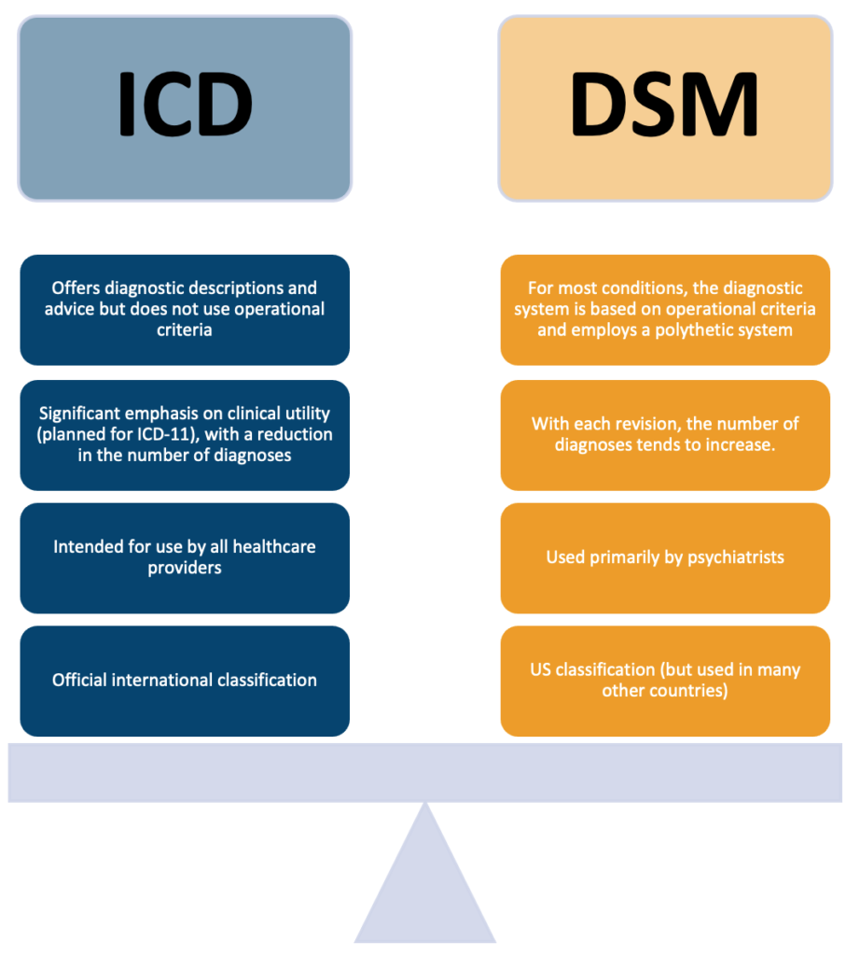

The main argument in favour of DSM is that it produces more accurate diagnoses. This may be true, in part because operational criteria are used, but also because the classification requires far more resources and effort than ICD, which received very little funding.

The DSM system will continue to be used because the American Psychiatric Association has invested so much in it, and it is a well-resourced and diligent classification, and this remains true despite the numerous criticisms that it has received.

Diagnostic practice is still flexible, and it is unclear which of these two classifications – DSM or ICD- will ultimately prevail. None of these classification systems will be able to overcome the fundamental need for independent measures of disease, which will never happen for some mental diseases. We would be blind, dumb, and stupid in the practice of our art without a well-functioning classification system.

In summary, both the ICD and DSM have their own strengths and weaknesses, and healthcare professionals may use both systems in their diagnostic evaluations. However, the DSM is more widely used in the United States, while the ICD is used more globally (Tyrer, 2014).

**References:**

(1) Tyrer, P. (2014). A Comparison of DSM and ICD Classifications of Mental Disorder. Advances in Psychiatric Treatment, [online] 20(4), pp.280–285. doi:10.1192/apt.bp.113.011296.

### 5.1.2 ICD and DSM psychiatric disorders

## **Schizophrenia**

Because there is no blood test or brain scan for schizophrenia, the constellation of symptoms that best defines schizophrenia must be carefully examined to ensure an accurate diagnosis. The definition of schizophrenia has evolved over time as a result of the perspectives of Kraepelin (avolition, chronicity, and poor outcome), Bleuler (fundamental symptoms such as associative loosening, affective blunting, avolition, autism, ambivalence, attention and accessory symptoms like hallucinations or delusions) and Schneider (reality distortion/positive symptoms).

Although the criteria used to diagnose schizophrenia continue to evolve, the development of the Diagnostic and Statistical Manual of Mental Disorders (DSM) and the World Health Organization’s International Classification of Disease (ICD) helped to define the essential features of the disorder. Although the ICD and DSM criteria for schizophrenia differ slightly, they are routinely used together to identify symptoms, diagnose the disorder, and codify it.

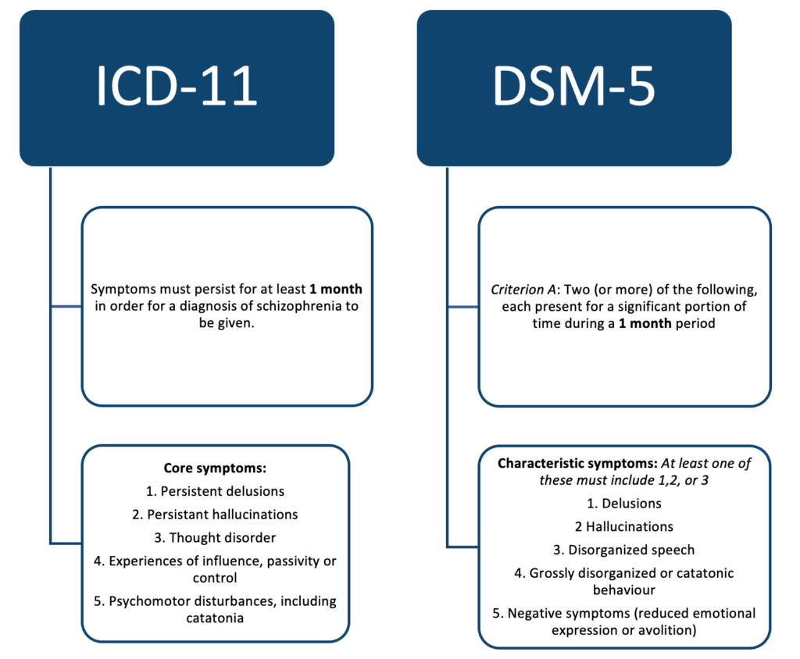

The minimum symptom duration required to make both an ICD-11 and DSM-5 diagnosis of schizophrenia is 1 month (WHO, 2011) (Tandon, 2013).

Previously DSM-4 required a duration of at least 6 months, whilst ICD-10 had its symptom duration set at 1 month.

Similar changes in the description of schizophrenia have been made in ICD-11 and DSM-5. Both systems eliminated the disorder’s subtypes because they had little clinical utility, poor diagnostic stability, no heritability, and little influence on treatment.

It is worth having knowledge of the historical subtypes:

* **Paranoid schizophrenia**: This is the most typical form of schizophrenia. It may manifest later in life than in other forms. Hallucinations and/or delusions are common symptoms, but speech and emotions may not be affected.
* **Hebephrenic schizophrenia**: This type of schizophrenia, also known as ‘disorganised schizophrenia,’ typically develops between the ages of 15 and 25. Symptoms include disorganised behaviour and thoughts, as well as brief delusions and hallucinations. They may have disorganised speech patterns, making it difficult for others to understand. Disorganized schizophrenia patients frequently exhibit little or no emotion in their facial expressions, voice tone, or mannerisms.
* **Catatonic schizophrenia**: This is the most uncommon form of schizophrenia, characterised by unusual, limited, and sudden movements. Patients may frequently alternate between being very active and very still. They may not speak much and may imitate the speech and movement of others.
* **Undifferentiated schizophrenia**: Signs of paranoid, hebephrenic or catatonic schizophrenia, but it doesn’t obviously fit into one of these types alone.
* **Residual schizophrenia**: Someone may be diagnosed with residual schizophrenia if they have a history of psychosis, but only experience the negative symptoms (such as slow movement, poor memory, lack of concentration and poor hygiene).
* **Simple schizophrenia**: In the United Kingdom, simple schizophrenia is rarely diagnosed. Negative symptoms (such as slow movement, poor memory, lack of concentration, and poor hygiene) emerge first and worsen over time, whereas positive symptoms (such as hallucinations, delusions, and disorganised thinking) are uncommon.
* **Cenesthopathic schizophrenia**: People with cenesthopathic schizophrenia experience unusual bodily sensations.
* **Unspecified schizophrenia**: Symptoms meet the general conditions for a diagnosis but do not fit into any of the above categories.

The diagnostic criteria for schizophrenia were changed in ICD-11 and DSM-5 in a similar way. The change entailed both systems removing Schneider’s first-rank symptoms from the diagnostic criteria for schizophrenia.

## **Post-schizophrenic depression:**

Within 12 months of an acute episode of schizophrenia, some schizophrenic patients develop depressive symptoms. To be diagnosed with post-schizophrenia depression, the most recent episode of relapse must have occurred within the last 12 months. If there are no current schizophrenic symptoms, depression can be diagnosed. If florid schizophrenia symptoms with minor affective disturbances are observed, relapse must be suspected.

## **Depressive Disorders**

ICD-11 has retained the mood disorders category that was present in ICD-10. The mood disorders section within ICD-11 has been reorganized. Mood episodes have been listed as depressive, manic, mixed and hypomanic.

At least 5 of the following symptoms have to have been present during the same 2-week period (and at least 1 of the symptoms must be diminished interest/pleasure or depressed mood:

* Depressed mood
  + For children and adolescents, this can also be an irritable mood.
* Diminished interest or loss of pleasure in almost all activities (anhedonia)
* Significant weight change or appetite disturbance
  + For children and adolescents, this can be a failure to achieve the expected weight gain.
* Sleep disturbance (insomnia or hypersomnia)
* Psychomotor agitation or retardation
* Fatigue or loss of energy
* Feelings of worthlessness
* Diminished ability to think or concentrate; indecisiveness
* Recurrent thoughts of death, recurrent suicidal ideation without a specific plan, or a suicide attempt or specific plan for committing suicide.

## **Atypical depression specifier:**

* Increased appetite or significant weight gain.
* Increased sleep.
* Feelings of heaviness in arms or sensitivities of the legs that extend far beyond the mood disturbance episode and result in significant impairment in social or occupational functioning.
* Longstanding interpersonal rejection sensitivity extends far beyond the mood disturbance episode and results in significant impairment in social or occupational functioning.

## **Seasonal depression:**

DSM-5 diagnostic criteria for major depressive disorder with seasonal pattern, depression should be present only at a specific time of year (winter) and full remission occurs at a characteristic time of year (spring). At least 2 episodes of depressive disturbance in the previous 2 years need to be present for a diagnosis. Seasonal episodes should significantly outnumber non-seasonal episodes. Worth noting that these patients are more like to present with atypical symptoms.

## **Post-partum depression:**

DSM-5 describes post-partum depression criteria as the onset of mood symptoms occurring during pregnancy or within 4 weeks following delivery of the child. The reality is that this almost arbitrary number variably defines the ability to provide a patient with a diagnosis in clinical practice at 4 weeks, 3 months, or 6 months after childbirth.

## **Bipolar Disorder**

Bipolar and related disorders grouping led to the subdivision of bipolar disorder into types 1, 2, and 3. This was already there in DSM-4 and has been continued in DSM-5.

Diagnosis of bipolar mood disorders in both ICD-11 and DSM-5 requires:

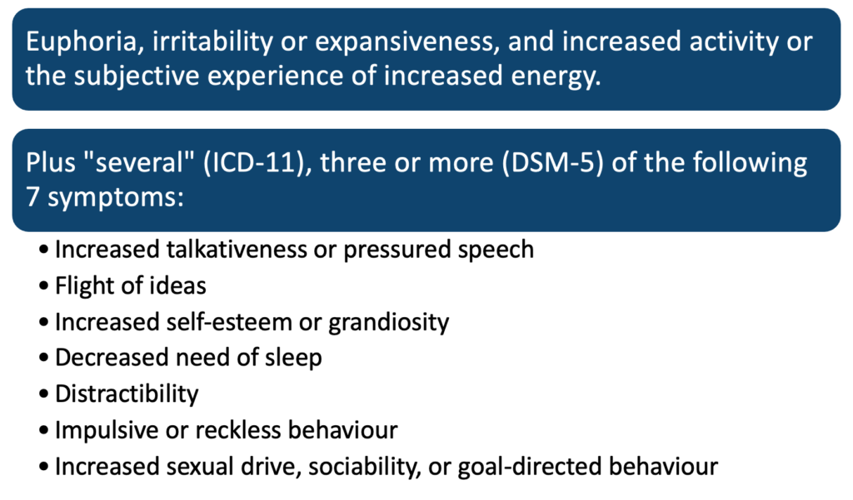

In DSM-5 mania is described to last at least 7 days. In hypomania, symptoms last for at least 4 days.

In ICD-11 hypomanic episodes are described to last “several days”.

Intensity: In mania, symptoms are severe, and in hypomania, they are mild to moderate.

The natural course of mania tends to last for 4 months while depression often lasts for 6 months if untreated. This highlights the importance of effective treatment and management so as not to cause a significant impact on the individual’s life.

## **Rapid cycling:**

The DSM-5 defines rapid cycling bipolar disorder as a pattern of presentation accompanied by 4 or more mood episodes in a 12-month period, with a typical course of mania or hypomania followed by depression or vice versa.

The episodes must be demarcated by a full or partial remission lasting at least 2 months or by a switch to a mood state of opposite polarity.

Some researchers have further classified rapid cycling into ultrarapid (cycling every few days) and ultradian (cycling that occurs daily).

The exact causes of rapid cycling bipolar disorder are not well understood, but several factors have been associated with the development of this subtype of the disorder, including:

* Genetics: Studies have shown that certain genetic mutations may be associated with an increased risk of rapid cycling bipolar disorder.
* Trauma: Adverse childhood experiences such as physical, sexual, or emotional abuse may be associated with rapid cycling bipolar disorder.
* Substance abuse: The abuse of alcohol and drugs can lead to mood instability and increase the risk of rapid cycling bipolar disorder.
* Hormonal changes: Rapid cycling bipolar disorder may be associated with hormonal changes in women, particularly during menopause. Hypothyroidism is associated with rapid cycling.
* Gender: Being female is a risk factor for rapid cycling.
* Medical conditions: Some medical conditions such as thyroid dysfunction, brain injury, and stroke can lead to rapid cycling bipolar disorder.
* Medications: Tricyclic antidepressants can also cause rapid cycling bipolar disorder.

## **Acute Stress Reaction**

Acute Stress Reaction (ASR) is a condition that can occur in response to a traumatic or life-threatening event. It is also referred to as acute stress disorder and can be considered a severe form of a normal stress response.

Symptoms of ASR can include intense distress, anxiety, and agitation, along with a range of physical symptoms such as rapid heartbeat, sweating, trembling, and difficulty breathing. Other symptoms may include difficulty sleeping, nightmares, flashbacks, and avoidance of reminders of the traumatic event.

According to the Diagnostic and Statistical Manual of Mental Disorders, Fifth Edition (DSM-5), to meet the criteria for ASR, symptoms must be present for at least three days and cannot last longer than a month. And it should be noted that the condition can be considered a risk factor for the development of post-traumatic stress disorder.

## **Post-Traumatic Stress Disorder**

According to the Diagnostic and Statistical Manual of Mental Disorders, Fifth Edition (DSM-5), a diagnosis of post-traumatic stress disorder (PTSD) requires that symptoms must be present for at least one month. The criteria for diagnosis include a range of symptoms such as re-experiencing the traumatic event, avoidance of reminders of the event, negative changes in mood or cognition and increased physiological arousal.

## **Alcohol Dependence**

ICD-11 alcohol dependence requires at least 3 features out of the following list to be satisfied in the last 12 months:

* Intense desire to drink alcohol
* Difficulty in controlling the onset, termination and level of drinking
* Experiencing withdrawal symptoms if alcohol is not taken
* Use of alcohol to relieve withdrawal symptoms
* Tolerance as evidenced by the need to escalate dose over time to achieve the same effect
* Salience which is neglecting alternate forms of leisure or pleasure in life
* A narrowing personal repertoire of alcohol use.

To assign the diagnosis, the constellation of behaviours indicating dependence must be present for at least 12 months if use is episodic, or for at least 1 month if use is continuous (daily or almost daily).

## **Notable alcohol-related conditions:**

|  |  |
| --- | --- |
| **Condition:** | **Summary:** |
| **Alcoholic blackouts** | The ICD-11 or DSM-5 do not include alcohol-related blackouts per se but classify them as a symptom of alcohol dependence syndrome. Blackouts are isolated episodes of anterograde amnesia caused by alcohol intoxication. During a blackout (during intoxication), remote memory is intact, but patients have specific short-term episodic memory deficits (they can talk about their childhood, but cannot remember what topic the conversation is about or how they got to where they were). They can even perform complex tasks but will not remember them later. The memory lapse typically lasts several hours, rarely a day or more. In the hippocampus, alcohol inhibits the consolidation of new memories into old memories. |
| **Alcoholic dementia** | Alcoholic Dementia is a form of cognitive impairment that can occur as a result of chronic excessive alcohol consumption. The condition can cause a range of symptoms, including memory loss, difficulty with coordination and balance, problems with problem-solving and decision making and difficulty learning new information. The brain’s ability to process and store information can be severely affected and this leads to cognitive dysfunction. |
| **Alcoholic hallucinosis** | Alcoholic Hallucinosis is a rare complication of chronic alcohol use that is characterized by auditory hallucinations, typically in the form of voices, without other symptoms of psychosis such as delusions. Individuals experiencing alcoholic hallucinosis may hear voices that are critical, accusing or threatening. These auditory hallucinations can be distressing and can occur while a person is still drinking or in a stage of withdrawal. Auditory hallucinations are the most common symptom of Alcoholic Hallucinosis, but visual and tactile hallucinations may also occur in some cases. |
| **Delirium tremens** | Delirium Tremens (DTs) is a severe form of alcohol withdrawal that occurs in a small percentage of individuals who have a history of heavy alcohol use and sudden cessation of alcohol. It is characterized by a range of symptoms including agitation, hallucinations and high fever, which can be life-threatening if not treated promptly. Agitation, visual, auditory or tactile hallucinations and high fever, are common symptoms of DTs and can include confusion, disorientation, tremors, seizures, and rapid heartbeat. |
| **Korsakoff’s syndrome** | Korsakoff’s Syndrome, also known as Korsakoff’s psychosis, is a chronic memory disorder caused by a deficiency of thiamine (vitamin B1) and is most commonly associated with alcohol abuse. One of the main characteristics of the syndrome is Confabulation which is the production of fabricated, distorted, or misinterpreted memories about one’s past experiences, in the absence of conscious intention to deceive. Confabulation is the primary symptom of Korsakoff’s Syndrome and is associated with a range of other memory deficits such as anterograde amnesia, an inability to retain new memories, and retrograde amnesia, difficulty in recalling past memories. |
| **Wernicke’s encephalopathy** | Wernicke’s Encephalopathy is a neurological disorder caused by a deficiency of thiamine (vitamin B1) and is most commonly associated with alcohol abuse. It is a serious condition that can lead to permanent brain damage and death if not treated promptly. Symptoms of Wernicke’s encephalopathy include confusion, ataxia, and nystagmus, which are all related to the brain’s functioning and coordination. Confusion and disorientation, ataxia, an inability to coordinate voluntary movements and Nystagmus, rapid, uncontrollable eye movements, are the most common symptoms. |

## **Delirium**

The majority of acute uncomplicated delirium cases resolve within 4 weeks.

It is noted that in chronic conditions such as lung disease or carcinomas, delirium can be up to 6 months to recover. However, recovery can sometimes take longer, depending on the underlying cause of the delirium and the overall health of the individual. In some cases, delirium may be a symptom of a more serious underlying condition, and the duration of the delirium may be an indicator of the severity of that condition. It’s important to note that some individuals may experience persistent cognitive impairment even after the delirium has resolved.

Unless there is a superimposed delirium or the patient is in an advanced state of profound dementia, dementia is not usually associated with altered consciousness.

## **Cannabis**

Smoking cannabis, also known as marijuana, is associated with an increased risk of developing schizophrenia and other psychosis-related disorders. The exact relationship between cannabis use and the development of schizophrenia is not fully understood, but research suggests that the active ingredient in cannabis, tetrahydrocannabinol (THC), may alter the way that the brain processes information and affects the functioning of certain neurotransmitters, such as dopamine.

Several studies have found that people who smoke cannabis are more likely to develop schizophrenia than those who do not. For example, a meta-analysis of population-based studies found that individuals who had ever used cannabis were about 1.5 times more likely to develop schizophrenia compared to those who had never used the drug (Smith, 2018). Similarly, another study found that individuals who smoked cannabis on a daily basis were more than 3 times more likely to develop schizophrenia than those who had never used the drug (Degenhardt, 2003).

It is also important to note that the risk of developing schizophrenia appears to be greater for individuals who start using cannabis at a younger age and those who use cannabis more frequently or with higher potency. Additionally, there is evidence to suggest that people who have a genetic predisposition or a family history of schizophrenia may be at an even higher risk for developing the disorder if they smoke cannabis.

It’s important to note that the relationship between cannabis use and schizophrenia is complex and multifactorial, and not all individuals who smoke cannabis will develop schizophrenia. More research is needed to better understand the underlying mechanisms and risk factors associated with this relationship. In general, it’s best to avoid smoking cannabis if you have a history of psychiatric conditions in your family, especially schizophrenia and psychosis.

## **Acute cannabis effect:**

Acute effects of cannabis use can include changes in mood, altered perception, difficulty with memory and concentration, and impaired motor coordination. These effects are typically felt within minutes of inhaling the drug and can last for several hours. Commonly reported symptoms to include feelings of euphoria, relaxation, and increased appetite, but some people may also experience anxiety, paranoia, or panic attacks.

Kinaesthetic hallucinations, also known as “body hallucinations”, are a less common but possible symptom of acute cannabis use. These types of hallucinations involve the perception of movement or sensation in the body, such as feeling that one’s limbs are elongating or contracting, or experiencing a sensation of “bugs crawling” on the skin. Kinaesthetic hallucinations can be distressing for those experiencing them and may be accompanied by other symptoms such as fear or confusion. These hallucinations are thought to be caused by the drug’s ability to disrupt the normal functioning of the brain’s sensory processing centres.

## **Personality Disorders**

The ICD-11 classification of personality disorders represents a diagnostic paradigm shift. This was deemed necessary due to major issues with previous personality disorder classifications. These included unnecessary complexity, inconsistency with data on normal personality traits, and a lack of consideration for severity, despite the fact that severity has been shown to be the most important predictor of outcome. Except for a general description of personality disorder, the ICD-11 classification eliminates all categories of personality disorder. This condition can be classified as “mild,” “moderate,” or “severe.” Negative affectivity, dissociability, anankastia, detachment, and disinhibition are five personality trait domains that can be used to describe patient behaviour. A borderline pattern qualifier can also be specified by clinicians.

The DSM-5 organizes personality disorders into three clusters, based on shared key features:

|  |  |
| --- | --- |
| **Cluster A disorder:** | **Summary:** |
| **Paranoid personality disorder** | Symptoms include chronic, pervasive distrust of other people; suspicion of being deceived or exploited by others, including friends, family, and partners. |
| **Schizoid personality disorder** | Characterized by social isolation and indifference toward other people. It affects slightly more men than women. People with this disorder often are described as cold or withdrawn, rarely have close relationships with other people, and may be preoccupied with introspection and fantasy. |
| **Schizotypal personality disorder** | Features odd speech, behaviour, and appearance, as well as strange beliefs and difficulty forming relationships. |

|  |  |
| --- | --- |
| **Cluster B disorder:** | **Summary:** |
| **Antisocial personality disorder** | Tends to show up in childhood, unlike most other personality disorders (most don’t become apparent until adolescence or young adulthood). Symptoms include a disregard for rules and social norms and a lack of remorse for other people. |
| **Borderline personality disorder** | Characterized by instability in interpersonal relationships, emotions, self-image, and impulsive behaviours. |
| **Histrionic personality disorder** | Features excessive emotionality and attention seeking that often leads to socially inappropriate behaviour in order to get attention. |
| **Narcissistic personality disorder** | Associated with self-centeredness, exaggerated self-image, and lack of empathy for others and is often driven by an underlying fragility in the sense of self. |

|  |  |
| --- | --- |
| **Cluster C disorder:** | **Summary:** |
| **Avoidant personality disorder** | A pattern of social inhibition and avoidance fueled by fears of inadequacy and criticism by others. |
| **Dependent personality disorder** | Involves fear of being alone and often causes those who have the disorder to do things to try to get other people to take care of them. |
| **Obsessive-compulsive personality disorder** | Characterized by a preoccupation with orderliness, perfection, and control of relationships. Though similarly named, it is not the same as obsessive-compulsive disorder (OCD). |

## **Neurodevelopmental Disorders**

According to the DSM-5, neurodevelopmental disorders include the following:

**Attention deficit hyperactivity disorder (ADHD)**: ADHD is a neurodevelopmental disorder characterized by symptoms of inattention, hyperactivity, and impulsivity. It is one of the most common childhood disorders and can persist into adulthood. The exact causes of ADHD are not fully understood, but it is believed to be related to a combination of genetic and environmental factors. Medications such as stimulants, non-stimulants, and antidepressants can help reduce symptoms of inattention and hyperactivity/impulsivity. Behavioural therapy, such as parent training and cognitive-behavioural therapy, can also help improve the child’s overall functioning and behaviour.

**DLD – Developmental language disorder (formerly known as SLI- Specific Language Impairment)**: DLD is characterized by difficulty in acquiring and using language. It is considered a specific disorder of language development and is not due to general cognitive delay, hearing loss, or other known causes.

**Communication, speech, or language disorders, expressive language disorder, fluency disorder, social (pragmatic) communication disorder, and speech sound disorder**: Expressive language disorder is characterized by difficulty in expressing oneself through language, including difficulty with vocabulary, grammar, and sentence structure. Fluency disorder, also known as stuttering, is characterized by disruptions in the flow of speech, such as the repetition of sounds, words, or phrases.

**Autism spectrum disorder (ASD)**: Autism Spectrum Disorder (ASD) is a neurodevelopmental disorder characterized by impairments in social interaction, communication, and repetitive behaviours or interests. The disorder is called “spectrum” because it affects individuals differently and to varying degrees. The exact causes of ASD are not fully understood, but it is believed to be related to a combination of genetic and environmental factors. Individuals with ASD may have difficulty with social interactions, such as initiating and maintaining conversations, understanding nonverbal cues, and interpreting emotions.

**Intellectual disabilities (IDs) or intellectual development disorder (IDD, previously called mental retardation) and global developmental delay (GDD)**: Intellectual Disabilities (IDs) are a group of disorders characterized by significant limitations in cognitive functioning and adaptive behaviours, which cover a range of everyday skills required for personal independence.

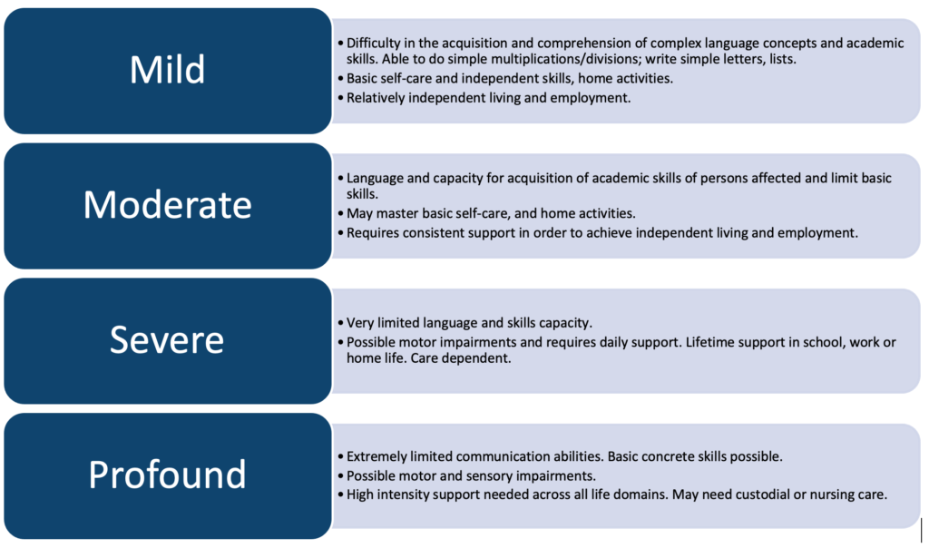(Patel, 2018)

**Motor disorders including developmental coordination disorder, stereotypic movement disorder, tic disorders (such as Tourette’s syndrome), and CAS – Apraxia of speech**: Stereotypic movement disorder is characterized by repetitive, non-functional movements, such as rocking or hair twisting. Tic disorders, such as Tourette’s syndrome, involve recurrent, sudden, and uncontrollable vocal or motor tics. Childhood Apraxia of Speech (CAS) is a motor speech disorder in which a child has difficulty planning and coordinating the movements needed for speech.

**Neurogenetic disorders, such as Fragile X syndrome, Down syndrome, Rett syndrome, and hypogonadotropic hypogonadal syndromes:** Neurogenetic disorders are a group of conditions that affect the nervous system and are caused by genetic mutations. Fragile X syndrome is the most common inherited cause of intellectual disability and is caused by a mutation on the X chromosome. Down syndrome is a chromosomal disorder that is characterized by intellectual disability and physical abnormalities. Rett syndrome is a rare genetic neurological and developmental disorder that affects the development of the brain. This disorder causes progressive loss of motor and language skills. Females are disproportionately affected by Rett syndrome. For the first six months of life, most babies with Rett syndrome appear to develop normally. Hypogonadotropic hypogonadal syndromes is a group of disorders that affect the hormones that regulate the development of primary and secondary sexual characteristics. These disorders can have a significant impact on a person’s physical and cognitive development and may require specialized treatment and support.

**Traumatic brain injury (including congenital injuries such as those that cause cerebral palsy)**: Traumatic brain injury (TBI) is an injury to the brain that occurs as a result of an external force, such as a blow to the head or a penetrating injury. TBI can range from mild (concussion) to severe (coma or death). Congenital injuries, such as those that cause cerebral palsy, are brain injuries that occur before or during birth and can be caused by a variety of factors such as infection, lack of oxygen, or genetic disorders.

**Fetal Alcohol Spectrum Disorders (FASD):**These disorders are caused by the toxic effects of alcohol on the developing fetus and can result in a range of cognitive, behavioural, and developmental problems. The most severe form of FASD is Fetal Alcohol Syndrome (FAS), which is characterized by facial abnormalities, growth deficits, and central nervous system dysfunction. FASD can exhibit a combination of the above, most commonly ADHD, because of this, FASD is usually underdiagnosed, yet it is estimated that about 1 in 20 people may be affected. Other conditions that fall under the umbrella of FASD include Alcohol-Related Neurodevelopmental Disorder (ARND), Alcohol-Related Birth Defects (ARBD) and Neurobehavioral Disorder Associated with Prenatal Alcohol Exposure (ND-PAE).

**References:**

(1) Angst, J., Ajdacic-Gross, V. and Rössler, W. (2020). Bipolar disorders in ICD-11: current status and strengths. International Journal of Bipolar Disorders, 8(1). doi:10.1186/s40345-019-0165-9.

(2) Degenhardt, L., Hall, W., & Lynskey, M. (2003). Exploring the association between cannabis use and depression. Addiction, 98(11), 1493-1504.

(3) Patel, D.R., Apple, R., Kanungo, S. and Akkal, A. (2018). Intellectual disability: definitions, evaluation and principles of treatment. Pediatric Medicine, [online] 1(0). doi:10.21037/pm.2018.12.02.

(4) Smith, J., & Jones, P. (2018). The relationship between cannabis use and schizophrenia: A meta-analysis. Journal of Mental Health, 57(2), 123-132.

(5) Tandon, R. et al. Definition and description of schizophrenia in the DSM-5. Schizophr. Res. **150**, 3–10 (2013).

(6) WHO. International statistical classification of diseases and related health problems – 10th revision. World Heal. Organ. (2011).

### 5.1.3 WHO classification of impairments, disabilities, and handicaps

## **WHO Classification of Impairments, Disabilities, and Handicaps**

A model of illness effects known as the World Health Organisation (WHO) International Classification of Impairments, Disability, and Handicaps (ICIDH) model was developed in the 1970s and later released in 1980 as a tool for the classification of the consequences of disease and of their implications for the lives of individuals. The classification system describes the effects of impairments, disabilities, and handicaps on individuals. This system, known as the International Classification of Functioning, Disability and Health (ICF), is designed to provide a comprehensive and standardized framework for describing and measuring health and disability at both the individual and population levels.

The ICF classifies impairments, disabilities, and handicaps according to two main components: the body functions and structures affected, and the activities and participation in which the individual is limited. This approach helps to identify and address the barriers that individuals with disabilities face, and promotes a focus on enabling them to participate in all aspects of life to the fullest extent possible.

This classification system is intended to be used in various settings such as in healthcare, rehabilitation, education and social services, and it aims to improve the provision of appropriate services, support and policy development to address the challenges faced by people with impairments, disabilities and handicaps.

The goal was to first clarify terminology, and then to create a model that went beyond a standard medical model with a sequence from aetiology to pathology to presentation. The medical model at the time was felt to be insufficient when applied to conditions that cannot be prevented or treated. This ICIDH model is more psychosocially orientated. As a result, the model offers a chain of consequences from impairment to disability to handicap, or from impairment to handicap directly.

According to the ICIDH model, disability is caused by impairment, which is caused by disease or disorder. Disability or impairment causes handicap.

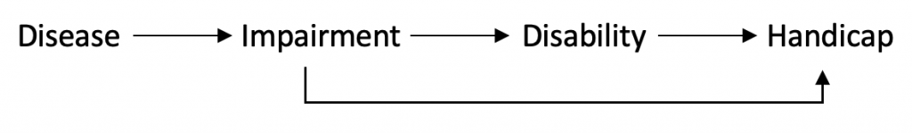

## **Impairment:**

Impairment is defined as a loss or abnormality of structure or function that operates at a level lower than that of the entire individual, frequently at the level of the organ.

## **Disability:**

Disability is defined as a restriction or lack of capacity to undertake tasks at the individual level. Any restriction or lack of capacity to do an activity in the way or range regarded as typical for a human being is termed a disability.

## **Handicap:**

Handicap refers to disadvantages and role constraints at the personal level in a social environment. A handicap is a disadvantage for a specific individual caused by an impairment or disability that restricts or prohibits that individual from fulfilling a normal function (depending on age, gender, and social/cultural variables). A handicap can emerge from impairment without the intervention of a disability state (eg. disfigurement). On the other hand, someone with a severe impairment may be able to live a somewhat normal life without being hampered.

**References:**

(1) Johnston, M. and Pollard, B. (2001). Consequences of disease: testing the WHO International Classification of Impairments, Disabilities and Handicaps (ICIDH) model. Social Science & Medicine, 53(10), pp.1261–1273. doi:10.1016/s0277-9536(00)00384-1.

(2) Kaplan, G. (2005). International Classification of Impairments, Disabilities and Handicaps – an overview – Biomedicine. [online] ScienceDirect. Available at: https://www.sciencedirect.com/science/article/pii/B012369398500267X.

### 5.1.4 A working knowledge of “statementing” for special needs education

## **A Working Knowledge of “Statementing” for Special Needs Education**

In England and Wales a **statement of Special Educational Needs (SEN)** or **“statementing**” will be issued following a formal assessment by the local authority to lay out what special aid the child needs, taking into account the opinions and desires of the child and their parents/caregivers. This is often organised by someone called an SEN Coordinator (SENCO).

The SEN statements are made up of **six fundamental sections**, which are shown below.

Typically, the local educational board organised the formal assessments and releases a suggested statement on which parents/caregivers are allowed to comment.

The board is legally bound by the final statement.

It is feasible to request reassessments in order to modify the statements.

There are six parts to an SEN statement:

**Part 1: Introduction**– demographics and child’s details plus those who hold parental responsibility.

**Part 2: Special Educational Needs (Learning Difficulties) –**details on the child’s special educational needs, gathered during assessment.

**Part 3: Special Educational Provision**:

1. **Objectives** – the main educational and developmental goals that you want the provision to achieve.
2. **Educational provision** – details of the educational provision considered appropriate for the difficulties described in Part 2.
3. **Monitoring** – the arrangements to monitor and review your child’s progress.

**Who decides what support is provided for the child?** The educational authority decides what education provision will be offered in Part 3 based on the ‘advice’ they receive from those who have contributed to the Statutory Assessment.

**Part 4:  Special Educational Provision: Placement**– details of school placement.

**Part 5: Non-educational needs**– important to note this bit is not legally binding.

**Part 6: Non-educational provision**– the plan in place for the non-educational needs to be met.

(SENAC, 2023).

**References:**

(1) SENAC, (2023). (n.d.). 3: What is a Statement? – The Special Educational Needs Advice Centre (SENAC). [online] Available at: https://senac.co.uk/advice/what-is-a-statement/.

## 5.2 Assessment of Psychiatric Disorders

### 5.2.1 History taking and examination of the mental state

## **History Taking and Examination of the Mental State**

One of the axioms of modern medical practice is that obtaining a clear and accurate history is key to making a correct diagnosis and developing a treatment plan. This is particularly true in psychiatry, in which laboratory or imaging investigations are not typically of great value. Any factor that compromises a history could compromise care.

Psychiatric history taking and mental state examination are core clinical skills. They are best learned by practice and repetition

**Always consider your personal safety when interviewing**: There is a risk of aggression or violence in only a small percentage of psychiatric patients. For most patients, the only risk of violence is directed toward themselves. Violence is rare and this can often result in doctors placing themselves in harm’s way due to thoughtlessness. Prior to an assessment/interview consider: who you are interviewing, where you are interviewing, and who will be accompanying you if needed. Always ensure the wider MDT are aware of the same risks you note. The ideal interview room has two doors, one for you and one for the patient. If this is not available, sit so that the patient is not between you and the door. Remove all potential weapons from the interview room.

**Familiarize yourself with the ward’s panic alarm system before you first need to use it.**

## **Psychiatric History**

The first step in taking a psychiatric history is gathering information about the patient’s medical history, including any previous psychiatric treatment or diagnoses, as well as any other relevant medical conditions.

The history should be conveyed in the patient’s own words as much as is feasible.

**Introduction:** (name, age, marital status, occupation, known previous contact, the reason for referral) (name, age, marital status, occupation, known previous contact, the reason for referral)

**Presenting complaint:**

* History of presenting complaint(s)
* Onset, course, other help sought, response to treatment so far
* Symptom details
* Precipitating events a) for illness; b) for seeking help

**Family history:**

* Family details (parents, siblings, ages)
* Relationship with family members
* Family history of psychiatric illness
* Deceased family members (circumstances, patient’s response, effect)

**Personal history:**

* Pregnancy & birth
* Early life – developmental milestones, the memory of difficulties within the family
* Schooling – educational achievement, ability to form friendships
* Occupational history
* Sexual/relationship history (ask for details appropriate to the interview)
* Serious life events

**Personal circumstances:**

* Current relationship
* Children
* Occupation
* Finances
* Recent stresses

**Past psychiatric and medical history:**

* Current medications
* Previous admissions
* Admissions under the Mental Health Act
* Previous treatment (medication or psychological)

**Personality before illness**:

* Collateral history from a reliable source (or the patient may be able to recall)

**Current and past drug/alcohol use:**

* If evidence of a problem then details:
  + Substance(s) used, quantity, timing, tolerance, withdrawal symptoms, attempts to cut down, complications, impact on relationships/work
  + Evidence of dependence
  + Harmful consequences of use

**Forensic history:**

* Clear details of circumstances and involvement
* Consider how this is important to your risk assessment

## **Questioning Techniques**

* Open vs closed questions – In general, begin the interview with open questions, turning to more closed questions to clarify details or factual points.
* Non-directive vs leading questions – try to avoid leading our patients to certain replies.

## Useful Acronyms

### **SADAFACES – Low mood:**

* Poor **S**leep
* **A**nhedoniaLack of enjoyment of previously enjoyed activities
* **D**ysthymiaLow mood
* Poor **A**ppetite
* **F**atigue
* **A**gitation
* Poor **C**oncentration
* Poor Self **E**steem
* **S**uicidality

### **FIDGET – High mood:**

* **F**light of ideas
* **I**nsomnia
* **D**istractibility
* **G**randiosity
* **E**nergy
* **T**alkativeness

### **SADPERSONS – Suicidality:**

* **S**ex
* **A**ge
* **D**epression
* **P**ast attempts
* **E**xcessive alcohol/substances
* **R**ational thinking loss
* **S**ocial supports
* **O**rganised plan
* **N**o support
* **S**ickness

## **Mental State Examination**

The MSE is an organised summary of the clinician’s findings regarding the patient’s mental experiences and behaviour during the interview. Its objective is to offer evidence for and against a mental disorder diagnosis, as well as to record the current type and intensity of symptoms if a mental condition is present. The information gathered, coupled with the psychiatric history, should allow for a determination of the presence and severity of any mental condition, as well as the risk of harm to oneself or others.

Use jargon only if the patient does. When presenting the mental State, you can demonstrate your ability to appropriately label symptoms. If the patient has auditory hallucinations, provide a direct statement of what they hear.

## **Appearance:**

* Apparent age
* Racial origin
* Style of dress
* Level of cleanliness
* General physical condition
* Abnormal involuntary movements, including tics, grimaces, stereotypies, dyskinetic movements, tremors, etc.

## **Behaviour:**

* Appropriateness of behaviour
* Level of motor activity
* Apparent level of anxiety
* Eye contact
* Rapport
* Abnormal movement or posture.
* Distractibility

## **Speech:**

* Volume, rate, and tone
* Quantity and fluency
* Abnormal associations, clangs, and punning
* Flight of ideas

## **Mood:**

* Subjective and objective assessment of mood
* Mood evaluation should include the quality, range, depth, congruence, appropriateness, and communicability of the mood state
* Anxiety and panic symptoms
* Obsessions and compulsions

## **Perception:**

* Hallucinations and pseudo-hallucinations
* Depersonalization and derealization. Illusions and imagery

## **Thought form:**

* Linearity
* Goal-directedness
* Associational quality
* Formal thought disorder

## **Thought content:**

* Delusions
* Over-valued ideas
* Preoccupations
* Obsessive thoughts, ideas, and impulses
* Thoughts of suicide or deliberate self-harm
* Thoughts of harm to others. Assess intent, the lethality of intent, plan, and inimicality. Does the patient show any urge to act upon the plan?

## **Cognition:**

* Attention and concentration
* Orientation to time, place, and person
* Level of comprehension
* Short-term memory

## **Insight:**

* Does the patient feel his experiences are a result of illness?
* Will he accept medical advice and treatment?

**References:**

(1) Manjunatha N, Saddichha S, Sinha BN, Khess CR. Assessment of Mood and Affect by Mental State Examination in Different Cultural Contexts. Psychopathology. 2008; 41: 336-337.

(2) Semple, D. and Smyth, R. (2019). Psychiatric assessment. Oxford Handbook of Psychiatry, [online] pp.45–98. doi:10.1093/med/9780198795551.003.0002.

### 5.2.2 Descriptive psychopathology

## **Descriptive Psychopathology**

Psychopathology is ‘the systematic study of abnormal experience, cognition and behaviour; the study of the products of a disordered mind’. Descriptive psychopathology is a method of assessing and comprehending the signs and symptoms of mental disorders that serves as the foundation for clinical psychiatry. In this application, the term descriptive refers to a value-free and theory-free interpretation of the mental and behavioural experiences that a patient can present with. It is critical for students of psychiatry to comprehend the relevance of this and the reasoning behind it.

## **Disorders of Self**

The notion of self is an awareness that all experiences articulate in the first person perspective as ‘my’ experience. “In other words, all conscious acts are intrinsically self-conscious, a feature sometimes designated as “self-affection” (Nelson, Parnas & Sass, 2014, pg. 479). People believe that the core sense of existing stems from personal experience and are responsible for their actions. Ipseity is based on inner time consciousness and is perceived as the origin of thoughts, experiences, and actions. Minimal self is the direct experience of selfhood and does not have specific properties. Instead, it refers to the ‘mine-ness’ and is implied; the person does not need reflection to know what they are experiencing. According to Sass et al. (2018), it is a source of activity, awareness medium, and the directedness toward life. Persons with disorders of self have self-awareness abnormalities. The minimal self is challenged to become unstable, ultimately resulting in self-disorders.

The disorder of self has three aspects: hyper-reflexivity, disturbed grip or hold, and diminished self-presence. Hyper-reflexivity is an exaggerated self-consciousness that makes a person disengage from ordinary processes of nature and society. People with this disorder have a tendency for focal attention, behaviour that would otherwise be experienced as part of oneself. On the other hand, a disturbed grip or hold is a distortion influencing the sense of ownership of experience and actions. The alterations commonly affect the tacit-focal structure of reality and the affordance quality of the real world. Diminished self-presence, also referred to as diminished self-affection, is a reduced or weakened sense of awareness of self.

## **Disorders of Emotion**

Understanding disorders of emotion starts with differentiating between feelings, emotions, and mood. Feelings refer to positive or negative reactions to specific events and are experienced consciously. On the other hand, emotions are stirred-up states caused by specific stimuli and tend to eliminate or maintain the causative stimuli (Casey & Brendan, 2019). Mood refers to sustained emotions that reflect a person’s perception of the world. According to Casey and Brendan (2019), the mood is measured through intensity, fluctuations, and duration. Emotional disorders affect the psychological well-being of a person and, ultimately, their ability to function. For example, an individual may be depressed and extremely sad, affecting their quality of life.

Emotions may be classified based on the fact that some are normal and have no negative consequences, while others are severe and warrant medical interventions. Normal emotions are the expected reactions to certain events. For instance, a person has grief reactions upon the death of their loved one, such as a friend or family member. Abnormal emotions are expected when a person is subjected to stressful events (Casey & Brendan, 2019). However, they lead to prolonged impairment or lasting effects on a person’s functioning. People expressing abnormal emotional reactions are aware of the abnormality and may be influenced by cultural norms (Casey & Brendan, 2019). Expressing emotions is also morbid, in which a patient is unaware of the abnormality. In such cases, a patient may have schizophrenia, a mental health issue characterized by abnormal interpretation of realities (Casey & Brendan, 2019). Disorders of emotion are disabling, so patients should seek medical treatment to improve the quality of their life.

## **Disorders of Speech**

Disorders of speech refer to conditions in which people have difficulties producing sounds to create words. Such disorders cause a person to strain during communication, and even when they speak, their speech is difficult to understand. Common speech disorders include phonological, articulation, resonance, and dis-fluency disorders (Kaneshiro, 2022). Dis-fluency is a state in which a person repeats sounds and may be caused by emotional distress, trauma, or genetic abnormalities (Kaneshiro, 2022). In articulation and phonological disorders, an individual does not produce sounds correctly and uses them in the wrong place. Resonance, also known as voice disorders, is characterized by symptoms such as voice break, odd speech sounds, and voice hoarseness (Kaneshiro, 2022). Practitioners provide interventions depending on the causes and severity of the speech disorder.

## **Disorders of Thought**

Thought disorders are a disturbance in how a person processes and expresses thoughts. Their causes are not clearly defined; however, medical experts believe that factors like brain abnormalities and genetics lead to thought disorders. Thinking requires a person to reason about a subject and organize those thoughts appropriately to express them clearly. A thought disorder disrupts this process, resulting in disorganized thinking and abnormal speaking or writing (Kubal & Moore, 2022). It is one of the symptoms denoting the presence of schizophrenia. Thought disorders may lead to positive or negative symptoms. Positive symptoms include signs of added behaviours such as poor judgment, whereas negative symptoms include the absence of specific aspects like a lack of emotions (Kubala & Moore, 2022). To identify thought disorders, practitioners ask patients open-ended questions to assess responses.

**Thought insertion** is a type of thought disorder characterized by the belief that one’s thoughts are being inserted or imposed upon by an external force. This can include the feeling that thoughts are being planted in one’s mind or that someone is controlling one’s thoughts.

**Thought withdrawal**is a type of thought disorder characterized by the belief that one’s thoughts are being taken away or removed by an external force. This can include the feeling that thoughts are being removed from one’s mind or that someone is controlling one’s thoughts.

**Thought broadcast** is a type of thought disorder characterized by the belief that one’s thoughts are being broadcast or transmitted to others. This can include the feeling that others can hear one’s thoughts or that one’s thoughts are being broadcasted to others against one’s will.

## **Disorders of Perception**

Perception refers to using sensory organs to integrate what is being presented into meaningful information. In other words, it is the ability to select a stimulus that requires action, attention, and interpretation. Perception disorders are grouped into two categories: sensory distortions and deceptions. Sensory distortion includes shifts in perceptions due to changes in stimulus quality and intensity (Casey & Brendan, 2019). An alteration in quality mainly affects visual perception. Casey and Brendan (2019) explain that intensity changes, hyper or hypo-aesthesia, result from intense emotions or a low psychological threshold. Resultantly, a patient may hear the sound of a closing door as thunder. A change in the spatial form, commonly known as dysmegalopsia, is the shift in the perceived shape of an object. For example, a patient may see an object as bigger than its actual size.

Sensory deceptions are classified into illusions and hallucinations, in which the former refers to stimuli misrepresentation, while the latter is false perceptions. A hallucination is a perception in the absence of a stimulus. An illusion is an altered perception of a stimulus and differs from a hallucination in that in hallucinations there is no stimulus. Casey and Brendan (2019) mention that illusions combine mental images with a perceived object to produce a false perception. They may occur without a psychiatric disorder; for instance, a person walking through a dark place may interpret shadows as an attacker. Although illusions mainly occur visually, they can present in different forms, like a person hearing their name being called out when a word that resembles their name is pronounced (Casey & Brendan, 2019). With hallucinations, an individual believes that their perceptions are accurate.

Kurt Schneider proposed first-rank symptoms in 1938. He introduced them as a practical way to help general practitioners (non-psychiatrists) identify schizophrenia.

|  |  |
| --- | --- |
| **First-rank Symptoms:** | **Summary:** |
| **Running commentary** | A type of auditory hallucination where the individual hears a voice or voices providing a continuous commentary on their thoughts, feelings or actions. |
| **Thought echo** | A type of auditory hallucination is where an individual hears their own thoughts repeated back to them as if they were spoken aloud. |
| **Voices heard arguing** | A type of auditory hallucination where the individual hears two or more distinct voices engaging in an argument or conversation. |
| **Thought insertion** | Delusional belief that someone or something is putting thoughts into the individual’s mind without their consent. |
| **Thought withdrawal** | Delusional belief that someone or something is taking thoughts out of the individual’s mind without their consent. |
| **Thought broadcast** | The belief that one’s thoughts are leaving the mind and being perceived by others. |
| **Delusional perception** | The belief that a normal perception has been altered or manipulated by an external force. |
| **Somatic passivity** | The belief that one’s body is being controlled by an external force. |
| **Made affect** | The belief that feelings are controlled by an outside/external force |
| **Made volition** | The belief that impulses and/or behaviour are controlled by an outside/external force |

(Norgaard, 2008)

| **Type of hallucination:** | **Summary:** |
| --- | --- |
| **Auditory** | These can be first person, in which the patient hears their own thoughts, second person, in which the patient hears a voice speaking directly to them, or third person, in which the patient hears a voice conversing. The term “thought echo” refers to hearing one’s own thoughts aloud shortly after thinking them. Gedankenlautwerden is an experience similar to thought echo in which patients hear their own thoughts aloud as they think them. |
| **Visual** | Seeing things that aren’t actually present. |
| **Gustatory** | Tasting things that aren’t actually present. |
| **Olfactory** | Smelling things that aren’t actually present. |
| **Tactile (haptic)** | These refer to false perceptions of touch. |
| **Functional hallucinations** | A patient experiences a hallucination at the same time as receiving a real stimulus in the same sensory modality. Hallucinations that are related to a specific function such as sexual or religious experiences often. |
| **Extracampine hallucination** | These are hallucinations beyond the possible sensory field. Hallucinations occur outside of the visual field, such as hearing voices that are coming from outside. |
| **Reflex hallucinations** | These occur in one sensory modality in response to a real stimulus in another sensory modality |
| **Hypnopompic hallucinations** | They occur during the transition from sleep to wakefulness. |
| **Hypnagogic hallucinations** | They occur during the transition from wakefulness to sleep. |
| **Lilliputian hallucinations** | Hallucinations of small, miniature people or objects. |
| **Kinaesthetic hallucinations** | These relate to hallucinations of muscle or joint sense. Hallucinations of movement or touch. |
| **Autoscopic hallucinations** | This refers to a person’s experience of seeing a double of themselves in their extrapersonal space without the experience of leaving one’s body. |
| **Third person hallucinations** | A type of auditory hallucination in which the individual hears voices or other sounds that are perceived as coming from outside of themselves and are directed towards a specific person or group of people. |
| **Secondary hallucinations** | Type of auditory hallucination in which the individual perceives voices or other sounds as coming from an external source, as opposed to originating within their own mind. |

| **Illusion type:** | **Summary*:*** |
| --- | --- |
| **Completion illusions** | The proclivity to fill in blanks in order to make sense of a stimulus |
| **Affect illusions** | Arise as a result of specific mood (affective) states, such as when a woman is walking home in the dark and is terrified, mistaking a tree for a tall man in a long coat. Another example is when an agitated person interprets harmless gestures as threatening. |
| **Pareidolic illusions** | Arise when detailed images of shapes are seen. For example, seeing the man in the moon or Michael Jordan on a burnt piece of toast. Pareidolic illusions occur when a person is concentrating, whereas affect and completion illusions occur when a person is distracted. |
| **Persecutory delusions** | Persecutory delusions are a type of delusional belief in which the individual believes that they are being singled out for harm, mistreatment, or harassment by one or more individuals or organizations. |

## Pseudohallucinations versus hallucinations:

Pseudohallucinations and hallucinations are both types of perceptual experiences, but they have some important differences. Hallucinations are defined as perceptions in the absence of an external stimulus. They can be experienced in any of the five senses, such as seeing something that isn’t there or hearing voices. On the other hand, pseudohallucinations are also perceptions in the absence of an external stimulus, but they are experienced as being less vivid and less real than hallucinations. They are often described as “internal” or “mental” rather than “perceptual” experiences, and they may be more like vivid thoughts or memories than actual perceptions. They are often associated with conditions such as schizophrenia, dissociative disorders and conversion disorder.

## **Movement Disorders**

Movement disorders are nervous system conditions that cause voluntary or involuntary body movements and increased or slow movements. One of the common movement disorders is ataxia, which affects the spinal cord or the brain. The effects result in problems such as clumsy balance, inaccuracy, or reduced coordination when a person moves voluntarily. Another movement disorder is dystonia, a condition characterized by involuntary muscle contractions. Dystonia affects any body part, such as the mouth, face, and limbs. It is caused by abnormal functioning of the basal ganglia, which is a part of the brain that controls movement. Essential tremor is another disorder that results in rhythmic shaking of body parts like hands. It results from abnormalities in the basal ganglia and worsens when a person tries making basic movements. Interventions such as surgery, medication, lifestyle changes, and physical therapies can improve symptoms caused by essential tremors.

Myoclonus is another movement disorder characterized by quick and uncontrollable muscle jerks. The movements have regular or regular contractions and may occur in one muscle or a group of muscles. Progressive Supranuclear Palsy (PSP) is a brain condition that leads to brain cell loss and movement issues. The problems may include decreased balance, walking, speech, and eye control. PSP commonly affects people aged 40 to 60 years, leading to severe symptoms after 6 to 10 years of infection (American Association of Neurological Surgeons, 2019). Other movement disorders include Rett Syndrome, Secondary Parkinsonism, Tourette Syndrome, Spasticity, Tardive Dyskinesia, Multiple System Atrophy (MSA), Huntington’s Disease, and Wilson’s disease.

| **Movement disorder:** | **Summary:** | **Associated conditions:** |
| --- | --- | --- |
| Akinesia | Absence, poverty, or loss of control of voluntary muscle movements (eg. absence of facial expression, decreased blinking). Often understood as a severe form of bradykinesia. | Parkinson’s Progressive Supranuclear Palsy Multiple System Atrophy |
| Bradykinesia | The slowness of voluntary movement. It is a core symptom of Parkinson’s disease. | Parkinson’s Progressive Supranuclear Palsy Multiple System Atrophy |
| Akathisia | The subjective feeling of inner restlessness is often caused by side effects of neuroleptic medication. It often manifests as an inability to sit still. | Antipsychotic medication use (mainly) Also reported with calcium channel blockers, antiemetics, and vertigo drugs |
| Athetosis | A continuous stream of slow, flowing, writhing involuntary movements. | Cerebral palsy Stroke Huntington’s disease Wilson’s disease Medication / donepezil |
| Chorea | Brief, ‘quasi-purposeful’, irregular contractions that are not repetitive or rhythmic, but appear to flow from one muscle to the next. Described as ‘dance-like’. | Huntington’s disease Wilson’s disease Spinocerebellar ataxia type 2 Autoimmune / SLE Endocrine / hyperthyroidism Infection / Sydenham chorea – AIDS – TB Metabolic/hepatic and renal failure Medication/anticonvulsants – cocaine – lithium |
| Dystonia | Involuntary sustained or intermittent muscle contractions. Can lead to twisting and repetitive movements, abnormal postures, or both. | Medication/antipsychotics – certain antiemetics – lithium – stimulants – certain antidepressants (SSRIs and TCAs) Idiopathic Cerebral palsy Multiple sclerosis Encephalitis Stroke Wilson’s disease |
| Dyskinesia | A general term referring to problems with voluntary movements and the presence of involuntary movements. |  |
| Myoclonus | A sequence of repeated, often non-rhythmic, brief shock-like jerks due to sudden involuntary contraction or relaxation of one or more muscles. | Sleep initiation (hypnic jerk)Epilepsy Stroke Renal and hepatic failure Poisoning Medication / tramadol – benzodiazepines – certain antiepileptics Multiple sclerosis Parkinson’s Alzheimer’s CJD |
| Parkinsonism | Syndrome characterized by tremors, rigidity, and bradykinesia. |  |
| Tic | Sudden, repetitive, non-rhythmic, stereotyped motor movement or vocalization involving discrete muscle groups. These are different to myoclonus as they are suppressible. | Tourette’s Other causes (e.g. Huntington’s and stroke are rare). |
| Tremor | Involuntary, rhythmic, alternating movement of one or more body parts. | Anxiety Medication/caffeine – lithium – amphetamines Hereditary (essential tremor) Stroke Metabolic / hyperthyroidism Degenerative / Wilson’s – multiple sclerosis – Parkinson’s Alcohol abuse and withdrawal Medication / valproic acid |
| Hemiballismus | Hyperkinetic involuntary movement disorder, which is characterised by intermittent, sudden, violent, involuntary, flinging, or ballistic high-amplitude movements involving the ipsilateral arm and leg, caused dysfunction in the contralateral side’s central nervous system. | Stroke Traumatic brain injury Nonketotic hyperglycaemia Infection Amyotrophic lateral sclerosis |
| Stereotypies | Repetitive, simple movements that can be voluntarily suppressed. | Autism Sensory deprivation Intellectual disability |

## **Disorders of Cognition**

Cognition disorders are mental health problems that affect memory, learning, problem-solving, and memory. The disorders affect a person to the extent that they cannot function normally without treatment. Cognitive disorders are grouped into three categories: dementia, delirium, and amnesia (Bonnice and Hoard, 2014). Dementia is a general term used to describe various mental health issues characterized by an impaired ability to make decisions, remember, or think. Abnormal brain changes cause disorders and affect other aspects of life, like behaviour, relationships, and feelings. Alzheimer’s disease is the primary cause of dementia, which leads to 60-80% of cases (Alzheimer’s Association, 2022). Although dementia affects older adults, it is not part of normal ageing.

Delirium is a sudden change in the brain that leads to reduced consciousness. It makes people appear distracted, confused, or unaware of their surrounding environment (Cleveland Clinic, 2020). Other delirium symptoms include difficulties remembering, thinking clearly, and maintaining focus. Cleveland Clinic (2020) reports that delirium differs from dementia since it occurs quickly. Delirium may be hyperactive or hypoactive: in the former case, a person becomes overactive and restless, whereas in the latter case, a person is inactive as they become sleepy. Amnesia is memory loss without other underlying cognitive deficits (Bonnice and Hoard, 2014). A person with amnesia forgets information, facts, and experiences. Unlike in movies and television shows, where they show people forgetting their identities, it is usually not the case in real-life situations (Cleveland Clinic, 2020). Damage, including infections or injuries, to the brain area responsible for memory processing, may cause amnesia.

## **Uncommon Psychiatric Syndromes**

Although people understand how the brain works and its different disorders, there are mechanisms that even experts may not explain concerning the human psyche. There are fascinating psychological disorders that are rare, ignored in diagnostic systems, or rarely taught in medical training. Some uncommon psychiatric syndrome: firstly Alice in Wonderland Syndrome (AIWS), in which victims have distorted perceptions of their surroundings, time, or body appearance (Sharpless, 2017). The second is Paris Syndrome, which refers to extreme disappointment by a person who visits Paris and finds that the city is the opposite of their expectations (Sharpless, 2017). The third syndrome is Capgras Syndrome, in which sufferers strongly believe that an identical imposter has replaced a person they know.

Another uncommon syndrome is Cotard’s Delusion which makes people believe that parts of their bodies are missing. It also makes sufferers think that they are dead, dying, or do not exist. Or Stendhal Syndrome, people experience panic attacks, anxiety, and hallucinations when exposed to art (Sharpless, 2017). The Alien hand syndrome causes sufferers to feel that one of their hands has a mind and operates independently. Clinical lycanthropy is another uncommon syndrome that makes an individual think they have turned into an animal (Wong, 2021). The factitious disorder causes people to exaggerate or fabricate symptoms to get attention. They feel consolation and pleasure for being patients (Sharpless, 2017). Uncommon psychiatric syndromes include disorders that appear fictional in real-world situations and include other varieties like Folie a Deux, the Fregoli delusion, Ekbom Syndrome, and Apotemnophilia.

**References:**

(1) Femi Oyebode (2022). SIMS’ Symptoms in the Mind: Textbook of Descriptive Psychopathology. S.L.: Elsevier Health Sciences.

(2) Summerfield, J. and Yousif, M. (2014). Descriptive Psychopathology. Oxford Assess and Progress: Psychiatry. [online] doi:10.1093/oso/9780199665662.003.0010.

(3) Alzheimer’s Association 2022, What Is Dementia?, Alzheimer’s Disease and Dementia, Alzheimer’s Association.

(4) American Association of Neurological Surgeons 2019, Movement Disorders – Classifications, Symptoms and Treatments, Aans.org.

(5) Bonnice, S & Hoard, C 2014, Cognitive disorders, Mason Crest, Broomall, Pennsylvania.

(6) Casey, PR & Brendan, K 2019, Fish’s clinical psychopathology: signs and symptoms in psychiatry, 4th edn, Royal College Of Psychiatrists, London.

(7) Cleveland Clinic 2020, Delirium and Mental Confusion: Symptoms, Causes, Treatment & Prevention, Cleveland Clinic.

(8) Kaneshiro, NK 2022, Speech and Language Disorders – Symptoms and Causes, www.pennmedicine.org.

(9) Kubala, K & Moore, M 2022, Thought Disorder: Signs, Causes, Treatment, and Related Conditions, Psych Central.

(10) Nelson, B, Parnas, J & Sass, LA 2014, ‘Disturbance of Minimal Self (Ipseity) in Schizophrenia: Clarification and Current Status’, Schizophrenia Bulletin, vol. 40, no. 3, pp. 479–482.

(11) Norgaard (2008) The Diagnostic Status of First-Rank Symptoms. Schizophrenia Bulletin 2008 34(1):137-154.

(12) Sass, L, Borda, JP, Madeira, L, Pienkos, E & Nelson, B 2018, ‘Varieties of Self Disorder: A Bio-Pheno-Social Model of Schizophrenia’, Schizophrenia Bulletin, vol. 44, no. 4, pp. 720–727, viewed 16 May 2021, <https://academic.oup.com/schizophreniabulletin/article/44/4/720/4839361?login=true>.

(13) Sharpless, BA 2017, Unusual and rare psychological disorders: a handbook for clinical practice and research, Oxford University Press, Oxford ; New York.

(14) Wong, DJ 2021, 11 rare and freaky mental illnesses that take bizarre to a whole new level, Mashable SEA.

### 5.2.3 Dynamic psychopathology

## **Dynamic Psychopathology**

Dynamic psychopathology explains personal traits by analyzing unconscious psychological processes. It holds that people’s behaviours, motives, and feelings stem from the unconscious mind. Dynamic psychopathology establishes that individuals are unaware of what is happening in their unconscious mind. Sigmund Freud divided human consciousness into three levels of awareness: the conscious, preconscious, and unconscious. Each of these levels corresponds and overlaps with his ideas of the id, ego, and superego.

The preconscious mind has information that can become conscious but is not conscious since a person focuses on other issues. Freud explained that focusing on material in the preconscious brings them to the conscious. The conscious mind is what a person is thinking or feeling at the moment. It holds the information that an individual is thinking at that particular time. The unconscious mind holds anxiety-producing material that is repressed against entering the conscious mind. The repression results from a protection mechanism that prevents a person from feeling uncomfortable.

The material in the unconscious mind results from unresolved childhood problems. For example, the death of a loved one, such as siblings or parents, may result in personality issues. Freud proposed that childhood events, including those happening during the first weeks or months of life, and experiences determine behaviours in adulthood. Unresolved childhood problems influence people’s personalities later in life and can lead to psychological issues. The underlying issues are majorly traumatic or may be socially embarrassing and result in anxiety. They are in the unconscious mind because the mind represses them to avoid any effects on the person.

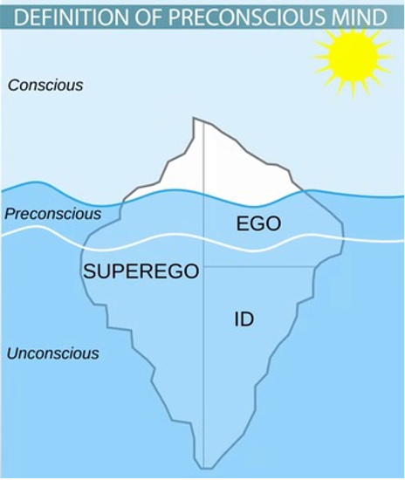

Cognitive structures, including the id, ego, and superego, explain how normal and abnormal personalities develop. The id strives to satisfy a person’s instincts and drives and develops first in the mind. An individual may have an impulsive personality, especially when instincts and the id predominate. The id is not concerned with societal moralities but somewhat interested in quick gratifications. The superego is the conscience, the proper norms, ideals, and ethics in a society that dictate how a person should behave. It intends to do what is morally right and provides standards of judgment. Therefore, the superego conflicts with the id since both have different drives. The ego balances the id and superego demands and avoids psychological issues.

In essence, the ego is a reality-oriented part of the mind that plays an integral role in psychological well-being. The ego helps manage anxiety through defence mechanisms, the mental reactions that emerge from the unconscious when a person feels threatened. The ego allows people to overcome events or experiences that could result in adverse consequences. Although ego is essential in psychological well-being, it leads to distortion of reality that can lead to severe psychological problems. For example, repression includes moving information from the conscious to the unconscious to block bad experiences or events. People may also deny that particular events occurred or are occurring, ignoring the potential effects of those events. Even though repression and denial help a person avoid destructive thoughts and feelings, the two defence mechanisms could lead to adverse psychological consequences when underlying issues are left untreated.

**References:**

(1) Femi Oyebode (2022). SIMS’ Symptoms in the Mind: Textbook of Descriptive Psychopathology. S.L.: Elsevier Health Sciences.

‌(2) Bornstein, R 2021, The Psychodynamic Perspective, Noba, viewed 8 December 2022, <https://nobaproject.com/modules/the-psychodynamic-perspective>.

### 5.2.4 Assessment of physical factors

## **Assessment of Physical Factors including Investigations**

In psychiatric assessments, physical factors and investigations play an important role in helping healthcare professionals arrive at a diagnosis. These assessments include:

1. **Physical examination:** A general physical examination is performed to rule out any underlying medical conditions that could be contributing to the patient’s mental symptoms.
2. **Vital signs:** Vital signs such as blood pressure, heart rate, and body temperature are checked to ensure the patient’s overall health.
3. **Laboratory tests:** Blood tests, urine tests, and other laboratory tests may be conducted to look for any evidence of underlying medical conditions, such as infections, electrolyte imbalances, or endocrine disorders.
4. **Neuroimaging studies:** Neuroimaging studies, such as MRI or CT scans, may be performed to rule out brain conditions that could be contributing to mental symptoms, such as brain tumours, strokes, or degenerative diseases.
5. **Electroencephalogram (EEG):**An EEG may be performed to evaluate brain activity and look for evidence of seizures or other neurological conditions.
6. **Psychophysiological tests:** Psychophysiological tests, such as heart rate variability, electrodermal activity, or pupillometry, may be used to measure specific physiological responses to stimuli that are relevant to mental disorders.
7. **Substance abuse tests:** Substance abuse tests, such as urine or blood tests, may be performed to determine if the patient is using drugs or alcohol that could be contributing to their mental symptoms.

These physical factors and investigations are important in helping healthcare professionals arrive at a comprehensive and accurate diagnosis and develop an effective treatment plan for their patients.

## **Depression**

Depression as a clinical diagnosis can present with a number of common chronic medical conditions. These include coronary artery disease, diabetes mellitus, renal disease, HIV, malignancies, neurological disorders, and stroke.

Before taking antidepressants, laboratory tests are often performed if medical causes are suspected or a baseline function needs to be determined.

|  |  |
| --- | --- |
| **Investigation** | **Purpose** |
| FBC (plus CRP) | Infections or inflammatory causes |
| TSH | Hypothyroidism can present like depression |
| Vitamin B12 | Deficiency can present like depression |
| Electrolytes (plus Ca2+, Mg2+, phosphate) | Fatigue or depression can present due to deficiencies |
| Renal function (eGFR, creatinine) | Prior to commencing antidepressants |
| LFTs | Prior to commencing antidepressants and rule out alcohol-related liver disease |
| Blood / Urine toxicology | Illicit substances can contribute to a depressive presentation |
| 24 hr urinary free cortisol | If Cushing’s disease is suspected |
| ACTH stimulation test | If Addison’s disease is suspected |
| HIV and Syphilis | If sexually transmitted infections are suspected to contribute to mental state |

## **Thyroid investigations:**

Patients with thyroid disorders are more prone to develop depressive symptoms and conversely, depression may be accompanied by various subtle thyroid abnormalities.

* 1-5% of depressed patients presenting with depressive symptoms show hypothyroidism.
* 4-40% show subclinical hypothyroidism.
* Both hypothyroidism and subclinical hypothyroidism can contribute to treatment failure.
* Reductions in serum T4 may be associated with:
  + Antidepressants
  + Lithium
  + Sleep deprivation
  + Electroconvulsive therapy
* Approximately 30% of patients presenting with clinical depression show blunted TSH response.

## **Anxiety**

Living with chronic anxiety can cause physical stress on your body, especially to your nervous, cardiovascular, digestive, immune, and respiratory systems. Research usually cannot address the direct causal relationship between a physical ailment and a mood disorder due to the lack of adequate study designs, methodologies, and population samples. What can be understood is the wide association and impact of mood disorders on a variety of physical illnesses.

Anxiety disorder is partly a diagnosis of exclusion. Excluding physical health conditions, other psychiatric disorders, medication side effects, or other substance use.

Physical examination and laboratory studies are generally normal if no co-existing issue is noted.

Diagnostic possibilities for anxiety or ‘panic attacks’ include paroxysmal atrial tachycardia, pulmonary embolus, seizure disorder, Meniere’s disease, transient ischemic attack, carcinoid syndrome, Cushing’s disease, hyperthyroidism, hypoglycemia, and pheochromocytoma. A physical examination is warranted for all first presentations; extensive medical evaluation for these disorders is indicated only when other features suggest physical disease.

## **Physical symptoms:**

* Headache
* Sweating
* Dizziness
* Gastrointestinal symptoms
* Palpitations
* Breathing difficulties
* Loss of libido
* Fatigue
* Muscular aches and pains

## **Investigations:**

* Thyroid function tests
* Blood/urine toxicology
* 24-hour urine for vanillyl mandelic and metanephrines
* Pulmonary function tests
* ECG
* Physical examination

## **Psychosis**

When presented with a patient who is suffering from suspected psychosis always consider physical health differential diagnosis and assess for a range of other factors:

## **Differential diagnoses:**

* **Severe affective (mood) disorders are associated with psychotic symptoms,**including severe depression or bipolar disorder.
* **Drug-induced psychosis is**caused by cannabis, corticosteroids, opioids, cocaine, or amphetamines.
* **Sepsis**— consider in people without a prior history of psychotic symptoms, particularly where there are featuressuggestive of specific infection, such as dysuria or productive cough.
* **Underlying medical conditions**, such as cerebrovascular disease, cerebral tumours, temporal lobe epilepsy, head trauma, encephalitis syndrome
* **Post-traumatic stress disorder (PTSD)** may include flashbacks that have a hallucinatory quality and hyper-vigilance that may reach paranoid proportions. PTSD is distinguished from psychotic disorders by the existence of a traumatic event and characteristic features such as reliving or re-enacting the event.
* **Obsessive-compulsive** disorder (OCD) strong irrational beliefs are held but related to specific fears, and for which the person has developed rituals could present similarly to psychosis.
* **Autism spectrum disorder or communication disorders** – people with these disorders may display symptoms that resemble a psychotic episode. They may be distinguished from psychotic disorders by their deficits in social interaction with repetitive and restricted behaviours.

## **Other factors:**

* Focal neurological deficits
* Abnormal body movements
* Memory loss
* Tremor especially in older patients
* Dietary history (deficiencies of vitamin B12, folate, thiamine, and niacin can all cause psychosis).

|  |  |
| --- | --- |
| **Investigation** | **Purpose** |
| **FBC (plus CRP)** | Infections or inflammatory causes plus baseline for starting antipsychotics ie. Olanzapine, Clozapine |
| **TFT’s** | Hypothyroidism or hyperthyroidism can present as psychosis |
| **Blood glucose and lipid profile** | A baseline for commencing antipsychotics. Metabolic syndrome is common among patients who suffer from psychosis |
| **Electrolytes (plus Ca2+, Mg2+, phosphate)** | Underlying metabolic or endocrine disturbances |
| **Renal function (eGFR, creatinine)** | Prior to commencing antipsychotics |
| **LFT’s** | Prior to commencing antipsychotics and ruling out alcohol-related liver disease |
| **Blood / Urine toxicology** | Illicit substances can contribute to a psychotic presentation |
| **Prolactin levels** | Prior to commencing antipsychotics |
| **ECG** | Prior to commencing antipsychotics |
| **HIV and Syphilis** | If sexually transmitted infections are suspected to contribute to the mental state |

**Autoimmune encephalitis presenting as psychosis:**Autoimmune disorders with antibodies secreted against neurotransmitter receptors can present with psychosis. There is evidence for N-methyl-d-aspartate receptor (NMDAR) hypofunction as a central part of the functional dysconnectivity There is also evidence for voltage-gated potassium channel dysfunction. With regard to NMDAR encephalitis: NMDAR antibody testing is more sensitive in CSF than serum. It is more common in females (80%) than males. Anti-NMDAR encephalitis should respond to 3 days of methylprednisolone oral/intravenous, alongside 5 days of plasma exchange. It is recommended to avoid antipsychotics in patients who have anti-NMDAR antibodies due to the risk of neuroleptic malignant syndrome or dystonic reactions.

## **Dementia**

Physical examinations when presented with a patient with dementia can help rule out treatable causes as well as precipitating factors. Examination and investigations could identify signs of a stroke or other neurological disorders than can contribute to dementia.

Assessment can identify pathology such as cardiovascular or renal disease that has a strong overlap with dementia.

A physical examination can help rule out treatable causes of dementia and identify signs of a stroke or other disorders that can contribute to dementia. It can also identify signs of other illnesses, such as heart disease or kidney failure, that can overlap with dementia. If a patient is taking medications that may be causing or contributing to his or her symptoms, the doctor may suggest stopping or replacing some medications to see if the symptoms go away.

|  |  |
| --- | --- |
| **Investigation** | **Purpose** |
| **FBC** | Infections or inflammatory causes plus baseline for starting antidementia medications |
| **TFT’s** | Low T4 or impaired thyroid function can impair cognition |
| **Blood glucose and lipid profile** | A baseline for commencing antidementia medications. Metabolic syndrome is common among patients who suffer from dementia |
| **Electrolytes (plus Ca2+, Mg2+, phosphate)** | Impaired cognition can present due to deficiencies |
| **Renal function (eGFR, creatinine)** | Prior to commencing antidementia medications |
| **LFT’s** | Prior to commencing antidementia medications |
| **Lumbar puncture** | Sometimes, a lumbar puncture (spinal tap) may be performed to obtain cerebrospinal fluid, which is then analyzed for evidence of Alzheimer’s disease proteins or of certain infections, inflammatory conditions, or other diseases |
| **Vitamin B12** | Deficiency can impair cognition |
| **Thiamine and folate** | Deficiency can impair cognition |
| **HIV and Syphilis** | HIV-associated dementia or neurosyphilis can notably impair cognition and predispose to opportunistic infections. |
| **CT or MRI head** | Routine imaging of elderly patients often provides low diagnostic yield, especially for Alzheimer’s disease. It is evident when suspicion of vascular dementia, or medical causes such as haematoma or tumours. |

## **Anorexia Nervosa**

Anorexia nervosa presents often with a varying degree of physical and psychosocial morbidity.

Patients with anorexia nervosa (AN) typically have low body weight, intense fear of gaining weight, and a body image disturbance. While more often detected in women, cases of AN in young men may be under-represented.

|  |  |  |
| --- | --- | --- |
| **Organ systems** | **Pathological findings** | **Leading systems** |
| **CNS** | Morphological/function cerebral changes; volume reduction in both cerebral grey and white matter | Cognitive deficits |
| **Dental systems and parotid glands** | Impaired dental status, increased risk of dental cavities, increased serum amylase | Dental decay, enlargement of the parotid glands |
| **Endocrine system and reproductive function** | Impairement of HPA axis, low T3, hypercortisol | Amenorrhoea in women, hypothyroidism, depression, increased stress levels |
| **Cardiovascular system** | Hypotension, bradycardia, arrhythmia | Syncope |
| **Gastrointestinal tract** | Impaired gastric emptying, GI ulcers, increased dilation of the stomach | Constipation, upper GI bleeding, ileus |
| **Haematological and immune system** | Bone marrow hypoplasia with decreased leucocytes and Ig | Anameia, bacterial infections, impaired immune system |
| **Renal tract** | Hypokalaemia, hypophosphataemia, hypernatraemia | Nephrolithiasis, oedema, syncope |
| **Bone** | Decreased bone density (osteopenia/osteoporosis) | Bone fractures or spinal compression, associated pain |

## **1st investigations:**

|  |  |
| --- | --- |
| **Height and weight; vital signs, such as heart rate, blood pressure and temperature** | Indicative of severity and acute body compensation |
| **FBC** | Normocytic normochromic anaemia; mild leukopenia; thrombocytopenia |
| **Electrolytes** | Metabolic alkalosis and hypokalaemia (if vomiting is present); metabolic acidosis, hyponatraemia and hypokalaemia (if laxative use is present), hypomagnesaemia, hypophosphataemia, hypocalcaemia, hypoglycaemia, elevated urea levels |
| **TFT’s** | Triiodothyronine (T3) low, thyroxine (T4) normal, thyroid-stimulating hormone (TSH) normal (changes are not generally clinically significant) |
| **LFT’s** | Elevated alanine aminotransferase, aspartate aminotransferase; elevated cholesterol |
| **Urinalysis** | Low specific gravity may indicate consumption of large quantities of free water; ketonuria may indicate significant semi-starvation |

## **Investigations to consider:**

|  |  |
| --- | --- |
| **ECG** | Bradycardia, conduction defects; prolongation of QT interval (corrected for rate) |
| **Bone densitometry (DAXA)** | Osteopenia, osteoporosis |
| **Estradiol in females** | Low or non-detectable levels |
| **Testosterone in males** | Low levels |

## **Electrocardiography**

Electrocardiography (ECG) is the process of creating an electrocardiogram, which is a recording of the electrical activity of the heart. It is a heart electrogram, which is a graph of voltage versus time of the electrical activity of the heart recorded with electrodes placed on the skin.

|  |  |
| --- | --- |
| **ECG feature:** | **Summary:** |
| **Rate** | The average rate is 60-100. Bradycardia is defined as less than 60 beats per minute, while tachycardia is defined as more than 100 beats per minute. |
| **ST section** | Myocardial infarction is indicated by an upsloping ST segment (referred to as ST elevation). A low ST segment indicates myocardial ischaemia. |
| **QTc interval** | The normal QTc interval range is 0.35-0.45 seconds. |
| **PR interval** | A typical PR interval is 0.12 to 0.2 seconds. First-degree heart block is defined as a PR interval that is consistently longer than 0.2s. |
| **T-waves** | In some leads, are peaked in hyperkalemia, flat and prolonged in hypokalemia, and inverted in normal, as well as in ischemia and infarction. |
| **U-shaped waves** | It can be normal, but it can also be found in hypokalemia. |

**References:**

(1) Hage, M.P. and Azar, S.T. (2012). The Link between Thyroid Function and Depression. Journal of Thyroid Research, [online] 2012, pp.1–8. doi:10.1155/2012/590648.

(2) Balon, R. (2006). Mood, anxiety, and physical illness: body and mind, or mind and body? Depression and Anxiety, 23(6), pp.377–387. doi:10.1002/da.20217.

(3) Bmj.com. (2019). Generalised anxiety disorder – Symptoms, diagnosis and treatment | BMJ Best Practice. [online] Available at: https://bestpractice.bmj.com/topics/en-gb/120.

(4) Zandi, M.S., Irani, S.R., Lang, B., Waters, P., Jones, P.B., McKenna, P., Coles, A.J., Vincent, A. and Lennox, B.R. (2010). Disease-relevant autoantibodies in first episode schizophrenia. Journal of Neurology, 258(4), pp.686–688. doi:10.1007/s00415-010-5788-9.

(5) stanfordhealthcare.org. (n.d.). Laboratory tests. [online] Available at: https://stanfordhealthcare.org/medical-conditions/brain-and-nerves/dementia/diagnosis/laboratory-tests.html.

(6) Zipfel, S., Giel, K.E., Bulik, C.M., Hay, P. and Schmidt, U. (2015). Anorexia nervosa: aetiology, assessment, and treatment. The Lancet Psychiatry, 2(12), pp.1099–1111. doi:10.1016/s2215-0366(15)00356-9.

(7) bestpractice.bmj.com. (n.d.). Log in | BMJ Best Practice. [online] Available at: https://bestpractice.bmj.com/topics/en-gb/440/investigations#firstOrder [Accessed 6 Dec. 2022].

### 5.2.5 Imaging of the nervous system

## **Imaging of the Nervous System**

Non-invasive imaging methods have become essential tools for understanding the central nervous system (CNS) in health and disease. The imaging of the nervous system plays a crucial role in psychiatric assessments and can provide important information to help healthcare professionals diagnose and understand mental disorders.

## **Structural Imaging**

## **Computed Tomography (CT):**

CT uses ionising x-ray radiation. A beam of x-rays which is directed through the head rotates around to produce a 2-D picture. The raw data can be reconstructed into different imaging planes i.e. axial, sagittal, and coronal planes. CT scans are shown in varying shades of grey depending on the absorption (or attenuation) patterns that different tissues exhibit when subjected to ionising radiation.

Unlike normal x-rays, which only show 5 densities (air/fat/soft tissue/bone/metal), CT shows a wide range of densities ranging from the air (black) through bone (white). Dense tissues such as bone attenuate (reduce in intensity) x-rays the most and appear white, whereas tissues such as air attenuate the least and appear black.

Psychiatric symptoms are often non-specific and commonly present in patients with medical as well as psychiatric disorders. Often CT head scans are utilised in psychiatry as a screening tool with the goal of detecting suspected and treatable diseases involving the central nervous system.

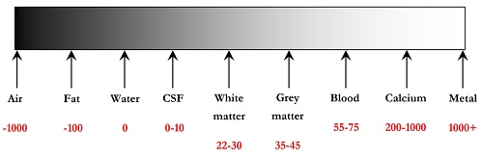

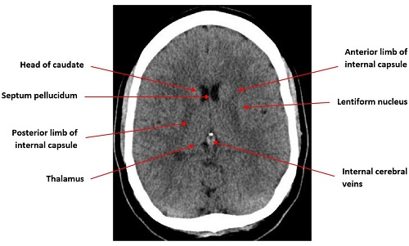

## **Functional Imaging**

## **Magnetic Resonance Imaging (MRI):**

This takes advantage of the magnetic characteristics of tissues. A substantial magnetic field is first applied to align all hydrogen atoms in the same direction. The atoms are then realigned using a radio frequency (Larmour frequency). When the radio frequency is switched off, the atoms realign and emit a signal. The MRI machine detects this signal and generates an image. T1 and T2 weighting describe how atoms realign after the radio frequency has been eliminated.  
  
The fact that blood with various degrees of oxygenation creates distinct signals is used by **functional MRI (fMRI)**. As a result, it is a measure of oxygen consumption. This is known as blood level-dependent (BOLD) contrast.

**Perfusion MRI (pMRI)** – evaluates microscopic blood flow within capillaries.

The introduction of MRI has significantly revolutionised the radiological examination of the central nervous system. MRI is a versatile modality that has been used to diagnose practically every type of brain, spinal cord, and surrounding structural problems. However, significant limitations exist, such as limited detectability of subarachnoid haemorrhage or calcifications, difficulties in seeing bone features, and other types of artefacts.

## **Emission Tomography (PET and SPECT):**

**Positron emission tomography (PET)** is a non-invasive imaging technique used to measure radioactivity in vivo. It entails injecting a positron-emitting radiopharmaceutical intravenously, waiting for systemic distribution, and then scanning for detection and measurement of radiopharmaceutical accumulation patterns within the body.

**Single photon emission computed tomography (SPECT)** is a 3D nuclear medicine imaging technology that combines scintigraphy with CT.  This permits the radionuclide distribution to be presented in 3D, providing more detail, contrast, and spatial information than planar nuclear imaging alone.

The physiologic information provided by PET and SPECT imaging is priceless, and the data quality is poor/noisy, limiting imaging spatial resolution. As a result, PET and SPECT scans are frequently coupled with CT imaging, allowing for the comparison of functional and anatomical imaging (“hybrid imaging”).

## **Magnetic Resonance Spectroscopy (MRS):**

Magnetic resonance spectroscopy (MR spectroscopy or MRS) is a tool for interrogating tissue for the presence and concentration of different metabolites.

Metabolites that can be measured include GABA, glutamate/glutamine, lactate, lipids, choline etc.

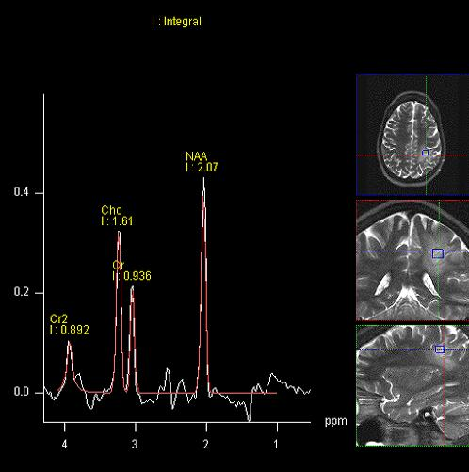

## **Diffusion Tensor Imaging (DTI):**

**Diffusion tensor imaging (DTI)**is an MRI technique that uses anisotropic diffusion to estimate the axonal (white matter tracts) organisation of the brain.

Some of the many applications include:

* Assessment of the deformation of white matter by tumours – deviation, infiltration, destruction of white matter
* Delineation of the anatomy of immature brains
* Alzheimer’s disease – detection of early disease
* Schizophrenia
* Multiple Sclerosis – plaque assessment

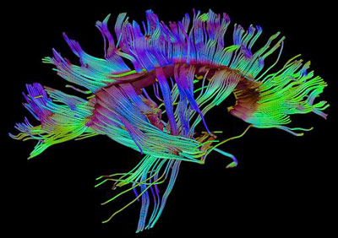

**References:**

 (1) Roarke MC, Nguyen BD, Pockaj BA. Applications of SPECT/CT in nuclear radiology. (2008) AJR. American journal of roentgenology. 191 (3): W135-50. doi:10.2214/AJR.07.3564 – Pubmed

(2) Kapoor V, McCook B, Torok F. An Introduction to PET-CT Imaging. Radiographics. 2004;24(2):523-43. doi:10.1148/rg.242025724 – Pubmed

(3) Al-okaili RN, Krejza J, Wang S et-al. Advanced MR imaging techniques in the diagnosis of intraaxial brain tumors in adults. Radiographics. 2006;26 Suppl 1 : S173-89. doi:10.1148/rg.26si065513 – Pubmed citation

(4) Jellison BJ, Field AS, Medow J et-al. Diffusion tensor imaging of cerebral white matter: a pictorial review of physics, fiber tract anatomy, and tumor imaging patterns. AJNR Am J Neuroradiol. 2004;25 (3): 356-69. Pubmed citation

### 5.2.6 Working knowledge of medicine

## **Working Knowledge of Medicine Including Physical Examination, Diagnosis, Investigation and Treatment of Common Conditions**

## **Physical examination and diagnosis**:

Examination of the patient’s physical state is a key part of any psychiatric assessment. A number of reasons why:

* Physical symptoms may be directly related to the psychiatric illness in question
  + Medical complications of alcohol dependency
  + Anorexia nervosa
  + Physical neglect in depression or schizophrenia
* Psychiatric medications are well known to have physical side effects
  + EPSEs from antipsychotics
  + Hypothyroidism
  + Lithium
  + Metabolic syndromes
  + Withdrawal syndromes
* Physical ailments can cause or worsen psychiatric symptoms
* Beneficial to have a physical health baseline recorded in case of future illness (or medico-legal issues)

## **General examination:**

## **Cardiovascular:**

|  |  |
| --- | --- |
| **Parkinsonian facies** | Antipsychotic medication, psychomotor retardation (depression) |
| **Abnormal pupil size** | Opiate use |
| **Argyll-Robertson pupil** | Neurosyphilis |
| **Enlarged parotids** | Bulimia nervosa (associated with vomiting) |
| **Hypersalivation** | Clozapine |
| **Goitre** | Thyroid disease |
| **Multiple forearm lacerations/scars** | Borderline personality disorder |
| **Multiple tattoos** | Dissocial personality disorder |
| **Need tracks/phlebitis** | Intravenous drug use |
| **Gynaecomastia** | Antipsychotic medication |
| **Russell’s sign** | Bulimia nervosa |
| **Lanugo hair** | Bulimia nervosa |
| **Excessive thinness** | Anorexia nervosa |
| **Piloerection (“goose flesh”)** | Opiate withdrawal |
| **Tachycardia or irregular pulse** | Anxiety disorder, drug/alcohol withdrawal, hyperthyroidism |
| **Bradycardia** | Hypothyroidism |

## **Neurological:**

|  |  |
| --- | --- |
| **Resting tremor** | Increased sympathetic drive (Parkinson’s, anxiety, drug/alcohol misuse) |
| **Involuntary movements** | Antipsychotic or lithium medication |
| **Abnormal posturing** | Antipsychotic medication, tic disorder, Huntington’s/Sydenham’s chorea |
| **Festinant (shuffling) gait** | Antipsychotic medication-induced dystonia |
| **Broad-based gait** | Antipsychotic medication, cerebellar disease, alcohol or lithium toxicity |

## **Abdominal:**

|  |  |
| --- | --- |
| **Hepatomegaly** | Alcoholic liver disease, hepatitis |
| **Multiple surgical squares (“chequerboard abdomen”)** | Somatization disorder |
| **Multiple self-inflicted scars** | Borderline personality disorder |

## **Investigations**

Clinical investigations, such as blood tests, imaging methods, and karyotyping, are less common in psychiatry than in other medical specialities. The general purpose they are carried out is to rule out of pathologies that may be part of the differential diagnosis (ie. hypothyroidism as a cause of depression and lethargy). Ideally, they should be a result of positive findings from the history of physical examination.

Basic investigations such as the FBC, LFTs, U&Es, and TFTs should be performed to assess general physical health and provide a baseline measure prior to commencing medication that can be known to have an adverse effect.

Other more invasive investigations are rarely requested. A lumbar puncture, for example, is reserved for situations where there is clear evidence to suspect a neurological disorder presenting with psychiatric symptoms e.g. meningitis, encephalitis, or multiple sclerosis. More often than not at this point, a referral will be made for medical input.

Imaging tools such as EEG, CT, MRI, SPECT, or PET require a clear rationale for their diagnostic need. It is often cited that EEG is overused by psychiatrists due to its difficulty to interpret especially since many psychotropic medications can interfere with the result. EEG may be useful upon suspicion of epilepsy, to assess atypical patterns of cognitive impairment, to investigate sleep disorders, or to aid in specific dementia diagnoses (HIV, vCJD). EEG is the gold standard for monitoring seizure activity during ECT. EEG should not be used as a screening tool. Cranial imaging adds little to primary psychiatric diagnosis unless there are suspected neurological problems such as prior head injury history, epilepsy, neurosurgery, or suspicion of a space-occupying lesion (localizing neurological signs, fluctuating consciousness level, severe headache, and marked or unexplained acute behavioural change).

The sensitivity and specificity of imaging findings for the majority of psychiatric disorders have yet to be established.

## **ECG and psychiatry medications:**

| ***ECG findings*:** | **Associated medication:** |
| --- | --- |
| Tachycardia | Clozapine TCAs MAOIs Antiparkinsonian Antipsychotics (generally the older ones) |
| Bradycardia | SSRIs Lithium Cholinesterase inhibitors |
| Heart blocks | TCAs |
| Repolarisation changes (ST segment & T wave changes) | Thioridazine Chlorpromazine |
| QTc prolongation | Wide range of antipsychotics and antidepressants |
| Torsades/VF | Haloperidol Thioridazine Mesoridazine Chlorpromazine |

**References:**

(1) Semple, D. and Smyth, R. (2019). Psychiatric assessment. Oxford Handbook of Psychiatry, [online] pp.45–98. doi:10.1093/med/9780198795551.003.0002.

### 5.2.7 Rating scales in psychiatry

## **Rating Scales in Psychiatry**

Rating scales are tools commonly used in psychiatry to assess and quantify the severity of mental and behavioural symptoms. They provide a standardized and objective method for measuring symptoms, which can be helpful in tracking changes over time, evaluating the effectiveness of treatment, and making comparisons between patients. Some of the most commonly used rating scales in psychiatry include:

|  |  |  |
| --- | --- | --- |
| **Condition** | **Clinician rated** | **Patient rated** |
| **Alcohol dependence** | AUDIT (Alcohol Use Disorders Identification Test) FAST (Fast Alcohol Screening Test) |  |
| **Bipolar** | YMRS (Young Mania Rating Scale) |  |
| **Dementia** | CAMDEX (Cambridge Mental Disorders of the Elderly Examination) |  |
| **Depression / Anxiety** | MADRS (Montgomery-Asberg Depression Rating Scale) HAMD (Hamilton Depression rating scale) BASDEC (Brief Assessment Schedule Depression Cards) HAMA (Hamilton Anxiety rating scale) CSDD (Cornell Scale for Depression in Dementia) | BDI (Beck Depression Inventory) GDS (Geriatric Depression Scale) ZSRDS (Zung Self-Rated Depression Scale) HAD (Hospital Anxiety Depression scale) EPDS (Edinburgh Postnatal major Depression Scale) |
| **Global function** | CGI (Clinical Global Impression) GAF (Global Assessment of Functioning) | GHQ (General Health Questionnaire) |
| **Medication** | AIMS (Abnormal Involuntary Movement Scale) SAS (Simpson-Angus Scale) | LUNSERS (The Liverpool University Neuroleptic Side Effect Rating Scale) DESS (Discontinuation-Emergent Signs and Symptoms scale) |
| **OCD** | Y-BOCS (Yale-Brown Obsessive Compulsive Scale) |  |
| **Schizophrenia** | BPRS (Brief Psychiatric Rating Scale) PANSS (Positive And Negative Syndrome Scale) |  |

(Semple, 2019)

## **Alcohol Dependence**

**AUDIT:** The WHO developed AUDIT (Alcohol Use Disorders Identification Test) as a simple method of screening for excessive drinking. The ten-question test attempts to cover the three domains of harmful use, hazardous use, and dependence. 10-question survey which takes about 2-3 minutes to finish. It has been demonstrated that it outperforms CAGE and biochemical markers in predicting alcohol problems. The minimum score is 0 and the maximum score is 40. A score of 8 or higher in men and 7 or higher in women indicates a high risk of hazardous or harmful alcohol consumption. A score of 15 or higher in men and 13 or higher in women indicates alcoholism.

**FAST:** (Fast Alcohol Screening Test) is a short and quick test with only four questions designed for use in a busy medical setting. It evolved from the AUDIT test. 4 question survey with a minimum score being 0 and a maximum score is 16. The hazardous drinking score is 3 or higher. In response to the first question, 1 drink is equal to 1/2 pint of beer, 1 glass of wine, or 1 single spirit. If the patient answers ‘never’ to the first question, he or she is not abusing alcohol. If the patient answers ‘Weekly’ or ‘Daily or almost daily,’ the patient is a hazardous, harmful, or dependent drinker. This one question will classify more than half of the population.

## **Bipolar**

**YMRS (Young Mania Rating Scale):**The YMRS is an 11-item questionnaire used to determine the severity of mania in people with bipolar illness.

## **Dementia**

**CAMDEX (Cambridge Mental Disorders of the Elderly Examination):** Created to aid in the early detection and assessment of dementia in the elderly. Includes three components: a clinical interview, a battery of cognitive tests, and an interview with a patient’s relative to get independent information about the patient’s past and present condition. It consists of 40 items that assess various aspects of cognitive and mental function, including memory, language, attention, and mood.

## **Depression and Anxiety**

**HAMD (Hamilton Depression rating scale):** The HAMD is a multiple-choice questionnaire designed to assess the severity of depression. There are either 17 or 21 things depending on the version used. Each item is rated between 3 and 5 points. The bigger the overall number of points obtained, the more severe the depression. Scores for the 17-item version (the most often used) vary from 0 to 54. Scores of 24 or above indicate serious depression.  
  
**HAMA (Hamilton Anxiety rating scale):** is a 14-item rating scale designed to measure the severity of anxiety. It is clinician-rated.  
  
**MADRS (Montgomery-Asberg Depression Rating Scale):**The MADRS is a ten-item diagnostic questionnaire that is used to determine the severity of depressive episodes. It was created to be more sensitive to the effects of antidepressants and other types of therapy.

**ZSRDS (Zung Self-Rated Depression Scale):** The ZSRDS was created to determine the severity of depression. The scale has 20 elements, each of which is rated from 1-4.  
  
**BDI (Beck Depression Inventory):** The BDI is a measure used to determine the severity of depression. There are a total of 21 elements, each with a score ranging from 0 to 3. In 1966, the scale was updated. 0-13 denotes mild depression, 14-19 moderate depression, 20-28 serious depression, and 29-63 severe depression.  
  
**GDS (Geriatric Depression Scale):** The GDS is a 30-item self-report measure used to test elderly people for depression. Each question has a yes or no response, resulting in a total score of 30. Normal is 0-9, mild depression is 10-19, and severe depression is 20-30.  
  
**BASDEC (Brief Assessment Schedule Depression Cards):** The BASDEC is a depression screening test. It employs a deck of cards with comments such as “I feel anxious all the time” or “I’m so lonely” which are presented to the patient. In response to each card, the patient indicates whether the card is accurate or untrue. There are 19 cards in all, with a possible score of 21. (two cards carry 2 points each). It is a fast test that may be completed in less than 5 minutes. A cut-off score of 7 is commonly utilised. The exam was designed for use in busy wards to provide some privacy.  
  
**CSDD (Cornell Scale for Depression in Dementia):** This test was designed primarily to detect depression in dementia patients. It consists of a 20-minute interview with a caregiver and a 10-minute conversation with the patient. A total of 19 elements are classified as ‘absent, mild/intermittent, or severe.’

**EPDS (Edinburgh Postnatal major Depression Scale)** typically takes around 10 minutes to complete, as it is a self-report questionnaire that assesses symptoms of depression and anxiety in women who have recently given birth.

## **Global** **Function**

**GAF (Global assessment of functioning):** The GAF provides a single measure of global functioning. It assesses occupational function and psychological function only. The overall score is out of 100.

**CGI (Clinical global impression):** The CGI is a scale that asks the clinician to score the severity of the patient’s disease at the time of evaluation in comparison to the physician’s previous experience with patients with the same diagnosis.

## **Medication**

**DESS (Discontinuation-Emergent Signs and Symptoms scale):** The DESS is used to quantify discontinuation symptoms associated with stopping antidepressants. This 43-item rating scale spans a broad spectrum of discontinuation symptoms and can be helpful in documenting symptoms of depressed patients in order to diagnose the likely cause of distress.  
  
**SAS (Simpson-Angus Scale):** The Simpson-Angus Scale (SAS) is a 10-item rating scale frequently used to measure neuroleptic-induced parkinsonism. It includes one element that measures gait (hypokinesia), six elements that measure rigidity, and three elements that measure glabella tap, tremor, and salivation, in that order.

**LUNSERS (The Liverpool University Neuroleptic Side Effect Rating Scale):**Self-rated scale for measuring the side-effect of antipsychotic medications. It measures the 41 known side effects of neuroleptics.

**AIMS (The Abnormal Involuntary Movement Scale):**A 12-item clinician-rated scale with the aim to assess the severity of dyskinesias in patients prescribed neuroleptics. It requires a short assessment time and thus can be used in routine clinical examinations.

## **Obsessive Compulsive Disorder**

**Y-BOCS (Yale-Brown Obsessive Compulsive Scale):** The Y-BOCS is used in two parts – the severity of OCD and the patient’s response to treatment. The Y-BOCS (Yale-Brown Obsessive Compulsive Scale) is primarily used to measure the severity of obsessive-compulsive symptoms in individuals who have been diagnosed with Obsessive Compulsive Disorder (OCD). The scale covers both obsessions and compulsions, and scores range from 0 to 40, with higher scores indicating more severe symptoms. It helps to monitor the symptom change during the treatment, and track the progress of the patient over time.

## **Schizophrenia**

**BPRS (Brief psychiatric rating scale):**A common tool for assessing psychopathology in schizophrenic patients. Originally comprised of 16 elements, the inclusion of two aspects resulted in the usual 18. Later, the enlarged 24-item version (Brief Psychiatric Rating Scale-Expanded) was established to evaluate additional features of schizophrenia, including items for odd behaviour, self-neglect, suicidality, high mood, motor hyperactivity, and distractibility.  
  
**The PANSS (Positive and Negative Syndrome Scale):**assesses both positive and negative symptoms in people with schizophrenia. It uses a diverse set of data, including data from interviews, as well as reports from medical staff and family members. The data collected is based on how the patient was the previous week. There are 30 elements in total.

**References:**

(1) Semple, D. and Smyth, R. (2019). Oxford handbook of psychiatry. Oxford: Oxford University Press.

### 5.2.8 Risk assessment

## **Understanding the Principles of Risk Assessment**

* A patient’s narrative regarding their own personal risk should be included in the assessment.
* Consent to risk assessment should be obtained, and the risks and benefits should be explained.
* Preparation is essential, and physicians should seek information from as many credible sources as possible.
* Involving the patient and caregivers (where appropriate) in the planning process can improve safety.
* The contact between the doctor and the patient is critical; positive relationships make assessment simpler and more accurate, and they may lower risk.
* All physicians should take detailed, inquisitive, and comprehensive histories.
* It may be difficult for a single clinician to conduct an appropriate risk assessment. Discussing evaluations and management strategies with a colleague or supervisor is always beneficial.

Risk Assessment should always attempt to consider past/present behaviours, and also any protective factors.

Often your hospital trust will use a standardised form of risk assessment. There are 85 mental health trusts in the UK, thus a lot of different forms.

**Some points to consider:**

* Self-harm
* Suicide
* Alcohol
* Illicit substances
* Driving
* Any children involved
* Self-neglect
* Harm to others
* Violence and aggression
* Exploitation by others
* Physical health
* Falls
* Absconding

## **Factors to Consider**

## **History:**

* Previous risk, whether investigated, mitigated for, or managed.
* Associations to mental state and risk.
* Absence of supporting relationships.
* Poor treatment adherence, discontinuance, or disengagement.
* Impulsivity
* Alcohol and illicit substance misuse.
* Being exposed to varying types of risk at a young age
* Are the risk variables steady, or have they lately changed?
* Is there anything that could affect the risk?
* Recent stresses, losses, or the fear of loss.
* Factors that have previously prevented the person from responding in a risky manner.
* Are the family/caregivers at risk?
* Empathy impairment.
* The relationship between risk and personality traits.

## **Environment:**

* Risk factors may differ depending on the setting and the patient population.
* Think about protective factors or the loss of protective factors.
* Reduced bed capacity and the risks or alternatives to admission.

## **Working Knowledge of at Least One Recognised Risk Assessment  Tool Used to Assess Risk**

There is an ever-increasing number of risk assessment tools and clinical algorithms in many areas of science and medicine. Risk assessment integrates psychological and social aspects as part of a thorough review to identify patient care requirements and estimate their risk of harm to themselves or others. Assessments frequently try to classify patients as high, medium, or low risk. Checklists or risk assessment tools are sometimes used for risk assessment, although evidence indicates that they are ineffective in predicting suicide.

NICE guidelines on the long-term management of self-harm state that risk assessment tools should “not be used to predict future suicide or repetition of self-harm, or to determine who should or should not be offered treatment”. The guidelines suggest they might be used as prompts or measures of change17.

A national confidential inquiry into suicide and safety in mental health was carried out in 2018: The assessment of clinical risk in mental health services National Confidential Inquiry into Suicide and Safety in Mental Health. The take-home messages can be seen below:

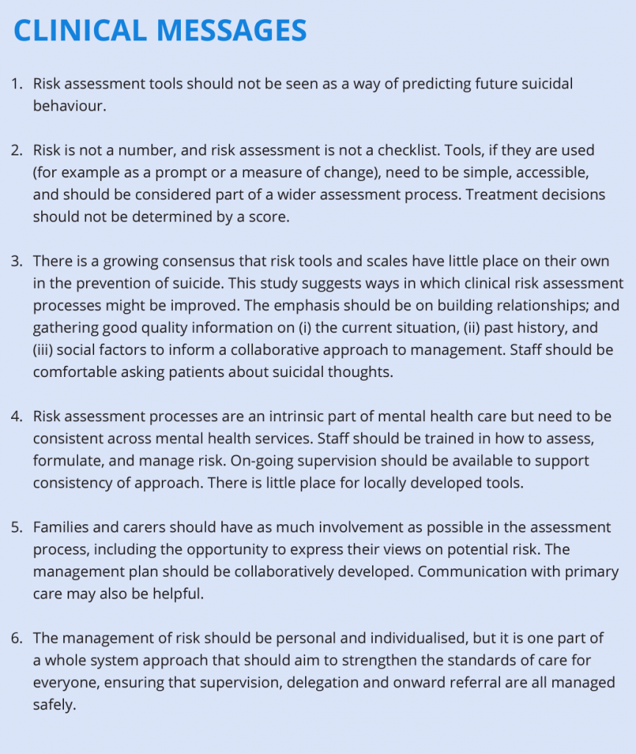

**References:**

(1) The assessment of clinical risk in mental health services National Confidential Inquiry into Suicide and Safety in Mental Health. (2018). [online] Available at: https://www.research.manchester.ac.uk/portal/files/77517990/REPORT_The_assessment_of_clinical_risk_in_mental_health_services.pdf.

(2) RCPSYCH ROYAL COLLEGE OF PSYCHIATRISTS. (n.d.). Assessing risk. [online] Available at: https://www.rcpsych.ac.uk/members/supporting-your-professional-development/assessing-and-managing-risk-of-patients-causing-harm/assessing-risk.

(3) National Institute for Health and Care Excellence (NICE). Self-harm in over 8s: long-term management. Clinical guideline. London: NICE, 2011. https://www.nice.org.uk/guidance/cg133/resources/selfharm-in-over-8slongterm-management-pdf-35109508689349